Comparative Study of Low-Code Development
versus Traditional Application Development Approaches
Name: Santhosh G | Roll No: 240701473

1. Aim
To study and compare the low-code application development approach with the traditional application development approach, and to analyse their respective processes, advantages, limitations, and suitability for different types of software projects.
2. Introduction to Traditional Approach
Traditional application development refers to the conventional method of building software applications by writing source code manually using programming languages such as Java, C++, C#, Python, or JavaScript. This approach follows a structured software development life cycle (SDLC) consisting of well-defined phases such as requirement analysis, system design, implementation, testing, deployment, and maintenance.
In this approach, developers have complete control over the architecture, logic, and functionality of the application. It requires skilled programmers, in-depth technical knowledge, and considerable time for coding, debugging, and testing. While traditional development offers high flexibility and is suitable for building complex, large-scale, and highly customised systems, it generally involves longer development cycles and higher costs compared to modern alternatives.
3. Introduction to Low-Code Development
Low-code development is a modern software development approach that enables the creation of applications with minimal hand-written code. It uses visual development environments that provide drag-and-drop components, pre-built templates, and configurable workflows, allowing users to design and deploy applications quickly.
Low-code platforms are designed to be used not only by professional developers but also by "citizen developers" with limited programming experience. This approach significantly reduces development time and cost, making it ideal for building business applications, internal tools, prototypes, and workflow automation systems. However, it may offer limited flexibility for highly complex or specialised requirements compared to traditional coding.

4. Diagram: Stages in Traditional Approach
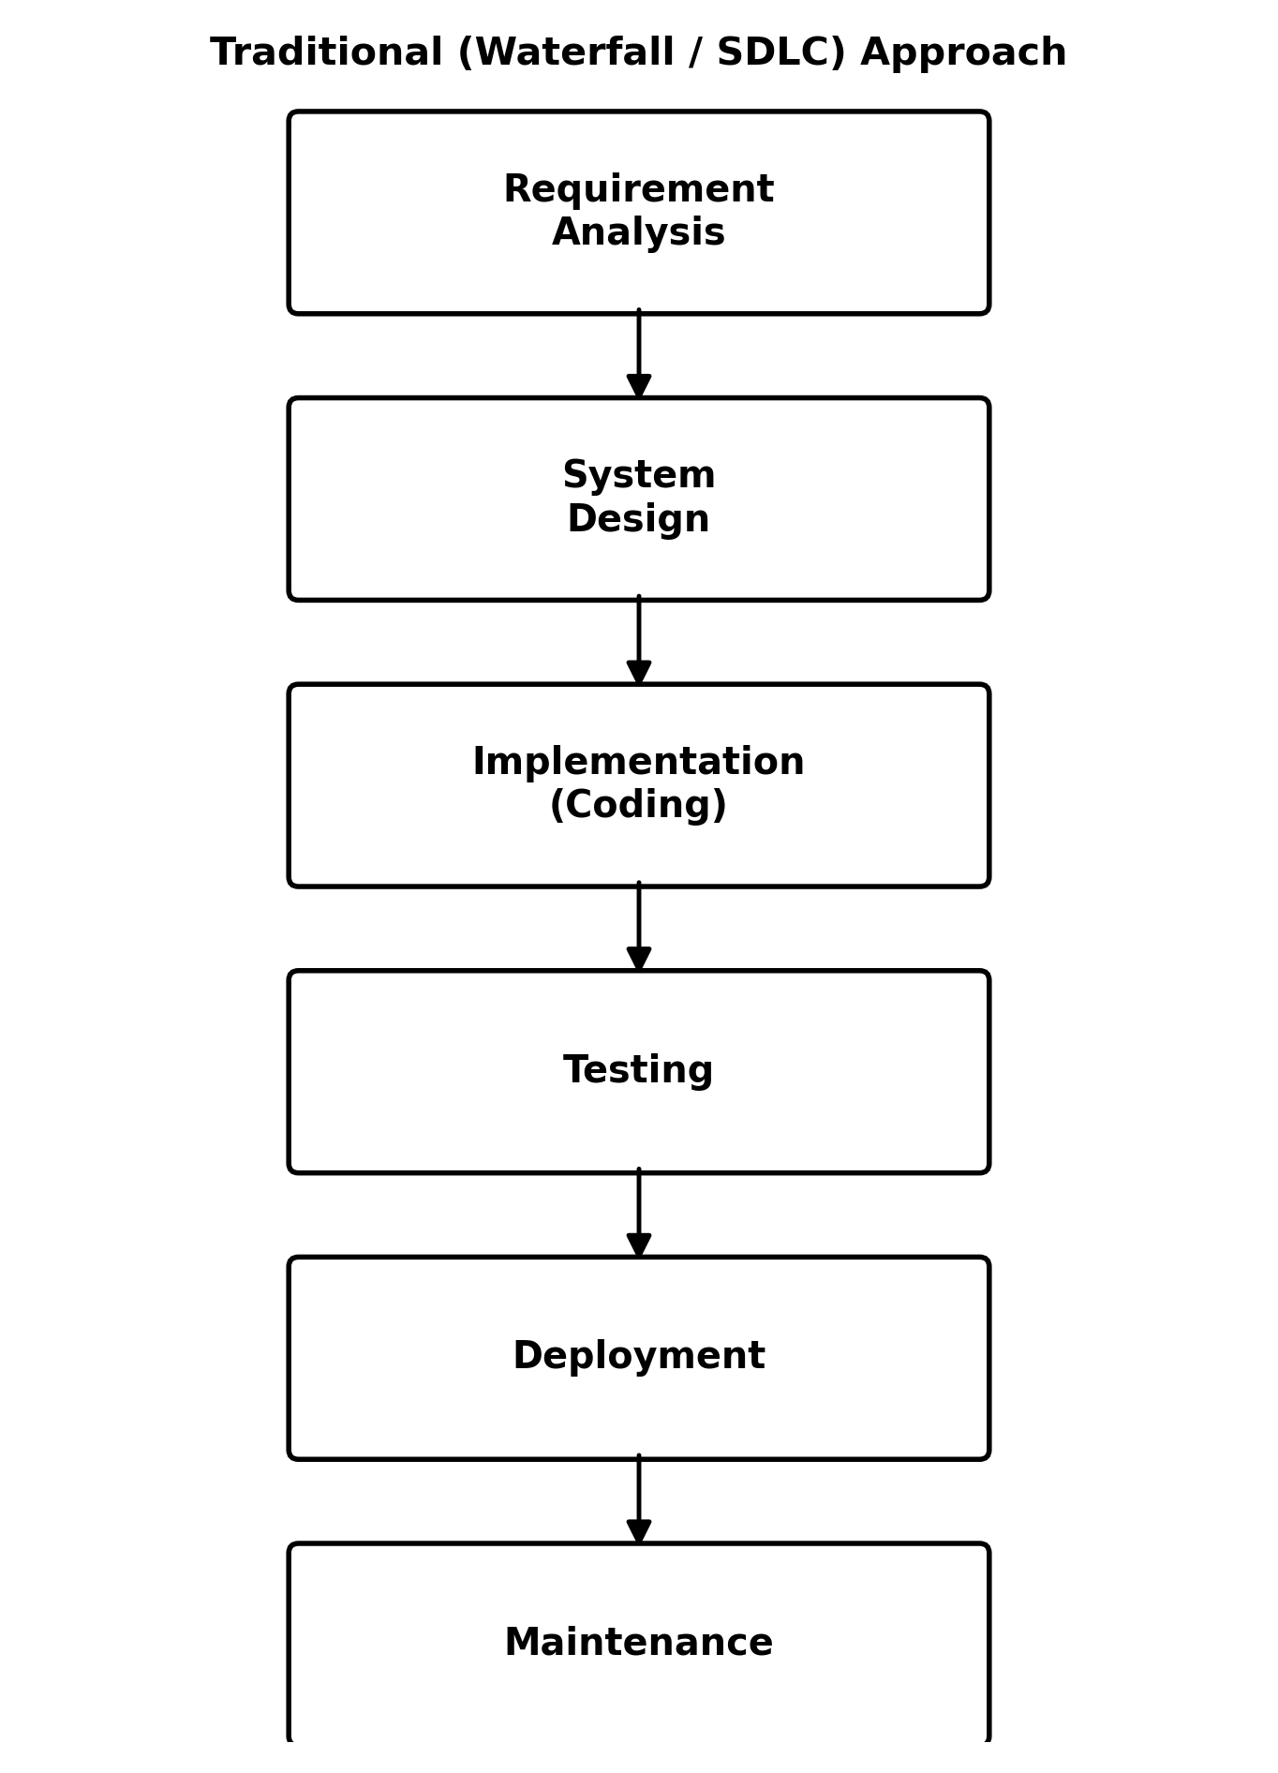
Fig. 1 — Stages of the Traditional (Waterfall/SDLC) Development Approach

5. Diagram: Steps in Low-Code Development
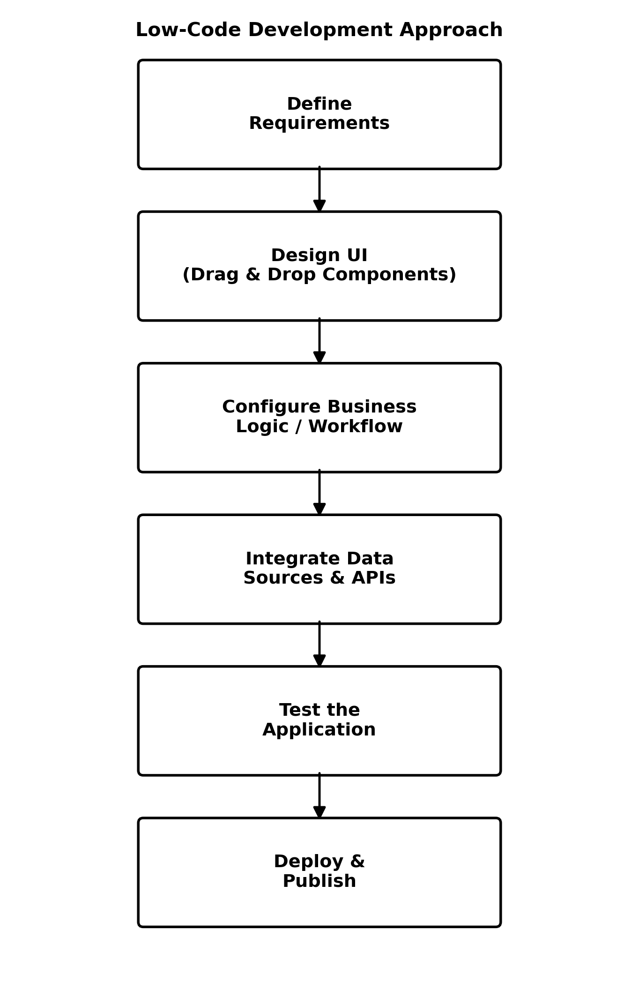
Fig. 2 — Steps in the Low-Code Development Approach

6. Comparative Analysis
The table below summarises the key differences between traditional application development and low-code development across various parameters:
Parameter | Traditional Development | Low-Code Development
Development Approach | Manual, hand-written source code using programming languages (Java, C#, Python, etc.) | Visual, drag-and-drop interface with pre-built components and minimal hand-written code
Development Speed | Slower; each module is built and tested from scratch | Much faster; reusable components and templates accelerate delivery
Skill Requirement | Requires trained programmers with strong coding knowledge | Can be used by professional developers as well as citizen developers with basic training
Cost of Development | Generally higher due to longer development time and specialised manpower | Lower overall cost due to reduced development time and effort
Flexibility & Customisation | Very high; developers have complete control over logic and architecture | Limited to what the platform allows; deep customisation may need custom code extensions
Maintenance | Requires ongoing manual code maintenance and documentation | Easier maintenance since platform handles most underlying code and updates
Scalability | Highly scalable if architected properly, but requires expert planning | Scalable for most business applications, but may face limits for very complex systems
Testing Effort | Extensive manual/automated testing of custom-written code is needed | Reduced testing effort as pre-built components are already tested by the vendor
Vendor Dependency | No dependency on any third-party platform or vendor | Dependent on the low-code platform vendor for updates, pricing and support
Best Suited For | Complex, large-scale, highly customised, or performance-critical applications | Rapid application development, prototypes, internal tools and business workflow apps

7. Result
The comparative study of traditional and low-code application development approaches was successfully carried out. It was observed that the traditional approach offers greater flexibility, control, and scalability, making it suitable for complex and large-scale applications, whereas the low-code approach offers faster development, lower cost, and ease of use, making it suitable for rapid application development and business process automation. The choice between the two approaches depends on the complexity, budget, timeline, and customisation requirements of the project.

