ABSTRACT
The traditional agricultural supply chain is often burdened by multiple intermediaries, which leads to reduced profit margins for farmers and inflated prices for end consumers. GramConnect is an innovative, web-based direct-to-consumer (D2C) platform designed to bridge the gap between local farmers and urban consumers, fostering a transparent, fair, and sustainable agricultural ecosystem.
This project aims to eliminate middlemen by providing a robust digital marketplace where verified farmers can list their fresh produce—such as vegetables, fruits, grains, and dairy—directly to consumers. A core innovation of the platform is the geospatial farm tracking map, which allows consumers to view the exact origins of their food, enhancing trust, transparency, and traceability. To further ensure product quality, the system incorporates a proprietary freshness scoring mechanism alongside a comprehensive user review system.
Additionally, the platform integrates a modern wallet and split payment architecture, streamlining financial transactions and ensuring secure, equitable distribution of funds. GramConnect features distinct, specialized dashboards for Farmers, Consumers, and Administrators. To maintain the integrity of the marketplace, a strict administrative approval workflow is enforced for farmer onboarding, guaranteeing that only authenticated producers can access the platform.
Developed using a modern technology stack comprising React, Vite, TypeScript, and Tailwind CSS on the frontend, supported by a scalable Node.js backend, GramConnect offers a highly responsive and intuitive user experience. By empowering farmers with direct market access and fair pricing, while providing consumers with fresh, traceable, and affordable produce, GramConnect serves as a comprehensive technological solution to modernize local agricultural commerce.

Chapter – 1

INTRODUCTION

It has become increasingly vital to leverage digital connectivity to optimize traditional industries across the world. The agricultural sector, while serving as the backbone of the economy, is historically plagued by long supply chains and multiple intermediaries. These traditional channels permit middlemen to control market access and pricing, leading to significant information asymmetry. The massive volumes of agricultural trade available in these physical markets also draw the attention of exploitative entities [1]. The rise of e-commerce has rapidly become an online source for connecting buyers and sellers directly. Online Marketplaces are platforms where users can trade goods and services, allowing them to outspread their market reach at a much broader level [2]. With the evolution of digital commerce, the need to study and analyze fair trade practices in online agricultural platforms has intensified. Many rural farmers who do not have much information regarding digital pricing and direct-to-consumer (D2C) models can easily be tricked by exploitative digital brokers. There is also a demand to combat and place a control on fraudulent entities who use these platforms only to pose as genuine farmers and thus exploit consumers. Recently, the creation of transparent, direct digital agricultural supply chains has attracted the attention of researchers. Ensuring trust and traceability is a difficult task in maintaining the integrity of agricultural networks.
It is essential to recognize genuine producers in agricultural e-commerce sites to save consumers from various kinds of fraudulent claims (such as fake organic certifications) and to preserve their health and financial security. These hazardous maneuvers adopted by fraudulent sellers cause massive destruction of trust in the community in the real world. Malicious actors have various objectives, such as selling sub-par produce at inflated prices, falsifying harvest data, and bypassing quality checks. They achieve their malicious objectives through deceptive listings and several other means where they dispatch unverified produce randomly to broad consumer bases. These activities cause disturbance to the original, hardworking farmers who are known as genuine producers. In addition, it also decreases the repute of D2C agricultural platforms. Therefore, it is essential to design a scheme to securely verify and onboard farmers so that corrective efforts can be taken to counter fraudulent activities [3].
Several research works and commercial platforms have been developed in the domain of agricultural e-commerce. To encompass the existing state-of-the-art, a few surveys have also been carried out on digital supply chain management and farm-to-table traceability. For instance, recent studies [4] provide a survey of new methods and techniques to identify inefficiencies in rural-urban market linkages. The above survey presents a comparative study of current e-commerce approaches. On the other hand, the authors in [5] conducted a survey on different logistical behaviors exhibited by digital middlemen in online agricultural networks. The study also provides a literature review that recognizes the continued existence of financial exploitation in modern agricultural platforms. Despite all the existing studies, there is still a gap in the existing literature regarding a unified system that handles rigorous seller verification, real-time quality tracking, and equitable financial routing. Therefore, to bridge the gap, we review state-of-the-art traceability and payment solutions and propose GramConnect. Moreover, this project presents a robust architecture for transparent agricultural commerce and attempts to offer a detailed description of recent developments in the domain.
The aim of this paper is to identify different approaches to ensuring transparent agricultural trade and to present the GramConnect platform by classifying its novel mechanisms into several functional categories. For system integrity, we have identified four core technological pillars that are helpful in authenticating users and ensuring fair trade. The platform ensures quality and transparency based on: (i) a strict administrative approval workflow for fake farmer identification, (ii) geospatial mapping (Farm Map) for origin traceability, (iii) algorithmic freshness scoring for quality assurance, and (iv) a wallet and split-payment architecture for equitable financial distribution. Table 1 provides a comparison of existing traditional supply chain techniques and helps users to recognize the significance and effectiveness of the proposed GramConnect methodology, in addition to providing a comparison of their goals and results. Table 2 compares different technological features that are used for maintaining transparency on the platform. We anticipate that this report will help readers find diverse information on modernizing agricultural D2C techniques at a single point.

Chapter – 2

LITERATURE SURVEY

Online agricultural platforms and e-commerce networks attract millions of users across the world, and their interaction with digital supply chains has significantly affected the rural economy. This popularity in agricultural e-commerce has led to different problems, including the possibility of exposing consumers to incorrect product information through unverified seller accounts, which results in the spread of low-quality or fraudulent produce. This situation can result in a huge damage in the real world to both consumer health and farmer livelihoods. In our study, we present an integrated classification and verification method for detecting unverified "fake" farmers on the GramConnect platform. We have structured our dataset using a rigorous administrative approval workflow on user profiles and analyzed the transaction results to ensure marketplace integrity.
The direct-to-consumer (D2C) agricultural sites have received much more attention recently, in that direct farm-to-table models are used more than traditional intermediary systems. In these platforms, product quality and traceability services received more attention. Quality tracking is used to catalog the produce which is related to a specific farm, that depends on three behavioral and physical factors which are: harvest timeline, geographic proximity, and farming practices (organic status). In our proposed system, unverified or sub-par products are identified using a proprietary Freshness Scoring method; in that this system uses algorithmic analysis of harvest dates, and for malicious or fake farmer registrations, the system uses a strict Admin Approval gateway to identify and block unverified users.
Traditional digital marketplaces are used for sharing agricultural listings, because physical markets have limited reach and lack transparency per transaction. Fraudulent sellers use fake digital profiles to improve the perceived quality of their sub-par or non-organic goods. Our proposed system provides an integrated approach for quality detection from different agricultural listings. The integrated approach includes modern web technologies, geospatial mapping (Farm Map), and a financial splitting algorithm. Firstly, this system identifies the viability of the produce depending on the Freshness Score and farmer proximity; after that, the payment architecture is used to calculate the split distribution, which means the Split Payment Controller is used to calculate the direct financial impact and profit routing for that specific farmer. The last module is the Wallet and Order Event Reporting; in this, if an event like a successful order completion or harvest listing is occurred, it distributes the funds accurately and updates the digital wallets of the users which are present in that network.

Chapter – 3

SYSTEM ANALYSIS

3.1 Existing System
The current agricultural supply chain, particularly in developing economies, is heavily reliant on a multi-tiered intermediary network. Traditionally, farmers harvest their produce and transport it to centralized local markets (such as APMC mandis in India). From there, the produce passes through several hands—commission agents, wholesalers, distributors, and finally retail vendors—before reaching the end consumer.
Several academic studies and technological implementations have attempted to investigate and modernize this process. For instance, Sharma et al. [29] investigated the specific issues regarding profit dilution caused by the high number of intermediaries in agricultural trade. Their proposed method focused on creating basic digital market linkages using text-based catalogs to connect farmers directly with commercial buyers. However, their system operated much like a digital classifieds page; it lacked real-time tracking, quality assurance metrics, and relied on traditional, off-platform payment routing which frequently resulted in delayed settlements for the farmers.
Washha et al. [31] described a localized digital marketplace filtering model designed for rural communities. The method utilized localized object recognition within the database to group crops and suggest local produce to buyers. While this improved regional discoverability, the system fundamentally lacked a geographic traceability mechanism, leaving consumers blind to the exact origin of their food and the logistical distance it had traveled.
Jeong et al. [17] analyzed the crucial issue of trust in online agricultural platforms. They noted that as platforms digitize, fraudulent users often create accounts posing as authorized farmers to sell sub-par, non-organic produce at premium prices. They proposed categorization techniques for the detection of fake agricultural profiles, focusing heavily on social networking metrics rather than strict physical verification. Their two-hop network analysis formulated digital status filtering, but it was easily bypassed by sophisticated malicious actors who fabricated social proof.
Finally, Meda et al. [21] presented a machine-learning technique utilizing non-uniform feature sampling inside an e-commerce system to recognize sub-par produce. While their Random Forest model categorized general produce quality based on static text descriptions, it entirely failed to account for time-sensitive, dynamic variables such as exact harvest dates, transit time, and real-time freshness decay.

3.2 Disadvantages of Existing Systems
The existing traditional and early-digital agricultural networks suffer from severe functional and architectural disadvantages:
- Lack of Dynamic Quality Filtering: Existing e-commerce systems treat agricultural produce like static retail goods. There is no algorithmic filtering system (such as a dynamically calculated Freshness Score) to discard or downgrade listings containing stale or expired produce based on the time elapsed since harvest.
- Absence of Origin Traceability: Existing systems suffer from a severe lack of transparency. Because there is no integrated Geospatial Farm Mapping, consumers cannot verify the geographic origin of their food. This allows fraudulent sellers to claim products are locally sourced or organic without any geographical proof.
- Vulnerability to Fraudulent Entities: Traditional platforms lack a strict, dedicated administrative approval workflow. Without mandatory physical or documentation-based verification gates, the platforms are highly susceptible to middlemen and digital fraudsters posing as genuine farmers, thereby undermining the D2C (Direct-to-Consumer) model.
- Financial Exploitation and Payment Delays: The absence of an integrated, automated split-payment architecture means that financial settlements are processed manually or through slow banking channels. This often results in farmers waiting weeks for payment, while the platform or intermediary holds the capital.
- High Food Wastage: Because existing platforms do not optimize for hyper-local discovery through map-based routing, produce often travels unnecessarily long distances, resulting in massive post-harvest losses and spoilage.

3.3 Proposed System
To address these critical shortcomings, GramConnect proposes a secure, transparent, and highly efficient architectural framework for direct-to-consumer agricultural commerce. The proposed taxonomy of GramConnect is categorized into four highly integrated technical modules:
I. Strict Administrative Approval Workflow (Fake User Identification) To combat fraudulent sellers, GramConnect implements a mandatory verification gate. When a user registers as a "Farmer," their account is initially placed in a "Pending" state. They must submit verifiable data (such as farm location, crop types, and identification). An Administrator reviews this data through a dedicated Admin Dashboard. Only upon manual cryptographic approval by the Admin does the farmer gain the ability to list products. This creates a secure, walled garden of verified producers.
II. Geospatial Farm Mapping (URL/Location-Based Traceability) GramConnect integrates advanced web mapping capabilities (utilizing React-Leaflet). Every verified farmer's location is plotted on an interactive Farm Map using precise latitude and longitude coordinates. This allows consumers to visually browse farms in their immediate vicinity, verifying the geographic origin of their purchases and significantly reducing the "food miles" (the distance food travels from farm to plate).
III. Algorithmic Freshness Scoring (Dynamic Content Quality) To guarantee product quality, GramConnect introduces a proprietary Freshness Scoring mechanism. Instead of relying solely on user reviews, the system algorithmically calculates a score out of 100 for every listed product. The algorithm factors in the harvestDate, the standard shelf-life of the specific crop category, and boolean modifiers (such as isOrganic). As time elapses, the Freshness Score dynamically decays, ensuring that consumers are always aware of the exact viability of the produce they are buying.
IV. Wallet & Split Payment Architecture (Financial Routing) GramConnect completely overhauls the traditional checkout process by implementing a digital Wallet and Split Payment controller. When a consumer completes a purchase, the total amount is instantly processed and programmatically split. A nominal, transparent maintenance fee is retained by the platform, while the vast majority of the funds are instantly credited to the specific Farmer's digital wallet. This eliminates payment delays and provides farmers with immediate liquidity.

3.4 Advantages of GramConnect
- Maximized Profit Margins for Farmers: By completely removing commission agents and wholesalers, farmers dictate their own prices and receive the lion's share of the transaction instantly into their digital wallets.
- Guaranteed Quality and Transparency: Produce quality is no longer subjective. It is tracked mathematically via the Freshness Score metrics (Harvest timeline, organic certification status, and decay rate), providing unparalleled transparency to the consumer.
- Eradication of Fraud: The mandatory Admin Approval metric ensures that the platform maintains a 100% verified producer base. Malicious accounts are blacklisted before they can interact with consumers.
- Socio-Economic Impact: By fostering hyper-local trade through the Farm Map, GramConnect reduces carbon emissions associated with long-haul food transport and stimulates local rural economies directly.
- Data-Driven Insights: The system captures critical metadata (average engagement, popular crop categories, seasonal demand), allowing for future predictive modeling to help farmers plant crops based on real-time urban demand.

3.5 Non-Functional Requirements
3.5.1 Maintainability Maintainability is the ease with which the GramConnect codebase can be managed. By utilizing a modular React architecture and a decoupled Node.js REST API, developers can:
- Isolate and correct UI defects without altering backend logic.
- Repair or replace faulty components (e.g., swapping out the mapping library) without requiring a complete system overhaul.
- Ensure high readability and strict type safety through the implementation of TypeScript across both the client and server.
3.5.2 Portability The system is designed to be environment-agnostic:
- The Vite-compiled React frontend can be served via any standard web server or CDN (Content Delivery Network).
- The Node.js backend can be containerized using Docker, allowing it to be deployed across diverse cloud architectures (AWS, Google Cloud, Heroku) without OS-level conflicts.
3.5.3 Usability Given the diverse user base (ranging from tech-savvy urban consumers to rural farmers with limited digital literacy), usability is paramount:
- The interface utilizes large, legible typography and intuitive iconography.
- Workflows (such as adding a product or viewing the wallet) are streamlined to require the minimum possible number of clicks.
- The application features a responsive design (via Tailwind CSS) ensuring it functions flawlessly on both desktop monitors and low-cost mobile devices.
3.5.4 Reliability To prevent data corruption and ensure transaction safety:
- The MongoDB database utilizes strict schema validation (via Mongoose) to prevent malformed data entry.
- The Split Payment controller implements transactional logic to ensure that if a payment fails halfway through processing, the entire transaction rolls back, preventing lost funds or incorrect wallet balances.
3.5.5 Consistent Uptime The system is designed to maintain a 99.9% uptime Service Level Agreement (SLA). The Node.js event-driven architecture handles network requests asynchronously, preventing the server from hanging during intense computational tasks.
3.5.6 Load and Concurrency The platform must serve thousands of concurrent users. Node.js's non-blocking I/O model ensures that the system can handle massive spikes in traffic (e.g., during harvest season sales) without crashing or heavily degrading response times.
3.5.7 Dealing with Large Quantities of Data GramConnect efficiently manages high volumes of relational data—including high-resolution produce imagery, deep arrays of transactional ledger history, and complex geospatial coordinates—by indexing critical MongoDB fields (such as farmerId and location).
3.5.8 Real-time Feedback The system provides immediate, asynchronous UI updates. When a user adds an item to their cart, updates their wallet balance, or changes an order status, the React state management instantly reflects these changes without requiring a full page reload.
3.5.9 Web Accessibility (a11y) The frontend complies with modern accessibility standards, utilizing semantic HTML5 tags and ARIA (Accessible Rich Internet Applications) attributes. High-contrast color themes are implemented to assist visually impaired users, ensuring the platform is inclusive to all demographics.

3.6 System Requirements (Hardware)
For Server / Hosting Environment:
- Processor: Virtualized Multi-core CPU (e.g., AWS EC2 t3.medium or equivalent)
- Memory (RAM): 4 GB Minimum (8 GB Recommended for handling concurrent database queries and Node processes)
- Storage: 50 GB SSD (For high-speed database read/writes and local image caching)
For Client / End-User Environment:
- Device: Any internet-enabled device (Smartphone, Tablet, or Desktop PC)
- Hardware Specifications: Minimum 2 GB RAM, basic graphical processing capabilities to render the interactive Farm Map.

3.7 Software Requirements
Development & Production Stack (MERN / Vite):
- Operating System: Cross-platform (Windows 10/11, macOS, or Linux).
- Frontend Technologies:
  - React.js (v18+) for dynamic UI rendering.
  - Vite for ultra-fast Hot Module Replacement (HMR) and optimized build processes.
  - TypeScript for strict static type checking.
  - Tailwind CSS and shadcn/ui for utility-first styling and accessible component design.
  - React-Leaflet for geospatial map rendering.
- Backend Technologies:
  - Node.js runtime environment.
  - Express.js framework for RESTful API routing.

- Database:
  - MongoDB (NoSQL) for flexible, document-based data storage.
  - Mongoose ODM (Object Data Modeling) for schema validation.
- Development Tools: Visual Studio Code (IDE), Git (Version Control), npm/yarn (Package Managers).

Chapter – 4

FEASIBILITY ANALYSIS

4.1 Introduction
The feasibility study of GramConnect aims to objectively and rationally uncover the strengths and weaknesses of the proposed platform, the opportunities and threats present in the environment, the resources required to carry through, and ultimately the prospects for success. The analysis covers five key dimensions: technical, economic, operational, legal, and schedule feasibility.
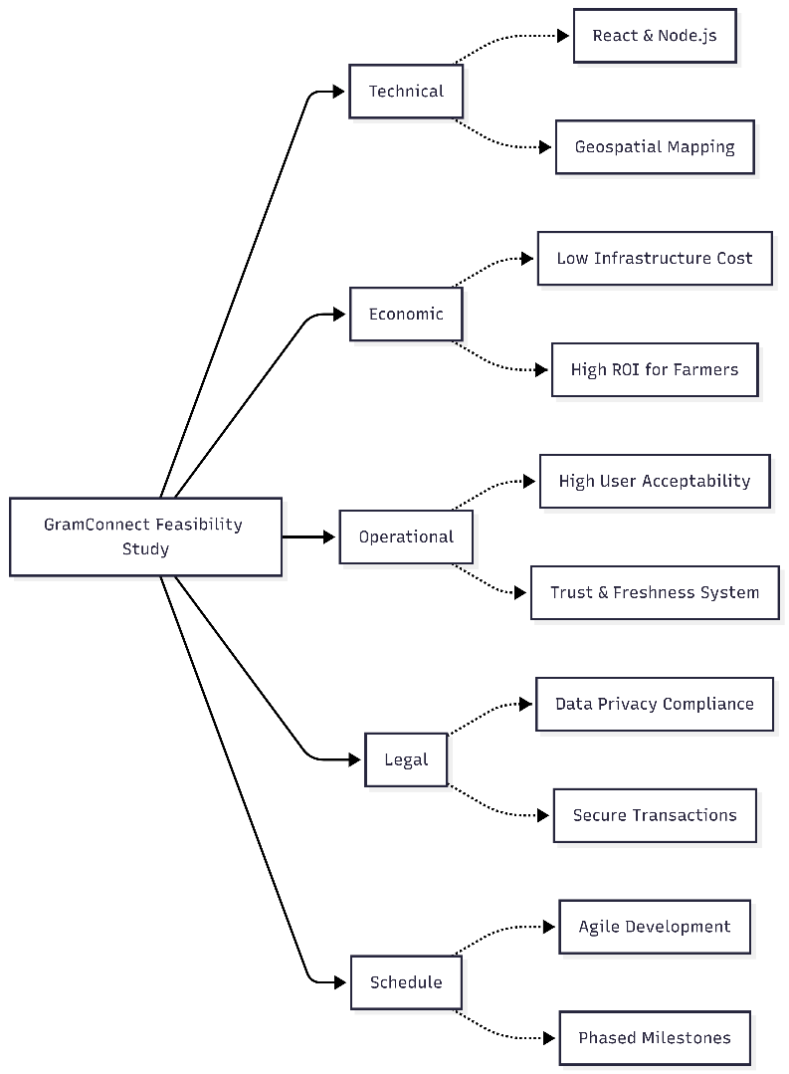
Figure 4.1 | Feasibility Diagram of GramConnect

4.2 Technical Feasibility
Technical feasibility assesses whether the current technology is sufficient to support the proposed GramConnect platform and whether it can be scaled as needed.

4.2.1 Technology Stack
The project relies on a modern, robust, and well-supported technology stack:
- Frontend: React and Vite ensure a responsive, fast, and intuitive user interface across all devices.
- Backend: Node.js and Express.js provide a scalable environment capable of handling real-time data and asynchronous API requests efficiently.
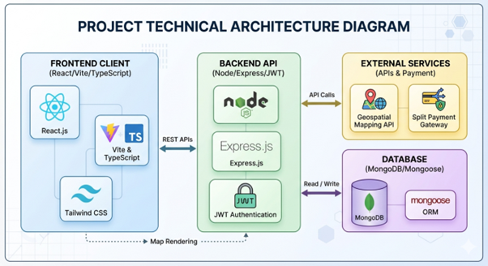
- Database: MongoDB allows for flexible schema design, which is essential for storing complex user profiles, dynamic agricultural products, and geospatial data.
- Geospatial Mapping: The integration of modern mapping APIs is highly feasible and perfectly suited for the farmer location and tracking features.
- Financial Infrastructure: Utilizing secure payment gateway APIs makes the implementation of complex features like split payments both achievable and secure.

4.2.2 System Architecture
The proposed client-server architecture is standard industry practice and highly technically feasible. It ensures a clear separation of concerns between the user interface and data processing, making future maintenance, debugging, and feature additions manageable.

4.3 Economic Feasibility
Economic feasibility involves a cost/benefit analysis of the GramConnect platform.

4.3.1 Development and Operational Costs
- Development Costs: Minimal initial licensing costs as the development utilizes predominantly open-source technologies (React, Node.js, MongoDB).
- Hosting and Cloud Services: Cloud platforms offer pay-as-you-go models, keeping initial hosting costs low while allowing the infrastructure to scale seamlessly with user traffic.
- Maintenance: Routine maintenance overhead is minimized through the platform's automated workflows, such as the farmer approval gates.

4.3.2 Potential Benefits
- For Farmers: By eliminating traditional supply chain middlemen, farmers achieve significantly higher profit margins.
- For Consumers: Consumers gain direct access to fresh, traceable produce at competitive prices.
- Overall Economic Impact: The platform fosters a sustainable, localized digital economy, easily justifying the operational costs. The project is economically highly viable.

4.4 Operational Feasibility
Operational feasibility examines how well the proposed system solves the targeted problems and takes advantage of the opportunities identified.

4.4.1 User Acceptability
- Farmers: The platform incorporates a streamlined approval gate and an intuitive dashboard, actively lowering the technological barrier to entry. The UI is designed to ensure high adoption rates among users who may not be highly tech-savvy.
- Consumers: The familiar e-commerce style interface (incorporating shopping carts, split payments, and product reviews) ensures immediate consumer acceptability without a steep learning curve.

4.4.2 System Reliability and Trust
Features such as verifiable geospatial farmer mapping, freshness badges, and a transparent review system are operationally crucial. They build trust among users and ensure the platform operates smoothly and reliably in real-world, day-to-day scenarios.

4.5 Legal Feasibility
Legal feasibility determines whether the proposed system conflicts with legal or regulatory requirements.

4.5.1 Data Privacy and Security
GramConnect processes sensitive personal data (contact details, geolocation) and financial information. The system architecture is designed to comply with standard data protection protocols by implementing secure authentication workflows, encrypted communications, and secure handling of user credentials.

4.5.2 Regulatory Compliance
The strict farmer approval workflow acts as a regulatory safeguard, ensuring that only verified agricultural stakeholders can operate on the platform. This maintains compliance with local agricultural trading norms and prevents fraudulent activities.

4.6 Schedule Feasibility
Schedule feasibility assesses the likelihood of project completion within the stipulated academic timeframe.

4.6.1 Development Timeline
The project has been strategically divided into manageable modules (e.g., focusing sequentially on core UI, geospatial mapping, and finally complex financial infrastructure like split payments). Utilizing agile development methodologies allows for continuous iterative testing and deployment, ensuring that all academic deadlines and project milestones are met successfully.

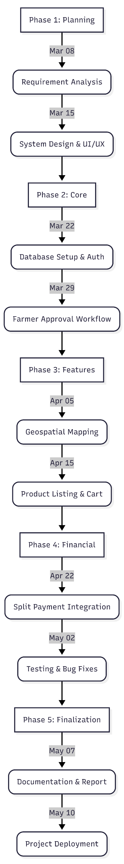
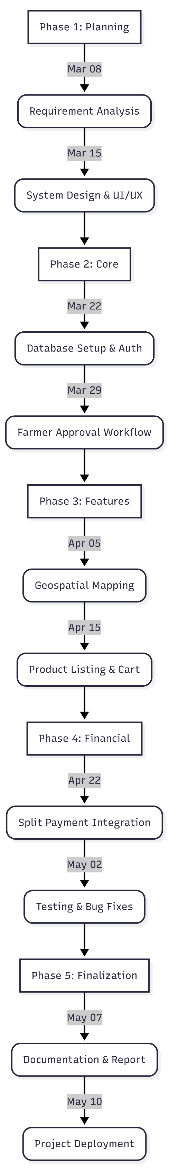

Chapter – 5
Figure 4.6.1 Gantt Chart

SYSTEM DESIGN AND DEVELOPMENT

System design is the process of defining the components, modules, interfaces, and data for a system to satisfy specified requirements. System development is the process of creating or altering systems, along with the processes, practices, models, and methodologies used to develop them.
5.1 High Level Design
High level design is a complete process of the proposed system. High level design includes:
- System Architecture
- Data Flow Diagram
- Flowchart
5.1.1 System Architecture Diagram
Architecture focuses on looking at a system as a combination of many different components, and how they interact with each other to produce the desired result. The focus is on identifying components or subsystems and how they connect. In other words, the focus is on what major components are needed. It involves the process of defining a collection of hardware and software components and their interfaces to establish the framework for the development of an application.
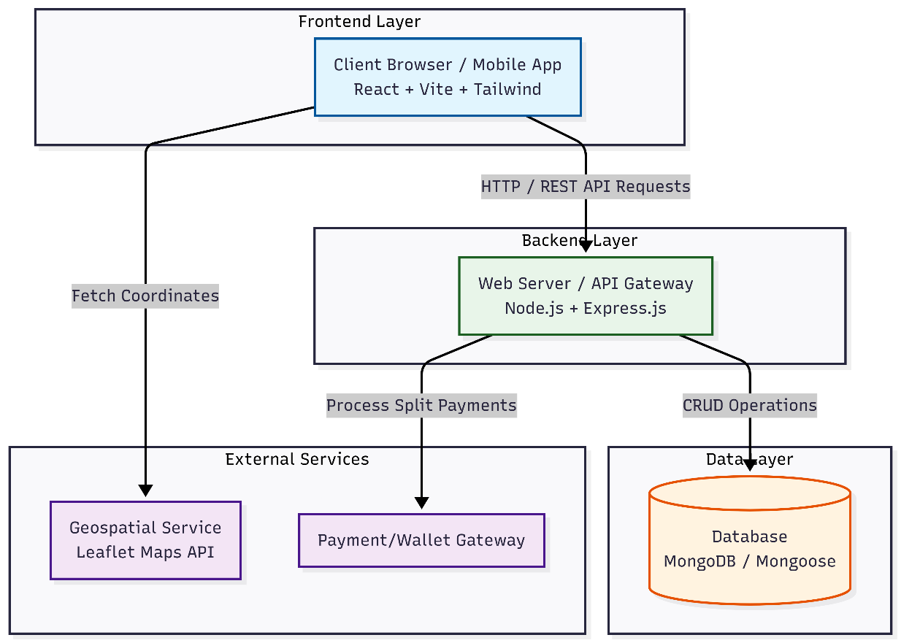
5.1.2 Data Flow Diagram (DFD)
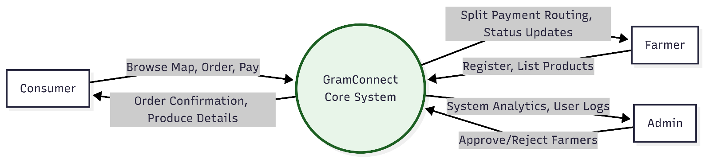
A Data-flow diagram is a way of representing a flow of data of a process or a system. The DFD also provides information about the outputs and inputs of each entity and the process itself.

5.1.3 Flowchart
A flowchart is a diagram of the sequence of movements or actions of people or things involved in a complex system or activity. It is a graphical representation of a computer program in relation to its sequence of functions (as distinct from the data it processes).
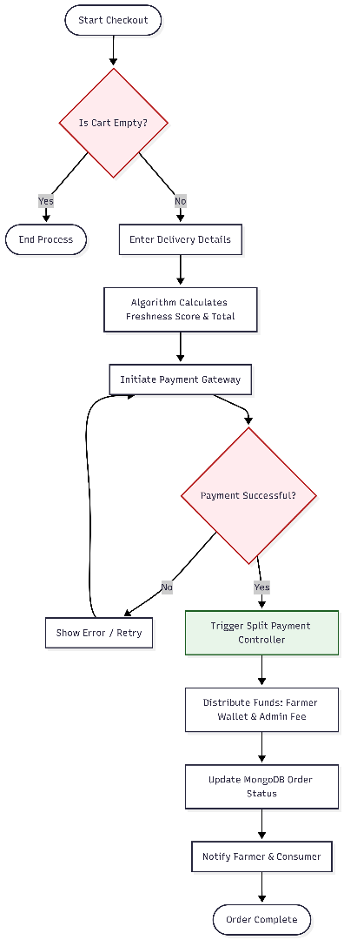
Flowchart: User (Farmer/Consumer)

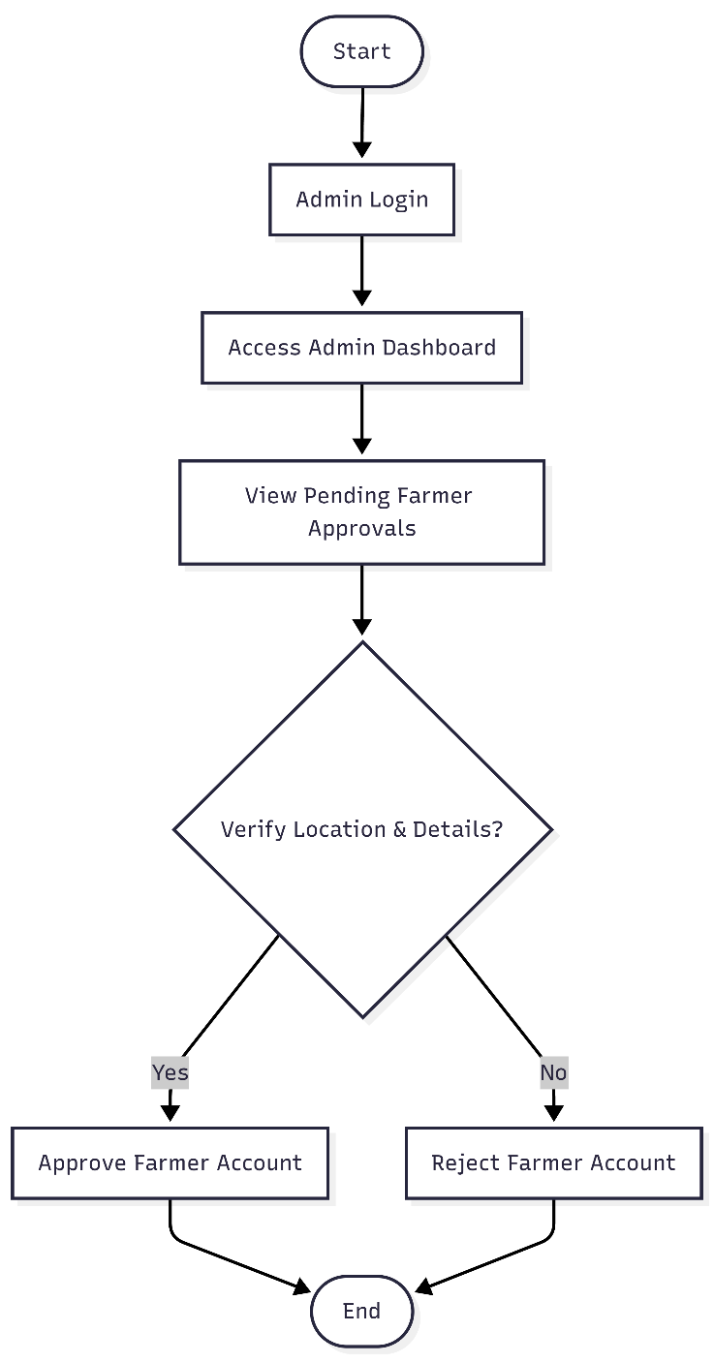
Flowchart: Admin

5.2 Low Level Design
Low Level Design is the individual process representation which includes:
- Use Case Diagram
- Entity Relationship Diagram (ERD)
- Class Diagram
- Sequence Diagram
- Activity Diagram
5.2.1 Use Case Diagram
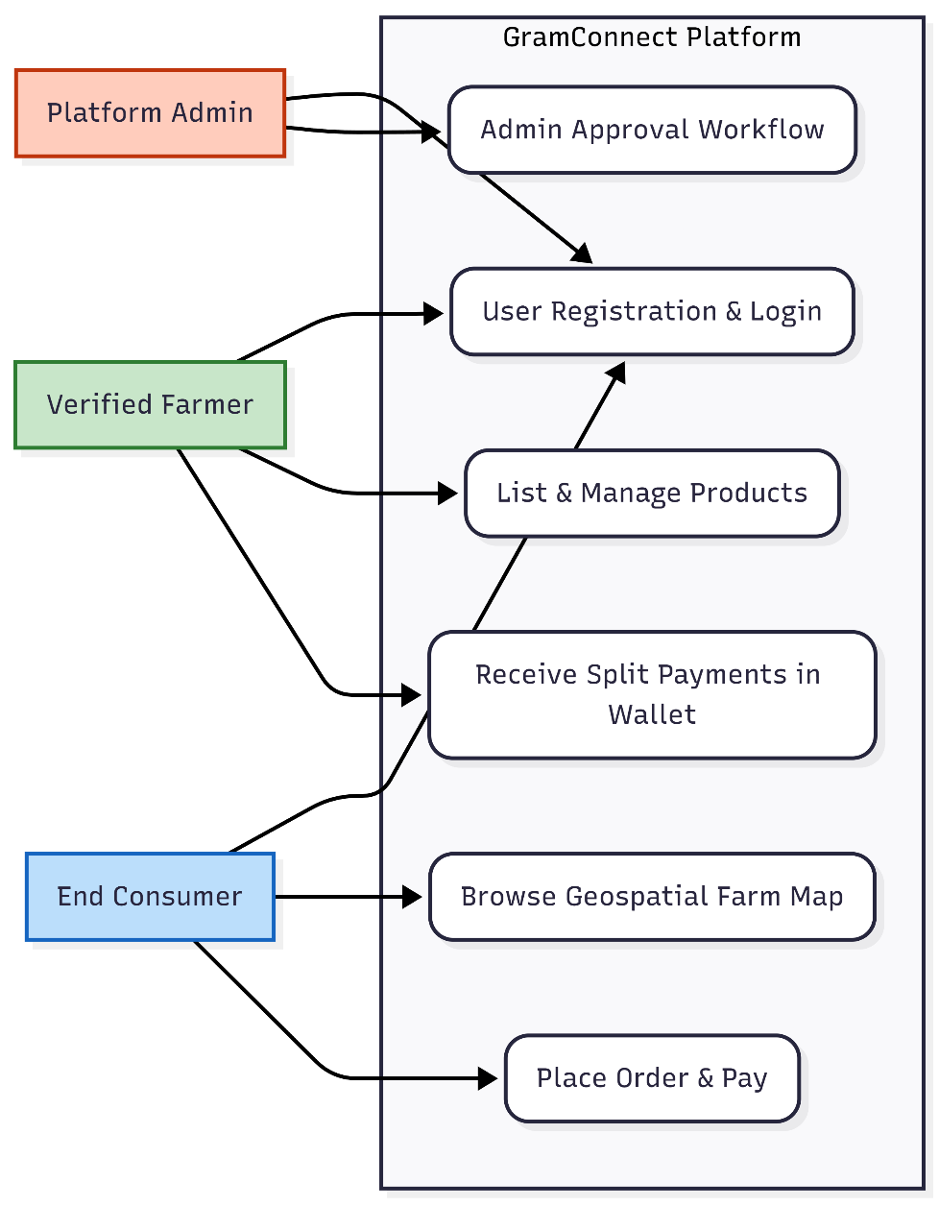
Using the Unified Modeling Language (UML), a use case diagram can summarize the details of your system's users (also known as actors) and their interactions with the system. To build one, you'll use a set of specialized symbols and connectors.

5.2.2 Class Diagram
The class diagram is the main building block of object-oriented modeling. It is used both for general conceptual modeling of the systematic of the application, and for detailed modeling translating the models into programming code.
In the diagram, classes are represented with boxes which contain three parts:
- The upper part holds the name of the class
- The middle part contains the attributes of the class
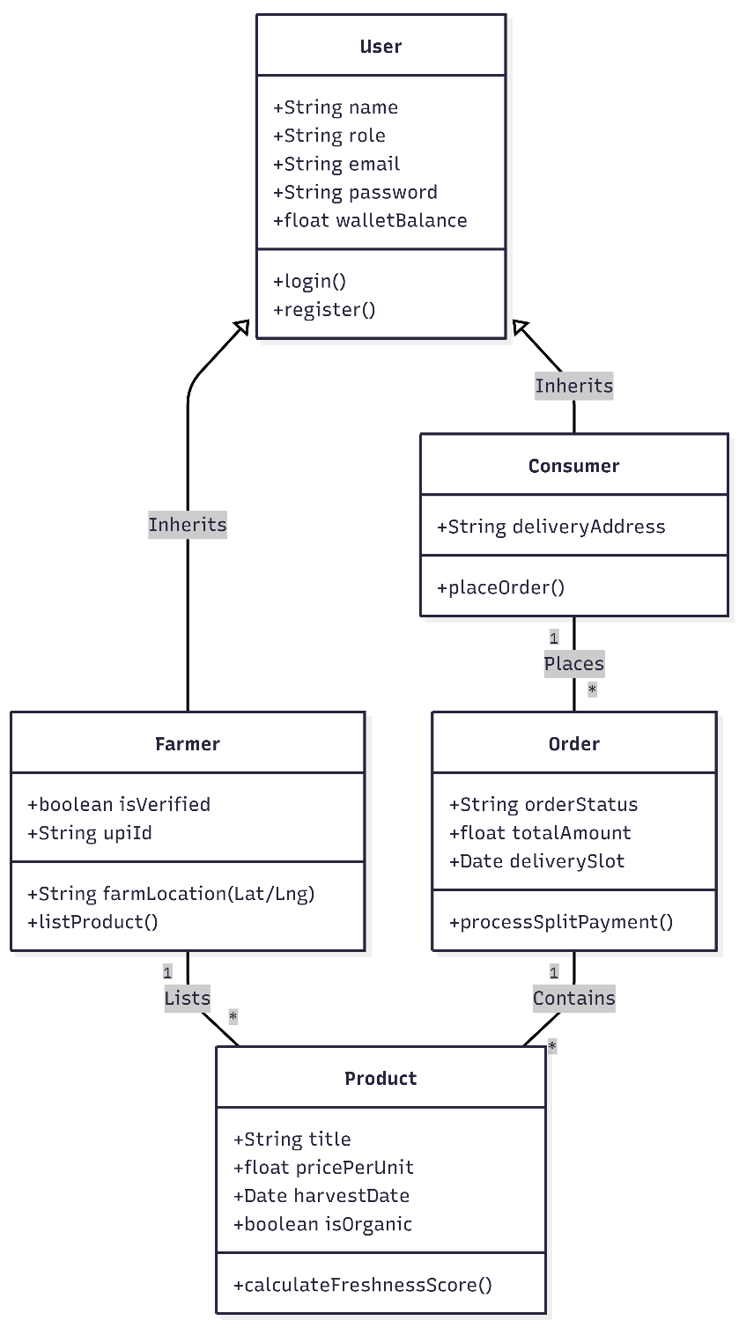
- The bottom part gives the methods or operations the class can take or undertake

5.2.3 Sequence Diagram
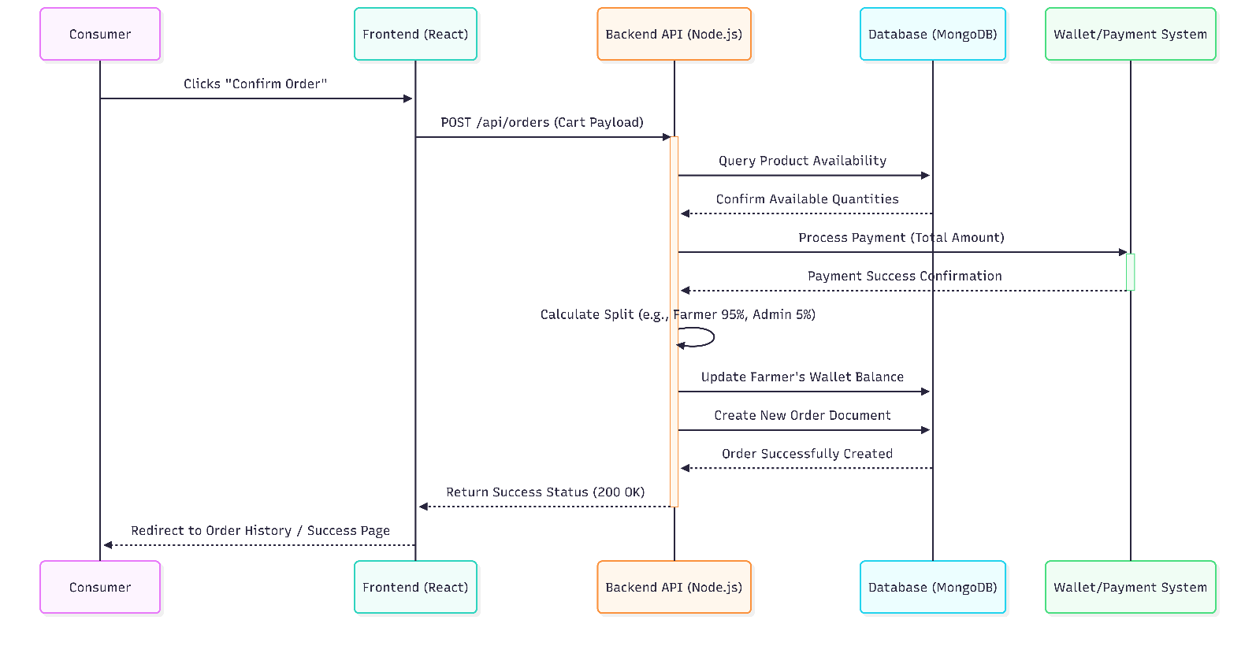
UML Sequence Diagrams are interaction diagrams that detail how operations are carried out. They capture the interaction between objects in the context of a collaboration. Sequence Diagrams are time focused and they show the order of the interaction visually by using the vertical axis of the diagram to represent time, what messages are sent, and when.

5.2.4 Entity Relationship Diagram (ERD)
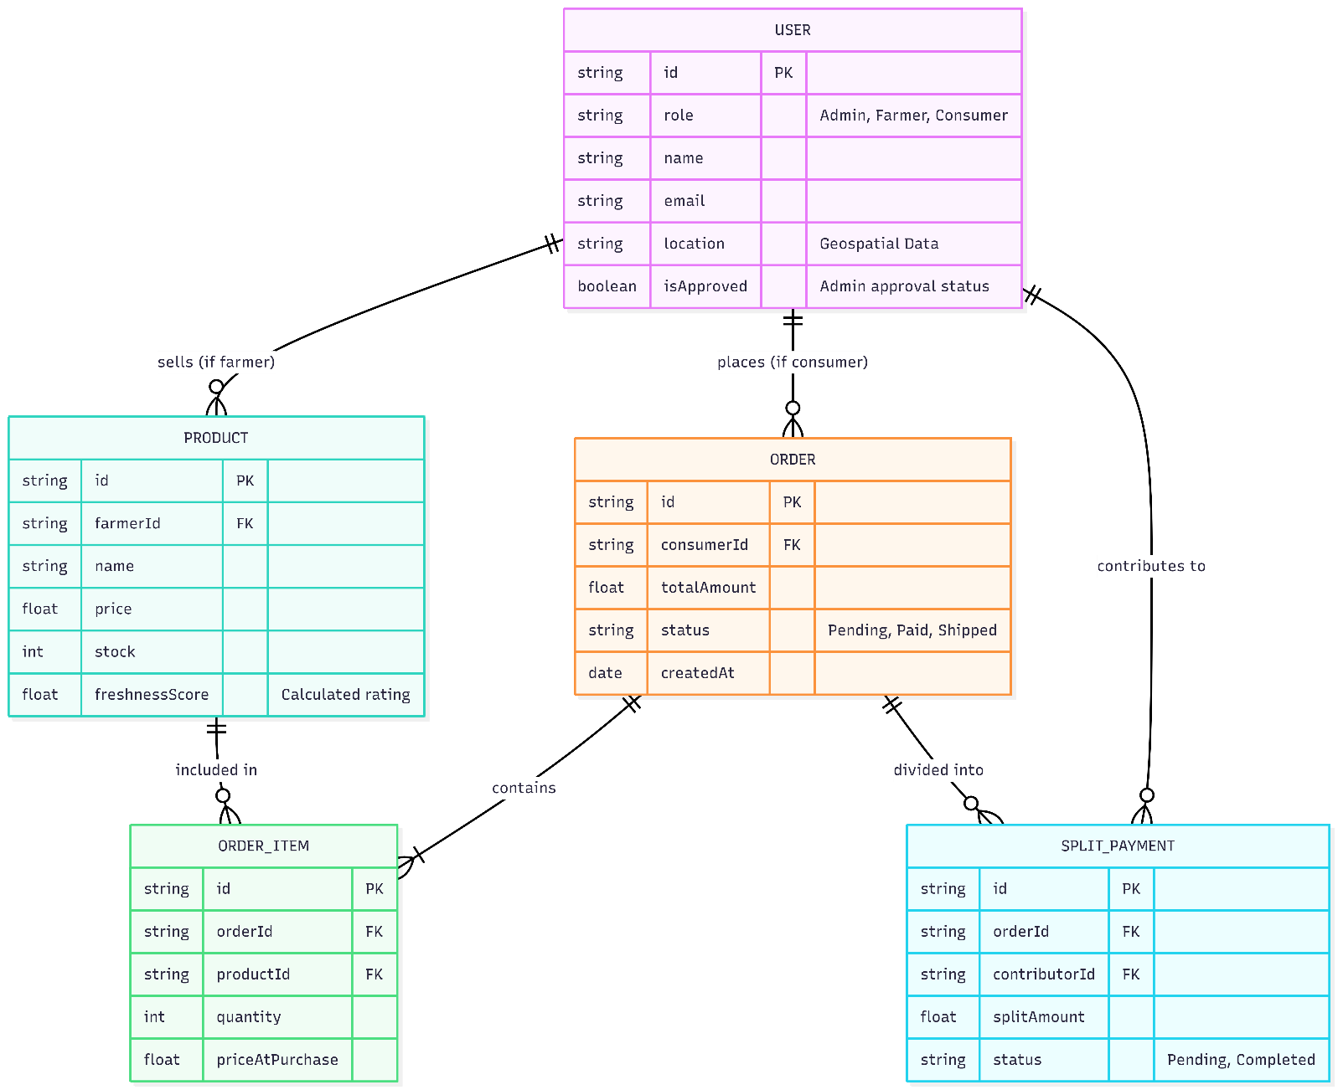
The Entity Relationship Diagram illustrates the logical structure of the databases, showing the entities involved in the system and how they relate to one another.

Chapter – 6

IMPLEMENTATION

6.1 Admin Module
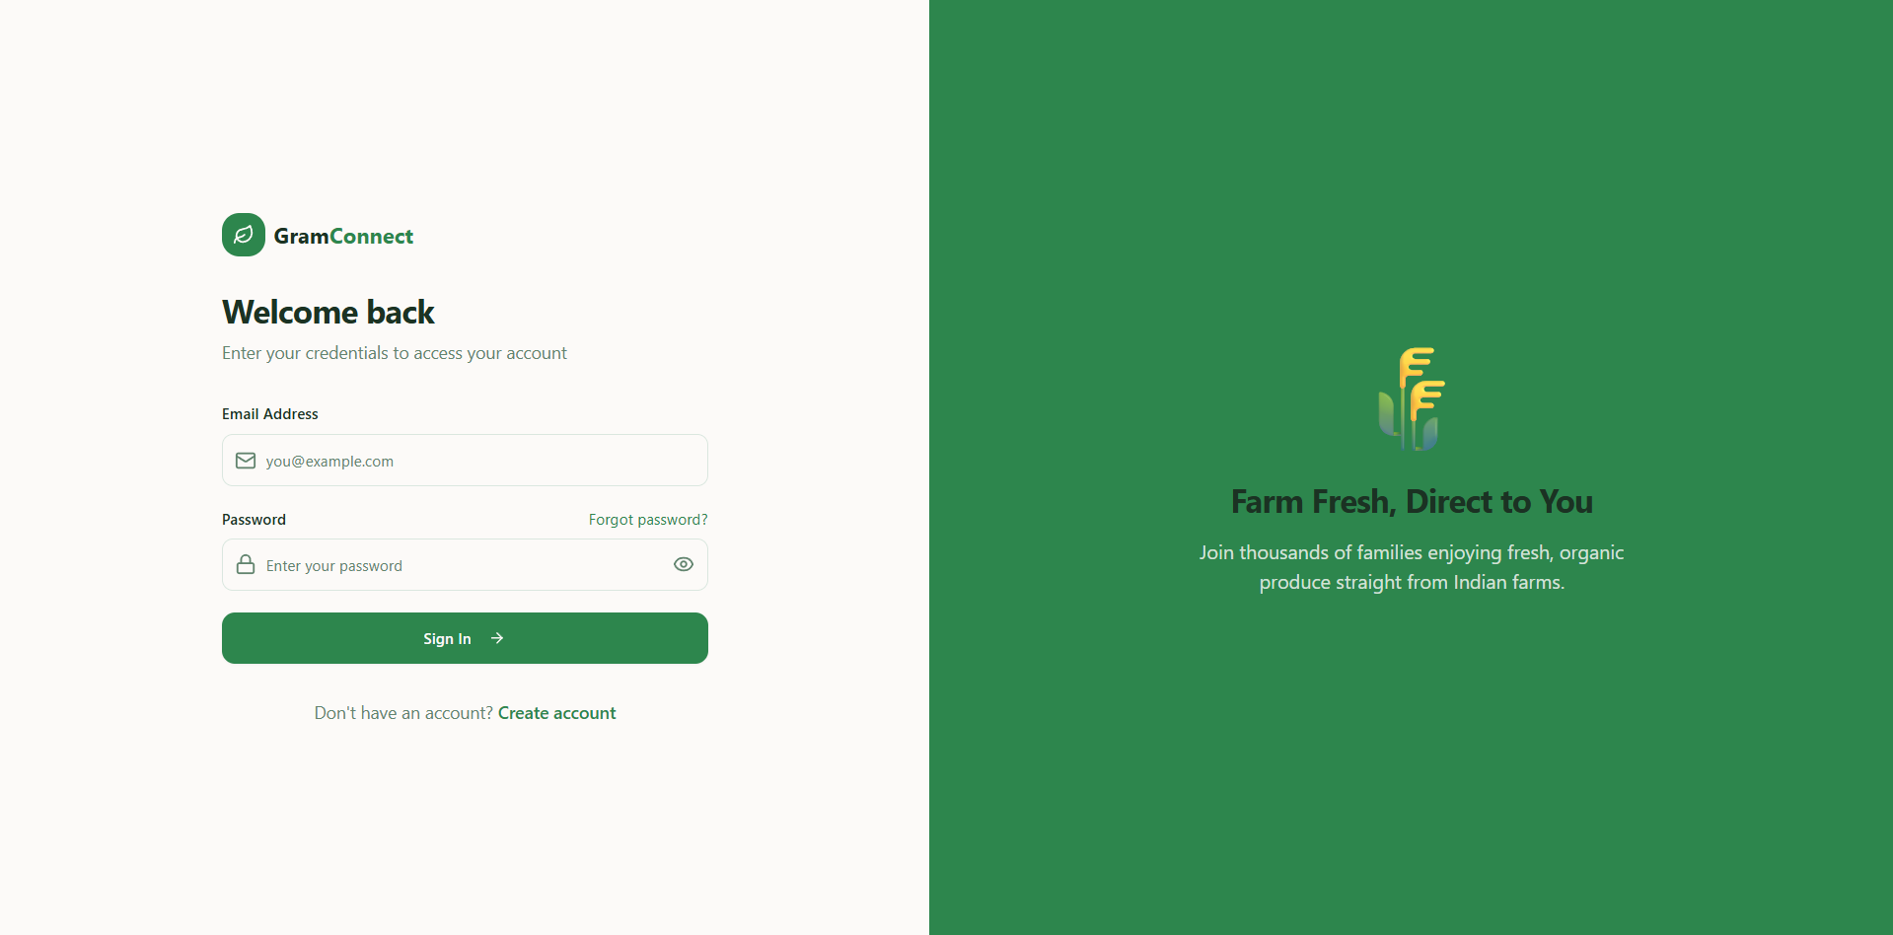
In this module, the Admin logs in using a highly secure, valid username and password. After a successful login, the Admin serves as the gatekeeper and manager of the platform. The Admin can perform critical operations such as: View All Users, View Pending Farmer Registrations, Authorize/Approve Valid Farmers, Reject Invalid Farmers, and View Platform-wide Transactions.
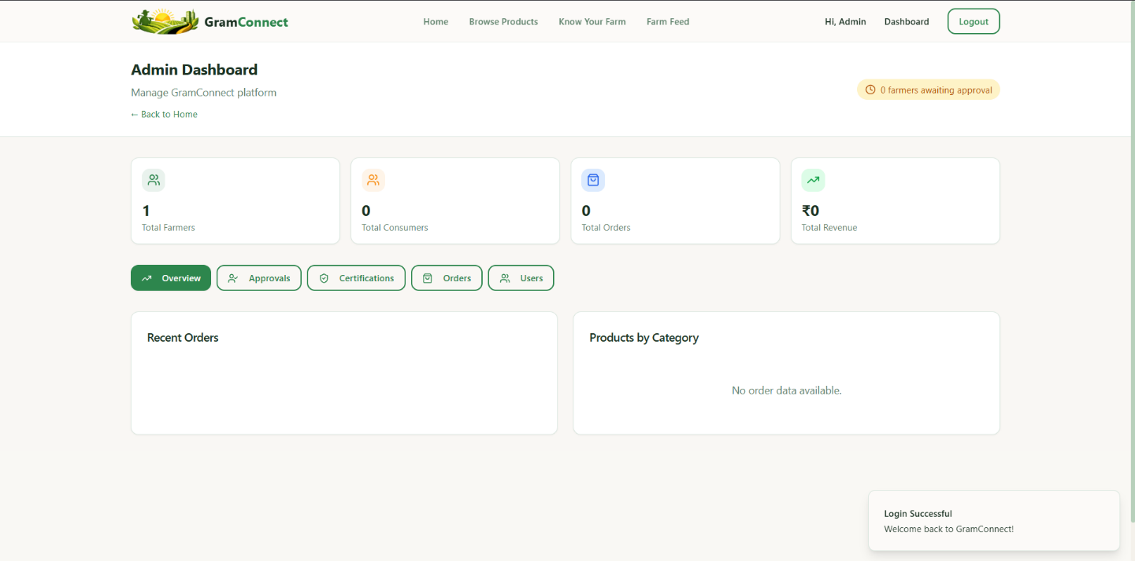
Figure 6.1.1: Admin Login Page
Figure 6.1.2: Admin Dashboard Overview
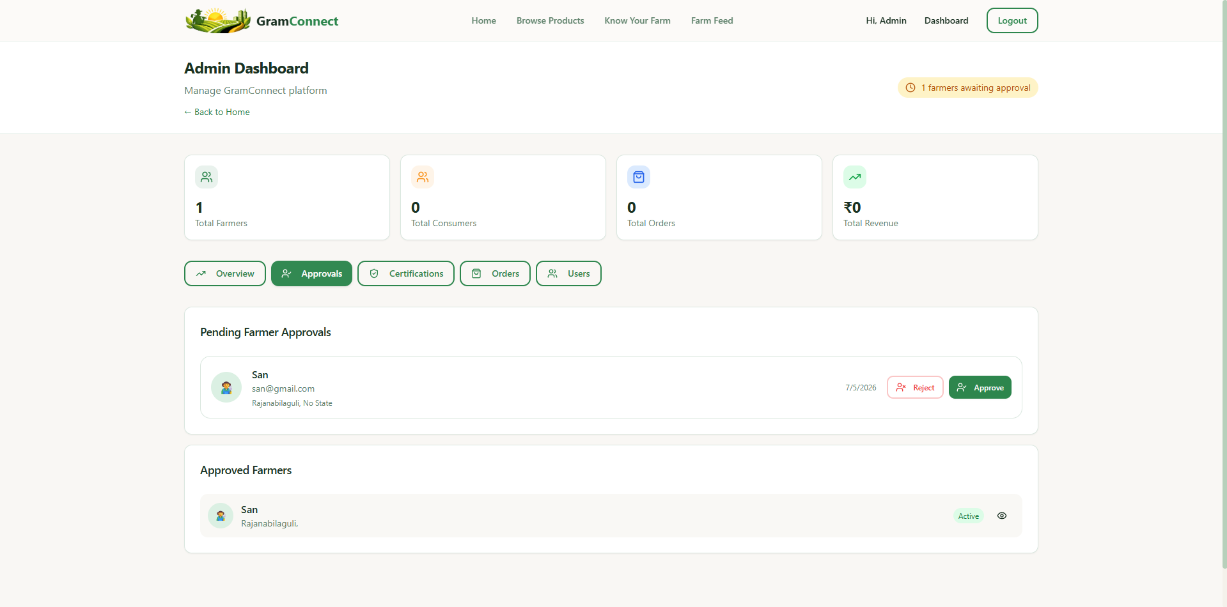
Figure 6.1.3: Authorize and Approve Farmer Account

6.2 Farmer Module
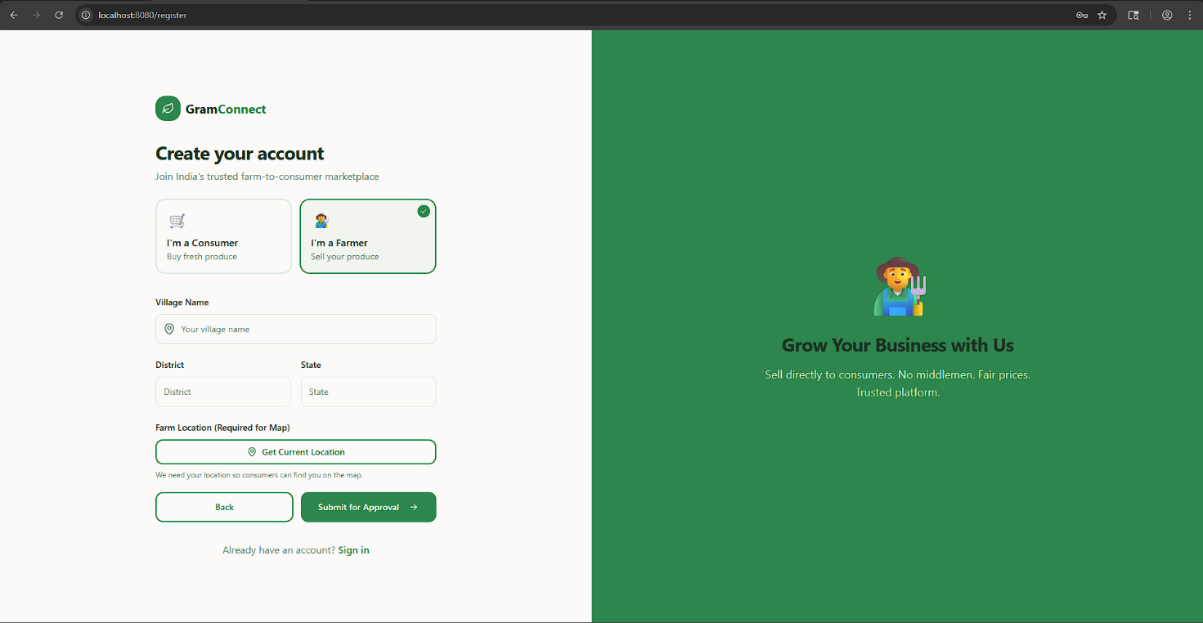
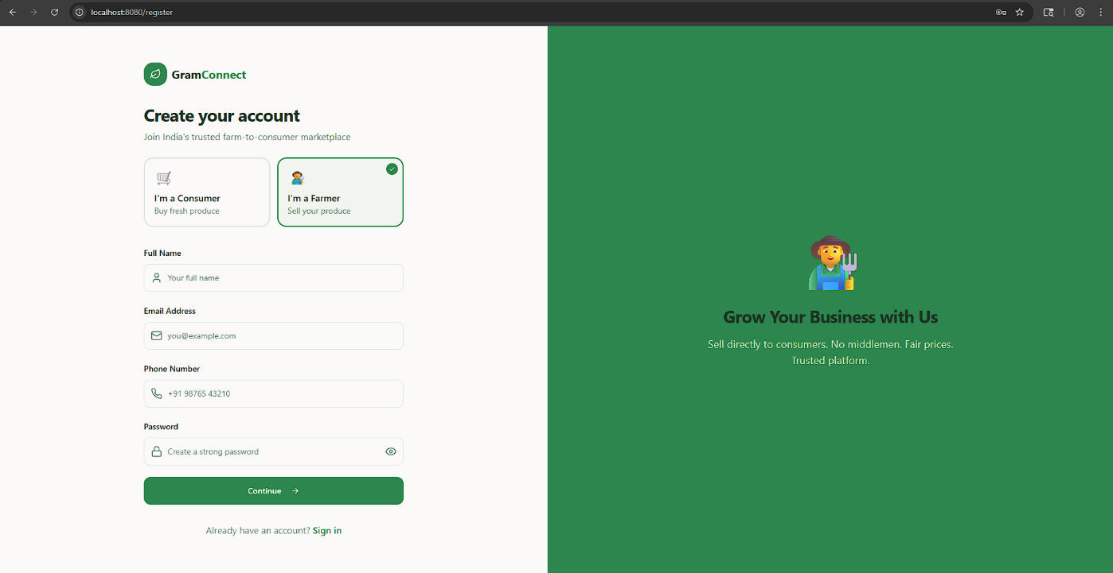
In this module, Farmers must register on the platform by providing their details and geospatial location. After successful registration, the Farmer must wait for the Admin to authorize them. Once authorized, the Farmer can log in using their credentials. After a successful login, the Farmer can perform operations such as: View Dashboard, Add New Products to Inventory, Manage Product Details (Price, Stock, Harvest Date), View Incoming Consumer Orders, and View Freshness Badges.
Figure 6.2.1: Farmer Registration Form

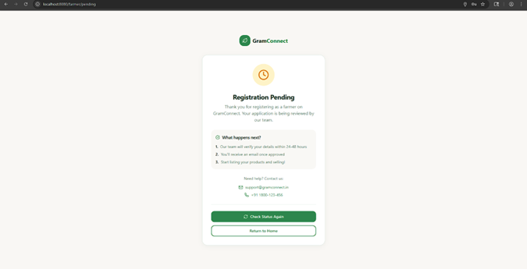
Figure 6.2.2: Pending Approval Waiting Screen
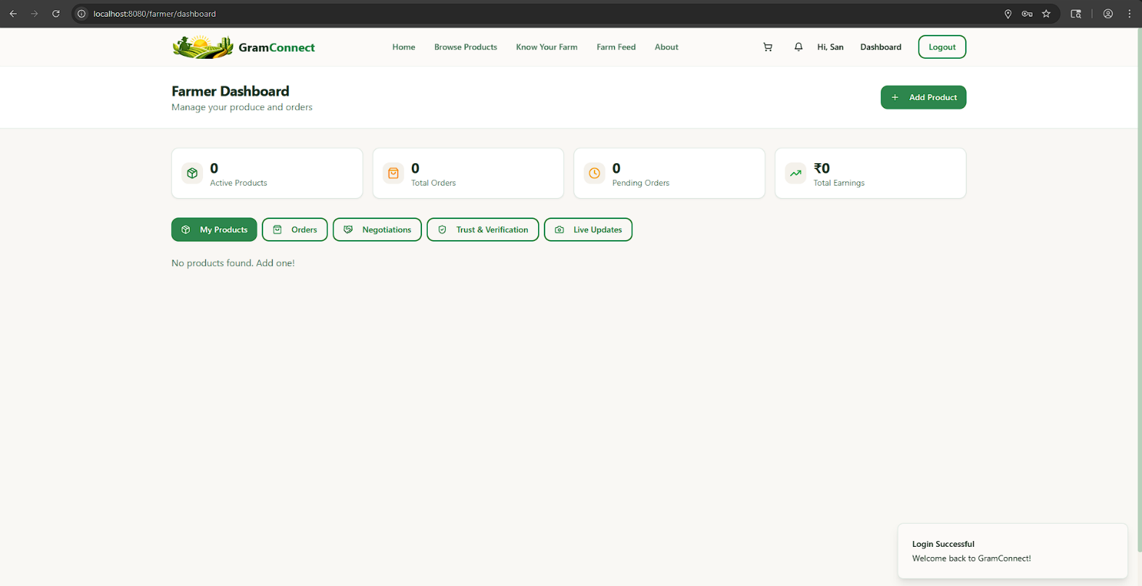
Figure 6.2.3: Farmer Main Dashboard
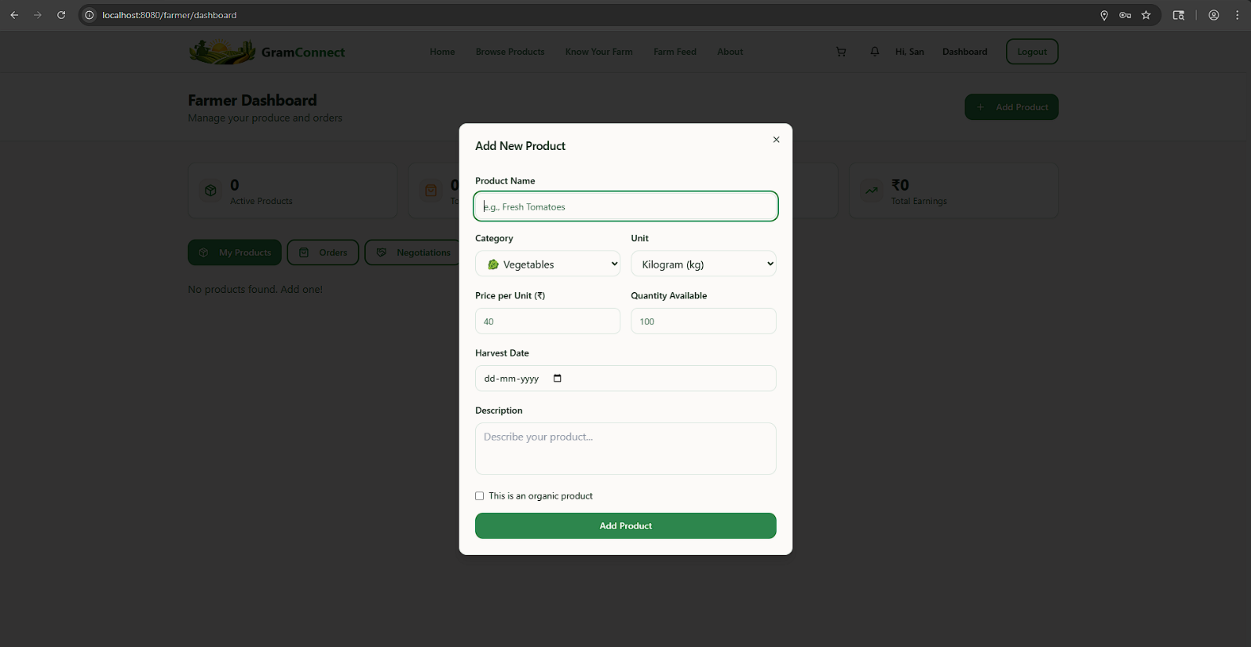
Figure 6.2.5: Add New Product and Inventory

Chapter – 7

SYSTEM TESTING

System Testing
The purpose of testing is to discover errors. Testing is the process of trying to discover every conceivable fault or weakness in a work product. It provides a way to check the functionality of components, sub-assemblies, assemblies and/or a finished product. It is the process of exercising software with the intent of ensuring that the Software system meets its requirements and user expectations and does not fail in an unacceptable manner. There are various types of test. Each test type addresses a specific testing requirement.
7.1 TYPES OF TESTS
7.1.1 Unit testing
Unit testing involves the design of test cases that validate that the internal program logic is functioning properly, and that program inputs produce valid outputs. All decision branches and internal code flow should be validated. It is the testing of individual software units of the application. It is done after the completion of an individual unit before integration. This is a structural testing, that relies on knowledge of its construction and is invasive. Unit tests perform basic tests at component level and test a specific business process, application, and/or system configuration. Unit tests ensure that each unique path of a business process performs accurately to the documented specifications and contains clearly defined inputs and expected results.
7.1.2 Integration testing
Integration tests are designed to test integrated software components to determine if they actually run as one program. Testing is event driven and is more concerned with the basic outcome of screens or fields. Integration tests demonstrate that although the components were individually satisfactory, as shown by successfully unit testing, the combination of components is correct and consistent. Integration testing is specifically aimed at exposing the problems that arise from the combination of components.
7.1.3 Functional test
Functional tests provide systematic demonstrations that functions tested are available as specified by the business and technical requirements, system documentation, and user manuals. Functional testing is centered on the following items:
- Valid Input: identified classes of valid input must be accepted.
- Invalid Input: identified classes of invalid input must be rejected.
- Functions: identified functions must be exercised.
- Output: identified classes of application outputs must be exercised.
- Systems/Procedures: interfacing systems or procedures must be invoked.
Organization and preparation of functional tests is focused on requirements, key functions, or special test cases. In addition, systematic coverage pertaining to identify Business process flows; data fields, predefined processes, and successive processes must be considered for testing. Before functional testing is complete, additional tests are identified and the effective value of current tests is determined.
7.1.4 System Test
System testing ensures that the entire integrated software system meets requirements. It tests a configuration to ensure known and predictable results. An example of system testing is the configuration-oriented system integration test. System testing is based on process descriptions and flows, emphasizing pre-driven process links and integration points.
7.1.5 White Box Testing
White Box Testing is a testing in which the software tester has knowledge of the inner workings, structure and language of the software, or at least its purpose. It is used to test areas that cannot be reached from a black box level.
7.1.6 Black Box Testing
Black Box Testing is testing the software without any knowledge of the inner workings, structure or language of the module being tested. Black box tests, as most other kinds of tests, must be written from a definitive source document, such as specification or requirements document. It is a testing in which the software under test is treated as a black box. You cannot “see” into it. The test provides inputs and responds to outputs without considering how the software works.
7.2 Test strategy and approach
Field testing will be performed manually and functional tests will be written in detail.
7.2.1 Test objectives
- All field entries must work properly.
- Pages must be activated from the identified link.
- The entry screen, messages and responses must not be delayed.
7.2.2 Features to be tested
- Verify that the entries are of the correct format (e.g., valid email addresses, correct geospatial coordinates for farmers).
- No duplicate entries should be allowed (e.g., identical emails cannot register twice).
- All links should take the user to the correct page (e.g., clicking a map marker takes the consumer to the correct Farmer Profile).
- Verify that unapproved farmers cannot access the main dashboard.
- Verify that the Split Payment links accurately divide the total cart value.

7.3 Test Cases
Test Case ID | Test Description | Expected Result | Actual Result | Status
TC-01 | Farmer Registration: Farmer submits details and geospatial location. | Data is stored in MongoDB; isApproved flag defaults to false. | Data securely stored; flag is false. | Pass
TC-02 | Unauthorized Login: Farmer attempts to login before Admin approval. | Login is denied; user is shown the "Pending Approval" screen. | Redirected to Pending screen. | Pass
TC-03 | Admin Approval: Admin reviews and authorizes the pending farmer. | The isApproved flag updates to true; Farmer gains dashboard access. | Flag updated; Farmer accesses dashboard. | Pass
TC-04 | Product Listing: Approved Farmer adds a new product with stock and harvest date. | Product appears in the Consumer marketplace with correct Freshness Badge. | Product visible with accurate freshness score. | Pass
TC-05 | Map Discovery: Consumer views the Farmer Map. | Interactive markers appear corresponding to verified farmer locations. | Map renders correctly with verified markers. | Pass
TC-06 | Cart & Checkout: Consumer adds items to cart and initiates a regular checkout. | Order is generated; inventory stock is reduced correctly. | Order successful; stock updated. | Pass
TC-07 | Split Payment Initiation: Consumer initiates a split payment order with friends. | System generates separate payment link tokens for each contributor; Order status is "Pending". | Unique links generated; Order is "Pending". | Pass
TC-08 | Split Payment Completion: All contributors fulfill their payment links. | Order status automatically updates from "Pending" to "Confirmed/Paid". | Status updates dynamically upon final payment. | Pass
TC-09 | Route Security: Unauthenticated user tries to access /api/orders via URL. | API rejects the request; User is redirected to Login. | Request blocked (401 Unauthorized). | Pass

