PD_TC_10 – OrangeHRM_Personal Details _check the Marital status dropdown

Launch the URL

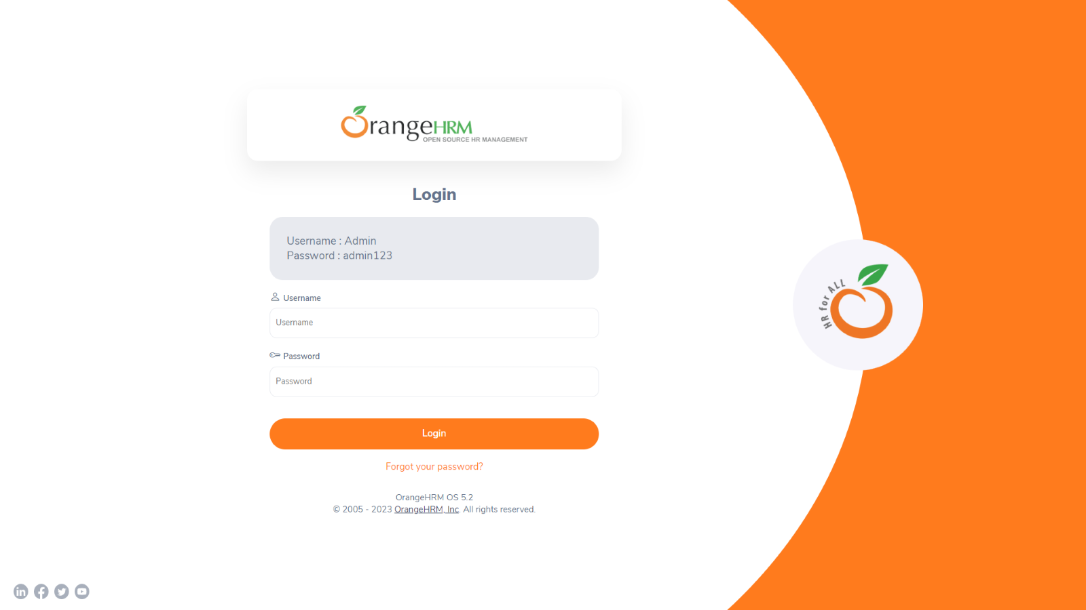

Login to the application with Valid credentials

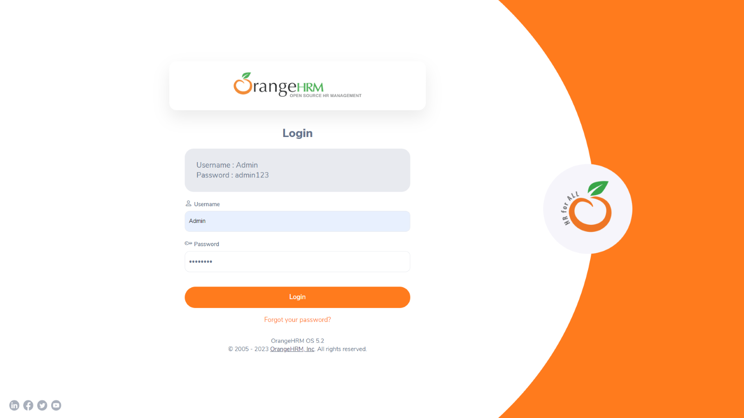

Logged successfully & navigated to personal details tab

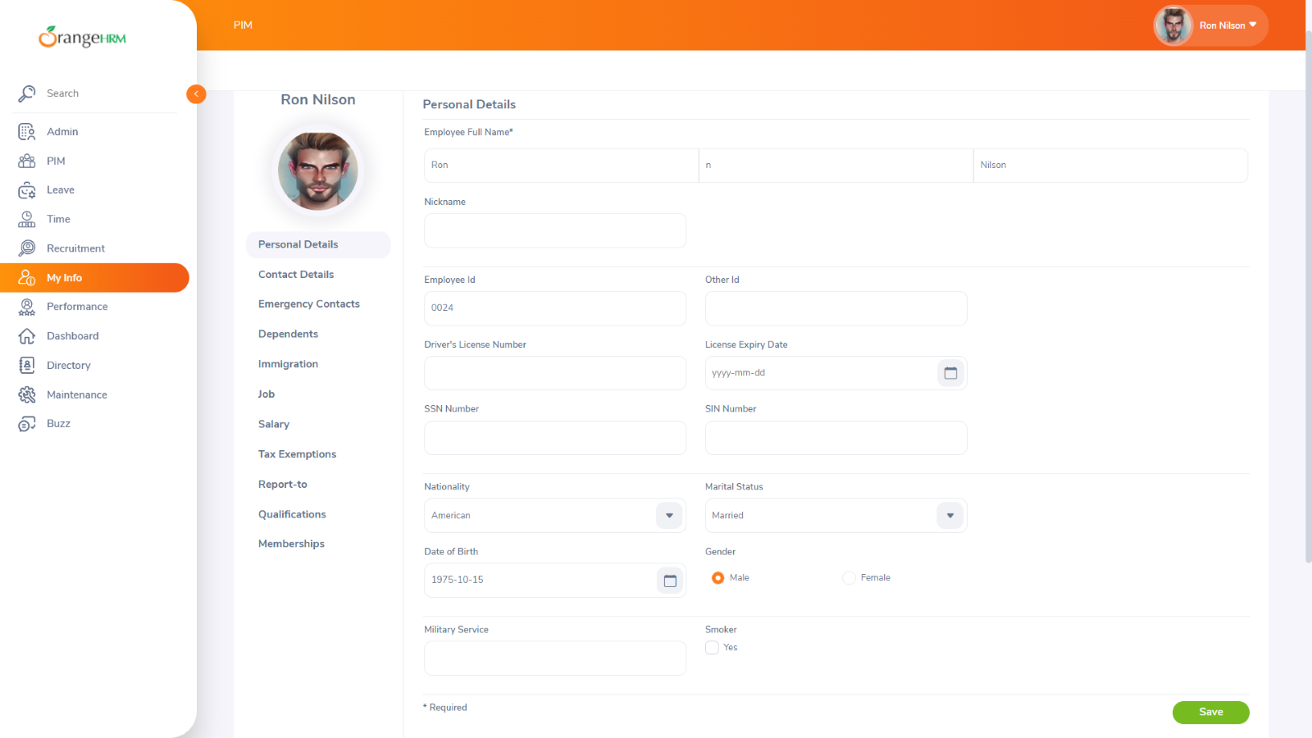

check the Marital status dropdown

