PD_TC_13 – OrangeHRM_Personal Details _ check the default value in the Nationality dropdown list

Launch the URL

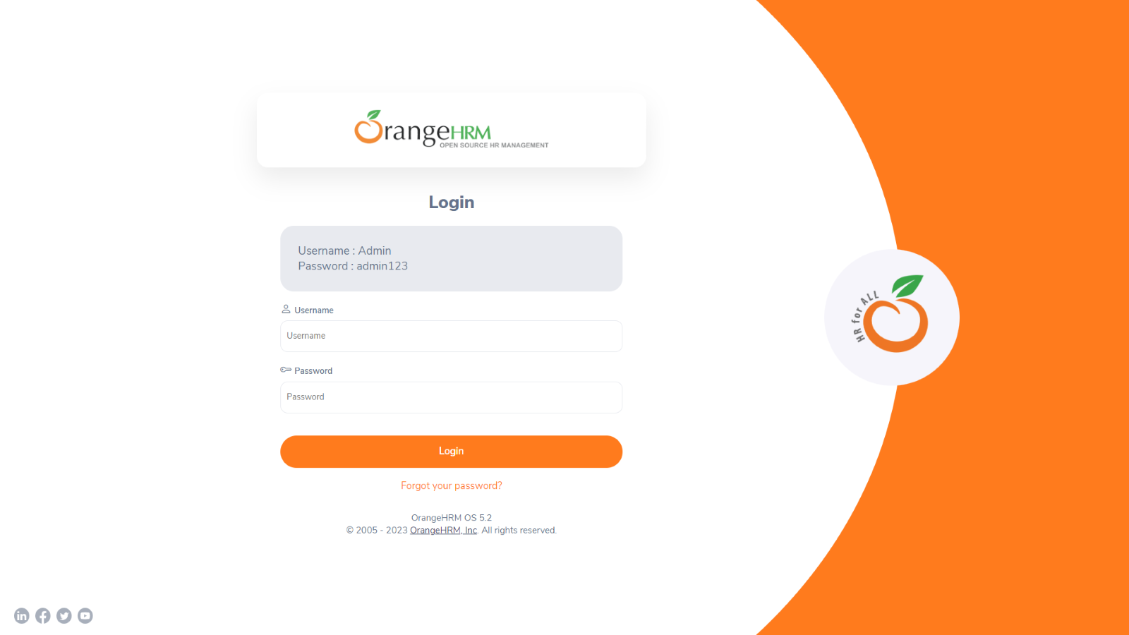

Login to the application with Valid credentials

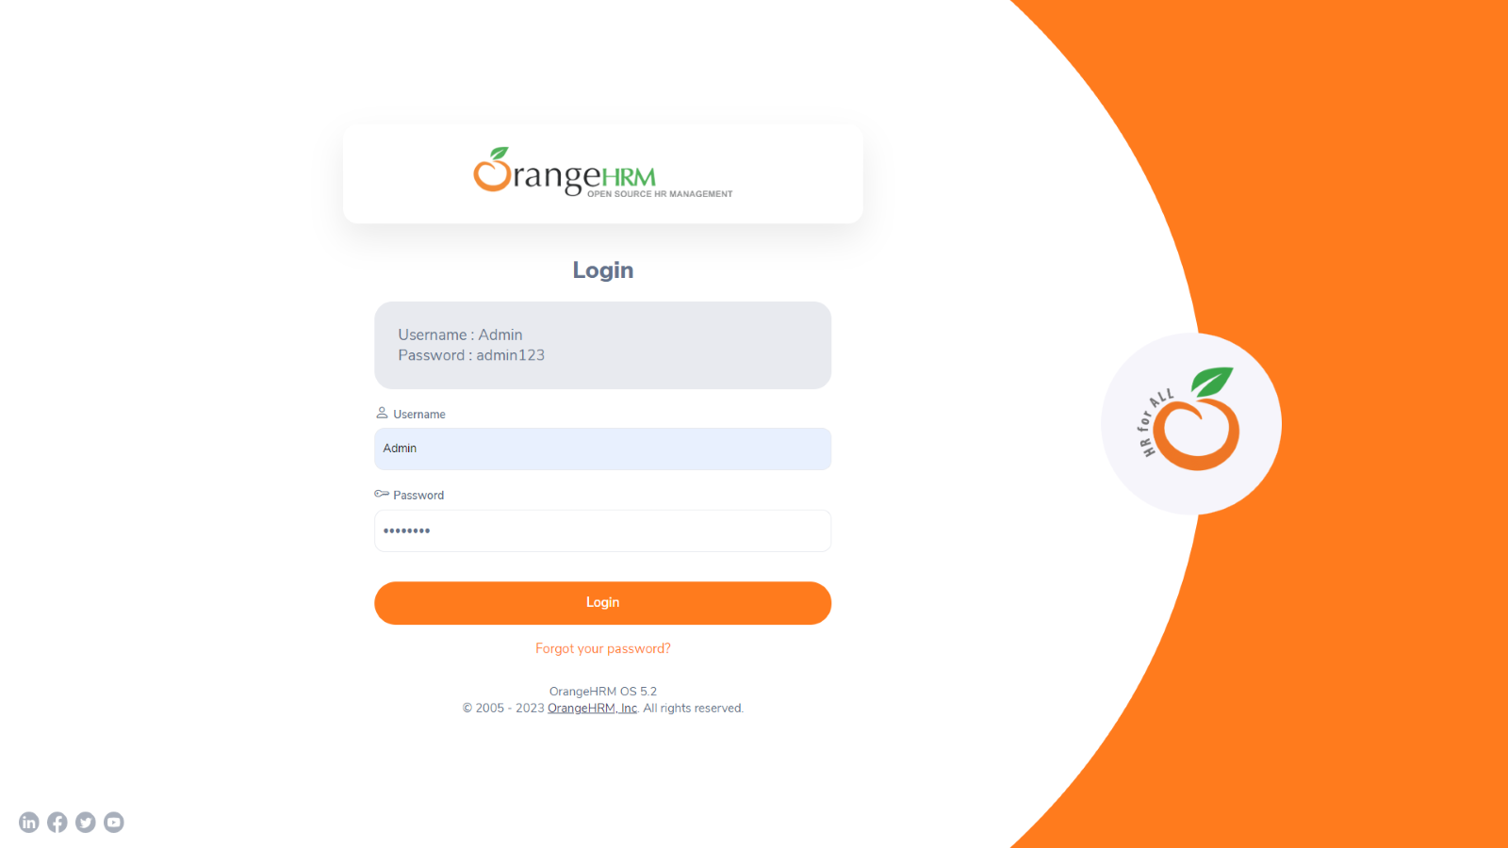

Logged successfully & navigated to personal details tab

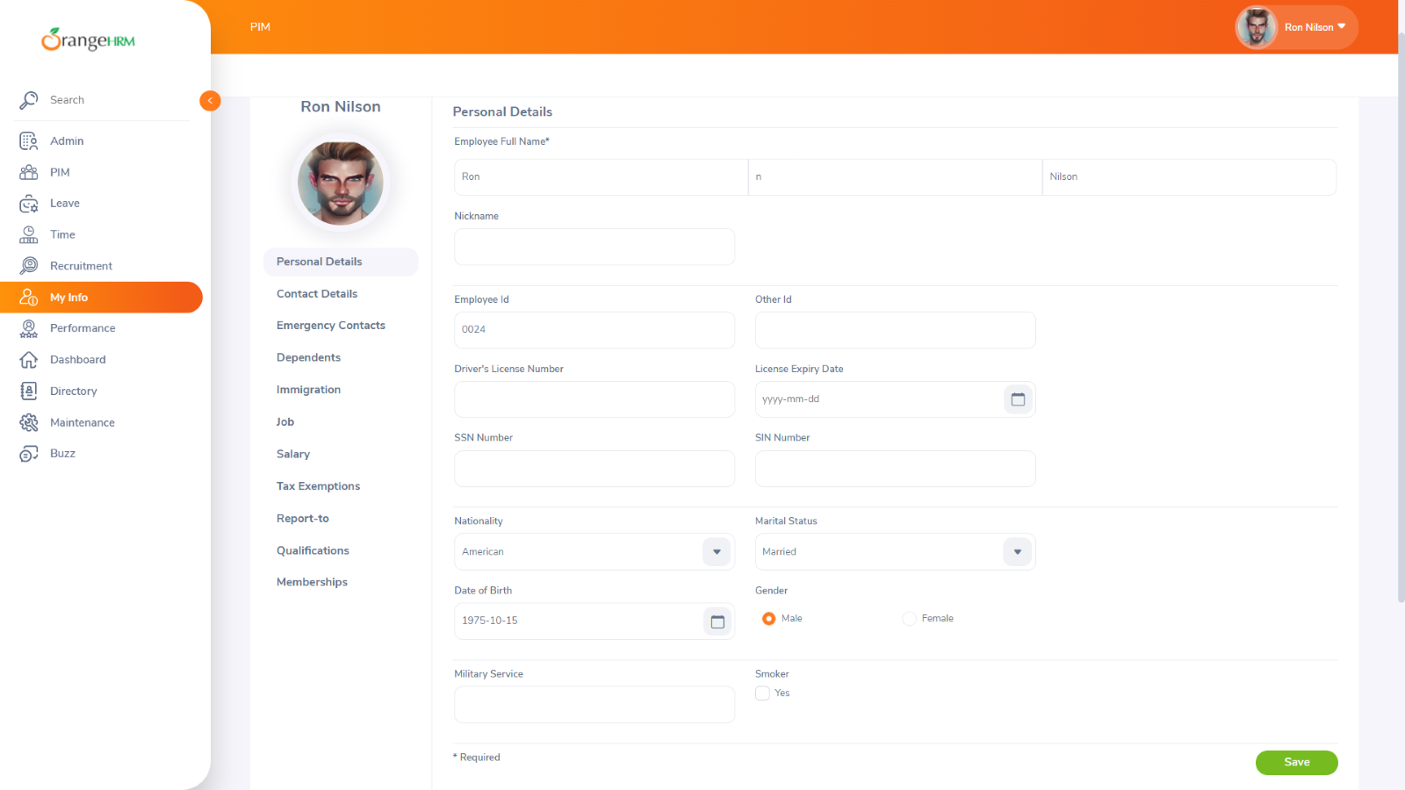

check the default value in the Nationality dropdown list

