PD_TC_15 - OrangeHRM_Personal Details _check the calendar is displayed for selecting the License expiry date

Launch the URL

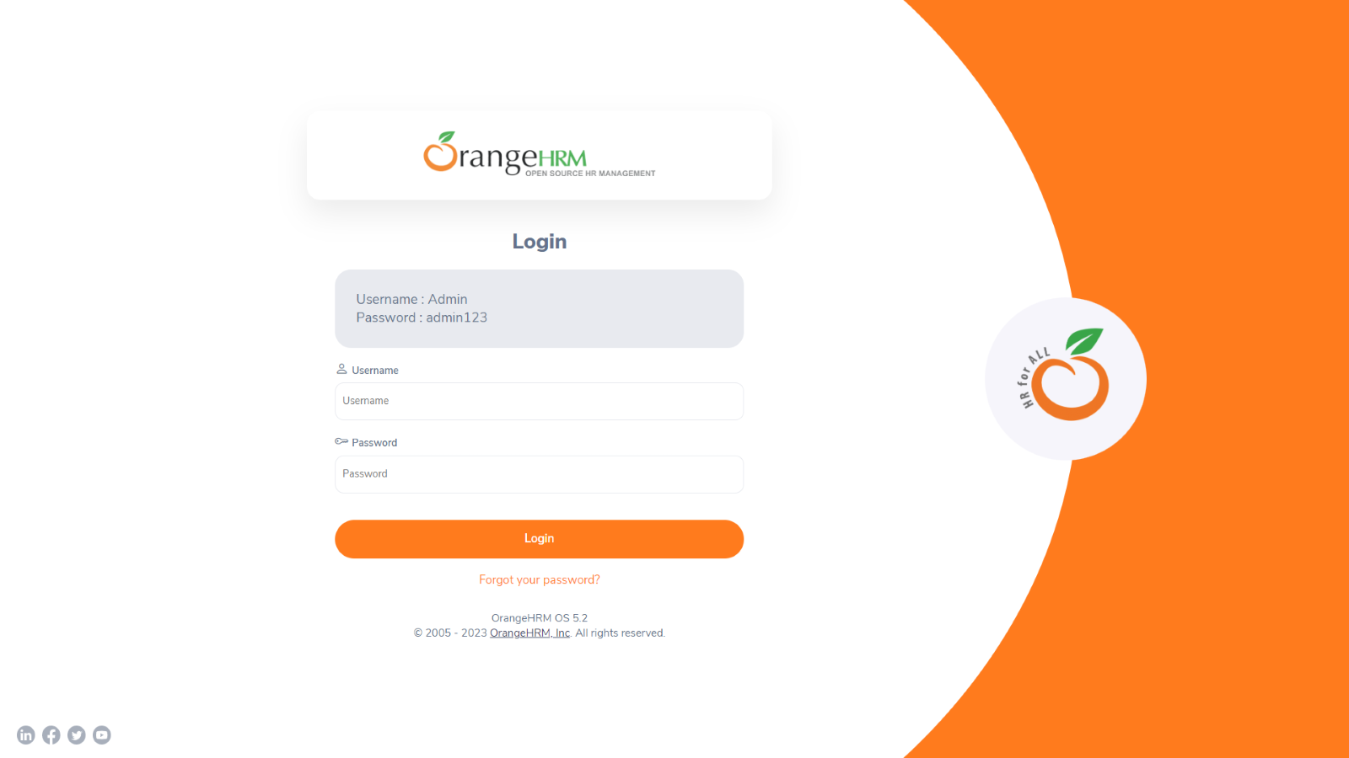

Login to the application with Valid credentials

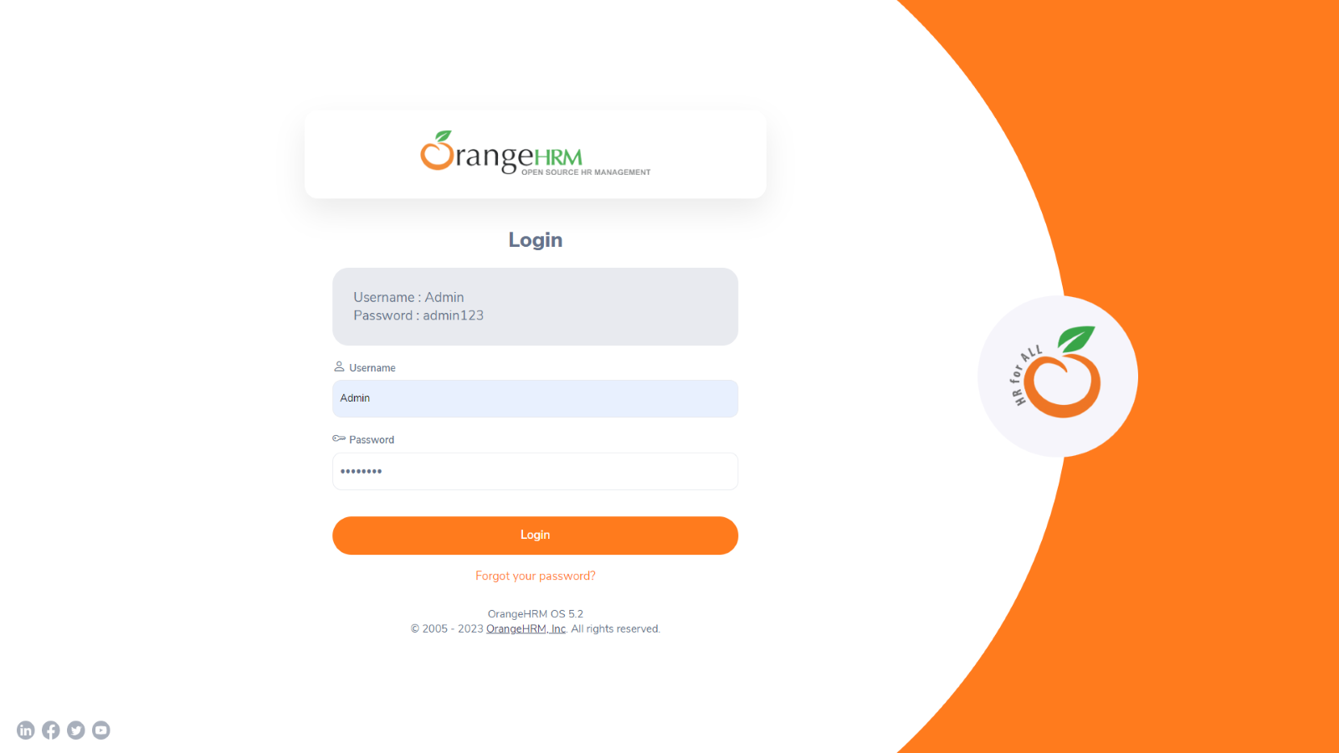

Logged successfully & navigated to personal details tab

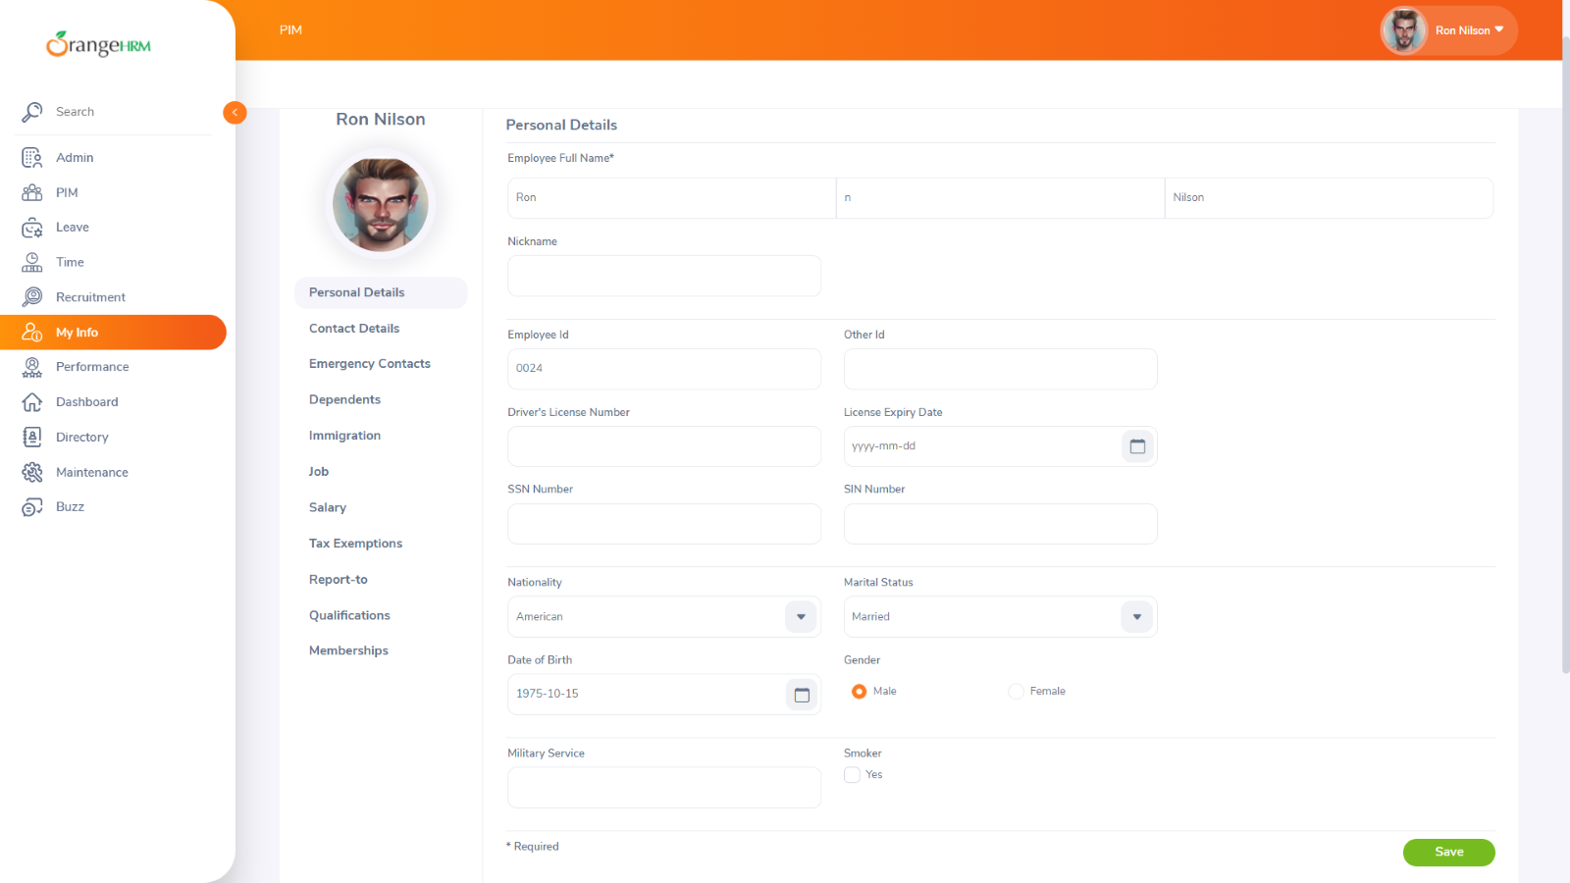

check the calendar is displayed for selecting the License expiry date

