PD_TC_16 - OrangeHRM_Personal Details _check the gender Radio button functionality

Launch the URL

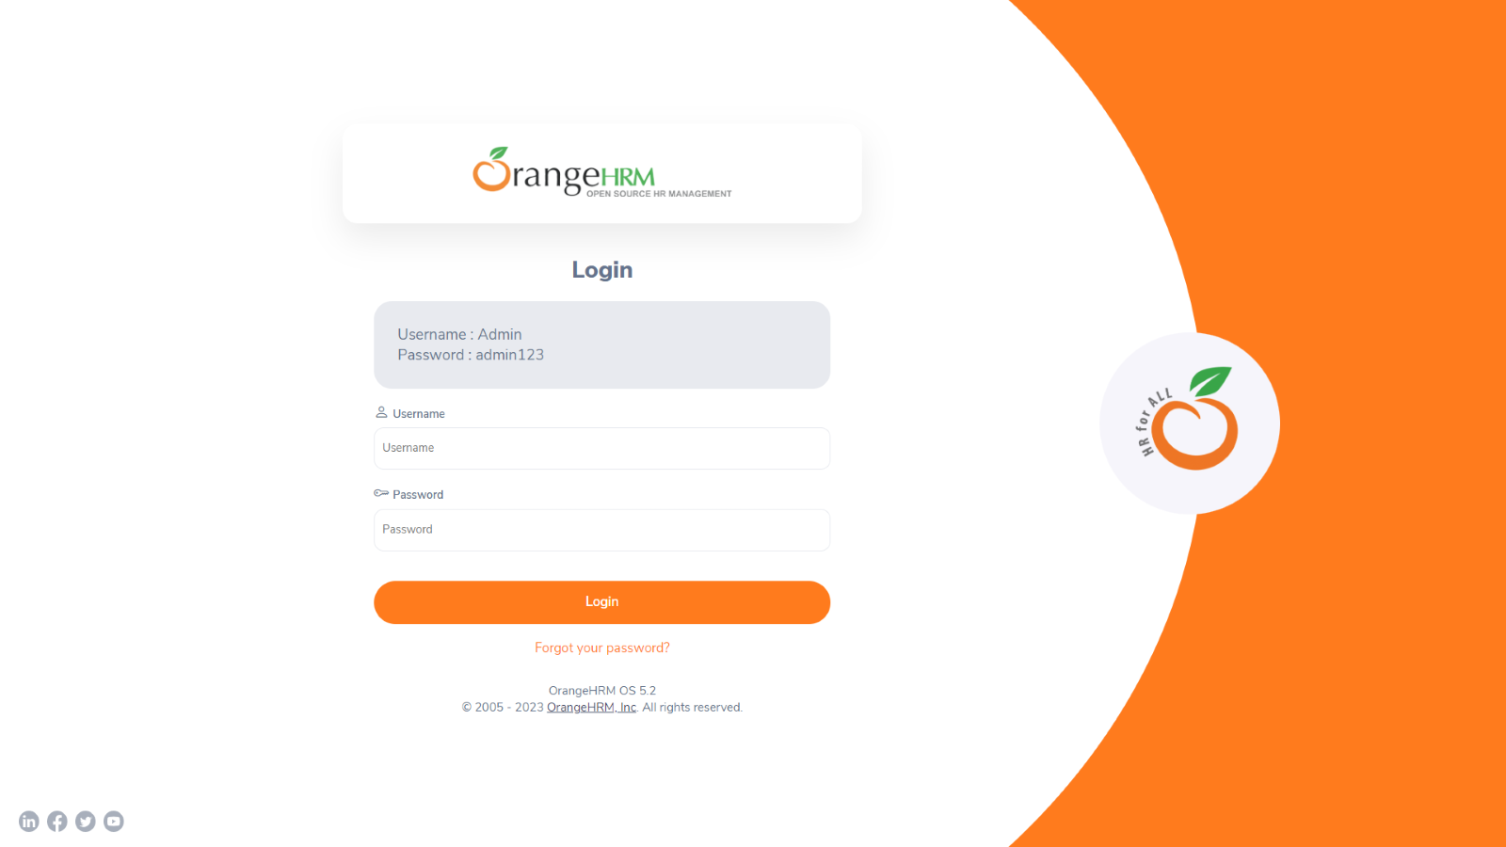

Login to the application with Valid credentials

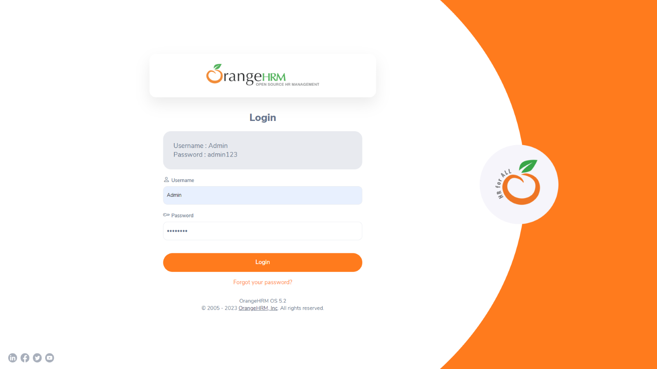

Logged successfully & navigated to personal details tab

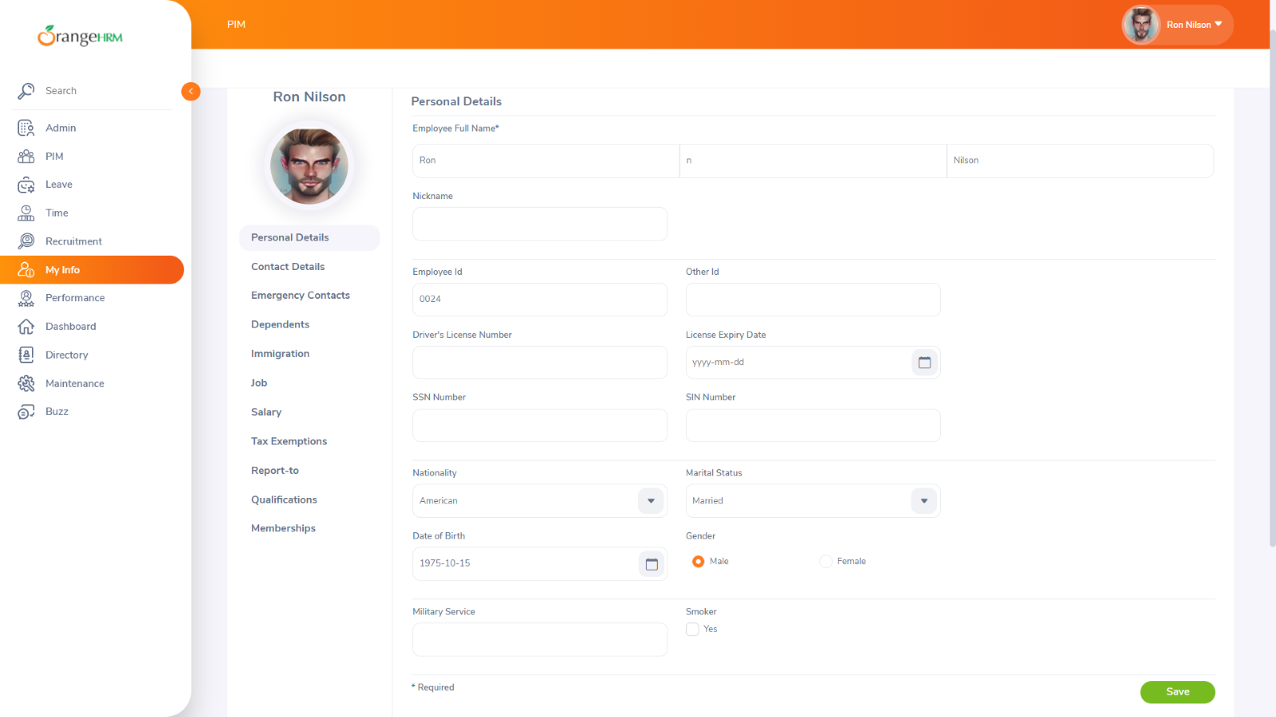

check the gender Radio button functionality

