PD_TC_17 – Orange HRM_Personal Details_Field Validation

Launch the URL

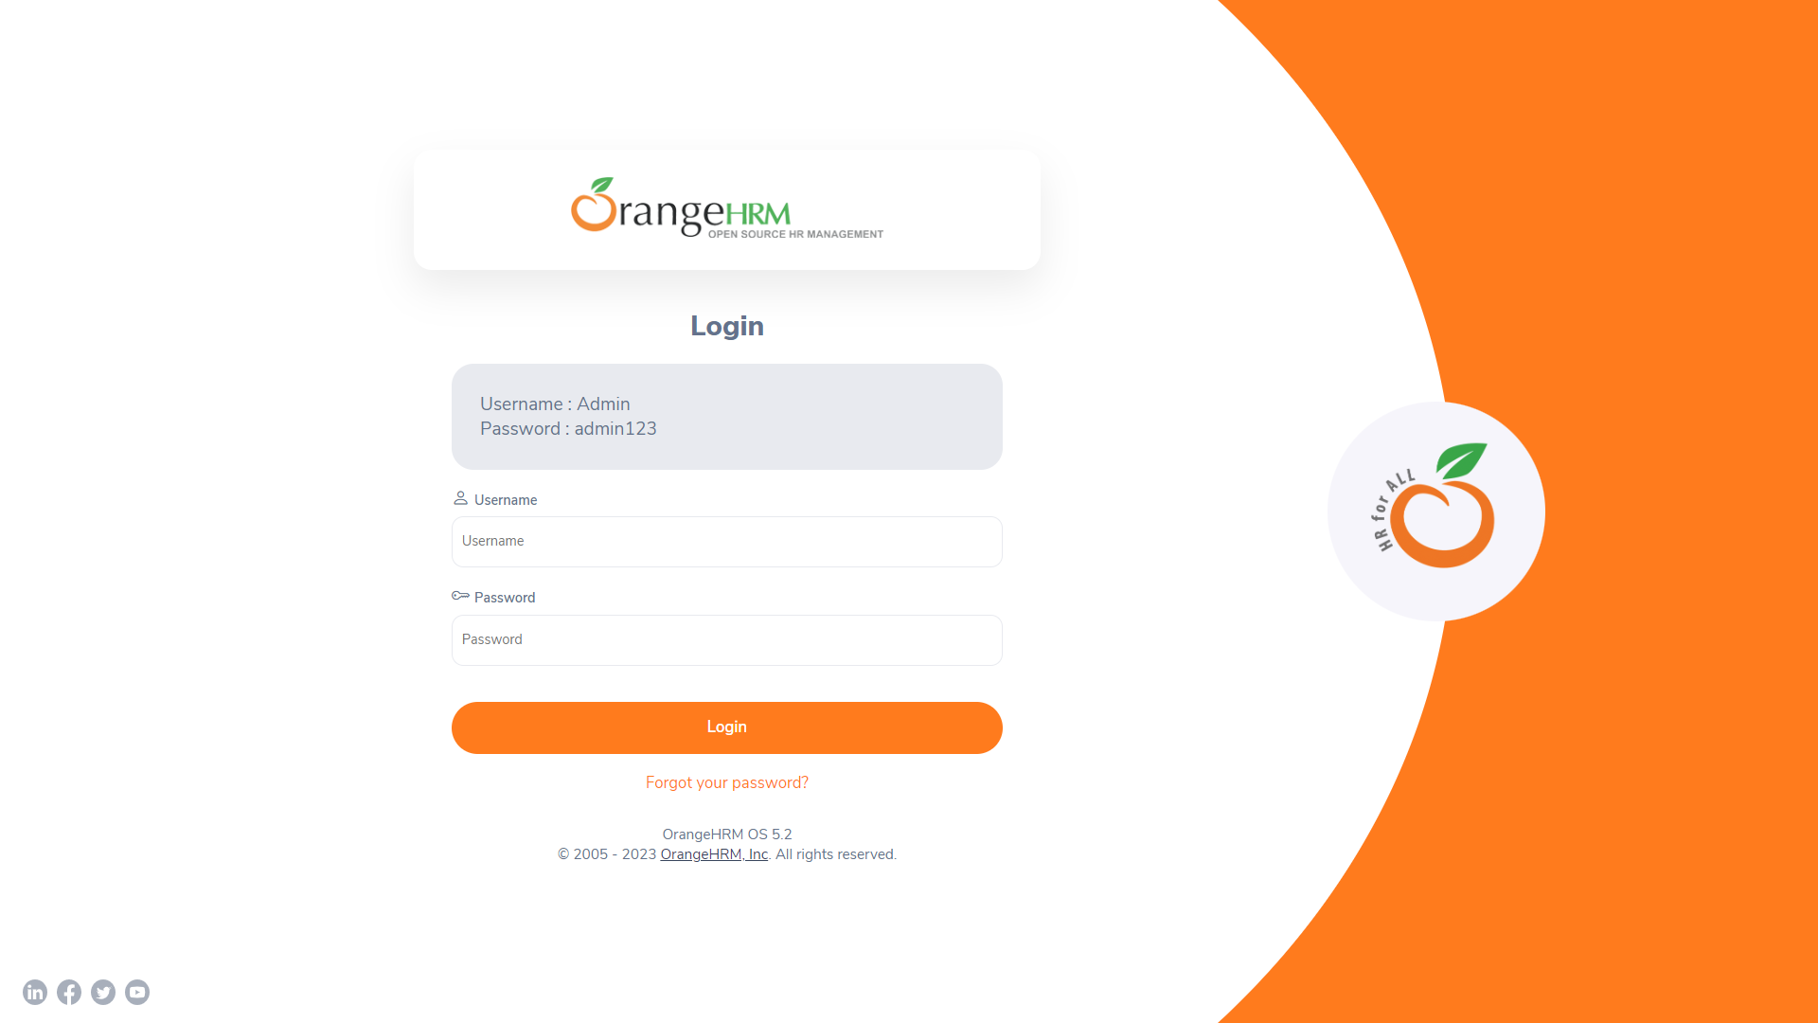

Login to the application with Valid credentials

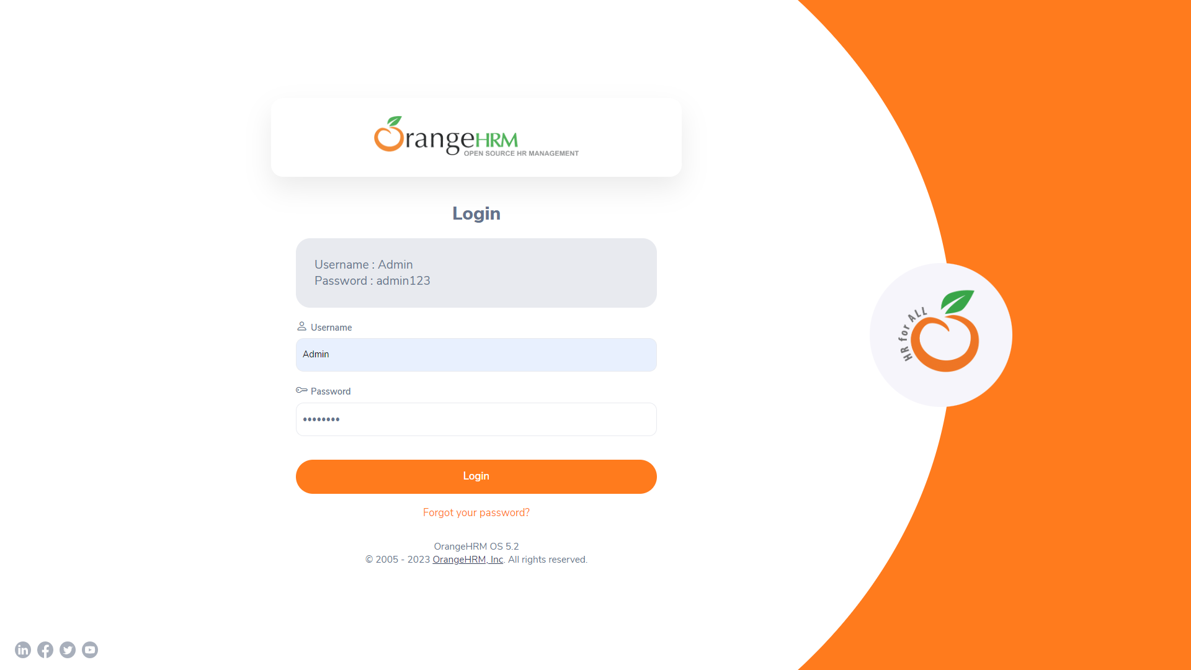

Logged successfully & navigated to personal details tab

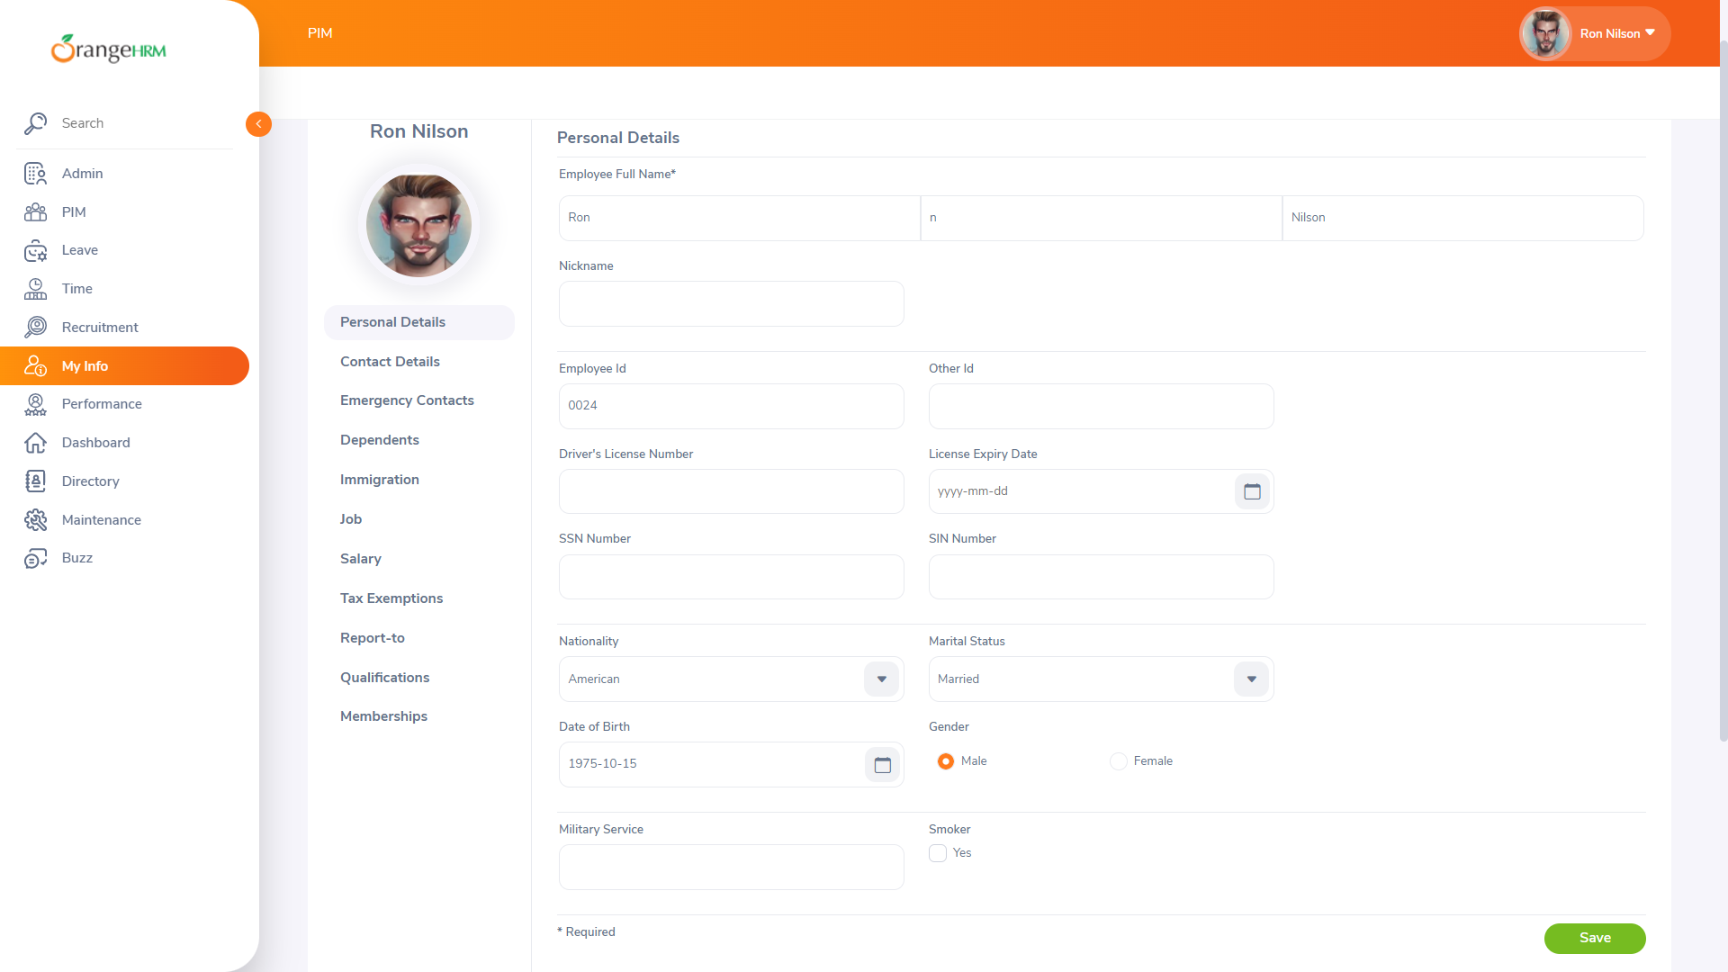

Field Validation

