Task-6

Git Repo URL: <https://github.com/Santhosh-crest/Guvi-Task/tree/master/Task-6>

Question 1  
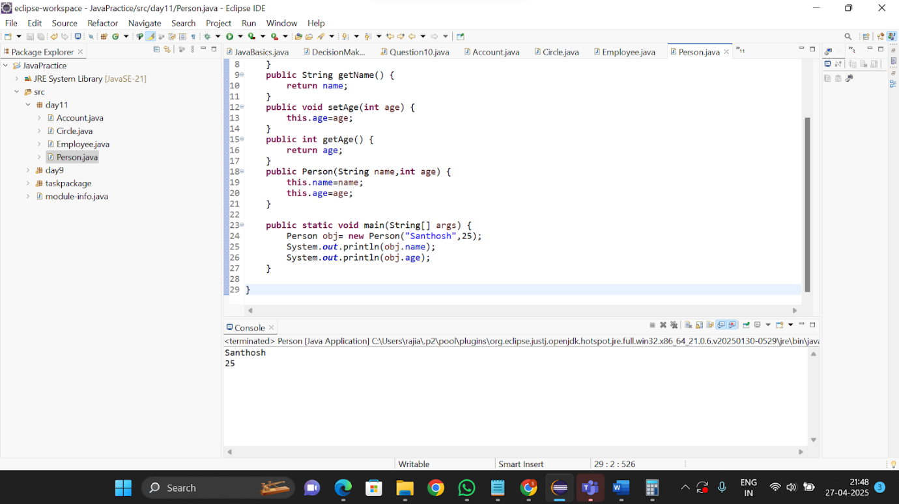  
Question 2

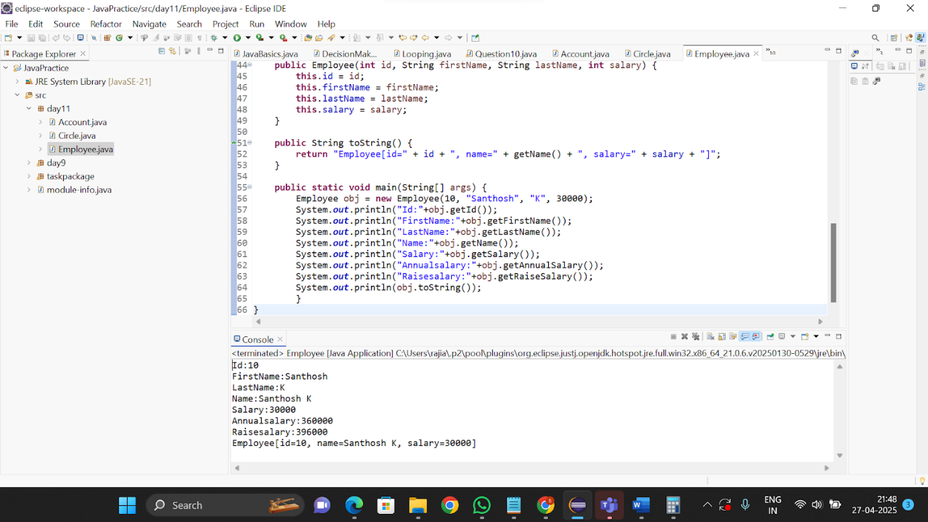

Question 3

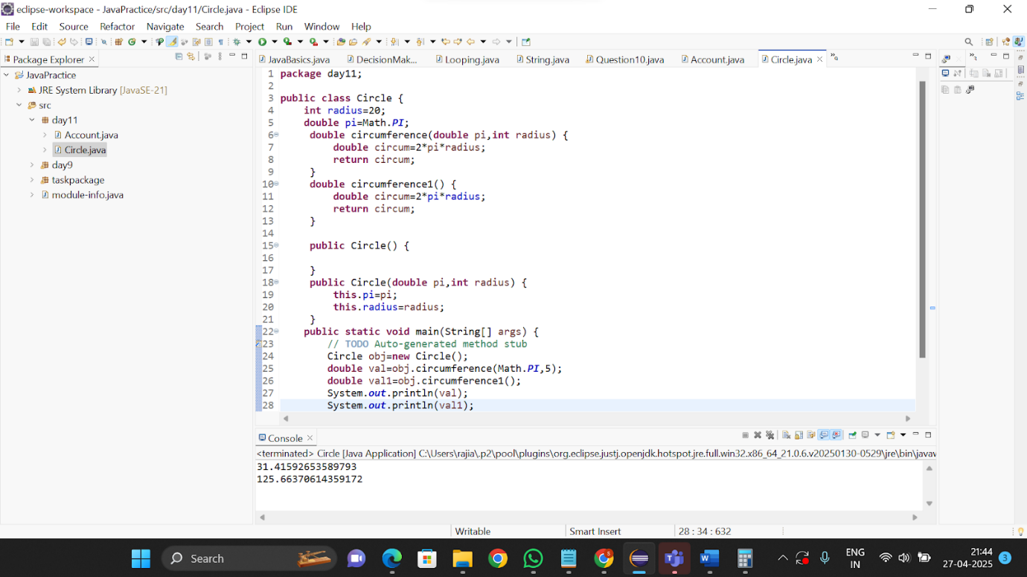  
  
Question 4

