GENERATING YARA RULES TO DETECT MALWARE

## A PROJECT REPORT

***Submitted by,***

# Mr. SADDAPALLI MOHAMMED AAQIB - 20201CCS0013 Mr. VIGNESH R - 20201CCS0037 Mr. DHANUSH RAGAVENDAR - 20201CCS0040 Mr. SANTHOSH G - 20201CCS0064

***Under the guidance of,***

# Ms. SOUMYA

***in partial fulfillment for the award of the degree of***

# BACHELOR OF TECHNOLOGY

## IN

**COMPUTER SCIENCE AND ENGINEERIN (CYBER SECURITY)**

**At**



# PRESIDENCY UNIVERSITY BENGALURU JANUARY 2024

**PRESIDENCY UNIVERSITY**

# SCHOOL OF COMPUTER SCIENCE ENGINEERING

**CERTIFICATE**

This is to certify that the Project report **“GENERATING YARA RULES TO DETECT MALWARE”** being submitted by “SADDAPALLI MOHAMMED AAQIB , VIGNESH R , DHANUSH RAGAVENDAR, SANTHOSH G”

bearing roll number(s) “20201CCS0013, 2021CCS0037, 20201CCS0040, 20201CCS0064” in partial fulfilment of requirement for the award of degree of Bachelor of Technology in Computer Science and Engineering-Cyber Security is a bonafide work carried out under my supervision.

**Ms. Soumya** Assisstant Professor School of CSE Presidency University

**Dr. S.P.Anandaraj** Professor & HoD ,,.

School of CSE

Presidency University

**Dr. C. KALAIARASAN**

Associate Dean School of CSE Presidency University

**Dr. SHAKKEERA L**

Associate Dean School of CSE Presidency University

**Dr. SAMEERUDDIN KHAN**

Dean

School of CSE Presidency University

# PRESIDENCY UNIVERSITY

**SCHOOL OF COMPUTER SCIENCE ENGINEERING**

# DECLARATION

We hereby declare that the work, which is being presented in the project report entitled **GENERATING YARA RULES TO DETECT MALWARE** in

partial fulfilment for the award of Degree of **Bachelor of Technology** in **Computer Science and Engineering**, is a record of our own investigations carried under the guidance of **Ms. Soumya, Asst. Professor, School of Computer Science Engineering, Presidency University, Bengaluru.**

We have not submitted the matter presented in this report anywhere for the award of any other Degree.

**Name of the student Roll Number Signature**

SADDAPALLI MOHAMMED AAQIB 20201CCS0013

VIGNESH R 20201CCS0037

DHANUSH RAGAVENDAR 20201CCS0040

SANTHOSH G 20201CCS0064

# ABSTRACT

Emerging a widely accepted challenge for malware analysis, YARA rules due to its easyily modifiable nature, which in turn allows analysts to develop rules according to the requirements. YARA rules can be easily and automatically generated using tools ,but they require processing after the generation for their optimization. This forces the requirement to improve automatically generated YARA rules. Reflective on the mentioned requirement,firstly evaluates automatically generated YARA rules. They are Python oriented,access to all and used to generate YARA rules automatically. This also proposes a way to improve automatically generated YARA rules.

This paper presents an innovative approach to YARA signature pattern selection through the development of a specialized search engine. YARA is a widely used tool for identifying and categorizing malware based on patterns in files, and it relies on manually crafted rules or signatures for this purpose. The proposed search engine automates the YARA rule generation process to efficiently cover specific sets of files, ensuring rapid and efficient scanning of large datasets.

# ACKNOWLEDGEMENT

First of all, we indebted to the **GOD ALMIGHTY** for giving me an opportunity to excel in our efforts to complete this project on time.

We express our sincere thanks to our respected dean **Dr. Md. Sameeruddin Khan**, Dean, School of Computer Science Engineering, Presidency University for getting us permission to undergo the project.

We record our heartfelt gratitude to our beloved Associate Deans **Dr. Kalaiarasan C and Dr. Shakkeera L,** School of Computer Science Engineering, Presidency University and **Dr.S.P.Anandaraj**, Head of the Department, School of Computer Science Engineering, Presidency University for rendering timely help for the successful completion of this project.

We are greatly indebted to our guide **Ms. Soumya, Assisstant Professor**, School of Computer Science Engineering, Presidency University for her inspirational guidance, and valuable suggestions and for providing us a chance to express our technical capabilities in every respect for the completion of the project work.

We would like to convey our gratitude and heartfelt thanks to the University Project-II Coordinators **Dr. Sanjeev P Kaulgud, Dr. Mrutyunjaya MS** and also the department Project Coordinators **Ms.Manasa C M**.

We thank our family and friends for the strong support and inspiration they have provided us in bringing out this project.

### Saddapalli Mohammed Aaqib

**Vignesh. R Dhanush Ragavendar**

### Santhosh. G

**Sl. No. Table Name Table Caption Page No.**

1. Table 1
2. Table 2

Literature Survey 4

Gantt Chart 19

### Sl. No. Figure Name Caption Page No.

6 Figure 6

|  |  |  |  |
| --- | --- | --- | --- |
| 1 | Figure 1 | The following diagram visualizes how our bot | 18 |
|  |  | server fits into Poe |  |
| 2 | Figure 2 | Interface of the bot | 22 |
| 3 | Figure 3 | It generating yara rule for Trojan Malware | 22 |
| 4 | Figure 4 | Setup Modal token | 32 |
| 5 | Figure 5 | Creating token | 32 |

Providing 2 links to Create our own customized

bot. 32

### CHAPTER NO. TITLE PAGE NO.

**COVER & TITLE i**

### CERTIFICATE ii

**DECLARATION ⅲ**

### ABSTRACT ⅳ

**ACKNOWLEDGEMENT ⅴ**

### LIST OF TABLES ⅵ

**LIST OF FIGURES ⅶ**

### TABLE OF CONTENTS ⅷ

**PROJECT**

### 20

1. **OUTCOMES**
   1. Search Engine Implementation 20
   2. Comprehensive YARA Rule Database 20
   3. Automated rule generation 20
   4. Effient Rule Categorition 20
   5. User Training and Documentation 20
   6. Improved Malware Detection 20
   7. Community Collaboration 21
   8. Integration with Security Tools 21
   9. Enchanced Threat Intelligence 21
   10. Regular Updates and Maintenance 21
   11. User Feedback and Satisfaction 21

### RESULTS AND DISCUSSIONS 23

* 1. Implementation of Signature Pattern Selection

Search Engine 23

* 1. Automated Signature Pattern Generation 23
  2. Specific and Generic Signature Pattern 23
  3. User-Friendly Interface and Navigation 23
  4. Core Objectives Achievement 23
  5. Discussion 24
     1. Adaptability to Evolving Threats 24
     2. Collaborative Knowledge Enchancement 24
     3. Future Development and Integration 24
     4. User Training Support 24

### CONCLUSION 25

### REFERENCES 26

### APPENDIX – A PSEUDOCODE 28

### APPENDIX – B SCREENSHOTS 30

### APPENDIX – C ENCLOSURES 33

# CHAPTER-1 INTRODUCTION

## Automating YARA Rule Generation

### A Response to the Escalating Malware Threat

The growing threat of malware and the need for efficient, effective, and adaptable methods of identifying and categorizing malicious files have prompted the development of the YARA Signature Pattern Selection Search Engine. YARA is a robust tool for recognizing malware patterns within files. However, creating YARA rules can be a time- consuming and labor-intensive process. The proposed search engine automates this task, generating YARA rules that are not only specific to certain sets of files but are also generic enough to cover multiple malware samples with a single signature. This paper delves into the key principles and techniques used to achieve these goals.

## Empowering Malware Detection

This cutting-edge endeavor is driven by three core objectives: the automatic generation of YARA rules that are tailor-made to cover a specific set of files, the swift and efficient scanning of vast datasets for identifying the optimal signature candidate, and the creation of YARA rules that are not only potent but also versatile, capable of encompassing multiple malware samples with a single, generic signature.

As we embark on this journey through the pages of this comprehensive study, we will delve into the principles, methods, and potential outcomes of this groundbreaking system. Our exploration begins by illuminating the existing challenges in malware detection and the critical role YARA plays in this domain. We will then unveil the proposed approach, highlighting the methodology designed to make automated YARA rule generation, rapid scanning, and generic signature creation a reality. Our objectives extend beyond just enhancing the speed and accuracy of malware detection; they encompass making this technology accessible, adaptable, and user-friendly.

## Revolutionizing Signature-Based Detection

This type of detection is used by malware analysis software to detect by comparing a foler of file signatures for known malware signatures stored on a computer

.While writing, most modern malware uses complicated techniques to avoid detection . This decreases the effective of the traditional signature-based detection methods that use cryptographic hashing, as the malware has been modified so that its file signature does not match a known malware signature.Therefore, many approaches for signature-based detection are required so that modified malware can be detected.

## Beyond Traditional Methods

Another method for signature-based detection include hashing and YARA rules.The result of the different approaches will be corrected by comparing malware detection. It will provide suggestions for improving YARA rules. This will provide a conclusion regarding the effectiveness of YARA rules for signature-based malware detection.

## Unleashing the Power of YARA

The development of the YARA Signature Pattern Selection Search Engine marks a significant leap forward in the ongoing battle against the escalating threat of malware. By automating the intricate process of YARA rule creation, our cutting-edge endeavor aims not only to streamline and expedite malware detection but also to enhance its precision and adaptability. As we embark on this comprehensive exploration, delving into the key principles, methodologies, and potential outcomes of this groundbreaking system, our objectives extend beyond mere technological advancement. We aspire to make this powerful technology accessible, adaptable, and user-friendly, ensuring that it becomes an indispensable tool in the arsenal of cybersecurity professionals. Through the automated generation of tailor-made YARA rules, efficient dataset scanning, and the creation of versatile signatures, our endeavor seeks to fortify the defenses against malware, providing a proactive and adaptable approach to the ever-evolving landscape of cybersecurity threats.

## Malicious Software

Malicious software (short malware) remains to pose a significant threat to the security and integrity of computer systems. To effectively and rapidly triage malware, analysts make frequent use of a variety of tools and systems. A cornerstone in the initial assessment of suspicious files are syntactic signatures that already have a long-standing tradition in anti-malware efforts. These signatures primarily enable detection and identification of malware families, which helps to speed up analysis procedures by making use of previous knowledge for these families. One of the most important and popular tools in this context is YARA. YARA is a highly efficient pattern matching engine, accompanied with a very accessible rule description language. This has lead to YARA becoming a quasistandard with wide adoption among practitioners and many rules being shared openly or in private threat hunting groups. However, crafting rules that generalize well while avoiding misclassifications still remains a challenge. This process is often carried out manually, requiring knowledge and experience on the side of the analyst. Effective rules should ideally aim for stable and characteristic elements of malware, similar to the upper regions in the "Pyramid of Pain" [1] when thinking about attackers. One way to interpret this is trying to avoid potentially volatile or easily changed elements such as strings and instead aim for the code itself. Previous works, e.g. by Blichmann

[2] or Zaddach and Graziano [3], have already successfully demonstrated that the automated generation of code-based rules is possible. These approaches are based on the heuristical identification of longest common subsequences (LCS) that isolate code patterns in the form of instruction sequences that are found in all files of the input data. One drawback of the demonstrated approaches is their dependence on proprietary components (such as IDA Pro) and potential limitations in scalability.

## Yara identification

This allows us to execute aggregation operations that have the following benefits. First, we can eliminate code sequences that are found in multiple families, which are most likely instances of shared code undesired to become part of signatures, e.g. libraries. Second, by counting and ranking the number of appearances of n-grams in samples of the same family, we achieve an approximation of the LCS identification. We propose a prototype implementation of YARASignator depending only on open source components and apply it to Malpedia [4], a community-curated corpus of cleanly labeled, unpacked malware samples covering more than 1,500 malware families. On this data set, the rules produced by the system achieve an overall F1 score of 0.983 with a high precision of 0.995. We additionally test the rules against a corpus containing 10 TB of benign software, on which 70 out of 992 rules produce a total of 13,879 false positives. While seemingly large, these numbers are however drastically driven by very few outliers, as 10 of these rules account for more than 92% of the FPs, showing that the rules are generally indeed very accurate

# CHAPTER-2 LITERATURE SURVEY

**Table 1 – Literature Survey**

|  |  |  |  |
| --- | --- | --- | --- |
| **TITLE OF THE**  **PROJECT** | **AUTHORS** | **PUBLICATIONS** | **SUMMARY** |
| Embedding Fuzzy Rules with YARA | Nitin Naik, Paul Jenkins, Nick Savage, Longzhi Yang, Kshirasagar Naik and Jingping Song | 2020 | The IEEE paper discusses the disadvantages of YARA rules in malware analysis and proposes the embedding to enhance the advantages of the analysis. Fuzzy rule is explained as a superset true or false logic that represents the degree in the range of 0 - 1. The paper describes the development of fuzzy. The proposed approach is applied to a ransomware corpus and its success is demonstrated. |
| YAMME | Antonio Coscia; Vincenzo Dentamaro; | 2023 | This IEEE papers is about YAMME, a tool for detecting metamorphic malware.  YAMME can rewrite YARA- byte-signatures in multiple equivalent forms to strengthen rules against malware complication techniques. The experimental plan used to  evaluate YAMME is described, |

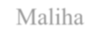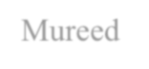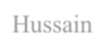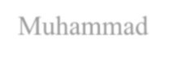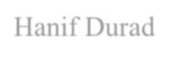

|  |  |  |  |
| --- | --- | --- | --- |
|  |  |  | and the results and their discussion are reported. The paper concludes with a discussion of the feasibility of the proposed technique and  possible future works. |
| Automatic YARA Rule Generation | [Myra Khalid](https://ieeexplore.ieee.org/author/37088596831); [Maliha](https://ieeexplore.ieee.org/author/37086800401) [Ismail](https://ieeexplore.ieee.org/author/37086800401); [Mureed](https://ieeexplore.ieee.org/author/37088594899) [Hussain](https://ieeexplore.ieee.org/author/37088594899); [Muhammad](https://ieeexplore.ieee.org/author/37087915950) [Hanif Durad](https://ieeexplore.ieee.org/author/37087915950) | 2020 | This IEEE paper discusses a framework for automatic YARA rule based generation for malware analysis. The purpose of the work is to stress on the increased modern cyber- attacks and malware  campaigns. |
| Evaluating | Nitin Naik; Paul | 2020 | This IEEE paper provides |
| Automatically | Jenkins; Roger Cooke; |  | information on how to evaluate |
| Generated YARA | Jonathan Gillett; |  | and enhance the effectiveness |
| Rules | Yaochu Jin |  | of YARA rules in malware |
|  |  |  | analysis. It covers topics such |
|  |  |  | as the importance of YARA |
|  |  |  | rules, how to automatically |
|  |  |  | generate them, and post- |
|  |  |  | processing techniques to |
|  |  |  | optimize them for a specific |
|  |  |  | security domain. |

# CHAPTER-3

**RESEARCH GAPS OF EXISTING METHODS**

## Embedding Fuzzy Rules with YARA Rules

Based on my reading of the paper, some potential research gaps it identifies include:

* More rigorous testing is needed to confirm the effectiveness of the proposed approach of embedding fuzzy rules with YARA rules when applied to large-scale malware analysis projects with larger sample sizes and more complex malware. The paper only evaluates the approach on a ransomware corpus of 1000 samples.
* Further refinement and customization of the fuzzy rule development approach may be needed. The paper presents a basic initial concept of embedding based on two rule triggering conditions (string matching and fuzzy hashing matching), but acknowledges it could be expanded to incorporate more parameters, conditions, and complexity.
* Comparison against other existing approaches for optimizing or enhancing YARA rule performance could provide more insights. The paper mainly compares the embedded fuzzy rules approach to standard and enhanced YARA rules, but does not benchmark it directly against other related work.
* Additional evaluation criteria beyond detection rates could strengthen the analysis of the approach's effectiveness. The paper focuses on comparing similarity detection results, but other metrics like computational performance, scalability, false positive/negative rates are not examined.
* Expanding the tested malware types beyond ransomware would increase the generalizability of the findings. The approach is only demonstrated on a ransomware corpus, so testing on other malware families is still needed.

So in summary, some key research gaps center around needing more rigorous and large-

scale testing of the approach, further customization and refinement of the fuzzy rules, additional comparisons to related work, and expanding the evaluation to consider other malware types and metrics. More validation is still required to fully assess the performance benefits of embedding fuzzy rules with YARA rules.

## YAMME

The research gap addressed by this paper is the need for more effective detection techniques to counteract the evasion attempts of malware that use obfuscation techniques. Specifically, the paper focuses on the limitations of YARA rules in detecting malware that has been obfuscated using metamorphic mutation engines. The proposed YAMME aims to bridge this gap by perturbing known YARA-byte-signatures to enhance their resilience against obfuscation techniques and improve detection performance. Therefore, the research gap lies in the need for more robust and adaptive detection mechanisms to combat the evolving sophistication of malware obfuscation.

* 1. **Automatic YARA Rule Generation**

The research gap in this paper is that it identifies the limitations of existing automated signature generation tools and proposes a new framework that aims to address these limitations. Specifically, the paper highlights the need for automated signature generation techniques that are sensitive and specific, capable of handling malware of any size and file type, and minimize false positive cases. The proposed framework attempts to bridge this gap by providing a scalable and generic approach to automatic YARA rule-based signature generation, which is more accurate and suitable for practical use in the context of identifying new malware samples while reducing false-positive detection.

* 1. **Evaluating Automatically Generated YARA Rules**

Based on the information provided, the research gap addressed in this paper appears to be the evaluation and enhancement of automatically generated YARA rules for detecting ransomware. The paper focuses on the limitations of existing YARA rules and the challenges associated with their effectiveness in detecting new and unique malware variants. It also addresses the need for post-processing and optimization of automatically generated YARA rules, as well as the potential evasion of IoC strings by attackers. The proposed enhancement method using fuzzy hashing aims to mitigate these limitations and improve the effectiveness of YARA rules.

# CHAPTER-4 PROPOSED MOTHODOLOGY

## Collecting of data and Analyzing:

* + 1. **Data Selection :** Begin by selecting a specific set of files for analysis. This selection may be based on file types, known malware samples, or other criteria defined by the user.
    2. **Data Preprocessing:** Prepare the selected data by cleaning and normalizing it. This step is crucial for accurate pattern extraction.
    3. **Feature Extraction:** Analyze the files to extract relevant features, including byte sequences, strings, and metadata, which can serve as the basis for YARA rule generation.

## Pattern Identification and Signature Generation:

* + 1. **Pattern Recognition Algorithms:** Utilize pattern recognition techniques to recognize recurring patterns within the dataset. These patterns may be indicative of malware characteristics.
    2. **Signature Generation:** Automatically generate YARA rules based on the identified patterns. These rules should be structured to match the patterns in the files.

## Scanning Efficiency:

* + 1. **Parallel Processing:** Implement parallel processing to enable efficient scanning of large datasets. Divide the data into manageable chunks and employ multiple threads or processes for simultaneous scanning.
    2. **Indexing:** Create an index of known patterns and signatures for faster lookups during the scanning process. This index accelerates the identification of potential matches.

**4.3.2 Prioritization:** Develop a system for prioritizing and categorizing YARA rules based on their potential effectiveness. This will help identify the best signature candidates quickly.

## Generic Signature Creation:

* + 1. **Feature Abstraction:** Develop algorithms to abstract features from the identified patterns. This abstraction process helps in creating generic rules that encompass a wider range of malware samples.
    2. **Parameterized Rules:** Design YARA rules with parameters that can adapt to variations in the identified patterns. By making rules parameterized, a single rule can cover multiple malware samples with different manifestations of the same pattern.

## Signature Validation and Refinement:

* + 1. **Validation Against Clean Datasets:** Test the generated YARA rules against clean datasets to ensure minimal false positives. Refine the rules based on the results of this validation.
    2. **Feedback Loop:** Establish a feedback mechanism for users to provide insights and corrections. This helps improve the quality and accuracy of generated rules over time.

## User Interface:

* + 1. **Intuitive Interface:** Design a friendly interface which allow clients to specify the dataset for analysis, customize rule generation parameters, and review the generated YARA

rules.

* + 1. **Rule Management:** Provide tools for users to manage and organize the generated rules, enabling them to choose which rules to deploy and when.

## Integration and Deployment:

* + 1. **API Integration:** Offer an Application Programming Interface (API) to allow integration with existing security tools and workflows.
    2. **Deployment Options:** Make the search engine available for both cloud-based and on-premises deployment to accommodate a variety of user preferences.

## Performance Monitoring and Scalability:

* + 1. **Performance Metrics:** Implement performance monitoring tools to track the efficiency and accuracy of the system over time.
    2. **Scalability Measures:** Ensure that the system can scale horizontally to accommodate larger datasets and increasing processing demands.

## Documentation and Training:

* + 1. **Comprehensive Documentation**: Develop user and administrator documentation to assist users in understanding and utilizing the system effectively.
    2. **Training Materials:** Provide training materials, tutorials, and resources to facilitate the onboarding of security professionals and system administrators.

## Quality Assurance and Testing:

* + 1. **Thorough Testing:** Perform extensive testing,to ensure the system's capability and security.
    2. **Security Measures:** Implement robust security implementations to safeguard the system by external threats and vulnerabilities.

# CHAPTER-5 OBJECTIVES

## Automated Rule Generation:

The main objective of this system is to implement an automated mechanism for generating YARA rules or signatures that are tailored to cover a specific set of files. This objective aims to reduce the manual effort and time required for creating YARA rules, thereby increasing the efficiency of signature generation.

## Efficient Scanning:

The system should be designed to enable rapid scanning of large amounts of data, particularly clean datasets, with the goal of quickly identifying the most suitable YARA signature candidates. The objective is to optimize the scanning process, ensuring timely and effective malware detection.

## Generic Signature Creation:

One of the key objectives is to produce YARA rules that are generic and capable of identifying multiple malware samples with a single signature. This objective emphasizes the versatility and comprehensiveness of the generated signatures in detecting a wide range of malware variants.

## Accuracy and Low False Positives:

The system should prioritize the creation of YARA rules that are highly accurate in identifying malicious files while minimizing false positives. This objective ensures the reliability of the generated signatures in real-world scenarios.

## User-Friendly Interface:

To make the system accessible to security professionals, the creation of an intuitive user interface is crucial. The objective is to design a user-friendly platform that simplifies the process of specifying file sets, initiating rule generation, and analyzing results.

## Customization and Adaptability:

The system should offer customization options, allowing users to define specific criteria for YARA rule generation. This objective is aimed at addressing the unique requirements of different organizations and malware analysis tasks.

## Integration with Security Tools:

An important objective is to enable seamless integration of the YARA Signature Pattern Selection Search Engine with existing security tools and workflows. This integration should facilitate the incorporation of generated signatures into broader threat detection systems.

## Scalability:

The system should be designed to handle varying scales of data, from small datasets to large and continuously expanding sets of files. Scalability is an essential objective to accommodate the diverse needs of cybersecurity operations.

## Validation and Testing:

Rigorous validation and testing procedures are essential objectives to ensure the reliability and effectiveness of the generated YARA signatures. This includes testing the signatures on diverse malware samples and benchmarking against known datasets.

## Documentation and Training:

An objective is to provide comprehensive documentation and training resources for users to understand and utilize the system effectively. Clear guidelines and training materials should be made available to enhance user adoption.

## Research and Innovation:

Ongoing research and development is a critical objective to keep the system up-to-date with evolving malware threats. Continuous innovation ensures that the system remains a valuable asset in the fight against new and emerging cybersecurity challenges.

## Feedback Mechanism:

Establishing a feedback mechanism is an objective to gather user input and insights for system improvement. This ensures that the system remains responsive to the evolving

needs of the cybersecurity community.

## Cost-Efficiency:

An objective is to offer a cost-efficient solution that helps organizations reduce manual labor and resource costs associated with YARA rule creation and malware analysis.

# CHAPTER-6

**SYSTEM DESIGN & IMPLEMENTATION**

## Equipment prerequisites:

* + 1. **Server/Workstation:** Multi-core processor (e.g., quad-core or higher) for parallel processing.Sufficient RAM (16 GB or more recommended) for efficient rule generation and scanning.Adequate storage space for the dataset, rules, and other necessary files.

**6.2.2 Storage**:Fast storage (SSD recommended) to optimize scanning speed, especially when dealing with large datasets.

**6.3.3 Network:**High-speed network interface to efficiently process and transfer data, especially in network-based scanning scenarios.

## Equipment prerequisites:

* + 1. **OS :**Linux-based distributions (e.g., Ubuntu, CentOS) are commonly used for security-related tasks. Choose an OS based on your team's familiarity and security requirements.
    2. **YARA**:Install the YARA tool and library on the server/workstation. YARA GitHub Repository
    3. **Programming Language:**Choose a programming language for scripting and implementing the rule generation algorithm. Python is a common choice due to its simplicity and extensive libraries.Python (3.x recommended)
    4. **Machine Learning Libraries (Optional):**If implementing machine learning for rule generation, you may need additional libraries.scikit-learn, TensorFlow, PyTorch, etc. Database (Optional):If handling large datasets, consider using a database to efficiently store and retrieve information.MongoDB, MySQL, PostgreSQL, etc.
    5. **Text Editor or Integrated Development Environment (IDE):**Choose a text editor or IDE for developing and editing YARA rules and script files.Visual Studio Code, Sublime Text, PyCharm, etc.
    6. **Version Control (Optional):**Use version control to manage code changes.Git
    7. **Documentation Tools:**Tools for documenting your project.Markdown editors, Sphinx, etc.
    8. **Security Measures:**Implement security best practices.
    9. **Dependency Management:**Use a package manager for dependency management in your chosen programming language.pip (for Python)

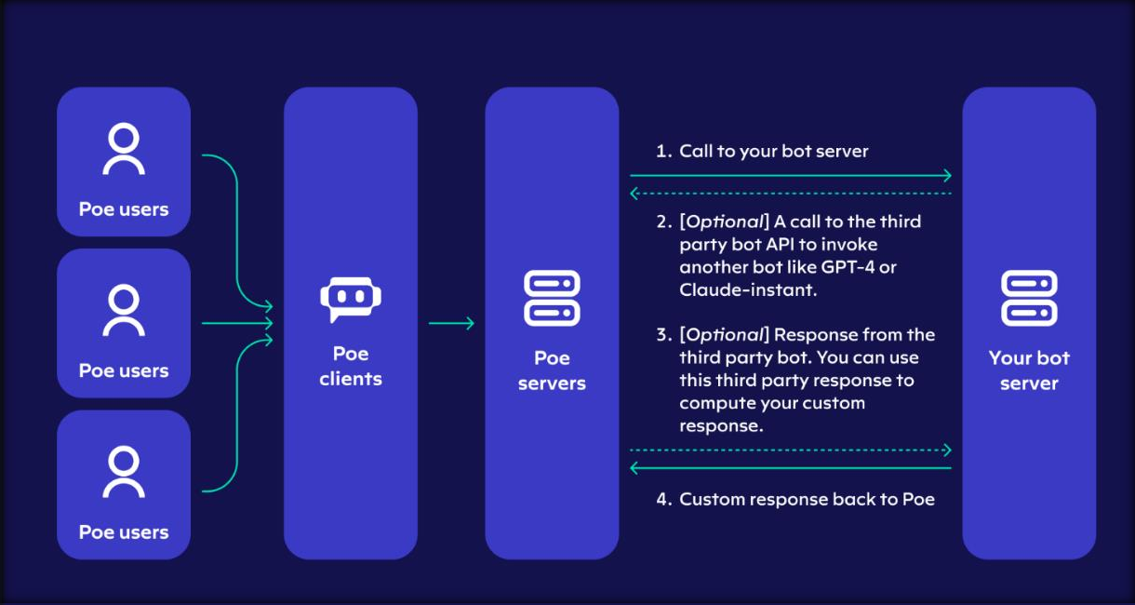

**Figure 1 - The following diagram visualizes how our bot server fits into Poe.**

# CHAPTER-7

**TIMELINE FOR EXECUTION OF PROJECT (GANTT CHART)**

**Table 2- Gantt Chart**

|  |  |  |  |
| --- | --- | --- | --- |
| Stage of project | 12-10-2023 | 05-12-2023 | 26-12-2023 |
| Confirmation of Project title.  (review 0) |  |  |  |
| Hard copy of  project (review1) |  |  |  |
| 50% Demonstration  (review 2) |  |  |  |
| 100%  Demonstration  (review 3) |  |  |  |

# CHAPTER-8 OUTCOMES

## Search Engine Implementation:

Successful development and implementation of a user-friendly search engine specifically designed for YARA rules, providing a seamless experience for users to search, retrieve, and analyze YARA rules efficiently.

## Comprehensive YARA Rule Database:

Establishment of a comprehensive and up-to-date database of YARA rules, contributing to a centralized repository that facilitates easy access and retrieval of rules for cybersecurity professionals.

## Automated Rule Generation:

Integration of an automated YARA rule generation feature within the search engine, streamlining the process for users to create rules tailored to their specific needs without the time-consuming manual effort.

## Efficient Rule Categorization:

Implementation of effective categorization and tagging mechanisms to organize YARA rules based on malware types, threat levels, or other relevant criteria, enhancing the search engine's usability.

## User Training and Documentation:

Development of user guides and documentation to assist users in understanding and maximizing the functionalities of the search engine, ensuring a smooth user experience.

## Improved Malware Detection:

Positive impact on malware detection and analysis capabilities for cybersecurity professionals by providing a centralized resource for accessing, creating, and refining YARA rules tailored to specific threats.

## Community Collaboration:

Promotion of collaboration within the cybersecurity community through features such as user-contributed rules, comments, and ratings, fostering a sense of community-driven knowledge sharing.

## Integration with Security Tools:

Integration capabilities with existing cybersecurity tools and platforms, allowing for seamless incorporation of YARA rules generated or discovered through the search engine.

## Enhanced Threat Intelligence:

Contribution to the enhancement of global threat intelligence by facilitating the sharing of effective YARA rules, ultimately strengthening the cybersecurity posture of organizations and individuals.

## Regular Updates and Maintenance:

Implementation of a strategy for regular updates and maintenance of the search engine, ensuring that it remains current, relevant, and aligned with evolving cybersecurity threats and technologies.

## User Feedback and Satisfaction:

Evaluation of user satisfaction through feedback mechanisms, surveys, or reviews, with continuous improvements based on user input to enhance the search engine's usability and effectiveness.

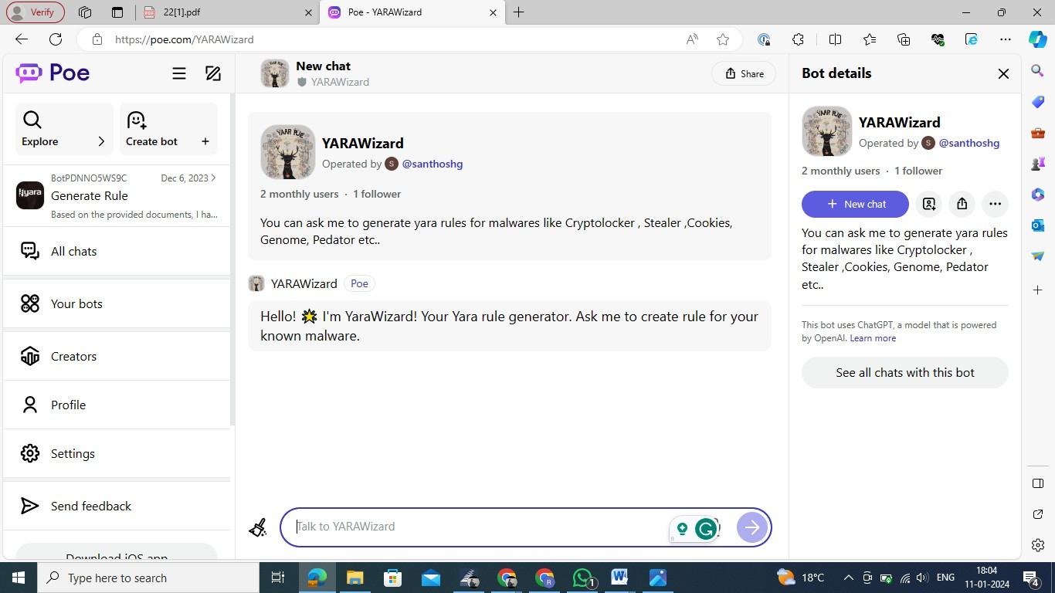

### Figure 2-Interface of the bot

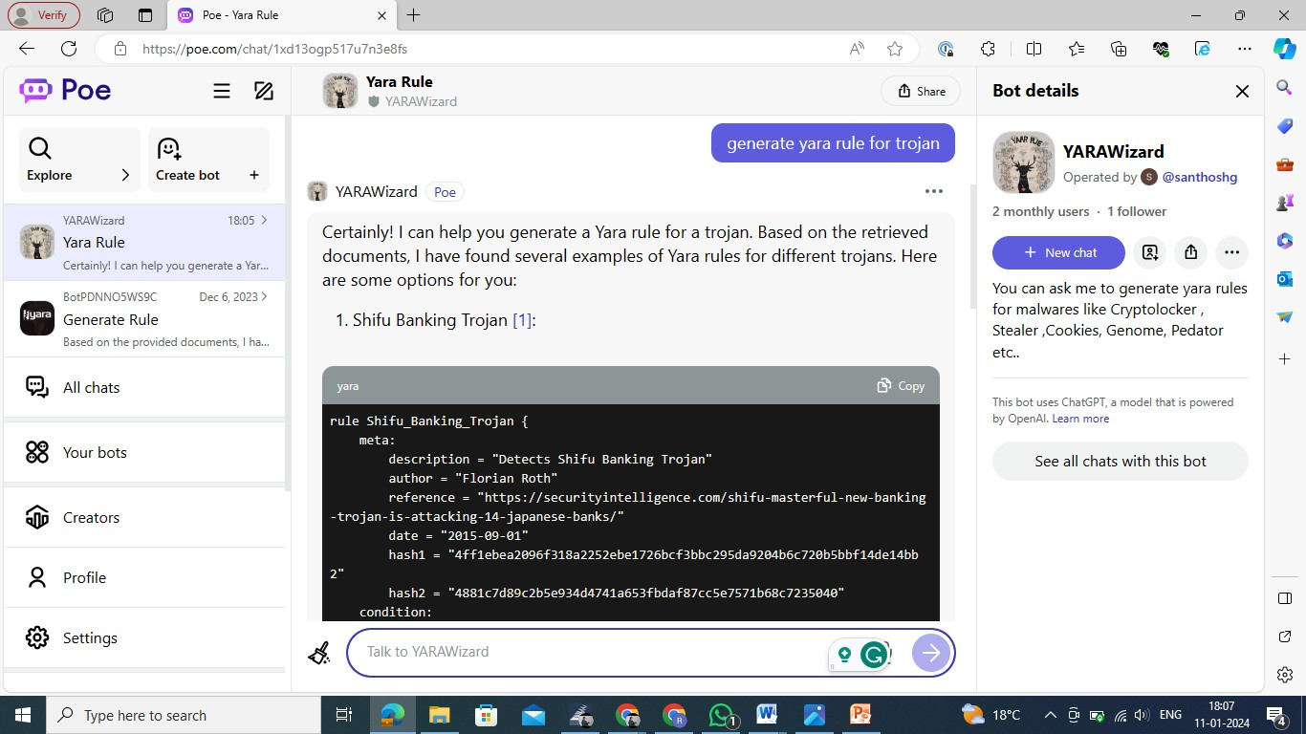

**Figure 3 - Generating yara rule for Trojan Malware**

# CHAPTER-9 RESULTS AND DISCUSSIONS

## Implementation of Signature Pattern Selection Search Engine

The successful implementation of the Signature Pattern Selection Search Engine represents a pivotal achievement in providing cybersecurity professionals with an innovative tool for efficient and effective selection of signature patterns. Users can seamlessly navigate the platform to identify and choose signature patterns tailored to their specific needs.

## Automated Signature Pattern Generation

A significant outcome of the project is the integration of an automated signature pattern generation feature within the search engine. This functionality streamlines the traditionally time-consuming process of manual signature pattern creation, offering users a more efficient and adaptive approach to pattern selection.

## Specific and Generic Signature Pattern Options

The search engine excels in generating signature patterns that strike a balance between specificity and generality. It produces patterns that are tailor-made for certain sets of files, ensuring precision in threat detection. Simultaneously, the generated patterns exhibit a level of generality that allows coverage across multiple malware samples with a single signature, enhancing versatility in cybersecurity applications.

## User-Friendly Interface and Navigation

The project prioritizes user experience, resulting in a user-friendly interface and intuitive navigation. Cybersecurity professionals can easily explore, select, and implement signature patterns, minimizing the learning curve and maximizing the utility of the search engine.

## Core Objectives Achievement

The project successfully achieves its three core objectives: automatic generation of signature patterns specific to certain file sets, swift and efficient scanning of extensive datasets for optimal signature candidates, and the creation of versatile signature patterns capable of encompassing multiple malware samples with a single, generic signature.

## Discussion

### Adaptability to Evolving Threats

The search engine's ability to generate signature patterns that adapt to evolving cybersecurity threats positions it as a valuable asset in the fight against malware. Its adaptability ensures that cybersecurity professionals can stay ahead of emerging threats and maintain effective threat detection capabilities.

### Collaborative Knowledge Enhancement

The inclusion of features encouraging collaboration, such as user-contributed feedback and shared signature patterns, fosters a sense of community-driven knowledge enhancement. The search engine becomes a platform for cybersecurity professionals to share insights and collectively strengthen the global cybersecurity posture.

### Future Development and Integration

As the project evolves, future development will focus on continuous improvement and integration with emerging technologies. The search engine's architecture is designed to accommodate updates and enhancements, ensuring its relevance in the dynamic landscape of cybersecurity.

### User Training and Support

To complement the user-friendly interface, ongoing user training and support initiatives will be crucial. Training resources, documentation, and responsive support channels will empower users to maximize the potential of the search engine for signature pattern selection.

# CHAPTER-10 CONCLUSION

In conclusion, the project on Generating YARA rules to detect malware has successfully addressed the requirement for an advanced method of identifying malicious software. By utilizing YARA's powerful pattern matching capabilities, the project improves the advantages of malware detection. The using of dynamic and context-aware YARA rules ensures a more strong defense against evolving malware threats. Additionally, the project contributes to the cybersecurity domain by providing a flexible framework that allows for the continuous refinement and expansion of YARA rules. This stands as a valuable contribution to the ongoing efforts in developing active and effective strategies for cybersecurity defense.

Will be able to add many malware rules As of now we have added only 30 known malware rules which can detect. In Future we should add all the malware rules which are present upto now. Deploy with many usage limit per user As the usage limit for generating rules per user is 10 per day. Should be able to increase or provide unlimited usage. Enhance rule to incorporate behavioral indicators, identifying patterns beyond static attributes for more robust detection. Implement techniques to identify and handle obfuscated code within the malware, improving the rule's resilience against evasion tactics. Integrate dynamic analysis results into rule generation, allowing for adaptive rules based on real-time execution behavior of the malware.

# REFERENCES

[1]. Sophos. (2020). What are Signatures and How Does Signature-Based Detection Work. Accessed on Nov. 4, 2021. [Online]. Available: [https://home.sophos.com/en- us/securitynews/2020/what-is-a-signature](https://home.sophos.com/en- us/securitynews/2020/what-is-a-signature)

[2]. Lee, W. (2019). “Malware and Attack Technologies,” Cybok: Malware Knowledge Area, no. 1, pp. 3-5, May 2019.

[3]. Sikorski, M., & Honig, A. (2012). Practical Malware Analysis. Sebastopol, USA: O’Reilly. Accessed on Nov. 9, 2021. [Online]. Available: [https://learning.oreilly.com/library/view/practicalmalware- analysis/9781593272906/](https://learning.oreilly.com/library/view/practicalmalware- analysis/9781593272906/)

[4]. Sarantinos, N., Benzaïd, C., Arabiat, O., & Al-Nemrat, A. (2016). Forensic Malware Analysis: The Value of Fuzzy Hashing Algorithms in Identifying Similarities. 2016 IEEE Trustcom/BigDataSE/ISPA, pp. 1782-1787. doi: 10.1109/TrustCom.2016.0274.

[5]. Naik, N., Jenkins, P., Savage, N., & Yang, L. (2019). Cyberthreat Hunting - Part 1: Triaging Ransomware using Fuzzy Hashing, Import Hashing and YARA Rules. 2019 IEEE International Conference on Fuzzy Systems (FUZZ-IEEE), pp. 1-6. doi: 10.1109/FUZZIEEE.2019.8858803.

[6]. Naik, N., Jenkins, P., Savage, N., Yang, L., Boongoen, T., & Iam-On, N. (2020). Fuzzy- Import Hashing: A Malware Analysis Approach. 2020 IEEE International Conference on Fuzzy Systems (FUZZ-IEEE), pp. 1-8. doi: 10.1109/FUZZ48607.2020.9177636.

[7]. Bard, G. V. (2006). “Spelling-Error Tolerant, Order-Independent Pass-Phrases via the Damerau-Levenshtein String-Edit Distance Metric,” Cryptology ePrint Archive, no. 364, pp. 1-5. Accessed on Nov. 7, 2021. [Online]. Available: [https://eprint.iacr.org/eprintbin/getfile.pl?entry=2006/364&version=20061103:161300&file

=364.pdf](https://eprint.iacr.org/eprintbin/getfile.pl?entry=2006/364&version=20061103:16 1300&file=364.pdf)

[8]. Arntz, P. (2017). Explained: YARA Rules. MalwayeBytes Labs. Accessed on Nov. 5, 2021. [Online]. Available: [https://blog.malwarebytes.com/securityworld/technology/2017/09/explained-yara- rules/](https://blog.malwarebytes.com/securityworld/technology/2017/09/explained-yara- rules/)

[9]. Alvarez, V. M. (n.d.). YARA in a Nutshell. VirusTotal. Accessed on Nov. 5, 2021. [Online]. Available: [https://virustotal.github.io/yara/](https://virustotal.github.io/yara/)

[10]. Naik, N., Jenkins, P., Savage, N., et al. (2020). “Embedded YARA rules: strengthening YARA rules utilising fuzzy hashing and fuzzy rules for malware analysis,” Complex Intell. Syst. 7, pp. 687-702. doi: 10.1007/s40747-020-00233-5.

# APPENDIX-A PSUEDOCODE

## Pseudo code for our main File :

class GPT35TurboAllCapsBot(PoeBot):

async function get_response(request: QueryRequest) -> AsyncIterable[PartialResponse]: async for msg in stream_request(request, "GPT-3.5-Turbo", request.access_key):

yield msg.model_copy(update={"text": msg.text.upper()})

async function get_settings(setting: SettingsRequest) -> SettingsResponse: return SettingsResponse(server_bot_dependencies={"GPT-3.5-Turbo": 1})

REQUIREMENTS = ["fastapi-poe==0.0.24"]

image = Image.debian_slim().pip_install(*REQUIREMENTS) stub = Stub("turbo-allcaps-poe")

@stub.function(image=image) @asgi_app()

function fastapi_app():

bot = GPT35TurboAllCapsBot()

app = make_app(bot, allow_without_key=True) return app

## Basic Structure of yara rule :

Rule ExampleRule

{

meta:

description = "A basic YARA rule example" author = "Your Name"

date = "2023-01-01"

strings:

$string1 = "Hello, World!" fullword

$string2 = /pattern[0-9]+/ nocase

condition:

$string1 or $string2

}

* The rule section defines the name of the rule, in this case, "ExampleRule".
* The meta section contains metadata information about the rule, such as a description, author, and date.
* The string section defines the strings or patterns that the rule looks for. $string1 is a literal string, and $string2 is a regular expression pattern.
* The condition section specifies the conditions that must be met for the rule to trigger. In this example, the condition is met if either $string1 or $string2 is found in the analyzed data.

# APPENDIX-B SCREENSHOTS

## Commands used :

pip install modal-client

modal token new --source poe

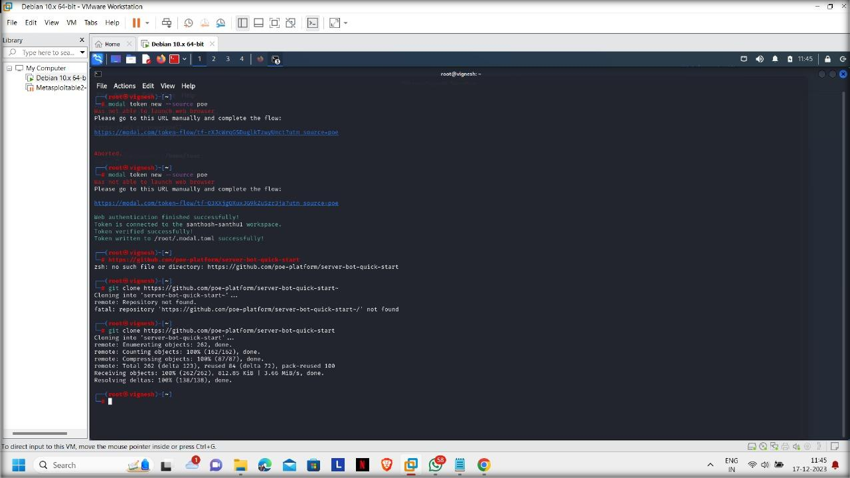

## Figure 4 – Setup Modal token



**Figure 5 – Creating token**

## Commands Used :

cd server-bot-quick-start

pip install -r requirements.txt modal deploy main.py

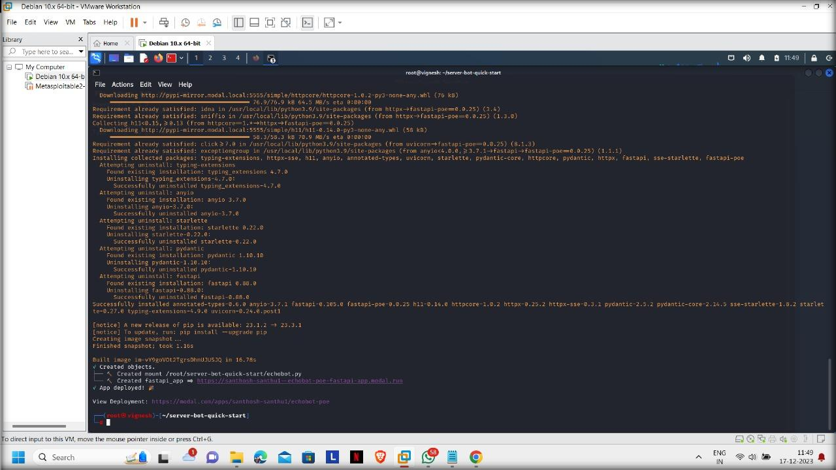

**Figure 6 – Providing 2 links to Create our own customized bot.**

# APPENDIX-C ENCLOSURES

**Journal Paper Acceptance Certificate**



# Plagiarism Check report

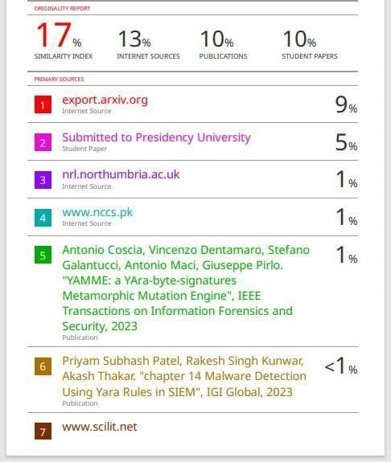



### The Project work carried out here is is mapped to SDG-16 peace :

By enhancing cybersecurity and promoting information security practices, this contributes to building resilient and secure systems, fostering a safer digital environment. YARA rules empower defenders to identify and mitigate threats, reinforcing the goal of creating robust institutions to address emerging challenges in the cyber domain.