VC3D Documentation

Step 1: To download Amazon DCV. Click the link.
Step 2: https://www.amazondcv.com/
Step 3:
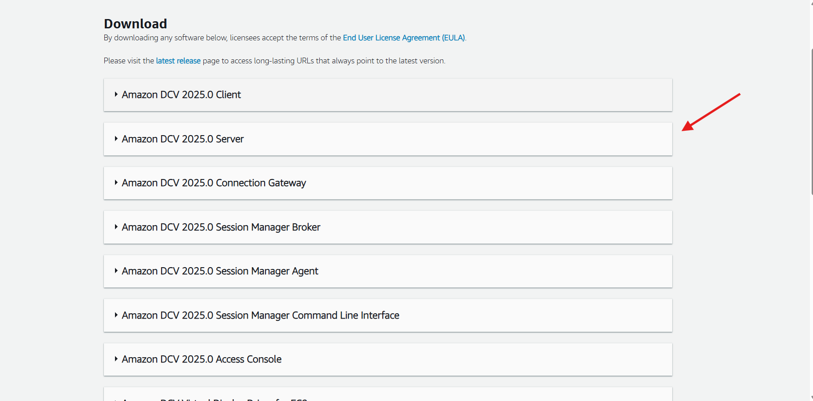

Step 4:
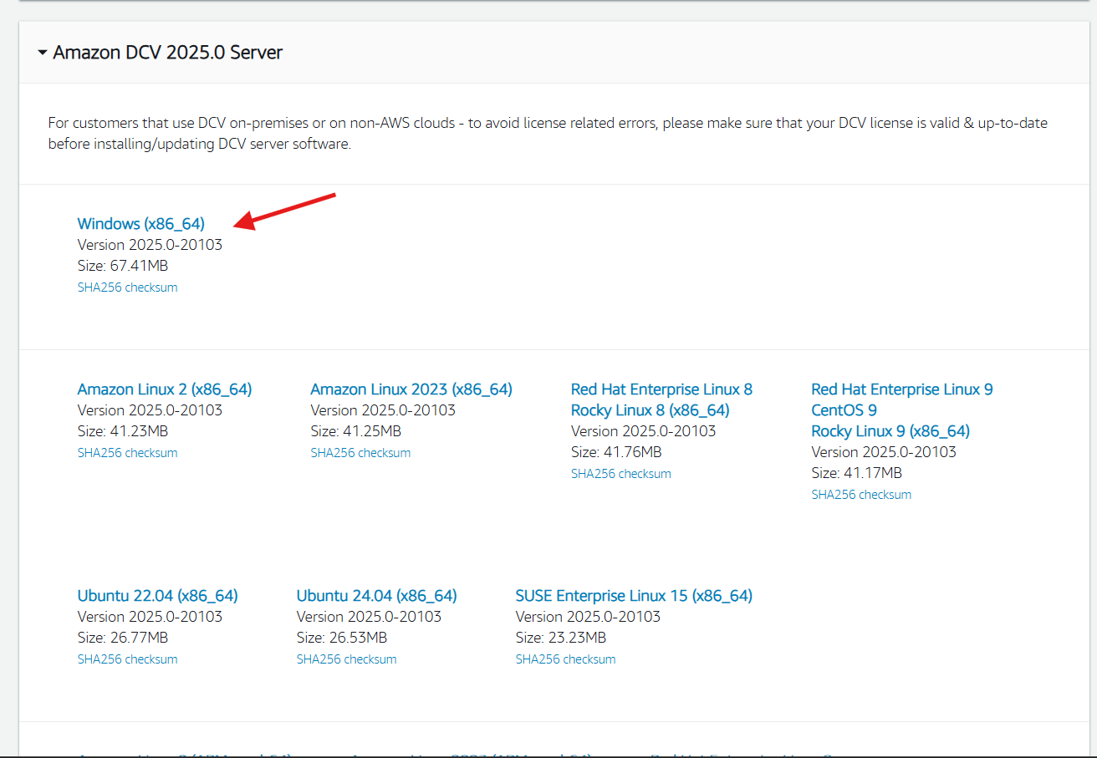

Current instance -3.85.172.152/3.92.65.22
User name - annotator
Password -dcv
There are two Terminals:
Bin Terminal (To open VC3D Tool):
- Command for vc3d - cd ~/villa/volume-cartographer/build/bin
- ulimit -Sn 750000
- ./VC3D

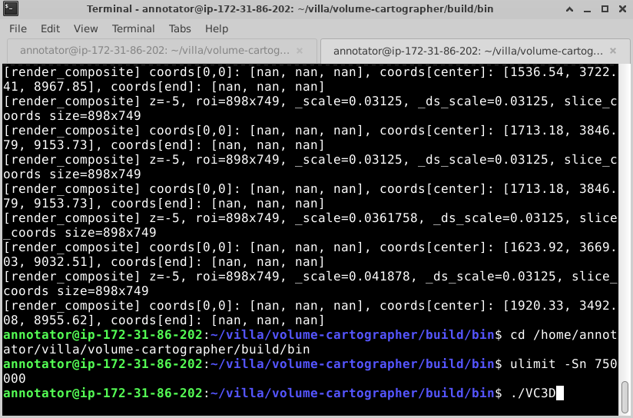

After giving the /vc3d command, it navigates to Tool:
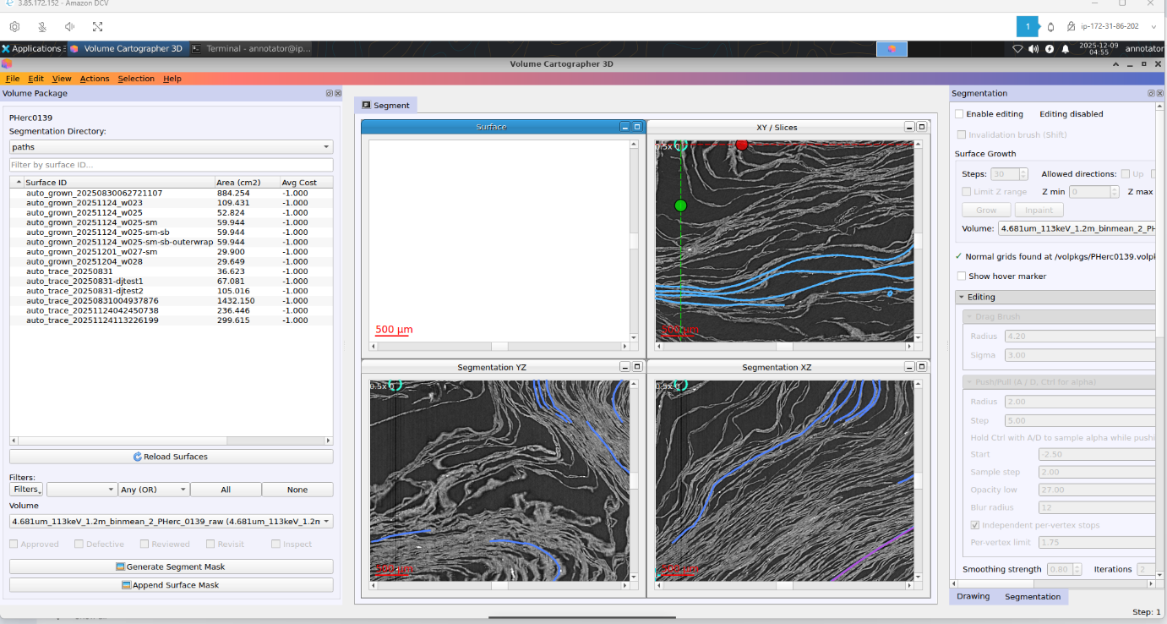

Scripts Terminal (To Using Sync):
cd /home/annotator/villa/volume-cartographer/scripts
python3 vc_sync.py sync /volpkgs/PHerc0139.volpkg/paths
File Open - File- Openvolpkg..-Computer-/-volpkgs-PHerc0172.volpkg-choose
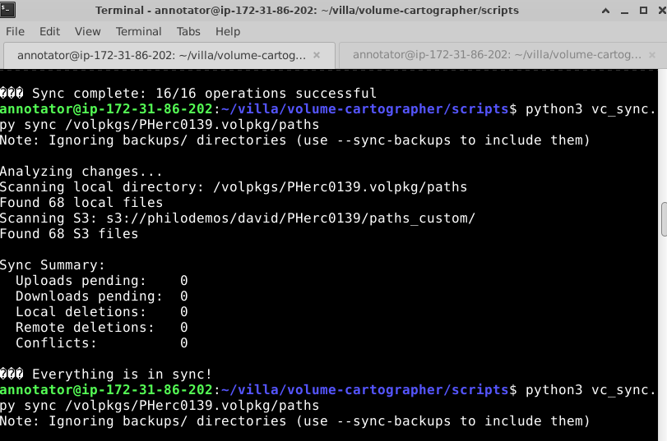

Key Bindings:
Use- r for previous points
PUSH AND PULL (Ctrl + A/D)
True -false symbol -default if there is no need to use -CTRL+t

GIMP Editing:
While editing the patch, there is a sheet switch that needs to be removed from that part using gimp and editing.
That process - First file name -right click any copy segment path
- Left corner click - Application -File manager
Search the copy segment path -and delete the current mask, and close the tab-then generate segment mask-Append surface mask-and the gimp is opening, then edit the unnecessary part and -Overwrite and discard. Refresh the page; the edited mask is reflected. Then, continue growing.

Direction Fields option:
For a Clear contrast
- .3fields Horizontal -Scale level -2 weight -0.1
- Vertical -Scale level -2 weight -0.1
- Normal -Scale level -3 weight -0.1
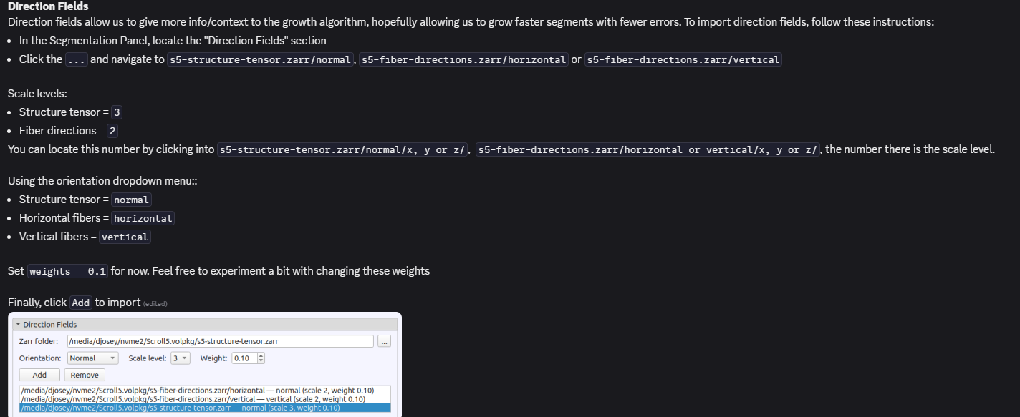

Custom param:
Need the external growth
{
"num_threads": 1,
"cache_root": "/volpkgs/PHerc0172.volpkg/cache/",
"reference_surface": {
"path": "/volpkgs/PHerc0172.volpkg/paths/auto_grown_20250926155332369-et/",
"penalty_weight": 1,
"min_clearance":4
}
}
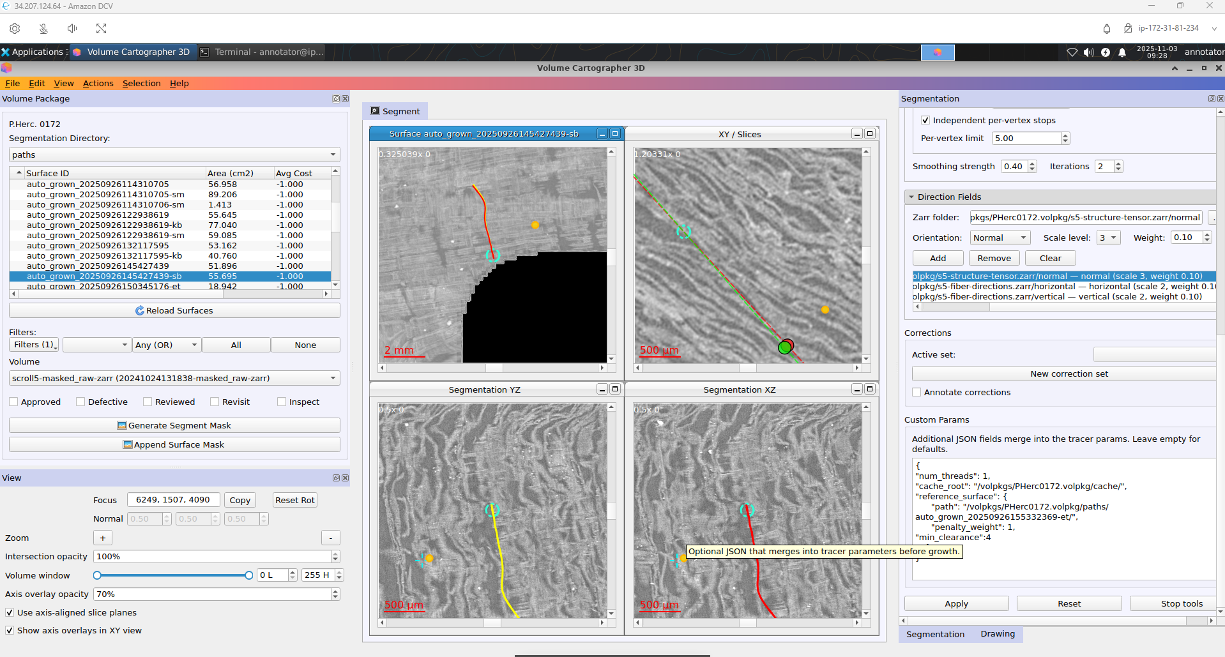

Updated instance (optional). Current instances are not working; instead, use these instances:
- 3.89.90.140
- 52.205.253.9

Point Collection Update:
The team learned to use point collections more effectively in VC3D for refining surface growth and correcting small alignment issues. By pressing T to start a new set of points, placing them around the target area, setting the step to 1, and clicking Grow, the tool helps smooth and accurately connect surfaces. This method improves precision during gap filling and reduces manual corrections.

Updates:
Later, they pushed an update so we can now see other segments in VC3D.
Use the “inspect” label in the segmentation directory, then filter by inspect to show selected neighbouring segments.
The volpkg now takes a bit longer to load, and some operations may feel slightly slower. However, the extra context is very helpful—especially for sheet-switch detection and checking alignment between wraps. Additionally, note that if “Show hover marker” is enabled, A/D push–pull won’t work. Increasing the “step” value (e.g., to 10) can also make push/pull more responsive.
November-17 -Update
We received the new instance -54.81.20.14

Refined to Older VC3D

1. Open a new terminal tab and navigate to villa
- cd /home/annotator/villa
2. Pull the latest repository updates
- git pull
3. Fetch earlier commit
- git fetch origin F82a0a743299b9a0e9514f4d3b22c6d4d21a1503
- git checkout F82a0a743299b9a0e9514f4d3b22c6d4d21a1503
Note: list of known stable commits
- F82a0a743299b9a0e9514f4d3b22c6d4d21a1503
  - After overlap was first added
- 043336d431f5f2dca9e22b5e49e8968cb273953e
  - Before zarr size checks
- ce67f5044fd11baaf2eabfec37dc6facfcdc21c7
  - Dec 4, 2025. Current version, for now, hoping it is stable
3. Change directory to volume-cartographer
- cd volume-cartographer
4. Rebuild:
- rm -rf build && mkdir build && cd build
cmake .. \
-GNinja \
-DCMAKE_BUILD_TYPE=Release \
-DVC_USE_CUDA_SPARSE=1
- ninja
HOW TO UNDO FETCHING AN OLD COMMIT:
1. Open a new terminal tab and navigate to villa
- cd /home/annotator/villa
2. Switch to main branch
- git switch main
3. Pull the latest repository updates
- git pull
4. Change directory to volume-cartographer
- cd volume-cartographer
5. Rebuild:
- rm -rf build && mkdir build && cd build
cmake .. \
-GNinja \
-DCMAKE_BUILD_TYPE=Release \
-DVC_USE_CUDA_SPARSE=1
- ninja(In Volume Cartographer 3D,
Ninja is the build tool used to compile the VC3D source code.)
Updated VC3D
1. Open a new terminal tab and navigate to villa
- cd /home/annotator/villa
2. Pull the latest repository updates
- git pull
3. Change directory to volume-cartographer
- cd volume-cartographer
4. Rebuild:
- rm -rf build && mkdir build && cd build
cmake .. \
-GNinja \
-DCMAKE_BUILD_TYPE=Release \
-DVC_USE_CUDA_SPARSE=1
- ninja
Notes:
- When pasting the command, you may get a warning about “Potentially Unsafe Paste”. Just proceed by choosing “Paste”
- There are often some warnings printed at the end of the building, like:
“In function '_Construct', …”, “119 | …” “In member function 'allocate',” “ 151 | …”.
This is fine.

5. Return to the terminal tab where you launched vc3d. If the current directory is still ~/villa/volume-cartographer/build/bin, then get out of build, then return to bin:
- cd ..
- cd ..
- cd build/bin
Then you should be ready to run the latest VC3D!
- ./VC3D

TROUBLESHOOTING:
If “git pull” results in a complaint about “dubious ownership”, add the suggested exception
- git config --global --add safe.directory /home/annotator/villa
- git pull
If “git pull” gives you “Permission denied”, contact David
How to check if you have the latest, most up-to-date version of Villa
- cd /home/annotator/villa
- git rev-parse --short HEAD
- Check if output matches latest commit: https://github.com/ScrollPrize/villa/commits/main/

After a reboot
There will probably be a prompt about colour settings:
- Enter the password “dcv” a few times in the prompt box
Open a terminal and navigate to the directories:
- Search for the correct terminal: xfce4-terminal
- cd /home/annotator/villa/volume-cartographer/build/bin
- ulimit -Sn 750000
- ./VC3D
Set up syncing commands:
- Open a new tab in the terminal
- cd /home/annotator/villa/volume-cartographer/scripts
Sync if necessary:
- Ensure all paths are in “paths” and not in “paths_hide”
- python3 vc_sync.py sync /volpkgs/PHerc0172.volpkg/paths/
- Move anything you want to hide back to “paths_hide”

Weekly Update
- Known bugs:
  - Inpaint is broken, doesn't fill the holes and outputs a completely scattered, broken mesh.
  - Show surface overlap doesn't seem to be working for multiwrap segments; nothing gets highlighted even though it should.
  - The append layer to mask feature isn't scaled well.
  - The latest versions that display every segment can't handle 1000s of patches in the paths directory. As a result, we have to revert to an old commit for seeding volumes. Maybe default to a certain mode above a certain number of active segments?
  - Expand/contract “copy in/out” to account for the change in circumference.
  - "Render Settings" needs to be added to the View menu.
  - “Delete segment” crashes vc3d now.
  - Troubleshoot/bug fix area calculation and re-calculation.
  - New bugs:
    - Transient focus point and Focus
    - Push-pull normals
    - Changing colour bug - set to specific colour
- Common problems:
  - Copy in / Copy out sometimes does the opposite
  - Growing only part of the side
  - “Show hover marker” is broken, disables push/pull
- Process for unrolling these scrolls:
  - If we can trace well, get a good trace
  - From the end of the trace, create “perfect” wrap
  - Push outward over and over
  - Use overlap overlay (once fixed)
  - Use branching approved areas to verify + correct
Render Settings Matter: rendering can reveal:
- missed growth regions
- overlapping sheets
- surface breaks
- ink that was completely invisible earlier
- noise that should be cropped
Good rendering = accurate segmentation.
VC3D – Seeding Process:
- Seeding creates initial seed patches used for growth, segmentation, and path detection.
- VC3D scans the volume to identify fibre continuity, local structures, and folds.
- Generates a paths folder containing all seed patches and fibre path data.
- Must be run before creating new working segments for accurate auto-growth.
- No other operations (grow, inspect, annotate, adjust) can be done while seeding runs.
- Seeding uses heavy GPU/CPU, so VC3D may appear frozen—this is normal.
- After seeding completes:
- Rename the current paths folder to archive it.
- Restore your working segment paths (paths_main → paths).
- Ensures the segment’s growth direction and structure detection are correct.
- Needed when creating new regions, new full wraps, or after major layer shifts.
If interrupted, the seeding process should be restarted for clean results.

