📘 Documentation of the Pure JavaScript LLM

🔹 1. Tokenizer
class Tokenizer {
constructor(text) { ... }
encode(words) { ... }
decode(ids) { ... }
}

Purpose:
- Converts text into word IDs (integers).
- Converts IDs back into words.

Variables:
- this.vocab → list of unique words (vocabulary).
- this.word2id → map: word → integer ID.
- this.id2word → map: integer ID → word.

Methods:
- encode(words) → turns an array of words into array of IDs.
- decode(ids) → turns array of IDs back into words.

🔹 2. Utility Functions
function randn(size) { ... }
function zeros(rows, cols) { ... }
function softmax(arr) { ... }
function crossEntropyLoss(logits, targetId) { ... }

Purpose:
- randn(size) → initializes small random numbers (weights).
- zeros(rows, cols) → creates zero arrays (bias, hidden layers).
- softmax(arr) → converts logits into probabilities.
- crossEntropyLoss(logits, targetId) → computes error between prediction & true word.

🔹 3. Embedding Layer
class Embedding {
constructor(vocabSize, embedDim) { ... }
forward(ids) { ... }
backward(dout) { ... }
}

Purpose:
- Stores word embeddings (like a lookup table).
- Each word → 512-dimensional vector.

Variables:
- this.W → matrix [vocabSize × embedDim] (trainable weights).
- this.ids → stores last used IDs for backprop.

Methods:
- forward(ids) → fetch embedding vectors for words.
- backward(dout) → updates embeddings with gradient.

🔹 4. Multi-Head Attention
class MultiHeadAttention {
constructor(embedDim, numHeads) { ... }
forward(X) { ... }
backward(dout) { ... }
}

Purpose:
- Implements self-attention with 8 heads.
- Each head learns different relationships between words.

Variables:
- this.Wq, Wk, Wv, Wo → weight matrices for Queries, Keys, Values, and output.
- this.numHeads → number of attention heads (8).
- this.headDim → 512 ÷ 8 = 64 dimensions per head.

Methods:
- forward(X):
  - Splits input into heads.
  - Computes Q, K, V.
  - Applies scaled dot-product attention with causal mask.
  - Concatenates head outputs.
- backward(dout) → updates Q, K, V, and output weights.

🔹 5. Feed Forward Network (FFN)
class FeedForward {
constructor(embedDim, hiddenDim) { ... }
forward(X) { ... }
backward(dout) { ... }
}

Purpose:
- Applies two linear layers with ReLU in between.
- Expands dimension (2048) then projects back to 512.

Variables:
- this.W1 → first layer weights [512 × 2048].
- this.b1 → first bias.
- this.W2 → second layer weights [2048 × 512].
- this.b2 → second bias.

🔹 6. Transformer Block
class TransformerBlock {
constructor(embedDim, numHeads, ffnHidden) { ... }
forward(X) { ... }
backward(dout) { ... }
}

Purpose:
- One block = LayerNorm → Multi-Head Attention → Residual → Feed Forward → Residual.
- This is the building block of GPT.

🔹 7. Transformer Model
class TransformerModel {
constructor(vocabSize, embedDim, numHeads, ffnHidden) { ... }
forward(ids) { ... }
backward(dlogits) { ... }
generate(prompt, maxLen) { ... }
}

Purpose:
- Full model combining all layers.
- Can train on sequences & generate text.

Variables:
- this.embedding → embedding layer.
- this.blocks → stack of Transformer blocks.
- this.Wo → final projection to vocab size.
- this.bo → output bias.

Methods:
- forward(ids) → runs embedding → transformer → softmax logits.
- backward(dlogits) → runs gradients through blocks & embeddings.
- generate(prompt, maxLen):
  - Takes starting words.
  - Predicts one word at a time.
  - Appends it to sequence.

🔹 8. Training Loop
for (let step = 0; step < steps; step++) {
...
let loss = crossEntropyLoss(logits, targetId);
model.backward(dlogits);
optimizer.step();
}

Purpose:
- Repeatedly shows the model input → target pairs.
- Uses cross-entropy loss to measure prediction quality.
- Calls backward() to compute gradients.
- Uses optimizer (Adam) to update weights.

🔹 9. Optimizer (Adam)
class Adam {
constructor(parameters) { ... }
step() { ... }
}

Purpose:
- Adjusts weights using gradients.
- Adam = momentum + adaptive learning rates.

🔹 10. Saving & Loading Weights
fs.writeFileSync("weights.json", JSON.stringify(weights));
- After training, saves all parameters to weights.json.
- On restart, loads the file so training continues.

📌 Summary
- Tokenizer → words ↔ IDs
- Embedding → maps IDs → 512d vectors
- Attention (8 heads) → learns context between words
- FFN → non-linear transformation (size 2048)
- Block → normalization + residual + attention + FFN
- Model → stacks blocks + predicts next word
- Loss → cross-entropy
- Optimizer → Adam
- Weights → stored in JSON for fine-tuning
- Generate → creates text like ChatGPT

Here’s a full documentation-style breakdown of the code, step by step, with that diagram as reference 👆.

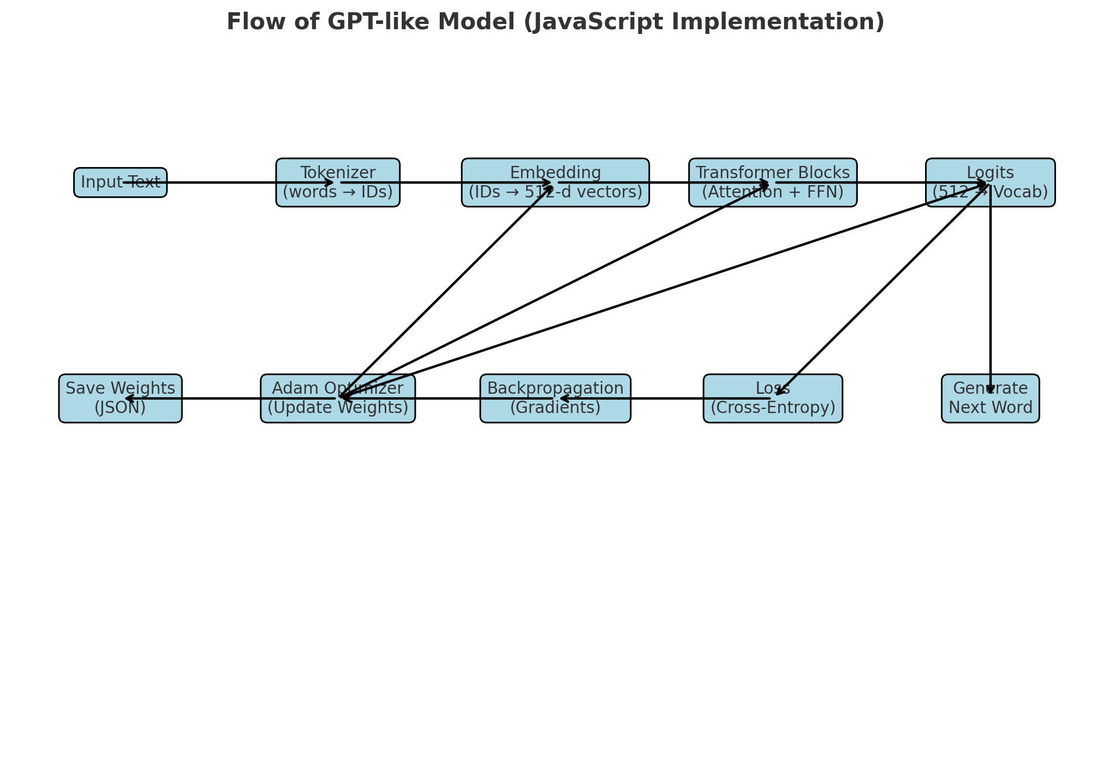

📘 Documentation for Pure JavaScript LLM (8-Head Transformer, Embedding=512)

🔹 1. Dataset & Tokenization
- corpusText: The input dataset (loaded from .txt file).
- Tokenizer class:
  - Splits text into words (not characters).
  - Builds word → id and id → word mappings.
  - Converts sentences into numerical IDs for training.

🔹 2. Embedding Layer
- Purpose: Converts each token ID into a 512-dimensional vector.
- Embedding class:
  - weights: A [vocabSize × 512] matrix.
  - forward(ids): Looks up embeddings for tokens.
  - backward(dLoss): Updates embeddings during backpropagation.

🔹 3. Multi-Head Self-Attention (8 heads)
- AttentionHead class:
  - Projects embeddings into Query (Q), Key (K), Value (V) matrices.
  - Computes:
Attention(Q,K,V) = softmax(QKᵀ / √d) V
  - Each head learns different “relationships” between words.
- MultiHeadAttention class:
  - Combines 8 attention heads.
  - Concatenates outputs, applies a linear projection.

🔹 4. Feed Forward Network (FFN)
- FeedForward class:
  - 2-layer MLP inside the Transformer.
  - Expands dimension: 512 → 2048 → 512.
  - Adds non-linearity (ReLU).
  - Learns transformations after attention.

🔹 5. Transformer Block
- TransformerBlock class:
  - LayerNorm + Residual connections:
    - x → Attention → Add + Norm → FFN → Add + Norm
  - Captures contextual meaning of words.

🔹 6. Final Projection (Output Layer)
- Logits layer:
  - Maps from hidden size 512 → vocab size.
  - Produces probabilities over all words.

🔹 7. Training Process
- Loss Function:
  - Cross-entropy between predicted word distribution & actual next word.
- Backpropagation:
  - Computes gradients for all parameters (embeddings, attention, FFN, projection).
- Optimizer:
  - Adam Optimizer adjusts weights using gradients.
- Saving:
  - Updates stored in weights.json after each training run.

🔹 8. Text Generation
- Greedy / Sampling:
  - Start with a prompt (["hello", "world"]).
  - Feed into model → predict next word.
  - Append prediction → repeat until desired length.
- Result: AI generates sentences like GPT.

🔑 Key Variables
Variable | Meaning
embeddingSize=512 | Vector size for each word
numHeads=8 | Number of attention heads
ffnHidden=2048 | Hidden size of FFN (4× embedding)
weights.json | Stores all learned weights & biases
vocab | Word-to-ID mapping
loss | Cross-entropy loss for training
gradients | Backpropagation updates

📌 In short:
- Tokenizer turns words into numbers.
- Embedding turns numbers into vectors.
- Attention + FFN process context.
- Logits predict next word.
- Backpropagation + Adam train the model.
- Weights saved in JSON for fine-tuning later.

