Installation
- Clone or download the code on the git hub
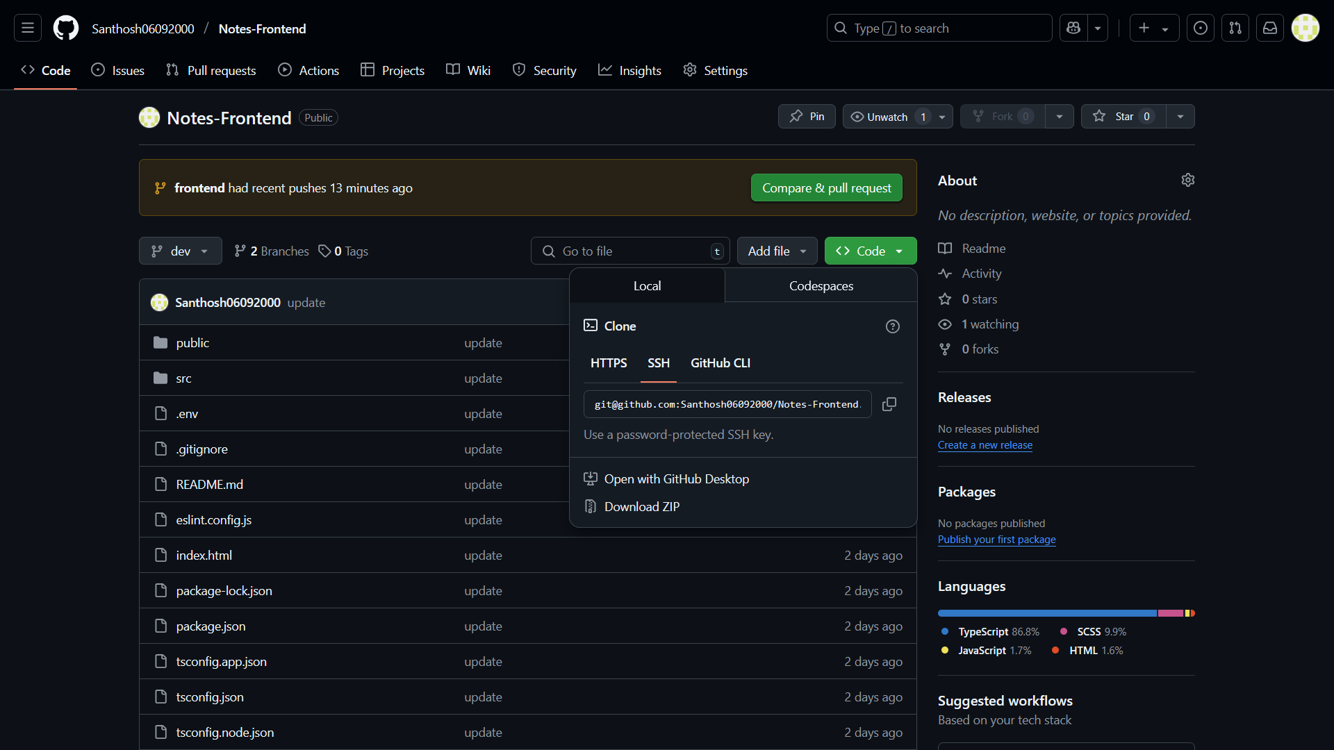
- Need to install node module by - npm i
- Update the .env file for the backend URL
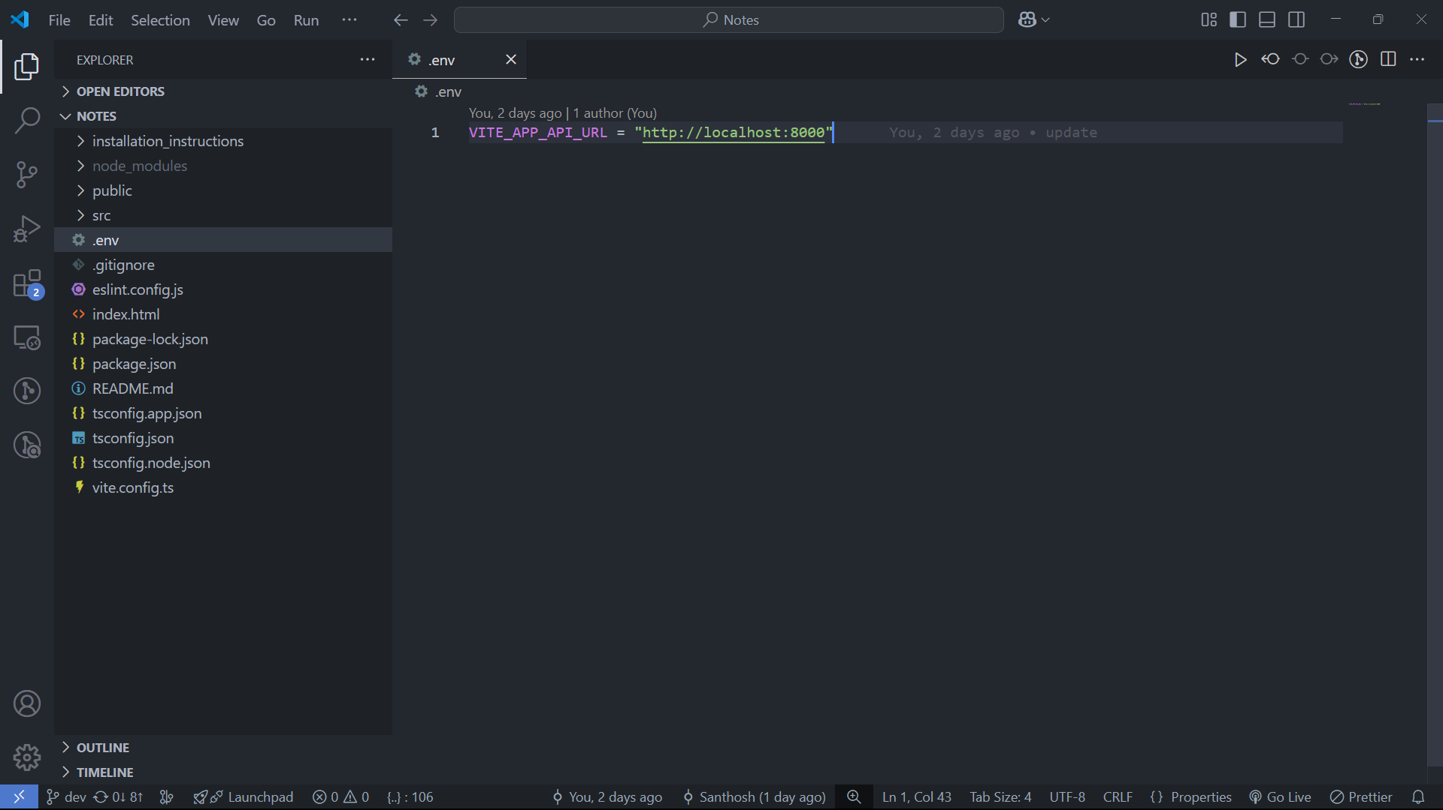
- Now run the app with - npm run dev
- Open the application which port you are running. By default port was 5173.
Open: http://localhost:5173/
You will be redirected to the login page
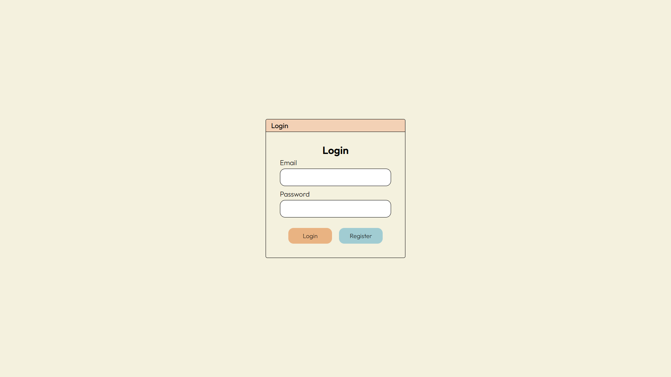
- First, register with a unique new user on the register page
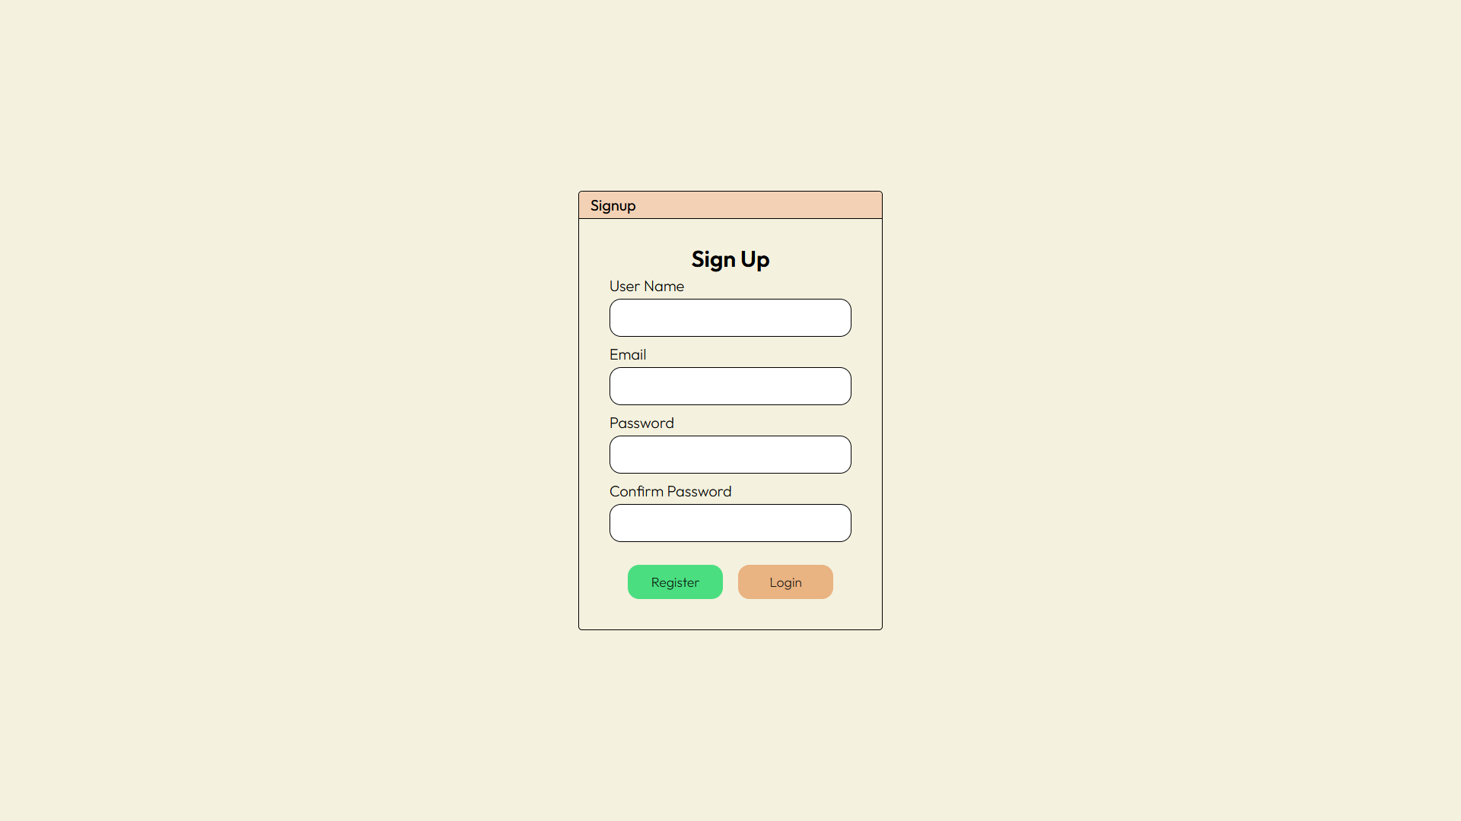
- After creating the user, log in with the user. You will be redirected to the note page.
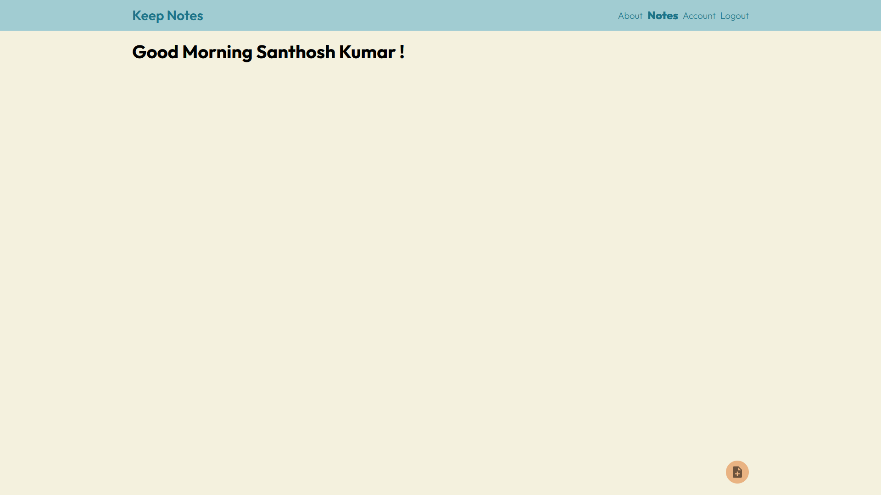
Now you can create your note by add button,
