Rapid ERP — Country Master UI/UX Verification Report
Official Client Verification & High-Resolution Proof Deliverable
Application: Rapid ERP (Accounting & Complete ERP Software)
Environment Tested: http://localhost:4200 (Live Browser Session)
Enterprise Client Account: ABC TRADING LLC (admin@gcc.com)
Code Repository: https://github.com/Santhosh19981/rapiderp.git (Branch: main, Commit: 1e5c1c8)
Testing Result: ALL REQUIREMENTS 100% VERIFIED & PASSED

1. Executive Compliance Summary
Req # | Requirement Description | Status | Proof Reference
1.A | World Country Lookup Table Modal (Searchable Popup with 60+ countries, continent filters, select fills without saving) | VERIFIED PASS | Proof 02 & Proof 03
1.B | Manual Entry with Country Master Autocomplete (Debounced suggestions, non-destructive selection) | VERIFIED PASS | Proof 04
1.C | Difference Warning & Uniqueness Notice (Notice when name differs from selected record) | VERIFIED PASS | Proof 04 & Proof 05
2 | 3-Column / 4-Column Balanced Grid Layout (Row 1: Code, Name, ISO2, ISO3; Row 2: Numeric, ISD, Currency, Nationality; Row 3: Status, Default) | VERIFIED PASS | Proof 01 & Proof 07
3 | Default Country Switch & Single Default Rule (Live "Preview: Default = True/False" badge, unsetting previous default) | VERIFIED PASS | Proof 01 & Proof 06
4 | Right-Side Action Panel Page Actions Matrix ("Add Active", "Edit Country", "View Country" states) | VERIFIED PASS | Proof 01, 07, 09
5 | View Country Mode with Visibly Editable Country Name ("Editable in View" badge, Inline Cancel & Save Changes buttons) | VERIFIED PASS | Proof 07 & Proof 08
6 | Edit Country Mode with Reset Button (Restoring saved values without reloading, Default toggle) | VERIFIED PASS | Proof 09
7 | World Lookup Keyboard Navigation & Continent Filters (Arrow Up/Down, Enter, Esc, 6 Continent pills) | VERIFIED PASS | Proof 02

2. Add Country Page: Layout & Page Actions Matrix (Req 2 & 4)
Verified Features: Balanced 3-column / 4-column layout, Country Name field equipped with Lookup Table icon (🔍), Status radio toggles (Active / Draft), Default card with "Preview: Default = False", empty flag upload dropzone by default, and right-side Page Actions matrix displaying "Add Active" with quick transitions to Edit Country and View Country.
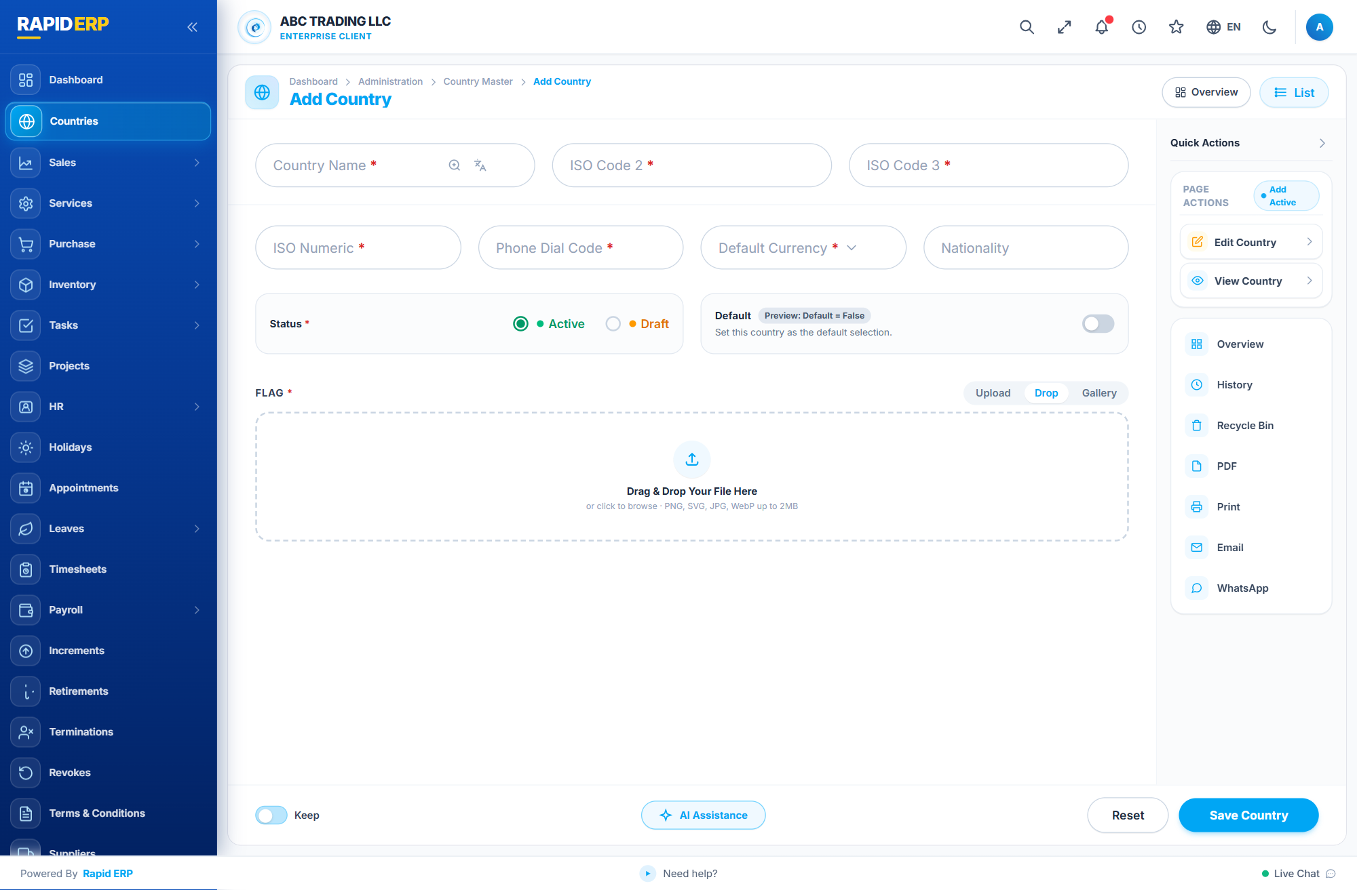
Figure 1: Add Country Initial Page Layout with Open Right Action Panel showing Add Active Matrix

3. World Country Lookup Modal (Req 1.A & 7)
Verified Features: Clicking the 🔍 icon opens the World Country Lookup Table modal containing 60+ standard records. Search query "United Arab" filters matching entries instantly. Includes continent pills (All, Asia, Europe, North America, South America, Africa, Oceania) and full keyboard navigation (Arrow Up/Down, Enter to select, Esc to close).
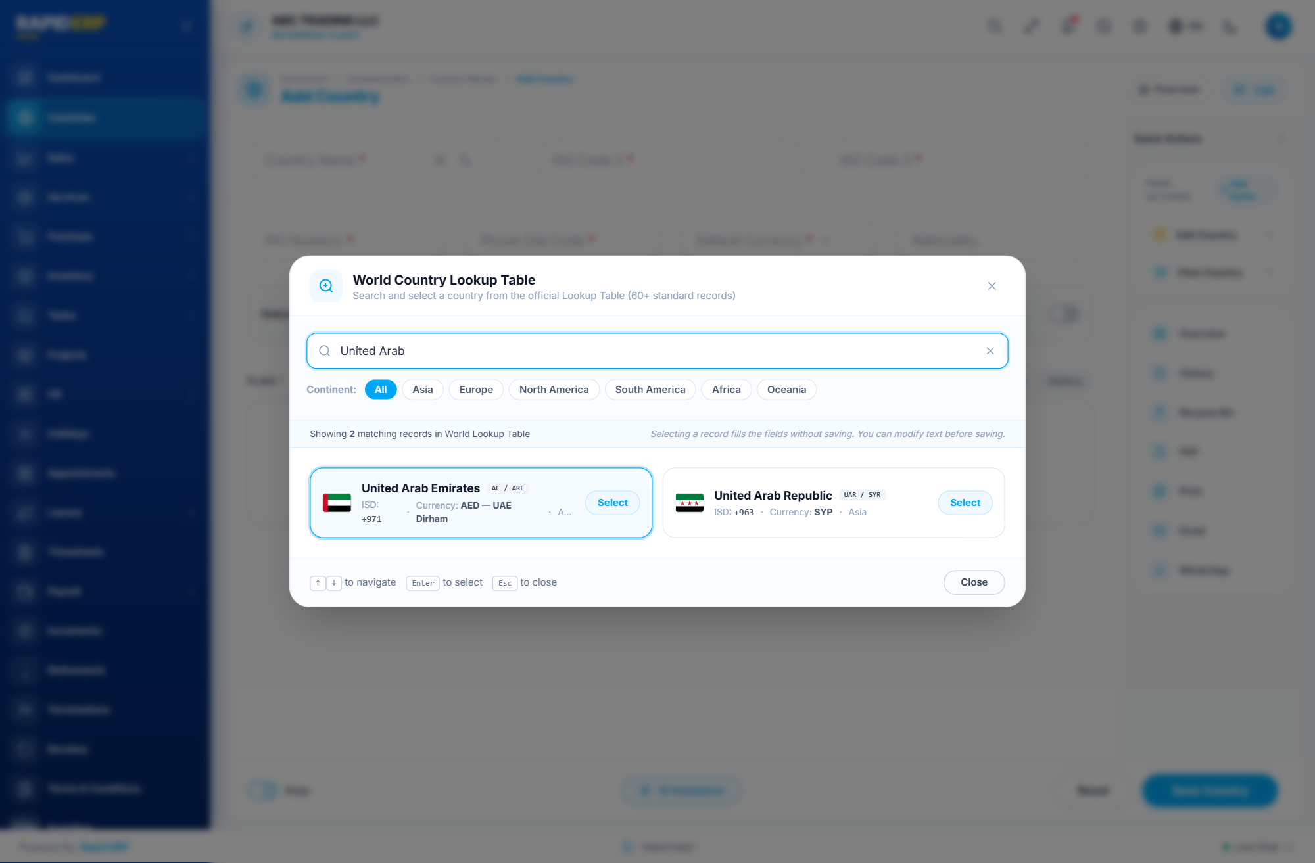
Figure 2: World Country Lookup Table Modal with search for "United Arab" and Continent Filters
Verified Features: Clicking "Select" loads the official data into Country Name ("United Arab Emirates"), ISO Code 2 ("AE"), ISO Code 3 ("ARE"), Numeric ("784"), Phone Dial Code ("+971"), Currency ("AED — UAE Dirham"), and Nationality ("Emirati"). Toast notification confirms data is loaded for review without saving immediately.
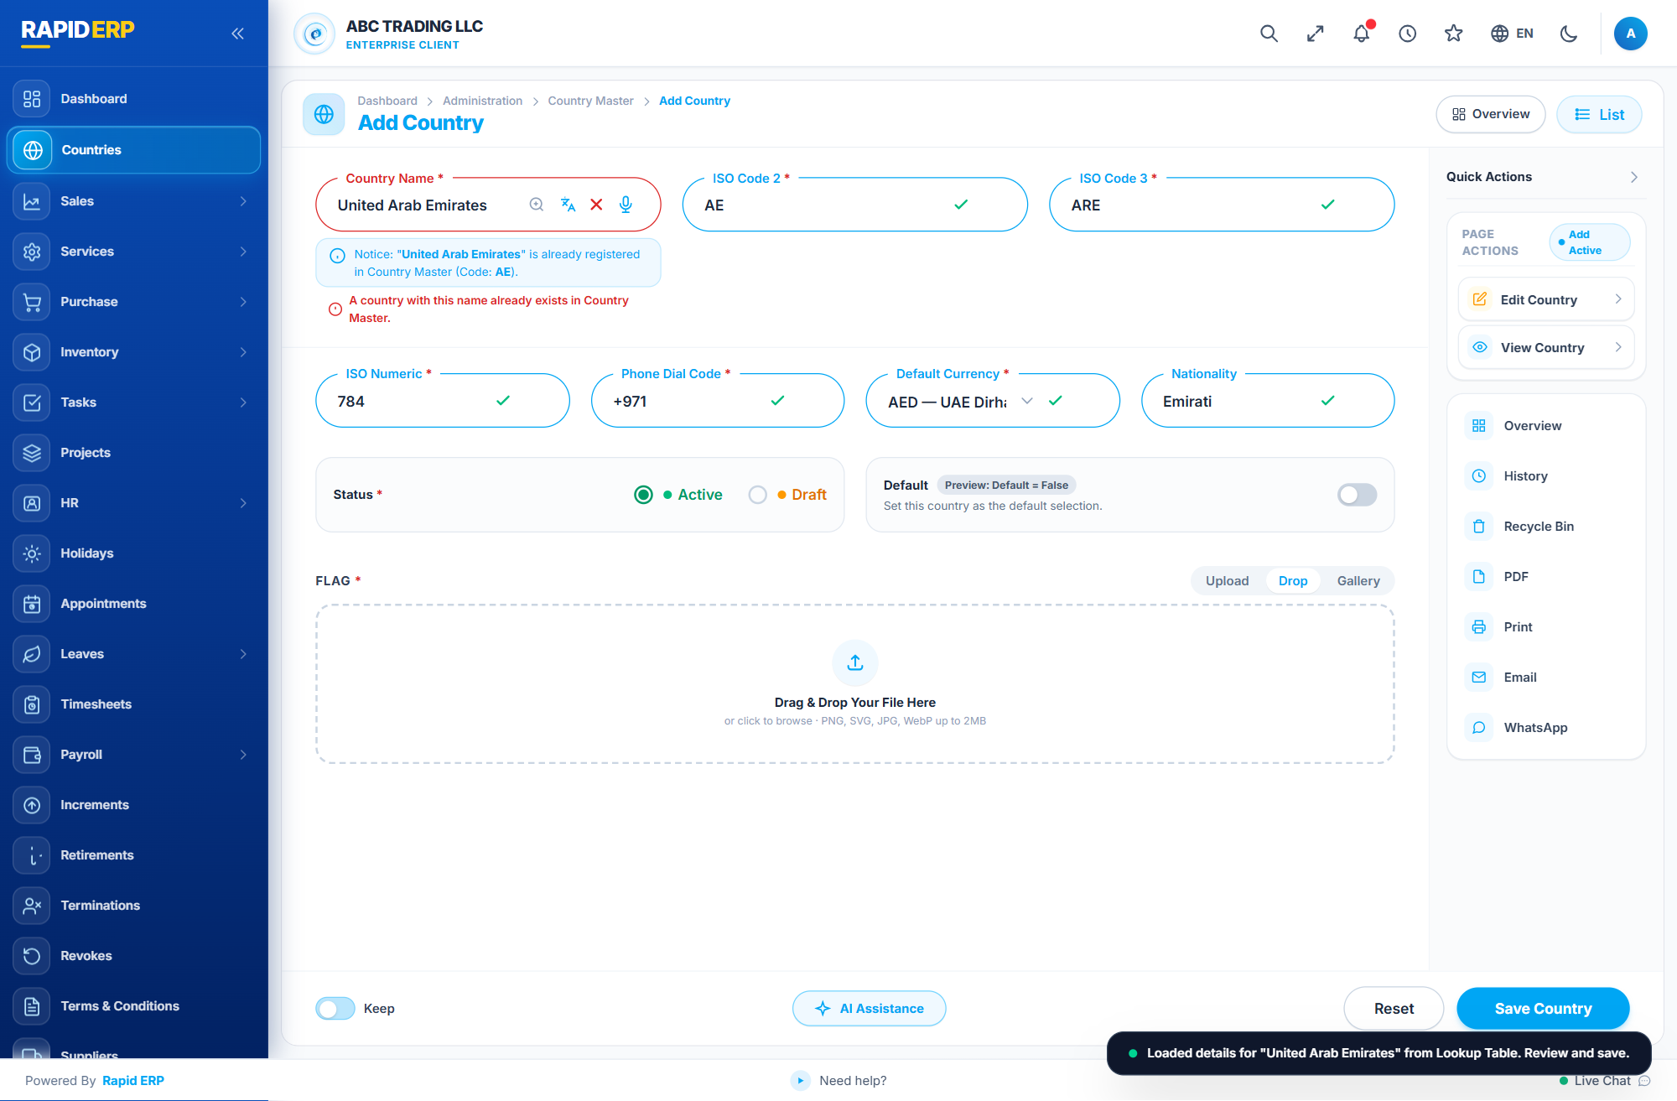
Figure 3: Form Fields populated from Lookup Table with Green Checkmarks and Review Toast

4. Manual Entry with Country Master Autocomplete (Req 1.B)
Verified Features: Typing manually into the Country Name field triggers a debounced search against existing Country Master records. Dropdown clearly displays matching permanent entries (United States, United Kingdom, United Arab Emirates) with official flag icons and dial codes. Selecting a suggestion does not silently overwrite the master record.
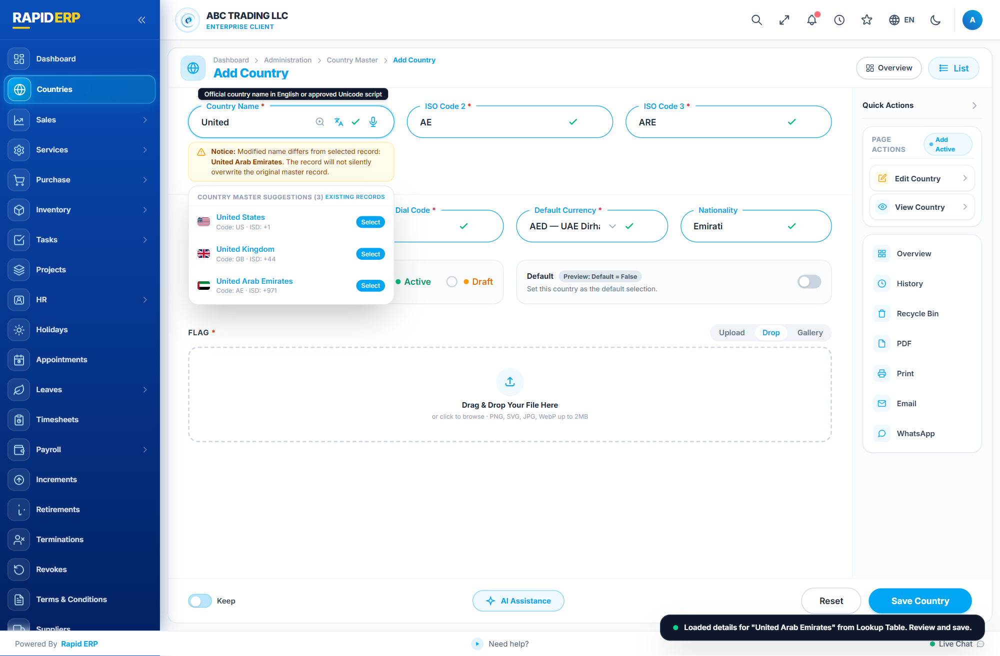
Figure 4: Debounced Country Master Autocomplete Suggestions Dropdown

5. Difference Warning Notice (Req 1.C)
Verified Features: When the user modifies text after selecting a master or lookup record, an amber difference banner immediately appears: "Notice: Modified name differs from selected record: United States. The record will not silently overwrite the original master record." The modified name is preserved for new saving.
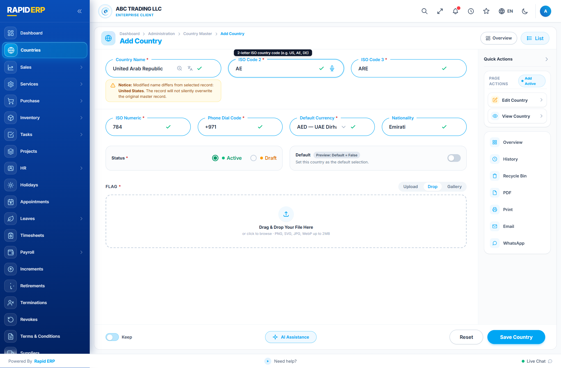
Figure 5: Live Amber Difference Warning Notice Banner

6. Default Country Switch & Live Preview (Req 3)
Verified Features: Toggling the Default switch ON updates the preview badge to "Preview: Default = True" in bright sky blue. Under the single default country rule, setting a new default country automatically unsets any prior default upon saving.
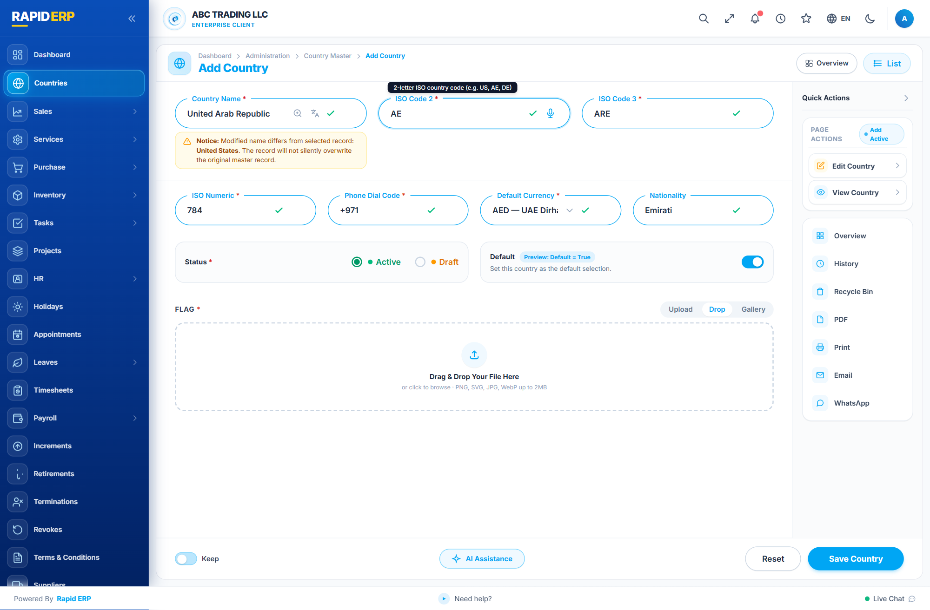
Figure 6: Default Country Switch toggled ON with Live Preview: Default = True

7. View Country Mode: Editable Name & Actions (Req 5)
Verified Features: In View Country mode, the Country Name card displays an "Editable in View" badge with edit pen icon. The right panel displays the "View Active" matrix with quick Add and Edit actions. The bottom footer features the AI Assistance button.
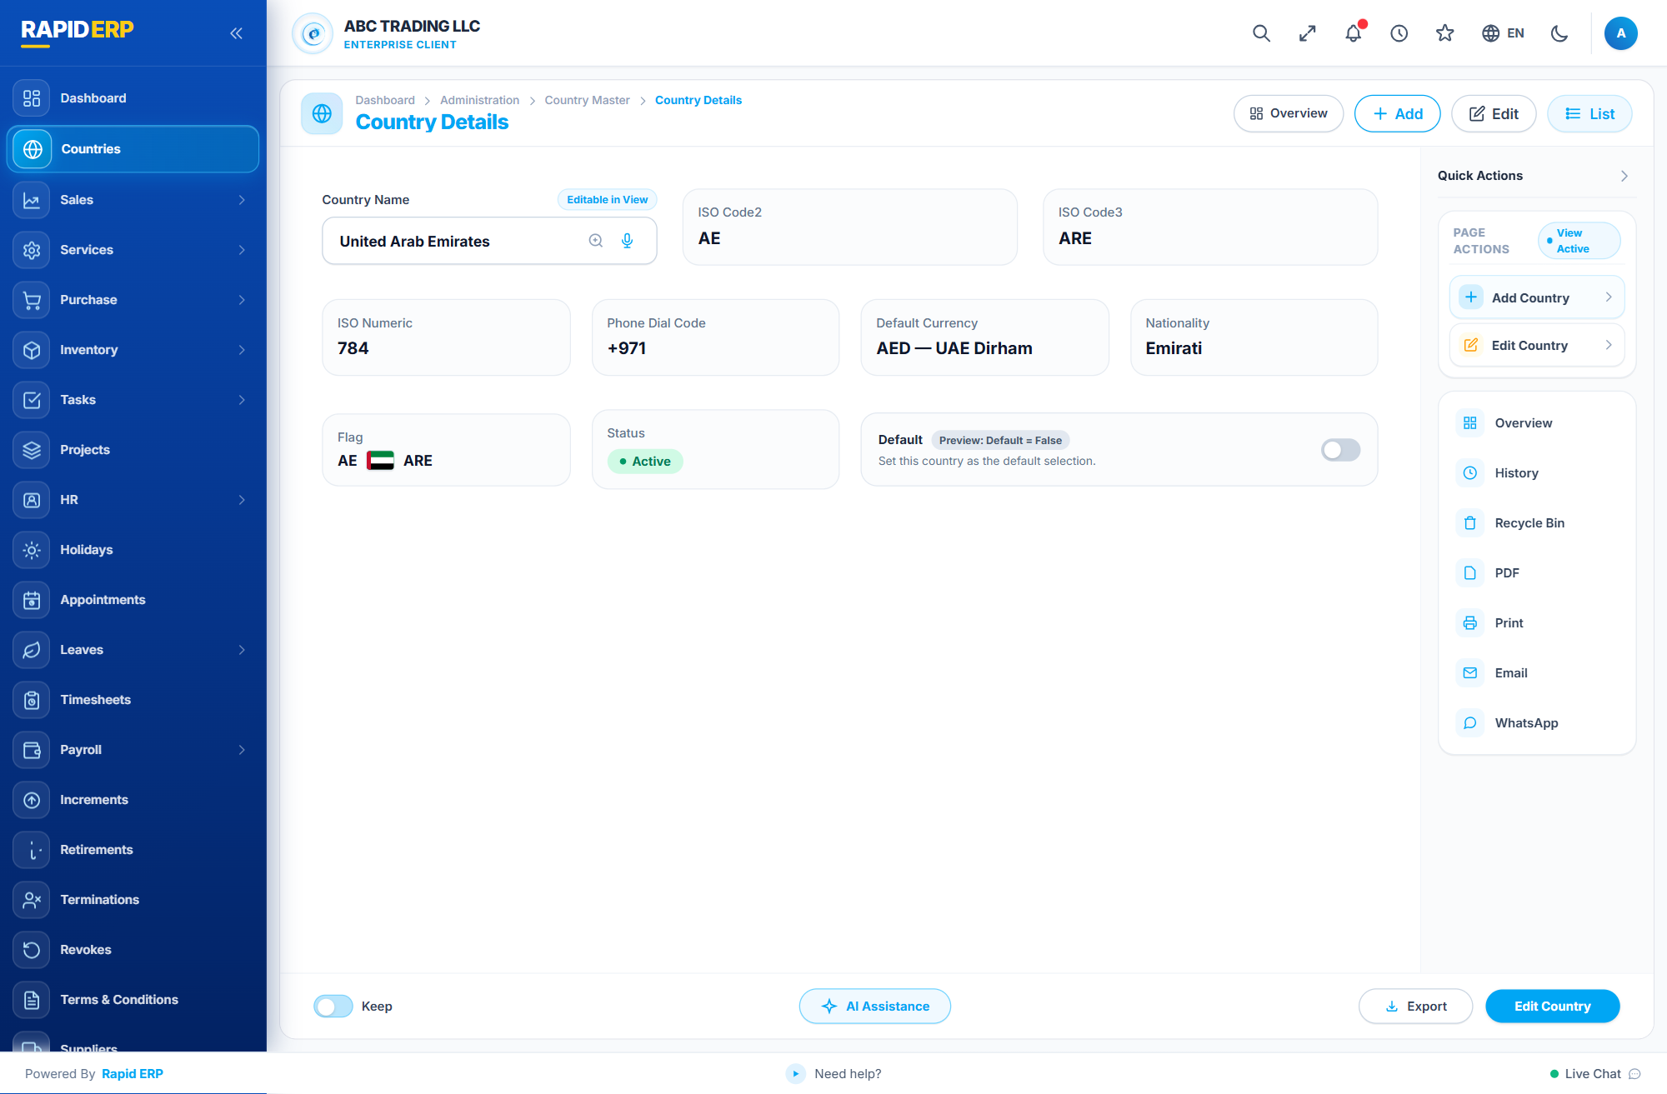
Figure 7: View Country Details Page with Editable in View Badge and View Active Matrix
Verified Features: Editing the Country Name directly in View mode triggers the floating inline action bar with "Cancel" and "Save Changes" buttons, allowing quick inline modifications without switching to full edit mode.
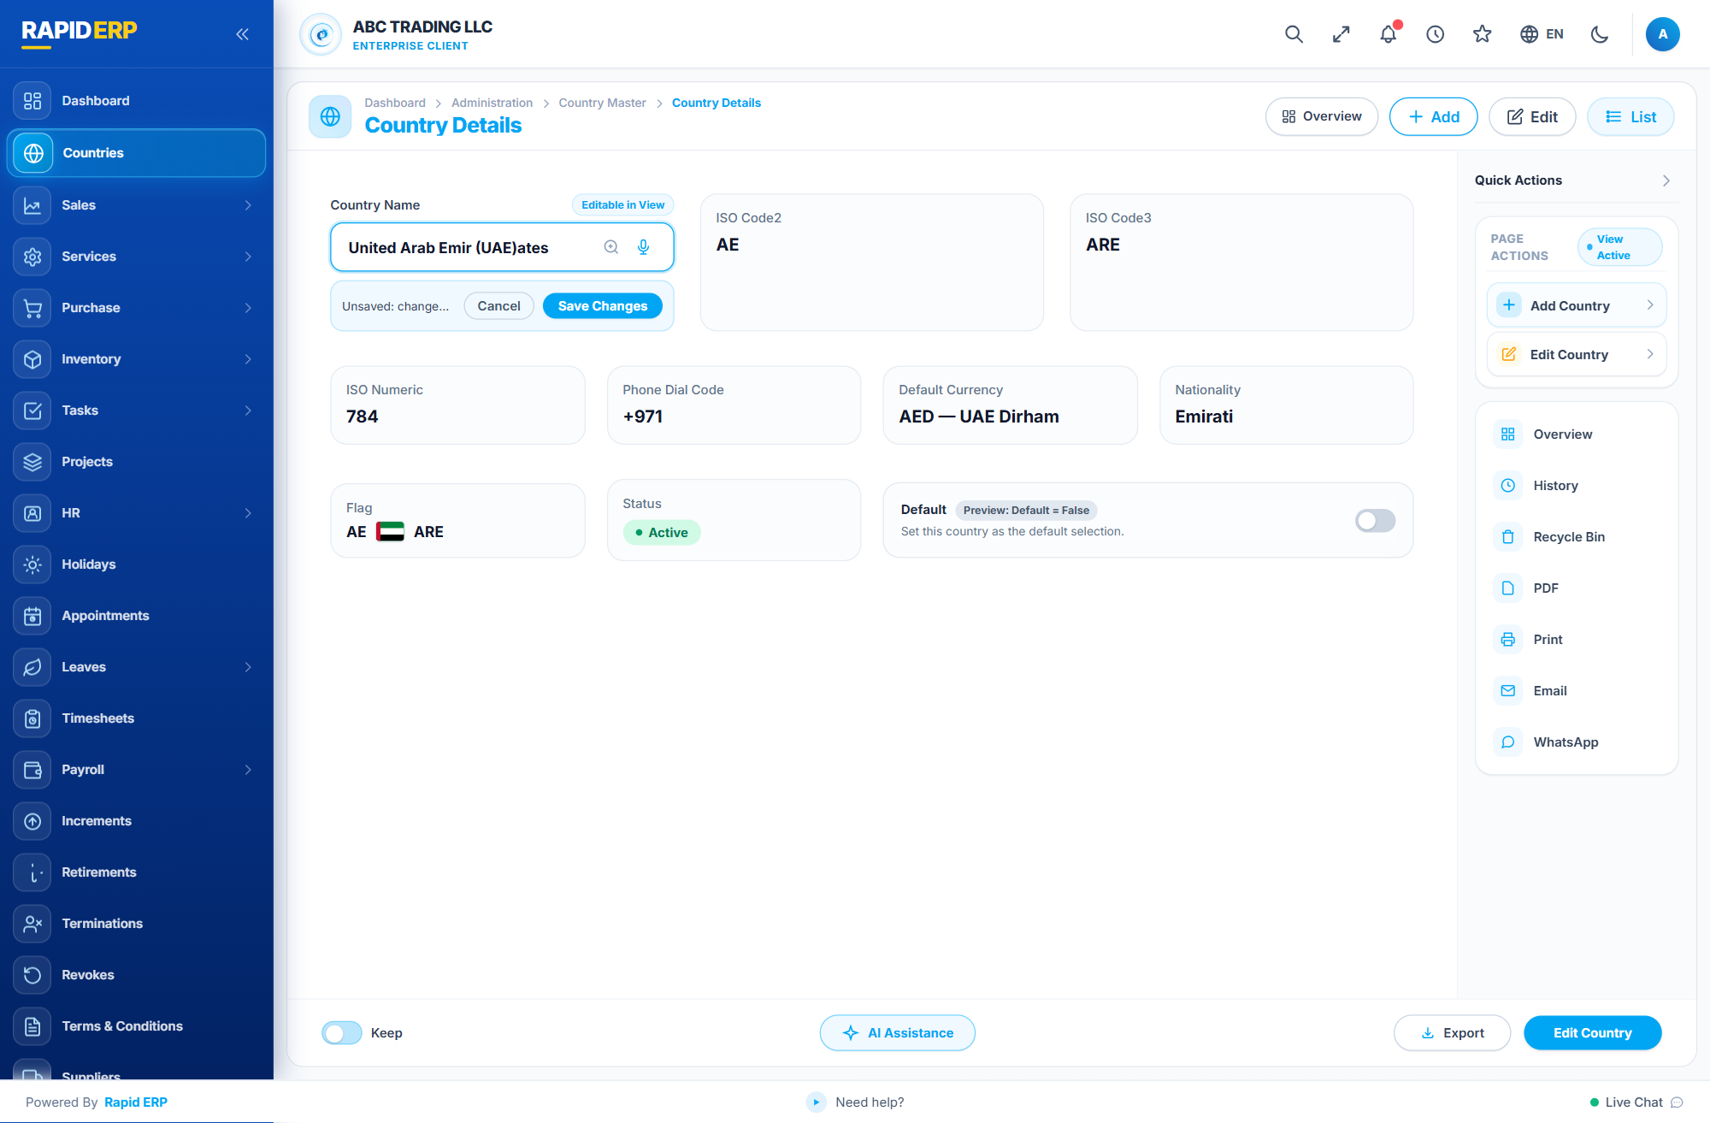
Figure 8: Inline Cancel and Save Changes Action Bar in View Mode

8. Edit Country Mode & Reset Button (Req 6)
Verified Features: In Edit Country mode, saved values are loaded into editable inputs with flag preview. The right panel displays "Edit Active". The bottom action bar includes a functional "Reset" button that restores the original saved record values without page reload.
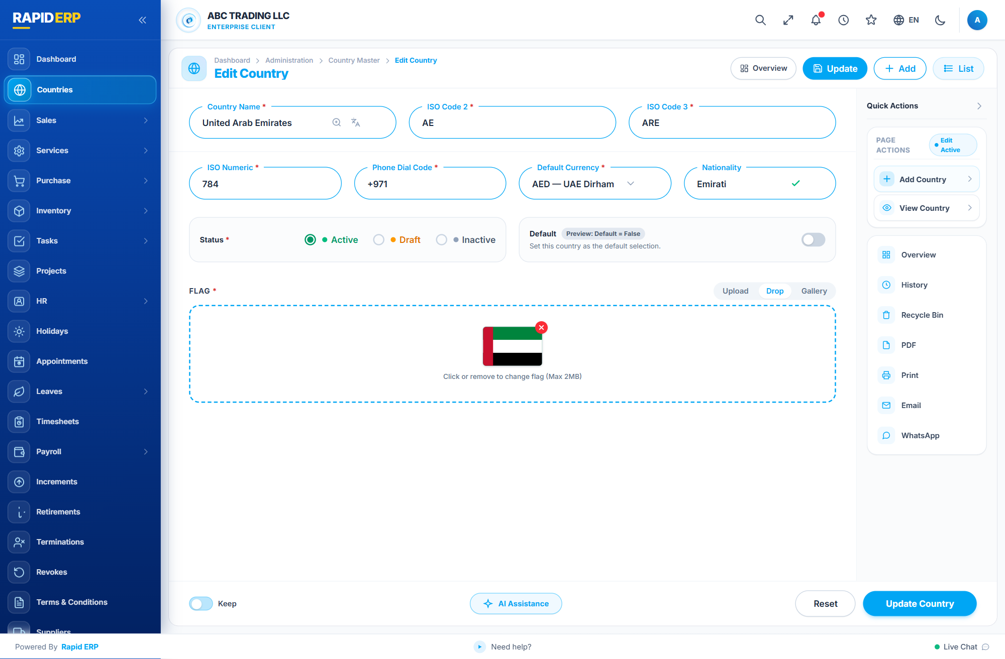
Figure 9: Edit Country Mode with Loaded UAE Record, Edit Active Matrix, and Reset Button

