EXPERIMENT 1: DEVOPS PRINCIPLES AND PRACTICES
AIM: To understand DevOps: Principles, Practices, and DevOps Engineer Role and Responsibilities.
Objectives:
• Understand core DevOps concepts such as collaboration, automation, CI/CD, and monitoring.
• Identify the responsibilities of a DevOps Engineer in the modern software development lifecycle. • Gain clarity on the DevOps lifecycle and the tools used at each stage.

1. Introduction to DevOps
DevOps is a modern software development approach that combines Software Development (Dev) and IT Operations (Ops) to work together throughout the software development lifecycle. It promotes collaboration, automation, and continuous improvement to develop, test, deploy, and maintain applications more efficiently. By reducing communication gaps and automating repetitive tasks, DevOps enables organizations to deliver high-quality software faster and more reliably. It is not just a set of tools, but a culture and a collection of practices that improve teamwork and streamline software delivery.
Example: When a developer fixes a bug in an online shopping application, DevOps tools automatically build, test, and deploy the updated application to the server. This allows customers to use the fixed version quickly without significant downtime.

2. Core Principles of DevOps
- Collaboration and Communication – breaking down the traditional wall between developers, testers, and operations staff so that all stakeholders share responsibility for the product from design through production.
- Automation – replacing manual, repetitive, and error-prone tasks (builds, testing, provisioning, deployment) with scripted, repeatable pipelines.
- Continuous Integration and Continuous Delivery (CI/CD) – integrating code changes frequently and keeping the software in a releasable state at all times.
- Infrastructure as Code (IaC) – managing and provisioning servers, networks, and environments through machine-readable configuration files instead of manual processes.
- Continuous Monitoring and Feedback – instrumenting applications and infrastructure so issues are detected early and feedback loops from production inform future development.
- Shared Ownership and Accountability – the team that builds a feature also supports it in production (“you build it, you run it”).
- Iterative and Incremental Improvement – delivering small, frequent changes rather than large infrequent releases, reducing risk per deployment.

3. Key DevOps Practices

3.1 Continuous Integration (CI)
Developers merge code changes into a shared repository frequently, often several times a day. Each merge triggers an automated build and test sequence, catching integration issues early rather than at the end of a release cycle.

3.2 Continuous Delivery / Deployment (CD)
Continuous Delivery ensures that every change that passes automated tests is automatically prepared for a release to production, while Continuous Deployment goes a step further and releases every validated change to production automatically, without manual approval gates.

3.3 Infrastructure as Code (IaC)
Tools such as Terraform, AWS CloudFormation, and Ansible allow infrastructure to be defined declaratively in version-controlled files, making environments reproducible, auditable, and easy to roll back.

3.4 Configuration Management
Tools like Ansible, Chef, and Puppet keep server configurations consistent across development, staging, and production environments, eliminating the “it worked on my machine” problem.

3.5 Continuous Monitoring and Logging
Platforms such as Prometheus, Grafana, and the ELK stack (Elasticsearch, Logstash, Kibana) provide real-time visibility into application health, performance, and user behaviour, closing the feedback loop back to development.

3.6 Containerization and Orchestration
Docker packages applications with their dependencies into portable containers, while Kubernetes automates the deployment, scaling, and management of those containers across clusters of machines.

3.7 Microservices Architecture
Applications are decomposed into small, independently deployable services, allowing teams to develop, test, and release components without impacting the entire system.

4. DevOps Lifecycle
The DevOps lifecycle is often visualised as an infinite loop of continuous phases, reflecting the fact that operations feed back into planning rather than the process ending at deployment.
Phase | What happens
Plan | Requirements, backlog, and sprint planning using Agile/Kanban boards (e.g., Jira).
Code | Developers write code, following version-control workflows and code review.
Build | Source code is compiled/packaged automatically via a build tool (Maven, Gradle, npm).
Test | Automated unit, integration, and regression tests validate the build before release.
Release | The validated build is versioned and staged for deployment.
Deploy | The release is pushed to staging/production using CI/CD pipelines and IaC.
Operate | The application runs in production; infrastructure is managed and scaled as needed.
Monitor | Logs, metrics, and alerts are analysed to feed improvements back into planning.

5. Roles and Responsibilities of a DevOps Engineer
A DevOps Engineer acts as the bridge between software development and IT operations, bringing automation, tooling, and process discipline to the entire software delivery lifecycle. Core responsibilities typically include:
- CI/CD Pipeline Management – designing, building, and maintaining automated build, test, and deployment pipelines (e.g., Jenkins, GitLab CI, GitHub Actions, Azure DevOps).
- Infrastructure Provisioning – writing and maintaining Infrastructure-as-Code scripts to provision cloud or on-premises resources reliably and repeatably.
- Version Control Administration – managing repositories, branching strategies, access permissions, and code review workflows.
- Containerization and Orchestration – packaging applications into containers and managing their deployment through orchestrators such as Kubernetes.
- Monitoring and Incident Response – setting up observability tooling, defining alerts, and participating in on-call rotations to resolve production incidents quickly.
- Security Integration (DevSecOps) – embedding automated security scanning and compliance checks directly into the pipeline rather than treating security as a final gate.
- Collaboration – working closely with developers, QA engineers, system administrators, and product owners to align delivery speed with quality and stability.
- Performance Optimisation – tuning build times, deployment speed, and infrastructure cost/efficiency on an ongoing basis.

6. Skills Required for a DevOps Engineer
- Scripting/programming (Python, Bash, Go)
- Cloud platforms (AWS, Azure, GCP)
- Containerization (Docker, Kubernetes)
- CI/CD tools (Jenkins, GitHub Actions, GitLab CI, Azure Pipelines)
- Configuration management (Ansible, Chef, Puppet)
- Version control (Git and remote repository platforms such as GitHub, GitLab, Bitbucket)
- Monitoring/logging tools (Prometheus, Grafana, ELK stack)
- Strong understanding of Linux/Unix systems and networking fundamentals
- Problem-solving mindset and cross-team communication skills

7. Conclusion
DevOps brings together culture, process, and automation to help organisations deliver software faster, more reliably, and with tighter feedback loops between building and operating a system. Version control — particularly Git, supported by remote repository platforms such as GitHub, GitLab, and Bitbucket — provides the collaborative backbone on which CI/CD pipelines, infrastructure automation, and monitoring are all built. A competent DevOps Engineer combines strong version-control discipline with automation skills across the plan, code, build, test, release, deploy, operate, and monitor stages of the DevOps lifecycle.

EXPERIMENT 2: VERSION CONTROL SYSTEM TOOLS FOR SOURCE CODE MANAGEMENT
AIM: To explore the Version Control System tools for Source Code Management.
Objectives:
• Understand the concepts of VCS: local and remote repositories.
• Learn basic Git commands for repository management.
• Understand how to commit, push, pull, and clone repositories.
Hardware and Software Requirements
• Hardware: Computer with internet connection
• Software:
- Git for Windows o Visual Studio Code (VS Code)
- GitHub account

1. Importance of Version Control
A Version Control System (VCS) records changes made to files over time, allowing specific versions to be recalled later, changes to be compared, and multiple people to collaborate on the same codebase without overwriting one another's work. It is a foundational tool in modern software engineering and DevOps.
- Collaboration – multiple developers can work on the same project simultaneously without conflicts.
- Complete History – every change is recorded with details of who made it, when, and why, providing a full audit trail.
- Backup and Recovery – code is never truly lost; any earlier version can be restored if something breaks.
- Branching and Experimentation – new features or fixes can be developed in isolation without affecting the stable codebase.
- Accountability – changes are traceable to individual contributors, supporting code review and quality control.
- Foundation for CI/CD – commits and merges act as triggers for automated build, test, and deployment pipelines.

2. Types of Version Control
- Local Version Control Systems – a simple local database tracks file changes on a single machine (e.g., RCS). Limited to one user, with no collaboration support.
- Centralized Version Control Systems (CVCS) – a single central server holds all versioned files; clients check out and commit changes to that central place (e.g., SVN, CVS, Perforce). Easier to administer, but the central server is a single point of failure.
- Distributed Version Control Systems (DVCS) – every developer's working copy is a full repository with complete history (e.g., Git, Mercurial). This supports offline work, faster operations, and resilience, since every clone is effectively a full backup.

3. Comparison of Version Control Tools
Tool | Type | Key Characteristics | Typical Use Case
Git | Distributed | Local full-history clone; fast branching/merging; staging area; open source | Default choice for almost all modern software projects
GitHub | Git hosting platform | Pull requests, code review, Actions (CI/CD), issue tracking | Open-source and enterprise collaboration
GitLab | Git hosting platform | Built-in CI/CD pipelines, container registry, single application for DevOps lifecycle | End-to-end DevOps toolchain in one platform
Bitbucket | Git hosting platform | Tight Jira/Trello integration, pipelines for CI/CD | Teams already using Atlassian products
Subversion (SVN) | Centralized | Single central repository; sequential revision numbers; simpler permission model | Legacy enterprise codebases, binary-heavy repos
Mercurial (Hg) | Distributed | Similar model to Git; simpler command set; good performance on large repos | Teams preferring a Git alternative with simpler UX
Perforce (Helix Core) | Centralized | Handles very large binary files well; fine-grained access control | Game development, large binary assets
CVS | Centralized | One of the earliest VCS tools; file-based versioning; largely superseded | Historical reference / legacy systems

4. Conclusion
Version Control Systems like Git are essential in modern software development for tracking changes, enabling collaboration, and ensuring code quality. In the DevOps workflow, Git plays a central role in managing source code, enabling automation in CI/CD pipelines, and supporting collaborative development.

EXPERIMENT 3: GIT AND GITHUB OPERATIONS

AIM: To install Git and create a GitHub account and to execute various GIT operations.
A ready-to-teach walkthrough: concept → install → GitHub account → hands-on Git operations with example code.
Objectives:
• Install Git and configure user credentials.
• Create a GitHub account and repository.
• Execute basic Git operations like clone, commit, push, and pull.
Hardware and Software Requirements
• Hardware: Computer with internet connection
• Software:
o Git for Windows o Visual Studio Code (VS Code)
o GitHub account

1. The Concept
Start with a relatable analogy before touching the terminal.
Key definitions:
Term | Meaning
Git | A version control system — software installed on your computer that tracks changes to files over time.
Repository (repo) | A project folder that Git is tracking.
Commit | A saved snapshot of your project at a point in time, with a message describing the change.
GitHub | A cloud hosting service for Git repositories — lets you back up code online and collaborate. Git ≠ GitHub (Git is the tool, GitHub is a website that uses it).
Clone | Downloading a copy of a remote repo to your computer.
Push | Uploading your local commits to GitHub.
Pull | Downloading updates from GitHub to your computer.
Branch | A parallel, independent line of development (e.g., to try a new feature without breaking the main code).

2. Installing Git
- Verify Git installation in Command Prompt:
git –version # Checks whether Git is installed and displays the currently installed Git version
Output:
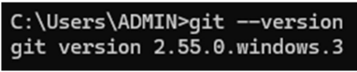

One-time configuration:
git config --global user.name "Your Name" #Configure user name
git config --global user.email "you@example.com" #Configure user email
These two commands print nothing if successful — that's normal for git config. Students can double-check the values with:
git config --global user.name
git config --global user.email
This is what gets attached to every commit — good moment to explain accountability in team projects.
Output:
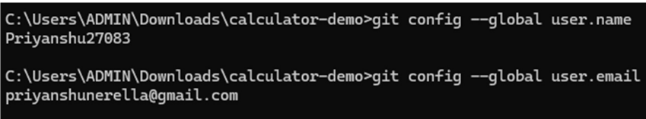

3. Hands-On: First Repository (Local → GitHub)

Step 1 — Create the project locally
mkdir calculator-demo #Creates a directory
cd calculator-demo
git init # Initializes the current project folder as a new Git repository
Output:
Initialized empty Git repository in /home/student/calculator-demo/.git/
git init: Initializes the current project folder as a new Git repository by creating a hidden .git directory to store version-control information.

Step 2 — Add code
Create calculator.py:
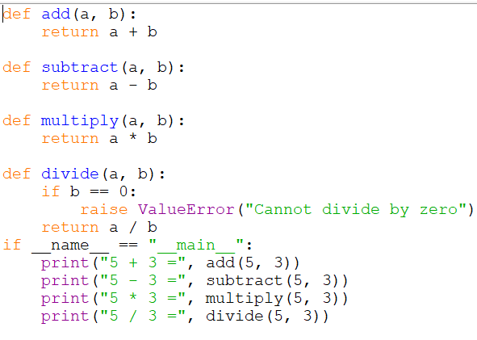
Also add a README.md:
# Calculator Demo
A simple calculator built to demonstrate Git & GitHub workflow.

Step 3 — Check status and stage files
git status # Displays the current repository status, including modified, untracked, and staged, files and the current branch
Output (before staging — untracked, shown in red in the terminal):
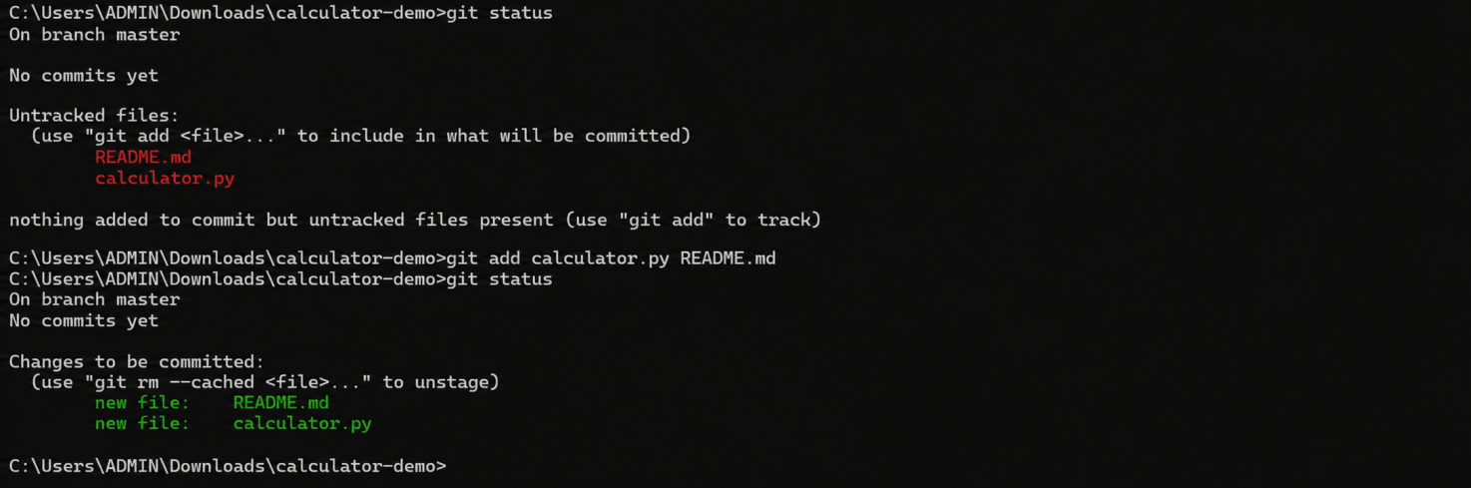
Output (after staging — shown in green in the terminal):

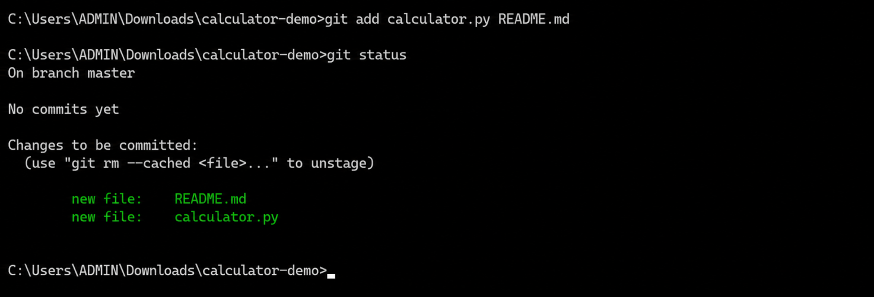

Step 4 — Commit
git commit -m "Initial commit: add basic calculator functions"
Creates a permanent snapshot of all staged changes in the repository with a message describing the changes.
Sample output:
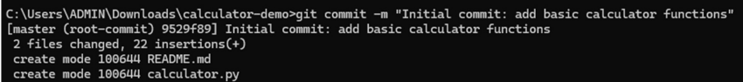
git log # Displays the history of commits in the repository

Output:
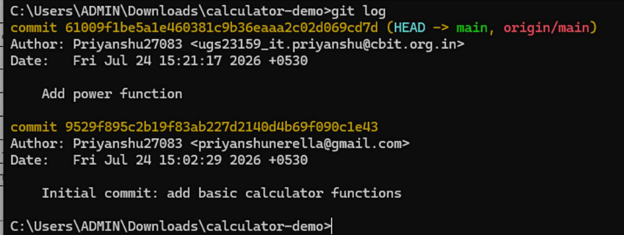

Step 5 — Create the repo on GitHub
On github.com → New repository → name it calculator-demo → do not initialize with a README (since one already exists locally) → Create.
GitHub will show setup commands — walk through them:
git remote add origin https://github.com/<username>/calculator-demo.git
git branch -M main
git push -u origin main
Output (git remote add and git branch -M print nothing on success; the interesting output is from git push):
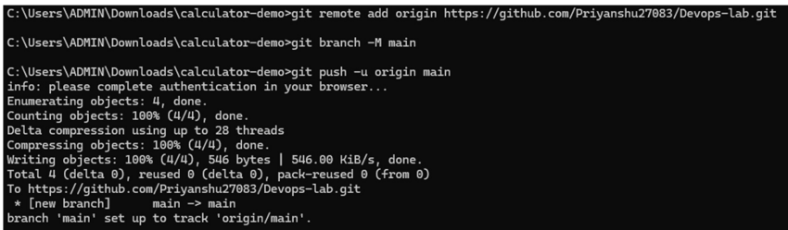
If it's the student's first push, GitHub may open a browser window asking them to sign in and authorize — walk through this once as a class since it trips up almost everyone the first time.
- remote add origin — links the local repo to the GitHub URL.
- branch -M main — renames the default branch to main.
- push -u origin main — uploads commits; -u remembers this remote/branch so future pushes can just be git push.
Refresh the GitHub page in class — students see their code live online. This is usually the "aha" moment.

Step 6 — Make a change and push again
# add to calculator.py
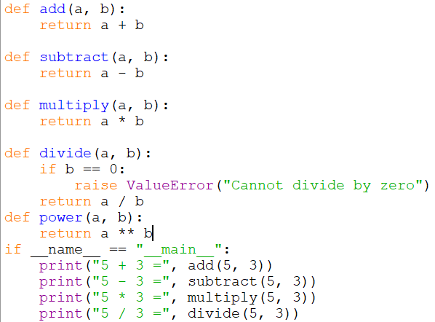
git add calculator.py
git commit -m "Add power function"
git push
Output:
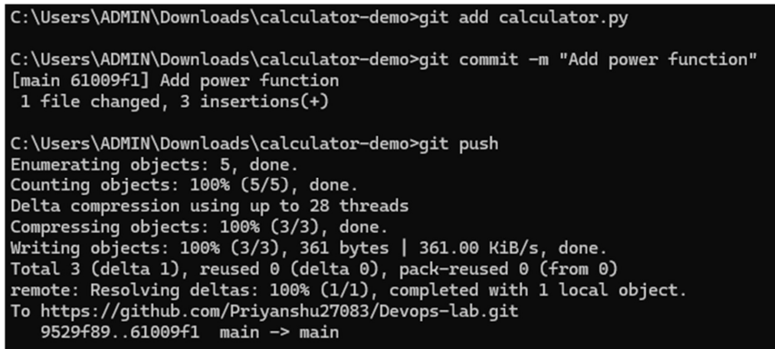

5. Branching & Merging
git branch feature-modulo # create a new branch
git checkout feature-modulo # switch to it

Output:
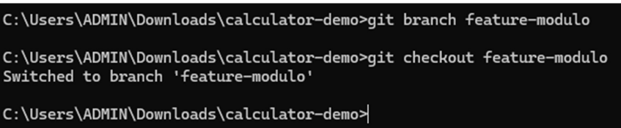
Or
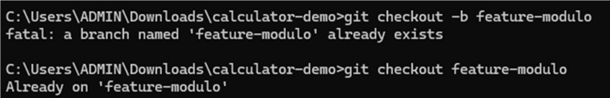
Add a modulo function, commit it on this branch, then:
git add calculator.py # Stages the modified calculator.py file for commit
git commit -m "Add modulo function"
git checkout main
Switched to branch 'main'
git merge feature-modulo # Merges the feature-modulo branch changes into the main branch
Sample output (clean, no-conflict merge):
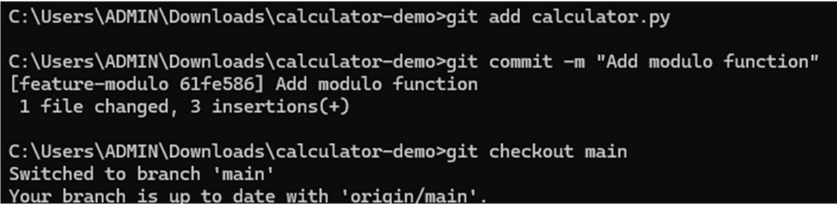
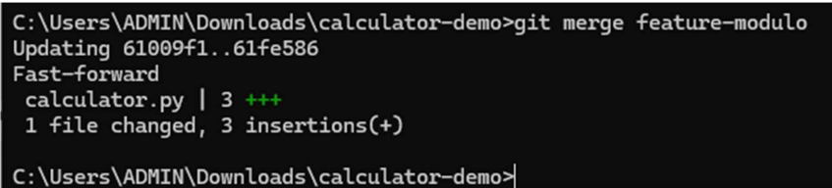
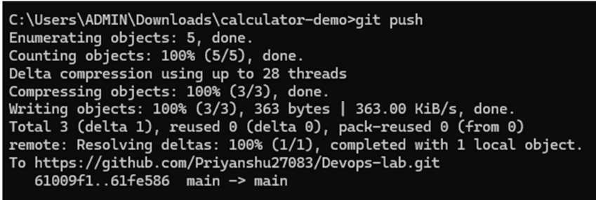
(same push-style output as before, updating main on GitHub) Good moment to mention merge conflicts: they happen when two branches edit the same lines — show a deliberate conflict as a demo if time allows.

6. Cloning an Existing Repo
For collaborative labs — one student creates the repo, others clone it:
git clone https://github.com/Priyanshu27083/calculator-demo.git
This creates a local copy of an existing GitHub repository on the computer.

Output:
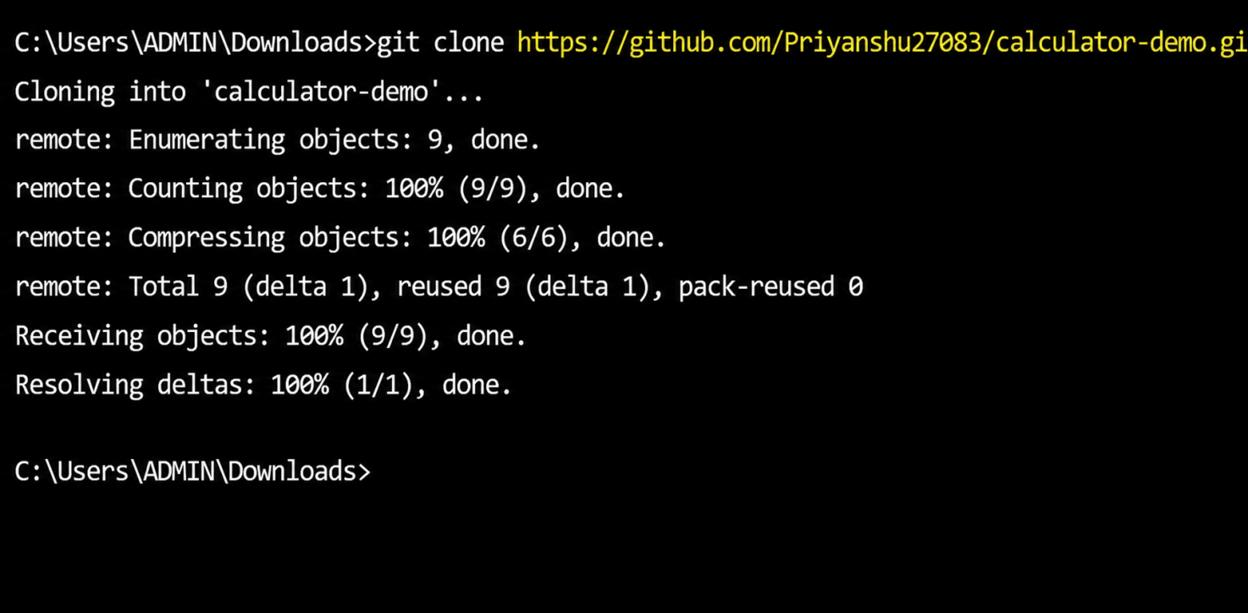

7. Pulling Updates
git pull origin main # Downloads and integrates the latest changes from the remote main branch into the local repository.
Sample output (when there are new commits to fetch):
remote: Enumerating objects: 5, done.
remote: Counting objects: 100% (5/5), done.
remote: Compressing objects: 100% (2/2), done.
Unpacking objects: 100% (3/3), 512 bytes | 512.00 KiB/s, done.
From https://github.com/<username>/calculator-demo
* branch main -> FETCH_HEAD
a71cd4e..9b3f0c2 main -> origin/main
Updating a71cd4e..9b3f0c2
Fast-forward
calculator.py | 3 +++
1 file changed, 3 insertions(+)
Output (when already up to date):
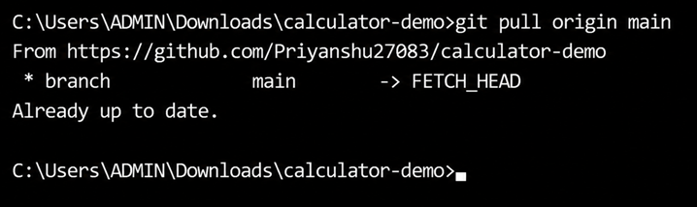
Avoids conflicts with teammates' pushes.

Observation
Git was successfully installed and configured with the user’s name and email. A local Git repository was created for the calculator project, and the project files were tracked using Git. The files were staged, committed, and the commit history was verified using git log. The local repository was then connected to a GitHub remote repository, and the project was successfully pushed to GitHub. Further modifications were committed and pushed successfully. Branch creation, switching, merging, repository cloning, and pulling updates from the remote repository were also performed successfully. Thus, the basic Git and GitHub operations required for version control and collaborative development were successfully observed and executed.

EXPERIMENT 4: JENKINS INSTALLATION, CONFIGURATION AND BUILD JOB
AIM: To install and configure Jenkins to set up a build job and comprehend Continuous Integration.
Objectives:
• To learn the basics of Continuous Integration using Jenkins.
• To install and configure Jenkins on a standalone system.
• To create and execute a simple build job in Jenkins.
• To verify build output and comprehend Jenkins job execution flow.
• To gain exposure to job scheduling, console output, and CI pipelines.
Hardware and Software Requirements
• Hardware:
• A personal computer/laptop.
• Minimum 4 GB RAM (8 GB recommended).
• Software:
• Operating System: Windows / Linux / macOS.
• Java Development Kit (JDK) (version 17 or above).
• Jenkins (LTS version).
• Git (optional, for source code integration).
• Web Browser (Chrome/Firefox/Edge).

Procedure
• Install Java (JDK 17 or higher) and verify installation using java -version.
• Download Jenkins (either .msi installer for Windows or .war file for any OS).
• Start Jenkins service and open Jenkins at http://localhost:8080.
• Unlock Jenkins using the initial admin password from the secrets file.
• Install Suggested Plugins during setup.
• Create an Admin User and complete the configuration.
• Create a new job (Freestyle Project).
• Configure build step with a simple script (echo Hello Jenkins).
• Save and execute the job.
• Observe the build console output and verify success.

Introduction:
Jenkins is an open-source automation server widely used for implementing Continuous Integration (CI) and Continuous Delivery/Deployment (CD) in software development. It automates repetitive tasks involved in the software development lifecycle, such as building source code, running tests, generating packages, and deploying applications.
Jenkins can integrate with tools such as Git and GitHub to automatically obtain the latest source code whenever changes are made. It supports Pipeline automation, allowing developers to define and execute a sequence of build, test, and deployment steps.
In this experiment, Jenkins is configured on a Windows system and used with a Java Calculator project. The Java program is compiled and executed, demonstrating how Jenkins can be used to automate the software build and testing process.
- Java Version Verification: The command java --version is used to confirm that Java is installed and to check its version (Java 25.0.4).
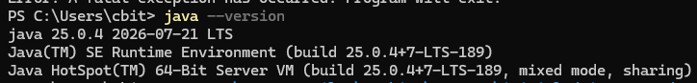
- Checking Jenkins Service Status: The command Get-Service Jenkins is run to verify if the Jenkins service is currently active and running on the system
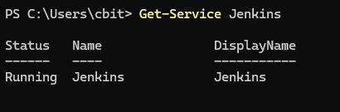
- Locating Jenkins Executable: The Get-CimInstance command queries Windows system information to find the file path of the jenkins.exe executable, which is located at C:\Program Files\Jenkins\jenkins.exe
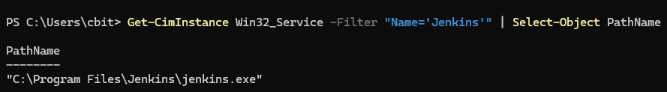
- Listing Jenkins Data Directory: The Get-ChildItem command lists the contents of the C:\ProgramData\Jenkins directory, revealing two folders: .jenkins and war.
- Retrieving Initial Admin Password: The type command is used to display the contents of the initialAdminPassword file located in the Jenkins secrets directory. The password 04eb2c253b7941ee911176cdae517328 is displayed.

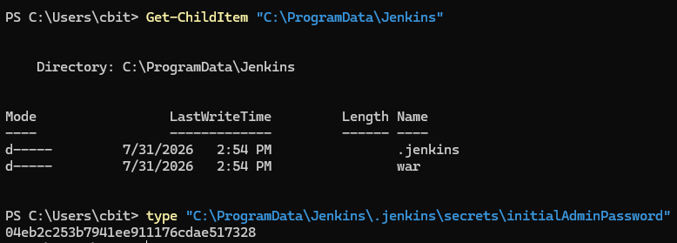
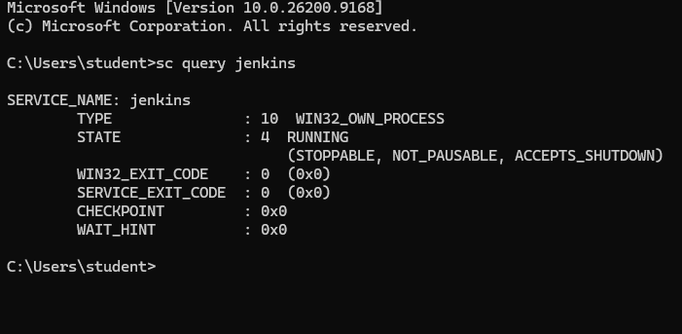
paste the password in the administration panel → http://localhost:8080/
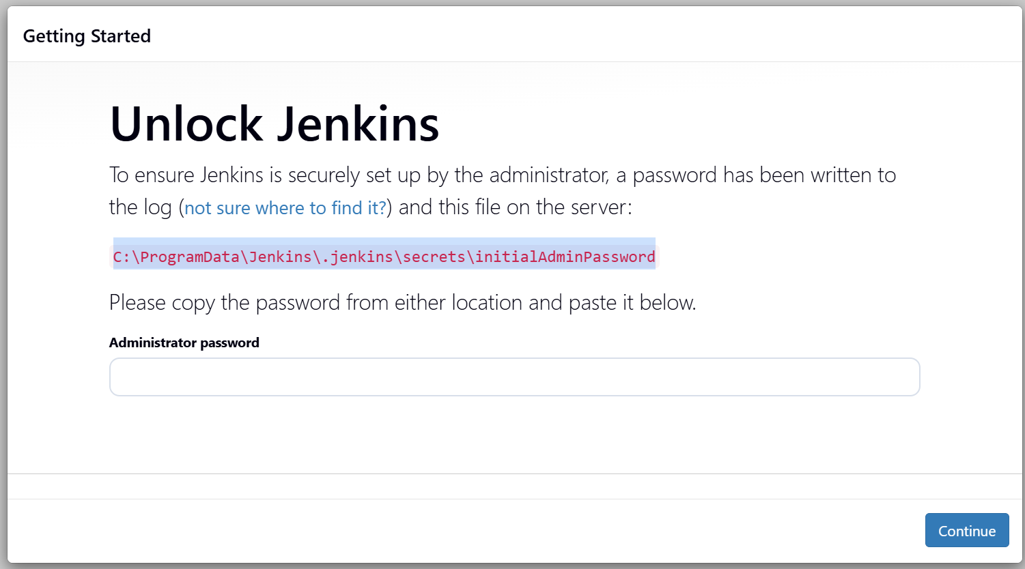
- Jenkins "Customize Jenkins" Screen: This screenshot shows the browser-based setup wizard after accessing http://localhost:8080/. You are presented with the option to either "Install suggested plugins" or "Select plugins to install."

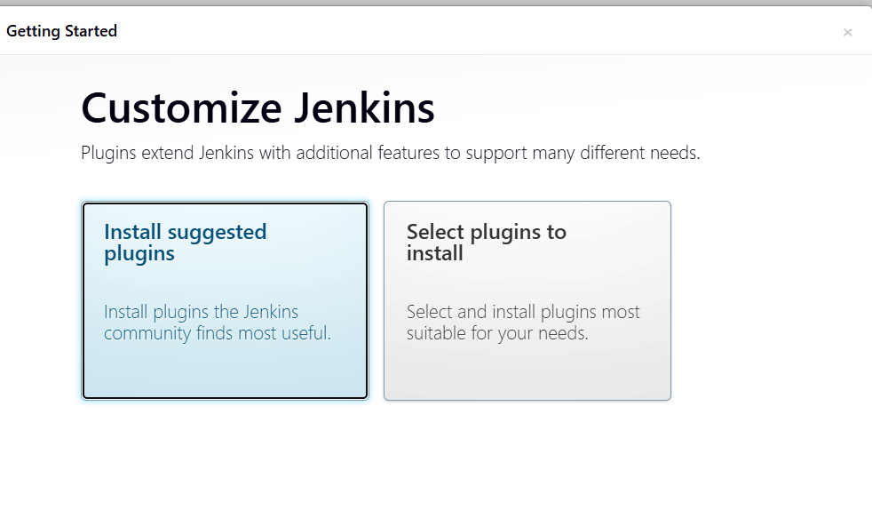
- Jenkins Plugins Installation: This shows the progress of the automated installation of various plugins (e.g., Folders, Pipeline, Git, Mailer, etc.) required for Jenkins to function.

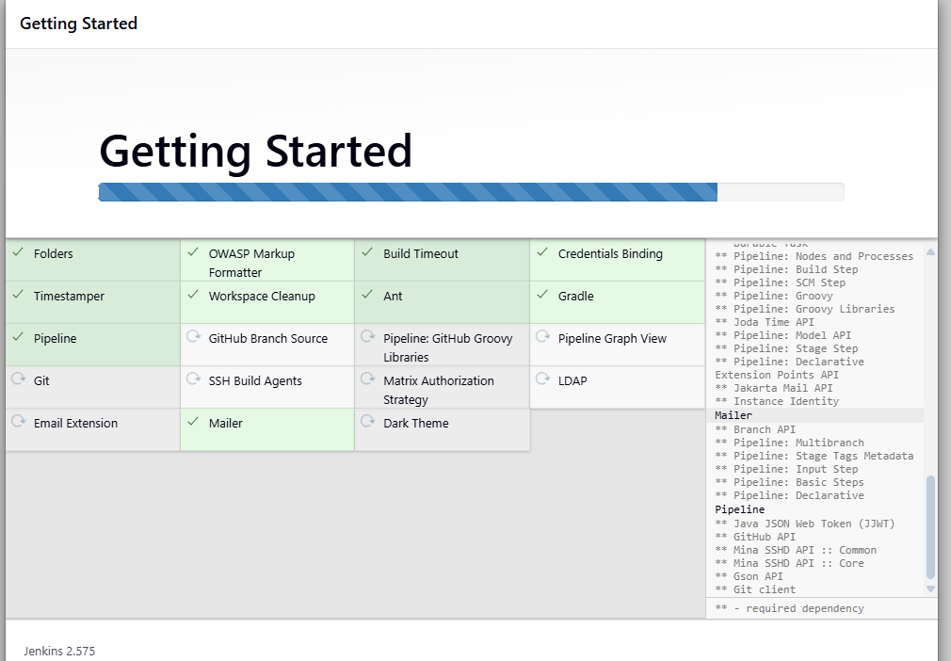

- Create First Admin User: The setup wizard prompts for administrative credentials, where you provide a username, password, full name, and email address to create the first admin account for the Jenkins instance.
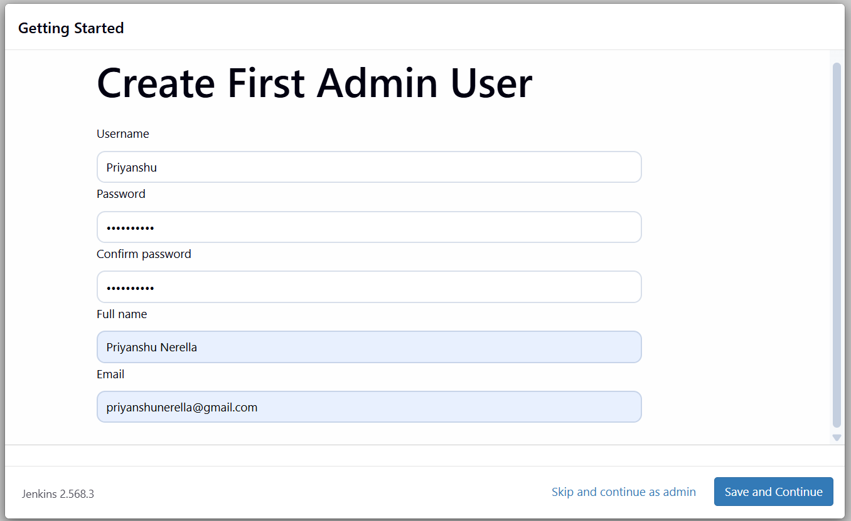
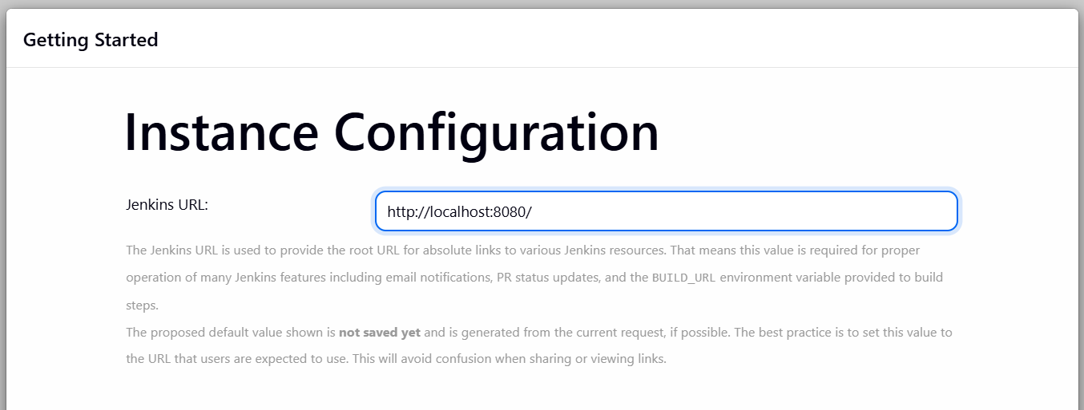
1. Create a Project Folder
Open Git Bash or CMD:

cd 160123737159: Navigates to a specific directory.

mkdir CalculatorProject: Creates a new folder named "CalculatorProject."
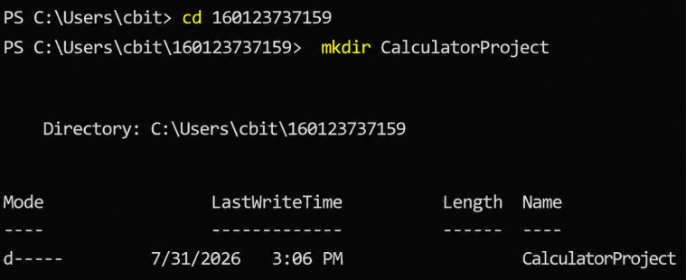
2. Add a Java Program
Create folders for Java package:
- Compiling and Running Java Code:
  - New-Item Calculator.java: Creates a new Java source file.
  - javac Calculator.java: Compiles the Java source code into bytecode.
  - java Calculator: Executes the compiled Java program, which then prompts for user input (first number, operator, second number) and calculates the result (1 + 5 = 6.0).
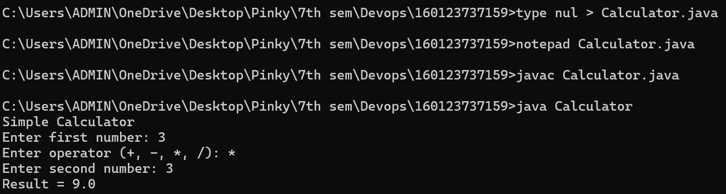
Jenkins is a CI/CD automation tool. It helps automate steps like:
- Get your code from GitHub/Git
- Compile the code
- Run tests
- Create a build/package
- Deploy the application
For your calculator example, Jenkins would do something like this:
Developer writes Calculator.java
|
↓
Push code to GitHub
|
↓
Jenkins
|
├── Download code
├── Compile Java code
├── Run tests
└── Report success/failure

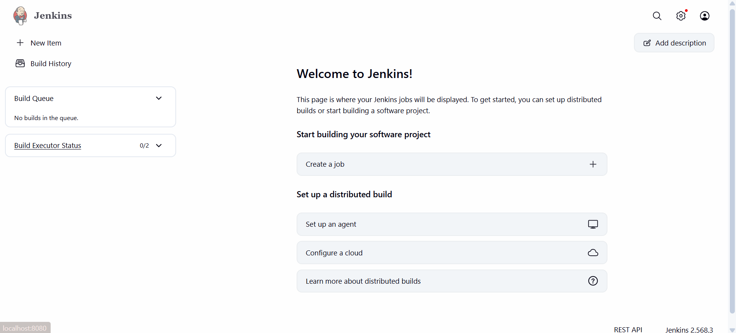
3. Add a Jenkinsfile
In the root of the project, create a file Jenkinsfile:
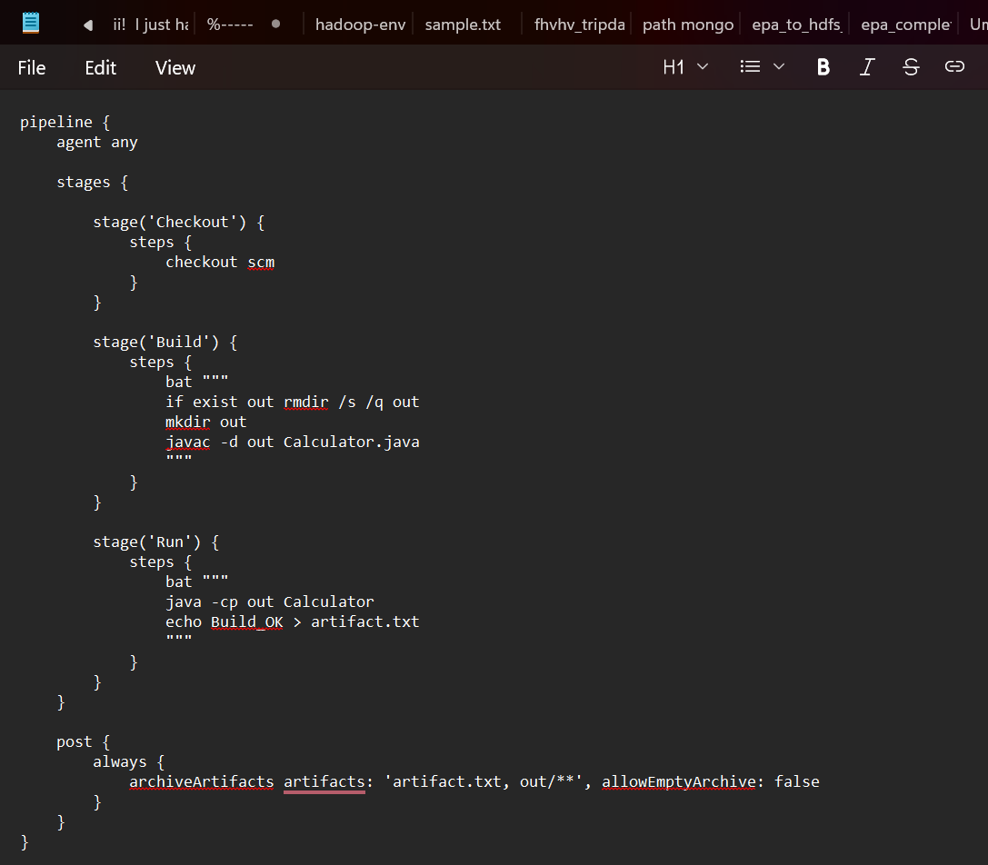
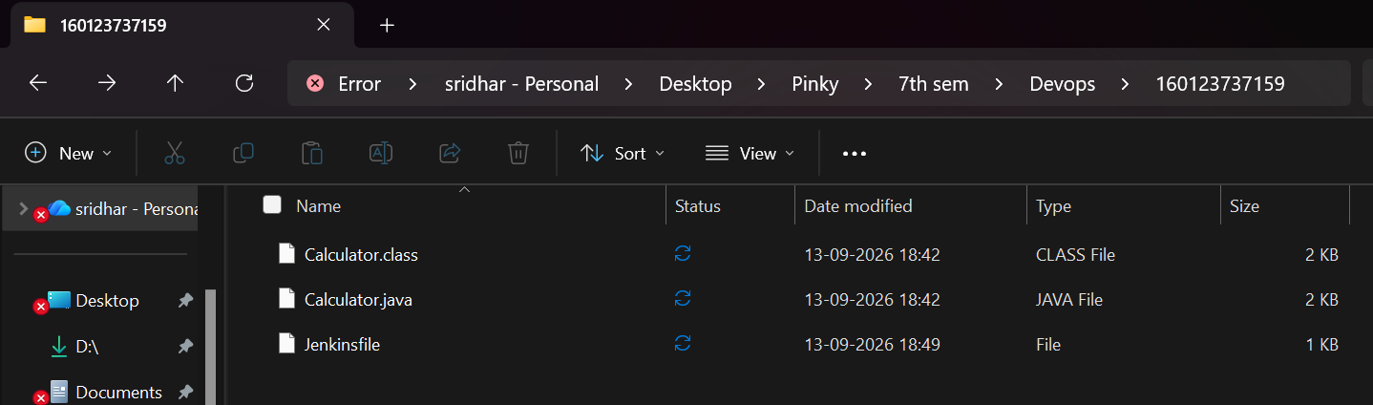
4. Initialize Git Repository
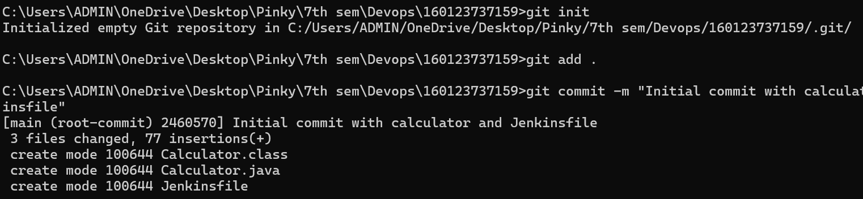
5. Connect to GitHub

Create a new repo on GitHub → calculator-jenkins.

Add remote:
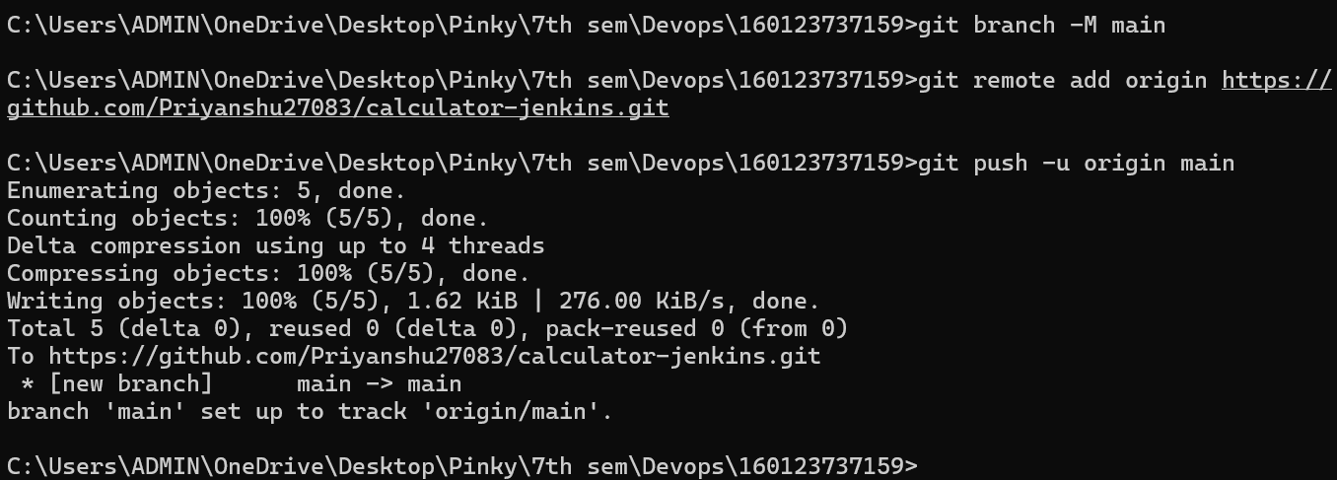
6. Create Jenkins Job (Pipeline)
1. Open Jenkins → http://localhost:8080.
2. New Item → Pipeline → Name: student-ci-demo → OK.
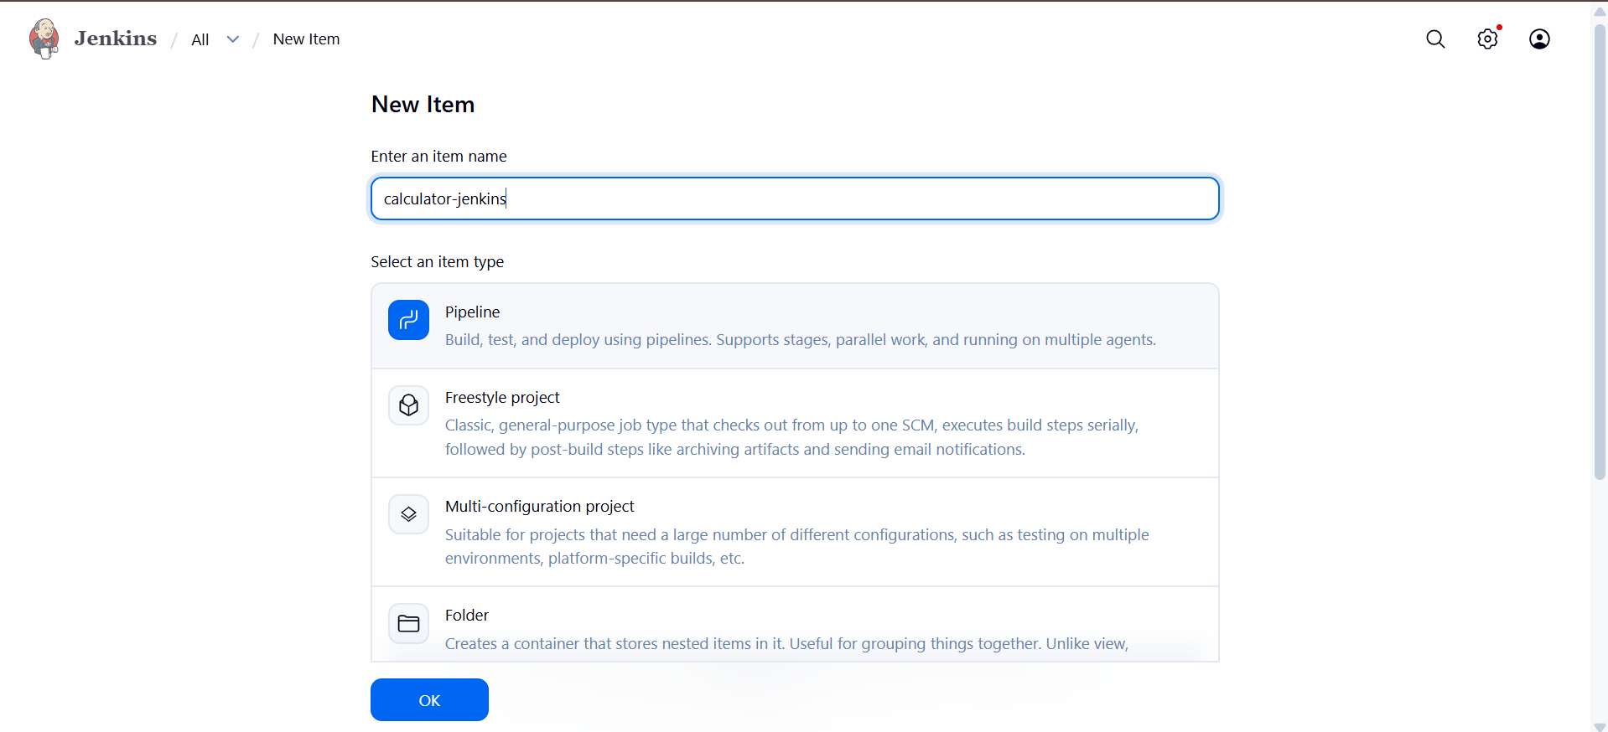
3. In Pipeline section:
○ Definition → Pipeline script from SCM
○ SCM → Git
○ Repo URL → https://github.com//student-ci-demo.git
Branch → main
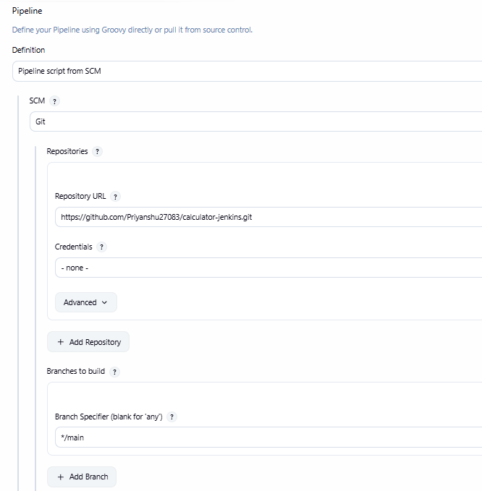
7. Configure Trigger (Poll SCM)
● Job → Configure → Build Triggers
● Check ✅ Poll SCM
In Schedule box type: H/2 * * * *
● Means Jenkins will check GitHub every ~2 minutes.
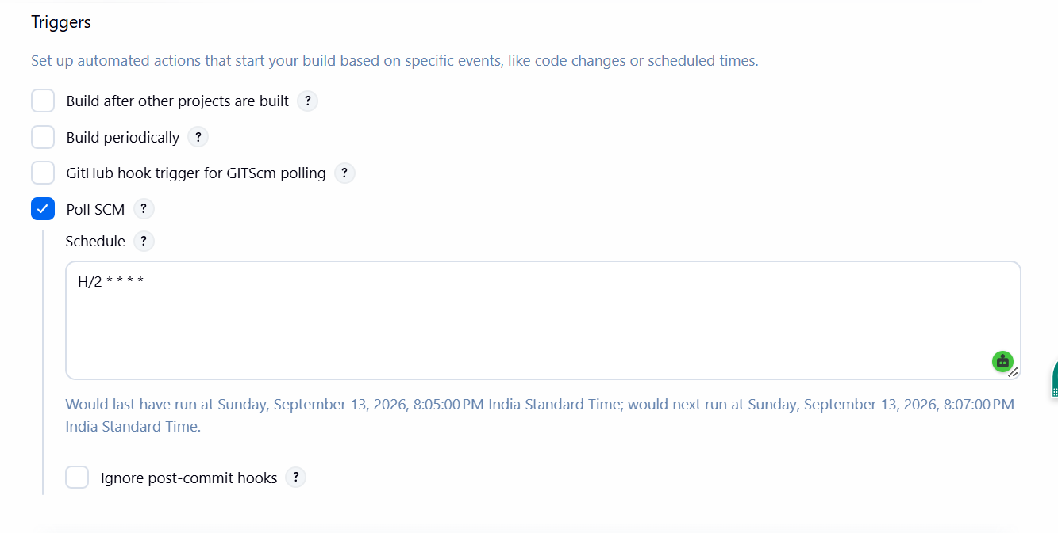

8. Run the Pipeline
● Click Build Now → Jenkins will:
1. Checkout repo
2. Compile Hello.java → out/hello/Hello.class
3. Run program → prints message
4. Save artifact → artifact.txt
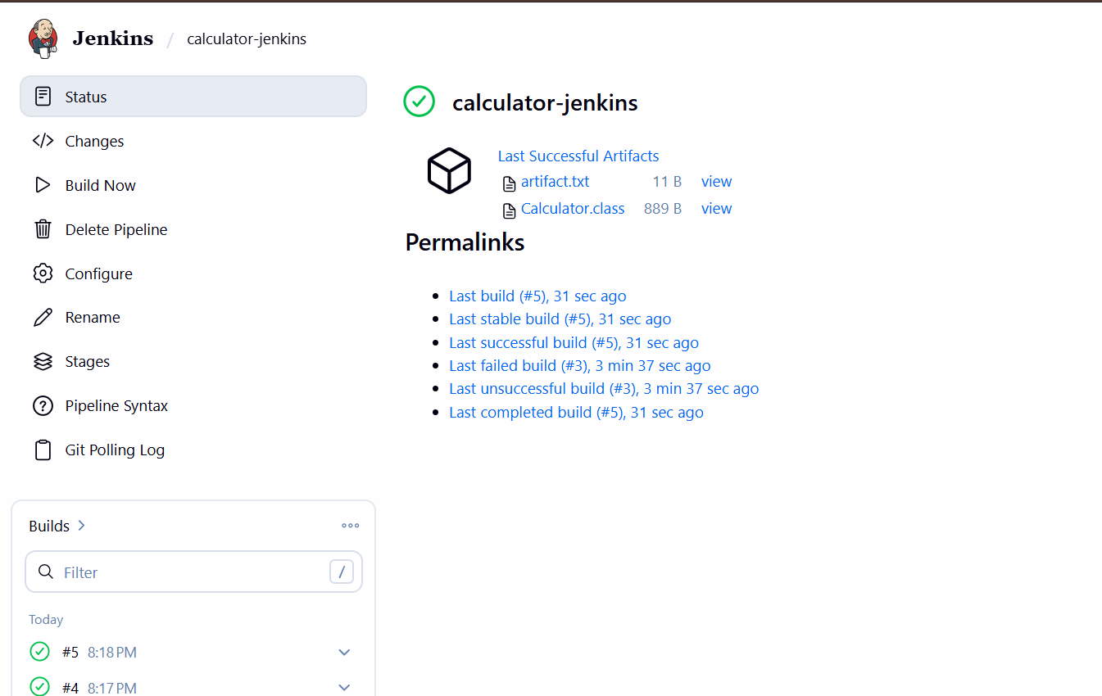

● Check Console Output → see steps.
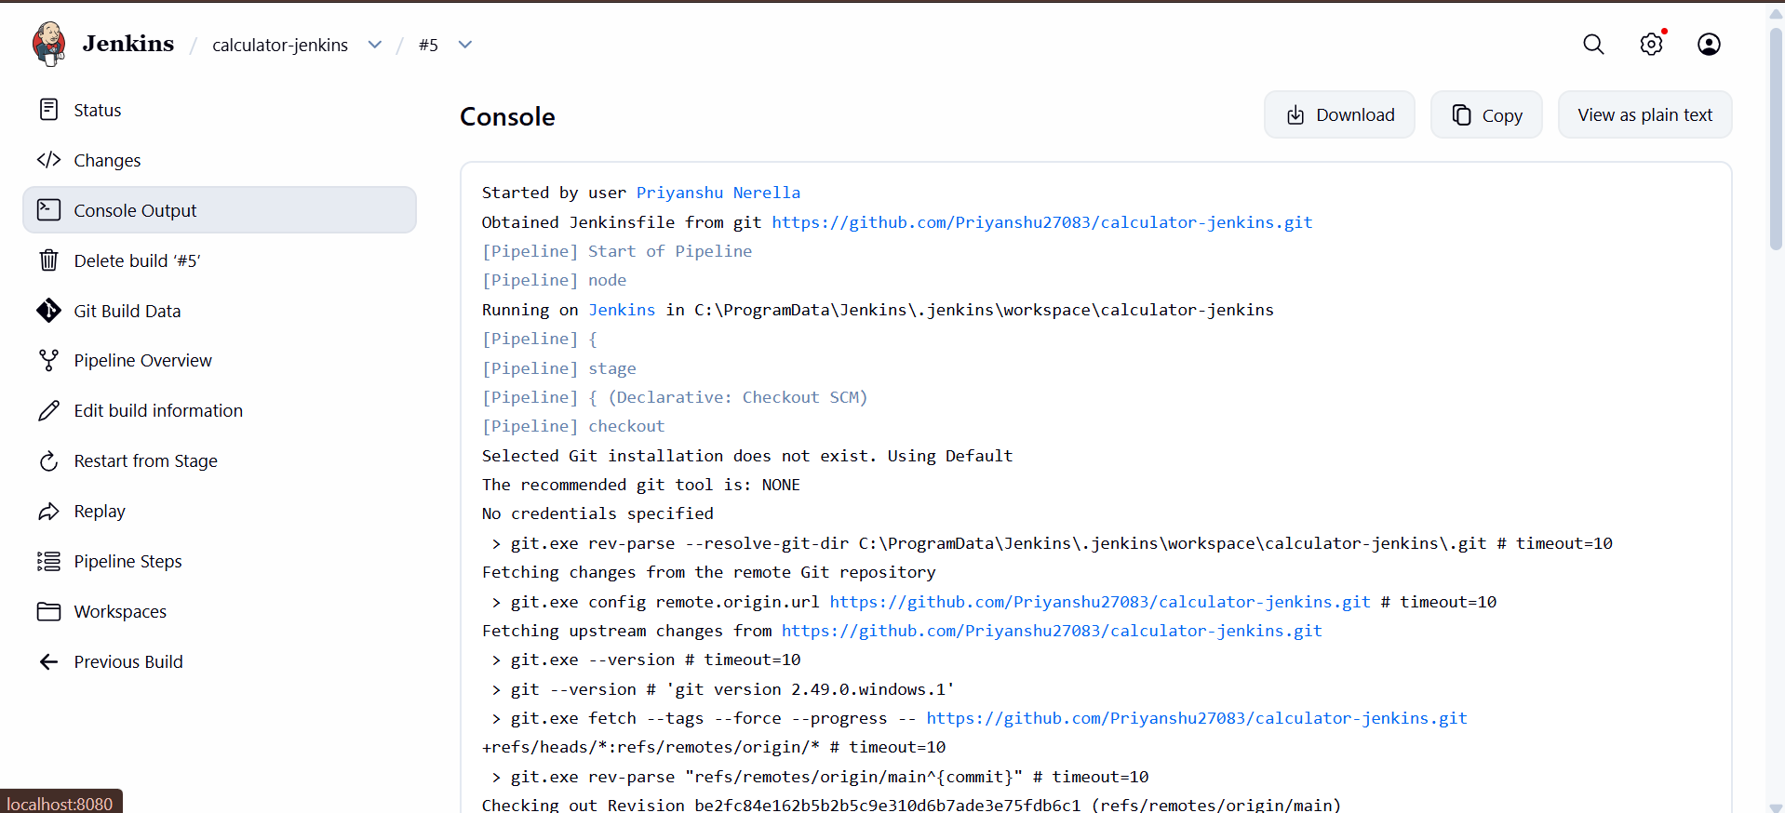

● Check Artifacts box → download files.
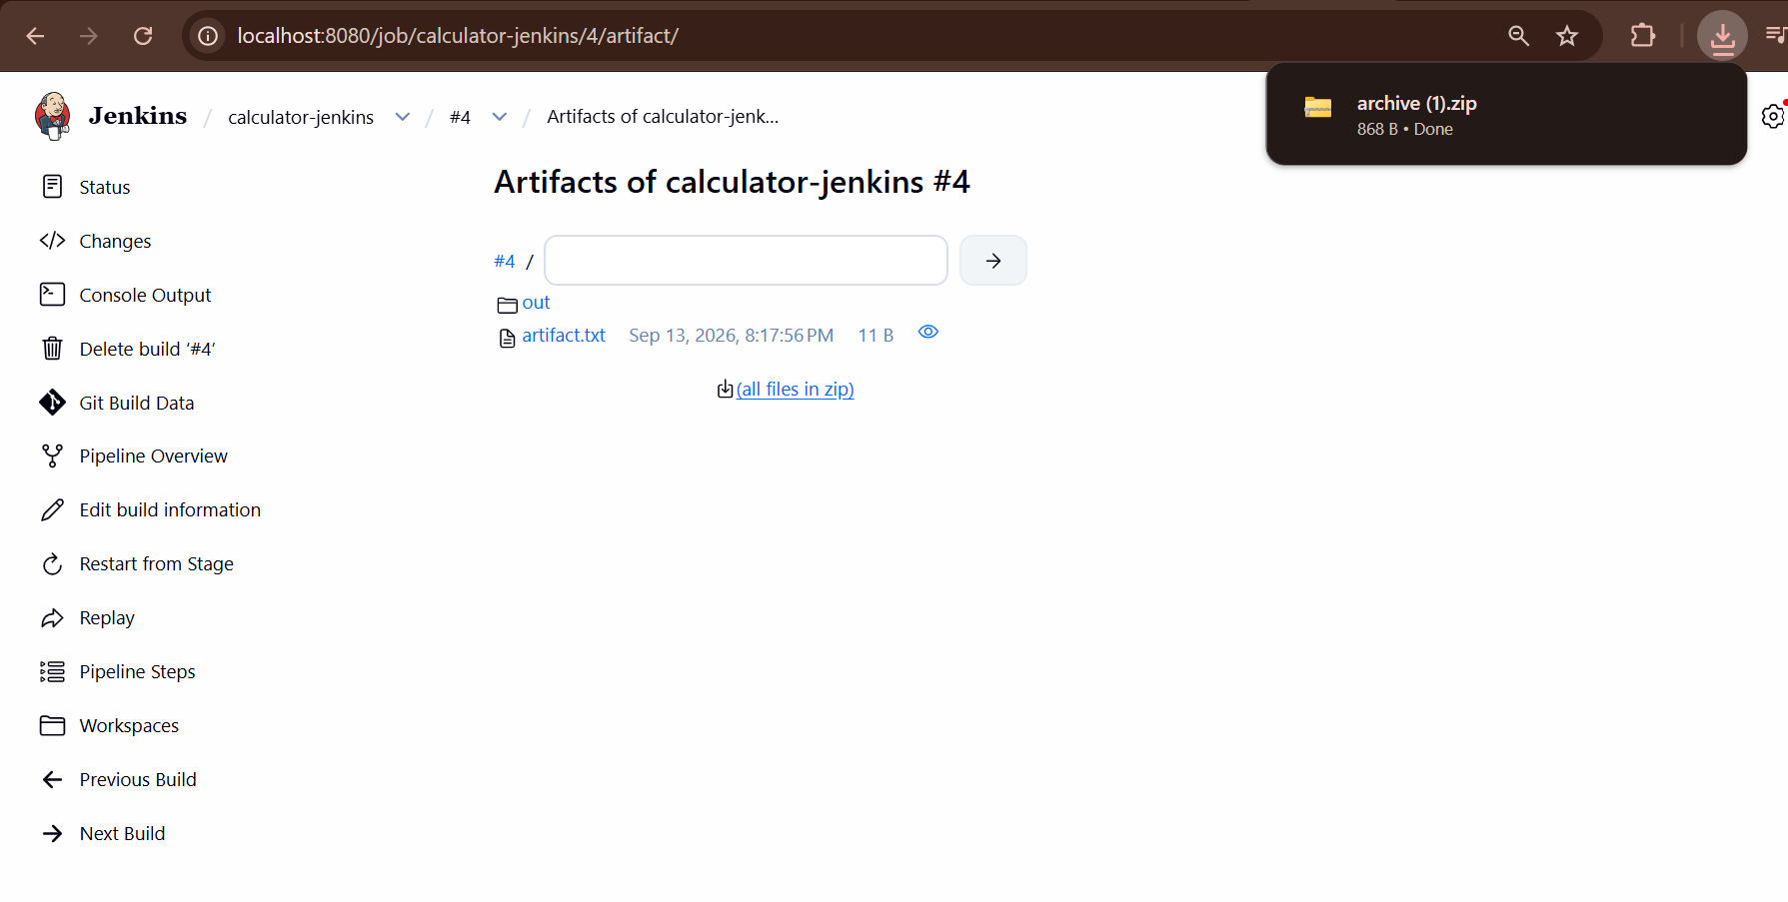

● Check Pipeline Overview
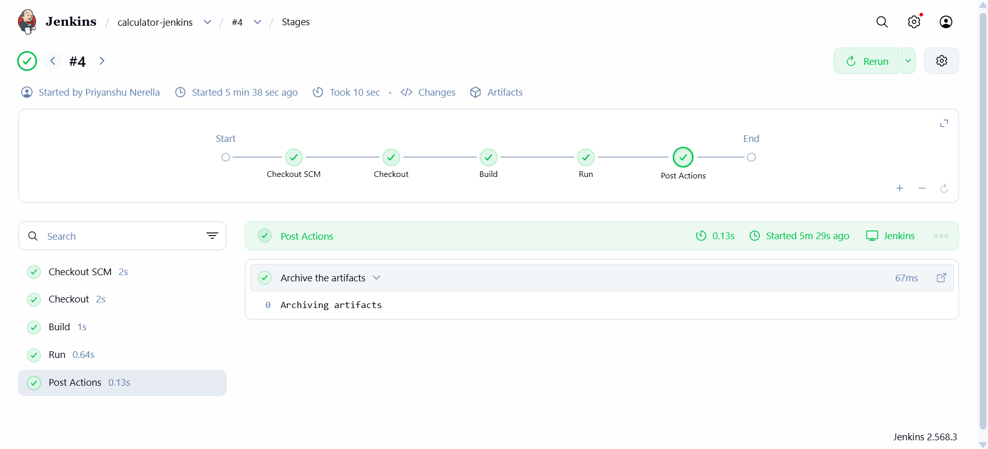
OBSERVATIONS:
The experiment successfully demonstrated the installation and configuration of Jenkins and its integration with a Java project. The Java calculator application was compiled and executed successfully, establishing the basic environment required for automating the build and testing process using Jenkins.

EXPERIMENT 5: JENKINS MASTER SLAVE ARCHITECTURE
AIM: To understand Jenkins Master-Slave Architecture and scale your Jenkins standalone implementation by implementing slave nodes.
Objectives:
• To learn the concept of Jenkins distributed build architecture.
• To configure Jenkins master and slave nodes.
• To run jobs on slave nodes using labels.
• To demonstrate scaling of Jenkins builds using multiple agents.

Hardware and Software Requirements
• Hardware:
- System with minimum 4 GB RAM, 2 Core CPU.
- Stable internet connection.

• Software:
- Operating System: Windows / Linux / macOS.
- Java Development Kit (JDK) (version 17 or above).
- Jenkins (LTS version).
- Git (optional, for source code integration).

Procedure
1. Install Java and Jenkins on the master system.
2. Start Jenkins and configure initial setup.
3. Create a new slave node in Jenkins and assign label win-agent-1.

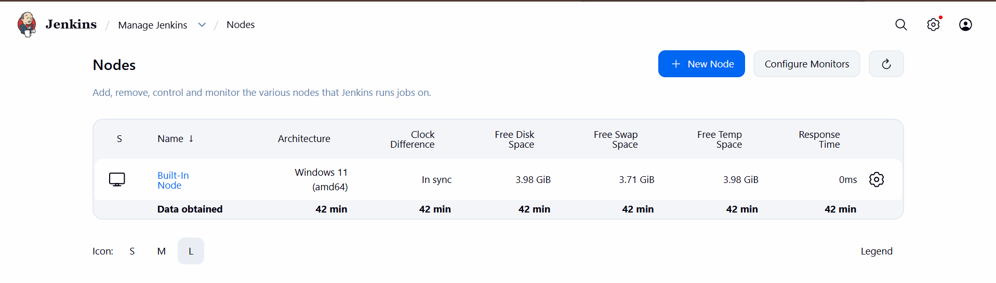
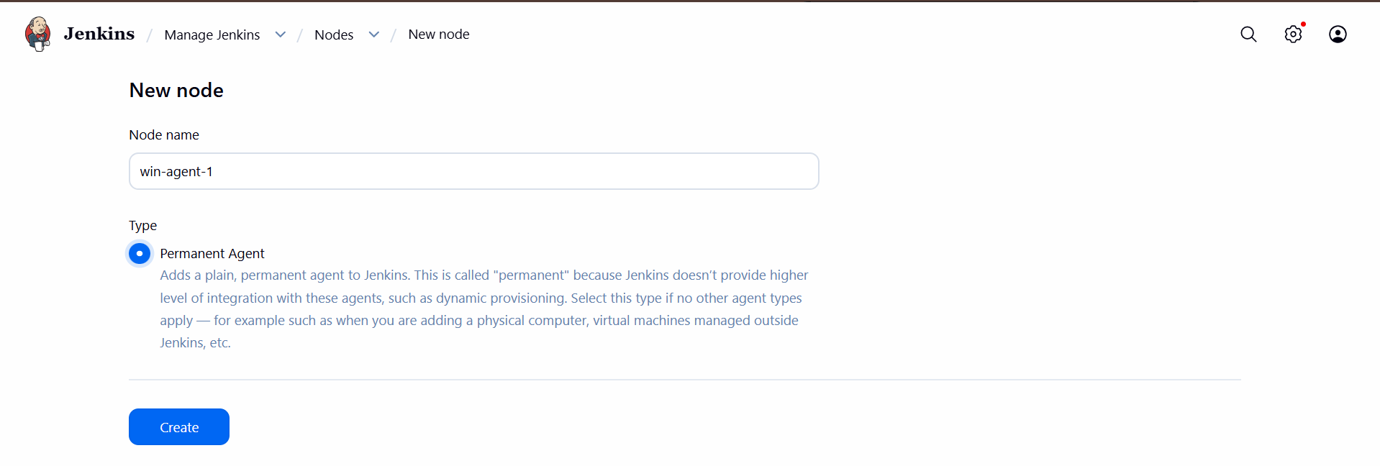
4. Configure the node
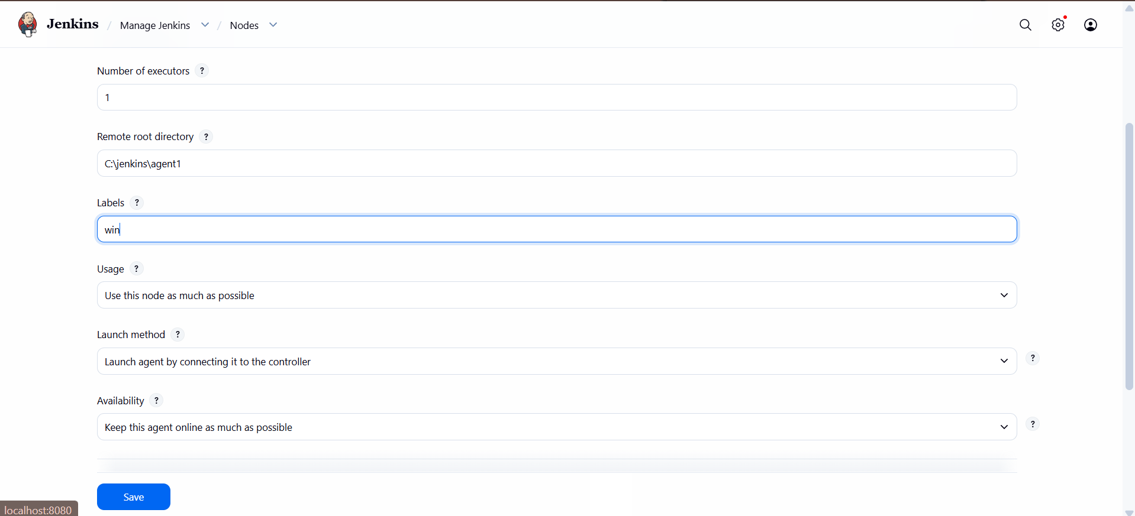
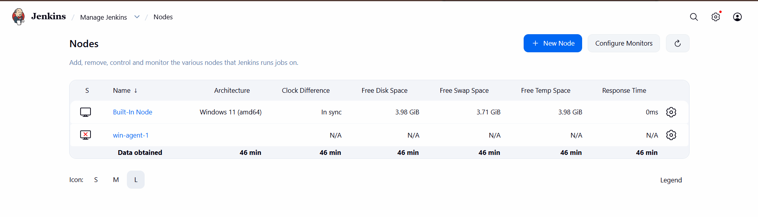
5. Connect the Windows Agent

Click on win-agent-1
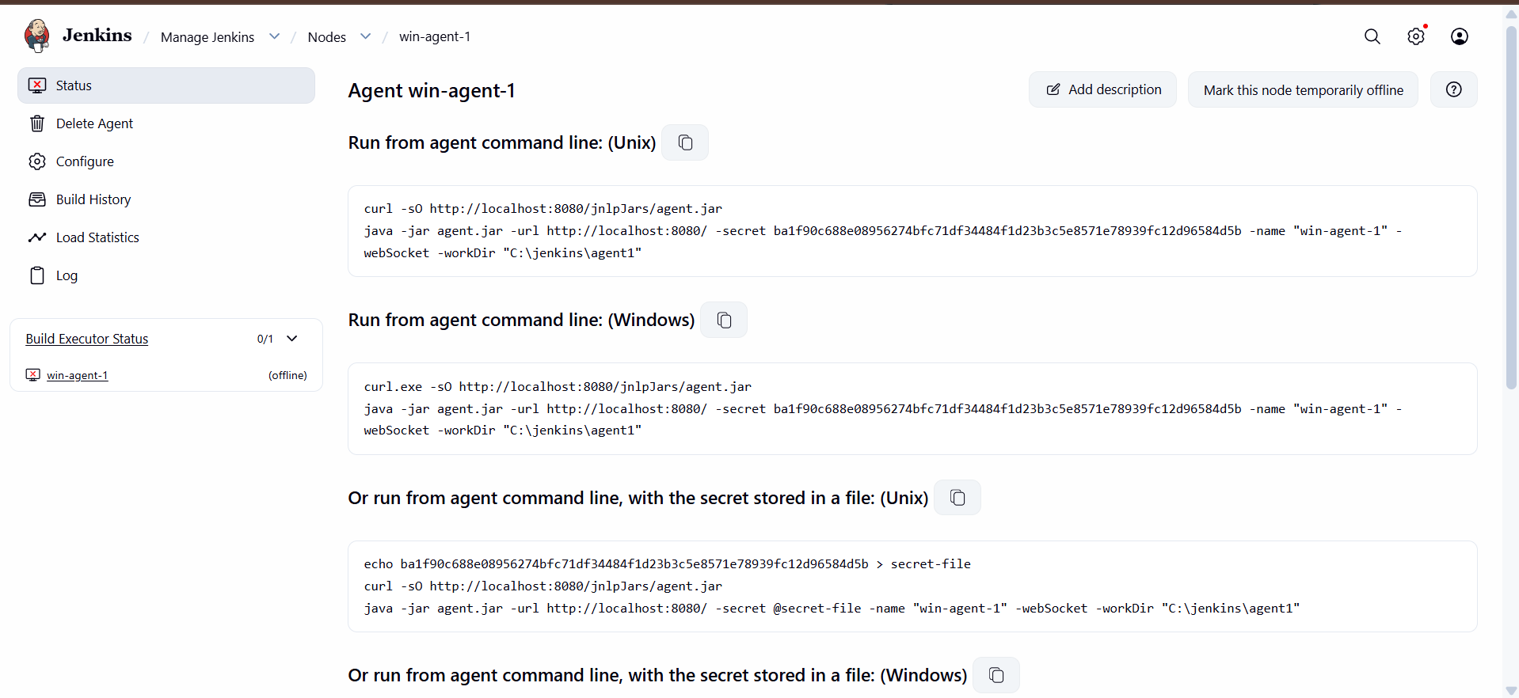

6. On the Windows Agent Machine
Now you need to run the commands on the Windows machine that is supposed to execute the build.
If your controller and agent are the same Windows computer, that's okay too. You're essentially making Jenkins use that machine as a separate agent.

Step 1: Open Command Prompt

Step 2: Create the agent folder
Run: mkdir C:\jenkins\agent1
Then run: cd C:\jenkins\agent1

Step 3: Download agent.jar
Run:
curl.exe -sO http://localhost:8080/jnlpJars/agent.jar
Then check:
dir
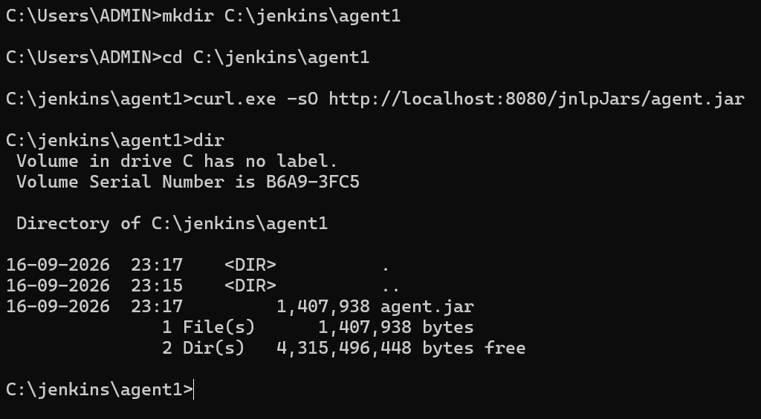

Step 4: Run the agent
Now copy the exact Java command Jenkins gave you.
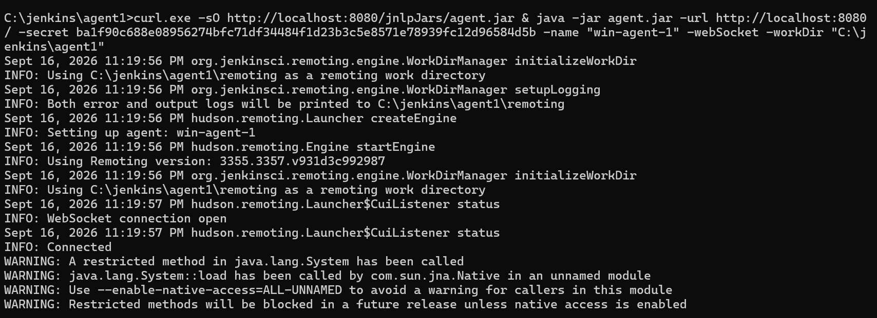

7. Check that the Agent is Online
Go back to Jenkins.
Go to:
Manage Jenkins → Nodes
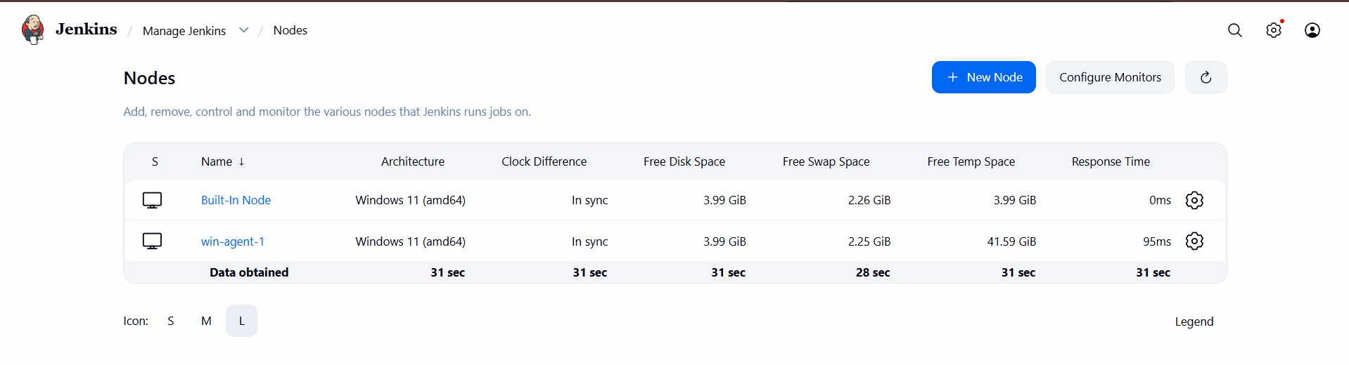
Change the Jenkins code from:
pipeline {
agent any

stages {

stage('Checkout') {
steps {
checkout scm
}
}

stage('Build') {
steps {
bat """
if exist out rmdir /s /q out
mkdir out
javac -d out Calculator.java
"""
}
}

stage('Run') {
steps {
bat """
java -cp out Calculator
echo Build_OK > artifact.txt
"""
}
}
}

post {
always {
archiveArtifacts artifacts: 'artifact.txt, out/**', allowEmptyArchive: false
}
}
}

To:
pipeline {
agent none

options {
timestamps()
timeout(time: 15, unit: 'MINUTES')
}

stages {

/* 1) WHERE AM I — run on Controller (built-in) */
stage('Where am I (Controller)') {
agent {
label 'built-in'
}

steps {
echo "NODE = ${env.NODE_NAME}"
echo "WORKSPACE = ${env.WORKSPACE}"
}
}

/* 2) BUILD & RUN — on Windows Agent (label: win) */
stage('Build on Windows Agent') {
agent {
label 'win'
}

steps {
bat """
if exist out rmdir /s /q out
mkdir out

javac -d out Calculator.java
java -cp out Calculator

echo Build_OK > artifact.txt
"""
}

post {
always {
archiveArtifacts artifacts: 'artifact.txt, out/**',
allowEmptyArchive: false
}
}
}

/* 3) PARALLEL DEMO — Controller vs Agent at the same time */
stage('Parallel: Controller vs Agent') {
parallel {

stage('Controller lane') {
agent {
label 'built-in'
}

steps {
echo "PARALLEL NODE = ${env.NODE_NAME}"
}
}

stage('Agent lane') {
agent {
label 'win'
}

steps {
bat "echo PARALLEL NODE = %NODE_NAME%"
}
}
}
}
}
}
8. Now push to github
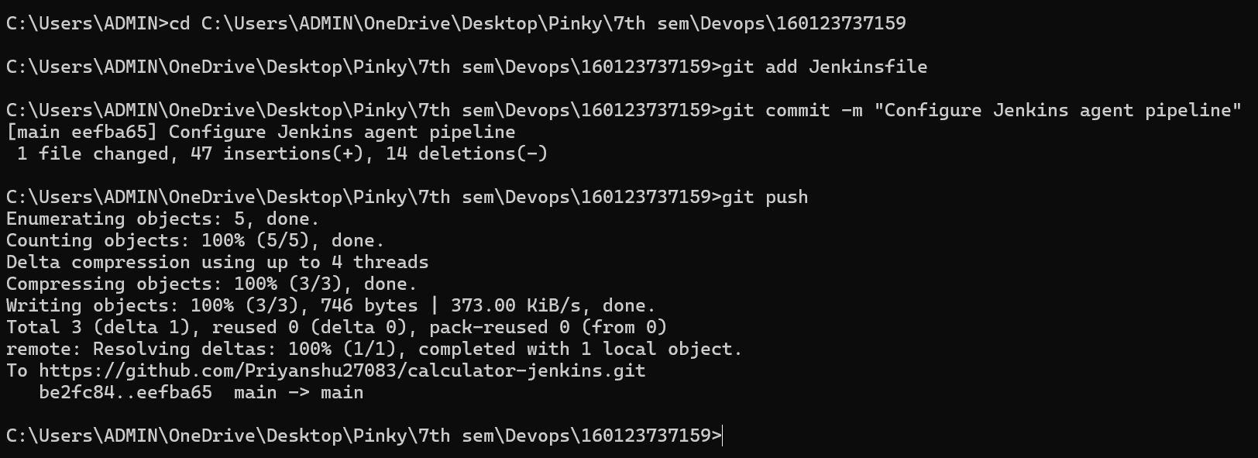
9. Build now on Jenkins
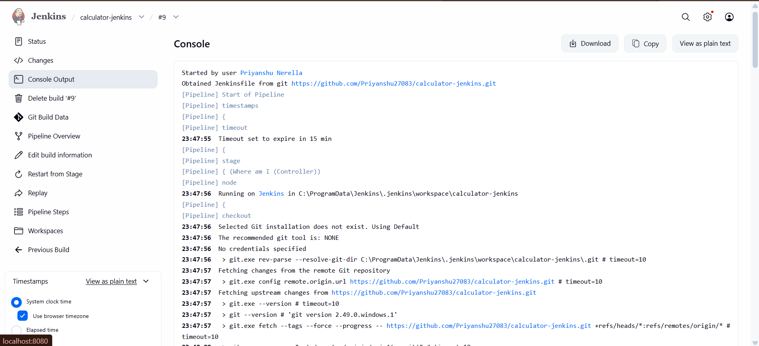
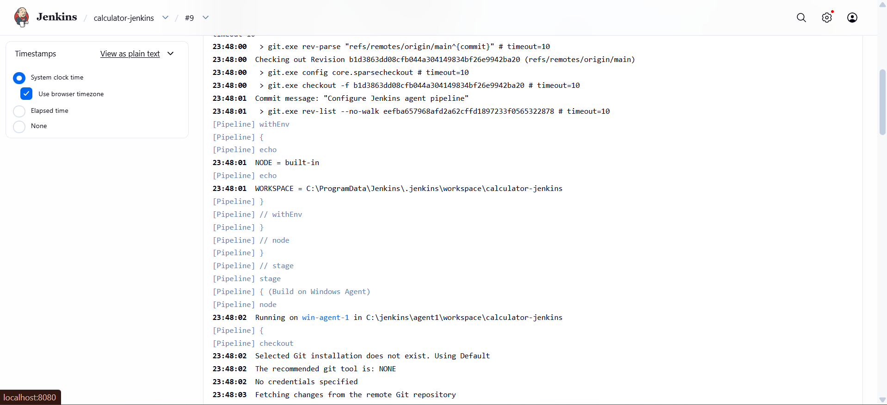
Pipeline Overview:
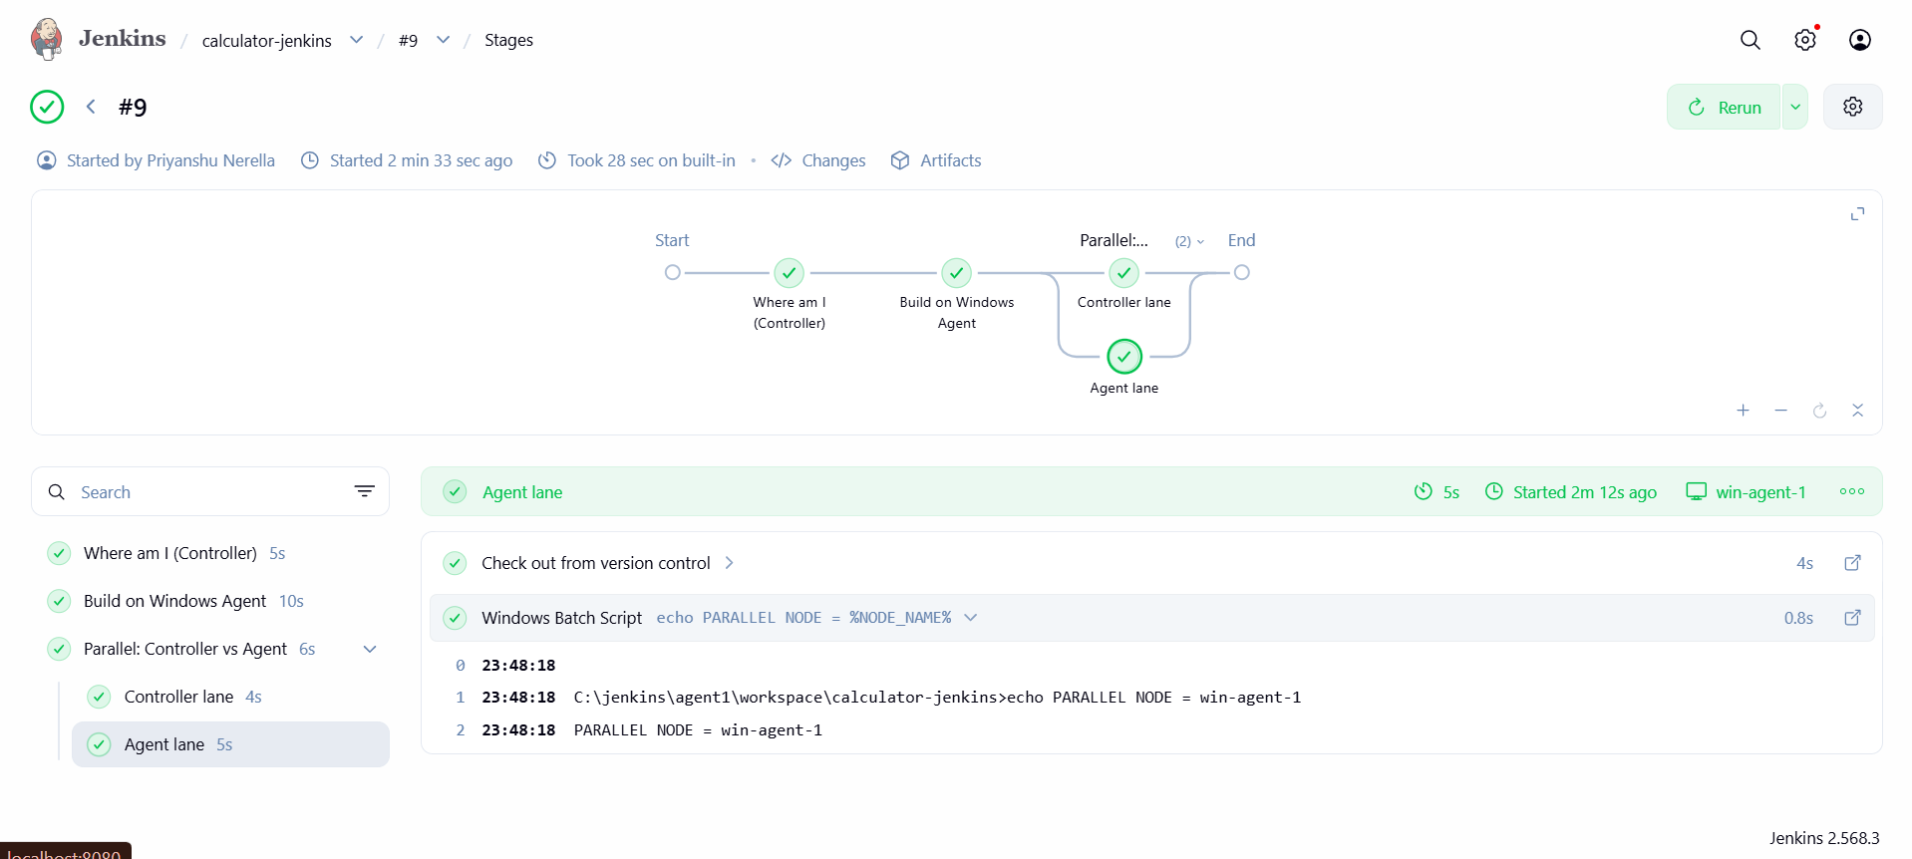

Observation:
By configuring Jenkins master and slave architecture, distributed builds can be achieved. This setup enables load distribution, better scalability, and efficient utilization of resources. Slave nodes can be targeted with labels, ensuring specific jobs run on specific environments..

