Apache Ant Cli – Task
- Santhosh M

1.xml file by ant
a.Default is build.xml
b.Other then build.xml We use -bulidfile command with ant
c.xml File root elment is project & target element Have the tasks

2.Here, I am Creat Simplel defeult bulid.xml

for:
ant (or) ant run(clean,compile&run)
ant compile(clean&compile)
ant init(clean&make classes foldes)
ant clean(delete build folder)

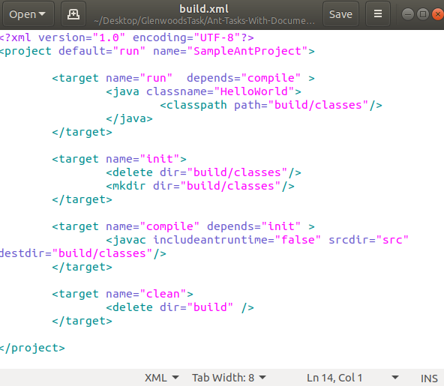

ant (or) ant run(clean,compile&run)

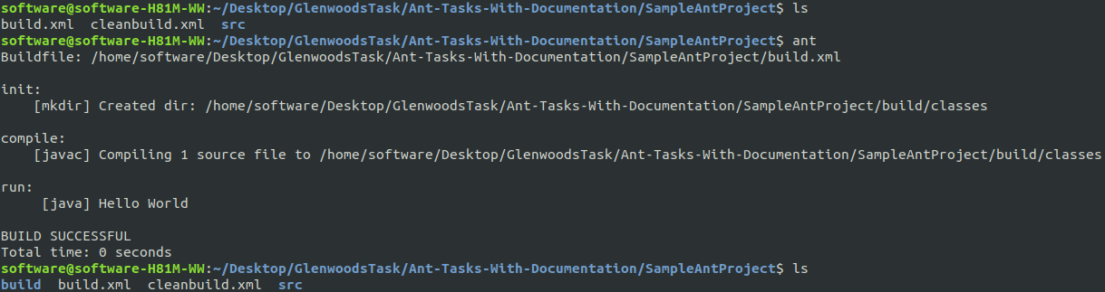
ant compile(clean&compile)

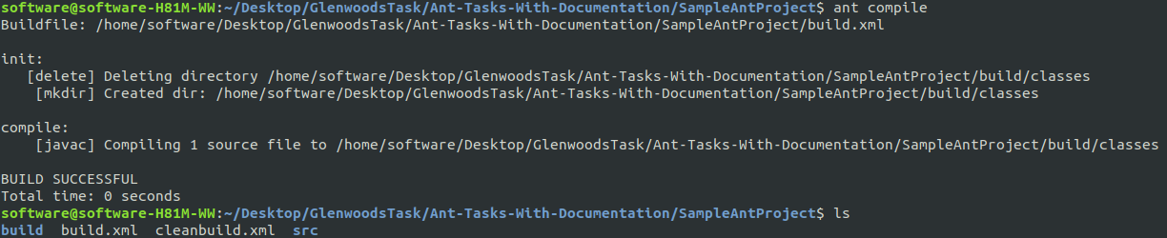
ant init(clean&make classes foldes)

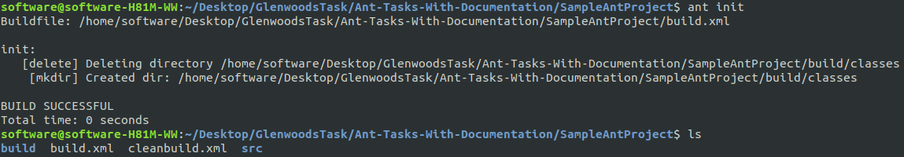
ant clean(delete build folder)

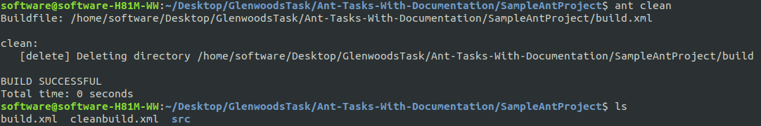

3.Here, I am creating othername xml file

To run this file use comand ant with -buildfile anf filename
ant -buildfile cleanbuild.xml(clean the build folder)

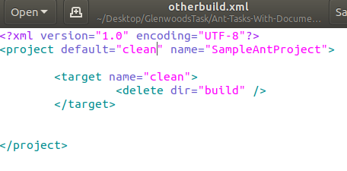

ant -buildfile cleanbuild.xml(clean the build folder)
