Git and GitHub Tasks
-Santhosh M

1.Git initialize repository:

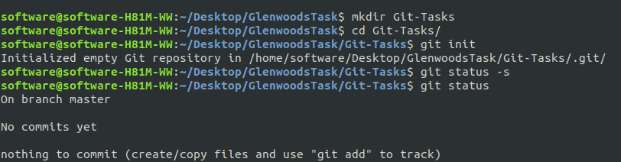
2.Working directory(Our local Folder with .git):
Show the Staged and unStaged files
3.Staging Files(ready to Commit Files):
Show only Staged files
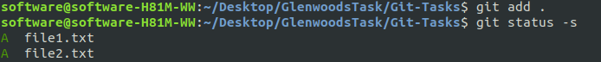
4.Git Local directory:
commited log detiails With commit id
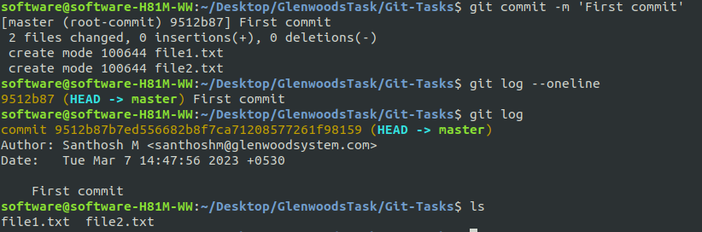
5.Git Local to Remote directory:
a.Creat one new repository in GitHub and Copy repository link
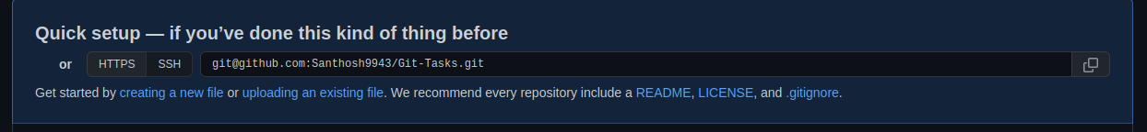
b.type - git remote add and link
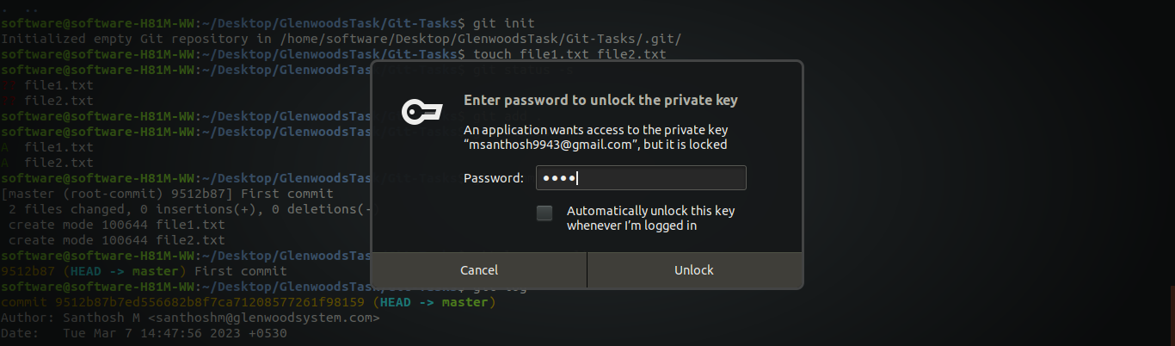
If your use github HTTPS means github psw or ssh link means your ssh key setup psw
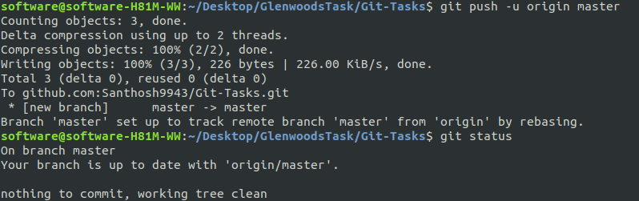
Here I am using ssh link
Your remote repository was ready
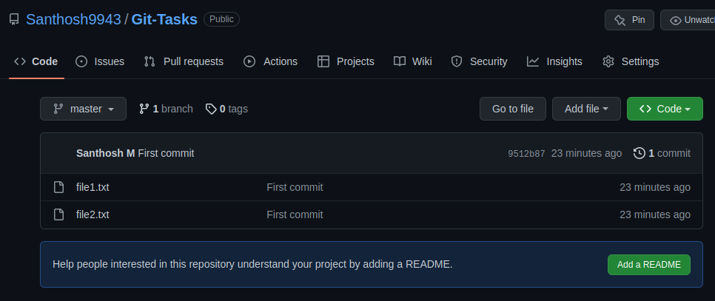
note : after these setup no need to type link again, just use git pull and push for remote and local exchange.

6.Git Remote to Local Directory:
a.Take any public repositiory link from github and type your terminal to git inizalized repository git clone (link) and also send pull request for the owner.

7.Understanding of Commit flow:
a.Each commit have unique address
b.Using that address we get that version directory
c.Every commit adress pointing to there previous commit address
e.g:
In this e.g 3rd point -> 2nd point-> 1st
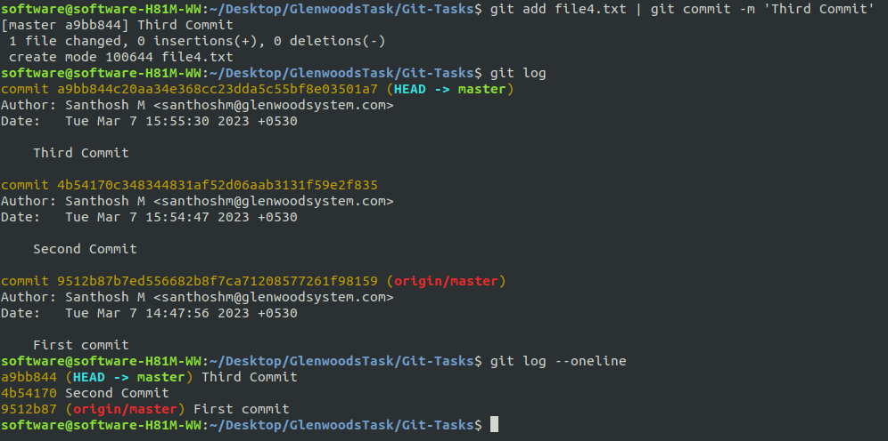

8.Git branch:
Use branch we working same version with another variant to implement our idio without affect the main version and also avoid unwanted commits and maintain our repository clean.
a.Creat ,View ,delete and checkout branch.
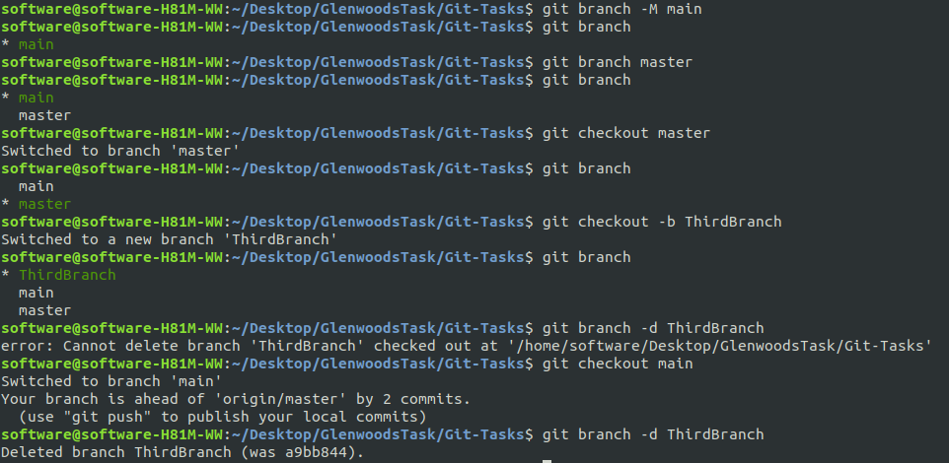
Before delete the branch first checkout from that branch.
9.Git merge and conflict:

My tips : Many Problems happend while merging, So before Start work with git repositry git pull is the good practics.(Or)Chang the remote repository only to accept the pull request without merge.

Merge conflict also happning while meargeing with our another branch also.

Below I am create same file name with diffrent codes for two branch,And merge that branches to create mini merge conflect
e.g: To Solve the merge conflict, Here I am using vimdiff to compare files and solve.
You can use any other text editers also.

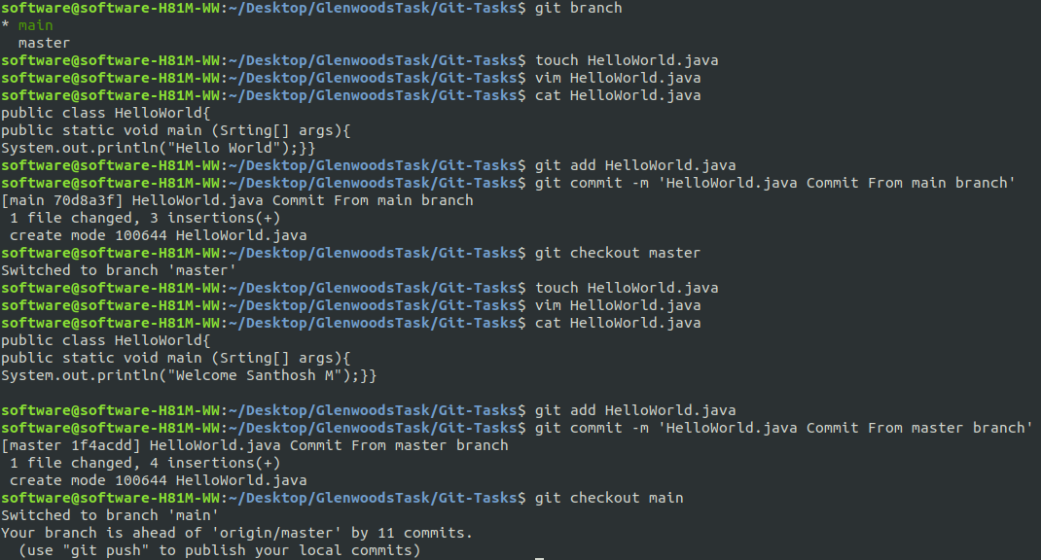
Mearge master branch to main
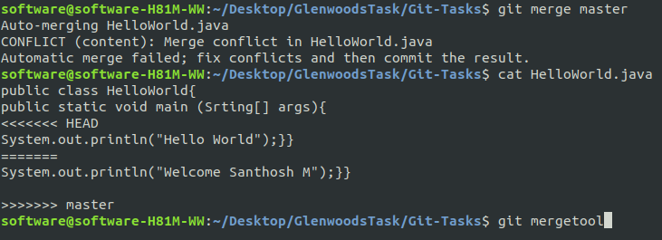

After merge conflixt i am open Configred tool vimdiff using ‘git merge tool command’

Compare the extra line and remove using these Vimdiff

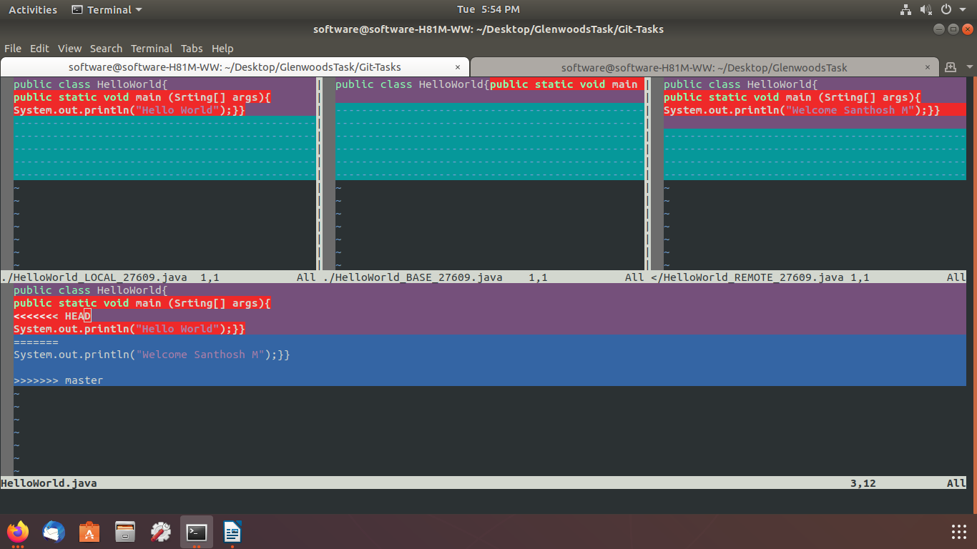

After Fix Close vimdiff using :wq Command

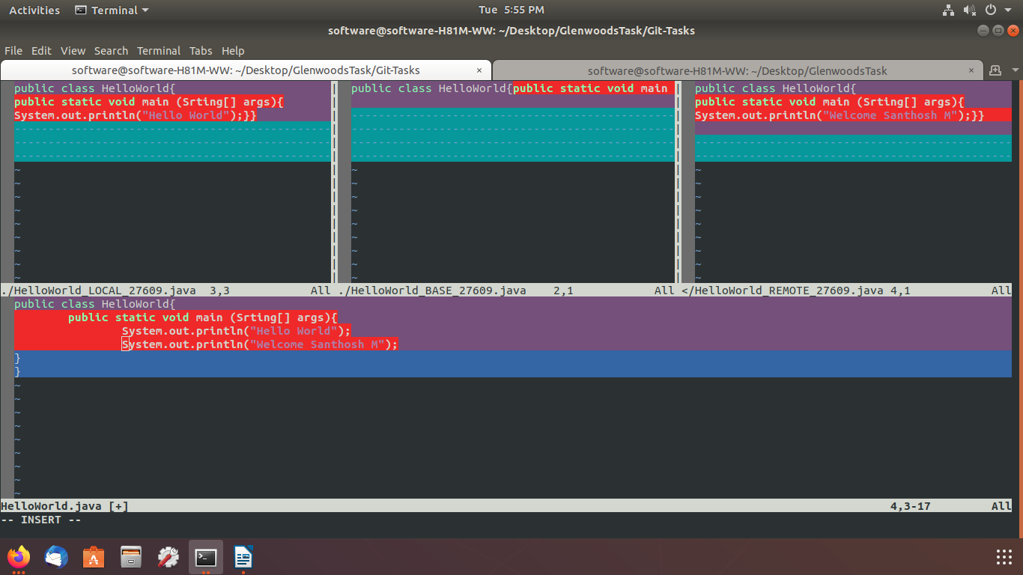

Now the code is corrected in main branch

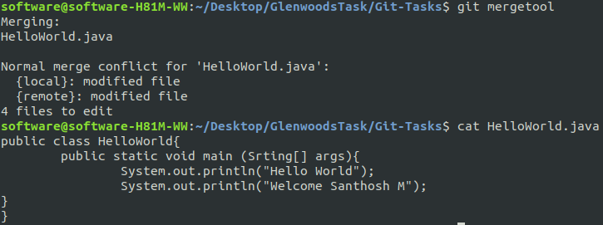
10.Git reset:Change and work Previous WD

git reset –hard: change working directory to exact reset version
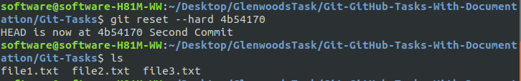
git checkout -b oldversion commitID : Create another branch with that reset version
