

SCHOOL OF ENGINEERING

Department of Artificial Intelligence and Machine Learning

CERTIFICATE

This is to certify that the Cornerstone project work entitled “STUDENT ENGAGEMENT & ACHIVEMENT ANALYSIS” is submitted by

A TEJASRI SAI SANTHOSH | (24B11AI019)
B KALYANI | (24B11AI044)
G MOUNIKA | (24B11AI135)
J AKSHARA HASINI | (24B11AI146)

in partial fulfillment of the requirements for the award of the B.Tech. degree in Artificial Intelligence and Machine Learning for the academic year 2025-2026.

Project Guide Head of the Department
Dr. K N S L Kumar, M.Tech., Ph.D, Dr. M. Venkatesh, M.Tech., Ph.D,
Assistant Professor, Associate Professor,
Department of AIML Department of AIML

DECLARATION

We hereby declare that the Cornerstone project entitled “STUDENT ENGAGEMENT & ACHIVEMENT ANALYSIS” is original and is submitted to ADITYA UNIVERSITY, Surampalem, in partial fulfillment of the requirements for the award of the B.Tech. degree in Artificial Intelligence and Machine Learning. We further declare that this project work has not been submitted, either in full or in part, for the award of any degree in this or any other institution. We also confirm that this work complies with the Institutional Academic Integrity and AI Usage Policy

Place: Surampalem
Date:

By

A T SAI SANTHOSH | (24B11AI019)
B KALYANI | (24B11AI044)
G MOUNIKA | (24B11AI135)
J AKSHARA HASINI | (24B11AI146)

ACKNOWLEDGEMENT

It is with immense pleasure that we would like to express us indebted gratitude to our project Guide Dr. K N S L Kumar, M.Tech,Ph.D., who has guided us a lot and encourage in every step of the project work, his valuable moral support and guidance throughout the project helped us a greater extent.
We are grateful to Dr. Maganti Venkatesh, Assoc. Prof. and HoD, for inspiring us all the way and for arranging all the facilities and resources needed for our project.
We wish to thank Dr. M.V. Rajesh, Assoc. Dean SoE. for the encouragement and support during the course of my project.
We would like to extend our sincere thanks to Dr. A. Ramesh, Pro Vice-Chancellor (Engg. & Sci.), Dr. G. Suresh, Registrar, Dr. S.Rama Sree, Pro Vice-Chancellor (Academics), Dr. M.B. Srinivas, Vice-Chancellor, Dr. M. Sreenivasa Reddy, Deputy Pro-Chancellor and Management, Aditya University for unconditional support for providing us the best infrastructural facilities and state of the art laboratories during our project.
Not to forget, Parents Faculty, Teaching, Non-Teaching Staff and our Friends who have directly or indirectly supported us in completing this project on time.

ABSTRACT
The modern education system is evolving beyond academic performance, where student success now depends on both academics and co-curricular engagement. However, most institutions only track participation as attendance, not the quality or impact of involvement, leading to an “Engagement-Achievement Gap.” This gap makes it difficult to understand which activities truly contribute to skill development and recognition. This project aims to bridge that gap using data mining techniques by analyzing the relationship between student engagement and achievement. It evaluates factors such as event category, role, and consistency of participation to identify meaningful patterns. By moving from traditional reporting to predictive analysis, the system uncovers key behaviors that influence student success. Machine learning techniques are used to gain deeper insights, where clustering methods like K-Means group students into different engagement profiles, and classification methods like Decision Trees predict achievement outcomes. The model helps distinguish high achievers from passive participants and identifies important factors such as leadership roles and active participation. It also highlights high-impact events that contribute significantly to student growth. This enables institutions to improve planning, optimize resource allocation, and replace low-impact activities with more effective ones. The system acts as a decision-support tool for administrators, providing data-driven insights for enhancing student engagement strategies. At the same time, students benefit by understanding how to improve their participation and build stronger profiles for future careers. Overall, the project promotes data-driven decision-making in education and ensures that co-curricular activities become a key factor in achieving student success.
Keywords:
Student Engagement, Data Mining , Machine Learning, Achievement Prediction

LIST OF CONTENTS
CONTENTS | PAGE NO
LIST OF FIGURES | iv
LIST OF TABLES | v
Chapter 1: INTRODUCTION | 1
1.1 Introduction of Project Domain | 1
1.2 Problem Statement | 1
1.3 Objectives of the Project | 1
1.4 Scope of the Project | 1
Chapter 2: SYSTEM OVERVIEW | 2
2.1 Existing System | 2
2.2 Limitations of Existing System | 2
2.3 Proposed System | 2
2.4 Software Requirements | 2
2.5 Hardware Requirements | 2
Chapter 3: TECHNOLOGIES USED | 3
3.1 WEKA | 3
3.2 Java | 3
3.3 CSV Files | 3
3.4 ARFF Format | 3
3.5 ETL Process | 3
Chapter 4: DATABASE DESIGN | 4
4.1 Database Table | 4
4.2 Table Structure | 4
4.3 Keys and Constraints | 4
4.4 Table Relationships | 5
4.5 Sample Data / Sample Record | 5
Chapter 5: SYSTEM MODULES | 6
Chapter 6: IMPLEMENTATION | 7
6.1 Input Validation | 7
6.2 Exception Handling | 7
6.3 Data Processing and Transformation | 7
6.4 Model Implementation | 7
6.5 Result Generation | 7
Chapter 7: OUTPUT SCREENS | 8
7.1 ReplaceMissingValues | 8
7.2 NominalToBinary | 9
7.3 Normalise | 10
7.4 Decision Tree Visualization using WEKA | 11
7.5 SimpleKMeans Algorithm | 12
Chapter 8: CONCLUSION | 13
Chapter 9: FUTURE ENHANCEMENTS | 14
Chapter 10: REFERENCES | 15
APPENDIX | 16

LIST OF FIGURES

FIGURE NO. | NAME OF THE FIGURE | PAGE NO
1 | Handling Missing Values using ReplaceMissingValues | 8
2 | Conversion of Categorical Attributes using NominalToBinary | 9
3 | Data Normalization using Normalize Filter | 10
4 | Decision Tree Visualization using J48 Algorithm | 11
5 | K-Means Clustering using SimpleKMeans Algorithm | 12

LIST OF TABLES

TABLE NO. | NAME OF THE TABLE | PAGE NO
1 | Student Engagement Table | 4
2 | _{Sample Student Engagement Data} | 5

1. INTRODUCTION

  - Introduction
Student engagement plays a vital role in determining academic success. This project uses machine learning techniques to analyze student engagement data and predict achievement levels. WEKA is used as the primary tool for preprocessing and classification. The system helps in identifying patterns and relationships between engagement factors and performance.
1.2 Problem Statement
In traditional systems, student performance analysis is done manually, which is time-consuming and prone to errors. It is difficult to identify key factors affecting student achievement using manual methods. Therefore, there is a need for an automated system that can efficiently analyze data and provide accurate predictions.
1.3 Objectives
- To analyze student engagement data
- To preprocess the dataset using WEKA
- To convert categorical data into machine-readable format
- To build a classification model using J48 algorithm
- To predict student achievement levels
1.4 Scope
The system can be used in analyze student behaviour and performance. It helps teachers and administrators understand how engagement impacts achievement and supports better decision-making.

2. SYSTEM OVERVIEW

2.1 Existing System
Currently, student data is analyzed manually or using basic tools like spreadsheets. There is no intelligent system to predict student performance based on engagement factors.
2.2 Limitations of Existing System
- Time-consuming process
- Prone to human errors
- Difficult to analyze large datasets
- No predictive capability
2.3 Proposed System
The proposed system uses WEKA to preprocess the dataset and apply machine learning algorithms. The J48 decision tree classifier is used to predict student achievement based on engagement attributes. This system automates data analysis and provides better insights.
2.4 Software Requirements
The system requires WEKA tool for data mining, along with Java environment. CSV/ARFF files are used for dataset handling. Basic operating system like Windows is sufficient.
2.5 Hardware Requirements
A basic computer system with at least 4GB RAM and standard processor is sufficient. No high-end hardware is required. It can run on any normal desktop or laptop.

3. TECHNOLOGIES USED

3.1 WEKA
WEKA is a data mining tool used in this project to perform data preprocessing and classification. It provides various filters such as ReplaceMissingValues, NominalToBinary, and Normalize to clean and transform the dataset. The J48 decision tree algorithm available in WEKA is used to build a classification model for predicting student achievement.

3.2 Java
Java is required to run WEKA since it is developed using the Java programming language. It provides platform independence and supports the execution of WEKA tools efficiently. Java ensures smooth functioning of the system environment used in this project.

3.3 CSV Files
CSV (Comma Separated Values) files are used to store and manage the student engagement dataset in a tabular format. These files are easy to handle and can be directly imported into WEKA for preprocessing and analysis.

3.4 ARFF Format
ARFF (Attribute Relation File Format) is the standard file format used by WEKA. It stores both data and metadata, making it suitable for machine learning tasks. The dataset is converted into ARFF format before applying algorithms.
3.5 ETL Process
ETL (Extract, Transform, Load) process is used to prepare the dataset for analysis. It involves extracting raw student engagement data, cleaning it by handling missing values, and transforming it into a structured format suitable for machine learning.

4. DATABASE DESIGN
4.1 Database Table
Student Engagement Table
This table stores all student engagement attributes along with the predicted achievement level.
4.2 Table Structure
Column Name | Data Type | Description
StudentID | VARCHAR | Unique identifier for each student
Dept | VARCHAR | Department of the student
Category | VARCHAR | Type of activity (Technical, Cultural, etc.)
Scale | VARCHAR | Level of activity (Department, College, National)
Participation | VARCHAR | Type of participation (Volunteer, Organizer, etc.)
Freq | INT | Frequency of participation
Time_Inv | FLOAT | Time invested in activities
Prior_Exp | VARCHAR | Prior experience (Yes/No)
Motivation | VARCHAR | Reason for participation (Skill, Social, etc.)
Role | VARCHAR | Role type (Individual/Team)
Mentor | VARCHAR | Mentorship support (Yes/No)
Achievement | VARCHAR | Target variable (High Achiever, Participant, etc.)
Table 4.1: Student Engagement Table

4.3 Keys and Constraints
4.3.1 Primary Key
- StudentID → Unique identifier for each student record
4.3.2 Constraints
- NOT NULL → Dept, Category, Participation, Motivation, Achievement
- CHECK Constraints:
- Prior_Exp IN ('Yes', 'No')
- Role IN ('Individual', 'Team')
- Range Constraints (logical):
- Freq ≥ 0
- Time_Inv ≥ 0
- StudentID should be UNIQUE
4.4 Table relationships:
No relationships (Single table only)
Since all data is in one dataset, no need for multiple tables
This is a flat table structure, suitable for data mining using WEKA
4.5 Sample Data / Sample Record:
_{Dept} | _{Category} | _{Participation} | _{Freq} | _{Time_Inv} | _{Motivation} | _{Role} | _{Achievement}
_{CSE} | _{Technical} | _{Volunteer} | ₃ | _{5.5} | _{Skill Dev} | _{Individual} | _{High Achiever}
_{ECE} | _{Cultural} | _{Attendee} | ₁ | _{2.0} | _{Social} | _{Team} | _{Participant}
_{CSE} | _{Sports} | _{Organizer} | ₄ | _{6.5} | _{Leadership} | _{Team} | _{Consistent Contributor}
_{MECH} | _{Technical} | _{Volunteer} | ₂ | _{4.0} | _{Skill Dev} | _{Individual} | _{Participant}
_{EEE} | _{Cultural} | _{Attendee} | ₁ | _{1.5} | _{Social} | _{Team} | _{Participant}
Table 4.2: Sample Student Engagement Data
5. SYSTEM MODULES
Module 1: Data Collection
This module is responsible for collecting student engagement data such as department, category of activity, participation level, motivation, role, prior experience, and time investment. The dataset is stored in CSV format and used for further processing in WEKA.
Module 2: Data Preprocessing (ETL)
In this module, the raw dataset is cleaned and prepared for analysis. Missing values are handled, irrelevant attributes such as StudentID are removed, and categorical data is transformed into a structured format suitable for machine learning using WEKA filters.
Module 3: Data Transformation
The cleaned dataset is converted into ARFF format and transformed using techniques such as NominalToBinary conversion and normalization. The target attribute (Achievement) is properly defined for classification.
Module 4: Model Building (J48 Algorithm)
This module applies the J48 decision tree algorithm to the processed dataset. The model is trained using student engagement attributes to classify and predict achievement levels. The decision tree structure helps in understanding relationships between attributes.
Module 5: Model Evaluation
The performance of the classification model is evaluated using 10-fold cross-validation. Metrics such as accuracy, precision, recall, and confusion matrix are used to assess the prediction performance.
Module 6: Result Visualization
The final decision tree is visualized using WEKA. The visualization clearly shows how different engagement attributes such as participation, motivation, and role influence student achievement.

6. IMPLEMENTATION
6.1 Input Validation
Before processing the dataset in WEKA, the input data is validated to ensure correctness and consistency. Missing values are handled, and invalid or inconsistent entries are removed. Categorical attributes such as participation, role, and prior experience are checked to ensure they contain valid values. This step ensures that only clean and reliable data is used for analysis.
6.2 Exception Handling
During preprocessing and model building, WEKA handles exceptions such as missing values, incompatible data types, and invalid attribute formats. These issues are resolved using preprocessing filters like ReplaceMissingValues and NominalToBinary. This ensures smooth execution of the data mining process without errors.
6.3 Data Processing and Transformation
The dataset is processed using WEKA filters to prepare it for machine learning. Irrelevant attributes such as StudentID are removed. Categorical data is converted into binary format using NominalToBinary, and normalization is applied to scale numeric values. The dataset is then converted into ARFF format for compatibility with WEKA.
6.4 Model Implementation
The J48 decision tree algorithm is applied to the preprocessed dataset. The model is trained using student engagement attributes, and 10-fold cross-validation is used for evaluation. The decision tree is generated to classify students into different achievement levels.
6.5 Result Generation
The output of the model includes classification accuracy, confusion matrix, and decision tree visualization. These results help in understanding the performance of the model and the influence of different attributes on student achievement.

7. OUTPUT SCREENS
The following section presents the output screens of the system. These screenshots demonstrate the preprocessing steps, classifier selection, and results obtained using WEKA. Each screen represents a stage in the implementation of the project.
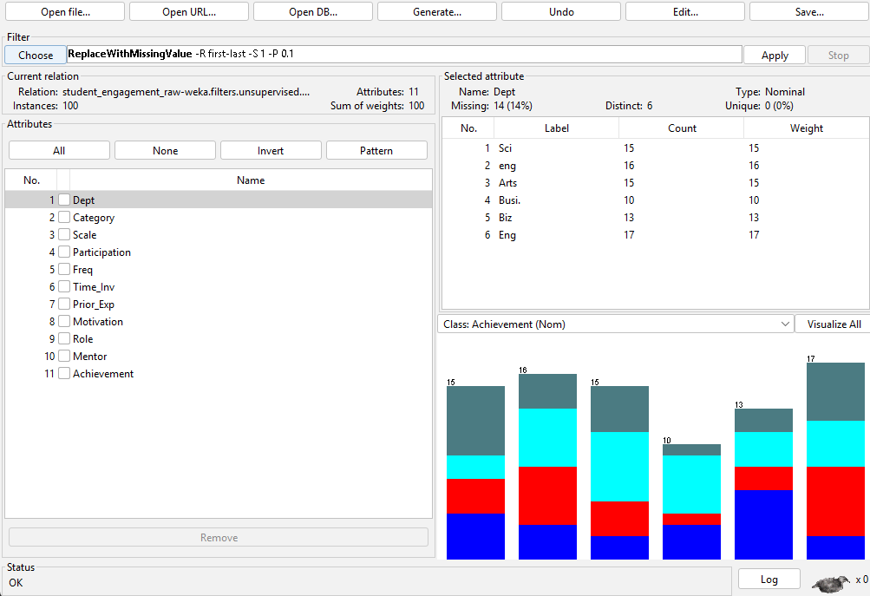
Figure 7.1: Handling Missing Values using ReplaceMissingValues Filter in WEKA
ReplaceMissingValues:
The dataset is loaded into WEKA’s Preprocess tab, where different student engagement attributes are displayed. The ReplaceMissingValues filter is selected to handle missing data, ensuring data completeness. Statistical details such as distribution and missing values are shown for each attribute, helping in better understanding of the data before applying the J48 algorithm.

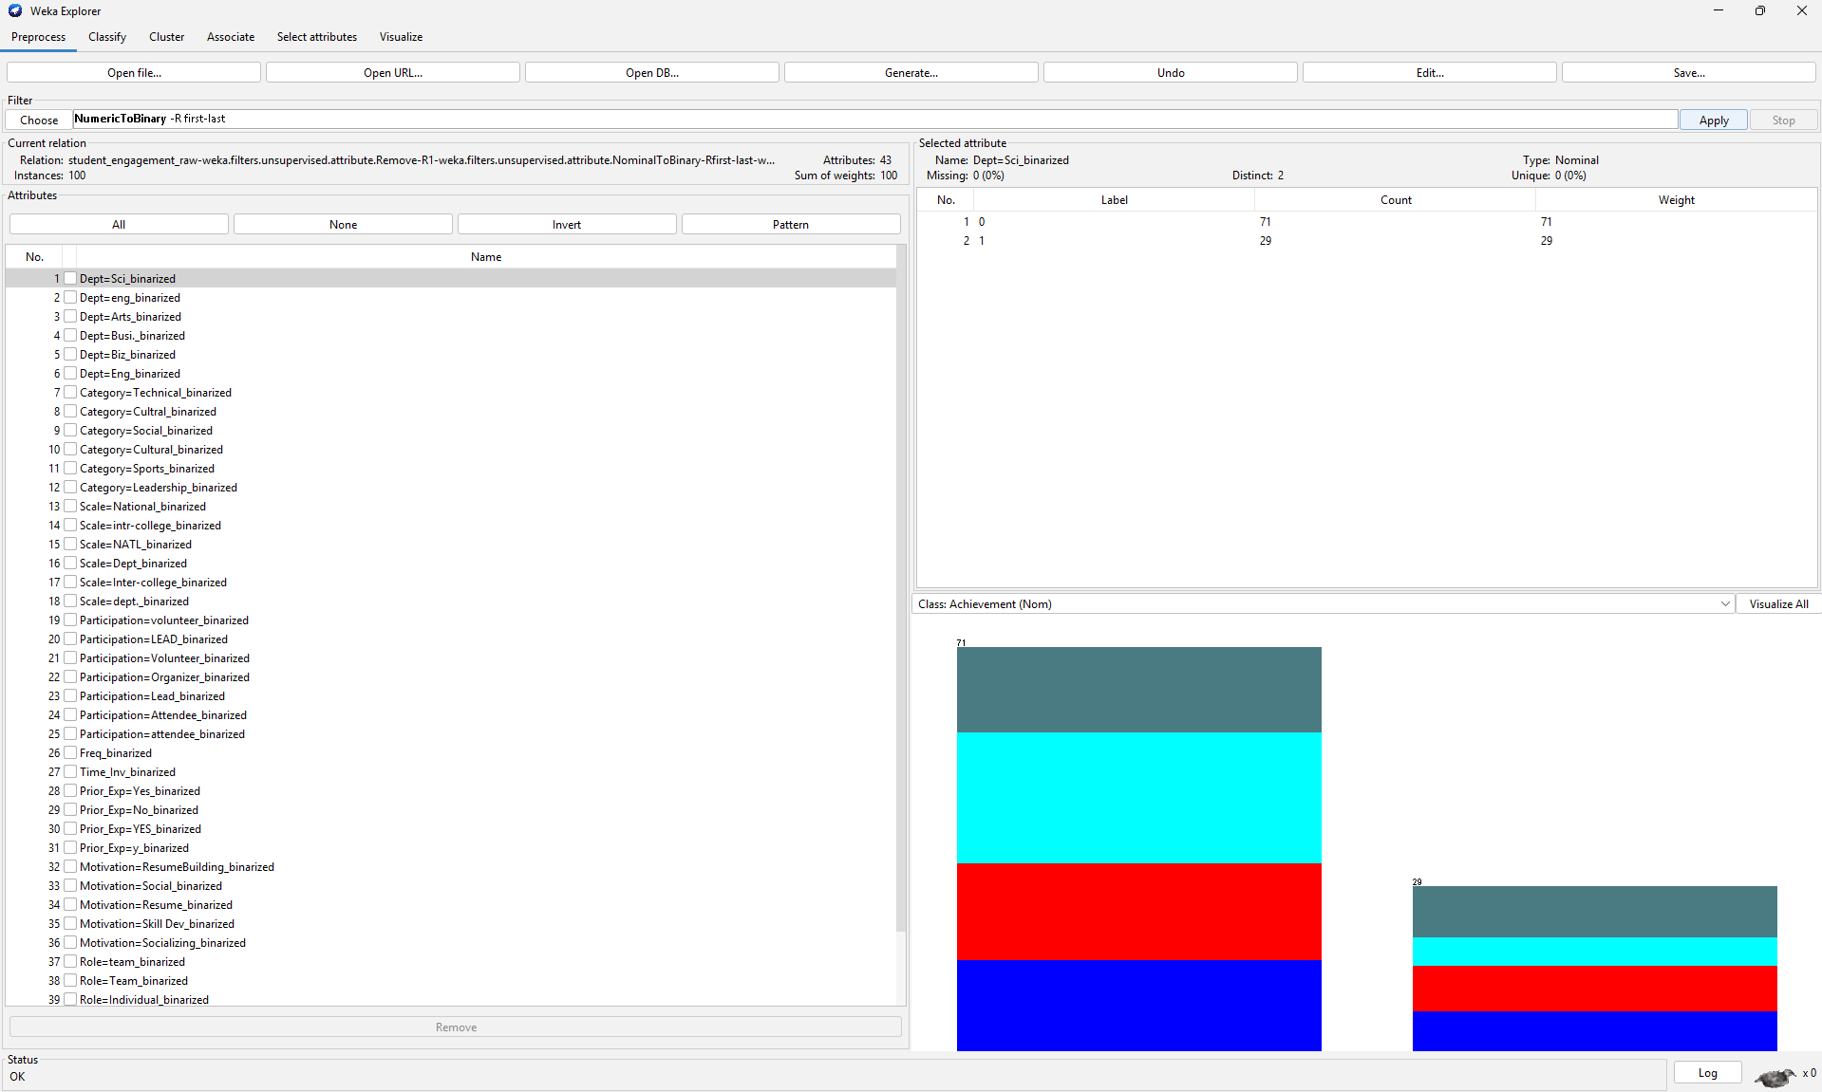
Figure 7.2: Conversion of Categorical Attributes using NominalToBinary Filter in WEKA
NominalToBinary:
The dataset is displayed in WEKA’s Preprocess tab after applying data transformation techniques. The NominalToBinary filter has been used to convert categorical attributes into binary format, resulting in multiple binarized attributes. The selected attribute shows binary values (0 and 1) with their distribution. The class attribute is set to Achievement, and the visualization panel displays the distribution of class labels. This transformation prepares the dataset for effective classification using the J48 algorithm.

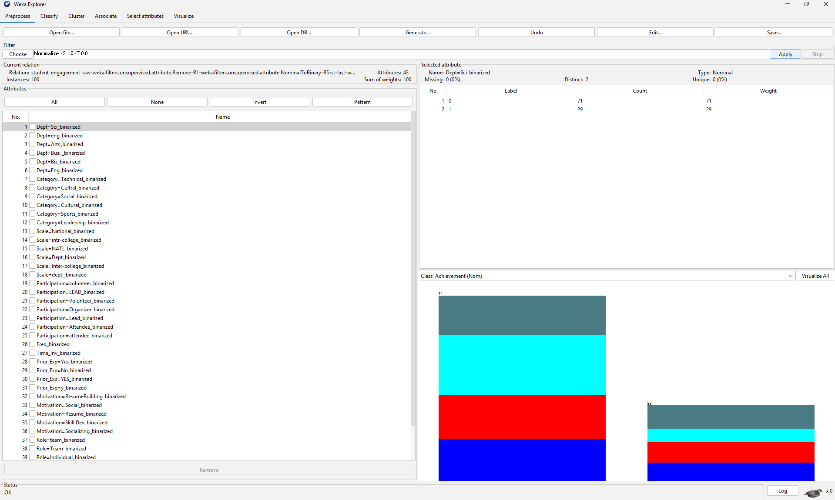
Figure 7.3: Data Normalization using Normalize Filter in WEKA
Normalize:
The dataset is displayed in WEKA’s Preprocess tab after applying normalization. The Normalize filter is selected to scale all numeric attribute values within a standard range, improving consistency across the dataset. The attributes have already been converted into binary format, and no missing values are present. The class attribute is set to Achievement, and the visualization panel shows the distribution of class labels. This step ensures that the dataset is properly scaled and ready for accurate classification using the J48 algorithm.

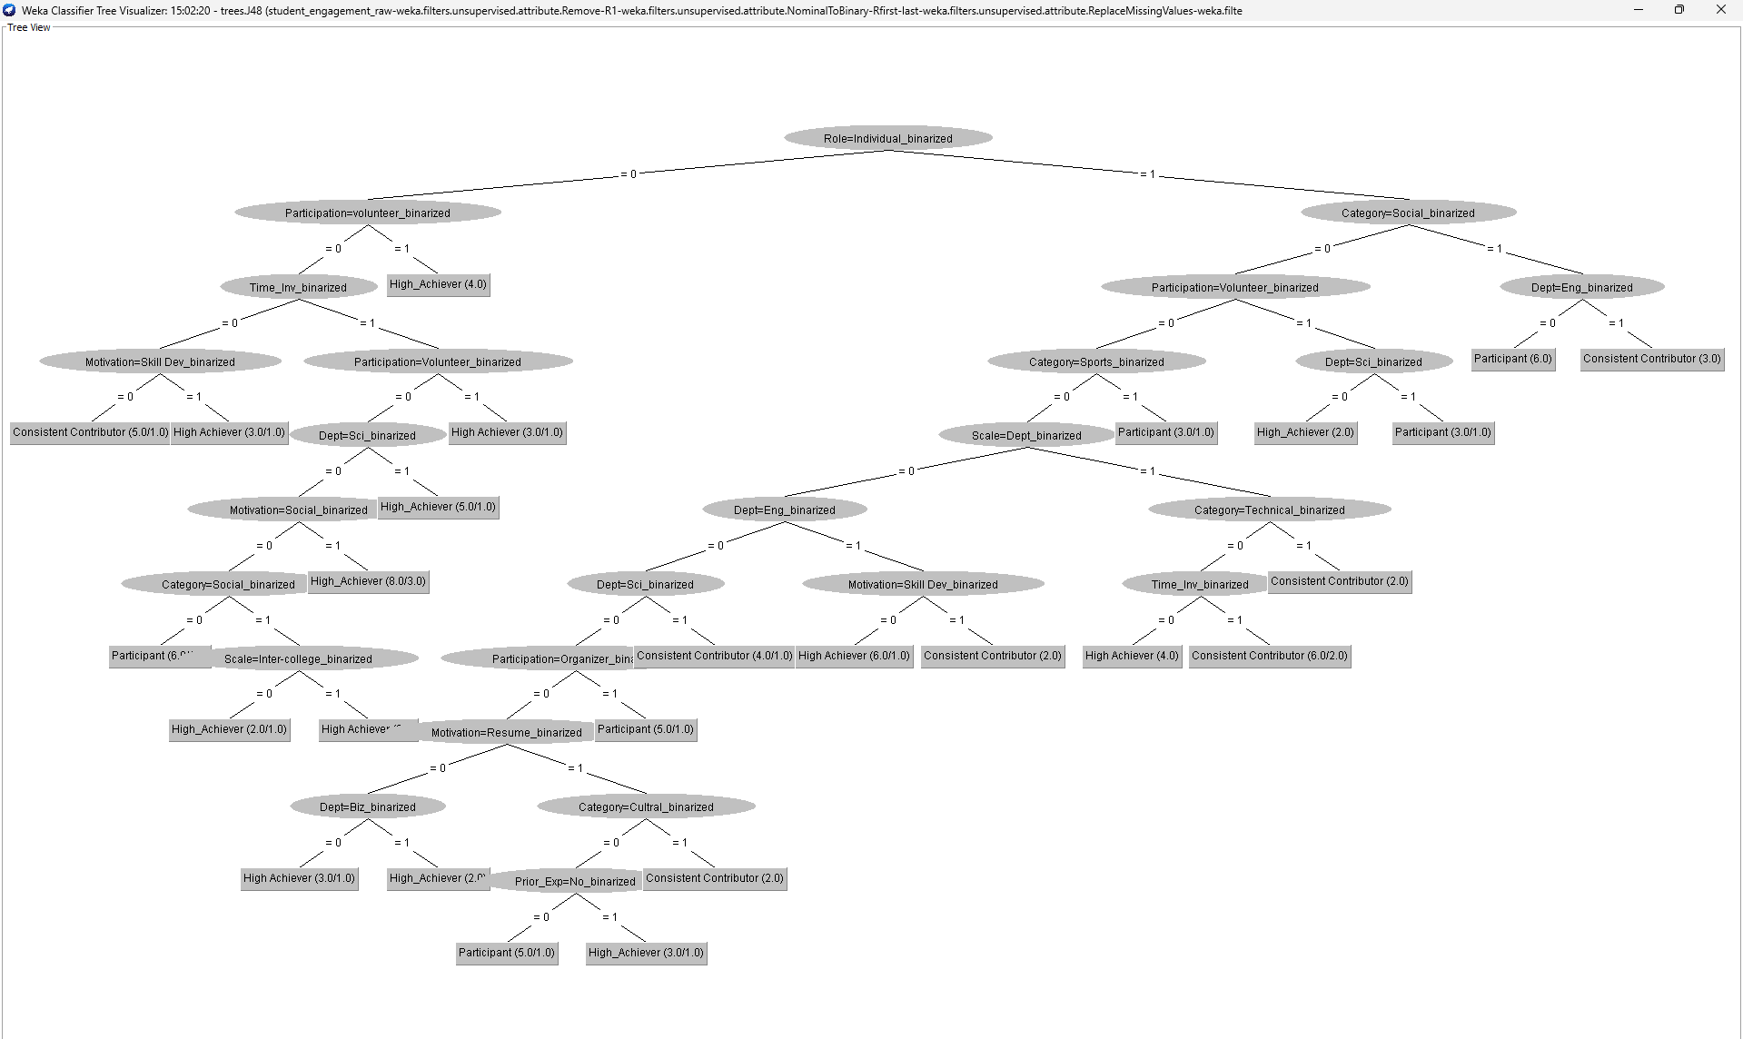
Figure 7.4: Decision Tree Visualization using J48 Algorithm in WEKA
Decision Tree:
This decision tree predicts student achievement using Role_Individual, followed by Participation_Volunteer, Category_Social, and Dept_Eng attributes.
If Role_Individual = 0, it checks Participation; if participation is high, it predicts High Achiever, otherwise it further evaluates time investment and motivation.
If Role_Individual = 1, it checks Category; if Category is Social, it evaluates department and predicts Consistent Contributor or Participant.
In some branches, attributes like Motivation, Scale, and Prior Experience are used to refine the prediction between High Achiever, Participant, and Consistent Contributor.

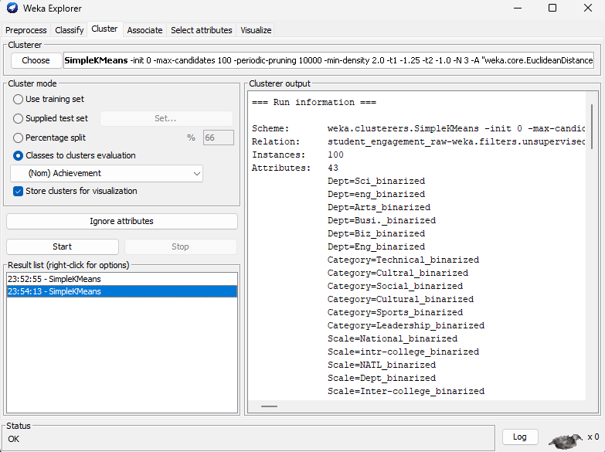

Figure 7.5: K-Means Clustering using SimpleKMeans Algorithm in WEKA
SimpleKMeans:
The dataset is processed in WEKA’s Cluster tab using the SimpleKMeans algorithm to perform clustering. The “Classes to clusters evaluation” option is selected with Achievement as the reference attribute. The model groups the data into clusters based on similarities among attributes such as participation, motivation, and role. The clustering results, including cluster distribution and attribute details, are displayed in the output section, helping to identify patterns in student engagement.

8. CONCLUSION
In this project, student engagement data was successfully analyzed using the WEKA data mining tool. The dataset was preprocessed by handling missing values, converting categorical attributes into binary format, and normalizing the data to improve consistency. The J48 decision tree algorithm was applied to build a classification model for predicting student achievement levels.
The results demonstrate that attributes such as participation, motivation, role, and category significantly influence student performance. The decision tree provided clear and interpretable rules for classification. Although the model achieved moderate accuracy, it effectively highlights the relationship between engagement factors and academic outcomes.
Overall, this project shows how machine learning techniques can be used to analyze educational data and support better decision-making in academic environments.
The model achieved an accuracy of 27%, which can be improved by using larger datasets and advanced algorithms.

9. Future Enhancements
- Real-time Data Integration – Integrate real-time student data from institutional systems for continuous performance monitoring and prediction.
- Multi-class Prediction Enhancement – Improve classification by refining achievement categories and handling more detailed performance levels.
- Improved Accuracy – Use advanced algorithms like Random Forest, Support Vector Machines, or Neural Networks to enhance prediction accuracy.
- User Interface Development – Develop a web or mobile application to allow easy interaction and visualization of student performance data.
- Personalized Recommendations – Provide suggestions to students based on their engagement patterns to improve performance.
- Data Visualization & Insights – Use graphs and dashboards to visualize trends in student engagement and achievement.
- Large Dataset Handling – Extend the system to handle larger datasets using big data technologies.
- Automation – Automate data collection, preprocessing, and prediction processes for efficient analysis.

10. REFERENCES

- WEKA Official Website – https://www.cs.waikato.ac.nz/ml/weka/
- Data Mining: Concepts and Techniques – For understanding data mining concepts and algorithms
- Machine Learning Basics – For basic machine learning theory and classification techniques
- WEKA Documentation – For learning preprocessing, filters, and classification methods
- GeeksforGeeks – For tutorials on data mining and machine learning concepts
- TutorialsPoint – For reference materials on WEKA and classification algorithms

11. APPENDIX

=== Run information ===

Scheme: weka.classifiers.trees.J48 -C 0.25 -M 2
Relation: student_engagement_raw-weka.filters.unsupervised.attribute.Remove-R1-weka.filters.unsupervised.attribute.NominalToBinary-Rfirst-last-weka.filters.unsupervised.attribute.ReplaceMissingValues-weka.filters.unsupervised.attribute.NumericToBinary-Rfirst-last-weka.filters.unsupervised.attribute.Normalize-S1.0-T0.0-weka.filters.unsupervised.attribute.Normalize-S1.0-T0.0-weka.filters.unsupervised.attribute.Normalize-S1.0-T0.0-weka.filters.unsupervised.attribute.Normalize-S1.0-T0.0-weka.filters.unsupervised.attribute.Normalize-S1.0-T0.0-weka.filters.unsupervised.attribute.Normalize-S1.0-T0.0-weka.filters.unsupervised.attribute.Normalize-S1.0-T0.0-weka.filters.unsupervised.attribute.Normalize-S1.0-T0.0-weka.filters.unsupervised.attribute.Normalize-S1.0-T0.0-weka.filters.unsupervised.attribute.Normalize-S1.0-T0.0-weka.filters.unsupervised.attribute.Normalize-S1.0-T0.0-weka.filters.unsupervised.attribute.Normalize-S1.0-T0.0-weka.filters.unsupervised.attribute.Normalize-S1.0-T0.0-weka.filters.unsupervised.attribute.Normalize-S1.0-T0.0-weka.filters.unsupervised.attribute.Normalize-S1.0-T0.0-weka.filters.unsupervised.attribute.Normalize-S1.0-T0.0
Instances: 100
Attributes: 43
Dept=Sci_binarized
Dept=eng_binarized
Dept=Arts_binarized
Dept=Busi._binarized
Dept=Biz_binarized
Dept=Eng_binarized
Category=Technical_binarized
Category=Cultral_binarized
Category=Social_binarized
Category=Cultural_binarized
Category=Sports_binarized
Category=Leadership_binarized
Scale=National_binarized
Scale=intr-college_binarized
Scale=NATL_binarized
Scale=Dept_binarized
Scale=Inter-college_binarized
Scale=dept._binarized
Participation=volunteer_binarized
Participation=LEAD_binarized
Participation=Volunteer_binarized
Participation=Organizer_binarized
Participation=Lead_binarized
Participation=Attendee_binarized
Participation=attendee_binarized
Freq_binarized
Time_Inv_binarized
Prior_Exp=Yes_binarized
Prior_Exp=No_binarized
Prior_Exp=YES_binarized
Prior_Exp=y_binarized
Motivation=ResumeBuilding_binarized
Motivation=Social_binarized
Motivation=Resume_binarized
Motivation=Skill Dev_binarized
Motivation=Socializing_binarized
Role=team_binarized
Role=Team_binarized
Role=Individual_binarized
Mentor=No_binarized
Mentor=Yes_binarized
Mentor=YES_binarized
Achievement
Test mode: 10-fold cross-validation

=== Classifier model (full training set) ===

J48 pruned tree
------------------

Role=Individual_binarized = 0
| Participation=volunteer_binarized = 0
| | Time_Inv_binarized = 0
| | | Motivation=Skill Dev_binarized = 0: Consistent Contributor (5.0/1.0)
| | | Motivation=Skill Dev_binarized = 1: High Achiever (3.0/1.0)
| | Time_Inv_binarized = 1
| | | Participation=Volunteer_binarized = 0
| | | | Dept=Sci_binarized = 0
| | | | | Motivation=Social_binarized = 0
| | | | | | Category=Social_binarized = 0: Participant (6.0/1.0)
| | | | | | Category=Social_binarized = 1
| | | | | | | Scale=Inter-college_binarized = 0: High_Achiever (2.0/1.0)
| | | | | | | Scale=Inter-college_binarized = 1: High Achiever (3.0)
| | | | | Motivation=Social_binarized = 1: High_Achiever (8.0/3.0)
| | | | Dept=Sci_binarized = 1: High_Achiever (5.0/1.0)
| | | Participation=Volunteer_binarized = 1: High Achiever (3.0/1.0)
| Participation=volunteer_binarized = 1: High_Achiever (4.0)
Role=Individual_binarized = 1
| Category=Social_binarized = 0
| | Participation=Volunteer_binarized = 0
| | | Category=Sports_binarized = 0
| | | | Scale=Dept_binarized = 0
| | | | | Dept=Eng_binarized = 0
| | | | | | Dept=Sci_binarized = 0
| | | | | | | Participation=Organizer_binarized = 0
| | | | | | | | Motivation=Resume_binarized = 0
| | | | | | | | | Dept=Biz_binarized = 0: High Achiever (3.0/1.0)
| | | | | | | | | Dept=Biz_binarized = 1: High_Achiever (2.0)
| | | | | | | | Motivation=Resume_binarized = 1
| | | | | | | | | Category=Cultral_binarized = 0
| | | | | | | | | | Prior_Exp=No_binarized = 0: Participant (5.0/1.0)
| | | | | | | | | | Prior_Exp=No_binarized = 1: High_Achiever (3.0/1.0)
| | | | | | | | | Category=Cultral_binarized = 1: Consistent Contributor (2.0)
| | | | | | | Participation=Organizer_binarized = 1: Participant (5.0/1.0)
| | | | | | Dept=Sci_binarized = 1: Consistent Contributor (4.0/1.0)
| | | | | Dept=Eng_binarized = 1
| | | | | | Motivation=Skill Dev_binarized = 0: High Achiever (6.0/1.0)
| | | | | | Motivation=Skill Dev_binarized = 1: Consistent Contributor (2.0)
| | | | Scale=Dept_binarized = 1
| | | | | Category=Technical_binarized = 0
| | | | | | Time_Inv_binarized = 0: High Achiever (4.0)
| | | | | | Time_Inv_binarized = 1: Consistent Contributor (6.0/2.0)
| | | | | Category=Technical_binarized = 1: Consistent Contributor (2.0)
| | | Category=Sports_binarized = 1: Participant (3.0/1.0)
| | Participation=Volunteer_binarized = 1
| | | Dept=Sci_binarized = 0: High_Achiever (2.0)
| | | Dept=Sci_binarized = 1: Participant (3.0/1.0)
| Category=Social_binarized = 1
| | Dept=Eng_binarized = 0: Participant (6.0)
| | Dept=Eng_binarized = 1: Consistent Contributor (3.0)

Number of Leaves : 26

Size of the tree : 51

Time taken to build model: 0.01 seconds

=== Stratified cross-validation ===
=== Summary ===

Correctly Classified Instances 27 27 %
Incorrectly Classified Instances 73 73 %
Kappa statistic 0.0276
Mean absolute error 0.3814
Root mean squared error 0.5569
Relative absolute error 101.7636 %
Root relative squared error 128.5655 %
Total Number of Instances 100

=== Detailed Accuracy By Class ===

TP Rate FP Rate Precision Recall F-Measure MCC ROC Area PRC Area Class
0.304 0.273 0.250 0.304 0.275 0.030 0.514 0.240 High_Achiever
0.280 0.293 0.241 0.280 0.259 -0.013 0.481 0.242 High Achiever
0.214 0.236 0.261 0.214 0.235 -0.023 0.425 0.269 Participant
0.292 0.171 0.350 0.292 0.318 0.129 0.505 0.255 Consistent Contributor
Weighted Avg. 0.270 0.243 0.275 0.270 0.270 0.028 0.479 0.252

=== Confusion Matrix ===

a b c d <-- classified as
7 6 5 5 | a = High_Achiever
8 7 6 4 | b = High Achiever
8 10 6 4 | c = Participant
5 6 6 7 | d = Consistent Contributor

=== Source code ===

// Generated with Weka 3.8.6
//
// This code is public domain and comes with no warranty.
//
// Timestamp: Sun Mar 22 20:46:57 IST 2026

package weka.classifiers;

import weka.core.Attribute;
import weka.core.Capabilities;
import weka.core.Capabilities.Capability;
import weka.core.Instance;
import weka.core.Instances;
import weka.core.RevisionUtils;
import weka.classifiers.Classifier;
import weka.classifiers.AbstractClassifier;

public class WekaWrapper
extends AbstractClassifier {

/**
* Returns only the toString() method.
*
* @return a string describing the classifier
*/
public String globalInfo() {
return toString();
}

/**
* Returns the capabilities of this classifier.
*
* @return the capabilities
*/
public Capabilities getCapabilities() {
weka.core.Capabilities result = new weka.core.Capabilities(this);

result.enable(weka.core.Capabilities.Capability.NOMINAL_ATTRIBUTES);
result.enable(weka.core.Capabilities.Capability.NUMERIC_ATTRIBUTES);
result.enable(weka.core.Capabilities.Capability.DATE_ATTRIBUTES);
result.enable(weka.core.Capabilities.Capability.MISSING_VALUES);
result.enable(weka.core.Capabilities.Capability.NOMINAL_CLASS);
result.enable(weka.core.Capabilities.Capability.MISSING_CLASS_VALUES);

result.setMinimumNumberInstances(0);

return result;
}

/**
* only checks the data against its capabilities.
*
* @param i the training data
*/
public void buildClassifier(Instances i) throws Exception {
// can classifier handle the data?
getCapabilities().testWithFail(i);
}

/**
* Classifies the given instance.
*
* @param i the instance to classify
* @return the classification result
*/
public double classifyInstance(Instance i) throws Exception {
Object[] s = new Object[i.numAttributes()];

for (int j = 0; j < s.length; j++) {
if (!i.isMissing(j)) {
if (i.attribute(j).isNominal())
s[j] = new String(i.stringValue(j));
else if (i.attribute(j).isNumeric())
s[j] = new Double(i.value(j));
}
}

// set class value to missing
s[i.classIndex()] = null;

return WekaClassifier.classify(s);
}

/**
* Returns the revision string.
*
* @return the revision
*/
public String getRevision() {
return RevisionUtils.extract("1.0");
}

/**
* Returns only the classnames and what classifier it is based on.
*
* @return a short description
*/
public String toString() {
return "Auto-generated classifier wrapper, based on weka.classifiers.trees.J48 (generated with Weka 3.8.6).\n" + this.getClass().getName() + "/WekaClassifier";
}

/**
* Runs the classfier from commandline.
*
* @param args the commandline arguments
*/
public static void main(String args[]) {
runClassifier(new WekaWrapper(), args);
}
}

class WekaClassifier {

public static double classify(Object[] i)
throws Exception {

double p = Double.NaN;
p = WekaClassifier.N48e49e0c0(i);
return p;
}
static double N48e49e0c0(Object []i) {
double p = Double.NaN;
if (i[38] == null) {
p = 0;
} else if (i[38].equals("0")) {
p = WekaClassifier.N29ecc8f1(i);
} else if (i[38].equals("1")) {
p = WekaClassifier.N291293fa9(i);
}
return p;
}
static double N29ecc8f1(Object []i) {
double p = Double.NaN;
if (i[18] == null) {
p = 0;
} else if (i[18].equals("0")) {
p = WekaClassifier.N685c8db02(i);
} else if (i[18].equals("1")) {
p = 0;
}
return p;
}
static double N685c8db02(Object []i) {
double p = Double.NaN;
if (i[26] == null) {
p = 3;
} else if (i[26].equals("0")) {
p = WekaClassifier.N35176ef43(i);
} else if (i[26].equals("1")) {
p = WekaClassifier.N596f92a44(i);
}
return p;
}
static double N35176ef43(Object []i) {
double p = Double.NaN;
if (i[34] == null) {
p = 3;
} else if (i[34].equals("0")) {
p = 3;
} else if (i[34].equals("1")) {
p = 1;
}
return p;
}
static double N596f92a44(Object []i) {
double p = Double.NaN;
if (i[20] == null) {
p = 0;
} else if (i[20].equals("0")) {
p = WekaClassifier.N2de1c7b25(i);
} else if (i[20].equals("1")) {
p = 1;
}
return p;
}
static double N2de1c7b25(Object []i) {
double p = Double.NaN;
if (i[0] == null) {
p = 0;
} else if (i[0].equals("0")) {
p = WekaClassifier.N215ceeb36(i);
} else if (i[0].equals("1")) {
p = 0;
}
return p;
}
static double N215ceeb36(Object []i) {
double p = Double.NaN;
if (i[32] == null) {
p = 2;
} else if (i[32].equals("0")) {
p = WekaClassifier.N2f3244a27(i);
} else if (i[32].equals("1")) {
p = 0;
}
return p;
}
static double N2f3244a27(Object []i) {
double p = Double.NaN;
if (i[8] == null) {
p = 2;
} else if (i[8].equals("0")) {
p = 2;
} else if (i[8].equals("1")) {
p = WekaClassifier.Na6d09528(i);
}
return p;
}
static double Na6d09528(Object []i) {
double p = Double.NaN;
if (i[16] == null) {
p = 0;
} else if (i[16].equals("0")) {
p = 0;
} else if (i[16].equals("1")) {
p = 1;
}
return p;
}
static double N291293fa9(Object []i) {
double p = Double.NaN;
if (i[8] == null) {
p = 1;
} else if (i[8].equals("0")) {
p = WekaClassifier.N6ffdc91d10(i);
} else if (i[8].equals("1")) {
p = WekaClassifier.N2fa04d324(i);
}
return p;
}
static double N6ffdc91d10(Object []i) {
double p = Double.NaN;
if (i[20] == null) {
p = 1;
} else if (i[20].equals("0")) {
p = WekaClassifier.N5257971411(i);
} else if (i[20].equals("1")) {
p = WekaClassifier.N728b647c23(i);
}
return p;
}
static double N5257971411(Object []i) {
double p = Double.NaN;
if (i[10] == null) {
p = 1;
} else if (i[10].equals("0")) {
p = WekaClassifier.N3092239512(i);
} else if (i[10].equals("1")) {
p = 2;
}
return p;
}
static double N3092239512(Object []i) {
double p = Double.NaN;
if (i[15] == null) {
p = 2;
} else if (i[15].equals("0")) {
p = WekaClassifier.Nda2fb3e13(i);
} else if (i[15].equals("1")) {
p = WekaClassifier.N28c7976121(i);
}
return p;
}
static double Nda2fb3e13(Object []i) {
double p = Double.NaN;
if (i[5] == null) {
p = 2;
} else if (i[5].equals("0")) {
p = WekaClassifier.Nc166eb614(i);
} else if (i[5].equals("1")) {
p = WekaClassifier.N3f39f70120(i);
}
return p;
}
static double Nc166eb614(Object []i) {
double p = Double.NaN;
if (i[0] == null) {
p = 2;
} else if (i[0].equals("0")) {
p = WekaClassifier.N6217b71715(i);
} else if (i[0].equals("1")) {
p = 3;
}
return p;
}
static double N6217b71715(Object []i) {
double p = Double.NaN;
if (i[21] == null) {
p = 0;
} else if (i[21].equals("0")) {
p = WekaClassifier.N43b8ae4b16(i);
} else if (i[21].equals("1")) {
p = 2;
}
return p;
}
static double N43b8ae4b16(Object []i) {
double p = Double.NaN;
if (i[33] == null) {
p = 0;
} else if (i[33].equals("0")) {
p = WekaClassifier.N59d9c60917(i);
} else if (i[33].equals("1")) {
p = WekaClassifier.N6605605a18(i);
}
return p;
}
static double N59d9c60917(Object []i) {
double p = Double.NaN;
if (i[4] == null) {
p = 1;
} else if (i[4].equals("0")) {
p = 1;
} else if (i[4].equals("1")) {
p = 0;
}
return p;
}
static double N6605605a18(Object []i) {
double p = Double.NaN;
if (i[7] == null) {
p = 2;
} else if (i[7].equals("0")) {
p = WekaClassifier.N39f5cc8219(i);
} else if (i[7].equals("1")) {
p = 3;
}
return p;
}
static double N39f5cc8219(Object []i) {
double p = Double.NaN;
if (i[28] == null) {
p = 2;
} else if (i[28].equals("0")) {
p = 2;
} else if (i[28].equals("1")) {
p = 0;
}
return p;
}
static double N3f39f70120(Object []i) {
double p = Double.NaN;
if (i[34] == null) {
p = 1;
} else if (i[34].equals("0")) {
p = 1;
} else if (i[34].equals("1")) {
p = 3;
}
return p;
}
static double N28c7976121(Object []i) {
double p = Double.NaN;
if (i[6] == null) {
p = 1;
} else if (i[6].equals("0")) {
p = WekaClassifier.N658d259322(i);
} else if (i[6].equals("1")) {
p = 3;
}
return p;
}
static double N658d259322(Object []i) {
double p = Double.NaN;
if (i[26] == null) {
p = 1;
} else if (i[26].equals("0")) {
p = 1;
} else if (i[26].equals("1")) {
p = 3;
}
return p;
}
static double N728b647c23(Object []i) {
double p = Double.NaN;
if (i[0] == null) {
p = 0;
} else if (i[0].equals("0")) {
p = 0;
} else if (i[0].equals("1")) {
p = 2;
}
return p;
}
static double N2fa04d324(Object []i) {
double p = Double.NaN;
if (i[5] == null) {
p = 2;
} else if (i[5].equals("0")) {
p = 2;
} else if (i[5].equals("1")) {
p = 3;
}
return p;
}
}
By:
24B11AI019
24B11AI044
24B11AI135
24B11AI146

