EXERCISE NO: 3

DATE:12.10.2020

AIM:

To write a python program to remove and print every second number from the list of numbers until the list becomes empty.

**PROGRAM:**

def removenumber(no):

p = 2 - 1

id = 0

lenoflist = (len(no))

while lenoflist > 0:

id = (p + id) % lenoflist

print(no.pop(id))

lenoflist -= 1

A=list()

n=int(input("Enter the size:"))

print("Enter the n")

for i in range(int(n)):

p=int(input(""))

A.append(int(p))

print("After remove ")

removenumber(A)

**LINK:**

<http://103.53.53.18/mod/vpl/forms/edit.php?id=231&userid=1728>

**OUTPUT:**

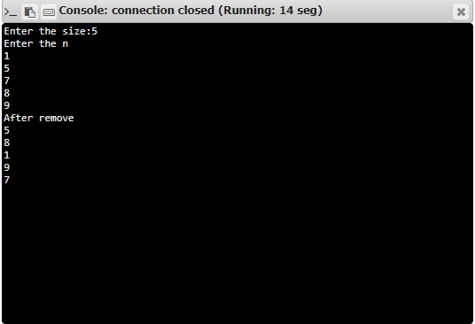

**RESULT:**

Removing and printing every second number from the list of numbers is done*.*