Amrita School of Engineering
Amrita Vishwa Vidyapeetham
Ettimadai, Coimbatore

V Sem B. Tech – Electronics and Communication Engineering

19ECE304
Microcontrollers and Interfacing
Term Project
Rain Sensor Interfacing with LPC2148 Microcontroller
Group no – 3
Name Roll No
DIVIT CB.EN.U4ECE21010
SHAAHID CB.EN.U4ECE21011
SANTHOSH CB.EN.U4ECE21012 ESWARAN CB.EN.U4ECE21014

Abstract:
This project aims to develop a raindrop-detecting sensor using LPC2148 Microcontroller. This sensor allows the measurement of moisture via analogue output pins and provides a digital output when a moisture threshold exceeds. The module is based on the LM393 op-amp. A raindrop sensor is basically a board on which nickel is coated in the form of lines. It works on the principle of resistance.
Pre-requisites:
- LPC2148 - GPIO Interfacing
- LPC2148 - LCD Interfacing
Components Required:
- LPC2148 - Board
- LCD Display module
- Rain sensor
Block Diagram:

Connections:
Sensor outputs will be connected to LM393 comparator, From the comparator, we will connect to the microcontroller.
- Comparator
  - VCC - 5V
  - GND – GND
  - D0/OUT – P1.24
- LCD
  - Register Selection – P0.8
  - Read/Write – P0.9
  - Enable – P0.10
  - Data Lines – P0.0 – P0.7
Basic design:

Code:
#include<lpc214x.h>
#define bit(x) (1<<x)
#define delay for(i=0;i<70000;i++);
#define RAIN (IO1PIN & (1<<24))
unsigned int i;
void lcd_int();
void dat(unsigned char);
void cmd(unsigned char);
void string(unsigned char *);
void main()
{
IO0DIR =0XFFF;
IO1DIR = 0x0;
lcd_int();
cmd(0x80);
string("Alert");
delay;delay;
while(1) {
if(RAIN == 0) {
string("!Rain Detected!");
delay;delay;
cmd(0x01);
}
}
}
void lcd_int()
{
cmd(0x38);
cmd(0x0c);
cmd(0x06);
cmd(0x01);
cmd(0x80);
}
void cmd(unsigned char a)
{
IO0PIN&=0x00;
IO0PIN|=(a<<0);
IO0CLR|=bit(8);
IO0CLR|=bit(9);
IO0SET|=bit(10);
delay;
IO0CLR|=bit(10);
}
void dat(unsigned char b)
{
IO0PIN&=0x00;
IO0PIN|=(b<<0);
IO0SET|=bit(8);
IO0CLR|=bit(9);
IO0SET|=bit(10);
delay;
IO0CLR|=bit(10);
}
void string(unsigned char *p)
{
while(*p!='\0') {
dat(*p++);
}
}

OUTPUT:

Working Principle of sensor:

Here, the sensor is composed of two parts, first one is the effective sensor that is exposed to rain, The plaque has two strips of conductive material, very close to each other. If we apply a voltage between the two strips, it will be an open circuit so we can expose the surface to rain. If water falls on the sensor the circuit will be closed.
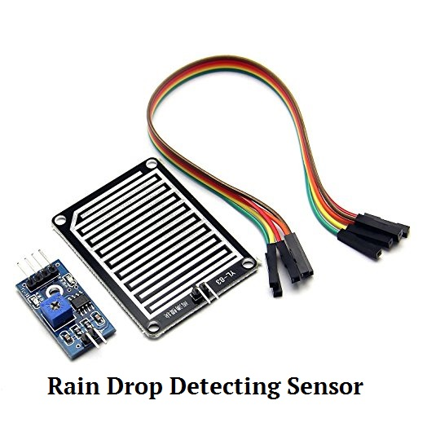
The sensor acts as a variable resistor, which will be lower when more water falls on the surface, connecting the stripes in more place.
The electronic circuit is responsible to process the data from the plaque as an analog and digital signal.
We have a digital output pin which operates as an active low, indicating whether the rain is detected or not so it will have the value of ground when rain is detected and the value of Vcc when rain is not detected.
Since the sensor is a variable resistor output will be an analog voltage that needs to be converted into digital. so, the electronic circuit uses an LM393 comparator for this purpose.
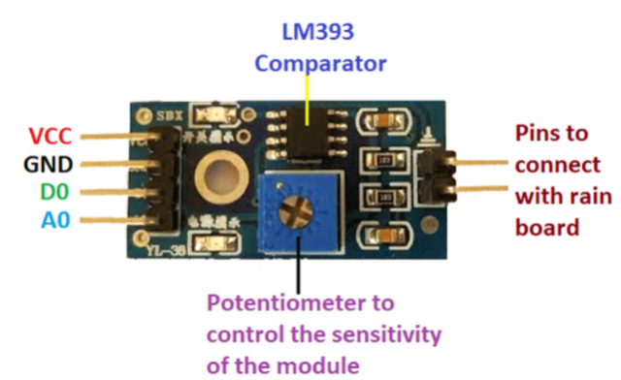
The electronic circuit has a potentiometer where we can set the sensitivity of the sensor.
The digital output from the electronic circuit will be connected as an input to the microcontroller, now microcontroller enables the LCD display pins and sends the given output to the LCD display.

