Problem Statement:
A client’s requirement is, he wants to predict whether the person has the chronic kidney disease based on several parameters.

Domain: Machine Learning
Learning: Supervised
Type: Classification
Name of the Project: Chronic Kidney Disease prediction
Dataset:
Number of Records: 399
Number of Columns: 25
Column Names: 'age', 'bp', 'sg', 'al', 'su', 'rbc', 'pc', 'pcc', 'ba', 'bgr', 'bu', 'sc', 'sod', 'pot', 'hrmo', 'pcv', 'wc', 'rc', 'htn', 'dm', 'cad', 'appet', 'pe', 'ane', 'classification'
Independent Variables: 'age', 'bp', 'sg', 'al', 'su', 'rbc', 'pc', 'pcc', 'ba', 'bgr', 'bu', 'sc', 'sod', 'pot', 'hrmo', 'pcv', 'wc', 'rc', 'htn', 'dm', 'cad', 'appet', 'pe', 'ane',
Dependent Variable: 'classification'

Ordinal data
Feature | Values
sg (Specific Gravity) | a, b, c, d, e
al (Albumin) | 0, 1, 2, 3, 4, 5
su (Sugar) | 0, 1, 2, 3, 4, 5
appet (Appetite) | poor < good

Nominal data
Feature | Values
rbc | normal, abnormal
pc | normal, abnormal
pcc | present, notpresent
ba | present, notpresent
htn | yes, no
dm | yes, no
cad | yes, no
pe | yes, no
ane | yes, no

GridSearch-Logistic
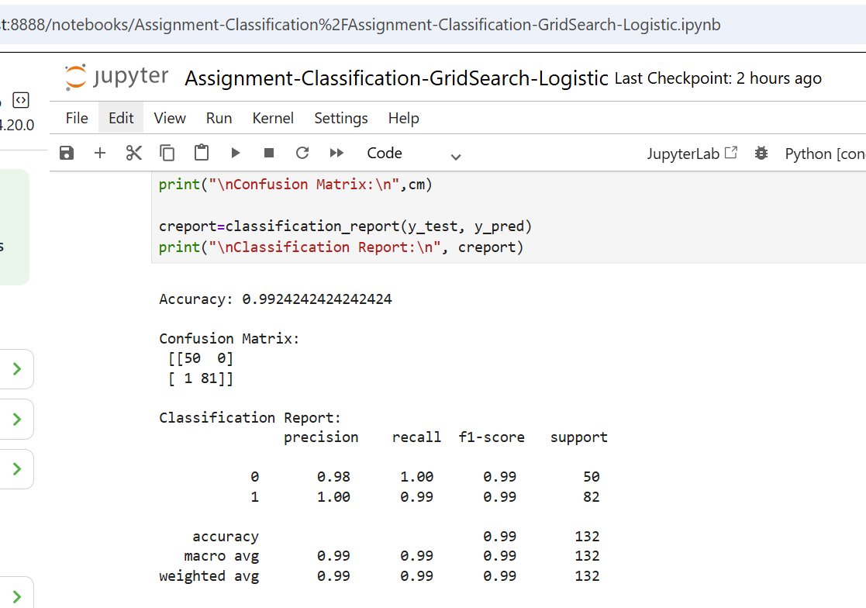

Classification-GridSearch-SVM
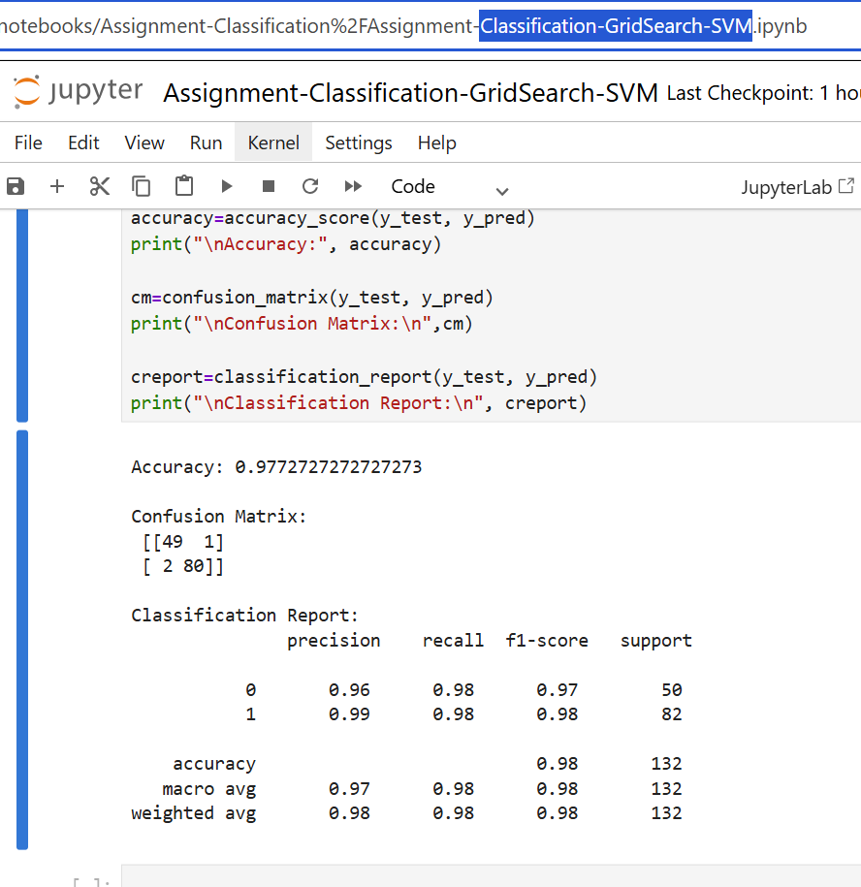

GridSearch-DecisionTree
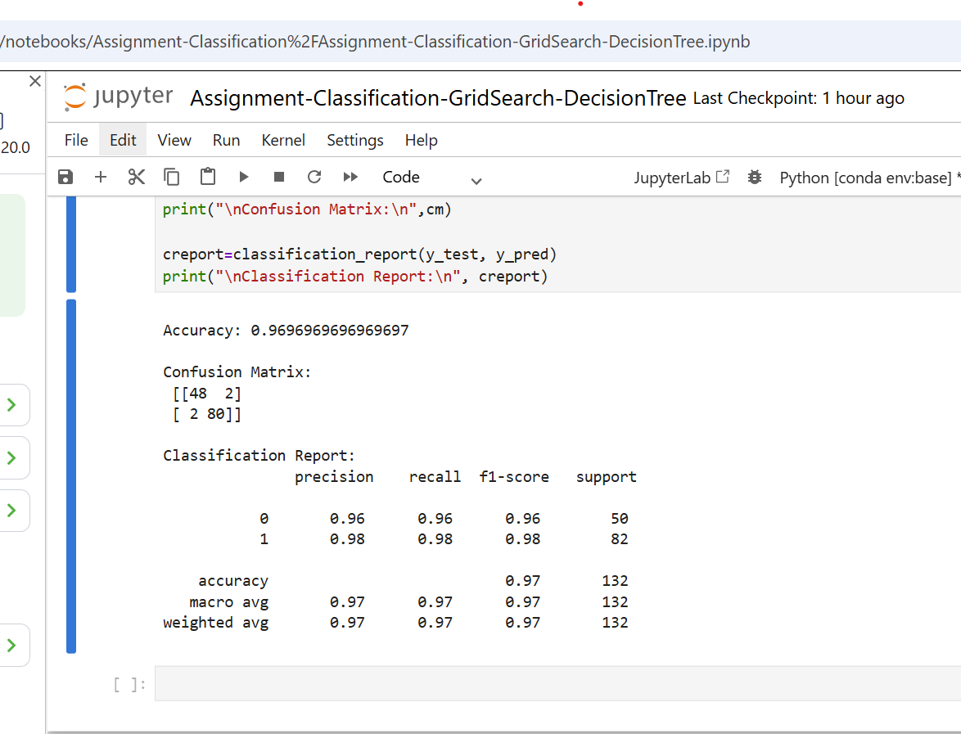

Classification-GridSearch-RandomForest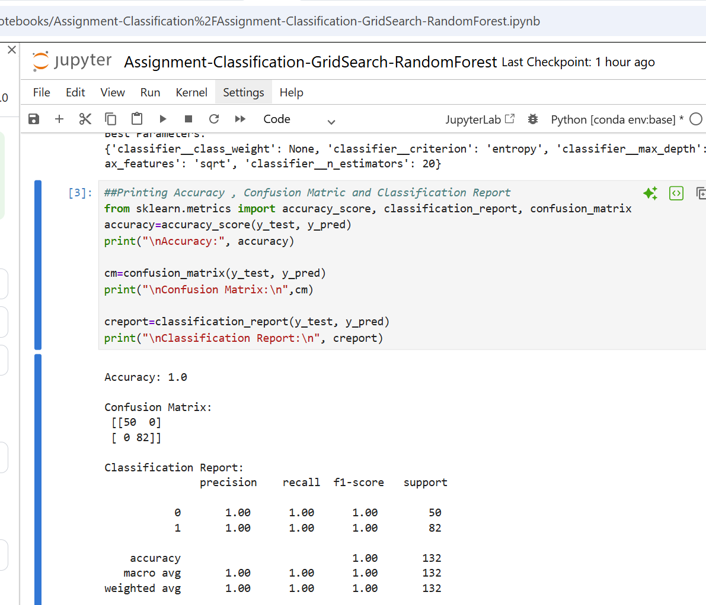NaviesBayes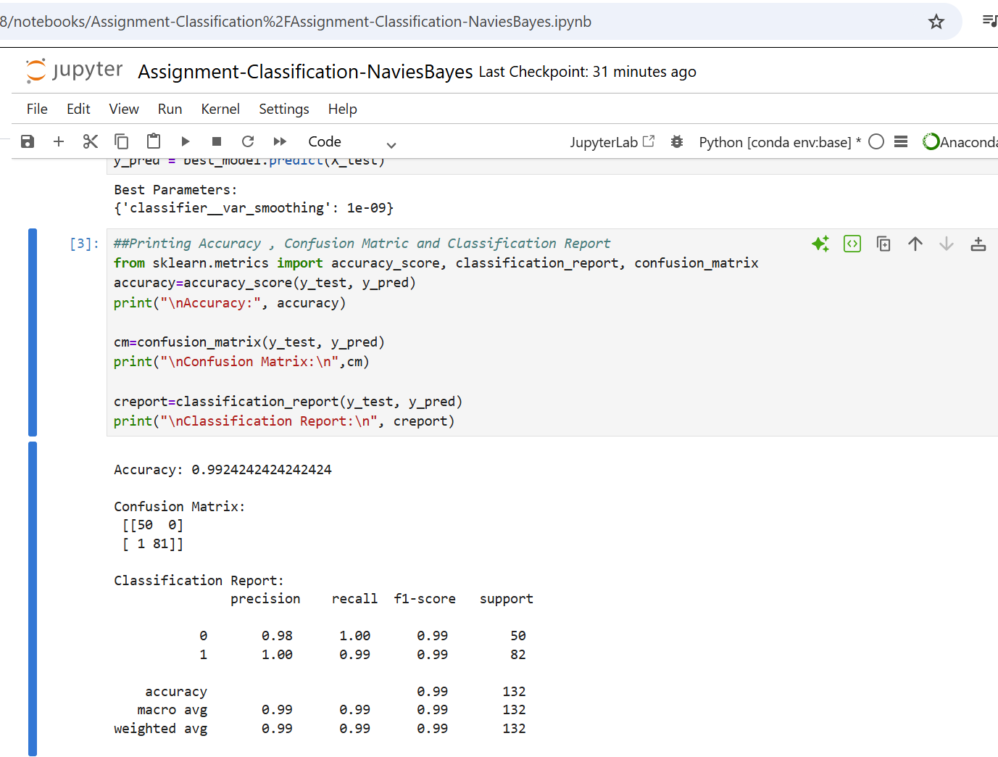
K-Nearest Neighbour
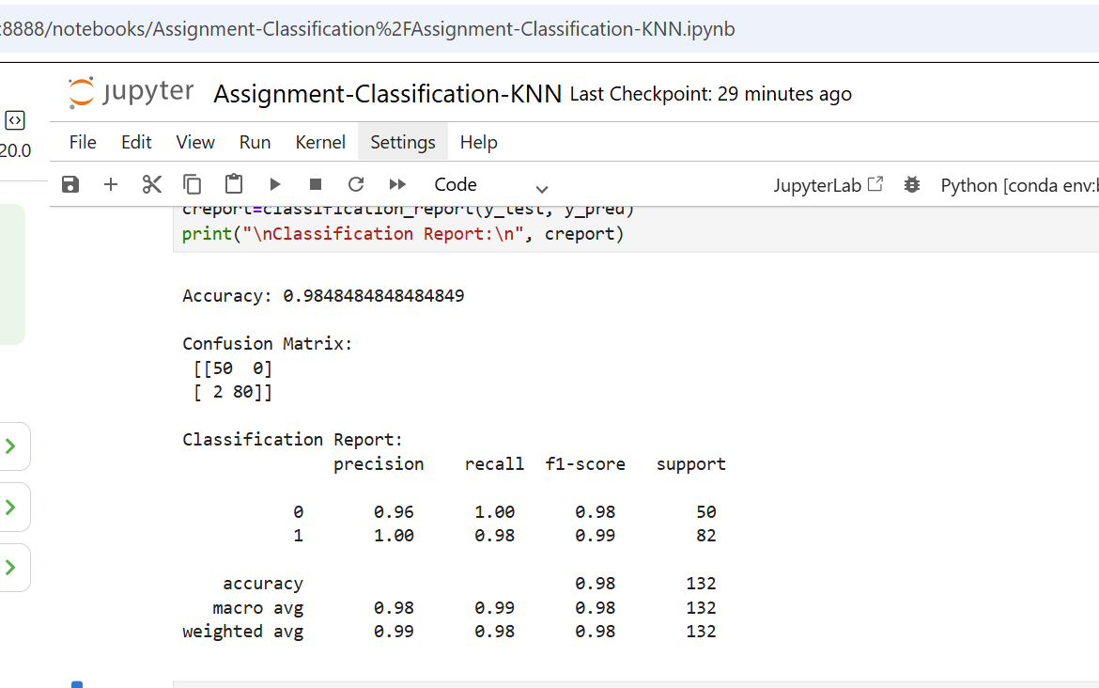

Algorithm | Accuracy
GridSearch-Logistic | 0.9924
GridSearch-SVM | 0.9772
GridSearch-DecisionTree | 0.9696
Classification-GridSearch-RandomForest | 1
NaviesBayes | 0.9924
K-Nearest Neighbour | 0.9848

