



**Car Sharing System**

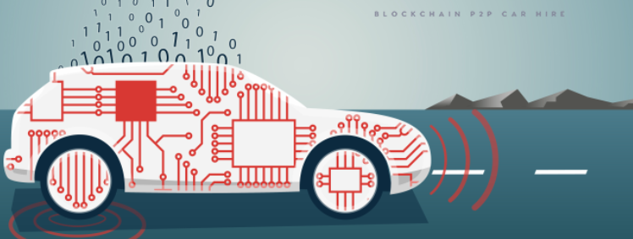

**Presented to**

**Mr. Krish Naik**

**29th November, 2021**

**Prepared by:**

**Aryamadev Das: B2020070**

**Charvi Modi: B2020075**

**Harsha Pareek: B2020082**

**Karan Jaiswal: B2020084**

**Masooma Sheikh: B2020085**

**Santhosh Kumar T: B2020109**

**Table of Contents**

1. Abstract…………….……………………………………………………………………………………………………………….1
2. Introduction……………………………………………………………………………………………………………………....1
3. General Description……………….……………………………………………………………………………………….….2
4. Traditional Architecture……………………………....…………………………………………………………………….3
5. Proposed Solution……………………………………………………….…......................................................3
6. Tools Used………………………………………..………………………………………………………………………………..4
7. Constraints………………………………………….……..………….…………………………………………………………..4
8. Assumptions………………….…………..………………………………………………………………………………………5
9. Design Details………………….…………………………………………………………………………………………………5
10. Conclusions……………………………….……………………………………………………………………………………….7
11. References ..………………………………………………………………………………………………………………………8
12. **Abstract**

The car-sharing sector, which allows car owners to share their unused cars to tenants, making the control rights of vehicles to be frequently transferred among individuals, is rapidly expanding in lines with population expansion, and has just overtaken automobile ownership in popularity.

Customers benefit from blockchain's security since it is a decentralized, immutable, public ledger that is impossible to mess with. The suggested solution's goal is to develop and implement a car-sharing system based on blockchain technology.

However, classic car-sharing system is based on a centralized database server which can often lead to hacker attacks or password leaks. Moreover, in a classic car-sharing system, the owners of the cars can misuse customers' data. As seen nowadays from a lot of use cases, the best solution to these problematic issues is to use blockchain technology. Blockchain as decentralized, immutable, public ledger provides the customers with security that is impossible to tamper. The aim of the proposed solution is to create and implement peer-to-peer short term car-sharing application based on blockchain technology.

1. **Introduction**

* 1. Why this High-Level Design Document?

HLD provides an overall overview of the entire solution, product, system, platform service, service, or platform. High-Level-Design (HLD) is an architectural approach that outlines architectural design in an overall system overview.

The main purpose of this document is to add the details needed to describe the current project to represent a good model for coding. This document also intends to help identify inconsistencies before coding and can be used as a reference for module interactions at the next level.

The HLD will:

* All the design elements are displayed
* Describes the user interface that is being implemented as well as the hardware and software interfaces that have been used.
* Outline the user's daily process flow and performance needs
* Includes the project's design elements and architecture.
  1. Scope

The database architecture, application flow, and technology architecture are all described in the High-Level Design documentation. High-Level Design documentation may use some non-technical words.

1. **General Description**

* 1. Product Perspective

The decentralized car-sharing control scheme is a blockchain based model which will help us to improve car sharing experience by providing faster user experience also there will be very low chances of data breach.

* 1. Problem statement

To create a solution using blockchain for ride sharing system and to implement the following use case:

* To keep the booking details information confidential
* To non-repudiate the origin of access token
* To deal with fraudulent actions taken by both owners and consumers
* To handle cancellations of the booking agreement and distribute the deposit according to the booking agreement
* To be able to deduct the required extra amount from the consumer’s deposit and transfer it to the owner

1. **TRADITIONAL ARCHITECTURE**

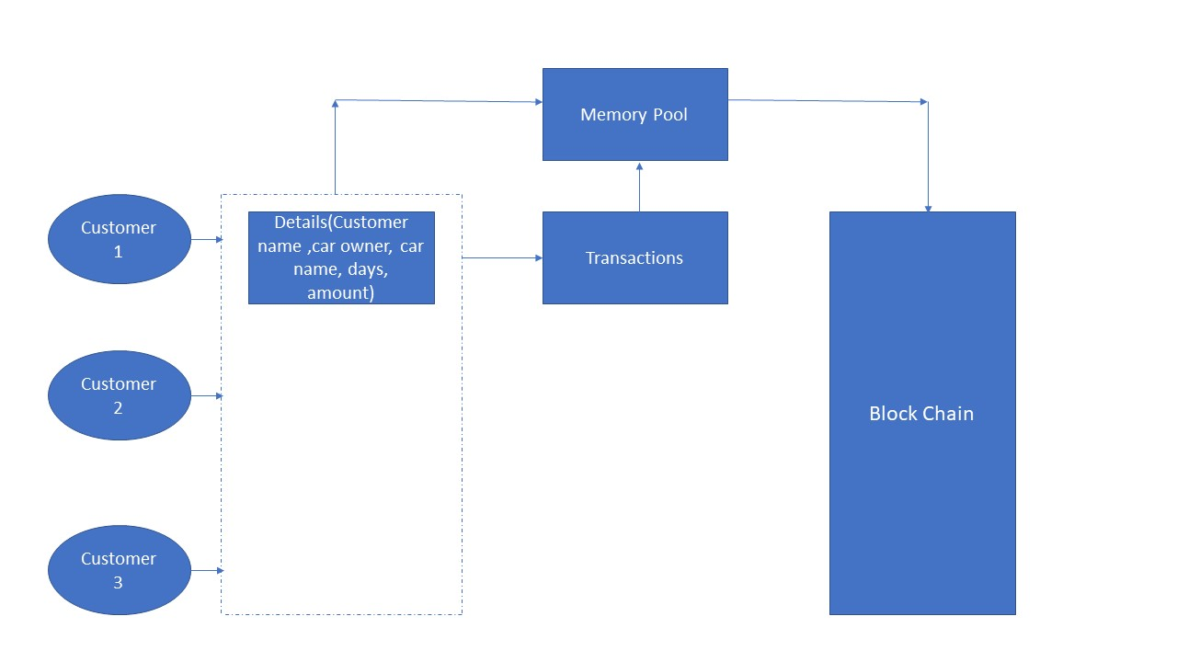

Fig: Traditional Architecture

1. PROPOSED SOLUTION

5.1 HLD:

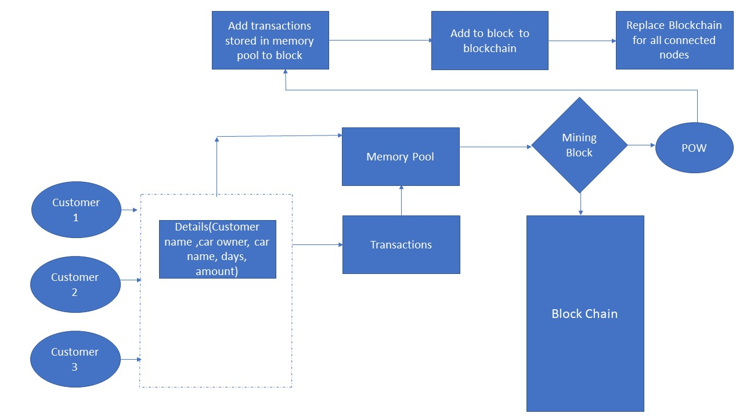

We propose a decentralized car-sharing control scheme, by using blockchain.  The scheme provides a secure platform for interactions among vehicles, individuals, and application providers to avoid some security issues. Several simulations are conducted to validate the feasibility and effectiveness of the proposed scheme. The benefits of having a distributed approach to maintaining users’ data and managing transactions between users include more automation, more transparency, better data privacy, and possibly more trust between users.

1. **TOOLS USED**

* Python Programming Language
* Spyder
* Github
* Postman
* Flask

 





1. **CONSTRAINTS**

Limitations in our smart contract are in the form of security and privacy exploits.   
In a scenario where the customer makes several bookings for the same car, it could be possible to match the blockchain address with a physical identity. The blockchain address is unique to every user, and whenever the user makes any transaction, he or she has to use the same address. Assuming an adversary could know the owner or the customer, it would be possible to link the transactions of the owner or the customer with their physical identities as all transactions are published on the distributed ledger that is visible to everyone. Also, our implementation does not cover KYC verification of clients.  

1. **ASSUMPTIONS**

* The main objective of the project is to implement the car sharing system previously mentioned (2.2 Problem Statement) using blockchain. It has been assumed that client and owner have valid details.
* The initial booking details are mutually agreed upon by the owner and the customer, and they are successfully kept confidential from third parties.
* Along with their digital certificates, we presume that the owner and the customer have a public/private key pair. Finally, the owner's and consumer's communication channels are both private and authentic.

1. **DESIGN DETAILS**
   1. Process Flow

Da

**Enter Transaction Details**

**Redirected to UI**

**Connect Node**

* User Details
* Price
* Car details
* Owner Details
* Days Details

**Addition of Transaction Details to Memory Pool**



To update the details on the whole blockchain

To mine a block of transactions

**Mine Block**

**Replace Chain**

* 1. Proposed Methodology

Carry out the whole booking and payments process in a secure way.   
• Implement a proper cancellation functionality. Only give access to the customer   
once the owner allows it.   
• In case of extra time taken by the customer, have a proper functionality to   
deduct the required extra amount from the customer’s deposit and transfer it   
to the owner.   
• Store the encrypted booking details so that the customer can access and decrypt them whenever required.

* 1. Functional Requirements
* **Booking process:**

The system should be able to handle bookings, car usage in a consistent manner. It should be able to accept booking requests.

* **Payment process:**

The system should also keep track of deposits made by owners/consumers.

* 1. Entities

**Owner:** An individual who wish to share his/her unused car

**Client:** A person who wish to take a car for rent for a specific period of time

**Car:** Car that is available to be shared

**Public ledger:** A structure that records transactions and is operated by a single or several decentralized parties. All transactions made in this system are recorded in this public ledger

1. **CONCLUSION**

The project focusses on the use Blockchain technology to address the issues faced by traditional car sharing setup.

* This can also be extended to a full-fledged web API .
* It can also enable the owner and the consumer to privately discuss booking details off-chain while having an easy to operate user-interface.
* We can also include features like KYC to validate the genuineness of the owner and customers.
* smart contracts can be implemented to specify obligations of both parties.

1. **REFRENCES**

<https://ieeexplore.ieee.org/abstract/document/9129439>

<https://www.apriorit.com/dev-blog/733-blockchain-implement-blockchain-in-car-sharing-service-using-the-cosmos-network>

<https://www.sciencedirect.com/science/article/pii/S2096720921000087>

<https://www.eos-intelligence.com/perspectives/technology/blockchain-a-potential-disruptor-in-car-rental-and-leasing-industry/>

<https://www.iieta.org/journals/ijsse/paper/10.18280/ijsse.110205>

<https://ieeexplore.ieee.org/abstract/document/8918650>

<https://www.esat.kuleuven.be/cosic/publications/thesis-313.pdf>

<https://www.linkedin.com/pulse/building-car-sharing-blockchain-paul-shumsky/>

<https://www.researchgate.net/publication/331779607_SC2Share_Smart_Contract_for_Secure_Car_Sharing>

<https://www.apriorit.com/dev-blog/733-blockchain-implement-blockchain-in-car-sharing-service-using-the-cosmos-network>