**Frontend Development with React.js**

**Project Documentation format**

**TEAM MEMBERS:**

1. **SANTHOSH KUMAR B**
2. **SANJAY NARAYANAN N**
3. **KARNESH M**

**4. KARTHIKEYAN**

1. **Introduction**

A cryptocurrency, crypto-currency, or colloquially, crypto, is a [digital currency](https://en.wikipedia.org/wiki/Digital_currency" \o "Digital currency) designed to work through a [computer network](https://en.wikipedia.org/wiki/Computer_network" \o "Computer network) that is not reliant on any central authority, such as a [government](https://en.wikipedia.org/wiki/Government" \o "Government) or [bank](https://en.wikipedia.org/wiki/Bank" \o "Bank), to uphold or maintain it.[[2]](https://en.wikipedia.org/wiki/Cryptocurrency" \l "cite_note-:02-2)

Individual coin ownership records are stored in a digital [ledger](https://en.wikipedia.org/wiki/Ledger" \o "Ledger) or [blockchain](https://en.wikipedia.org/wiki/Blockchain" \o "Blockchain), which is a computerized [database](https://en.wikipedia.org/wiki/Database" \o "Database) that uses a consensus mechanism to secure [transaction](https://en.wikipedia.org/wiki/E-commerce" \o "E-commerce) records, control the creation of additional coins, and verify the transfer of coin ownership.[[3]](https://en.wikipedia.org/wiki/Cryptocurrency" \l "cite_note-crypto_currency-3)[[4]](https://en.wikipedia.org/wiki/Cryptocurrency" \l "cite_note-reuterspricing-4)[[5]](https://en.wikipedia.org/wiki/Cryptocurrency" \l "cite_note-5) The two most common consensus mechanisms are [proof of work](https://en.wikipedia.org/wiki/Proof_of_work" \o "Proof of work) and [proof of stake](https://en.wikipedia.org/wiki/Proof_of_stake" \o "Proof of stake).[[6]](https://en.wikipedia.org/wiki/Cryptocurrency" \l "cite_note-6) Despite the name, which has come to describe many of the [fungible](https://en.wikipedia.org/wiki/Fungibility" \o "Fungibility) blockchain tokens that have been created, cryptocurrencies are not considered to be [currencies](https://en.wikipedia.org/wiki/Currency" \o "Currency) in the traditional sense, and varying legal treatments have been applied to them in various jurisdicitons, including classification as [commodities](https://en.wikipedia.org/wiki/Commodity" \o "Commodity), [securities](https://en.wikipedia.org/wiki/Security_(finance)" \o "Security (finance)), and currencies. Cryptocurrencies are generally viewed as a distinct asset class in practice.[[7]](https://en.wikipedia.org/wiki/Cryptocurrency" \l "cite_note-7)[[8]](https://en.wikipedia.org/wiki/Cryptocurrency" \l "cite_note-8)[[9]](https://en.wikipedia.org/wiki/Cryptocurrency" \l "cite_note-9)

**Project Title**:[cryptoverse]

**Team Members**: Santhosh kumar.B

Sanjay narayana.N

Karthick,N

Karnesh.M

1. **Project Overview** 
   * **Purpose**: Cryptoverse serves as a digital ecosystem for block-chain-based assets, applications, and decentralized finance.
   * **Features**: :Cryptoverse features decentralized finance (DeFi), NFTs, blockchain gaming, virtual real estate, and secure digital transactions.

**3.Architecture**

* + **Component Structure**:Component structure:The component structure of the Cryptoverse includes Blockchain, Cryptocurrencies, Exchanges,Wallets, Mining, Smart Contracts, Decentralized Applications (dApps), and Non-Fungible Tokens (NFTs)
  + **ManageStatement**:State management in the Cryptoverse relies on blockchain consensus, smart contracts, and decentralized protocols to ensure data integrity and synchronization.
  + **Routing**: Routing in the Cryptoverse utilizes blockchain protocols, smart contracts, and decentralized networks to securely direct transactions and data flows.

1. **Setup Instructions**
   * **Prerequisites**:Prerequisites of the Cryptoverse include blockchain technology, cryptographic security, smart contracts, decentralized networks, and digital assets.
   * **Installation**:Installing the Cryptoverse involves setting up a blockchain wallet, accessing decentralized apps (dApps), and integrating with Web3 platforms.

**5.Folder Structure**

* + **Client**:A Cryptoverse client is a Web3-enabled application or wallet that interacts with blockchain networks, dApps, and digital assets.
  + **Utilities**:The utilities of the Cryptoverse include digital transactions, decentralized finance, NFTs, smart contracts, virtual assets, and blockchain-based applications.

**6.Running the Application**

To **run Cryptoverse**:

1. **Check System Requirements** (Windows 10/11, i5/Ryzen 5, GTX 1660+, 8GB RAM).
2. **Download** from the [official site](https://cryptoverse.vip/" \t "_new).
3. **Install & Launch** the application.
4. **Create Profile** and explore the metaverse.
5. **Buy land, interact, and play** in the virtual world.

**Frontend**:

The **frontend of Cryptoverse** is built using **Unreal Engine**, offering a high-quality 3D user experience. Key elements include:

🔹 **Immersive UI/UX** – Smooth, interactive, and visually rich interface.  
🔹 **3D Virtual Environments** – Realistic metaverse experience with customizable land.  
🔹 **User Avatars & Navigation** – Players can move, interact, and explore seamlessly.  
🔹 **Marketplace & Dashboard** – Buy/sell land, assets, and NFTs via an intuitive UI.  
🔹 **Cross-Platform Support** – Likely compatible with Web, PC, and VR devices.

**7.Component Documentation**

* + **Key Components**: The key components of the Cryptoverse include blockchain, cryptocurrencies, smart contracts, DeFi, NFTs, dApps, metaverse, governance, and security protocols.
  + **Reusable Components**:Reusable components of the Cryptoverse include smart contracts, blockchain protocols, cryptographic security, decentralized identity, and interoperability frameworks.

**8.State Management**

* + **Global State**:The global state of the Cryptoverse is maintained through blockchain consensus, distributed ledgers, and decentralized governance for real-time data synchronization
  + **Local State**:The local state of the Cryptoverse is managed within individual nodes, wallets, and dApps, reflecting real-time user interactions and transa

1. **User Interface**

### ****Key Features of Cryptoverse UI:****

🔹 **3D Navigation** – Users explore virtual worlds with smooth movement controls.  
🔹 **Customizable Avatars** – Create and personalize avatars easily.  
🔹 **Interactive Menus** – Intuitive dashboards for profile, assets, and settings.  
🔹 **Marketplace UI** – Buy/sell land and NFTs through a visually rich interface.  
🔹 **Social & Chat Features** – Seamless communication tools for in-world interactions.  
🔹 **VR/AR Compatibility** – Supports immersive experiences for metaverse engagement.

1. **Styling**

The styling of the Cryptoverse focuses on a futuristic, immersive, and decentralized design approach, incorporating:

* **CSS Frameworks/Libraries**:
* 1. Dark Mode & Neon Accents
* 2. 3D & Metaverse Element
* 3. Minimalist UI/UX
* 4. Customizable Themes
* 5. Responsive & Cross-Platform
* 6.Animatedinteractive
* Components
* 7. Decentralised
* **Theming**:The theming of the Cryptoverse revolves around a futuristic, decentralized, and immersive digital experience, incorporating:
* 1. Cyberpunk & Futuristic Aesthetics
* 2. Blockchain & Digital Finance Vibes
* 3. Metaverse & Virtual World Integration
* 4. Decentralized Identity & Web3 Styling
* 5. Adaptive & Customizable UI – User
* 6. Minimalist & Intuitive Layouts
* 7. Gamification & Interactive Animation**Testing**

**11.Testing**

* **Testing Strategy**:The testing strategy of the Cryptoverse includes smart contract audits, security testing, blockchain transaction validation, UI/UX testing, and interoperability checks.
* **Code Coverage**: The code coverage of the Cryptoverse ensures thorough testing of smart contracts, blockchain logic, security protocols, and dApp functionality for reliability.

**12.Screenshots or Demo**

**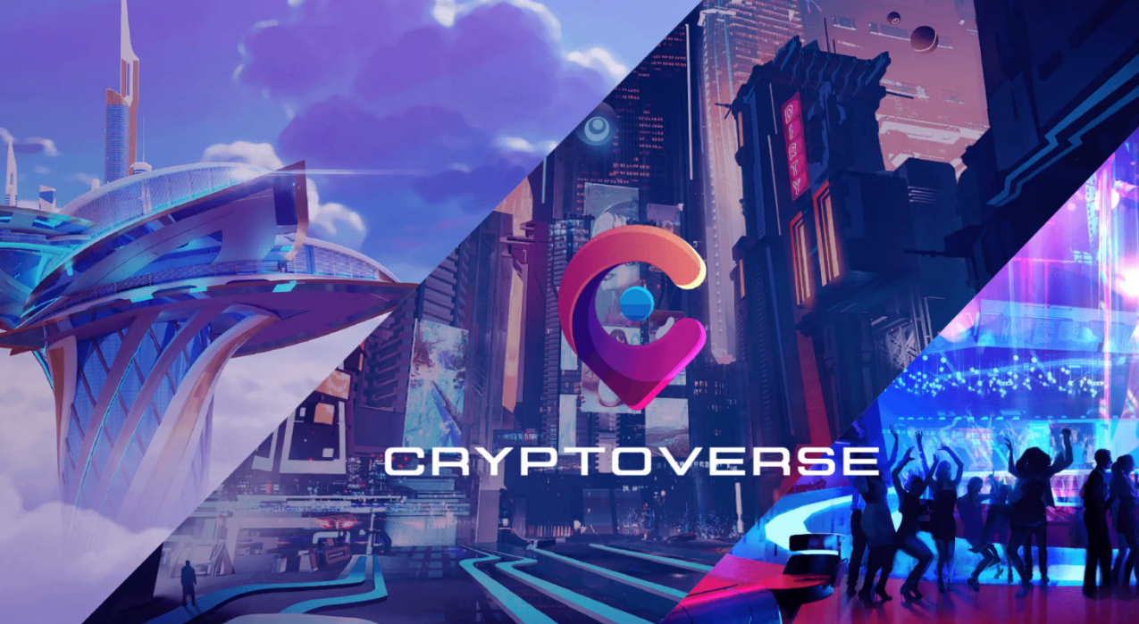**

**13.Known Issues**

* Known issues of the Cryptoverse include scalability limitations, high transaction fees, smart contract vulnerabilities, interoperability challenges, and user experience complexities.

**14.Future Enhancements**

* Future enhancements of the Cryptoverse include improved scalability, lower transaction fees, advanced AI integration, enhanced security, and seamless cross-chain interoperability.