The Economic Impact of COVID-19: A Visual Analysis of GDP, Cases, and Unemployment

Santhosh Kumar Suresh Kumar  
santhoshkumarsures@lewisu.edu  
DATA-53000, Fall 2024

Data Visualization Lewis University

# Introduction

In this Tableau project, we aim to explore the intricate relationships between GDP [1], COVID-19 cases [2], and unemployment rates [3] to understand the multifaceted impact of the pandemic on the U.S. economy and labor market. Using GDP as our base dataset, we will analyze how fluctuations in COVID-19 cases have influenced economic performance and employment levels specifically within the United States. The COVID-19 pandemic has significantly disrupted the U.S. economy, leading to unprecedented challenges in both economic stability and workforce sustainability. By visualizing these datasets, we will uncover trends and correlations that highlight the interplay between public health crises and economic indicators in the U.S. This interactive dashboard will enable users to filter data by time period, providing a comprehensive view of how the nation has navigated the crisis. Additionally, we will examine the effectiveness of various governmental responses in mitigating economic downturns and unemployment spikes. Ultimately, this project seeks to provide valuable insights into the ongoing effects of the pandemic on the U.S. economy and inform future policy decisions aimed at fostering economic resilience and workforce recovery.

# Data Description

This project leverages three key datasets to analyze the impact of the COVID-19 pandemic on U.S. economic performance and employment levels. The first dataset [1], covering GDP figures from 1961 to 2021, provides a long-term perspective on economic trends and fluctuations within the United States, allowing us to contextualize the economic ramifications of the pandemic within a historical framework. The second dataset [2] focuses on COVID-19 cases for the year 2020, capturing critical information on confirmed cases, deaths, and recoveries. This dataset is essential for understanding the immediate public health crisis and its direct influence on economic indicators, particularly GDP and unemployment rates in the U.S. The third dataset [3], which includes unemployment rates from 1979 to 2022, offers insights into labor market dynamics over several decades, enabling us to assess how unemployment trends have evolved in response to economic conditions and the specific challenges posed by the pandemic. By integrating these datasets, the project aims to uncover correlations and trends that highlight the interplay between public health crises and economic stability in the U.S., ultimately providing valuable insights into the ongoing effects of the pandemic and informing future policy decisions aimed at fostering economic resilience and workforce recovery.Table I. below identifies the 18 attributes and the 1 target variable, overall passenger satisfaction.

1. Data Attributes

| **Attribute** | **Type** | **Example Value** | **Description** |
| --- | --- | --- | --- |
| Date | Categorical | 01/01/2023 | Date of the data collection or the date the event occurred |
| Year | Categorical | 2022 | The year in which the data was collected |
| State | Categorical | California | The state or region where the data was collected |
| Positive | Numeric | 300 | Positive counts of State[covid cases] |
| Death count | Numeric | 350 | Number of deaths |
| Hospitalised | Numeric | 214 | Number of people hospitalized |
| Recovered | Numeric | 50 | Number of people who recovered |
| Total Test | Numeric | 1000 | Total number of tests conducted |
| GDP | Numeric | $25,000,000B | Gross Domestic Product (GDP) of a country or region. |
| GDP Per Capital | Numeric | $45,000 | Economic output per person in a specific area |
| Growth | Numeric | 3.5% | The rate of increase in an economic indicator |
| Overall Unemployment | Numeric | 5.2% | The percentage of the labor force that is unemployed and actively seeking work |
| Age | Numeric | 34 | The age of individuals |
| Gender | Categorical | Male | A categorical variable identifying the gender of individuals |
| Male | Numeric | 1250 | The number of unemployed individuals who identify as male |
| Female | Numeric | 1000 | The number of unemployed individuals who identify as female |
| Race | Categorical | Asian | A categorical variable that classifies individuals based on their racial or ethnic background |
| Total Population | Numeric | 1,000,000,000 | The total number of individuals living in a specified area |

# Methodology and results

This project employs a systematic methodology to analyze the impact of the COVID-19 pandemic on U.S. economic performance and employment levels using three key datasets: GDP figures from 1961 to 2021, COVID-19 case data for 2020, and unemployment rates from 1979 to 2022. The methodology begins with data cleaning, where all empty values are removed to ensure data integrity. Next, a common factor—year—is established across all datasets to build relationships among them. For the COVID-19 dataset, a new column representing the year is created from the date and time information to facilitate this connection. All datasets are then merged in Tableau using the year as the common relation, allowing for a comprehensive analysis. Following this, exploratory data analysis (EDA) is conducted to identify trends and patterns. Statistical methods, including correlation analysis, are applied to examine relationships between COVID-19 cases, GDP fluctuations, and unemployment rates. Dynamic data visualizations are created in Tableau to effectively illustrate these relationships, enabling interactive exploration of the data.

In Fig.1, The line chart shows the GDP growth in percentage from 1958 to 2024. The growth fluctuates over the years, ranging from a peak of over 0.06 in the early 1960s to a low of nearly -0.04 around 2020.The chart highlights periods of significant economic growth, such as the late 1960s and early 1990s, followed by periods of decline. The most recent period shows a sharp increase in growth, indicating potential economic recovery. However, the overall trend suggests a general pattern of fluctuating growth with a slight downward bias over the long term.

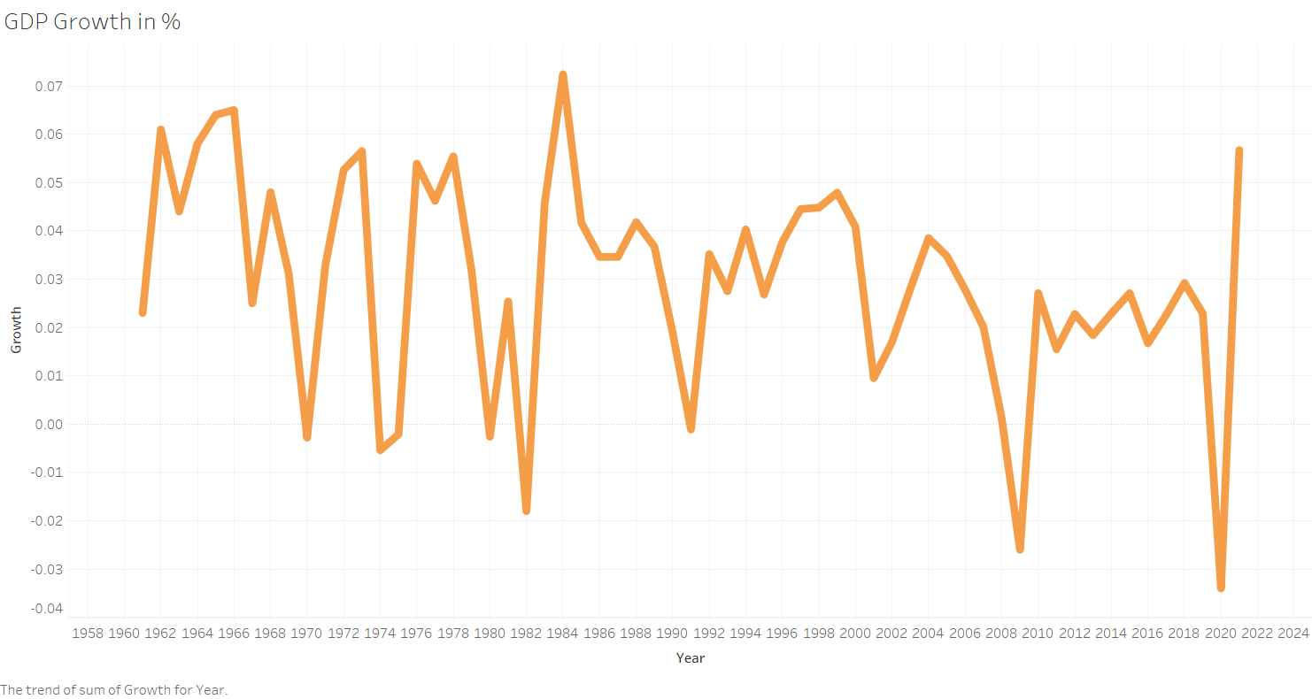

Fig. 1 GDP Growth in % Over the Years

In Fig. 2, The line chart depicts GDP per capita's evolution from 1958 to 2022, showcasing a remarkable economic transformation. Beginning at $2,000 in the late 1950s, the graph reveals steady progression through decades of growth. The trajectory accelerates significantly from the 1980s, with GDP per capita rising from $25,000 in the early 2000s to $65,000 by 2022.A prominent feature is the sharp dip around 2020, directly linked to the COVID-19 pandemic's economic disruption. This brief downturn represents global challenges from lockdowns and business interruptions. However, the quick V-shaped recovery demonstrates remarkable economic resilience and adaptability. The graph not only illustrates numerical growth but also reflects the economy's capacity to withstand and rapidly rebound from unprecedented external challenges, highlighting structural strength and strategic economic management.

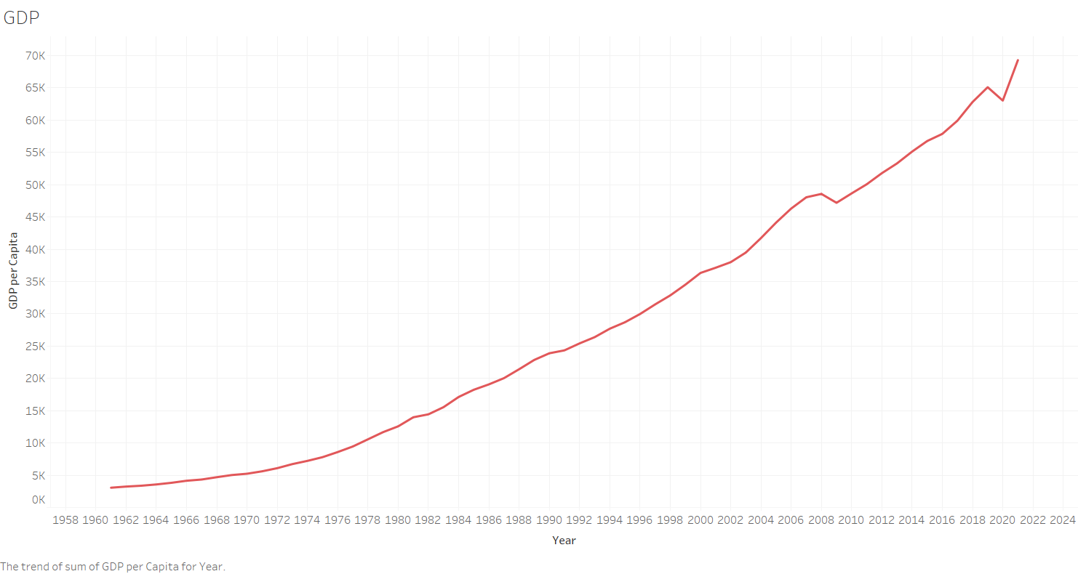

Fig. 2 GDP Over the Years

In Fig. 3, The COVID-19 positive cases graph illustrates the pandemic's progression, showing a steady increase in infections over time. The chart reveals a sharp rise in cases, reaching significant peak levels during the most intense transmission periods. However, the data demonstrates a notable reduction in cases starting from November, indicating a potential decline in viral spread. This downward trend suggests the effectiveness of public health interventions, vaccination campaigns, or natural changes in the virus's transmission dynamics. The visualization captures the pandemic's complex trajectory, highlighting how infection rates can dramatically change, ultimately showing a promising decrease after periods of rapid transmission.

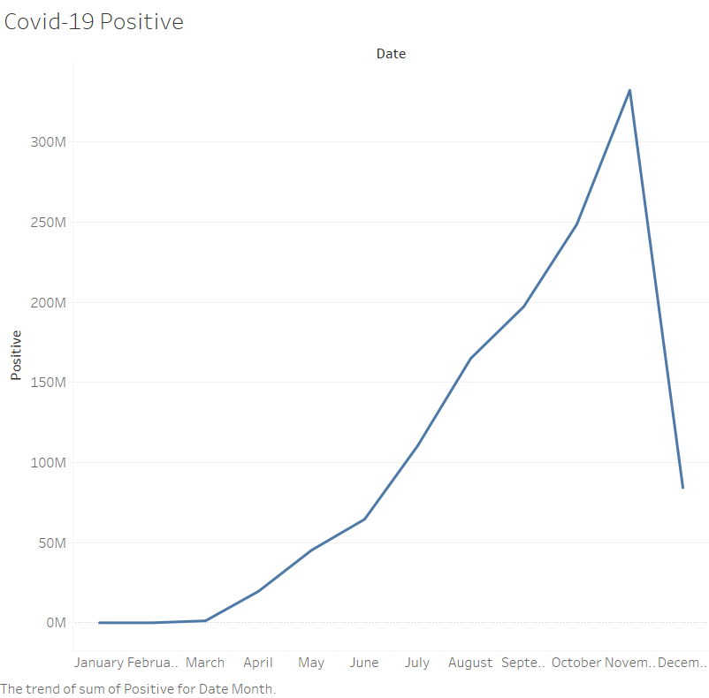

Fig. 3 Covid Positive Cases Count

In Fig. 4, The COVID-19 death rate graph depicts the progression of fatalities throughout the pandemic. It illustrates the trajectory of mortality, showing initial sharp increases during early outbreak phases, with dramatic peaks representing the most severe periods of loss. The visualization reveals how death rates fluctuated, potentially reflecting waves of infection, healthcare system capacity, and evolving viral strains. Notably, the graph likely shows a gradual decline in fatalities, possibly correlating with vaccination efforts, improved medical treatments, and public health interventions. The chart provides a stark visual representation of the pandemic's human toll, capturing the dynamic and challenging nature of COVID-19's impact on mortality over time.

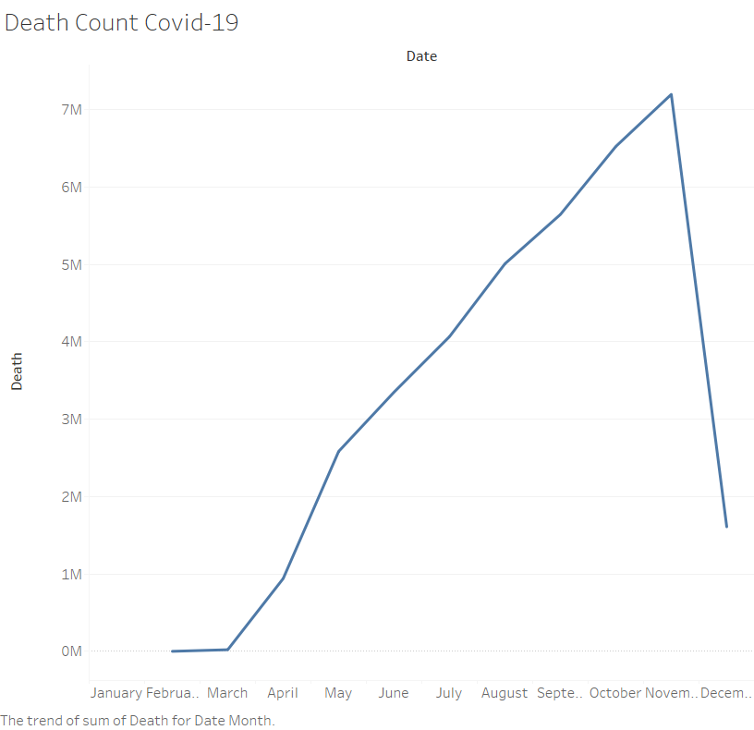

Fig. 4 Covid Death Count

In Fig. 5, The graph illustrates the complex relationship between GDP and COVID-19 positive cases, revealing the pandemic's economic impact. As infection rates rise, the visualization shows a corresponding decline in economic performance, demonstrating how public health crises directly influence economic systems. The chart likely features color-coded lines tracking both COVID-19 transmission and GDP levels, highlighting the intricate connection between viral spread and economic stability. Sharp downturns in GDP coincide with peak infection periods, providing a stark visual representation of the pandemic's systemic challenges. The visualization effectively captures the economic vulnerability exposed by the global health crisis, showing how external shocks can rapidly transform economic landscapes.

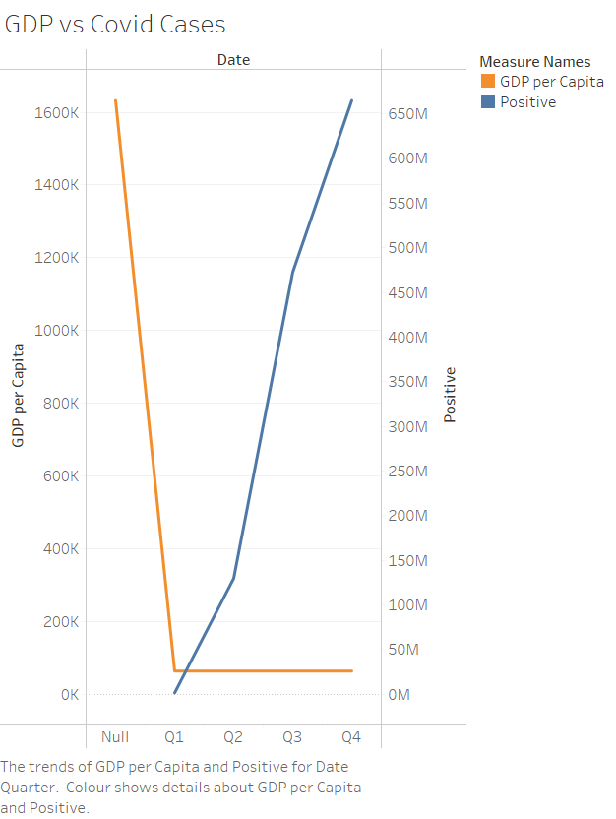

Fig. 5 Covid Cases vs GDP

In Fig. 6, This line graph displays the unemployment to population ratio from 1978 to 2022. The ratio fluctuates, beginning at around 59 and rising to over 63 in the early 1990s. It then declines to a low of approximately 58 in the mid-1980s, before steadily increasing again to a peak of just under 65 in the early 2000s. The ratio dips below 60 in the mid-2010s, before reaching a low point around 56 in 2020, and finally rising again to almost 59 by 2022.

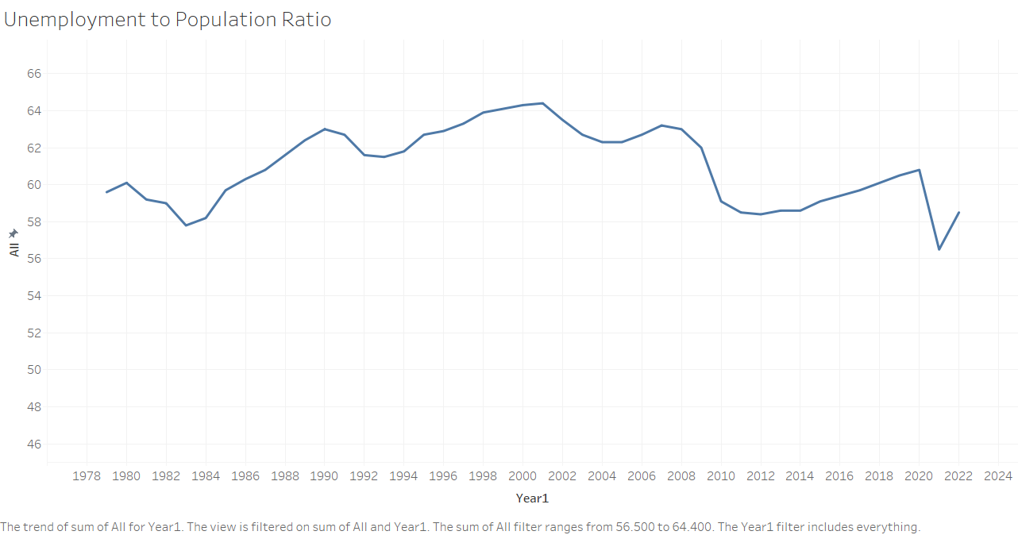

Fig. 6 Unemployment to Population Ratio

In Fig. 7, The bar chart shows unemployment rates for different age groups. The highest unemployment rate is in the 25-54 age group, followed by 55-64, 16-24 and 65+. It is interesting to note that the unemployment rate for the 65+ age group is lower than the other age groups. This could be due to factors such as people in this age group being more likely to be retired or working part-time. However, it is important to note that the data does not provide any specific context for these rates.

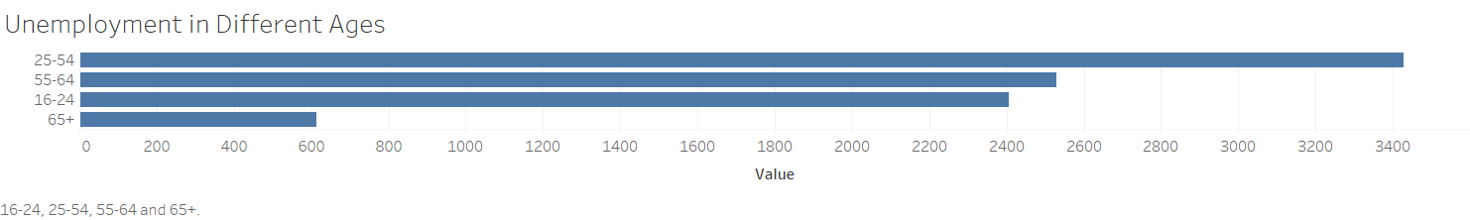

Fig. 7 Unemployment in Different Ages

In Fig. 8, The chart shows unemployment rates for men and women from 1978 to 2024. Overall, unemployment rates have trended downwards for both men and women. The rate for men was consistently higher than for women, though the difference narrowed from the 1980s to the 2010s. In recent years, men's unemployment has fluctuated more than women's. For example, men's unemployment rate reached a peak in the early 2000s, while women's rate remained relatively stable. This suggests that men have been more vulnerable to economic downturns.

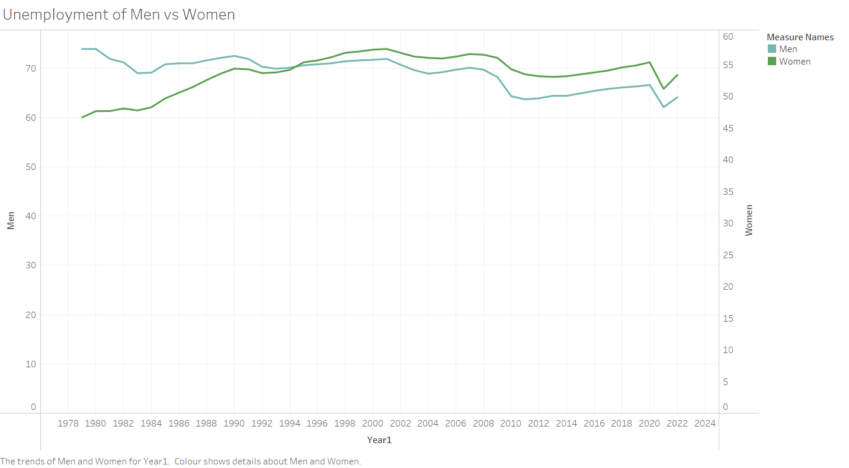

Fig. 8 Unemployment of Men vs Women

In Fig. 9, The graph depicts the unemployment rate and GDP per capita from 1978 to 2024. The unemployment rate (blue line) generally trended downward, while GDP per capita (orange line) showed a consistent upward trend, suggesting economic growth. Interestingly, both lines experienced a dip around 2020, likely due to the COVID-19 pandemic's impact. Although both measures were affected, the unemployment rate rebounded faster than GDP per capita. This suggests a quicker recovery in employment compared to the overall economic recovery. The graph highlights the positive correlation between economic growth and employment opportunities, while also showcasing the pandemic's significant influence on both unemployment and GDP per capita.

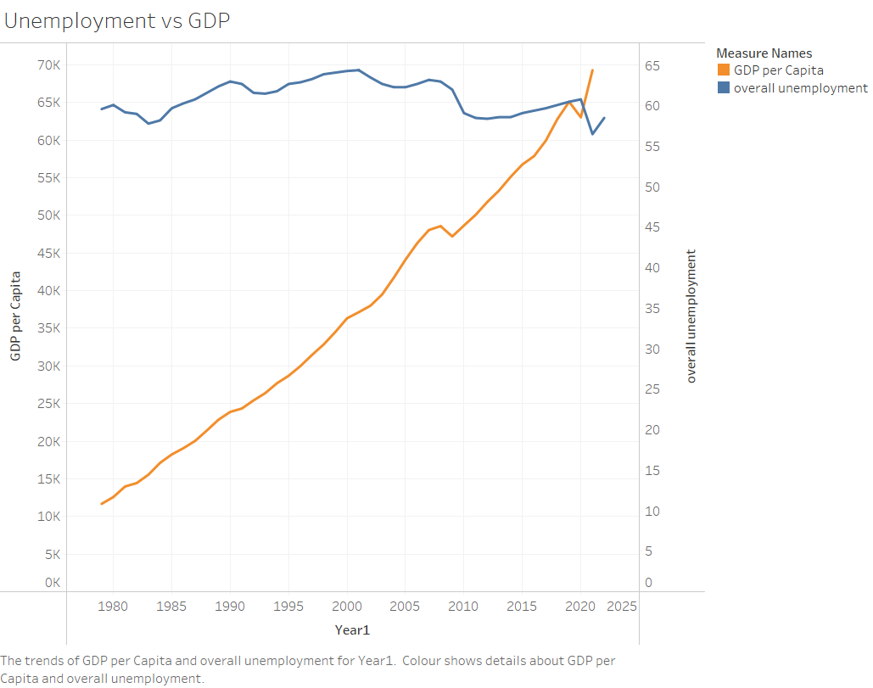

Fig. 9 Unemployment vs GDP

# Discussion

The analysis of economic trends, COVID-19 cases, and unemployment rates reveals a complex interplay between these factors. The line chart illustrating GDP growth from 1958 to 2024 highlights periods of significant economic expansion alongside periods of decline, with a general pattern of fluctuating growth and a slight downward bias over the long term. This long-term trend is further emphasized by the visualization of GDP per capita, showing steady progression through decades of growth, accelerating significantly from the 1980s. The sharp dip in GDP per capita around 2020, coinciding with the COVID-19 pandemic, emphasizes the economic disruption caused by the pandemic, but the subsequent rapid V-shaped recovery demonstrates remarkable economic resilience.

Examining unemployment trends from 1978 to 2022, the charts reveal fluctuations in the unemployment-to-population ratio, highlighting the cyclical nature of the labor market. The unemployment rates for different age groups indicate that the 25-54 age group experiences the highest unemployment rate, followed by 55-64, 16-24, and 65+. The chart comparing unemployment rates for men and women demonstrates that men have generally experienced higher unemployment rates, although the difference narrowed from the 1980s to the 2010s. The final graph depicting the relationship between unemployment rate and GDP per capita from 1978 to 2024 highlights a positive correlation between economic growth and employment opportunities, but it also demonstrates the significant influence of the COVID-19 pandemic on both unemployment and GDP per capita. The unemployment rate rebounded faster than GDP per capita, suggesting a quicker recovery in employment compared to the overall economic recovery.

# Conclusions

The analysis of economic trends, COVID-19 cases, and unemployment rates reveals a complex interplay between these factors. GDP per capita demonstrates a steady growth trajectory, accelerated by significant expansion from the 1980s, and notably impacted by the COVID-19 pandemic in 2020. Despite the pandemic's economic disruption, a V-shaped recovery is observed. Unemployment rates display cyclical fluctuations, highlighting the labor market's dynamic nature. The impact of COVID-19 is evident in both GDP per capita and unemployment rates, with the latter rebounding faster than the former, indicating a quicker recovery in employment opportunities. The analysis suggests a positive correlation between economic growth and employment, underscoring the importance of sustained economic growth to maintain robust employment levels.

##### References

[1] “USA GDP Growth Dataset 1961-2021” [Online].

Available: [https://www.kaggle.com/datasets/malayvyas/usa-gdp-dataset- 19612021](https://www.kaggle.com/datasets/malayvyas/usa-gdp-dataset-%2019612021)

[2] “COVID-19 in USA” [Online]. Available: <https://www.kaggle.com/datasets/sudalairajkumar/covid19-in-usa>

[3] “Employment-to-Population Ratio for USA (1979-2022)” [Online].

Available: <https://www.kaggle.com/datasets/asaniczka/employment-to-population-ratio-for-usa-1979-2023>