**Goal 5:** To visualize the average percent salary hike of an employee in different job roles and their experience in that company with regards to their job satisfaction. This chart is drawn using Microsoft Power BI and the chart is area chart.

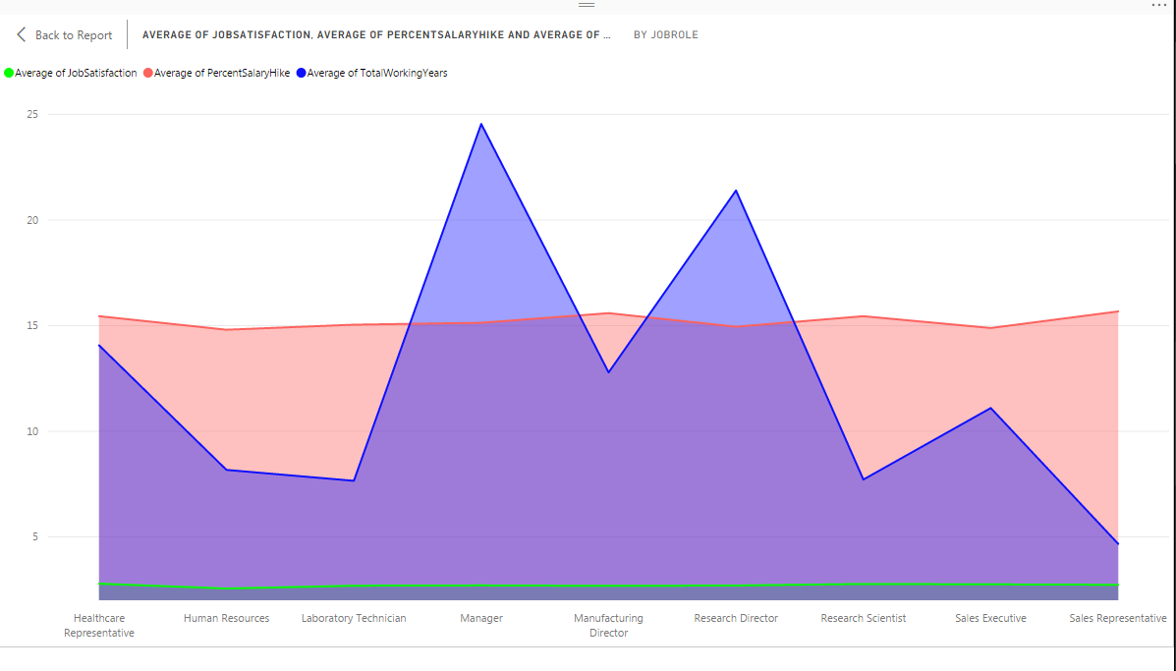

The above chart can be used to represent employees their experience in different job roles and their satisfaction in their work. The blue color in the graph is used to represent the no. of years an employee worked for that company and the red color in the area chart is used to plot the salary hike rate for that employee with respect to his number of years he worked for that company. The green color is used to show his job satisfaction. From this graph we can conclude that the job satisfaction and the percent salary hike rate for an employee are same over the job roles. The average experience of an employee in manager role is maximum i.e., nearly 24 years where for an employee in the sales representative job is at the minimum i.e., 5 years.