# REPORT FOR THE USER ADOPTION-ANALYSIS

# 

**ANALYSING CONCEPT**

* With The Groping Function I GroupUp The User Id And Count The Number Of Times Log By Indiduval User And Merge The Logg Count Into User Signup Table.
* Using Time Stamp Of Log Analysed The Number Of Log Atleast 3 Times Per Week And Merge It With  The User Signup Table And Make The Adopted Colum With It.
* Compare Each Factor Influence The Adoptability Of User(Creation Source, Marketing Drip Enabled, Enabled Opted To Mail And Time Span To Use The App)

**ML MODEL USED FOR TRAINING AND PREDICTION**

* Here I Am Using Logistic Regression Algorithm To Train The Model.
* By Using Classification Report We Get 99.5% Accuracy
* Factors = [Creation Source, Opted To Mailing List, Marketing Drip, Time Span]
* Regression Co-Efficient = [-0.15446028, -0.14785362, 0.08701948, 1.02253987]
* Intercept = [-7.64831909]

**THE VIZUAL REPRESENTATION FOR THE CO-REALATION OF FEATURES**

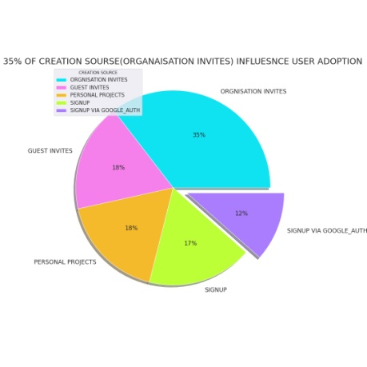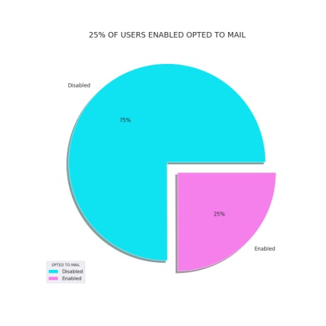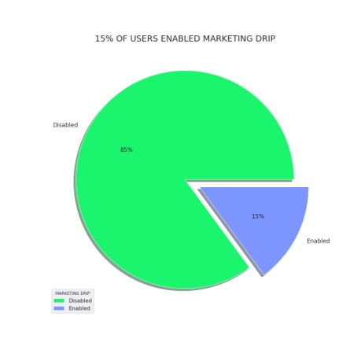

**SUMMARY**

* Org_Invites Was Play Major Role In The Adopted User And Google_Auth Is The Least
* 0.15 Factor of Creation Source Increase In Adapted User.
* 0.14 Factor of Enable To Marketing Mail Increase The Adapted User.
* 0.08 Factor of Opted To Mailing List Decrease The Adapted User
* Factor Of Time Taken To Log Decrease The Adapted Used

**FUTURE RESEARCH DATA TO BE INCLUDED**

* Personal info: gender, married status, income, location
* Social info : No. of social media active, No of friends, social media post regard this product category.
* App installed: categories of app used previously.
* Need of using this app (reason).