FRONTEND DESIGN AND TESTING LAB
DEVELOP A PERSONAL PORTFOLIO WEBSITE (ANGULAR & TYPESCRIPT)
GOOGLE DRIVE / GITHUB REPOSITORY LINK:
https://github.com/SanthoshPyaram/MY-PORTFOLIO.git
Files included (Angular & TypeScript Architecture)
7 core Angular & TypeScript production source modules are included in this complete assignment submission:
- src/app/models/portfolio.models.ts — TypeScript interfaces for Projects, Skills, Education, Certifications, and Social Profiles
- src/app/services/portfolio.service.ts — Angular Injectable state service with 4 featured projects (including 2 ECS projects) and credentials
- src/app/services/theme.service.ts — Angular reactive theme switching service with localStorage persistence and signal-based state
- src/app/components/projects/projects.component.ts — Angular component rendering 4 project cards with detail modal trigger bindings
- src/app/components/skills/skills.component.ts — Angular component rendering skill matrix, progress bars, and Embedded Systems & IoT (ECS) category
- src/app/components/resume-modal/resume-modal.component.ts — Angular component rendering printable resume document with print-to-PDF handler
- src/styles.css — Design tokens, Charcoal & Cobalt palette, glassmorphism, responsive grid, animations, and print media queries

1. TypeScript Data Models & Contract Definitions
src/app/models/portfolio.models.ts
CODE
export interface Project {
id: string;
title: string;
subtitle: string;
category: string;
categoryBadgeClass: string;
typeBadge: string;
description: string;
image: string;
tags: string[];
modalId: string;
overview: string;
capabilities: { title: string; description: string }[];
technologies: { name: string; badgeClass: string }[];
}
export interface SkillItem {
name: string;
icon: string;
iconColor: string;
status: string;
statusClass: string;
percentage: number;
progressBarClass?: string;
}
export interface SkillCategory {
title: string;
subtitle: string;
icon: string;
items: SkillItem[];
}
export interface Certification {
title: string;
issuer: string;
badge: string;
badgeClass: string;
icon: string;
description: string;
}
export interface Achievement {
title: string;
badge: string;
badgeClass: string;
icon: string;
iconBoxStyle?: string;
description: string;
tags: string[];
image?: string;
}
export interface Education {
degree: string;
institution: string;
period: string;
score: string;
scoreType: string;
scoreBadgeClass: string;
status: string;
streamOrFocus: string;
details: string;
}
export interface SocialProfile {
platform: string;
url: string;
icon: string;
colorClass: string;
title: string;
}
OUTPUT / SCREENSHOT — Home / Hero Section & Sticky Navigation Bar
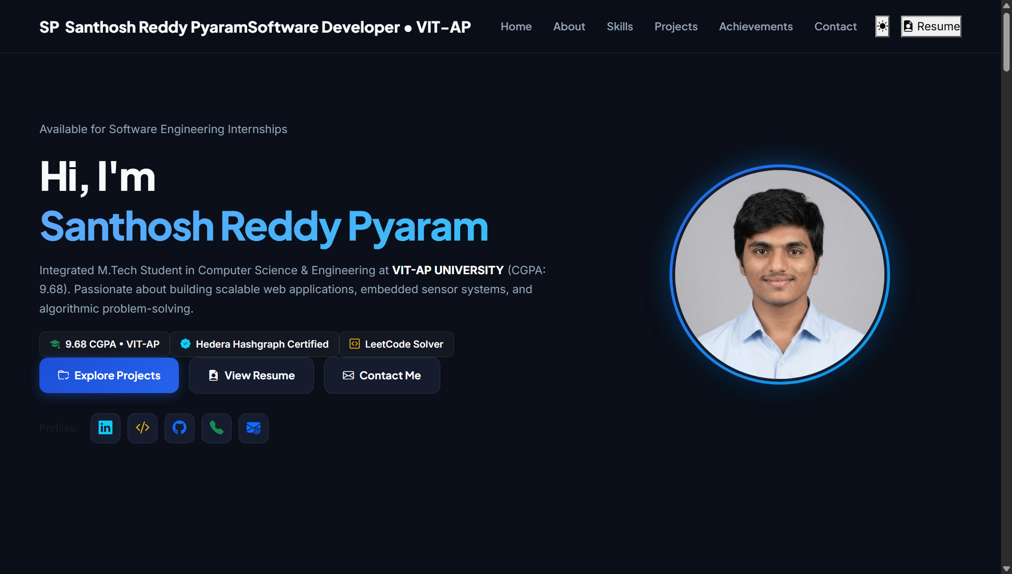
Figure 1.1: Angular application Home hero section displaying brand navbar, developer headline, tech halo avatar, and primary action buttons.

2. Angular Portfolio State & Data Service
src/app/services/portfolio.service.ts
CODE
import { Injectable, signal } from '@angular/core';
import { Project, SkillCategory, SkillItem, Certification, Achievement, Education, SocialProfile } from '../models/portfolio.models';
@Injectable({
providedIn: 'root'
})
export class PortfolioService {
readonly developerName = 'Santhosh Reddy Pyaram';
readonly registrationNo = '24MIC7312';
readonly institution = 'VIT-AP UNIVERSITY';
readonly course = 'SWE3004 FRONTEND DESIGN AND TESTING';
readonly role = 'Integrated M.Tech in Computer Science & Engineering | Software Developer';
readonly email = 'santhoshpyaram@gmail.com';
readonly phone = '+91 7287954409';
readonly location = 'Bondaladinne, Tadipatri, Anantapur, Andhra Pradesh, India';
readonly githubRepo = 'https://github.com/SanthoshPyaram/MY-PORTFOLIO.git';
// Active selected project for modal viewing
selectedProject = signal<Project | null>(null);
readonly socialProfiles: SocialProfile[] = [
{
platform: 'LinkedIn',
url: 'https://www.linkedin.com/in/pyaram-santhosh',
icon: 'bi-linkedin',
colorClass: 'text-info',
title: 'LinkedIn: pyaram-santhosh'
},
{
platform: 'LeetCode',
url: 'https://leetcode.com/u/SanthoshPyaram/',
icon: 'bi-code-slash',
colorClass: 'text-warning',
title: 'LeetCode Profile'
},
{
platform: 'GitHub',
url: 'https://github.com/SanthoshPyaram',
icon: 'bi-github',
colorClass: 'text-primary',
title: 'GitHub Profile'
},
{
platform: 'Phone',
url: 'tel:7287954409',
icon: 'bi-telephone-fill',
colorClass: 'text-success',
title: 'Call Santhosh'
},
{
platform: 'Email',
url: 'mailto:santhoshpyaram@gmail.com',
icon: 'bi-envelope-at-fill',
colorClass: 'text-primary',
title: 'Email Santhosh'
}
];
readonly educationList: Education[] = [
{
degree: 'Integrated M.Tech in Computer Science & Engineering',
institution: 'VIT-AP UNIVERSITY',
period: '2024 – 2029',
score: '9.68 / 10 CGPA',
scoreType: 'Current CGPA',
scoreBadgeClass: 'bg-success',
status: 'Currently Pursuing',
streamOrFocus: 'Computer Science & Software Engineering',
details: 'Data Structures & Algorithms, Object-Oriented Programming (Java/Python), Database Management Systems, Web Technologies, Computer Networks, Operating Systems, Discrete Mathematics.'
},
{
degree: 'Higher Secondary Education / Intermediate (Class XI – XII)',
institution: 'Narayana Junior College',
period: '2022 – 2024',
score: '982 / 1000 (98.2%)',
scoreType: 'Intermediate Score',
scoreBadgeClass: 'bg-primary',
status: 'Completed',
streamOrFocus: 'MPC (Mathematics, Physics, Chemistry)',
details: 'Mathematics, Physics, Chemistry (MPC) with rigorous analytical problem-solving foundation.'
},
{
degree: 'Secondary School Certificate (SSC / Class X)',
institution: 'APRSOE Kodigenahalli',
period: '2022',
score: '589 / 600 (98.17%)',
scoreType: 'SSC Score',
scoreBadgeClass: 'bg-info',
status: 'Completed',
streamOrFocus: 'General Sciences & Mathematics',
details: 'General Sciences, Mathematics, English Communication, and Foundational Information Technology.'
}
];
readonly skillCategories: SkillCategory[] = [
{
title: 'Programming',
subtitle: 'Core Languages',
icon: 'bi-terminal-split',
items: [
{ name: 'Java', icon: 'bi-cup-hot', iconColor: 'text-warning', status: 'Proficient', statusClass: 'status-core', percentage: 75 },
{ name: 'Python', icon: 'bi-filetype-py', iconColor: 'text-info', status: 'Proficient', statusClass: 'status-core', percentage: 70, progressBarClass: 'progress-cyan' },
{ name: 'Data Structures & Algo', icon: 'bi-braces', iconColor: 'text-primary', status: 'Proficient', statusClass: 'status-core', percentage: 72 }
]
},
{
title: 'Frontend',
subtitle: 'UI & Modern Frameworks',
icon: 'bi-window-stack',
items: [
{ name: 'HTML5 & CSS3', icon: 'bi-filetype-html', iconColor: 'text-danger', status: 'Core Tech', statusClass: 'status-core', percentage: 85 },
{ name: 'JavaScript (ES6+)', icon: 'bi-filetype-js', iconColor: 'text-warning', status: 'Core Tech', statusClass: 'status-core', percentage: 75, progressBarClass: 'progress-cyan' },
{ name: 'TypeScript & Angular', icon: 'bi-filetype-tsx', iconColor: 'text-primary', status: 'Core Framework', statusClass: 'status-core', percentage: 80, progressBarClass: 'progress-cyan' },
{ name: 'Bootstrap 5', icon: 'bi-bootstrap-fill', iconColor: 'text-primary', status: 'Responsive Grid', statusClass: 'status-core', percentage: 85 },
{ name: 'React', icon: 'bi-atom', iconColor: 'text-info', status: 'Familiar', statusClass: 'status-practicing', percentage: 60, progressBarClass: 'progress-amber' }
]
},
{
title: 'Backend & Storage',
subtitle: 'Server & Databases',
icon: 'bi-server',
items: [
{ name: 'Node.js & Express', icon: 'bi-node-plus-fill', iconColor: 'text-success', status: 'REST APIs', statusClass: 'status-practicing', percentage: 65 },
{ name: 'MongoDB', icon: 'bi-database', iconColor: 'text-success', status: 'NoSQL', statusClass: 'status-core', percentage: 70, progressBarClass: 'progress-cyan' },
{ name: 'SQL / SQL Server', icon: 'bi-table', iconColor: 'text-info', status: 'Relational', statusClass: 'status-core', percentage: 72 }
]
}
];
readonly ecsSkills: SkillItem[] = [
{ name: 'Embedded Systems', icon: 'bi-cpu', iconColor: 'text-info', status: 'ECS Core', statusClass: 'status-core', percentage: 75, progressBarClass: 'progress-cyan' },
{ name: 'IoT Fundamentals', icon: 'bi-broadcast', iconColor: 'text-primary', status: 'Connected Tech', statusClass: 'status-core', percentage: 70, progressBarClass: 'progress-cyan' },
{ name: 'Sensor-Based Systems', icon: 'bi-activity', iconColor: 'text-warning', status: 'Sensing', statusClass: 'status-core', percentage: 72, progressBarClass: 'progress-amber' },
{ name: 'Hardware-Software Integration', icon: 'bi-motherboard', iconColor: 'text-success', status: 'Integration', statusClass: 'status-core', percentage: 74, progressBarClass: 'progress-cyan' },
{ name: 'Assistive Technology', icon: 'bi-universal-access', iconColor: 'text-info', status: 'Accessibility', statusClass: 'status-practicing', percentage: 70, progressBarClass: 'progress-cyan' },
{ name: 'Environmental Technology', icon: 'bi-wind', iconColor: 'text-success', status: 'Clean Tech', statusClass: 'status-practicing', percentage: 68, progressBarClass: 'progress-cyan' }
];
readonly softSkills: { name: string; icon: string; colorClass: string }[] = [
{ name: 'Problem Solving', icon: 'bi-puzzle-fill', colorClass: 'text-warning' },
{ name: 'Team Collaboration', icon: 'bi-people', colorClass: 'text-info' },
{ name: 'Analytical Thinking', icon: 'bi-graph-up-arrow', colorClass: 'text-success' },
{ name: 'Adaptability & Rapid Learning', icon: 'bi-arrow-repeat', colorClass: 'text-primary' },
{ name: 'Time Management', icon: 'bi-clock-history', colorClass: 'text-danger' },
{ name: 'Communication Skills', icon: 'bi-chat-left-dots-fill', colorClass: 'text-cyan' }
];
readonly projects: Project[] = [
{
id: 'agriculture',
title: 'Smart Agriculture System',
subtitle: 'Data-driven crop analytics and market price prediction platform',
category: 'Agri-Tech Platform',
categoryBadgeClass: 'bg-success-subtle text-success border border-success-subtle',
typeBadge: 'Academic Project',
description: 'A data-driven agriculture project that explores crop information, farmer data, market prices, supply and demand, storage, transportation, weather, and price prediction to support agricultural decision-making.',
image: 'assets/project-agriculture.jpg',
tags: ['Python', 'MongoDB', 'Data Analysis', 'Prediction Models', 'IoT Analytics'],
modalId: 'projectModalAgriculture',
overview: 'A data-driven agriculture project that explores crop information, farmer data, market prices, supply and demand, storage, transportation, weather, and price prediction to support agricultural decision-making.',
capabilities: [
{ title: 'Crop & Soil Analytics', description: 'Tracks soil moisture, environmental temperature, and nutrient metrics.' },
{ title: 'Price Forecasting', description: 'Utilizes historical crop pricing trends to forecast seasonal market value peaks.' },
{ title: 'Cold Storage & Logistics', description: 'Simulates transit routes and warehouse capacity utilization for harvested yields.' },
{ title: 'Farmer Decision Support', description: 'Presents clear recommendations on planting schedules and optimal selling cycles.' }
],
technologies: [
{ name: 'Python', badgeClass: 'bg-primary-subtle text-primary' },
{ name: 'MongoDB', badgeClass: 'bg-success-subtle text-success' },
{ name: 'Data Analysis', badgeClass: 'bg-info-subtle text-info' },
{ name: 'Prediction Models', badgeClass: 'bg-warning-subtle text-warning' }
]
},
{
id: 'coopnex',
title: 'COOPNEX — Cooperative Services Platform',
subtitle: 'Full-stack cooperative services and verified tradesperson marketplace',
category: 'Marketplace Platform',
categoryBadgeClass: 'bg-primary-subtle text-primary border border-primary-subtle',
typeBadge: 'Full-Stack Concept',
description: 'A digital cooperative services marketplace concept designed to connect workers, service providers, and customers through service discovery, worker profiles, booking, scheduling, and cooperative administration.',
image: 'assets/project-coopnex.jpg',
tags: ['HTML5', 'CSS3', 'JavaScript', 'React', 'Node.js', 'MongoDB'],
modalId: 'projectModalCoopnex',
overview: 'A digital cooperative services marketplace concept designed to connect workers, service providers, and customers through service discovery, worker profiles, booking, scheduling, and cooperative administration.',
capabilities: [
{ title: 'Verified Worker Directory', description: 'Showcase certified cooperative tradespeople with skills, verified ratings, and transparent fees.' },
{ title: 'Automated Booking & Dispatch', description: 'Customers select available date/time slots with automated allocation.' },
{ title: 'Fair Cooperative Revenue Distribution', description: 'Transparent fee split allocating majority payout directly to workers alongside cooperative welfare funds.' },
{ title: 'Society Admin Portal', description: 'Real-time dashboard monitoring active bookings, member welfare metrics, and user feedback.' }
],
technologies: [
{ name: 'HTML5', badgeClass: 'bg-danger-subtle text-danger' },
{ name: 'CSS3', badgeClass: 'bg-primary-subtle text-primary' },
{ name: 'JavaScript', badgeClass: 'bg-warning-subtle text-warning' },
{ name: 'React', badgeClass: 'bg-info-subtle text-info' },
{ name: 'Node.js', badgeClass: 'bg-success-subtle text-success' },
{ name: 'MongoDB', badgeClass: 'bg-success-subtle text-success' }
]
},
{
id: 'smart-shoes',
title: 'Smart Shoes for Blind Persons',
subtitle: 'Assistive embedded technology for real-time obstacle detection',
category: 'Embedded Systems / Assistive Technology',
categoryBadgeClass: 'bg-info-subtle text-info border border-info-subtle',
typeBadge: 'ECS Project',
description: 'An assistive-technology project designed to help visually impaired individuals detect obstacles and navigate their surroundings more safely.',
image: 'assets/project-smart-shoes.jpg',
tags: ['Embedded Systems', 'Sensor-Based Systems', 'Hardware-Software Integration', 'Assistive Technology', 'Obstacle Detection'],
modalId: 'projectModalSmartShoes',
overview: 'An assistive-technology project designed to help visually impaired individuals detect obstacles and navigate their surroundings more safely.',
capabilities: [
{ title: 'Sensor-Based Obstacle Detection', description: "Real-time detection of ground-level and knee-level obstacles in the user's path." },
{ title: 'Surroundings Navigation', description: 'Assists visually impaired users in navigating physical spaces with enhanced confidence and safety.' },
{ title: 'Hardware-Software Integration', description: 'Seamless link between embedded sensors and navigational response mechanisms.' },
{ title: 'Assistive Technology', description: 'Dedicated human-centric design focused on accessibility and mobility independence.' }
],
technologies: [
{ name: 'Embedded Systems', badgeClass: 'bg-info-subtle text-info' },
{ name: 'Sensor-Based Systems', badgeClass: 'bg-primary-subtle text-primary' },
{ name: 'Hardware-Software Integration', badgeClass: 'bg-warning-subtle text-warning' },
{ name: 'Assistive Technology', badgeClass: 'bg-success-subtle text-success' },
{ name: 'Obstacle Detection', badgeClass: 'bg-secondary-subtle text-light' }
]
},
{
id: 'air-purifier',
title: 'Smart Air Purification System',
subtitle: 'Intelligent environmental sensing and automated indoor air quality control',
category: 'Embedded Systems / Environmental Technology',
categoryBadgeClass: 'bg-success-subtle text-success border border-success-subtle',
typeBadge: 'ECS Project',
description: 'An engineering project focused on improving indoor air quality through a smart air-purification system.',
image: 'assets/project-air-purifier.jpg',
tags: ['Embedded Systems', 'IoT Fundamentals', 'Sensor-Based Systems', 'Hardware-Software Integration', 'Environmental Technology'],
modalId: 'projectModalAirPurifier',
overview: 'An engineering project focused on improving indoor air quality through a smart air-purification system.',
capabilities: [
{ title: 'Indoor Air Quality Monitoring', description: 'Continuous real-time sensing of indoor air quality and ambient conditions.' },
{ title: 'Automated Air Purification', description: 'Dynamic activation and regulation of air purification based on sensor readings.' },
{ title: 'IoT Fundamentals & Embedded Logic', description: 'Environmental sensing loop integrating microcontroller logic with automated filtration.' },
{ title: 'Environmental Technology', description: 'Engineered to create healthier indoor living and working environments.' }
],
technologies: [
{ name: 'Embedded Systems', badgeClass: 'bg-success-subtle text-success' },
{ name: 'IoT Fundamentals', badgeClass: 'bg-info-subtle text-info' },
{ name: 'Sensor-Based Systems', badgeClass: 'bg-primary-subtle text-primary' },
{ name: 'Hardware-Software Integration', badgeClass: 'bg-warning-subtle text-warning' },
{ name: 'Environmental Technology', badgeClass: 'bg-success-subtle text-success' }
]
}
];
readonly achievements: Achievement[] = [
{
title: '100% Attendance Award (Academic Year 2024–2025)',
badge: 'University Honor',
badgeClass: 'bg-warning-subtle text-warning border border-warning-subtle',
icon: 'bi-award-fill',
iconBoxStyle: 'color: #f59e0b; border-color: rgba(245,158,11,0.4); background: rgba(245,158,11,0.15);',
description: 'Conferred the prestigious 100% Attendance Award for the academic year 2024–2025 by VIT-AP University during the 8th University Day Celebrations, recognizing exceptional consistency, discipline, and commitment to academic excellence.',
tags: ['100% Attendance', 'VIT-AP University', 'Academic Excellence', 'Discipline & Consistency'],
image: 'assets/award-attendance.jpg'
},
{
title: 'Smart India Hackathon (SIH)',
badge: 'National Hackathon',
badgeClass: 'bg-primary-subtle text-primary border border-primary-subtle',
icon: 'bi-trophy-fill',
description: "Selected participant in India's premier nationwide open innovation initiative. Collaborated with a multidisciplinary team to ideate, architect, and prototype a software solution targeting a critical real-world national problem statement.",
tags: ['Problem Analysis', 'Rapid Prototyping', 'Team Collaboration', 'Jury Evaluation']
},
{
title: 'Inter-College Tech Fest & Project Innovation Expo',
badge: 'Project Exhibition',
badgeClass: 'bg-info-subtle text-info border border-info-subtle',
icon: 'bi-lightbulb-fill',
iconBoxStyle: 'color: #38bdf8; border-color: rgba(6,182,212,0.4); background: rgba(6,182,212,0.15);',
description: 'Showcased technical prototype and presented architecture diagrams to a panel of engineering faculty and industry reviewers. Recognized for innovative application of software systems to everyday operational challenges.',
tags: ['Software Architecture', 'Live Demonstration', 'Technical Presentation']
}
];
readonly certifications: Certification[] = [
{
title: 'Blockchain Hashgraph & Hedera Certificate',
issuer: 'Hedera Hashgraph Developer Program',
badge: 'Blockchain',
badgeClass: 'cert-badge-hedera',
icon: 'bi-link-45deg',
description: 'Mastery of Hedera Consensus Service (HCS), Token Service (HTS), smart contracts, and distributed ledger fundamentals.'
},
{
title: 'Python for Data Science & Problem Solving',
issuer: 'Professional Technical Certification',
badge: 'Python & DSA',
badgeClass: 'bg-primary-subtle text-primary border border-primary-subtle',
icon: 'bi-filetype-py',
description: 'Advanced Python paradigms, computational complexity analysis, data structures, and algorithmic implementation.'
},
{
title: 'Database Management & SQL Specialist',
issuer: 'Relational Database Program',
badge: 'Database',
badgeClass: 'bg-success-subtle text-success border border-success-subtle',
icon: 'bi-database-check',
description: 'Comprehensive schema design, SQL querying, transactional integrity (ACID), normalization, and database indexing.'
}
];
openProjectModal(project: Project): void {
this.selectedProject.set(project);
if (typeof window !== 'undefined') {
const modalElement = document.getElementById(project.modalId);
if (modalElement && (window as any).bootstrap) {
const modal = new (window as any).bootstrap.Modal(modalElement);
modal.show();
}
}
}
}
OUTPUT / SCREENSHOT — About Me Section & Academic Credentials
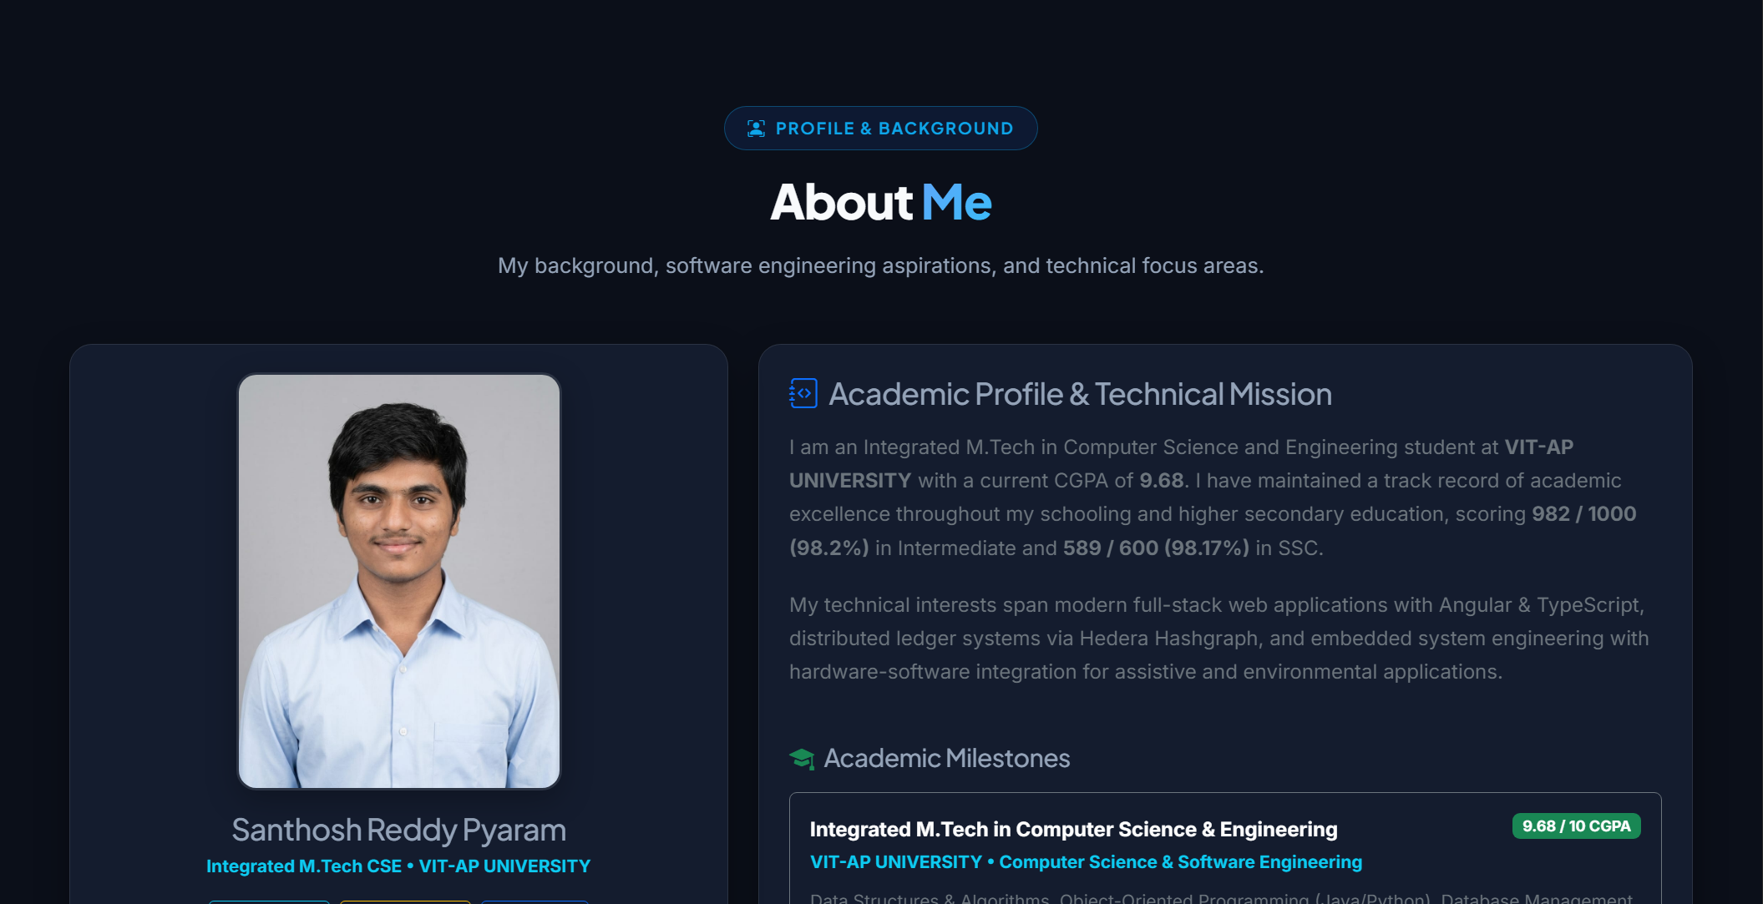
Figure 2.1: Angular application About section showcasing personal narrative, verified academic scores (9.68 CGPA, 982/1000 Intermediate, 589/600 SSC), and profile portrait.

3. Angular Reactive Theme Switching Service
src/app/services/theme.service.ts
CODE
import { Injectable, signal } from '@angular/core';
export type ThemeMode = 'dark' | 'light';
@Injectable({
providedIn: 'root'
})
export class ThemeService {
private readonly STORAGE_KEY = 'portfolio_theme_mode';
currentTheme = signal<ThemeMode>('dark');
constructor() {
this.initTheme();
}
private initTheme(): void {
if (typeof window !== 'undefined' && window.localStorage) {
const saved = localStorage.getItem(this.STORAGE_KEY) as ThemeMode;
const initial = saved === 'light' || saved === 'dark' ? saved : 'dark';
this.setTheme(initial);
}
}
setTheme(theme: ThemeMode): void {
this.currentTheme.set(theme);
if (typeof document !== 'undefined') {
document.documentElement.setAttribute('data-theme', theme);
}
if (typeof window !== 'undefined' && window.localStorage) {
localStorage.setItem(this.STORAGE_KEY, theme);
}
}
toggleTheme(): void {
const next = this.currentTheme() === 'dark' ? 'light' : 'dark';
this.setTheme(next);
}
}
OUTPUT / SCREENSHOT — Technical Skills Section & Embedded ECS Category
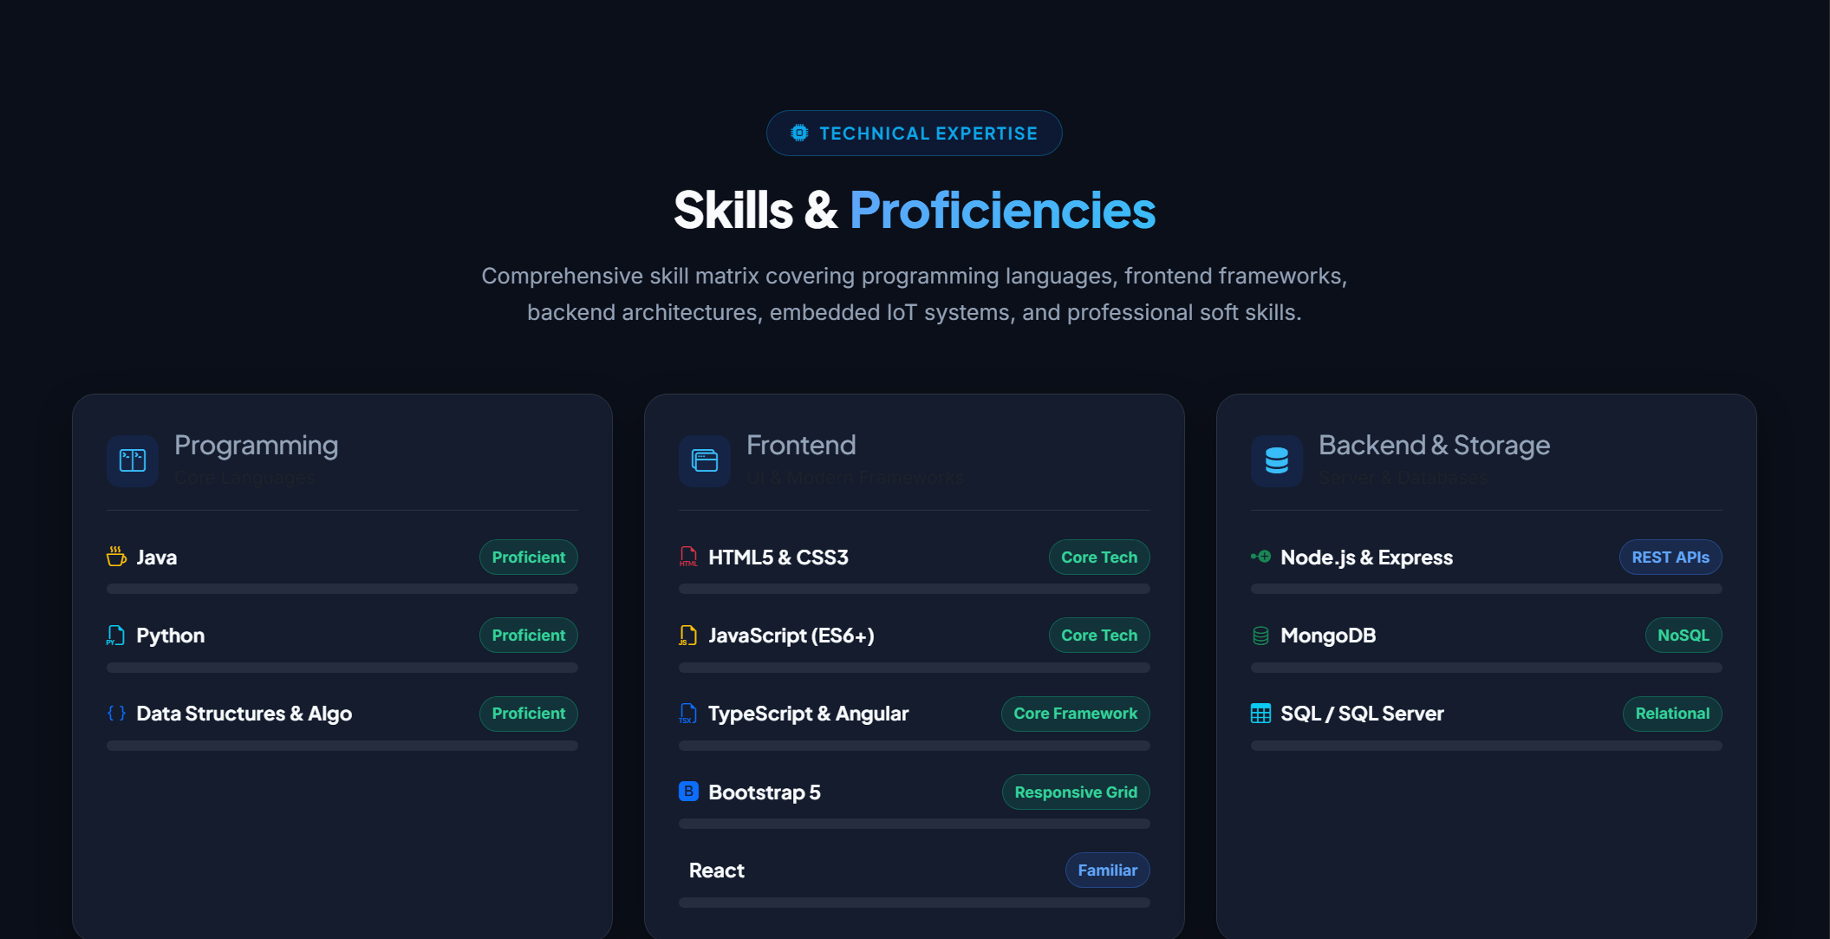
Figure 3.1: Angular application Skills section demonstrating responsive category cards, animated progress bars, and the Embedded Systems & IoT (ECS) skill matrix.

4. Angular Projects Component (4 Featured & ECS Projects)
src/app/components/projects/projects.component.ts
CODE
import { Component, inject } from '@angular/core';
import { CommonModule } from '@angular/common';
import { PortfolioService } from '../../services/portfolio.service';
import { Project } from '../../models/portfolio.models';
@Component({
selector: 'app-projects',
standalone: true,
imports: [CommonModule],
template: `
<section id="projects" class="section-padding bg-black-subtle" aria-label="Projects Section">
<div class="container">
<!-- Section Header -->
<div class="section-header">
<span class="section-badge"><i class="bi bi-folder-check"></i> Featured Creations</span>
<h2 class="section-title">My <span class="gradient-text">Projects</span></h2>
<p class="section-subtitle">
Real-world software architectures, digital marketplaces, and embedded ECS assistive &amp; environmental solutions.
</p>
</div>
<!-- 2-Column Responsive Grid for 4 Projects -->
<div class="row g-4">
@for (proj of portfolio.projects; track proj.id) {
<div class="col-lg-6">
<article class="glass-card project-card">
<div class="project-img-wrapper">
<img [src]="proj.image" [alt]="proj.title + ' preview thumbnail'" class="project-img">
<div class="project-overlay"></div>
</div>
<div class="project-body">
<div class="d-flex justify-content-between align-items-center mb-2">
<span class="badge" [ngClass]="proj.categoryBadgeClass">{{ proj.category }}</span>
<span class="text-muted small">
<i class="bi" [ngClass]="proj.typeBadge.includes('ECS') ? 'bi-cpu me-1' : 'bi-calendar-event me-1'"></i>
{{ proj.typeBadge }}
</span>
</div>
<h3 class="project-title">{{ proj.title }}</h3>
<p class="project-description">{{ proj.description }}</p>
<!-- Tech Badges -->
<div class="tech-badge-container">
@for (tag of proj.tags; track tag) {
<span class="tech-badge">{{ tag }}</span>
}
</div>
<!-- Action Buttons -->
<div class="project-footer">
<button type="button" class="btn-project-primary" (click)="portfolio.openProjectModal(proj)">
<i class="bi bi-info-circle"></i> View Details
</button>
<button type="button" class="btn-project-secondary" disabled>
<i class="bi" [ngClass]="proj.typeBadge.includes('ECS') ? 'bi-cpu' : 'bi-github'"></i>
{{ proj.typeBadge.includes('ECS') ? 'ECS Project' : 'Source Code' }}
</button>
</div>
</div>
</article>
</div>
}
</div>
</div>
</section>
`
})
export class ProjectsComponent {
portfolio = inject(PortfolioService);
}
OUTPUT / SCREENSHOT — Featured Projects Showcase (4 Projects)
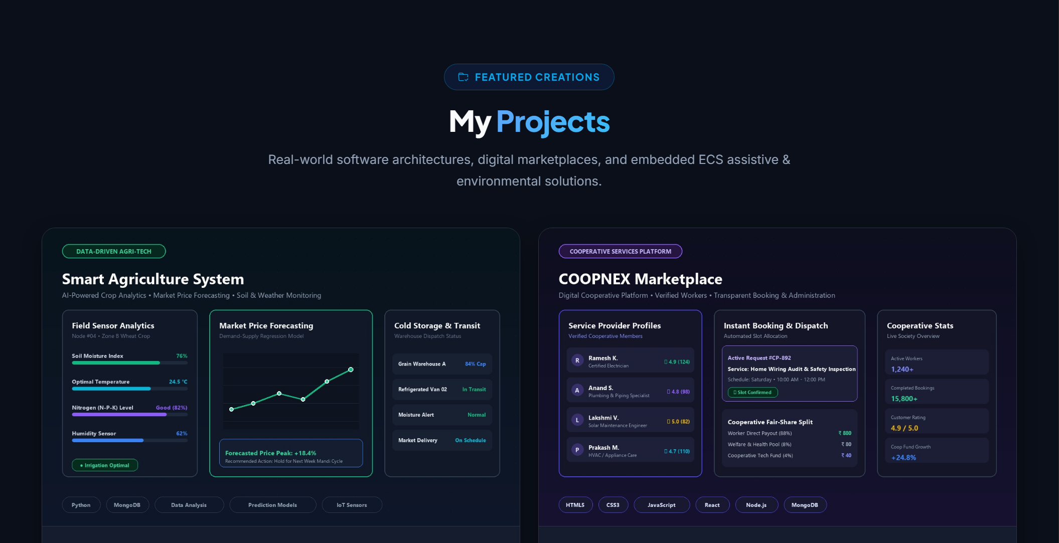
Figure 4.1: Angular application Projects showcase featuring Smart Agriculture, COOPNEX, Smart Shoes for Blind Persons, and Smart Air Purification System.

5. Angular Skills Component & Progress Indicators
src/app/components/skills/skills.component.ts
CODE
import { Component, inject } from '@angular/core';
import { CommonModule } from '@angular/common';
import { PortfolioService } from '../../services/portfolio.service';
@Component({
selector: 'app-skills',
standalone: true,
imports: [CommonModule],
template: `
<section id="skills" class="section-padding" aria-label="Skills Section">
<div class="container">
<!-- Section Header -->
<div class="section-header">
<span class="section-badge"><i class="bi bi-cpu-fill"></i> Technical Expertise</span>
<h2 class="section-title">Skills &amp; <span class="gradient-text">Proficiencies</span></h2>
<p class="section-subtitle">
Comprehensive skill matrix covering programming languages, frontend frameworks, backend architectures, embedded IoT systems, and professional soft skills.
</p>
</div>
<div class="row g-4">
<!-- 3 Primary Technical Categories -->
@for (cat of portfolio.skillCategories; track cat.title) {
<div class="col-lg-4 col-md-6">
<div class="glass-card skill-card">
<div class="skill-category-header">
<div class="skill-cat-icon">
<i class="bi" [ngClass]="cat.icon"></i>
</div>
<div>
<h3 class="h5 mb-0">{{ cat.title }}</h3>
<span class="text-muted small">{{ cat.subtitle }}</span>
</div>
</div>
@for (item of cat.items; track item.name) {
<div class="skill-item">
<div class="skill-item-header">
<span class="skill-name">
<i class="bi" [ngClass]="[item.icon, item.iconColor]"></i> {{ item.name }}
</span>
<span class="skill-status-tag" [ngClass]="item.statusClass">{{ item.status }}</span>
</div>
<div class="custom-progress">
<div class="progress-bar" [ngClass]="item.progressBarClass || ''" [style.width.%]="item.percentage"></div>
</div>
</div>
}
</div>
</div>
}
<!-- 4. Embedded Systems & IoT (ECS) Section -->
<div class="col-12">
<div class="glass-card p-4">
<div class="skill-category-header mb-3">
<div class="skill-cat-icon">
<i class="bi bi-cpu-fill"></i>
</div>
<div>
<h3 class="h5 mb-0">Embedded Systems &amp; IoT (ECS)</h3>
<span class="text-muted small">Hardware-Software Integration &amp; Sensor Systems</span>
</div>
</div>
<div class="row g-3">
@for (skill of portfolio.ecsSkills; track skill.name) {
<div class="col-md-4 col-sm-6">
<div class="skill-item mb-0">
<div class="skill-item-header">
<span class="skill-name">
<i class="bi" [ngClass]="[skill.icon, skill.iconColor]"></i> {{ skill.name }}
</span>
<span class="skill-status-tag" [ngClass]="skill.statusClass">{{ skill.status }}</span>
</div>
<div class="custom-progress">
<div class="progress-bar" [ngClass]="skill.progressBarClass || ''" [style.width.%]="skill.percentage"></div>
</div>
</div>
</div>
}
</div>
</div>
</div>
<!-- 5. Soft Skills Highlight Section -->
<div class="col-12">
<div class="glass-card p-4">
<h3 class="h5 mb-3 d-flex align-items-center gap-2">
<i class="bi bi-people-fill text-info"></i> Key Soft Skills &amp; Professional Attributes
</h3>
<div class="d-flex flex-wrap gap-3">
@for (soft of portfolio.softSkills; track soft.name) {
<div class="soft-skill-chip">
<i class="bi" [ngClass]="[soft.icon, soft.colorClass]"></i> {{ soft.name }}
</div>
}
</div>
</div>
</div>
</div>
</div>
</section>
`
})
export class SkillsComponent {
portfolio = inject(PortfolioService);
}
OUTPUT / SCREENSHOT — Interactive Contact Section with TypeScript Form
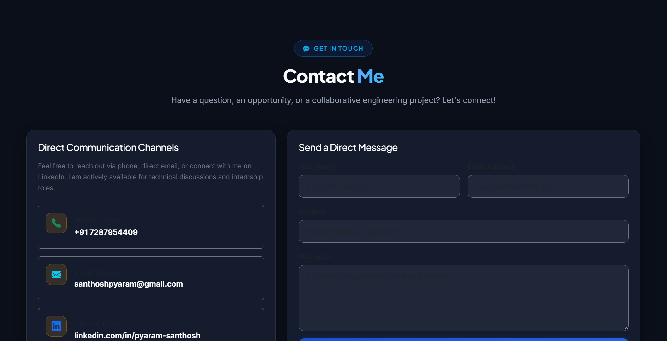
Figure 5.1: Angular application Contact section featuring interactive message form with real-time field validation, contact channels, and social media connectivity.

6. Angular Resume Modal Component with Print Handler
src/app/components/resume-modal/resume-modal.component.ts
CODE
import { Component, inject } from '@angular/core';
import { CommonModule } from '@angular/common';
import { PortfolioService } from '../../services/portfolio.service';
@Component({
selector: 'app-resume-modal',
standalone: true,
imports: [CommonModule],
template: `
<div class="modal fade" id="resumeModal" tabindex="-1" aria-labelledby="resumeModalLabel" aria-hidden="true">
<div class="modal-dialog modal-dialog-centered resume-modal-dialog">
<div class="modal-content">
<div class="modal-header">
<h3 class="modal-title h5" id="resumeModalLabel">
<i class="bi bi-file-earmark-person-fill text-info me-2"></i>Resume — {{ portfolio.developerName }}
</h3>
<button type="button" class="btn-close" data-bs-dismiss="modal" aria-label="Close"></button>
</div>
<div class="modal-body p-3 p-md-4">
<!-- Professional Printable Resume Container -->
<div class="resume-paper" id="resumePrintableArea">
<!-- Header with Headshot Photo & Contact Details -->
<div class="resume-header">
<div class="d-flex justify-content-between align-items-center flex-wrap gap-3">
<div class="flex-grow-1">
<h1 class="resume-name">{{ portfolio.developerName | uppercase }}</h1>
<div class="resume-role">
Integrated M.Tech in Computer Science &amp; Engineering | Software Developer &bull;
<strong>{{ portfolio.institution }}</strong> (CGPA: 9.68)
</div>
<!-- Contact Pills -->
<div class="resume-contact-bar mt-2">
<span class="resume-contact-item">
<i class="bi bi-telephone-fill text-success"></i> {{ portfolio.phone }}
</span>
<span class="resume-contact-item">
<i class="bi bi-envelope-fill text-info"></i> {{ portfolio.email }}
</span>
<a href="https://www.linkedin.com/in/pyaram-santhosh" target="_blank" rel="noopener noreferrer" class="resume-contact-item text-decoration-none">
<i class="bi bi-linkedin text-info"></i> linkedin.com/in/pyaram-santhosh
</a>
<span class="resume-contact-item">
<i class="bi bi-geo-alt-fill text-danger"></i> Anantapur, Andhra Pradesh, India
</span>
<a href="https://github.com/SanthoshPyaram" target="_blank" rel="noopener noreferrer" class="resume-contact-item text-decoration-none">
<i class="bi bi-github text-primary"></i> github.com/SanthoshPyaram
</a>
<a href="https://leetcode.com/u/SanthoshPyaram/" target="_blank" rel="noopener noreferrer" class="resume-contact-item text-decoration-none" style="border-color: rgba(255,161,22,0.5);">
<i class="bi bi-code-slash text-warning"></i> leetcode.com/u/SanthoshPyaram
</a>
</div>
</div>
<!-- Headshot Photo in Resume -->
<div class="resume-photo-box text-center">
<img src="assets/profile-headshot.jpg" alt="Santhosh Reddy Pyaram Headshot" class="resume-photo-img">
</div>
</div>
</div>
<!-- 1. Professional Objective -->
<div class="mb-4">
<div class="resume-section-title title-cyan">
<i class="bi bi-bullseye"></i> Professional Summary &amp; Objective
</div>
<p class="small text-secondary mb-0">
Ambitious and disciplined Integrated M.Tech in Computer Science &amp; Engineering student at <strong>VIT-AP UNIVERSITY</strong> with an exceptional academic record (<strong>9.68 CGPA</strong>), robust foundations in object-oriented programming, data structures, algorithms, and Angular/TypeScript full-stack web architectures. Proven problem-solving ability through competitive programming on <strong>LeetCode</strong> and collaborative project building in the <strong>Smart India Hackathon</strong>. Certified in <strong>Hedera Hashgraph Blockchain</strong> with hands-on experience developing web platforms, machine learning applications, and embedded sensor systems. Seeking software developer internships to build robust, scalable applications.
</p>
</div>
<!-- 2. Education (3 Complete Tiers) -->
<div class="mb-4">
<div class="resume-section-title title-indigo">
<i class="bi bi-mortarboard-fill"></i> Education &amp; Academic Excellence
</div>
@for (edu of portfolio.educationList; track edu.degree) {
<div class="resume-entry">
<div class="resume-entry-header">
<span class="resume-entry-title">{{ edu.degree }}</span>
<span class="resume-entry-date">{{ edu.period }}</span>
</div>
<div class="resume-entry-sub text-info">
<strong>{{ edu.institution }}</strong> &bull; Score: <span class="badge text-white fw-bold" [ngClass]="edu.scoreBadgeClass">{{ edu.score }}</span> &bull; Status: {{ edu.status }}
</div>
<div class="small text-secondary">
<strong>Focus:</strong> {{ edu.details }}
</div>
</div>
}
</div>
<!-- 3. Technical & Soft Skills -->
<div class="mb-4">
<div class="resume-section-title title-emerald">
<i class="bi bi-tools"></i> Technical &amp; Soft Skills
</div>
<!-- Programming Languages -->
<div class="resume-skill-group">
<span class="resume-skill-label text-primary">Languages:</span>
<span class="resume-pill pill-lang">Java</span>
<span class="resume-pill pill-lang">Python</span>
<span class="resume-pill pill-lang">TypeScript</span>
<span class="resume-pill pill-lang">JavaScript (ES6+)</span>
<span class="resume-pill pill-lang">SQL</span>
</div>
<!-- Frontend Web Development -->
<div class="resume-skill-group">
<span class="resume-skill-label text-cyan">Frontend:</span>
<span class="resume-pill pill-front">Angular (v21)</span>
<span class="resume-pill pill-front">HTML5</span>
<span class="resume-pill pill-front">CSS3</span>
<span class="resume-pill pill-front">Bootstrap 5</span>
<span class="resume-pill pill-front">React (Familiar)</span>
</div>
<!-- Backend & Databases -->
<div class="resume-skill-group">
<span class="resume-skill-label text-success">Backend &amp; DB:</span>
<span class="resume-pill pill-back">Node.js</span>
<span class="resume-pill pill-back">Express.js</span>
<span class="resume-pill pill-db">MongoDB</span>
<span class="resume-pill pill-db">SQL Server</span>
<span class="resume-pill pill-db">RESTful APIs</span>
</div>
<!-- Developer Tools -->
<div class="resume-skill-group">
<span class="resume-skill-label text-warning">Developer Tools:</span>
<span class="resume-pill pill-tool">Git &amp; GitHub</span>
<span class="resume-pill pill-tool">Visual Studio Code</span>
<span class="resume-pill pill-tool">Angular CLI</span>
<span class="resume-pill pill-tool">MongoDB Compass</span>
<span class="resume-pill pill-tool">Chrome DevTools</span>
</div>
<!-- Embedded Systems & IoT (ECS) -->
<div class="resume-skill-group">
<span class="resume-skill-label" style="color: #06b6d4;">Embedded &amp; ECS:</span>
@for (s of portfolio.ecsSkills; track s.name) {
<span class="resume-pill pill-front">{{ s.name }}</span>
}
</div>
<!-- Soft Skills -->
<div class="resume-skill-group">
<span class="resume-skill-label" style="color: #ec4899;">Soft Skills:</span>
@for (soft of portfolio.softSkills; track soft.name) {
<span class="resume-pill pill-soft">{{ soft.name }}</span>
}
</div>
</div>
<!-- 4. Academic Projects -->
<div class="mb-4">
<div class="resume-section-title title-amber">
<i class="bi bi-code-square"></i> Key Academic Projects
</div>
<!-- Project 1 -->
<div class="resume-entry">
<div class="resume-entry-header">
<span class="resume-entry-title">1. Smart Agriculture System</span>
<span class="resume-entry-date">Python, MongoDB, Data Analysis, Prediction Models</span>
</div>
<ul class="small text-secondary mb-0 ps-3">
<li>Architected a data-driven agriculture decision platform exploring crop data, weather metrics, and demand cycles.</li>
<li>Implemented predictive regression algorithms for crop market price forecasting to assist farmers in timing market sales.</li>
<li>Designed schema in MongoDB to track warehouse storage logistics, soil parameters, and transit schedules.</li>
</ul>
</div>
<!-- Project 2 -->
<div class="resume-entry">
<div class="resume-entry-header">
<span class="resume-entry-title">2. COOPNEX — Cooperative Services Platform</span>
<span class="resume-entry-date">HTML5, CSS3, JavaScript, React, Node.js, MongoDB</span>
</div>
<ul class="small text-secondary mb-0 ps-3">
<li>Designed a digital cooperative services marketplace connecting tradespeople, clients, and society administration.</li>
<li>Engineered worker profile discovery, slot booking schedules, transparent fee breakdowns, and automated booking dispatch.</li>
<li>Constructed modular responsive frontend interfaces with Bootstrap 5 and interactive client-side validations.</li>
</ul>
</div>
<!-- Project 3 -->
<div class="resume-entry">
<div class="resume-entry-header">
<span class="resume-entry-title">3. Smart Shoes for Blind Persons (ECS Project)</span>
<span class="resume-entry-date">Embedded Systems, Sensor-Based Systems, Assistive Technology</span>
</div>
<ul class="small text-secondary mb-0 ps-3">
<li>An assistive-technology project designed to help visually impaired individuals detect obstacles and navigate their surroundings more safely.</li>
<li>Implemented sensor-based obstacle detection and hardware-software integration for real-time surroundings navigation guidance.</li>
</ul>
</div>
<!-- Project 4 -->
<div class="resume-entry">
<div class="resume-entry-header">
<span class="resume-entry-title">4. Smart Air Purification System (ECS Project)</span>
<span class="resume-entry-date">Embedded Systems, IoT Fundamentals, Environmental Technology</span>
</div>
<ul class="small text-secondary mb-0 ps-3">
<li>An engineering project focused on improving indoor air quality through a smart air-purification system.</li>
<li>Integrated sensor-based air quality monitoring with automated response controls for continuous purification.</li>
</ul>
</div>
</div>
<!-- 5. Certifications & Hackathons -->
<div>
<div class="resume-section-title title-violet">
<i class="bi bi-patch-check-fill"></i> Certifications &amp; Honors
</div>
<ul class="small text-secondary ps-3 mb-0">
@for (cert of portfolio.certifications; track cert.title) {
<li class="mb-1"><strong>{{ cert.title }}:</strong> {{ cert.description }}</li>
}
@for (ach of portfolio.achievements; track ach.title) {
<li class="mb-1"><strong>{{ ach.title }}:</strong> {{ ach.description }}</li>
}
</ul>
</div>
</div>
</div>
<div class="modal-footer">
<span class="text-muted small me-auto">
<i class="bi bi-info-circle me-1"></i> Formatted for high-quality standard A4 print and PDF saving
</span>
<button type="button" class="btn btn-secondary btn-sm" data-bs-dismiss="modal">Close</button>
<button type="button" class="btn btn-primary-gradient btn-sm" (click)="printResume()">
<i class="bi bi-printer-fill me-1"></i> Print / Save as PDF
</button>
</div>
</div>
</div>
</div>
`
})
export class ResumeModalComponent {
portfolio = inject(PortfolioService);
printResume(): void {
if (typeof window !== 'undefined') {
window.print();
}
}
}
OUTPUT / SCREENSHOT — Dynamic Interactive Resume Modal View
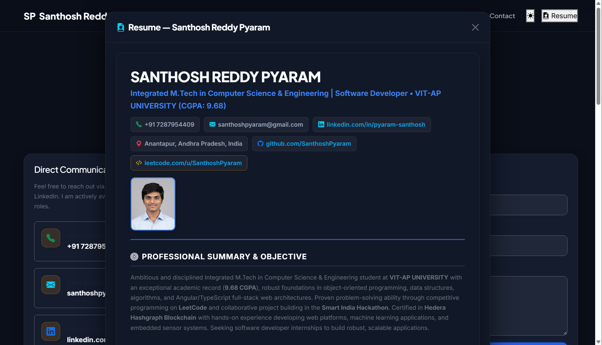
Figure 6.1: Angular application Resume modal rendered dynamically with print-to-PDF formatting, exact 9.68 CGPA, and all 4 projects.

7. Global Styles, Design Tokens & Glassmorphism System
src/styles.css
CODE
/* ==========================================================================
PERSONAL PORTFOLIO - SANTHOSH REDDY PYARAM
Authentic, Professional Software Engineering Portfolio
Theme: Deep Charcoal & Cobalt Tech (Clean Human-Crafted Developer Aesthetic)
100% Contrast & Legibility in Dark & Light Modes
========================================================================== */
/* --------------------------------------------------------------------------
1. CSS VARIABLES (AUTHENTIC DEVELOPER TOKENS)
-------------------------------------------------------------------------- */
:root {
/* Dark Theme - Deep Charcoal & Cobalt Slate (Professional Engineering Palette) */
--bg-primary: #0b0f19;
--bg-secondary: #111827;
--bg-card: #141c2e;
--bg-card-hover: #19243c;
--bg-badge: rgba(37, 99, 235, 0.12);
/* Clean Borders (No Neon Clutter) */
--border-color: rgba(255, 255, 255, 0.1);
--border-color-hover: #3b82f6;
--border-subtle: #1e293b;
/* Text Colors - High Contrast */
--text-primary: #f8fafc;
--text-secondary: #94a3b8;
--text-muted: #64748b;
--text-accent: #38bdf8;
/* Professional Software Accents */
--accent-blue: #2563eb;
--accent-blue-light: #3b82f6;
--accent-sky: #0ea5e9;
--accent-teal: #14b8a6;
--accent-emerald: #10b981;
--accent-amber: #f59e0b;
--accent-leetcode: #ffa116;
/* Realistic Human Developer Gradients (Cobalt to Sky) */
--gradient-primary: linear-gradient(135deg, #1d4ed8 0%, #2563eb 100%);
--gradient-subtle: linear-gradient(135deg, #1e293b 0%, #0f172a 100%);
--gradient-text: linear-gradient(135deg, #60a5fa 0%, #38bdf8 100%);
/* Realistic Shadows */
--shadow-sm: 0 2px 8px rgba(0, 0, 0, 0.25);
--shadow-card: 0 10px 30px -5px rgba(0, 0, 0, 0.45);
--shadow-card-hover: 0 16px 36px -6px rgba(0, 0, 0, 0.6);
/* Navbar */
--nav-bg: rgba(11, 15, 25, 0.94);
--nav-blur: blur(16px);
/* Clean Developer Typography */
--font-heading: 'Plus Jakarta Sans', -apple-system, BlinkMacSystemFont, 'Segoe UI', Roboto, sans-serif;
--font-body: 'Inter', -apple-system, BlinkMacSystemFont, 'Segoe UI', Roboto, sans-serif;
--font-mono: 'JetBrains Mono', Consolas, Monaco, monospace;
--transition-fast: 0.18s ease;
--transition-base: 0.25s ease;
}
/* --------------------------------------------------------------------------
LIGHT MODE (HIGH CONTRAST, EXECUTIVE PLACEMENT THEME)
-------------------------------------------------------------------------- */
[data-theme="light"] {
--bg-primary: #f8fafc;
--bg-secondary: #ffffff;
--bg-card: #ffffff;
--bg-card-hover: #f1f5f9;
--bg-badge: rgba(37, 99, 235, 0.08);
--border-color: #cbd5e1;
--border-color-hover: #2563eb;
--border-subtle: #e2e8f0;
--text-primary: #0f172a !important;
--text-secondary: #334155 !important;
--text-muted: #64748b !important;
--text-accent: #1d4ed8;
--gradient-primary: linear-gradient(135deg, #1d4ed8 0%, #2563eb 100%);
--gradient-text: linear-gradient(135deg, #1d4ed8 0%, #0284c7 100%);
--shadow-card: 0 6px 20px -2px rgba(0, 0, 0, 0.06);
--shadow-card-hover: 0 14px 28px -4px rgba(37, 99, 235, 0.15);
--nav-bg: rgba(255, 255, 255, 0.96);
}
/* Light Theme Overrides - 100% Readable */
[data-theme="light"] body {
background-color: #f8fafc;
color: #334155 !important;
}
[data-theme="light"] h1,
[data-theme="light"] h2,
[data-theme="light"] h3,
[data-theme="light"] h4,
[data-theme="light"] h5,
[data-theme="light"] h6 {
color: #0f172a !important;
}
[data-theme="light"] p {
color: #334155 !important;
}
[data-theme="light"] strong {
color: #0f172a !important;
}
[data-theme="light"] .text-light,
[data-theme="light"] .text-white {
color: #0f172a !important;
}
[data-theme="light"] .text-secondary {
color: #475569 !important;
}
[data-theme="light"] .text-muted {
color: #64748b !important;
}
[data-theme="light"] .bg-black-subtle {
background-color: #f1f5f9 !important;
color: #0f172a !important;
border-color: #cbd5e1 !important;
}
[data-theme="light"] .border-secondary {
border-color: #cbd5e1 !important;
}
[data-theme="light"] .glass-card {
background: #ffffff !important;
border: 1px solid #cbd5e1 !important;
box-shadow: 0 6px 24px rgba(0, 0, 0, 0.05) !important;
color: #0f172a !important;
}
[data-theme="light"] .highlight-chip {
background: #ffffff !important;
border-color: #cbd5e1 !important;
color: #0f172a !important;
}
[data-theme="light"] .soft-skill-chip {
background: #ffffff !important;
border-color: #cbd5e1 !important;
color: #0f172a !important;
}
[data-theme="light"] .badge.bg-black-subtle {
background-color: #f1f5f9 !important;
color: #334155 !important;
border-color: #cbd5e1 !important;
}
[data-theme="light"] .modal-content {
background: #ffffff !important;
color: #0f172a !important;
border-color: #cbd5e1 !important;
}
[data-theme="light"] .modal-title {
color: #0f172a !important;
}
[data-theme="light"] .modal-header,
[data-theme="light"] .modal-footer {
border-color: #e2e8f0 !important;
}
[data-theme="light"] .resume-paper {
background: #ffffff !important;
border: 1px solid #cbd5e1 !important;
color: #0f172a !important;
box-shadow: 0 8px 30px rgba(0, 0, 0, 0.06) !important;
}
[data-theme="light"] .resume-header {
border-bottom-color: #2563eb !important;
}
[data-theme="light"] .resume-name {
color: #0f172a !important;
}
[data-theme="light"] .resume-role {
color: #2563eb !important;
}
[data-theme="light"] .resume-contact-item {
background: #f8fafc !important;
border-color: #cbd5e1 !important;
color: #0f172a !important;
}
[data-theme="light"] .resume-section-title {
color: #1e3a8a !important;
border-bottom: 2px solid #2563eb !important;
}
[data-theme="light"] .resume-entry-title {
color: #0f172a !important;
}
[data-theme="light"] .resume-entry-date {
color: #2563eb !important;
}
[data-theme="light"] .resume-entry-sub {
color: #475569 !important;
}
[data-theme="light"] .resume-skill-label {
color: #0f172a !important;
}
[data-theme="light"] .resume-pill {
border: 1px solid #cbd5e1 !important;
}
[data-theme="light"] .form-control {
background: #ffffff !important;
border-color: #cbd5e1 !important;
color: #0f172a !important;
}
[data-theme="light"] .form-control:focus {
border-color: #2563eb !important;
box-shadow: 0 0 0 3px rgba(37, 99, 235, 0.2) !important;
}
[data-theme="light"] .btn-close {
filter: invert(0.2);
}
/* --------------------------------------------------------------------------
2. GLOBAL BASE STYLES
-------------------------------------------------------------------------- */
* {
margin: 0;
padding: 0;
box-sizing: border-box;
}
html {
scroll-behavior: smooth;
scroll-padding-top: 85px;
}
body {
background-color: var(--bg-primary);
color: var(--text-secondary);
font-family: var(--font-body);
font-size: 1rem;
line-height: 1.68;
overflow-x: hidden;
position: relative;
transition: background-color var(--transition-base), color var(--transition-base);
}
h1, h2, h3, h4, h5, h6 {
font-family: var(--font-heading);
color: var(--text-primary);
font-weight: 700;
line-height: 1.25;
letter-spacing: -0.02em;
}
p {
margin-bottom: 1.15rem;
}
a {
color: var(--accent-sky);
text-decoration: none;
transition: color var(--transition-fast);
}
a:hover {
color: #60a5fa;
}
/* --------------------------------------------------------------------------
3. UTILITIES & REUSABLE COMPONENTS
-------------------------------------------------------------------------- */
.gradient-text {
background: var(--gradient-text);
-webkit-background-clip: text;
-webkit-text-fill-color: transparent;
display: inline-block;
}
.section-padding {
padding: 85px 0;
position: relative;
z-index: 1;
}
@media (max-width: 768px) {
.section-padding {
padding: 55px 0;
}
}
.section-header {
text-align: center;
max-width: 720px;
margin: 0 auto 48px auto;
}
.section-badge {
display: inline-flex;
align-items: center;
gap: 8px;
padding: 6px 18px;
border-radius: 50px;
font-size: 0.82rem;
font-family: var(--font-heading);
font-weight: 700;
text-transform: uppercase;
letter-spacing: 1.2px;
background: var(--bg-badge);
color: var(--accent-sky);
border: 1px solid rgba(14, 165, 233, 0.35);
margin-bottom: 16px;
}
.section-title {
font-size: 2.4rem;
font-weight: 800;
margin-bottom: 14px;
}
@media (max-width: 768px) {
.section-title {
font-size: 1.9rem;
}
}
.section-subtitle {
color: var(--text-secondary);
font-size: 1.05rem;
margin-bottom: 0;
}
/* Glass Cards */
.glass-card {
background: var(--bg-card);
border: 1px solid var(--border-color);
border-radius: 18px;
box-shadow: var(--shadow-card);
transition: border-color var(--transition-base), box-shadow var(--transition-base);
}
.glass-card:hover {
border-color: var(--border-color-hover);
box-shadow: var(--shadow-card-hover);
}
/* --------------------------------------------------------------------------
4. NAVIGATION BAR
-------------------------------------------------------------------------- */
.custom-navbar {
background: var(--nav-bg);
backdrop-filter: var(--nav-blur);
-webkit-backdrop-filter: var(--nav-blur);
border-bottom: 1px solid var(--border-color);
padding: 14px 0;
transition: all var(--transition-base);
z-index: 1030;
}
.custom-navbar.navbar-scrolled {
padding: 9px 0;
box-shadow: 0 8px 24px rgba(0, 0, 0, 0.35);
}
.navbar-brand {
font-family: var(--font-heading);
font-size: 1.35rem;
font-weight: 800;
color: var(--text-primary) !important;
display: flex;
align-items: center;
gap: 8px;
}
.brand-icon {
width: 36px;
height: 36px;
border-radius: 10px;
background: var(--gradient-primary);
color: #ffffff;
display: flex;
align-items: center;
justify-content: center;
font-size: 1.1rem;
box-shadow: 0 2px 10px rgba(37, 99, 235, 0.35);
}
.navbar-nav .nav-link {
color: var(--text-secondary) !important;
font-family: var(--font-heading);
font-weight: 600;
font-size: 0.94rem;
padding: 8px 15px !important;
position: relative;
transition: color var(--transition-fast);
}
.navbar-nav .nav-link:hover,
.navbar-nav .nav-link.active {
color: var(--text-primary) !important;
}
.navbar-nav .nav-link::after {
content: '';
position: absolute;
bottom: 2px;
left: 15px;
right: 15px;
height: 2px;
background: #3b82f6;
border-radius: 2px;
transform: scaleX(0);
transform-origin: center;
transition: transform var(--transition-base);
}
.navbar-nav .nav-link:hover::after,
.navbar-nav .nav-link.active::after {
transform: scaleX(1);
}
.theme-toggle-btn {
width: 40px;
height: 40px;
border-radius: 10px;
border: 1px solid var(--border-color);
background: var(--bg-card);
color: var(--text-primary);
display: inline-flex;
align-items: center;
justify-content: center;
cursor: pointer;
font-size: 1.1rem;
transition: all var(--transition-base);
}
.theme-toggle-btn:hover {
border-color: #3b82f6;
color: #3b82f6;
}
.btn-nav-resume {
background: var(--gradient-primary);
color: #ffffff !important;
border: none;
padding: 8px 20px;
border-radius: 10px;
font-family: var(--font-heading);
font-weight: 700;
font-size: 0.88rem;
box-shadow: 0 4px 14px rgba(37, 99, 235, 0.35);
transition: all var(--transition-base);
display: inline-flex;
align-items: center;
gap: 7px;
}
.btn-nav-resume:hover {
box-shadow: 0 6px 18px rgba(37, 99, 235, 0.5);
}
/* --------------------------------------------------------------------------
5. HERO SECTION (PHOTO HIGHLIGHTED, HAIR 100% VISIBLE, NO DELAYS)
-------------------------------------------------------------------------- */
.hero-section {
min-height: 90vh;
padding-top: 125px;
padding-bottom: 60px;
display: flex;
align-items: center;
position: relative;
z-index: 1;
}
.hero-portfolio-pill {
display: inline-flex;
align-items: center;
gap: 8px;
padding: 6px 20px;
border-radius: 50px;
background: rgba(37, 99, 235, 0.12);
border: 1px solid rgba(59, 130, 246, 0.35);
color: var(--accent-blue-light);
font-family: var(--font-heading);
font-weight: 700;
font-size: 0.88rem;
letter-spacing: 1.5px;
text-transform: uppercase;
margin-bottom: 18px;
}
.hero-title {
font-size: 3.5rem;
font-weight: 900;
letter-spacing: -0.03em;
margin-bottom: 16px;
color: var(--text-primary);
}
@media (max-width: 991px) {
.hero-title {
font-size: 2.7rem;
}
}
@media (max-width: 576px) {
.hero-title {
font-size: 2.1rem;
}
}
.hero-role-bar {
display: flex;
align-items: center;
flex-wrap: wrap;
gap: 10px;
margin-bottom: 20px;
font-family: var(--font-heading);
font-size: 1.15rem;
font-weight: 700;
}
@media (max-width: 576px) {
.hero-role-bar {
font-size: 1rem;
justify-content: center;
}
}
.role-badge {
padding: 5px 14px;
border-radius: 8px;
font-size: 0.9rem;
font-weight: 700;
}
.role-cs {
background: rgba(37, 99, 235, 0.15);
color: #60a5fa;
border: 1px solid rgba(37, 99, 235, 0.35);
}
.role-dev {
background: rgba(14, 165, 233, 0.15);
color: #38bdf8;
border: 1px solid rgba(14, 165, 233, 0.35);
}
.role-solver {
background: rgba(16, 185, 129, 0.15);
color: #34d399;
border: 1px solid rgba(16, 185, 129, 0.35);
}
.hero-intro {
font-size: 1.12rem;
color: var(--text-secondary);
max-width: 620px;
margin-bottom: 26px;
}
.hero-highlights-strip {
display: flex;
flex-wrap: wrap;
gap: 10px;
margin-bottom: 28px;
}
.highlight-chip {
display: inline-flex;
align-items: center;
gap: 8px;
padding: 6px 14px;
border-radius: 8px;
background: rgba(255, 255, 255, 0.04);
border: 1px solid var(--border-color);
font-size: 0.86rem;
font-weight: 600;
color: var(--text-primary);
}
.hero-cta-group {
display: flex;
gap: 14px;
flex-wrap: wrap;
align-items: center;
margin-bottom: 28px;
}
/* Buttons */
.btn-primary-gradient {
background: var(--gradient-primary);
color: #ffffff !important;
border: none;
padding: 12px 26px;
border-radius: 12px;
font-family: var(--font-heading);
font-weight: 700;
font-size: 0.95rem;
box-shadow: 0 4px 16px rgba(37, 99, 235, 0.35);
transition: all var(--transition-fast);
display: inline-flex;
align-items: center;
gap: 8px;
}
.btn-primary-gradient:hover {
box-shadow: 0 6px 22px rgba(37, 99, 235, 0.55);
}
.btn-outline-glass {
background: var(--bg-card);
color: var(--text-primary) !important;
border: 1px solid var(--border-color);
padding: 12px 26px;
border-radius: 12px;
font-family: var(--font-heading);
font-weight: 700;
font-size: 0.95rem;
transition: all var(--transition-fast);
display: inline-flex;
align-items: center;
gap: 8px;
}
.btn-outline-glass:hover {
border-color: #3b82f6;
color: #3b82f6 !important;
}
.hero-social-links {
display: flex;
align-items: center;
gap: 10px;
}
.social-link-btn {
width: 42px;
height: 42px;
border-radius: 10px;
background: var(--bg-card);
border: 1px solid var(--border-color);
color: var(--text-primary);
display: inline-flex;
align-items: center;
justify-content: center;
font-size: 1.2rem;
transition: all var(--transition-fast);
}
.social-link-btn:hover {
border-color: #3b82f6;
color: #3b82f6;
}
.social-link-btn.btn-leetcode:hover {
border-color: #ffa116 !important;
color: #ffa116 !important;
}
/* Hero Right Column: Developer Photo (Hair 100% visible) */
/* ==========================================================================
HERO PORTRAIT WITH TECH-HALO & FLOATING LEVITATION ANIMATION
========================================================================== */
.profile-wrapper {
position: relative;
width: 320px;
height: 320px;
margin: 0 auto;
display: flex;
justify-content: center;
align-items: center;
animation: floatHeroPortrait 6s ease-in-out infinite;
}
@keyframes floatHeroPortrait {
0%, 100% {
transform: translateY(0);
}
50% {
transform: translateY(-10px);
}
}
/* Soft Ambient Glow Halo Behind Circle (Behind card, zero effect on photo) */
.profile-glow-ring {
position: absolute;
inset: -10px;
border-radius: 50%;
background: radial-gradient(circle, rgba(37, 99, 235, 0.4) 0%, rgba(14, 165, 233, 0.2) 60%, transparent 75%);
filter: blur(14px);
opacity: 0.85;
animation: pulseGlow 4s ease-in-out infinite alternate;
z-index: 1;
pointer-events: none;
}
@keyframes pulseGlow {
0% {
transform: scale(0.95);
opacity: 0.65;
}
100% {
transform: scale(1.04);
opacity: 0.95;
}
}
/* Portrait Card Container with Crisp Cobalt & Cyan Gradient Border */
.profile-card {
position: relative;
z-index: 2;
width: 310px;
height: 310px;
padding: 4px;
border-radius: 50%;
background: linear-gradient(135deg, #2563eb, #0ea5e9);
box-shadow: 0 12px 35px rgba(0, 0, 0, 0.45), 0 0 25px rgba(37, 99, 235, 0.25);
transition: transform 0.4s ease, box-shadow 0.4s ease;
}
/* Hair 100% visible: center top alignment with 100% natural skin colors (NO filters) */
.profile-img {
width: 100%;
height: 100%;
object-fit: cover;
object-position: center top;
border-radius: 50%;
display: block;
border: 4px solid var(--bg-card);
filter: none !important;
transition: transform 0.4s ease;
}
.profile-wrapper:hover .profile-card {
transform: scale(1.04);
box-shadow: 0 16px 45px rgba(37, 99, 235, 0.4), 0 0 35px rgba(14, 165, 233, 0.35);
}
@media (max-width: 576px) {
.profile-wrapper { width: 250px; height: 250px; }
.profile-card { width: 240px; height: 240px; }
}
/* --------------------------------------------------------------------------
6. ABOUT ME SECTION (CLEAN FULL PORTRAIT, ZERO CUTTING, NO OVERLAYS)
-------------------------------------------------------------------------- */
.about-photo-card {
padding: 22px;
text-align: center;
position: relative;
overflow: hidden;
height: 100%;
}
.about-photo-wrapper {
position: relative;
max-width: 260px;
margin: 0 auto 16px auto;
border-radius: 16px;
overflow: hidden;
border: 2px solid var(--border-color);
box-shadow: 0 8px 24px rgba(0, 0, 0, 0.25);
background: var(--bg-card);
}
/* Full portrait visibility (3:4 ratio) with complete hair and body */
.about-photo-img {
width: 100%;
height: auto;
max-height: 330px;
aspect-ratio: 3 / 4;
object-fit: cover;
object-position: center top;
display: block;
transition: transform 0.3s ease;
}
.about-photo-wrapper:hover .about-photo-img {
transform: scale(1.03);
}
.about-info-card {
padding: 20px;
height: 100%;
border-radius: 14px;
background: var(--bg-card);
border: 1px solid var(--border-color);
}
.about-icon-box {
width: 44px;
height: 44px;
border-radius: 10px;
display: flex;
align-items: center;
justify-content: center;
font-size: 1.35rem;
margin-bottom: 12px;
background: var(--bg-badge);
color: #38bdf8;
}
.learning-box {
border-radius: 14px;
padding: 20px;
background: rgba(37, 99, 235, 0.08);
border: 1px dashed rgba(59, 130, 246, 0.4);
display: flex;
align-items: center;
justify-content: space-between;
flex-wrap: wrap;
gap: 14px;
}
.pulse-dot {
width: 10px;
height: 10px;
border-radius: 50%;
background-color: var(--accent-emerald);
display: inline-block;
}
/* --------------------------------------------------------------------------
7. EDUCATION SECTION
-------------------------------------------------------------------------- */
.education-card {
position: relative;
padding: 28px;
height: 100%;
display: flex;
flex-direction: column;
}
.edu-level-badge {
display: inline-flex;
align-items: center;
gap: 6px;
padding: 4px 12px;
border-radius: 50px;
font-size: 0.8rem;
font-weight: 700;
}
.edu-status-pursuing {
background: rgba(16, 185, 129, 0.15);
color: #34d399;
border: 1px solid rgba(16, 185, 129, 0.4);
}
.edu-status-completed {
background: rgba(14, 165, 233, 0.15);
color: #38bdf8;
border: 1px solid rgba(14, 165, 233, 0.4);
}
.edu-icon-badge {
width: 48px;
height: 48px;
border-radius: 12px;
display: flex;
align-items: center;
justify-content: center;
font-size: 1.4rem;
color: #ffffff;
flex-shrink: 0;
}
.edu-icon-college {
background: linear-gradient(135deg, #1d4ed8, #0ea5e9);
}
.edu-icon-inter {
background: linear-gradient(135deg, #0ea5e9, #10b981);
}
.edu-icon-school {
background: linear-gradient(135deg, #6366f1, #3b82f6);
}
.edu-tag {
display: inline-block;
font-size: 0.78rem;
padding: 4px 10px;
border-radius: 6px;
background: var(--bg-badge);
color: var(--text-secondary);
border: 1px solid var(--border-color);
margin: 3px;
}
/* --------------------------------------------------------------------------
8. TECHNICAL & SOFT SKILLS SECTION
-------------------------------------------------------------------------- */
.skill-card {
padding: 26px;
height: 100%;
}
.skill-category-header {
display: flex;
align-items: center;
gap: 12px;
margin-bottom: 22px;
padding-bottom: 12px;
border-bottom: 1px solid var(--border-color);
}
.skill-cat-icon {
width: 40px;
height: 40px;
border-radius: 10px;
background: var(--bg-badge);
color: #38bdf8;
display: flex;
align-items: center;
justify-content: center;
font-size: 1.25rem;
}
.skill-item {
margin-bottom: 18px;
}
.skill-item:last-child {
margin-bottom: 0;
}
.skill-item-header {
display: flex;
justify-content: space-between;
align-items: center;
margin-bottom: 7px;
}
.skill-name {
font-family: var(--font-heading);
font-weight: 700;
font-size: 0.94rem;
color: var(--text-primary);
display: flex;
align-items: center;
gap: 8px;
}
.skill-status-tag {
font-size: 0.74rem;
padding: 3px 9px;
border-radius: 50px;
font-weight: 700;
}
.status-core {
background: rgba(16, 185, 129, 0.15);
color: #34d399;
border: 1px solid rgba(16, 185, 129, 0.35);
}
.status-learning {
background: rgba(245, 158, 11, 0.15);
color: #fbbf24;
border: 1px solid rgba(245, 158, 11, 0.35);
}
.status-practicing {
background: rgba(59, 130, 246, 0.15);
color: #60a5fa;
border: 1px solid rgba(59, 130, 246, 0.35);
}
.custom-progress {
height: 8px;
border-radius: 50px;
background: rgba(255, 255, 255, 0.08);
overflow: hidden;
}
[data-theme="light"] .custom-progress {
background: #e2e8f0;
}
.custom-progress .progress-bar {
border-radius: 50px;
background: var(--gradient-primary);
}
.progress-cyan {
background: linear-gradient(90deg, #0ea5e9, #38bdf8) !important;
}
.progress-amber {
background: linear-gradient(90deg, #f59e0b, #d97706) !important;
}
.soft-skill-chip {
display: inline-flex;
align-items: center;
gap: 8px;
padding: 9px 16px;
border-radius: 10px;
background: var(--bg-card);
border: 1px solid var(--border-color);
color: var(--text-primary);
font-weight: 600;
font-size: 0.9rem;
}
/* --------------------------------------------------------------------------
9. FEATURED PROJECTS SECTION
-------------------------------------------------------------------------- */
.project-card {
height: 100%;
display: flex;
flex-direction: column;
overflow: hidden;
border-radius: 18px;
}
.project-img-wrapper {
position: relative;
overflow: hidden;
width: 100%;
aspect-ratio: 16 / 10;
background: var(--bg-card);
border-bottom: 1px solid var(--border-color);
}
.project-img {
width: 100%;
height: 100%;
object-fit: cover;
object-position: center;
display: block;
transition: transform 0.4s ease;
}
.project-card:hover .project-img {
transform: scale(1.02);
}
.project-overlay {
display: none;
}
.project-body {
padding: 26px;
display: flex;
flex-direction: column;
flex-grow: 1;
}
.project-title {
font-size: 1.45rem;
margin-bottom: 10px;
color: var(--text-primary);
}
.project-description {
font-size: 0.98rem;
color: var(--text-secondary);
margin-bottom: 20px;
flex-grow: 1;
}
.tech-badge-container {
display: flex;
flex-wrap: wrap;
gap: 8px;
margin-bottom: 22px;
}
.tech-badge {
font-size: 0.8rem;
font-family: var(--font-mono);
padding: 4px 10px;
border-radius: 6px;
background: var(--bg-badge);
color: var(--accent-sky);
border: 1px solid var(--border-color);
}
.project-footer {
display: flex;
gap: 12px;
align-items: center;
border-top: 1px solid var(--border-color);
padding-top: 18px;
}
.btn-project-primary {
flex: 1;
background: var(--gradient-primary);
color: #ffffff !important;
border: none;
padding: 10px 16px;
border-radius: 10px;
font-size: 0.9rem;
font-weight: 700;
display: inline-flex;
align-items: center;
justify-content: center;
gap: 6px;
transition: all var(--transition-fast);
}
.btn-project-primary:hover {
box-shadow: 0 4px 14px rgba(37, 99, 235, 0.45);
}
.btn-project-secondary {
flex: 1;
background: var(--bg-card);
color: var(--text-secondary) !important;
border: 1px solid var(--border-color);
padding: 10px 16px;
border-radius: 10px;
font-size: 0.9rem;
font-weight: 700;
display: inline-flex;
align-items: center;
justify-content: center;
gap: 6px;
}
/* --------------------------------------------------------------------------
10. ACHIEVEMENTS & CERTIFICATIONS SECTION
-------------------------------------------------------------------------- */
.achievement-card {
padding: 26px;
height: 100%;
border-radius: 18px;
position: relative;
overflow: hidden;
}
.achievement-icon-box {
width: 48px;
height: 48px;
border-radius: 12px;
display: flex;
align-items: center;
justify-content: center;
font-size: 1.5rem;
margin-bottom: 16px;
background: rgba(245, 158, 11, 0.15);
color: #fbbf24;
border: 1px solid rgba(245, 158, 11, 0.35);
}
.cert-card {
padding: 24px;
height: 100%;
border-radius: 16px;
border: 1px solid var(--border-color);
background: var(--bg-card);
}
.cert-badge-hedera {
background: rgba(37, 99, 235, 0.15);
border: 1px solid rgba(37, 99, 235, 0.4);
color: #60a5fa;
}
/* Coding Profiles Cards (LeetCode & GitHub) */
.profile-brand-card {
padding: 24px;
border-radius: 16px;
height: 100%;
display: flex;
flex-direction: column;
justify-content: space-between;
}
.profile-leetcode-card {
border-color: rgba(255, 161, 22, 0.35);
background: var(--bg-card);
}
.btn-leetcode-action {
background: #ffa116;
color: #000000 !important;
font-weight: 700;
border: none;
padding: 10px 20px;
border-radius: 10px;
display: inline-flex;
align-items: center;
justify-content: center;
gap: 8px;
}
/* --------------------------------------------------------------------------
11. RESUME MODAL & PRINT FORMAT (WITH PHOTO & BUTTON AT BOTTOM)
-------------------------------------------------------------------------- */
.resume-modal-dialog {
max-width: 900px;
}
.resume-paper {
background: var(--bg-secondary);
border: 1px solid var(--border-color);
border-radius: 16px;
padding: 34px;
color: var(--text-primary);
box-shadow: var(--shadow-card);
}
.resume-header {
border-bottom: 2px solid var(--accent-blue);
padding-bottom: 20px;
margin-bottom: 22px;
}
.resume-name {
font-size: 2.1rem;
font-weight: 900;
color: var(--text-primary);
margin-bottom: 3px;
}
.resume-role {
font-size: 1.1rem;
font-weight: 700;
color: var(--accent-blue-light);
margin-bottom: 12px;
}
.resume-photo-img {
width: 105px;
height: 125px;
object-fit: cover;
object-position: center top; /* Hair 100% visible */
border-radius: 10px;
border: 2px solid #3b82f6;
display: block;
box-shadow: 0 4px 10px rgba(0, 0, 0, 0.2);
}
.resume-contact-bar {
display: flex;
flex-wrap: wrap;
gap: 10px;
font-size: 0.88rem;
color: var(--text-secondary);
}
.resume-contact-item {
display: inline-flex;
align-items: center;
gap: 6px;
background: rgba(255, 255, 255, 0.05);
padding: 5px 12px;
border-radius: 6px;
border: 1px solid var(--border-color);
font-weight: 600;
}
.resume-section-title {
font-size: 1.12rem;
font-weight: 800;
text-transform: uppercase;
letter-spacing: 0.8px;
padding-bottom: 6px;
margin-top: 24px;
margin-bottom: 14px;
border-bottom: 2px solid rgba(255, 255, 255, 0.1);
display: flex;
align-items: center;
gap: 8px;
}
.title-blue { color: #3b82f6; border-color: rgba(59, 130, 246, 0.4); }
.title-sky { color: #38bdf8; border-color: rgba(56, 189, 248, 0.4); }
.title-emerald { color: #34d399; border-color: rgba(52, 211, 153, 0.4); }
.title-amber { color: #fbbf24; border-color: rgba(251, 191, 36, 0.4); }
.resume-entry {
margin-bottom: 16px;
}
.resume-entry-header {
display: flex;
justify-content: space-between;
align-items: baseline;
flex-wrap: wrap;
gap: 6px;
margin-bottom: 3px;
}
.resume-entry-title {
font-size: 1.02rem;
font-weight: 700;
color: var(--text-primary);
}
.resume-entry-date {
font-size: 0.86rem;
font-weight: 700;
color: var(--accent-blue-light);
}
.resume-entry-sub {
font-size: 0.92rem;
color: var(--text-muted);
margin-bottom: 6px;
}
.resume-skill-group {
margin-bottom: 10px;
}
.resume-skill-label {
font-weight: 700;
color: var(--text-primary);
font-size: 0.9rem;
min-width: 135px;
display: inline-block;
}
.resume-pill {
display: inline-block;
padding: 3px 9px;
border-radius: 6px;
font-size: 0.8rem;
font-weight: 600;
margin: 2px;
}
.pill-lang { background: rgba(37, 99, 235, 0.15); color: #60a5fa; border: 1px solid rgba(37, 99, 235, 0.3); }
.pill-front { background: rgba(14, 165, 233, 0.15); color: #38bdf8; border: 1px solid rgba(14, 165, 233, 0.3); }
.pill-back { background: rgba(16, 185, 129, 0.15); color: #34d399; border: 1px solid rgba(16, 185, 129, 0.3); }
.pill-db { background: rgba(99, 102, 241, 0.15); color: #818cf8; border: 1px solid rgba(99, 102, 241, 0.3); }
.pill-tool { background: rgba(245, 158, 11, 0.15); color: #fbbf24; border: 1px solid rgba(245, 158, 11, 0.3); }
.pill-soft { background: rgba(236, 72, 153, 0.15); color: #f472b6; border: 1px solid rgba(236, 72, 153, 0.3); }
/* Print Media Stylesheet */
@media print {
body * {
visibility: hidden;
}
#resumeModal, #resumeModal * {
visibility: visible;
}
#resumeModal {
position: absolute;
left: 0;
top: 0;
width: 100%;
margin: 0;
padding: 0;
background: #ffffff !important;
}
.modal-dialog {
max-width: 100% !important;
margin: 0 !important;
}
.modal-content {
border: none !important;
box-shadow: none !important;
background: #ffffff !important;
color: #0f172a !important;
}
.modal-header, .modal-footer, .btn-close {
display: none !important;
}
.resume-paper {
background: #ffffff !important;
color: #0f172a !important;
border: none !important;
box-shadow: none !important;
padding: 20px !important;
}
.resume-name { color: #0f172a !important; }
.resume-role { color: #1d4ed8 !important; }
.resume-entry-title { color: #0f172a !important; }
.resume-entry-sub { color: #475569 !important; }
.resume-section-title { color: #1e3a8a !important; border-bottom: 2px solid #2563eb !important; }
.resume-contact-item { background: #f1f5f9 !important; color: #0f172a !important; }
.resume-pill { border: 1px solid #cbd5e1 !important; color: #0f172a !important; }
}
/* --------------------------------------------------------------------------
12. CONTACT SECTION
-------------------------------------------------------------------------- */
.contact-info-card {
padding: 30px;
height: 100%;
}
.contact-item {
display: flex;
align-items: flex-start;
gap: 14px;
margin-bottom: 20px;
}
.contact-icon-box {
width: 44px;
height: 44px;
border-radius: 10px;
background: var(--bg-badge);
color: #38bdf8;
display: flex;
align-items: center;
justify-content: center;
font-size: 1.25rem;
flex-shrink: 0;
}
.contact-form-card {
padding: 32px;
}
.form-label {
font-family: var(--font-heading);
font-weight: 700;
font-size: 0.92rem;
color: var(--text-primary);
margin-bottom: 6px;
}
.form-control {
background: rgba(255, 255, 255, 0.05);
border: 1px solid var(--border-color);
border-radius: 10px;
color: var(--text-primary);
padding: 12px 16px;
font-size: 0.95rem;
transition: all var(--transition-fast);
}
.form-control:focus {
border-color: #3b82f6;
color: var(--text-primary);
box-shadow: 0 0 0 3px rgba(59, 130, 246, 0.25);
}
/* --------------------------------------------------------------------------
13. FOOTER & BACK TO TOP
-------------------------------------------------------------------------- */
.custom-footer {
background: var(--bg-secondary);
border-top: 1px solid var(--border-color);
padding: 60px 0 30px 0;
position: relative;
z-index: 1;
}
.footer-brand {
font-family: var(--font-heading);
font-size: 1.4rem;
font-weight: 800;
color: var(--text-primary);
margin-bottom: 10px;
}
.footer-links {
list-style: none;
padding: 0;
margin: 0;
}
.footer-links li {
margin-bottom: 8px;
}
.footer-links a {
color: var(--text-secondary);
font-size: 0.92rem;
transition: color var(--transition-fast);
}
.footer-links a:hover {
color: #38bdf8;
padding-left: 3px;
}
.footer-bottom {
margin-top: 40px;
padding-top: 22px;
border-top: 1px solid var(--border-color);
display: flex;
justify-content: space-between;
align-items: center;
flex-wrap: wrap;
gap: 15px;
font-size: 0.9rem;
color: var(--text-muted);
}
.back-to-top-btn {
position: fixed;
bottom: 30px;
right: 30px;
width: 48px;
height: 48px;
border-radius: 50%;
background: var(--gradient-primary);
color: #ffffff;
border: none;
box-shadow: 0 6px 20px rgba(37, 99, 235, 0.45);
display: flex;
align-items: center;
justify-content: center;
font-size: 1.3rem;
cursor: pointer;
z-index: 999;
opacity: 0;
visibility: hidden;
transition: all var(--transition-base);
}
.back-to-top-btn.show {
opacity: 1;
visibility: visible;
}
/* Modals */
.modal-content {
background: var(--bg-secondary);
border: 1px solid var(--border-color);
border-radius: 18px;
color: var(--text-secondary);
box-shadow: 0 20px 55px rgba(0, 0, 0, 0.65);
}
.modal-header {
border-bottom: 1px solid var(--border-color);
padding: 20px 26px;
}
.modal-title {
color: var(--text-primary);
font-family: var(--font-heading);
font-weight: 800;
}
.modal-body {
padding: 26px;
}
.modal-footer {
border-top: 1px solid var(--border-color);
padding: 16px 26px;
}
.btn-close {
filter: invert(0.8);
}
/* --------------------------------------------------------------------------
14. ZERO JUMPY ANIMATIONS
-------------------------------------------------------------------------- */
.reveal-on-scroll {
opacity: 1 !important;
transform: none !important;
}

LAB SUBMISSION & VERIFICATION DETAILS
REGNO | 24MIC7312
NAME | P SANTHOSH REDDY
COURSE | FRONTEND DESIGN AND TESTING
COURSE CODE | SWE3004
SLOT | L41+L42
DATE | 21-october-2026
FACULTY | KANDRU LAKSHMI SAI PRANEETH
VENUE | CB-409
GOOGLE DRIVE / GITHUB LINK:
https://github.com/SanthoshPyaram/MY-PORTFOLIO.git

