GITHUB BRANCH BASED DEPLOYMENT

A PROJECT REPORT
ON
22ITT62 DEVOPS

Submitted by
SANTHOSH RAMESH
23ITR145

DEPARTMENT OF INFORMATION TECHNOLOGY



PERUNDURAI, ERODE - 638060

APRIL 2026

ii

DEPARTMENT OF INFORMATION TECHNOLOGY

KONGU ENGINEERING COLLEGE
(Autonomous) PERUNDURAI ERODE – 638060
APRIL 2026

BONAFIDE CERTIFICATE

This is to certify that the Project report entitled “GITHUB BRANCH BASED DEPLOYMENT”
is the Bonafide record of project work done by and SANTHOSH RAMESH (23ITR145) in partial fulfilment of the requirements for the award of the Degree of Bachelor of Technology in INFORMATION TECHNOLOGY of Anna University Chennai during the year 2025 - 2026.

SUPERVISOR HEAD OF THE DEPARTMENT
Date: (Signature with seal)

Submitted for the end semester viva voce examination held on .

INTERNAL EXAMINER EXTERNAL EXAMINER

iii

CHAPTER 1

AIM AND ABSTRACT

AIM

To demonstrate a fully automated, GitHub Branch Based Deployment lifecycle for a containerized React application using Jenkins, Docker, and AWS EC2, focusing on environment isolation, automated quality assurance, and high-performance cloud orchestration.

ABSTRACT

The project implements a robust and scalable CI/CD (Continuous Integration and Continuous Deployment) architecture designed to manage the lifecycle of a modern React-based weather dashboard. By utilizing a Branch-Based Deployment strategy, the system provides distinct, isolated environments for Development and Production on a single AWS EC2 instance, ensuring that experimental features never compromise the stability of the live application.
The core of the system is a Jenkins Multibranch Pipeline that automatically detects code changes across different Git branches. Upon a push event, the pipeline executes a multi-stage workflow: installing dependencies, performing static analysis (ESLint), and running 22+ unit tests (Vitest) to ensure code integrity. Successful builds are containerized using Docker with optimized multi-stage images and pushed to a central registry. Finally, Jenkins orchestrates a remote deployment via SSH, swapping old containers for new ones on dedicated ports (8090 for Dev, 8000 for Prod).
To overcome real-world infrastructure constraints, such as ISP port blocking, an Nginx Reverse Proxy is implemented to manage external traffic efficiently. This project illustrates the transition from manual, error-prone deployment to a modern, "hands-off" DevOps workflow, highlighting the critical role of automation, containerization, and cloud infrastructure in professional software delivery.

iv

TABLE OF CONTENTS

CHAPTER NO. | TITLE | PAGE NO.
 | AIM AND ABSTRACT | iii
 | SCOPE AND OBJECTIVES | 1
 | HARDWARE AND SOFTWARE REQUIREMENTS | 3
 | PROJECT DESIGN AND PROPOSED SYSTEM | 4
 | IMPLEMENTATION OF THE PROJECT | 5
 | ADVANTAGES AND OUTPUT SCREENSHOT | 6
 | CONCLUSION | 8
 | COMMANDS AND CODING | 9
 | COURSE COMPLETION CERTIFICATE | 12

CHAPTER 2
1

SCOPE AND OBJECTIVES

SCOPE

This project demonstrates the implementation of a professional GitHub Branch Based Deployment system, providing a foundation for understanding how modern web applications are moved from local development to cloud-based production environments. It focuses on the use of Jenkins Multibranch Pipelines, Docker Containerization, and AWS Cloud Infrastructure to automate the build, test, and deployment cycles.

The scope of this project extends to real-world software engineering practices where environment isolation is critical. By mapping specific Git branches (dev and main) to isolated server ports, the project provides a safe sandbox for testing experimental features before they reach live users. This methodology can be easily expanded to support complex microservices architectures, additional staging environments (QA, UAT), and automated load balancing.

Furthermore, the project addresses critical "Day 2" DevOps operations, including disk space management through automated Docker pruning and the use of Nginx Reverse Proxying to bypass network/ISP port restrictions. This makes the approach suitable for production-grade deployments where reliability, security, and automation are primary requirements in a cloud-native landscape.

OBJECTIVES
2

The primary objective of this project is to build and deploy a real-time Weather Dashboard as a containerized web application, demonstrating a fully automated CI/CD lifecycle that removes the need for manual server intervention.

To Implement Branch-Based Automation: Using Jenkins to detect and deploy code based on the GitHub branch pushed.

To Achieve Environment Isolation: To host separate Development and Production environments on a single AWS instance using unique port mapping (8090 and 8000).

To Integrate Automated Quality Gates: To execute a suite of 22+ unit tests (Vitest) and linting checks within the pipeline to prevent broken code from being deployed.

To Optimize Deliverables: To use Docker multi-stage builds to create secure, production-ready images with a minimal footprint (~25MB).

To Resolve Infrastructure Constraints: To implement an Nginx Reverse Proxy for reliable external access and automated cleanup scripts for system stability.

To Demonstrate Cloud Orchestration: To provide a comprehensive understanding of how GitHub, Jenkins, Docker, and AWS interact to create a seamless software delivery pipeline.

3

CHAPTER 3

HARDWARE AND SOFTWARE REQUIREMENTS

HARDWARE REQUIREMENTS

System: Laptop

Processor: Ryzen 7 or above (or equivalent)

RAM: Minimum 8 GB (16 GB recommended for smooth performance)

Storage: At least 10 GB free disk space

Internet Connection: Required for downloading tools and images

SOFTWARE REQUIREMENTS

Operating System: Windows, Linux, or macOS

Jenkins (for CI/CD automation)

Docker (for containerization)

Nginx (for reverse proxy and serving the app)

Git & GitHub (for source control and webhooks)

Web Browser (Chrome/Firefox)

Code Editor (VS Code or any text editor)

CHAPTER 4
4

PROJECT DESIGN & PROPOSED SYSTEM

The project is designed to demonstrate a professional GitHub Branch Based Deployment strategy using a fully automated CI/CD pipeline. The architecture is built on a distributed system involving local development, a centralized version control system (GitHub), a dedicated automation server (Jenkins), a container registry (Docker Hub), and a cloud-based runtime environment (AWS EC2).

The proposed system utilizes a Multibranch Pipeline logic. Code pushed to the dev branch is automatically routed to a Development environment, while code merged into the main branch is deployed to a Production environment. This isolation is achieved on a single AWS EC2 instance by mapping each environment to unique high-performance ports (8090 for Dev and 8000 for Prod). An Nginx Reverse Proxy is designed to sit at the front of the server on Port 80, ensuring that Jenkins remains accessible even when home ISP restrictions block standard high ports.

The design emphasizes the concept of Immutable Infrastructure. Every code change results in a new, versioned Docker image, ensuring that the application state is consistent across all stages. By automating the transition from code-commit to cloud-deployment, the system eliminates human error, improves release frequency, and provides a scalable blueprint for modern cloud-native software delivery.

CHAPTER 5
5

IMPLEMENTATION OF THE PROJECT

The project was implemented by building a complete "Code-to-Cloud" pipeline for a React-based weather dashboard. Initially, a cloud infrastructure was established on an AWS EC2 instance running Ubuntu 24.04. Docker and Jenkins were installed and configured on this server, with Nginx set up as a reverse proxy to manage external traffic.

The application, WeatherSphere, was developed using the React/Vite framework. A Jenkins Multibranch Pipeline was then created to oversee the lifecycle of the project. A Jenkinsfile was written to define the automation logic, including nine critical stages: code checkout, dependency installation, linting with ESLint, unit testing with Vitest, Docker image creation, and automated deployment via SSH.

GitHub webhooks were configured to ensure that every git push event instantly triggers the Jenkins pipeline. During implementation, a multi-environment strategy was successfully executed where the dev branch code was deployed to Port 8090 and the main branch code to Port 8000. Each build securely injected the OpenWeatherMap API key using Docker build-args and Jenkins secrets, keeping sensitive data out of the source code.

The final phase of implementation involved optimizing the system for performance on limited hardware. This included adding automated Docker Pruning commands to the pipeline to manage disk space and configuring healthy /health endpoints to allow Docker to monitor the status of the running containers in real-time.

CHAPTER 6
6

ADVANTAGES AND OUTPUT SCREENSHOT

ADVANTAGES

100% Automated Workflow: Changes go from a developer's computer to the live cloud server in under 2 minutes without any manual intervention.

Environment Isolation: Experimental features in the dev branch can be tested safely without any risk to the live main production site.

Immutable Deployments: Docker ensures that the application environment is identical in development, testing, and production.

Continuous Quality Assurance: Integrated Vitest unit testing acts as a "Quality Gate," automatically stopping the deployment if errors are detected.

Resource Efficiency: Multiple environments are hosted on a single low-cost AWS instance, significantly reducing infrastructure costs.

High Visibility: The Jenkins dashboard provides real-time logs and status reports for every single build and deployment.

Network Resilience: The Nginx reverse proxy setup ensures that the system works perfectly even behind restrictive home or ISP firewalls.

Zero Downtime Swapping: Docker's container management allows for the seamless replacement of the old application version with the new one.

OUTPUT SCREENSHOTS:

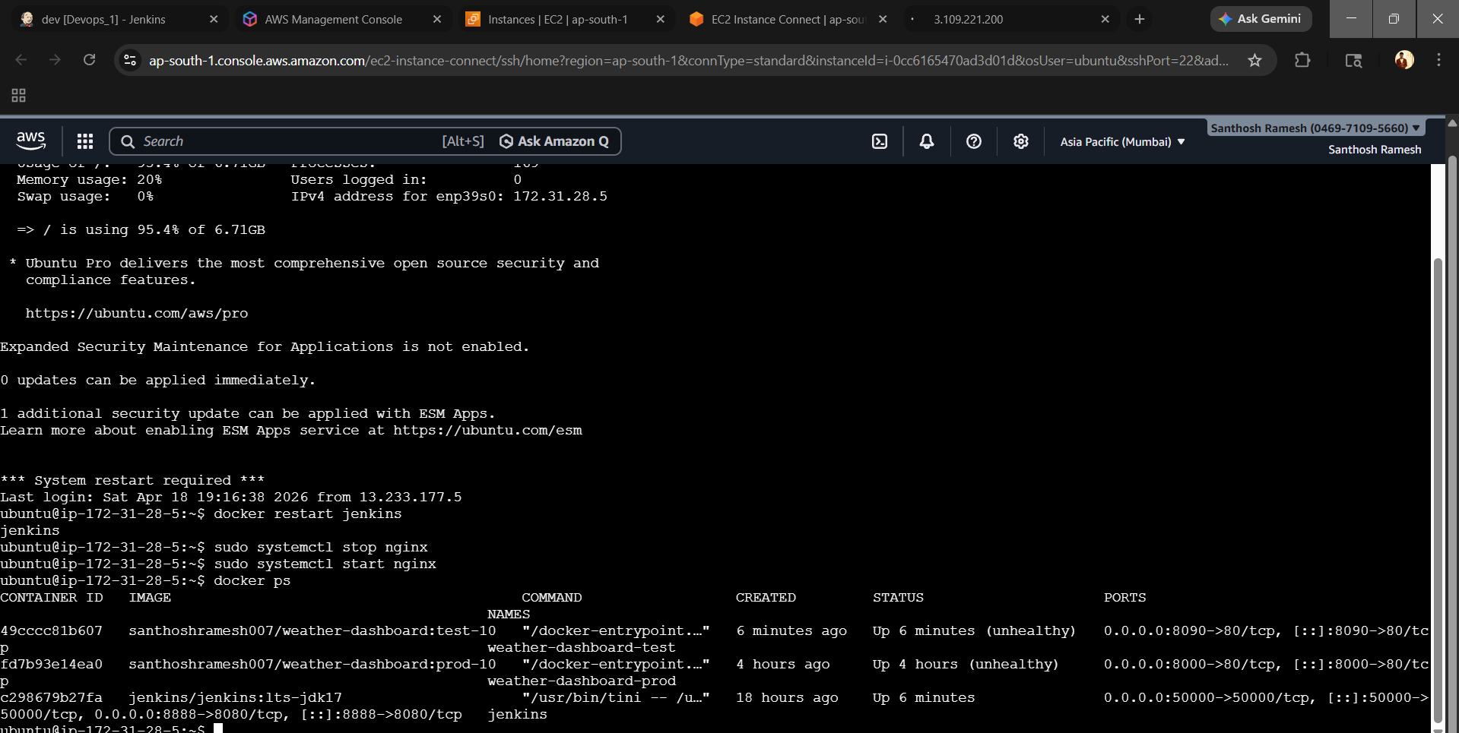

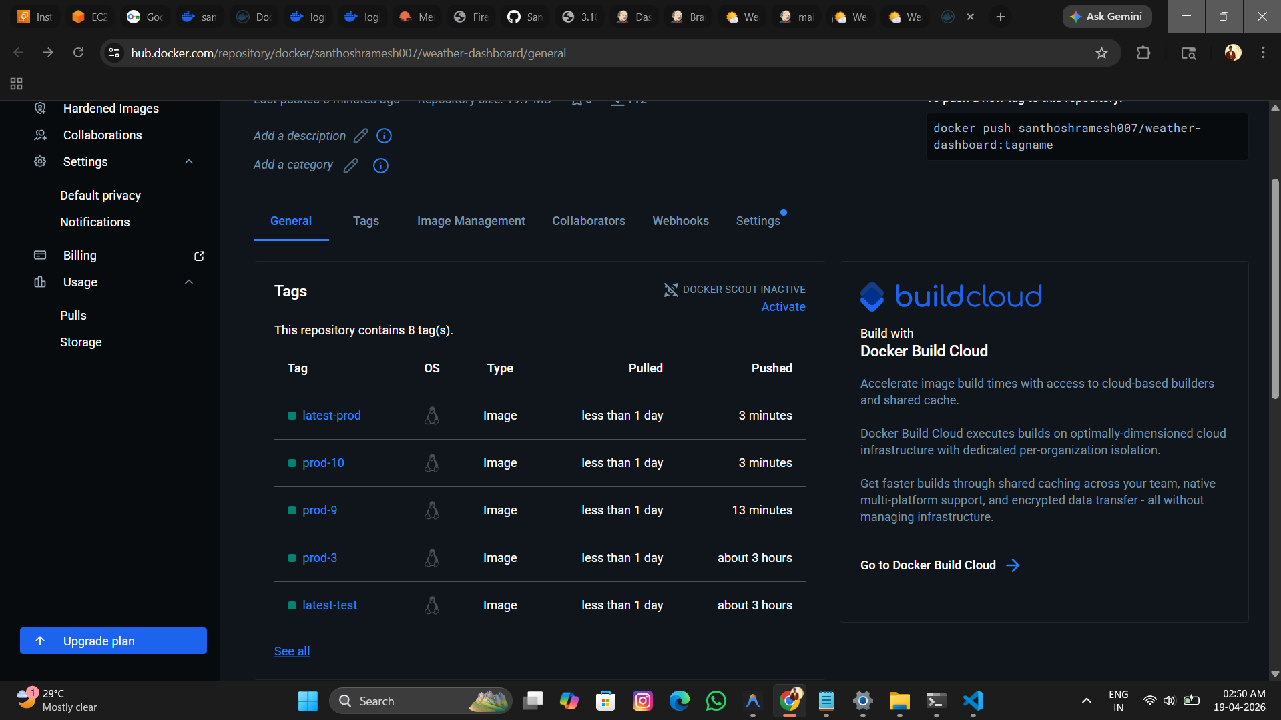

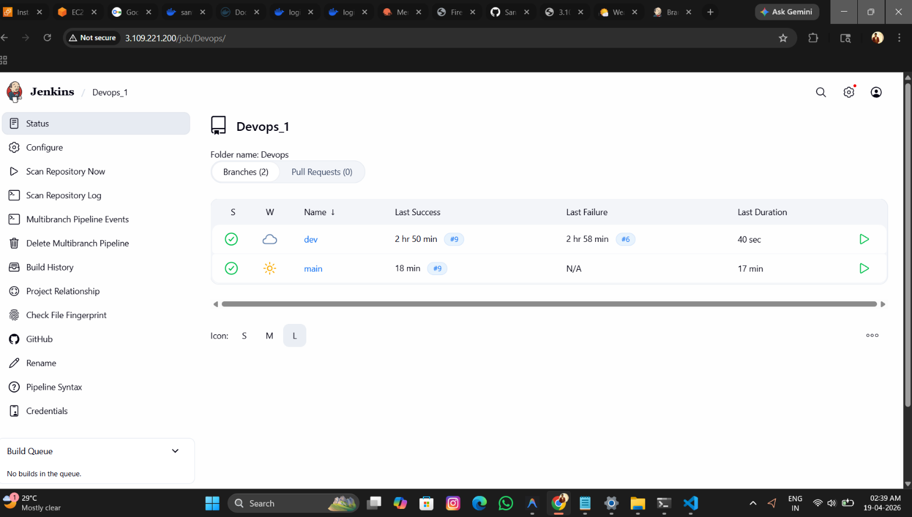

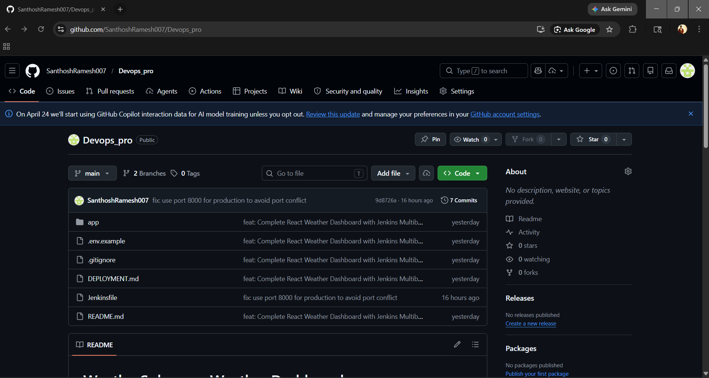

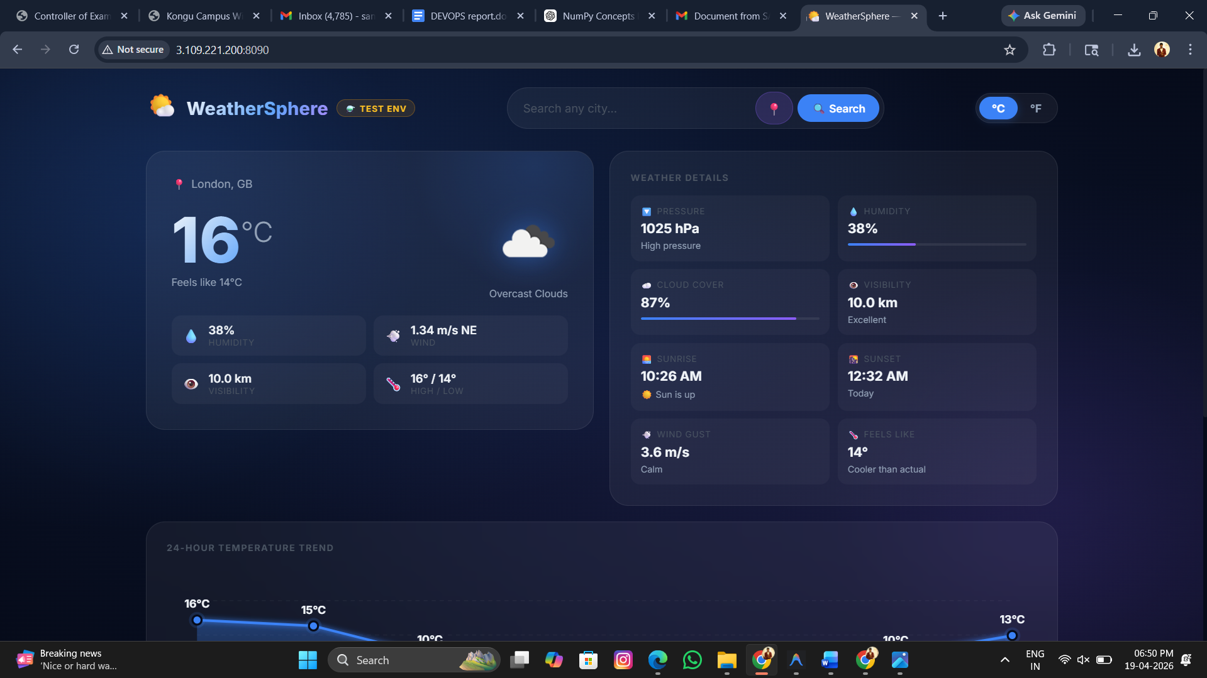

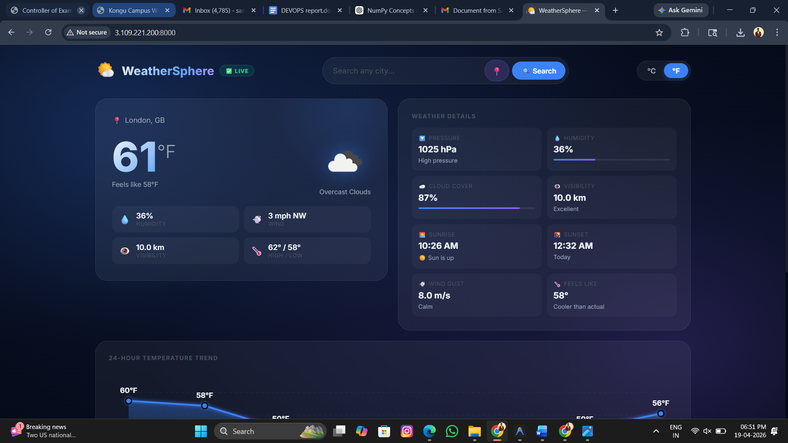

CHAPTER 7
8

CONCLUSION

This project successfully demonstrates the implementation of a professional GitHub Branch Based Deployment system using a React-based weather dashboard. By integrating a Jenkins Multibranch Pipeline with Docker and AWS EC2, the project highlights the critical DevOps concept of environment isolation and continuous delivery.

The implementation shows that application code can be moved from a local development environment to multiple isolated cloud environments (Development and Production) instantly and automatically. The use of unique port mapping on a single AWS instance allows for safe testing in the dev branch while maintaining a stable, live version in the main branch. Furthermore, the integration of automated quality gates, such as Vitest testing and ESLint, ensures that only high-quality, verified code reaches the users.

Overall, the project provides a clear and practical understanding of how modern automation tools like Jenkins and Docker simplify the complex process of application deployment and infrastructure management. It lays a powerful foundation for developing more advanced, cloud-native deployments and demonstrates the efficiency of a "Code-to-Cloud" automated workflow in a professional DevOps landscape.

LIVE DEMONSTRATION LINKS:

Dashboard (Prod): http://3.109.221.200:8000

Dashboard (Dev): http://3.109.221.200:8090

Build Logs (Jenkins): http://3.109.221.200

Docker Hub Repository: santhoshramesh007/weather-dashboard

CHATPER 8
9

COMMANDS AND CODING

COMMANDS

git push origin [branch-name] (Trigger the automated deployment)

docker ps (Check status of running Dev and Prod containers)

docker system prune -a -f (Clear disk space and old images on EC2)

docker logs [container-name] (View real-time application logs)

sudo systemctl restart nginx (Restart the Nginx Reverse Proxy)

docker restart jenkins (Restart the Automation Server)

npm test (Run 22+ unit tests locally via Vitest)

CODING

Jenkinsfile (Pipeline Logic)

pipeline {

agent any

environment {

DOCKER_HUB_USER = 'santhoshramesh007'

IMAGE_NAME = 'weather-dashboard'

EC2_HOST = '3.109.221.200'

PROD_PORT = '8000'

TEST_PORT = '8090'

}

stages {

stage('Quality Gate: Lint & Test') {

steps {

sh 'npm install'

sh 'npm run lint'

sh 'npm test' // Executing 22+ Vitest cases

}

}

stage('Docker Build & Push') {

steps {

script {

// Logic to tag based on branch

sh "docker build -t ${DOCKER_HUB_USER}/${IMAGE_NAME}:${TAG} ."

sh "docker push ${DOCKER_HUB_USER}/${IMAGE_NAME}:${TAG}"

}

}

}

stage('Deploy to AWS EC2') {

steps {

sshagent(['ec2-ssh-key']) {

sh """

ssh ${EC2_HOST} '

docker pull ${DOCKER_HUB_USER}/${IMAGE_NAME}:${TAG}

docker stop ${CONTAINER_NAME} || true

docker rm ${CONTAINER_NAME} || true

docker run -d -p ${PORT}:80 --name ${CONTAINER_NAME} ${IMAGE_NAME}

'

"""

}

}

}

}

}

Dockerfile (Container Strategy)

# Stage 1: Build React App

FROM node:20-alpine AS builder

WORKDIR /app

COPY package*.json ./

RUN npm install

COPY . .

RUN npm run build

# Stage 2: Production Server (Nginx)

FROM nginx:alpine

COPY --from=builder /app/dist /usr/share/nginx/html

COPY nginx.conf /etc/nginx/conf.d/default.conf

EXPOSE 80

CMD ["nginx", "-g", "daemon off;"]

nginx.conf (Network Routing)

server {

listen 80;

server_name localhost;

location / {

root /usr/share/nginx/html;

index index.html;

try_files $uri $uri/ /index.html; # Supports React Router

}

# Docker Health Check Endpoint

location /health {

access_log off;

return 200 '{"status":"healthy"}';

add_header Content-Type application/json;

}

}

COURSE COMPLETION CERTIFICATE
12

