EXERCISE: 11

DATE: 20.11.2020

AIM:

To write a Python program to find the greatest common divisor (GCD) of two integers using recursion.

PROGRAM:

def gcd(a,b):

if(b==0):

return a

else:

return gcd(b,a%b)

a = int(input("Enter first number: "))

b = int(input("Enter second number: "))

GCD = gcd(a,b)

print("GCD is: ")

print(GCD)

LINK:

<http://103.53.53.18/mod/vpl/forms/submissionview.php?id=326&userid=1727>

OUTPUT:

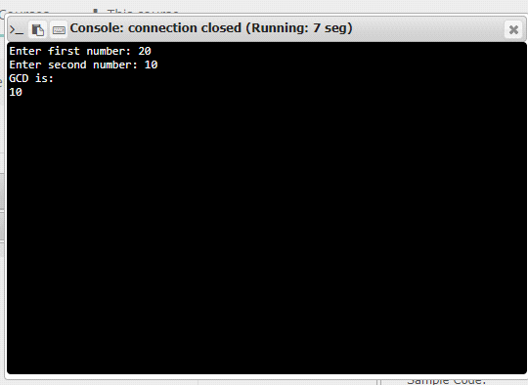

RESULT:

The output of the program is verified successfully.