EXERCISE: 14

DATE: 20.11.2020

AIM:

To write a Python class to find validity of a string of parentheses, '(', ')', '{', '}', '[' and '].

PROGRAM:

def areBracketsBalanced(expr):

stack = []

for c in expr:

if c in ["(","{","["]:

stack.append(c)

else:

if not stack:

return False

current_c = stack.pop()

if current_c =="(":

if c!=")":

return False

if current_c == "{":

if c!="}":

return False

if current_c == "[":

if c!="]":

return False

if stack:

return False

return True

if __name__ == "__main__":

expr = input("input:")

if areBracketsBalanced(expr):

print("Output: Valid")

else:

print("Output: Invalid")

LINK:

<http://103.53.53.18/mod/vpl/forms/submissionview.php?id=327&userid=1727>

OUTPUT:

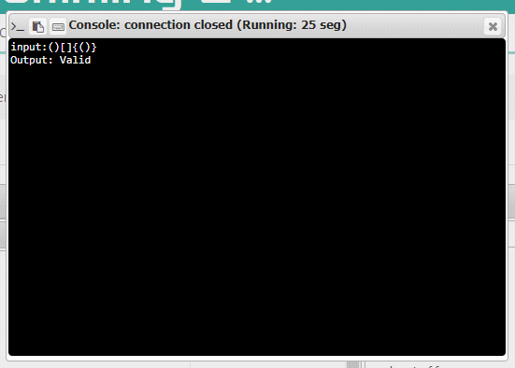

RESULT:

The output of the program is verified successfully.