**Data Modelling for Information Professionals**

**General Description:**

This SQL project focuses on establishing a robust system for managing product inflow and outflow records. It involves the creation of an efficient relational database comprising eight distinct tables, each dedicated to a specific aspect of the process.

The primary aim of this system is to facilitate the seamless tracking and administration of inventory levels, along with monitoring the flow of products. This initiative stands to greatly benefit managers and other team members engaged in inventory management by enabling them to establish and maintain optimal inventory thresholds.

The database consists of eight interlinked tables, meticulously connected through the implementation of primary and foreign keys. Among these, the product description table boasts four essential attributes. Here, the product ID assumes the role of the primary key, while the supplier ID functions as the foreign key. A one-to-one relationship exists between the product description and product tables.

**Database Overview and Relationships**

The product description and supplier tables share a many-to-many relationship. Conversely, the supplier table and supplier details exhibit a one-to-one correspondence. In addition, a many-to-many relationship is established between the product and stock tables. Notably, a one-to-many association is present between the product and orders tables, while a similar relationship exists between the orders and customers tables.

The customer table encompasses customer ID and customer name as fundamental attributes. Concurrently, the customer details table encompasses customer ID, customer address, customer city, customer phone, customer mail, and customer date of birth. The customer ID serves as the primary key in this context, establishing a one-to-one relationship between the two tables.

The supplier table is characterized by two vital attributes: supplier ID and supplier name. Complementing this, the supplier details table encompasses four key entities—supplier ID (a foreign key), supplier address, supplier city, supplier phone, and supplier mail.

To uphold robust data integrity, a set of constraints has been meticulously applied to the attributes. This measure contributes significantly to the reliability and accuracy of the stored information.

This system can also be used to:

Generate reports about inventory levels, product sales, and supplier and customer relationships.

**Choice of DBMS**: Relational Database management system - MySQL 8.0

**User Requirements:**

The following user requirements have been identified for the database system:

Viewing Tables and Data

* Users should have the capability to view all tables along with their respective data.

Supplier, Product, Customer, and Order Management

* Users should be able to add, update, and delete records related to suppliers, products, customers, and orders.

Supplier Details and Products Supplied

* Users should have the ability to view detailed information about specific suppliers, including the products they supply.

Product Descriptions and Category Filtering

* Users should be able to access product descriptions and filter them based on specific categories.

Customer Search

* Users should have a search functionality to locate customers by name, address, or other relevant details.

Order Tracking and Product Analysis

* Users should be able to view all orders placed by a particular customer or those containing a specific product.

Stock Monitoring and Notifications

* Users should be able to monitor stock levels and receive notifications when stock levels approach the reorder threshold.

Order Placement and Stock Availability

* Users should have the capability to place orders for products, ensuring quantities do not exceed available stock.

Customer Insights and Marketing Efforts

* Users should be able to view customer age and order history to gain insights into customer preferences, aiding targeted marketing efforts.

**Business Rules:**

Supplier Management:

* Each supplier must be assigned a unique ID and possess a corresponding name.
* Suppliers are required to provide unique contact details, including address, phone number, and email address.
* Suppliers default to being in Dallas, though they may also operate in other cities.

Product Management:

* Every product is mandated to have a distinct ID along with a comprehensive description.
* Products must possess a price and belong to a specific category.
* A product is exclusively supplied by one supplier, while a supplier may supply multiple products.

Customer Management:

* Each customer is assigned a unique ID and is required to have a corresponding name.
* Customers must provide unique contact details, encompassing address, phone number, and email address.
* A customer's date of birth must precede the current date.

Order Management:

* Every order is mandated to have a unique ID, a date, a customer ID, a product ID, and a quantity.
* An order is obligated to consist of at least one item.

Stock Management:

* Each product's stock must be associated with a quantity, a reorder level, and a minimum order threshold.

**Entity-Relationship Diagram (ERD) of the system:**

The Entity-Relationship Diagram (ERD) below offers a visual representation of the database system, incorporating the tables and relationships defined in this project. It provides a clear overview of the entities, their attributes, and the connections between them, offering valuable insights into data organization and flow.

The ERD encompasses the following tables: Supplier, Product Description, Product, Stock, Orders, Customer, Customer Details, Supplier Details.

**The data dictionary of the system:**

The data dictionary below provides a comprehensive overview of the database schema, outlining the tables, their attributes, data types, constraints, and relationships within the system. This structured documentation serves as a vital reference for understanding the composition and organization of the database.

**Queries:**

**Creating inventory database.**

**Table creation and data insertion:**

**Customer table:**

**Customer details table:**

**Order Table:**

**Product Table:**

**Product Description table:**

**Supplier details table:**

**Supplier table:**

**Stock table:**

**Data Retrieval and Reports:**

* **Retrieving number of products per category**

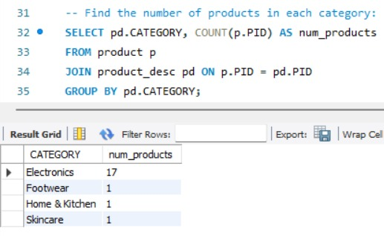

* **Retrieving number of unique customers**

* **Retrieving total revenue generated by each supplier.**

* **Retrieving number of orders placed by each customer**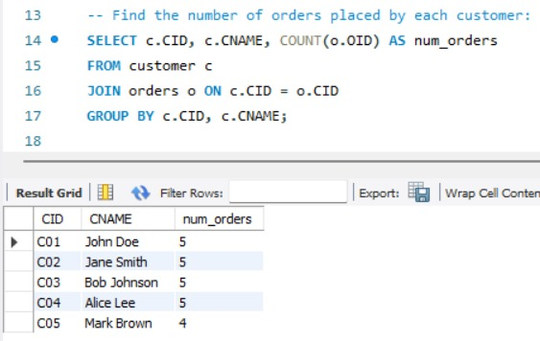
* **Retrieving number of unique customers**

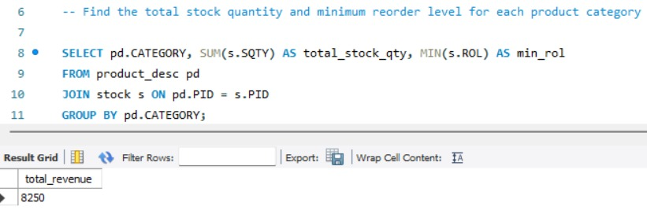

* **Retrieving total revenue**

* **Finding customers who have placed more than 3 orders.**

* **Retrieving top 5 customers by Total Order value.**

