Alzheimer Disease Prediction using Machine Learning Algorithms
Alzheimer Disease is one of the incurable and dangerous disease and its timely prediction can help in saving patients life. So author of this paper using machine learning algorithms such as SVM and decision tree to predict cured, non-Alzheimer and Alzheimer patients. To trained this algorithms author using dataset which contains patient AGE, number of visits to hospital and many other parameters. After training model we can apply test data on this model to predict patient condition as Normal or Alzheimer.
Below screen showing dataset details used in this project
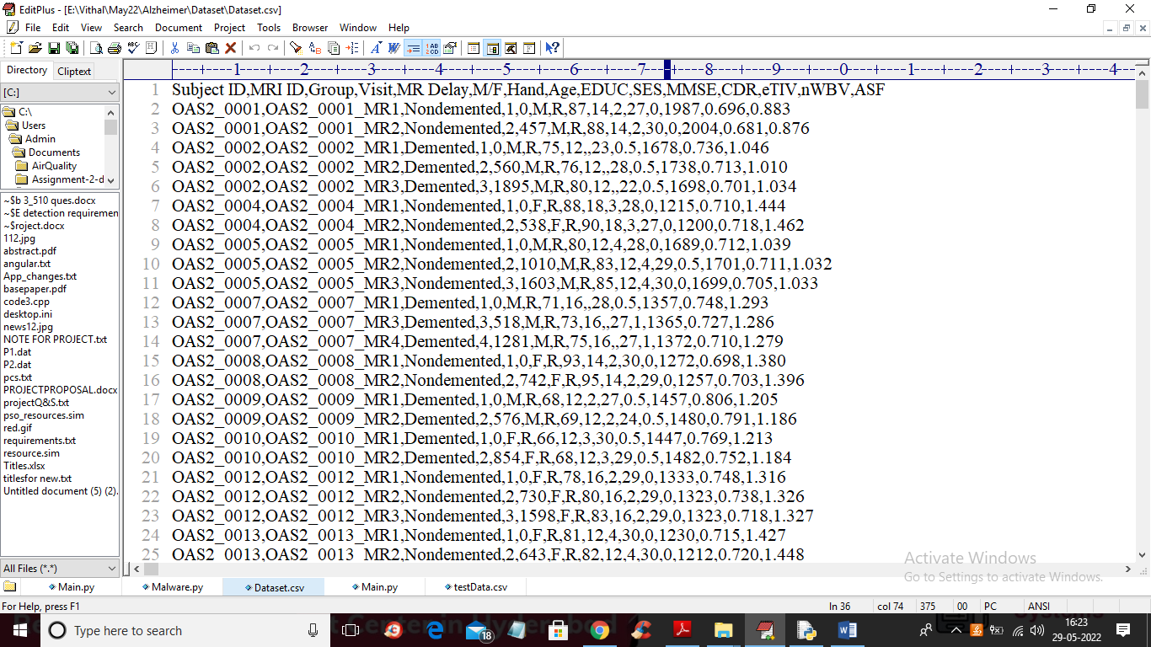
In above screen first row contains dataset column names and remaining rows contains dataset values and by using above dataset we are training SVM and Decision tree algorithms and then comparing their performance in terms of accuracy.
To implement this project we have designed following modules
- Upload Alzheimer Disease Dataset: using this module we will upload dataset to application
- Dataset Preprocessing: using this module we will read dataset and then encode non-numeric values in above dataset to numeric and then replace missing values with 0 and then split dataset into train and test part where application used 80% dataset for training and 20% for testing
- Run SVM Algorithm: using this module we will train SVM with 80% training data and then calculate its accuracy by predicting 20% test data
- Run Decision Tree Algorithm: using this module we will train decision tree with 80% training data and then calculate its accuracy by predicting 20% test data
- Comparison Graph: using this module we will plot accuracy comparison graph between all algorithms
- Predict Disease from Test Data: using this module we will upload test and then machine learning algorithm will predict weather test data is normal or contains Alzheimer symptoms
SCREEN SHOTS
To run project double click on ‘run.bat’ file to get below screen
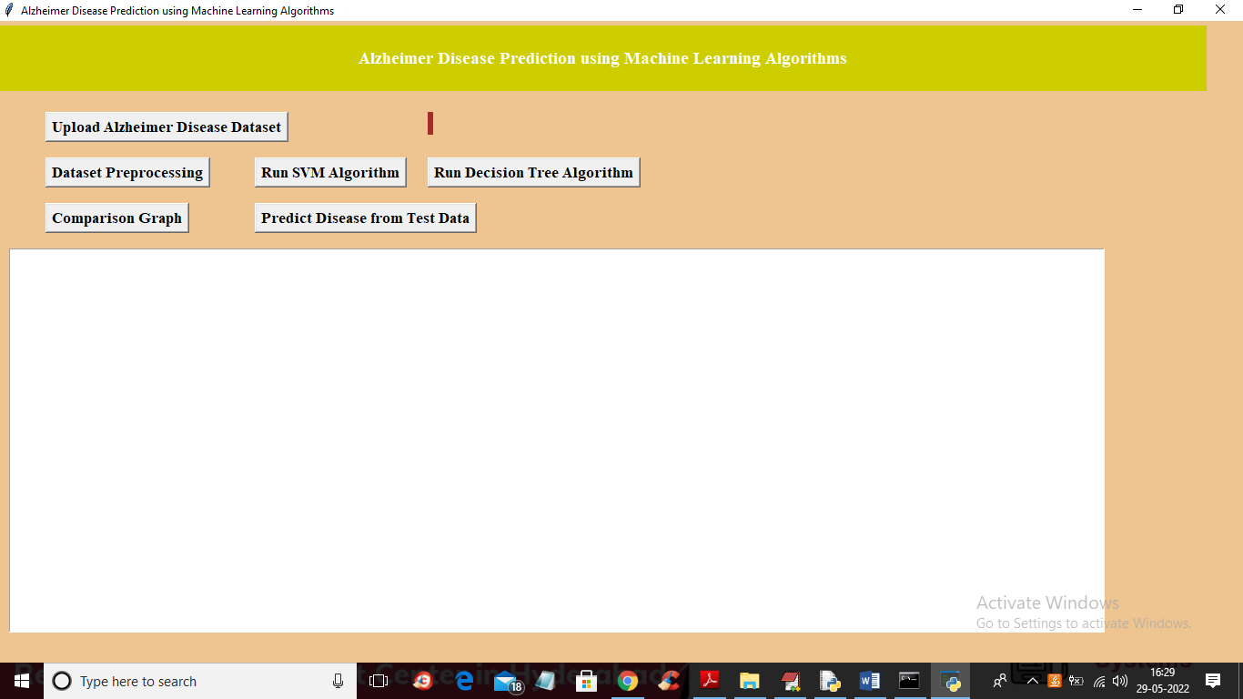
In above screen click on ‘Upload Alzheimer Disease Dataset’ button to upload dataset and to get below screen
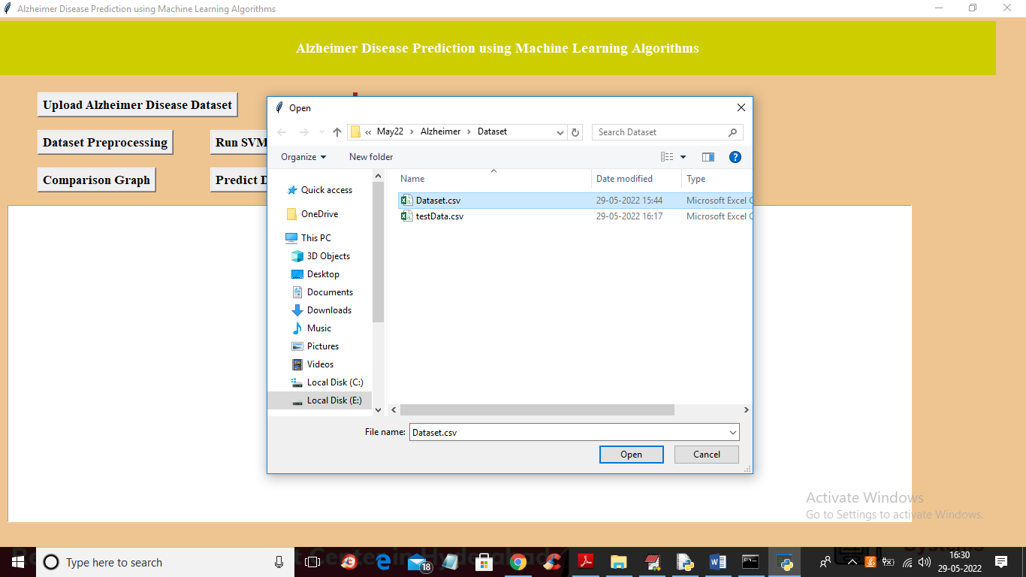
In above screen selecting and uploading ‘Dataset.csv’ file and then click on ‘Open’ button to load dataset and get below output
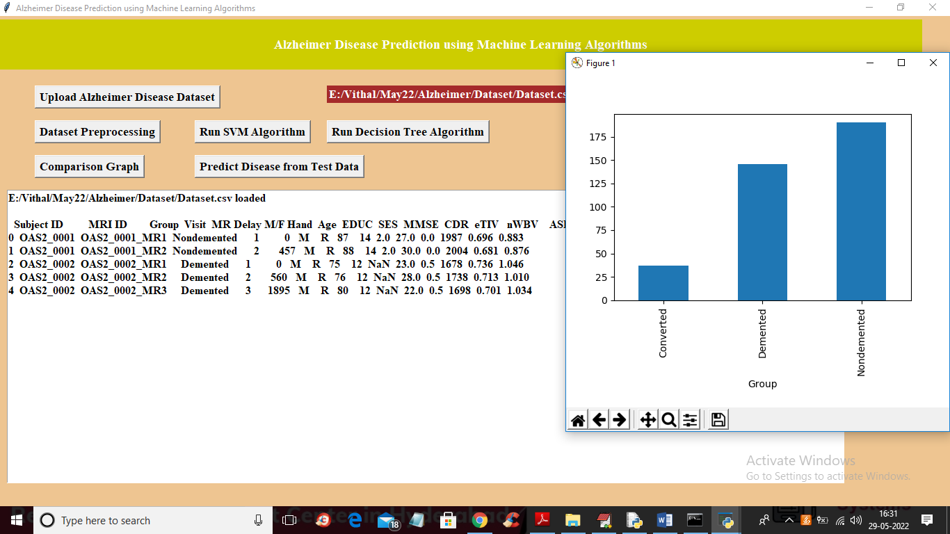
In above screen dataset loaded and we can see dataset contains some NAN or missing values and contains nom-numeric data also so we need to preprocess dataset to remove such values and in above graph x-axis contains LABELS such as ‘Converted’ mean cured and Demented means presence of Alzheimer and Nondemented means normal and y-axis represents number of records found in that category in dataset. Now close above graph and then click on ‘Dataset Preprocessing’ button to process dataset and get below output
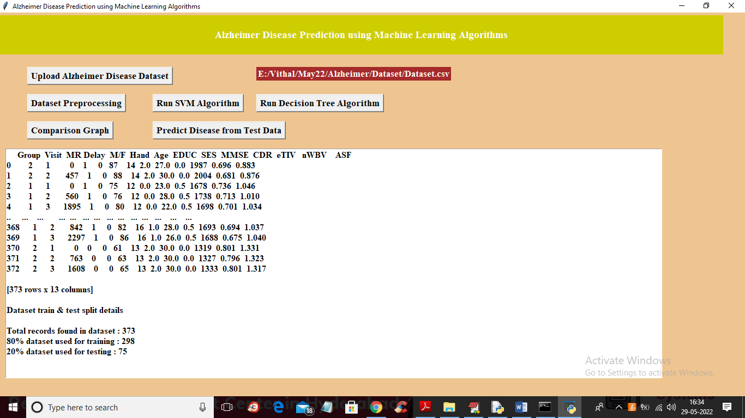
In above screen we can see all dataset values are converted to numeric and we can see dataset contains 373 records and 298 (80%) are using for training and 75 (20%) records are used for testing algorithm prediction accuracy. Now train and test data is ready and now click on ‘Run SVM Algorithm’ button to train SVM and get below output
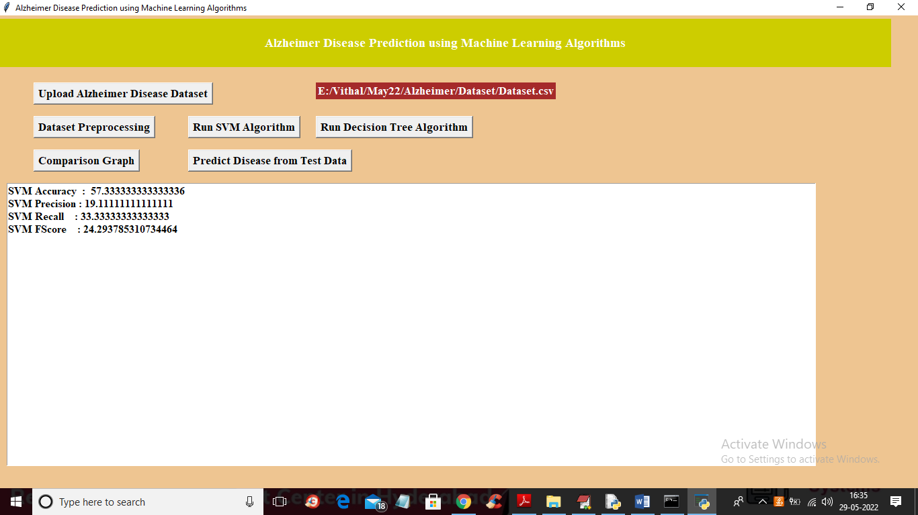
In above screen with SVM we got 57% accuracy and now click on ‘Run Decision Tree Algorithm’ button to train Decision tree and get below output
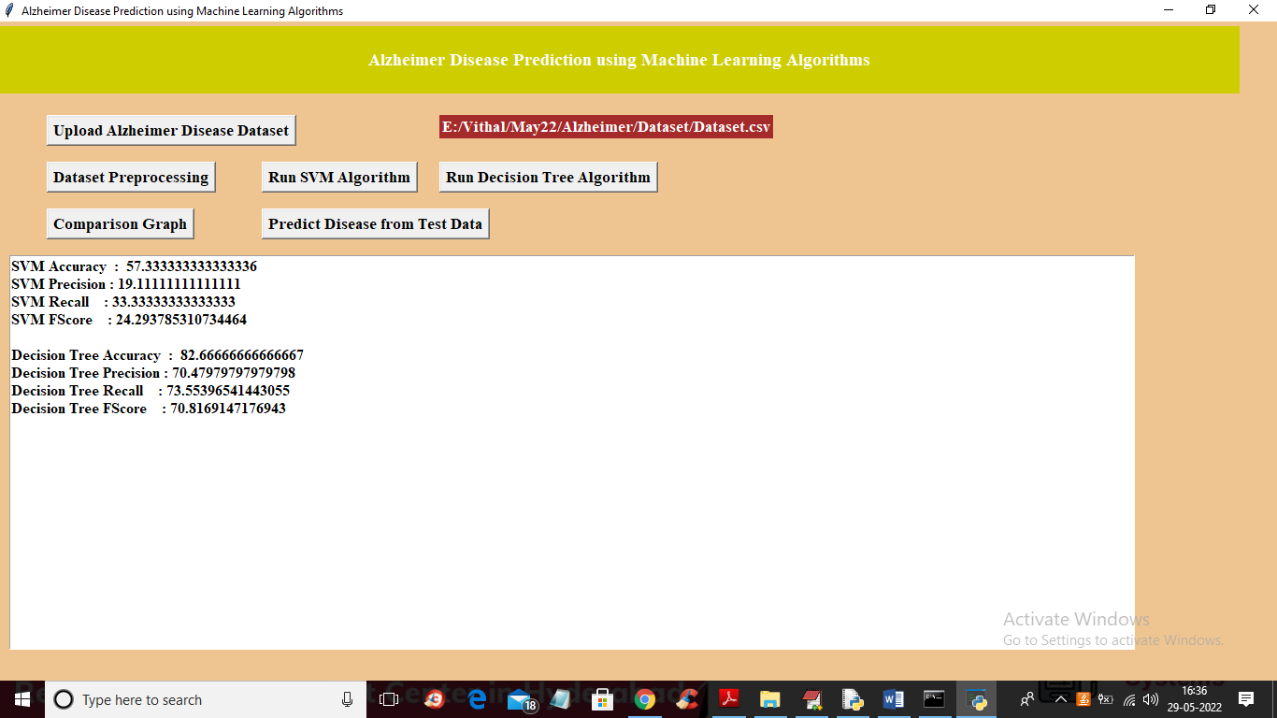
In above screen with decision tree we got 82% accuracy and now click on ‘Comparison Graph’ button to get below output
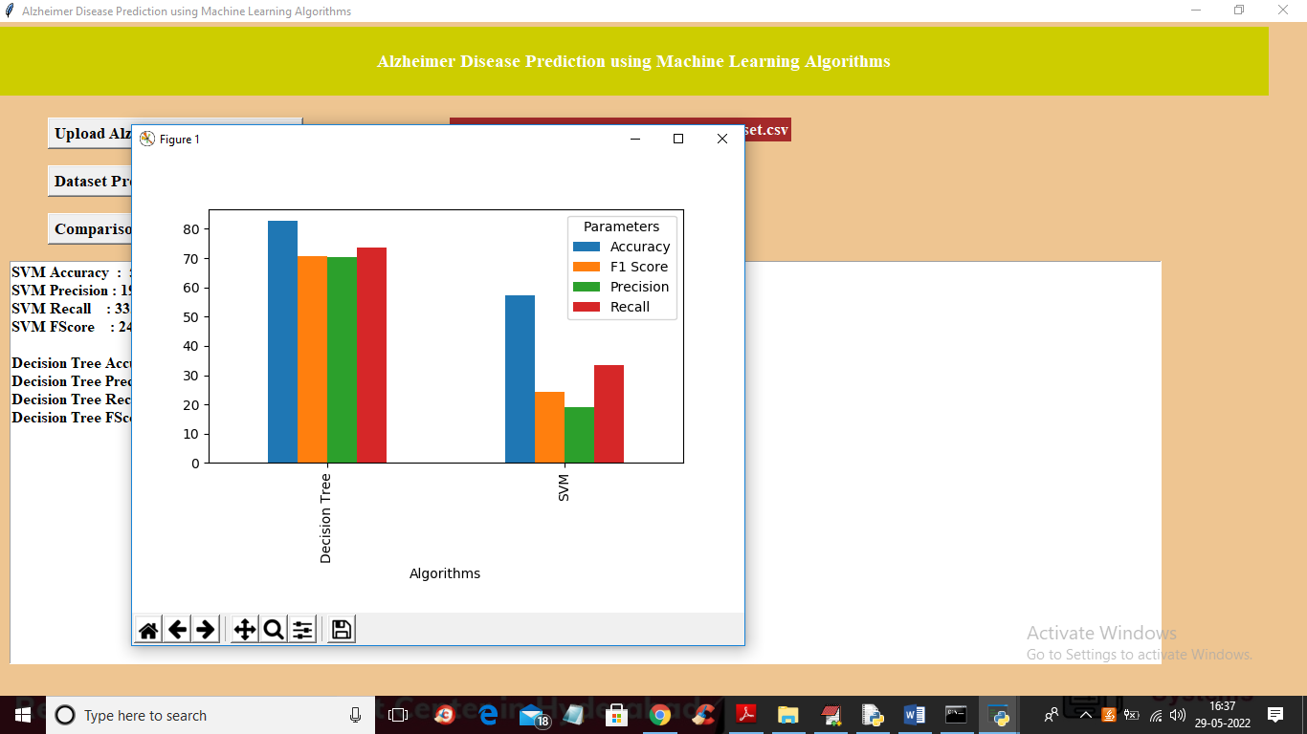
In above graph x-axis represents algorithm names with different bar in different colour metrics such as accuracy, precision, recall and FSCORE and y-axis represents values. In above graph we can see Decision Tree got high performance and now close above graph and then click on ‘Predict Disease from Test Data’ button to upload test and get prediction output
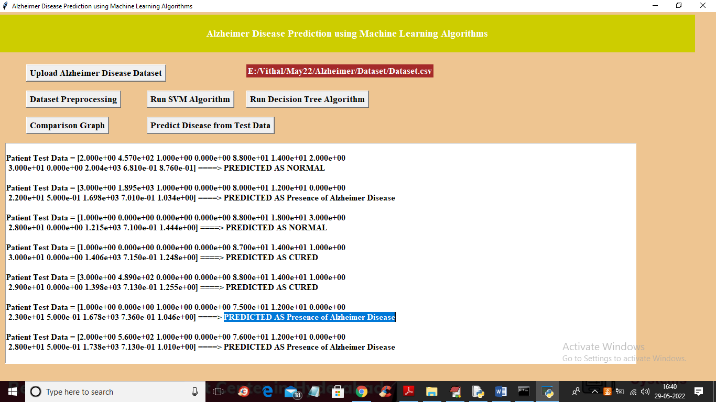
In above screen in square bracket we can see patient test data and after = arrow symbol we can see predicted output as NORMAL or CURED or Presence of Alzheimer disease.

