Project Design Phase-II: BookNest - Where Stories Nestle

Date: 27 June 2025

Team ID: LTVIP2025TMID20432

Project Name: BookNest: Where Stories Nestle

Maximum Marks: 4 Marks

# Technical Architecture

This architectural diagram illustrates the complete technology stack of BookNest.

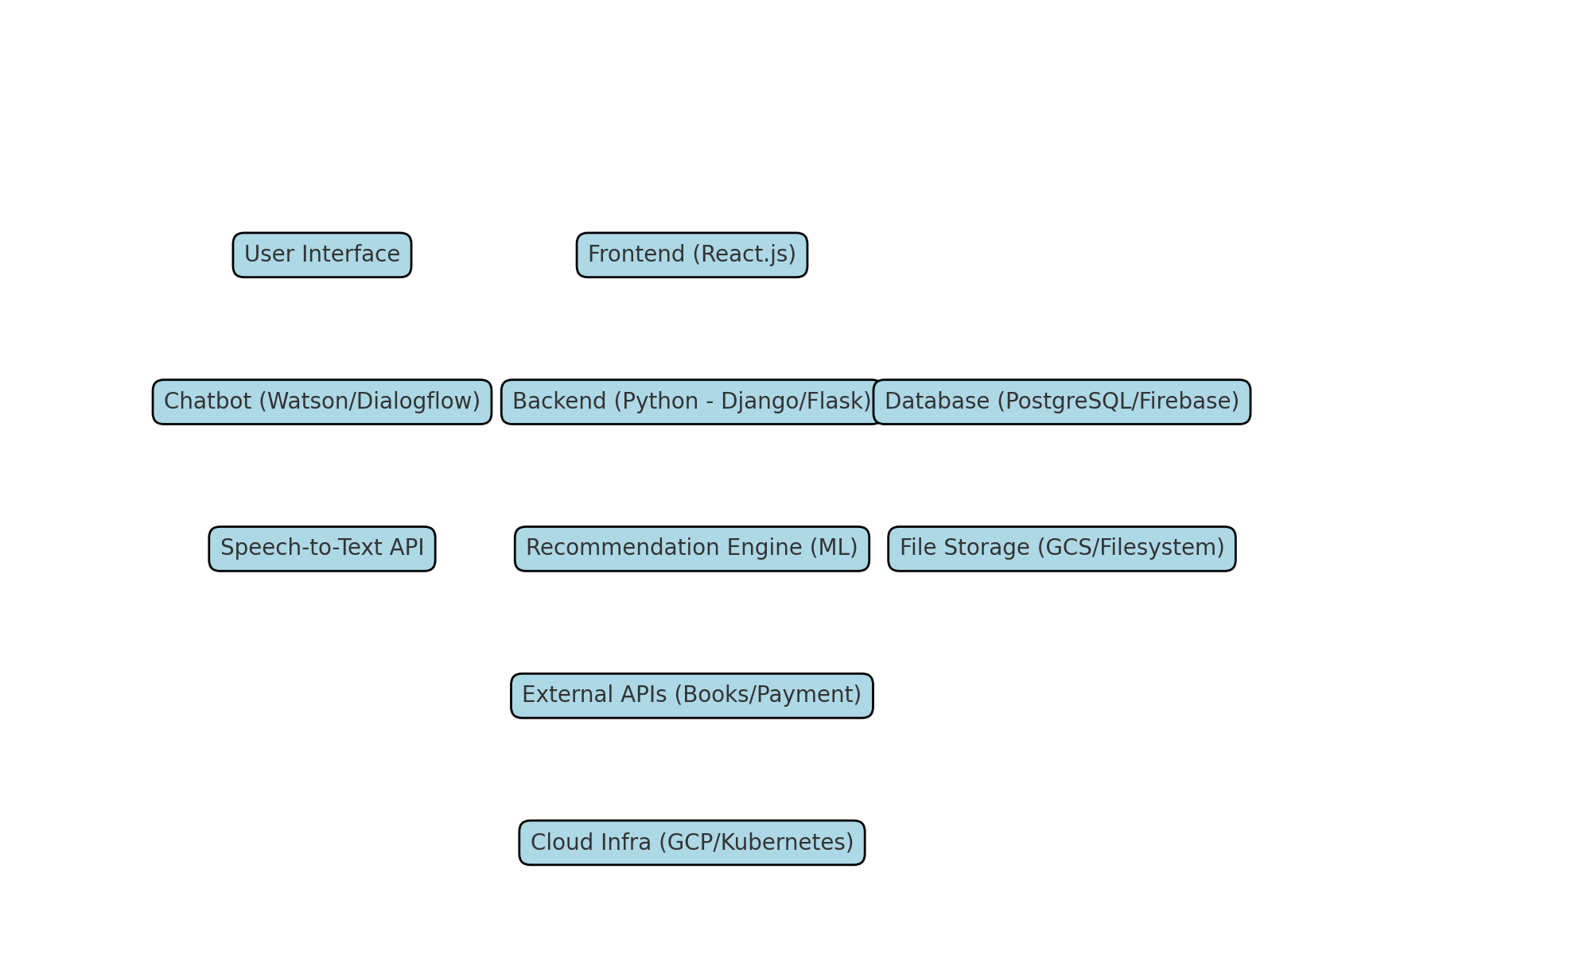

# Table-1: Components & Technologies

|  |  |  |  |
| --- | --- | --- | --- |
| S.No | Component | Description | Technology |
| 1 | User Interface | Web-based interface for users | HTML, CSS, JavaScript, React.js |
| 2 | Application Logic-1 | Core logic for user and book handling | Python (Django/Flask) |
| 3 | Application Logic-2 | Speech to text conversion | Google Cloud Speech-to-Text API |
| 4 | Application Logic-3 | Chatbot for user assistance | Dialogflow / IBM Watson Assistant |
| 5 | Database | Stores user, book, review data | PostgreSQL |
| 6 | Cloud Database | Managed scalable DB | Google Cloud SQL / Firebase |
| 7 | File Storage | Store images and files | Google Cloud Storage / Local FS |
| 8 | External API-1 | Book metadata | Google Books API |
| 9 | External API-2 | Payment/Auth services | Razorpay API / Auth0 |
| 10 | Machine Learning Model | Recommend books | Collaborative Filtering / NLP |
| 11 | Infrastructure | Cloud deployment | Google Cloud Platform, Kubernetes |

# Table-2: Application Characteristics

|  |  |  |  |
| --- | --- | --- | --- |
| S.No | Characteristics | Description | Technology |
| 1 | Open-Source Frameworks | Frameworks used for frontend/backend | React.js, Django, Flask |
| 2 | Security Implementations | Auth, encryption, firewall | JWT, OAuth 2.0, HTTPS, IAM |
| 3 | Scalable Architecture | Microservices, containerized deployment | Docker, Kubernetes |
| 4 | Availability | Redundant setup, high uptime | Load Balancer, GCP Multi-zone |
| 5 | Performance | Optimized data flow and caching | Redis, Cloud CDN |

# References

* https://c4model.com/
* https://developer.ibm.com/patterns/online-order-processing-system-during-pandemic/
* https://www.ibm.com/cloud/architecture
* https://aws.amazon.com/architecture
* https://medium.com/the-internal-startup/how-to-draw-useful-technical-architecture-diagrams-2d20c9fda90d