**BRANCHING**

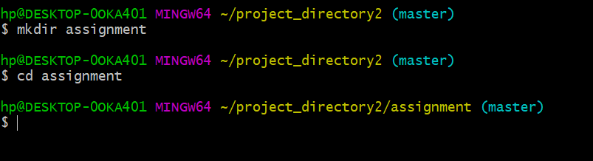

**Mkdir and cd directory**

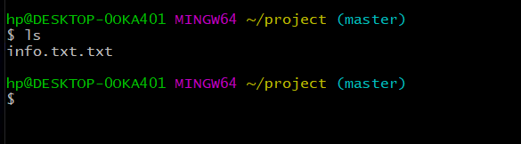

**Text file created**

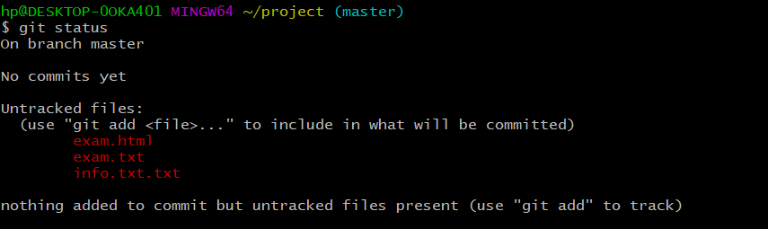

**Untracked files**

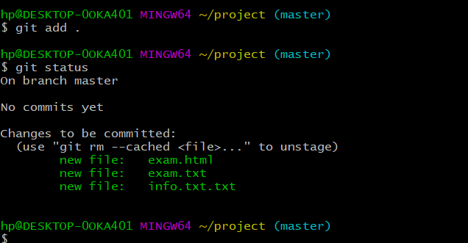

**Commited files**

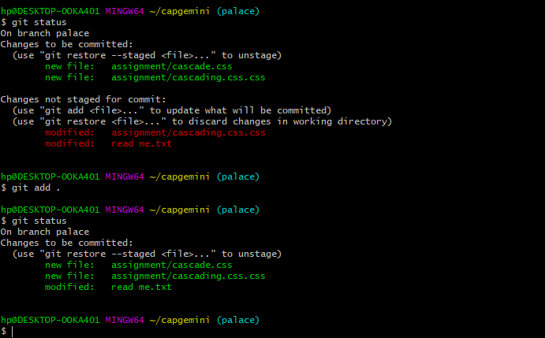

**Changes made and committed**

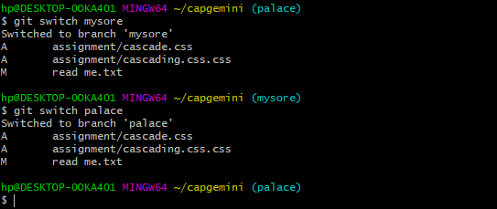

**Switching into the main branch**

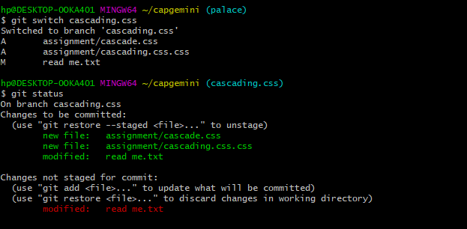

**Changes made**

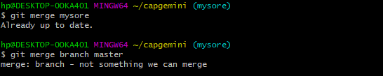

**Merging**

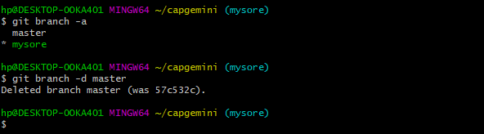

**Finlly deleted**