**SECTION REMOTING**

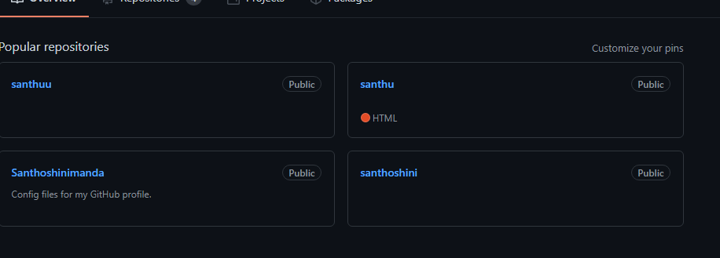

**Login for github**

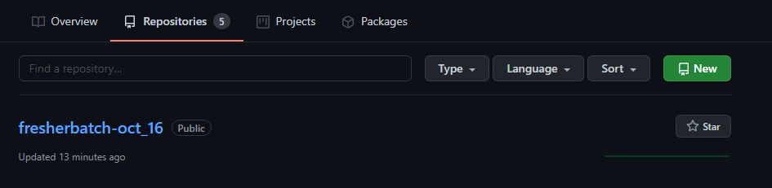

**Repository created**

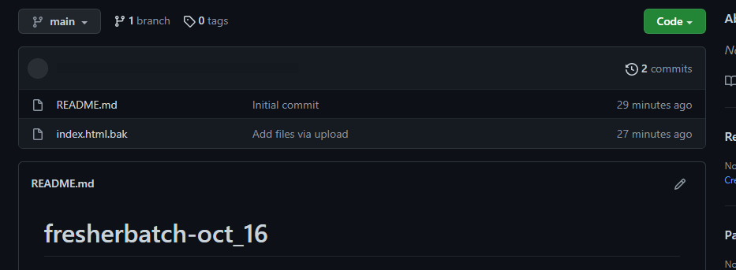

**Sample file**

**Section 4**



**Repository creation**

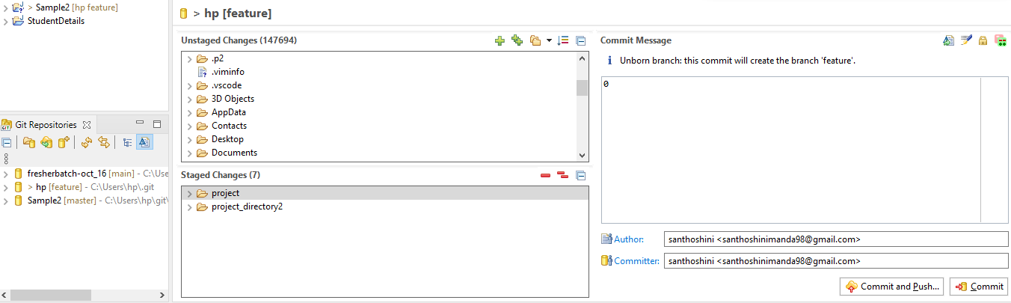

**Added git sample project**

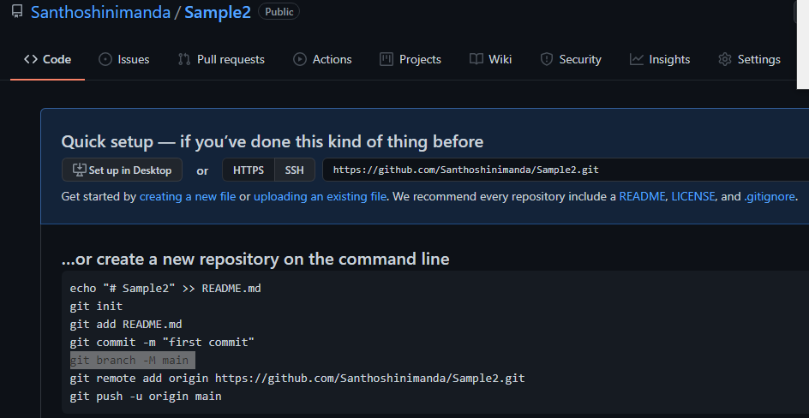

**Sample2 on repository**