SECTION 0

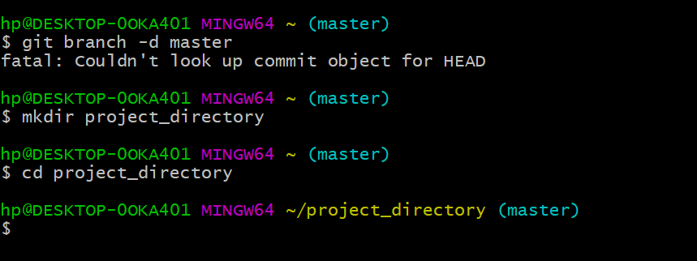

**MAKING AND CD OF A DIRECTORY**

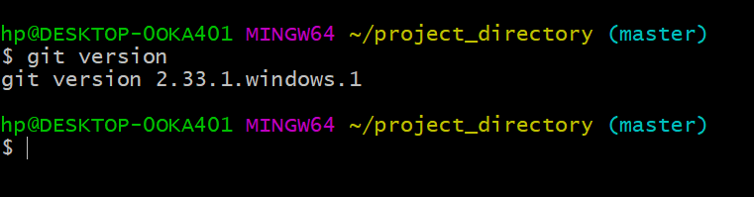

**VERSION OF GIT**

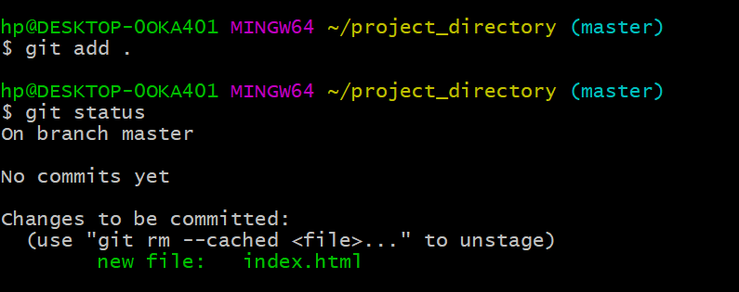

**commiting**

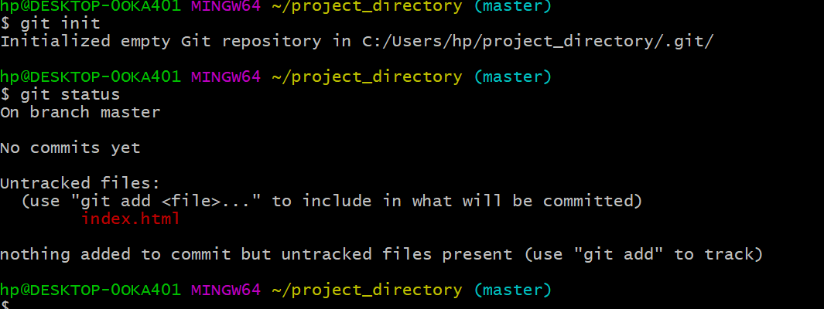

**Checking and tracking untracked file**

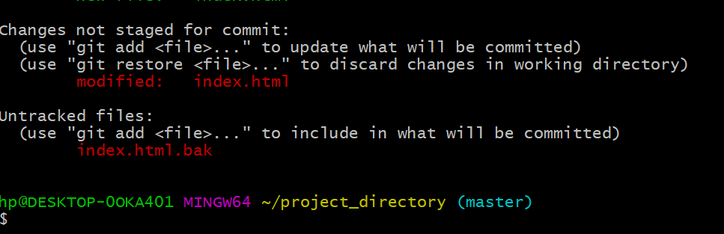

**Modified file**

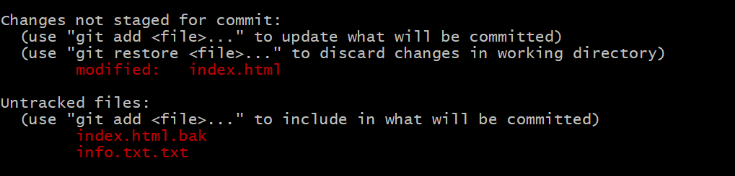

**Untracked text and html file**

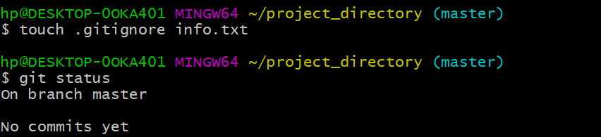

**Ignoring a file**

**Staging the untracked file**

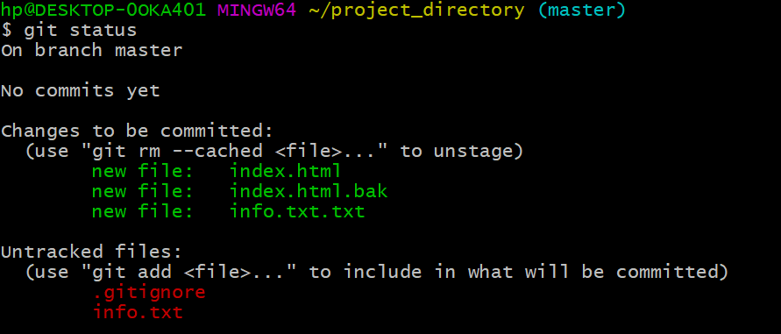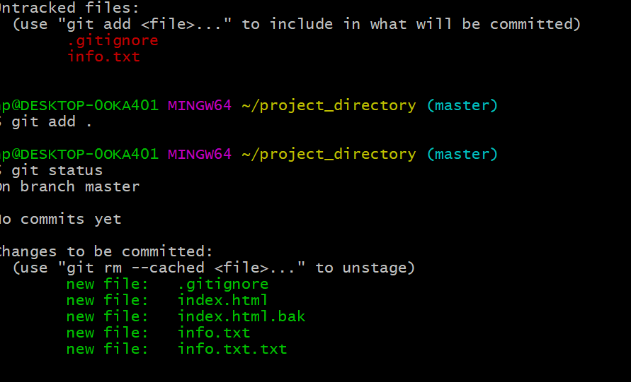

**Commiting the file**

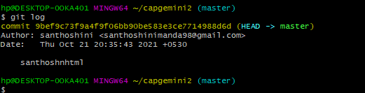

**Logging all commits**

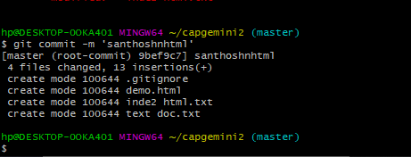

**Commiting the changes**

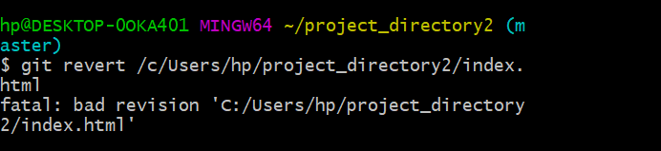

**Revert**

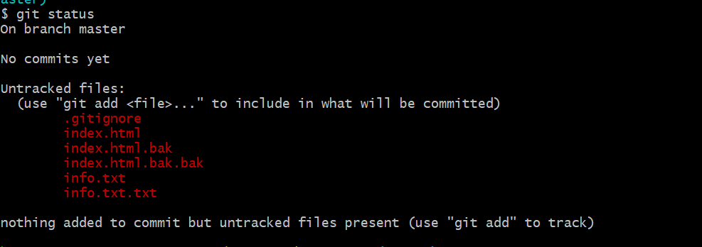

**Status of the index .html**

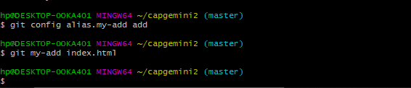

**Rename**

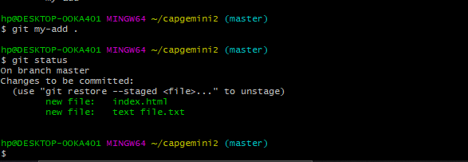

**Commiting changes**

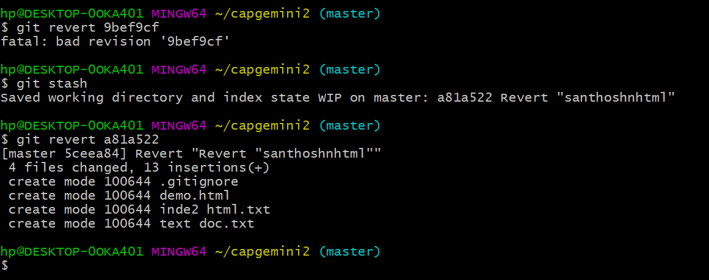

**Revert the last commit**