**JMETER – Load Testing reports Overview**

1. **Create Test plan**
2. **Create Thread group**
3. **Http request defaults**
4. **Http request**
5. **Reports**

* **Summary report**
* **Graph results**
* **View results in table**
* **View results in tree**

**Test Plan:**

Go to the path \apache-jmeter-2.13\bin

Run jmeter.bat or ApacheJMeter.jar

JMeter console should open up with Test plan and workbench in tree

Click on the test plan and rename it to some meaning full name.

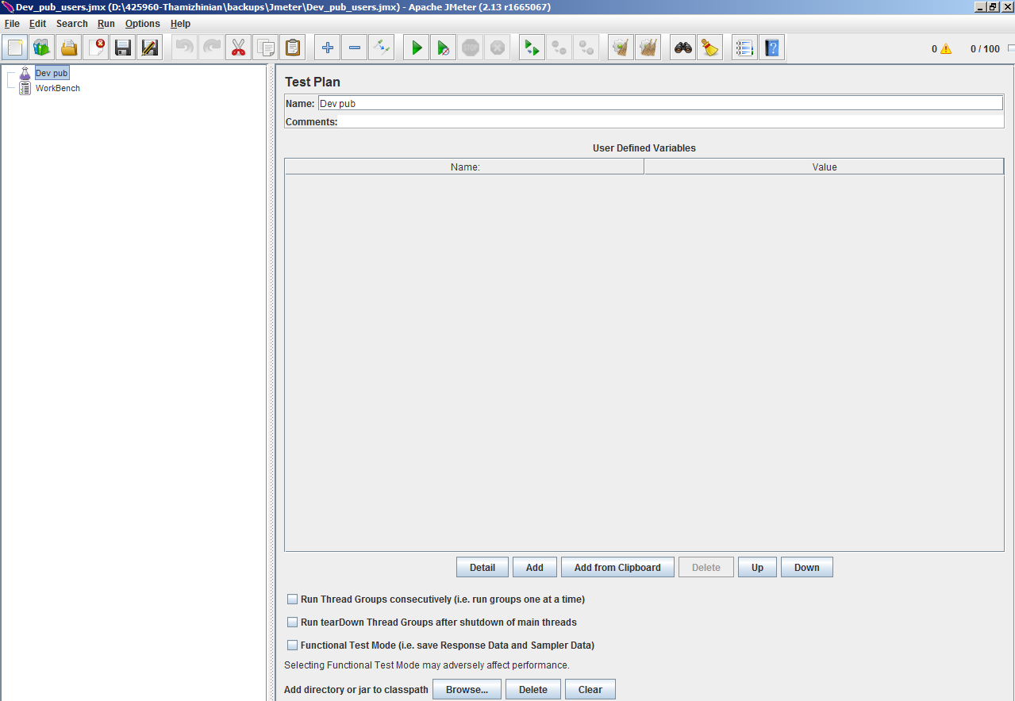

**Thread group:**

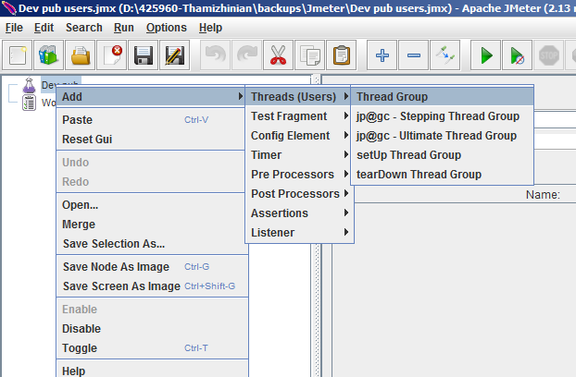

* Name – Enter a meaning full name to the thread group.
* Number of Threads – Enter the number of users or connections to your server application.
* Ramp-Up Period – Define how long it will take JMeter to get all threads running.
* Loop Count − Define the number of times to execute the test.

**Thread Group Properties settings:**

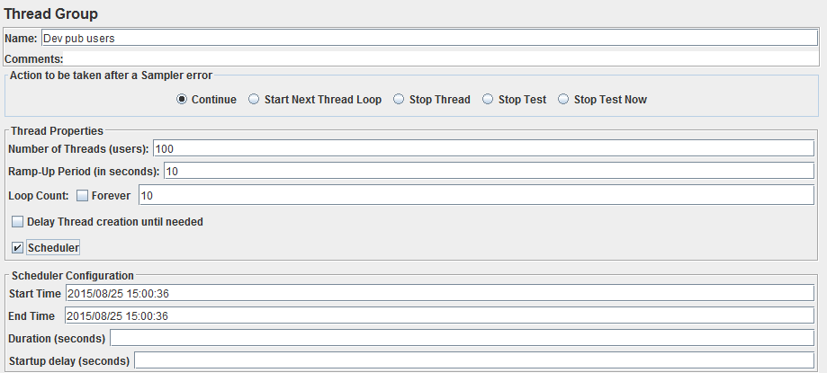

**Number of Threads (users):**   
Described the total number of threads or users used to execute test plan. Each and every user will execute full test plan.  
**Ramp-Up Period (In Seconds) :**  
Describes time to load all users given in "Number of Threads(users)" Property.  
**Number of Threads VS Ramp-Up Period Example 1:**  
If you will set  
 Number of Threads(users) = 10  
 and  
 Ramp-Up Period (In Seconds) = 100  
then Jmeter will load all 10 users in 100 seconds means every 1 user will be loaded after every 10 seconds (100(seconds)/10(Users) = 10 seconds).  
**Number of Threads VS Ramp-Up Period Example 2:**  
If you will set  
 Number of Threads(users) = 100  
 and  
 Ramp-Up Period (In Seconds) = 10  
then Jmeter will load all 100 users in 10 seconds means every 10 user will be loaded after every 1 seconds (10(seconds)/100(Users) = 0.1 seconds).  
You can set Number of Threads VS Ramp-Up Period ratio based on your requirement. In bellow given image, I have set Number of Threads (users) = 5 and Ramp-Up Period (In Seconds) = 5 so it jmeter will load 1 user after every 1 second.

**Loop Count:**   
Describes how many times your test plan will be executed. If you will set it 5 then full test plan will be executed 5 time. If you will select "Forever" check box then your test plan will run your test plan forever time. You have to stop its execution manually if you selected "Forever" check box. If we have set Loop Count = 2 So jmeter will run test plan only 2 times.  
  
**Scheduler:**   
You can configure test start time, end time, duration and start up delay of your load test plan using Scheduler Configuration section. Click on Scheduler check box then it will show you

* **Start Time:**   
  Describes when to start test. we have set it "2013/06/29 16:38:53". So your test will be started at "16(Hrs):38(Mins):53(Secs)" on 29th June, 2013. (Note: Your jmeter should be running on given date and time in "Start Time" field).
* **End Time:**   
  Describes when to End test. we have set it "2013/06/29 16:45:70". So your test will be ended at "16(Hrs):45(Mins):70(Secs)" on 29th June, 2013. Here please note one thing - End Time is maximum allowed time to finish execution of your test plan means if your all threads has not completed its test execution on given "End Time" then jmeter will stop all pending threads execution immediately. On other end, All threads can also complete its test execution before specified "End Time".
* **Duration (seconds):**  
  You can set duration of test to execute. For Example, If you will set Duration (seconds) = 2 then your test will be executed only for 2 seconds without considering (1.) End time and (2.) All threads have completed its test or not. Jmeter will stop test in 2 seconds.
* **Startup delay (seconds):**  
  You can set delay on startup of test. If you will set it 5, then jmeter will not load any user in 1st 5 seconds when you start running your test and as soon as completion of 5 seconds, jmeter will start loading users as per given load profile settings.

**HTTP Request defaults**

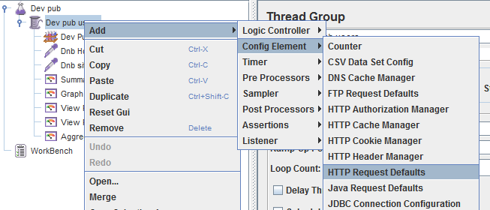

Right Click on the User node and select Add > Config Element > HTTP Request Defaults,

Enter name, Server name / IP, Port. Leave the path field empty

**HTTP Request**

Right Click on User Node and select Add > Sampler > HTTP Request

Give it a sensible name and enter just the path parameter

Remember that you do not have to set the Server Name field because you already specified this value in the HTTP Request Defaults element.

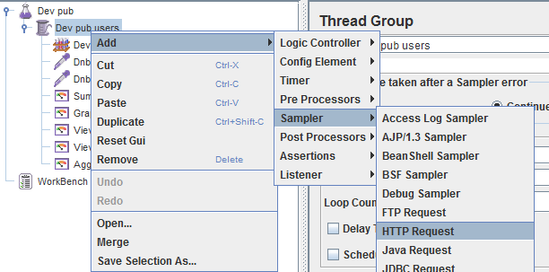

**Reports**

Right Click on User Node and select Add > Listener > select report

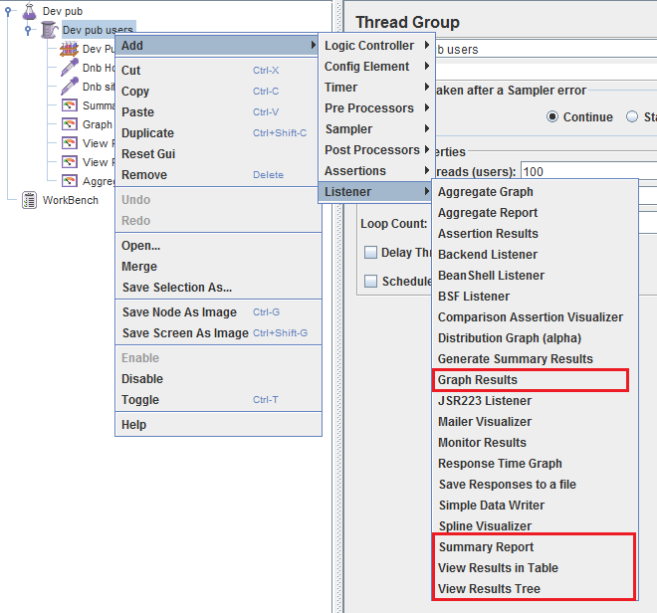

**Analysis on Summary & Aggregate reports:**

Thread group > Add > Listener > Summary report / Aggregate report

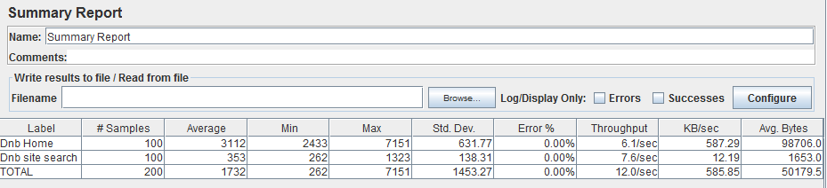

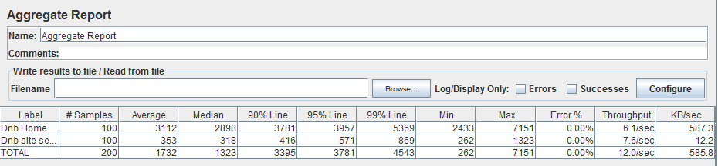

* **# Samples** is the number of samples with the same label.
* **Average** is the average time of a set of results.
* **Median** is a number which divides the samples into two equal halves. Half of the samples are smaller than the median, and half are larger. [Some samples may equal the median.] This is a standard statistical measure. The Median is the same as the 50th Percentile.
* **90% Line** (90th Percentile) meaning 90% of the samples took no more than this time.
* **Min** is the shortest time for the samples with the same label
* **Max** is the longest time for the samples with the same label
* **Error %** is the percent of requests with errors
* **Throughput** is measured in requests per second/minute/hour. The time unit is chosen so that the displayed rate is at least 1.0. When the throughput is saved to a CSV file, it is expressed in requests/second, i.e. 30.0requests/minute is saved as 0.5.
* **Std.Dev** is [Standard Deviation](http://en.wikipedia.org/wiki/Standard_deviation) - a measure of the variability of a data set. JMeter calculates population standard deviation ([STDEVP](http://office.microsoft.com/en-001/excel-help/stdevp-HP005209281.aspx) function analogue)
* **Kb/sec** - throughput measured in Kilobytes per second. Time is in milliseconds.

**Graph results**

Thread group > Add > Listener > Graph Results

Once graph results loaded successfully then right click on graph results and choose save node as image (Ctrl + g), you can able to save the graph as image.

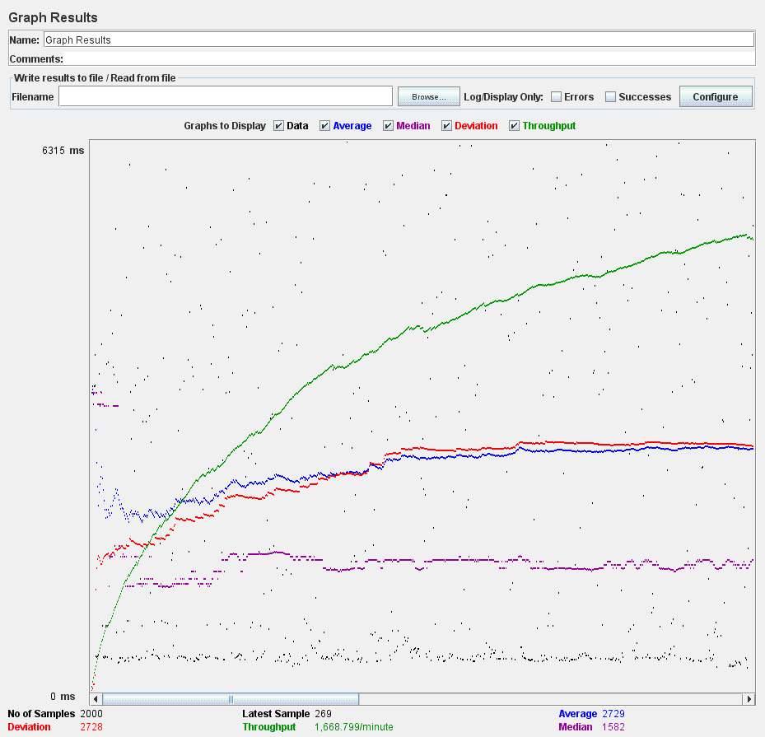

**View Results in Table**

Thread group > Add > Listener > View Results in Table

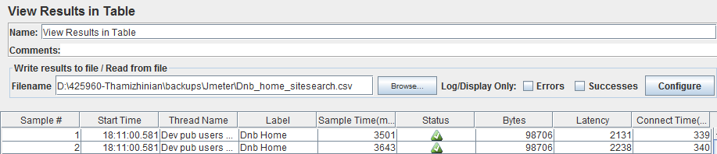

Export the results from View Results in Table listener

* In View Results in Table, Check for the Filename field and a Configure button
* Before entering anything into the Filename field, click on Configure button
* If you want to write the result in csv, xls format, choose options accordingly by unchecking checkboxes which say to save in XML format
* If you want the Field Name to be displayed, check the Save Field Name(CSV) checkbox and click on Done button
* Once configuration is done, copy the path from your machine where you want the results to be exported like "D:\apache-jmeter-2.13\bin\**viewresultsintable.csv**
* The one in bold here is the name of file with type of extention we want the file to be. It can be .csv, .xls, .jtl
* Run the test, once done, go to the path where you wanted to Save the Results, you will see the file in that path with the extention and name you provided
* The file will contains all data collected in listener during the RUN.

**View Results in Tree**

Thread group > Add > Listener > View Results Tree

Result tree listeners,

* Sampler
  + The first tab is Sampler Results. It shows JMeter data as well as data returned by the web server. Usually browsers hide this data from us as it is not related to showing the web page. This data is utilized internally by the browser, for example when there is a Response Code: 404 then the browser shows a page not found error page, and when the Response Code is 200 the browser shows the received web page HTML.
* Request
  + The second tab is Request, where all the data which was sent to the web server as part of the request is shown.
* Response data
  + The last tab is Response data. In this tab the listener shows the data received from server as it is in text format. It also have facility to show the data in XML, HTML formats but that will be just the data in other way (no JavaScript will be executed). This may look different that the page actually seen in the browser.

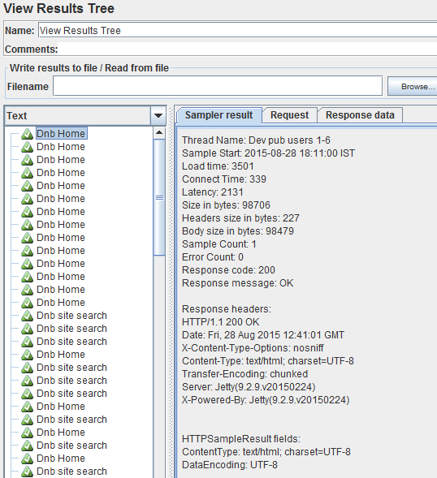

**Please refer to the below url for more details:**

[**http://jmeter-expert.blogspot.in/**](http://jmeter-expert.blogspot.in/)

**http://www.slideshare.net/vivizam/how-to-analyze-reports-in-jmeter**