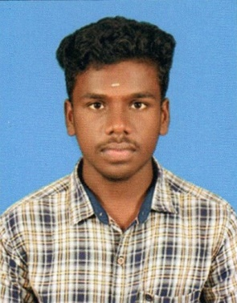

**SANTHOSH KARMEGHAM**

P.N.Palayam ,Nookkampalayam Road

Perumbakkam, Chennai.

[**Vksan131@gmail.com**](mailto:Vksan131@gmail.com)

**9003592441**

[**https://santhoshkarmegham.github.io/personal-site/**](https://santhoshkarmegham.github.io/personal-site/)

## Career objective

To apply full potential of my intrinsic talents and to take upon the inspiring and challenging task and do my duties with genuineness and effectiveness.

## Academic Qualification

|  |  |  |  |  |
| --- | --- | --- | --- | --- |
| QUALIFICATION | SCHOOL/COLLEGE | YEAR | BOARD/UNIVERSITY | PERCENTAGE |
| B.sc Computer science | Bishop Heber College | 2017-2020 | Bharadhiadasan University | 71% |
| HSC | Govt.boys higher secondary school | 2017 | State Board | 67.5% |
| SSLC | Rama Nataraja High School | 2015 | State board | 90.6% |

## Area of interest

* JAVA(Oracle certification se7 programming)
* SERVLETS &JSP

**Technical Skill**

**PROGRAMMING**

* JAVA

**WEB TECHNOLOGY**

* FULL STACK WEB DEVELOPER(USING JAVASCRIPT)
* .NET

**MOBILE TECNOLOGY**

* ANDROID NATIVE (KOTLIN)

**Experience**

* **2 Months** Experience In Android Native (Kotlin) Working As Freelancer

In The Level of **Dependency Injection** and **Dagger Tool**

And **Design Patterns** And **Retrofit**

**projects**

**ONLINE LIBRARY MANAGEMENT SYSTEM**

Front –End : HTML,CSS,JAVASCRIPT,BOOTSTRAP

Middle : C#

Framework : ASP.NET

Database : MySql

**Inter Personality strengths**

* Ability to rapidly build relationship and set up trust.
* Confident and determined.

**Extracurricular activities**

* Cricket

**Personal profile**

Date of birth : 25/10/2000

Father’s name : R. KARMEGHAM

Nationality : INDIAN

Gender : MALE

Preferred Work Location : Anywhere in India

Languages known :

|  |  |  |  |
| --- | --- | --- | --- |
|  | Read | Write | Speak |
| Tamil | yes | Yes | Yes |
| English | Yes | Yes | Yes |

## DECLARATION

I am SANTHOSH K do here by confirm that the information given above is true to best of my knowledge and belief . I shall overdue by the terms &condition there in.

Date: Yours sincerely,

(SANTHOSH K)

Place: