S.SANTHOSH KUMAR

Abstract

Hospital Management System provides the beneﬁts of streamlined operations, enhanced administration, control, superior patient care, strict cost control and improved proﬁtability.

HOSPITAL  
MANAGEMENT SYSTEM

**M.S.D HOSPITAL**

**Table of Contents**

|  |  |
| --- | --- |
| **Title** | **Page No.** |
| **Chapter 1 – Introduction** | **8** |
| **1.1 Overview** | **8** |
| **1.2 Abstract** | **8** |
| **1.3 Significance of the Study** | **9** |
| **1.4 Related Work** | **11** |
| **1.5 Project objectives** | **11** |
| **1.6 Background to the Study** | **12** |
| **1.7 System Requirement** | **15** |
| **1.8 Information about programming languages for the project** | **16** |
| **CHAPTER 2 - Project planning** | **19** |
| **2.1 Introduction** | **19** |
| **2.2 Definitions of problems** | **19** |
| **2.3 methodology, Project planning and scheduling** | **19** |
| **2.4 Design and Implementation of Hospital Management System** | **20** |
| **2.5 Relevance of Hospital information System** | **21** |
| **2.6 Technology and Efficiency** | **21** |
| **2.7 Financial Resources** | **23** |
| **CHAPTER 3- Explain the practical application** | **24** |
| **3.1Introduction** | **24** |
| **3.1Login interface** | **24** |
| **3.2 Main program interface** | **25** |
| **3.3 recording all patient data** | **26** |
| **3.4 show all patient data** | **27** |
| **3.5 entering the patient's financial information** | **28** |
| **3.6 room information** | **29** |
| **3.7 add staff** | **30** |
| **CHAPTER 4- Results and Discussion** | **31** |
| **CHAPTER 5- Conclusion** | **32** |
| **5.1 Introduction** | **32** |
| **5.2 challenges in use of Hospital Management System** | **33** |
| **5.3 Conclusion (and Future work)** | **34** |
| **References** | **35** |

**List of Tables**

|  |  |
| --- | --- |
| **Table Name** | **Page No.** |
| **Table (1.1): Hardware Requirement** | **15** |
| **Table (1.2): Software Requirements** | **15** |

**List of Figures**

|  |  |
| --- | --- |
| **Table Name** | **Page No.** |
| **Figure (3-1): Homepage** | 18 |
| **Figure (3-2): Admin dashboard** | 20 |
| **Figure (3-3): Doctor dashboard** | 21 |
| **Figure (3-4): Patient dashboard** | 23 |
| **Figure (3-5): Appointment** | 24 |
| **Figure (3-6): Flow chart process** | 25 |

**CHAPTER ONE**

**1.1 Overview**

Human Body is a very complex and sophisticated structure and comprises of millions of functions. All these complicated functions have been understood by man him, part-by-part their research and experiments. As science and technology progressed, medicine became an integral part of the research. Gradually, medical science became an entirely new branch of science. As of today, the Health Sector comprises of Medical institutions i.e. Hospitals, HOSPITALs etc. research and development institutions and medical colleges. Thus the Health sector aims at providing the best medical facilities to the common man.

**1.2 Abstract**

Hospital Management System provides the beneﬁts of streamlined operations, enhanced administration, control, superior patient care, strict cost control and improved proﬁtability. HMS is powerful, ﬂexible, and easy to use and is designed and developed to deliver real conceivable beneﬁts to hospitals. More importantly it is backed by reliable and dependable support. The project ‘Hospital Management System’ is based on the database, object oriented and networking techniques. As there are many areas where we keep the records in database for which we are using MY SQL software which is one of the best and the easiest software to keep our information. This project uses JAVA as the front-end software which is an Object Oriented Programming and has connectivity with MY SQL. Hospital Management System is custom built to meet the speciﬁc requirement of the mid and large size hospitals across the globe. All the required modules and features have been particularly built to just ﬁt in to your requirement. This package has been widely accepted by the clients in India and overseas. Not stopping only to this but they are highly satisﬁed and appreciating. Entire application is web based and built on 3 tier architecture using the latest technologies. The sound database of the application makes it more users friendly and expandable. The package is highly customizable and can be modiﬁed as per the needs and requirements of our clients. Prolonged study of the functionalities of the hospital and its speciﬁc requirement has given it a wonderful shape both technically and usability wise. It covers all the required modules right from Patient Registration, Medicine details, Doctor, Wards, , Admin, Store, Patient appointment, bill payment, record modiﬁcation, discharge details etc. Human Body is a very complex and sophisticated structure and comprises of millions of functions. All these complicated functions have been understood by man him, part-by-part their research and experiments. As science and technology progressed, medicine became an integral part of the research. Gradually, medical science became an entirely new branch of science. As of today, the Health Sector comprises of Medical institutions i.e. Hospitals, HOSPITALs etc. research and development institutions and medical colleges. Thus the Health sector aims at providing the best medical facilities to the common man.

Problem Statement Since Hospital is associated with the lives of common people and their day-to-day routines so I decided to work on this project. The manual handling of the record is time consuming and highly prone to error. The purpose of this project is to automate or make online, the process of day to-day activities like Room activities; Admission of New Patient, Discharge of Patient, Assign a Doctor, and ﬁnally compute the bill etc. I have tried my best to make the complicated process Hospital Management System as simple as possible using Structured Modular technique Menu oriented interface. I have tried to design the software in such a way that user may not have any diﬃculty in using this package further expansion is possible without much eﬀort. Even though I cannot claim that this work to be entirely exhaustive, the main purpose of my exercise is perform each Hospital’s activity in computerized way rather than manually which is time consuming. I am conﬁdent that this software package can be readily used by non-programming personal avoiding human handled chance of error.

**1.3 Significance of the Study**

The study is important to the hospital patients since they could have medical information without experiencing delays and incorrect information. If they wanted to access their medical history, they would not be going through a difficult process. The hospital especially the pharmacy and billing department would not go through a lot of paper reports when it comes to payments and accounting records. The use of paper would still be there but it could be reduced so that excessive paper loads would not be a problem.

The study was also significant to the staffs since they would be able to register, update, delete, and search information within the system. It was beneficial to the hospital since it could improve their management through connecting all their existing computers in one system. In general, the study was important to the hospital and patients for it could serve as an applicable tool to maintain the productivity and quality of service in the hospital.

Hospital is a leading among the public hospital. Health system functioning depends on production and use of quality health data and information at all levels of the health system. This study serves as a starting point for the assessment of HIS based on the situation in public to identify the strengths and weakness of the system in improving health system functioning. The study forms a basis for further research on evidence based management of health services in general and specifically lead to generation of new ideas for better and more efficient management of health facilities in Nairobi and the country at large. The study will look at the use of hospital information system in a private and a public hospital.

Findings and recommendations of the study would contribute towards the ongoing efforts of ministry of health to develop better health management operations system that would benefit facilities and healthcare workers identify their weakness and thus propose better ways that could help improve their efficiency through improved information use. The findings of the study will be used by all health care workers and health care managers as and will not rely on haphazard personal experiences or subjective personal judgments or of friends /relative other than base their decisions and actions on concrete evidence and thus help re-invent themselves as problem solvers.

**1.4 Related Work**

Hospital Management System (HMS) is designed for multispecialty hospitals, to cover a wide range of hospital administration and management processes of patient-centric system. It is an integrated end-to-end Hospital Management System that provides relevant information across the hospital to support effective decision making for patient care (medical records management and billings), and hospital administration, in a seamless flow. In existence, some researchers have contributed positively in the improving of health care institutions management systems. Therefore, we discuss in this section below, some of the related works done in hospital management system by researchers in the field.

The work of [8] focused on understanding the performance indicators of Hospital information systems (HIS), summarizing the latest commonly agreed standards and protocols like Health Level Seven (HL7) standards for mutual message exchange, HIS components, etc. The study is qualitative and descriptive in nature and most of the data is based on secondary sources of survey data. However, the researchers identified several modules for the implementation of E-Hospital Management and Hospital Management System in which Emergency Management was one of them. The contents operation within this module excludes the incorporation and use of Biometric Fingerprint Technology. Thus, this indicates that emergency cases in the intensive units where the registration of patients is trivial cannot be handled adequately with respect to time. It was noted that the success factors of E – HMS / HIS tend to vary depending upon leadership support, training, technology adoption, user friendliness, etc. within a country.

[1] identified the challenges existing in Mother-love Hospital, such as Data redundancy, data inconsistency, difficulty in accessing data, data isolation, integrity problems, atomicity problem, concurrent access anomalies, and some security problems. They cited [4] among others which pinpointed at techniques behind Database Management technologies, and thus overcome the existing challenges. The system is visualized as a web based application with three tier architecture. This architecture provides an increased degree of security because its multiple zones isolate protected healthcare data making it difficult for a hacker to get system-level access to the database. The solution proffered by this system did not incorporate enabling technology to handle patients’ in critical condition(s).

**1.5 Project objectives**

The objective of this project is to develop hospital management software based on Microsoft window application with structured Query language (T-SQL and SQL Server as a database) as the back-end database hospital from file based system to a computer database system. This software will help the company to be more efficient in handling the daily activities and registration of their patients. The purpose of this project is to give a complete requirement documentation, design, and implementation of the software. It also explains the user interface, hardware and software and different models that could be used to develop software such as this.

Hospital are the essential part of our lives, providing best medical facilities to people suffering from various ailments, which may be due to change in climatic conditions, increased work-load, emotional trauma stress etc. It is necessary for the hospitals to keep track of its day-to-day activities & records of its patients, doctors, nurses, ward boys and other staff personals that keep the hospital running smoothly & successfully.

But keeping track of all the activities and their records on paper is very cumbersome and error prone. It also is very inefficient and a time-consuming process Observing the continuous increase in population and number of people visiting the hospital. Recording and maintaining all these records is highly unreliable, inefficient and error-prone. It is also not economically & technically feasible to maintain these records on paper. Thus keeping the working of the manual system as the basis of our project. We have developed an automated version of the manual system, named as “Administration support system for medical institutions. ”

The main aim of our project is to provide a paper-less hospital up to 90%. It also aims at providing low-cost reliable automation of the existing systems. The system also provides excellent security of data at every level of user-system interaction and also provides robust & reliable storage and backup facilities.

**1.6 Background to the Study**

Healthcare especially in the developed world is characterized by rapidly increasing use of information technology in patient care, increasing documentation, coding and billing, and management. Rise of health information technology worldwide is increasing the efficiency of health service delivery, reducing medical errors, improving quality of care and providing better information for patients and physicians (Pollak and Lorch, 2007:4).

The overall goal of the information management function is to obtain, manage, and use information to improve health care and medical services, performance, governance and management and support processes.

The importance of healthcare to individuals and governments and its growing costs to the economy have contributed to the emergence of healthcare as an important area of research for scholars in business and other disciplines. Information systems (IS) have much to offer in managing healthcare costs and in improving the quality of care (Kolodner et al. 2008: 394). In additional, Piontek et al., (2010: 618) asserts that healthcare influences the quality of human lives and function in the society. Healthcare mistakes have serious consequences that can affect ability to carry out social and productive endeavors. Recent reports highlight the gravity of adverse events in hospitals and the dangers such events pose to individuals and the public. Healthcare information systems have changed the healthcare industry drastically over the last decade as well as the last few years (Abraham & Jungles).

The forces of competition and advancements in healthcare technology are pushing hospitals to follow the trend. Paperless healthcare systems have become inevitable and any healthcare institute that doesn’t follow this trend will fall behind the rest of the industry.

Health information system is a must and the faster this is adopted the more successful the healthcare facility will be.(Swanson et al. 2010: 9). Delone and Mclean being one of the most cited models in the fields of information systems seeks to provide a comprehensive understanding of information systems success by identifying, describing, and explaining the relationships between six success variables categories: systems quality, information quality, user, user satisfaction, individual impact, and organizational impact. Delone & Mclean (2003) model provides a comprehensive frame work for measuring the performance of the information system and enhances the understanding of information systems success.

World Health Organization (WHO, 2008) cautions that, the goal of a health information system is often narrowly defined as the production of good-quality data. The ultimate goal is to produce relevant information that health system stakeholders can use for making transparent and evidence-based decisions for health system interventions. Health information management system performance should therefore be measured not only on the quality of data produced, but on evidence of the continued use of data to improve health system performance, respond to emergent threats, and improve health (WHO, Improving health information systems in terms of data availability, quality and use often requires interventions that address a wide range of possible ‘determinants of performance.

Health information systems recognizes that although new developments in technology, including the use of the internet and other modes of communication offer great potential in the flow of information amongst the providers and recipients regarding the provision and management of healthcare services, the Kenyan health sector remains far behind in taking advantage of such developments to improve reporting (HIS, 2008). Despite vast amounts of resources and time invested in the development and implementation of health information systems, health data is barely used by health workers for service delivery planning and decision-making. Performance is grossly under reported with developments to improve information management lagging behind other sectors improvement activities; the whole culture of information generation and use remain under-developed; and mechanisms for validating and assuring reliability are not optimally functional.

**1.7 System Requirement**

|  |  |  |
| --- | --- | --- |
|  | Hardware Requirement |  |
| Disk space | RAM | Processor |
| 5400 RPM hard drive and 5 GB of available hard disk space | 1GB of RAM (1.5 GB if running on a virtual machine) | 1.6 GHz or faster processor |

Table (1.1): Hardware Requirement

|  |  |  |  |
| --- | --- | --- | --- |
| Operating system | Database | User interface | Server |
| Windows XP, Windows 7 Windows 8, Windows10 Windows 11 | My SQL | Eclipse IDE, chrome, edge, opera, firefox, brave browsers | Apache Tomcat server v8.95 |

Table (1.2): Software Requirement

**1.8** **Information about programming languages for the project:**

**SQL**

The origins of the SQL take us back to the 1970s, when in the IBM laboratories, new database software was created - System R. And to manage the data stored in System R, the SQL language was created. At first it was called SEQUEL, a name which is still used as an alternative pronunciation for SQL, but was later renamed to just SQL. In 1979, a company called Relational Software, which later became Oracle, saw the commercial potential of SQL and released its own modified version, named Oracle V2.

Now into its third decade of existence, SQL offers great flexibility to users by supporting distributed databases, i.e. databases that can be run on several computer networks at a time. Certified by ANSI and ISO, SQL has become a database query language standard, lying in the basis of a variety of well-established database applications on the [Internet](https://www.ntchosting.com/internet/) today. With the progress in database technology SQL-based applications have become increasingly affordable for the regular user. This is due to the introduction of various open-source SQL database solutions such as [MySQL](https://www.ntchosting.com/mysql/), [PostgreSQL](https://www.ntchosting.com/postgresql/), and SQLite.

## SQL Standard

The SQL Standard has gone through a lot of changes during the years, which have added a great deal of new functionality to the standard, such as support for XML, triggers, regular expression matching, recursive queries, standardized sequences and much more. Due to SQL Standard’s sheer volume, a lot of database solutions based on it, such as MySQL or PostgreSQL; do not implement the whole standard. In a lot of cases, the database behavior for [file](https://www.ntchosting.com/internet/file.html) storage or [indexes](https://www.ntchosting.com/internet/indexes.html) is not well defined and it's up to the vendors of the various SQL implementations to decide how the database will behave. This is the reason why, even though all SQL implementations have the same base, they are rarely compatible.

## SQL Language elements

The SQL language is based on several elements. For the convenience of SQL developers all necessary language commands in the corresponding [database management systems](https://www.ntchosting.com/databases/database.html#Database_management_systems) are usually executed through a specific SQL command-line interface (CLI).

* **Clauses** - the clauses are components of the statements and the queries
* **Expressions** - the expressions can produce scalar values or tables, which consist of columns and rows of data
* **Predicates** - they specify conditions, which are used to limit the effects of the statements and the queries, or to change the program flow
* **Queries** - a query will retrieve data, based on a given criteria
* **Statements** - with the statements one can control transactions, program flow, connections, sessions, or diagnostics. In database systems the SQL statements are used for sending queries from a client program to a server where the databases are stored. In response, the [server](https://www.ntchosting.com/server.html) processes the SQL statements and returns replies to the client program. This allows users to execute a wide range of amazingly fast data manipulation operations from simple data inputs to complicated queries.

**Java**

Java is a programming language and computing platform first released by Sun Microsystems in 1995. It has evolved from humble beginnings to power a large share of today’s digital world, by providing the reliable platform upon which many services and applications are built. New, innovative products and digital services designed for the future continue to rely on Java, as well.

While most modern Java applications combine the Java runtime and application together, there are still many applications and even some websites that will not function unless you have a desktop Java installed. Java.com, this website, is intended for consumers who may still require Java for their desktop applications – specifically applications targeting Java 8. Developers as well as users that would like to learn Java programming should visit the [dev.java](https://dev.java/) website instead and business users should visit [oracle.com/java](https://www.oracle.com/java/) for more information.

**Why Java ?**

Java can be used in many different applications, but here are the most popular ways the language is used:

### **Android mobile apps**

Java is the official language for Android mobile app development. In fact, the Android operating system itself is written in Java. Even though Kotlin has recently become an alternative to using Java for Android development, Kotlin still uses the Java Virtual Machine and can interact with Java code. Today, Android has [85% of the global market share](https://www.idc.com/promo/smartphone-market-share) for mobile devices. Therefore, developing Android apps is probably the most popular use of Java just because of the prevalence of Android phones.

### **Desktop applications**

Java has been used to create desktop applications since its inception. AWT, Swing, and JavaFX are Java libraries that give desktop application developers pre-built components like buttons, menus, and form fields that they can use to build full-featured desktop applications.

### **Web applications**

Java first became popular as a web development language because it provides applets that can run in a web browser. Applets are a thing of the past, but Java is still very popular for creating back-end web applications, which run on a web server. Now web developers use Java technologies like Struts, Servlets, or JSP instead of Applets to create all types of full-featured web applications.

### **Game development**

Java is a free, open-source language. Many game developers use it because they can get started without paying any licensing fees and because of the powerful Java 3D game engine, JMonkeyEngine. Some video games written in Java include Tetris, The Sims 3, Space Invaders, Street Fighter II, and Contra. One of the best-known Java games, Minecraft, was created by a single developer.

### **Big data processing**

Java and big data go hand in hand. Many of the top applications used for big data are written in Java. Hadoop is a Java framework that helps data scientists process large datasets. Spark is a tool that data scientists use for stream processing, machine learning analytics, and other big data processes. Storm handles real-time data streams. All of these frameworks are written in the Java [programming language](https://www.codecademy.com/resources/blog/programming-languages/?utm_source=ccblog&utm_medium=ccblog&utm_campaign=ccblog&utm_content=cw_what_is_java_used_for_blog).

### **IoT applications**

Java was originally designed to run on all types of hardware, making it one of the main programming languages used for the Internet of Things, or IoT. IoT refers to a network of physical devices that connect and exchange data over the Internet. The devices include smartwatches, wearables, smart TVs, smart lighting, and more.

### **Distributed applications**

Many distributed applications run in a cloud environment and are designed to scale when the load changes. But distributed applications are not necessarily easy to deploy and manage. Java provides the Java Intelligent Networking Infrastructure or JINI to make distributing applications simpler. JINI is an infrastructure to provide, register, and manage distributed Java applications.

### **Cloud-based applications**

Java is also heavily used in cloud-based applications. Because of its low cost and wide use, many companies use it to develop SaaS, IaaS, and PaaS services in the cloud.

### **Enterprise Development**

Java is used heavily in enterprise development to build intranets and internal software for all types of businesses, big and small. Java Enterprise Edition (Java EE) is specifically designed for enterprise development. It comes with network applications, web services, and a scripting environment that make setting up an intranet with Java simpler.

**CHAPTER TWO**

**2.1 Introduction:**

This chapter provides a comprehensive definition of the problem, people's perception of the problem, and then provides a conceptual strategy for problem solving, ways to solve it, the importance of problem solving, and then it passes to theoretical program design for problem solving and technology. The study used to solve this problem.

**2.2 Definitions of problems**

**A theoretical study of the problem and how to solve it**

Problems with conventional system:

1. Lack of immediate retrievals: -The information is very difficult to retrieve and to find particular information like- E.g. - To find out about the patient’s history, the user has to go through various registers. This results in inconvenience and wastage of time.

2. Lack of immediate information storage: - The information generated by various transactions takes time and efforts to be stored at right place.

3. Lack of prompt updating: - Various changes to information like patient details or immunization details of child are difficult to make as paper work is involved.

4. Error prone manual calculation: - Manual calculations are error prone and take a lot of time this may result in incorrect information. For example: calculation of patient’s bill based on various treatments.

5. Preparation of accurate and prompt reports: - This becomes a difficult task as information is difficult to collect from various registers.

**2.3 Methodology. Project planning and scheduling**

Project planning is part of project management, which relates to the use of schedules such as Gantt charts to plan and subsequently report progress within the project environment. Initially, the project scope is defined and the appropriate methods for completing the project are determined. Following this step, the durations for the various tasks necessary to complete the work are listed and grouped into a work breakdown structure. The logical dependencies between tasks are defined using an activity network diagram that enables identification of the critical path.

We have used Iterative and Incremental Development model (IID) for our project development. This development approach is also referred to as Iterative Waterfall Development approach. Iterative and Incremental Development is a software development process developed in response to the more traditional waterfall model. This model is designed to take care of such big project. The large and complicate project chiefly demand better development and testing procedure. The waterfall model is well known for its repeated testing process. Hence I choose the waterfall model for developing my software.

**2.4 Design and Implementation of Hospital Management System**

Hospitals are information-intensive organization and pay great attention to information management and processing, which have to be to be carried out using appropriate information system. Hospital information system and clinical information system are computer- based systems used in hospitals to assist the overall management of the health care facility through information about diseases and information about patient care (Haux, 2004) in terms of record keeping of patient information, accounting, human resource management, asset management, and stock management and knowledge management.

Task of the hospital information system is to support patient care and associated administration by providing: information, primarily about patients that information must be correctly collected, stored, processed and documented; Knowledge, primarily about diseases- such as drug actions and adverse effects-to support diagnosis and therapy; information about the quality of patient care and hospital performance and costs (Haux, 2004). Hospital management system is of great importance in modern hospital. Liu stated that the system must be made of several parts such as: marking card, registration, medical treatment, drug information management, pharmacy dispensing, emergency, data dictionary maintenance, database backup, report printing and so on. There are seven function modules that are to be considered, including: Emergency Register Management, Price Making, Charge, Nurse Station Management, and Data Dictionary Maintenance. Based on the above design, the system can provide high quality treatments and good services for patients and their families.

**2.5 Relevance of Hospital information System**

Due to extensive changes in medical technology and increased expectation of patients in the twenty-first century hospitals that lack hospital information Systems will not be able to compete with other hospitals. The most important necessity and reason for hospitals information systems automation are inefficiency manual procedures (Meinert & Peterson2009:9). Hospital information systems help to improve operational efficiency, care quality and more informed decision making. According to Ghosh (2010), hospital information systems give comfortable and quick access to patient data.

**2.6 Technology and Efficiency**

Technology as the sub-factors hardware, software and connectivity, the hardware needed should be identified before the introduction of the system. This means that at the start of the project an assessment should be made about the hardware already available and the hardware which is still needed for full introduction of the system. One of the major concerns with IS, is the fact that users often claim that they are not user friendly and lack intuitive data input. The way in which data is put into a system reflects the individual’s practice style. The interface design and structure of the data need therefore to conform to each other. The other issue is that it depends on the technology being used. Flexibility and adaptability is also a challenge when introducing such a system. Looking for the right terminology for input is also a concern Software content issues include the lack of local content creation, the language used and the relevance of content to the local situation. Appropriate language is frequently neglected in ICT programmers and little content is available in local languages for health programmers. Another concern of any health organization in the integration of health information systems is the fact that healthcare institutions need timely patient information from various sources at the point of- care. This means buying a fully functional system fulfilling all their needs from one vendor. This suggests working with standards for better data integration (Kuhn et. al2001). With connectivity one has to deal with things like the lack of an enabling telecom policy and regulatory environment; access to electricity, solar power options, back-ups, insufficient infrastructure, connectivity access and high costs. The better these things are functioning the greater the chance for successful implementation. The actual integration of isolated systems is an important issue for the success of an information system. The use of simpler systems fitted better with the clinical work processes should also add to better solutions.

**2.7 Financial Resources**

Generally, there is little investment in ICT for health in most developing countries. The picture is one of fragmentation, with many different varieties of ICT being acquired from different donors. Invariably, there is no national health information and information technology infrastructure to underpin the delivery of health care. It is very important to make a realistic financial plan for all the costs in the system before the introduction of the health management information system (Gladwin et. al 2003:12).

Sustainability is very important when considering the introduction of the health management information system in the organization, especially in local hospitals in developing countries. Being able to continue supporting the system financially on the long run is the important issue to consider. Plans for sustainability should be clearly expressed ensuring that capital investments and costs are identified up front as well as ICT, capacity and infrastructure requirements. Monitoring and evaluation is also part of the sustainability failure to adopt a particular IM strategy may signal inappropriateness. Encouraging partnerships between stakeholders on local, national, regional and international level sustainability can grow.

**CHAPTER THREE**

**3.1 Introduction**

In this chapter, we explain how to work on the application, enter the mechanism, and use it with pictures, along with an explanation of each image about its content.

**Explain the practical application**

**3.1 Homepage:**

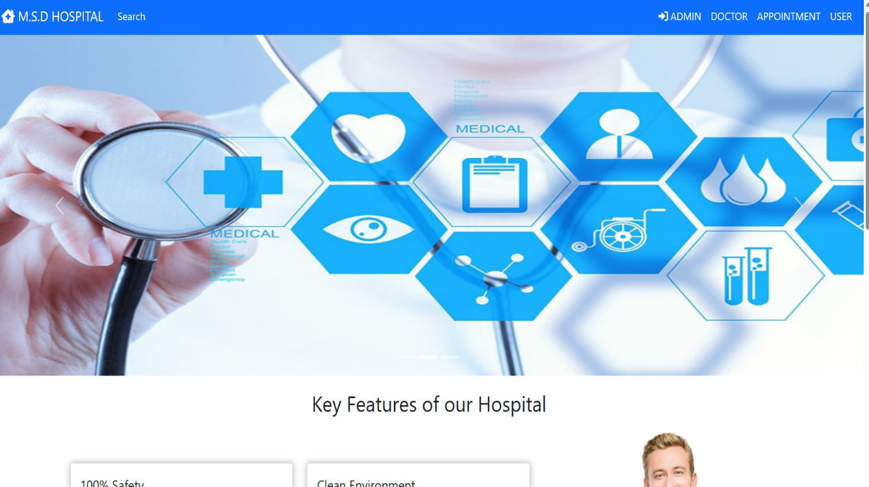

**1-Admin:** **to login**

**2- Doctor: to login or create account**

**3-Appointment: to book appointment of registered patient**

**4- User (patient): to login or create account**

**5- Search: to search the doctors to consult**

**3.2 Admin dashboard:**

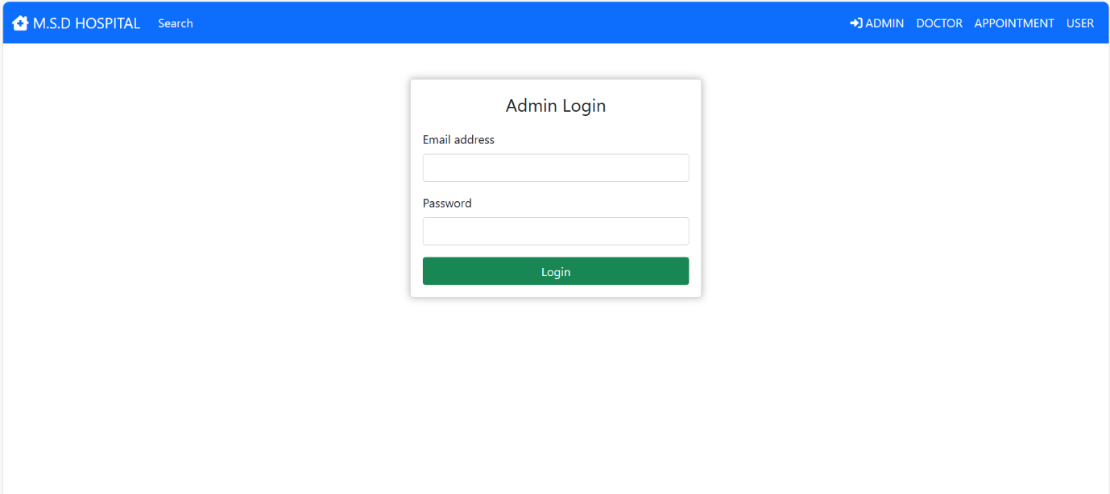

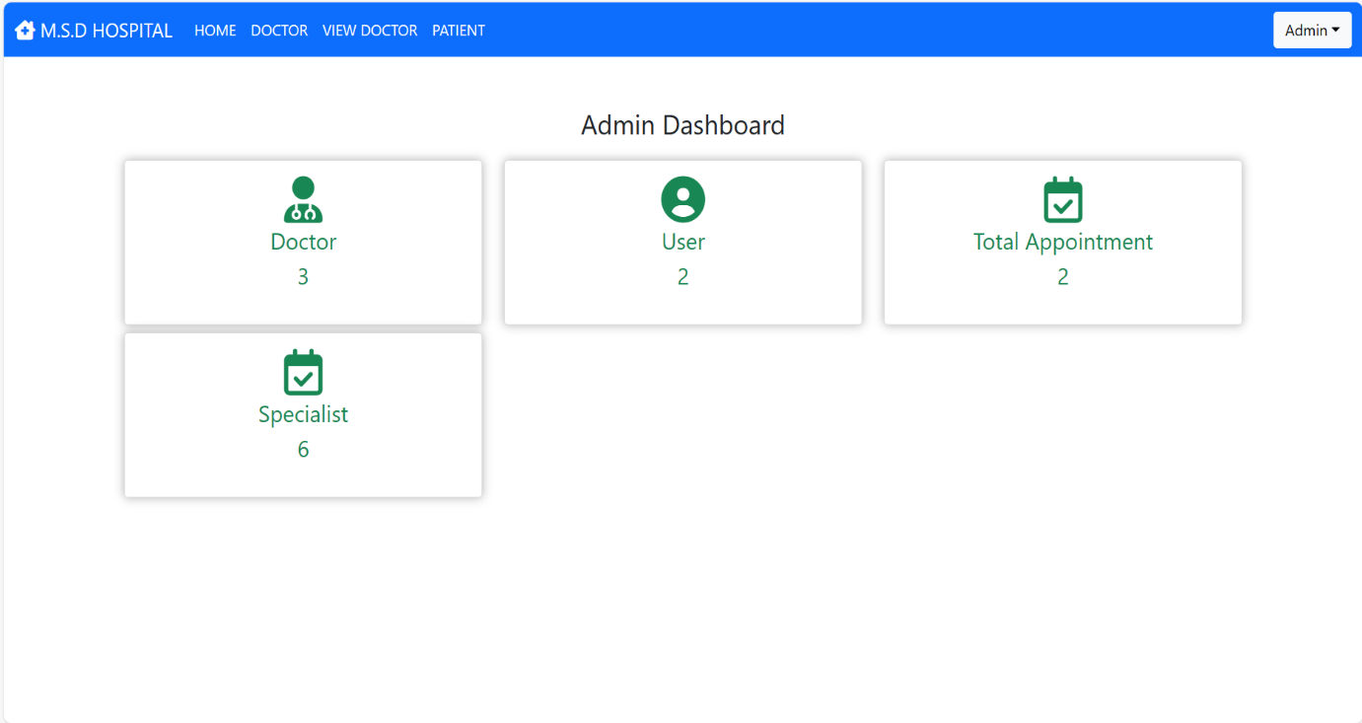

**Doctor:** To check about the doctors

**User:** To know about the patient details

**Total appointment:** To know about the appointments to patients

**Specialist:** To add the doctor’s category

**Logout:** Log out of the account

**3.3 Doctor dash board:**

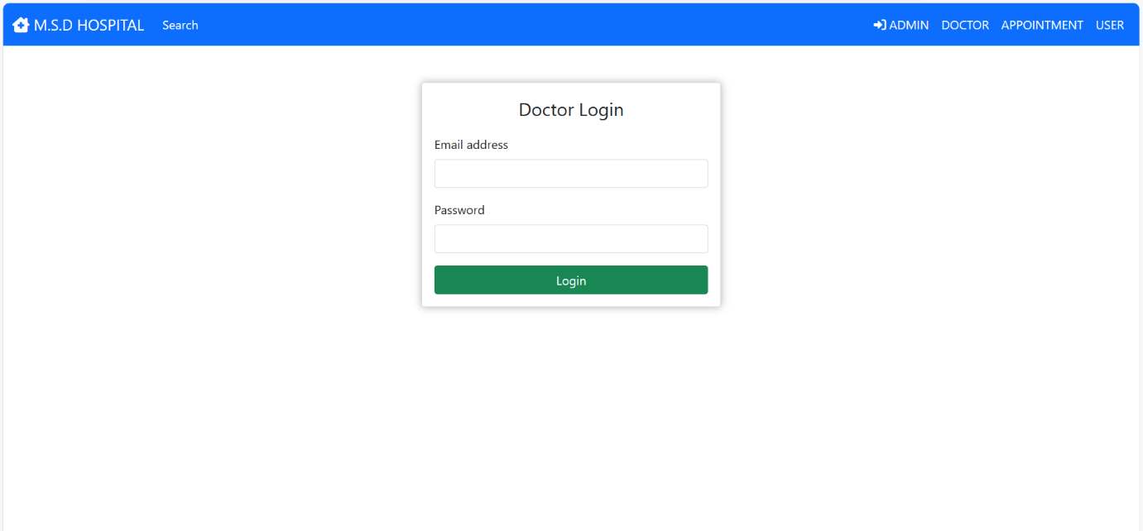

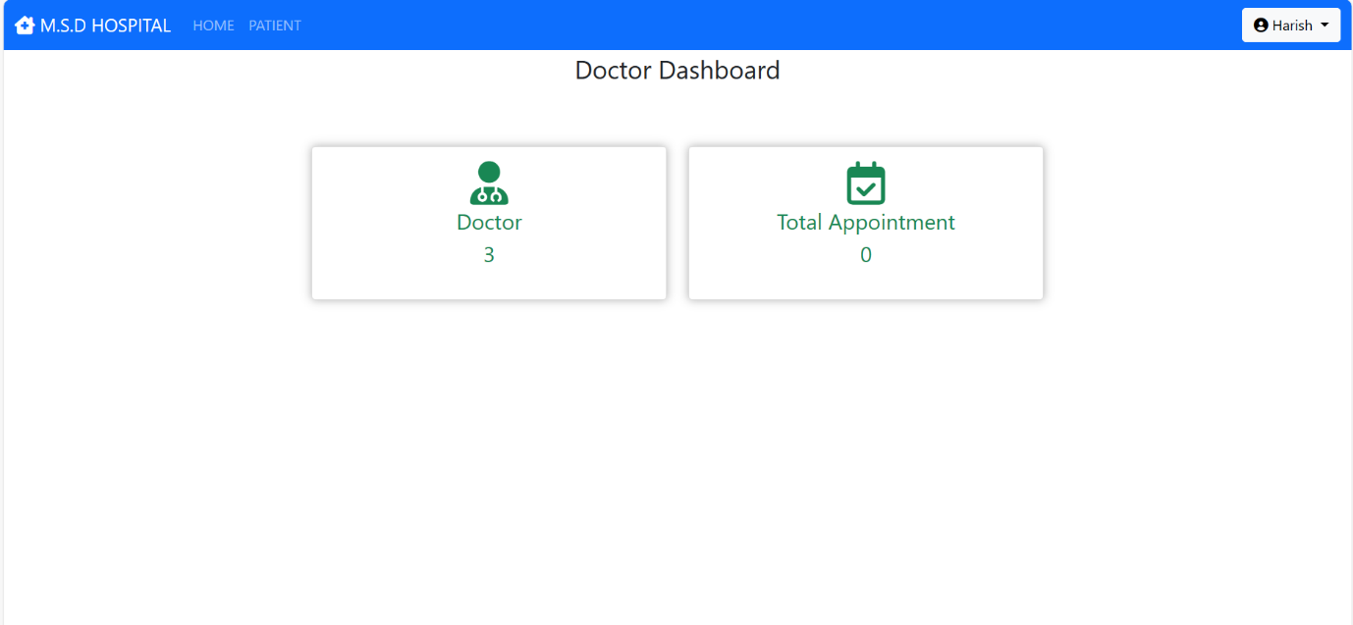

**Doctor:** To check about the doctors

**Patient:** To know about the patient details

**Total appointment:** To know about the appointments to patients

**Logout:** Log out of the account

**3.4 User dash board:**

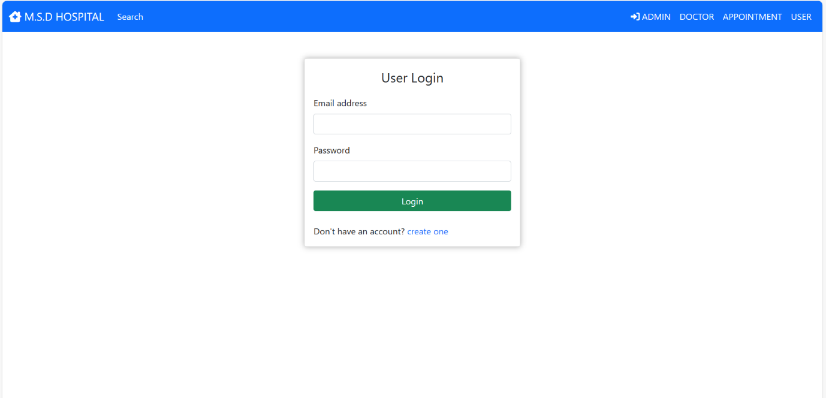

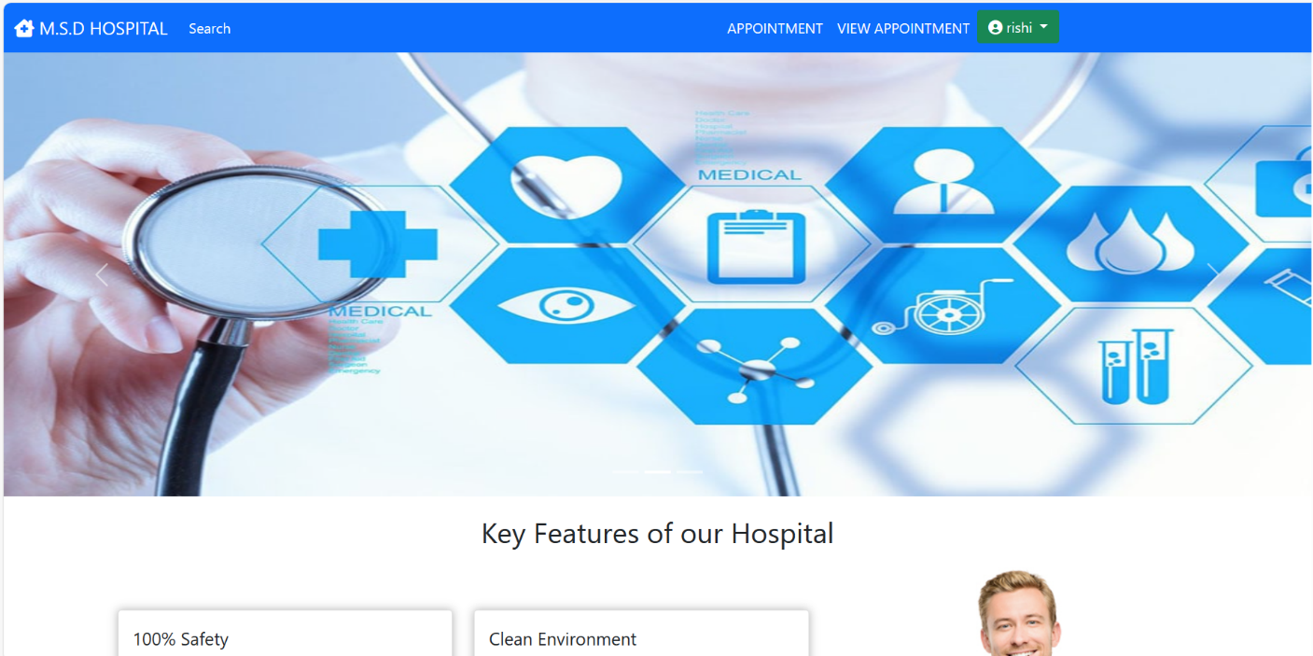

**Appointment:** To register the new appointments

**View appointment:** To know about the Previous finished appointments (if applicable) to patients

**3.5 Appointment:**

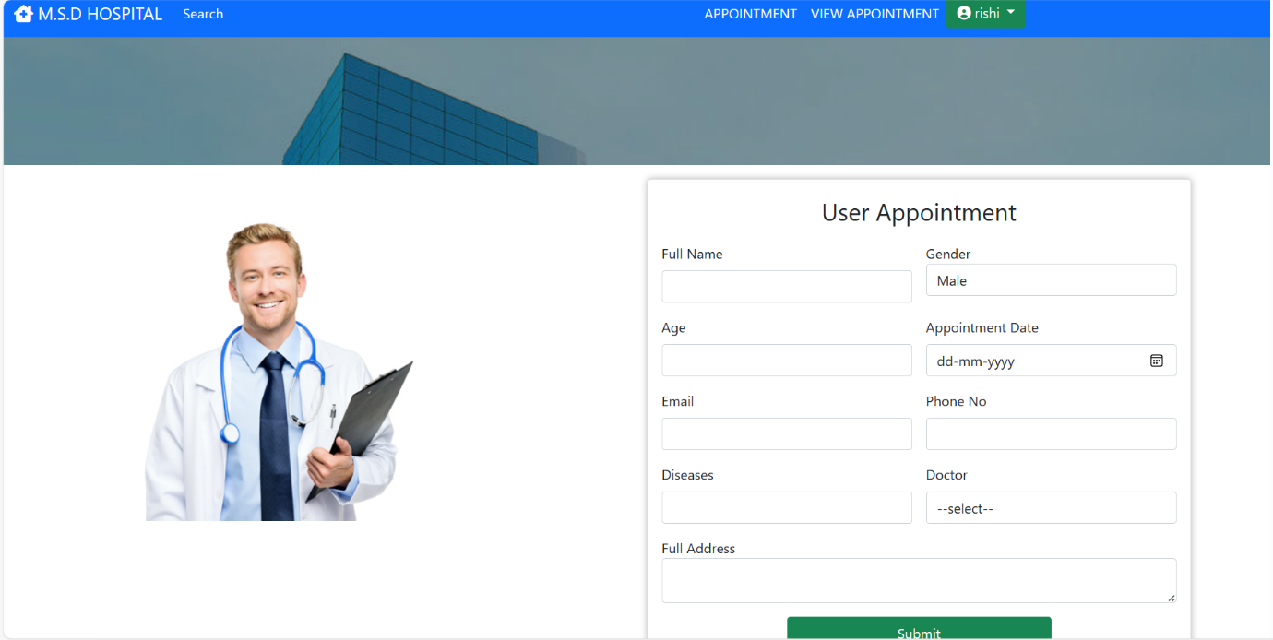

To book new appointments for the patients who have account in this application.

It requires the following details like

* Full Name
* Gender
* Age
* Appointment date
* Email id
* Phone no
* Diseases
* Doctor to consult
* Address

**3.5 Flow chart:**

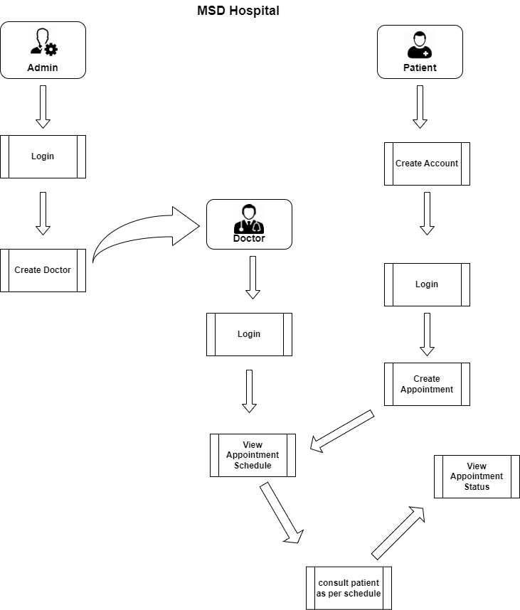

**CHAPTER FOUR**

**Results and Discussion**

The project results are summarized that despite several difficulties, whether software or bad support, we have been able to program a simple and basic program for hospital management and knowing almost all details, whether for patients or rooms or for the staff and we can use and apply in Iraqi hospitals to support hospitals and help by introducing technology to hospitals and also we can in the future of work On developing this project to be better in all respects, we also explained in our research the problem that the project will address and the people's view of the problem and how the work was previously and how we are trying through our research to help, even with a small part of treating the problem and pushing technology forward and help to introduce computers and their technologies to Iraqi hospitals, and this is important This position, as all developed countries do not use the papers in the hospital records or in their financial transactions, but have moved to apply the technology in their hospitals and transfer them to the electronic system.

This project has been a rewarding experience in more than one way. The entire project work has enlightened us in the following areas:

a) We have gained an insight into the working of the HOSPITAL. This represents a typical real world situation.

b) Our understanding of database design has been strengthened this is because in order to generate the final reports of database designing has to be properly followed.

c) Scheduling a project and adhering to that schedule creates a strong sense of time management.

d) Sense of teamwork has developed and confidence of handling real life project has increased to a great extent.

e) Initially, there were problem with the validation but with discussions, we were to implement validations.

**CHAPTER FIVE**

**5.1 Introduction**

This chapter gives an overview of the findings, conclusion and recommendations made from the study. These are based on the objectives and research questions of the study.

The aim of the study was to find out the use of hospital information management system in provision of relevant and effective services in hospitals. It is a comparative study between a private and public hospital.

**Objectives of the study were to:**

1. To assess the use of the hospital information systems in the two selected hospitals.

2. Establish the extent to which the hospital information system provides accurate and relevant information of the patient.

3. Establish the perception of the healthcare workers towards the system.

4. Find out the challenges faced in the use of hospital information management systems in the hospitals.

5. Find out possible solutions to the identified.

**5.2 Challenges in Use of Hospital Management System**

The fourth objective of this study was to establish challenges healthcare workers in both hospitals encounter in the use of hospital information management system.

**The main challenges encountered in:**

Mater hospital as system being slow, poor changeover between the new and old system, Few ICT staff to assist when needed, system keeps going on and off, and incapability between the old and new system., few ICT staff to assist when needed, few computers for use, inadequate software coverage, systems is slow and lack of training of users, system not yet implemented in some areas. Were found out as system providing inaccurate information, respondents not knowledgeable with the system, System not user friendly, and employees having negative attitude towards the system. Respondents’ recommendations on improving system.

In Mater Hospital more respondents would want development of electronic resource planning system for the hospital and development of specific tools to the current structure.

**5.3 Conclusion and Future work**

The project Hospital Management System (HMS) is for computerizing the working in a hospital. The software takes care of all the requirements of an average hospital and is capable to provide easy and effective storage of information related to patients that come up to the hospital.

It generates test reports; provide prescription details including various tests, diet advice, and medicines prescribed to patient and doctor. It also provides injection details and billing facility on the basis of patient’s status whether it is an indoor or outdoor patient.

**References**

1. HTML &CSS <https://www.w3schools.com/>
2. Bootstraphttp://getbootstrap.com/
3. <https://stackoverflow.com>
4. Abraham Silberschatz, Henry F. Korth and S. Sudarshan “Eighth Edition Database System Conceptsreleased
5. <https://books.google.iq/books?id=hxMiygsvOh8C&pg=PA36&lpg=PA36&dq=hms+c%23&source=bl&ots=uh0E6Kov04&sig=ACfU3U23pLOPSMtsRQuQs6ab44a6pqV5Nw&hl=ar&sa=X&ved=2ahUKEwifgb-RlKDqAhUoxKYKHSFsATEQ6AEwCXoECAgQAQ#v=onepage&q=hms%20c%23&f=false>
6. [https://books.google.iq/books?id=gK3l6LM5DhQC&pg=RA1-PA121&lpg=RA1-PA121&dq=hms+c%23&source=bl&ots=mxo_T96ia1&sig=ACfU3U0vG17DHSzUqTQQKFNrut](https://books.google.iq/books?id=gK3l6LM5DhQC&pg=RA1-PA121&lpg=RA1-PA121&dq=hms+c%23&source=bl&ots=mxo_T96ia1&sig=ACfU3U0vG17DHSzUqTQQKFNrut38OOMj7g&hl=ar&sa=X&ved=2ahUKEwifgb-RlKDqAhUoxKYKHSFsATEQ6AEwCnoECAcQAQ#v=onepage&q=hms%20c%23&f=false)
7. <https://www.youtube.com/watch?v=iqm1Y6fNqbg>
8. <https://www.edx.org/course/cs50s-introduction-to-computer-science>
9. <https://www.freecodecamp.org/>