Q1. This is the git command when we want to clone to our local branch

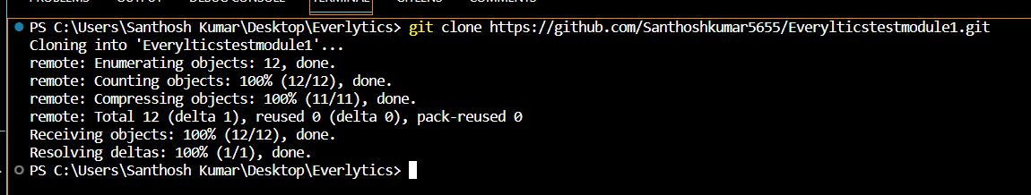

Q2. Write git commands step by step to push the local git branch into the GitLab (or GitHub) repository.

Step 1: we have to add all git files to the repository whatever we want



Step2 : we have to commit the message



Step3: we have to create branch name using git branch command



Step4: we have to shift to that branch



Step5 : pushing the code to repository by push branch



Q3. How to resolve merge conflicts in GitLab (or GitHub)?

Step1 : we have to merge the code by using git merge Assume if you want to merge your code with repository y you are in x you have to checkout x branch and perform merge this command



Step2 : once we have identifdied merge conflict we will solve by this command



Step3: it will open a window like colour all code comparisons will be there so we need to resolve that

Step4: after resolving merge conflicts we have to save the file

Step5 : check whether the modified changes are reverted or not.

Q.4. How to create local branch from test branch present in gitlab or Github.

1 . first of all cloning to the we need to checkout test branch we have to be in test branch

2. We need to create branch on test branch git branch san

3. We need to checkout branch san

q5.How to push local branch in our computer to GitLab by using this command

