Covid-19 Vaccines Analysis

Problem Definition:

 The problem is to conduct an in-depth analysis of Covid-19 vaccine data, focusing on vaccine

efficacy, distribution, and adverse effects. The goal is to provide insights that aid policymakers

and health organizations in optimizing vaccine deployment strategies. This project involves data

collection, data preprocessing, exploratory data analysis, statistical analysis, and visualization.

Design Thinking:

1. Data Collection: Collect Covid-19 vaccine data from reputable sources like health organizations,

government databases, and research publications.

2. Data Preprocessing: Clean and preprocess the data, handle missing values, and convert

categorical features into numerical representations.

3. Exploratory Data Analysis: Explore the data to understand its characteristics, identify trends, and

outliers.

4. Statistical Analysis: Perform statistical tests to analyze vaccine efficacy, adverse effects, and

distribution across different populations.

5. Visualization: Create visualizations (e.g., bar plots, line charts, heatmaps) to present key findings

and insights.

6. Insights and Recommendations: Provide actionable insights and recommendations based on the

analysis to assist policymakers and health organizations.

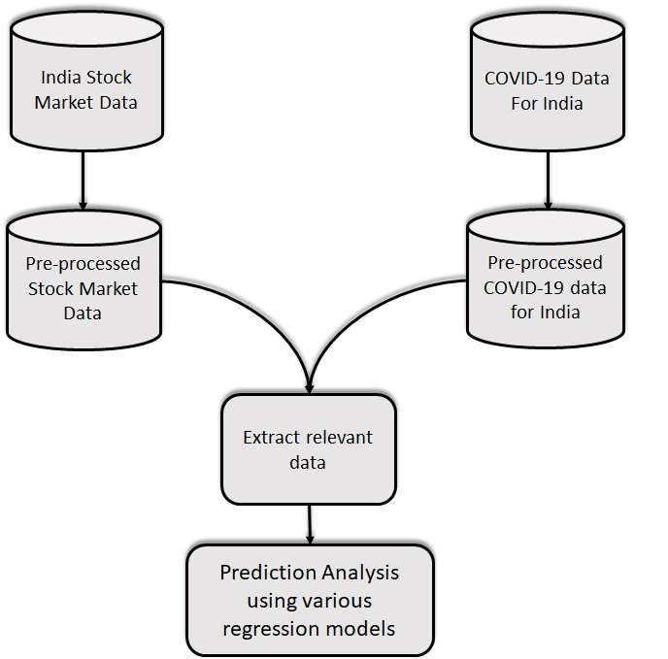

By

k.santhosh