OOTB – Asset Types  
[Overview of packaged asset types (collibra.com)](https://productresources.collibra.com/docs/collibra/latest/Content/Assets/AssetTypes/ref_ootb-asset-types.htm)

OOTB – Attribute Types

[Overview of packaged attribute types (collibra.com)](https://productresources.collibra.com/docs/collibra/latest/Content/Assets/Characteristics/Attributes/AttributeTypes/ref_attribute-types.htm)

Operating Model

* Establishes data stewardship and data management foundation
* Addresses three key design questions
  + What is to be governed?
    - Structural Concepts
  + Who governs it?
    - Organization Concepts
  + How is it to be governed?
    - Execution and Monitoring Concepts

Collibra Operating Model

|  |  |  |  |
| --- | --- | --- | --- |
| **Metamodel** | |  |  |
| **Asset Model (What)** | **Organizational Concepts (Who)** | **Execution & Monitoring Concepts (How)** | |
| Asset Types | Communities | Constraints and Rules | Status types |
| Attribute Types | Domains | Articulation score | Workflow definitions |
| Relation Types | Domain Types | Role types | Assignments |
| Complex relation types | Scopes | Views | Traceability |

Operating Model checklist

Execution and monitoring concepts + structural concepts + organization concepts

* Metamodel is defined
* Asset lifecycle is defined for every asset type
* Articulation scores indicators are defined
* Statuses are defined, configured and implemented in workflows
* Validation rules are designed and applied to particular assets types
* Processes are described
* Workflows are designed and applied to the asset types/communities or global
* Collibra Platform Roles are defined (within workflows and outside of them)
* Issue categories are defined
* Issue Management Process is designed and configured
* Views, search filters, dashboards and traceability diagrams are configured

Operating Model Design Procedure (OMDP)

Approach strategy

* Divide into manageable subareas
  + Take a slice and extend gradually
  + Take a business case and leverage with other business cases
* Apply the OMDP to each subarea
* Integrate the sub-models into a global operating model

**Operating Model Design Procedure OMDP steps by design category**

|  |  |  |
| --- | --- | --- |
| **What** | **Who** | **How** |
| 1. Idenitfy the types of assets, relations and attributes | 4. Identify communities and domains | 6. Add constraints and validation rules |
| 2. Validate the created operating model and update if necessary | 5. Create scopes by grouping domains and communities and add scoped assignments to the right asset types | 7. Define the status types for all created asset types |
| 3. Check whether the created types can be combined into one and update the type(s) if applicable |  | 8. Identify the necessary roles per community and domain |
|  |  | 9. Design and implement workflows or modify out-of-the-box workflows |

Operating Model Design Procedure OMDP Step 1

Identify the types of assets, relations and attributes

* Collect metadata related to your use case -> a spreadsheet has been provided
* Use this metadata to identify needed:
  + Asset types
  + Attribute types
  + Relation types
  + Complex relation types
* Create these types and assign the attribute and relation types to the correct asset types via the global assignment

We will start with the first 6 spreadsheets

Identify assets and attributes

Finding assets

Ask the following questions to determine if the object is an asset

* Will this information have its own lifecycle?
* Will it be stored in different location or coming from another data source?
* Will this information have a different owner?
* Will there be a different process?
* Will this information have its own characteristics?
* Could it be governed in the future?

**Assets vs attributes**

|  |  |
| --- | --- |
| **Assets** | **Attributes** |
| Easily searchable | Overlay in a traceability diagram |
| Dedicated node in traceability diagrams | Not shown in quick search |
| Can capture metadata about it | Only linked to a single asset |
| Can be linked to multiple assets |  |
| Must have unique name in a domain |  |

Note: There could be situations where information could be implemented as either an asset or an attribute.

**Asset Types**

**Settings -> Asset Types  
? -> Product documentation -> Administrator Guide under associated documentation for version instance**   
**Choosing asset types**

**For each asset, choose its asset type**

**Strategy**

* Try to use OOTB types when possible
* Choose the parent asset type first and get more specific

|  |  |  |  |
| --- | --- | --- | --- |
| Parent Asset Type | Color | Description | Examples |
| Business asset | Blue | Business concepts that help build semantics | Business Term Business Process |
| Data asset | Yellow | Represents details of data Logical Layer – Independent of technology Physical Layer – considers the implementation system | Data Element (Logical) Table (Physical) |
| Governance asset | Green | Used to monitor Business and Data assets in alignment with Organiational/Business goals | Policy Rule |
| Technology asset | Red | Information technology (hardware, software, database, software platform) | Database File |
| Issue asset | Gray | Used when a user raises an issue about another asset | Data issue |

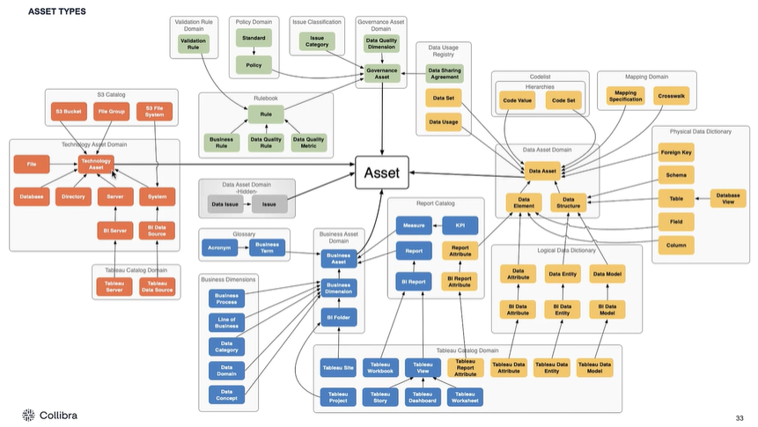

Determine asset types for ICD example

Asset and Types

|  |  |  |  |
| --- | --- | --- | --- |
| Field | Asset Type | Level 2 | Level 3 |
| Term | Business Asset | Business Term |  |
| Abbreviation | Business Asset | Business Term | Acronym |
| Versions | Business Asset | Business Term |  |
| Healthcare Systems | Technology Asset | System |  |
| Term | Business Asset | Business Term |  |
| Abbreviation | Business Asset | Business Term | Acronym |
| Required by | Governance Asset | Policy |  |
| Chapter/CCS Level 1 Category | Data Asset | Code Set |  |
| CCS Level 2 Category | Data Asset | Code Set |  |
| Diagnosis Code | Data Asset | Code Value |  |

Notes:

* If you can’t identify an appropriate OOTB asset type, you may need to create a custom asset type
* When using a custom asset type, you should identify parent asset types
* In your spreadsheets, you should add column next to each identified asset to specify its asset type

Attribute Types

Settings -> Characteristics -> Attributes

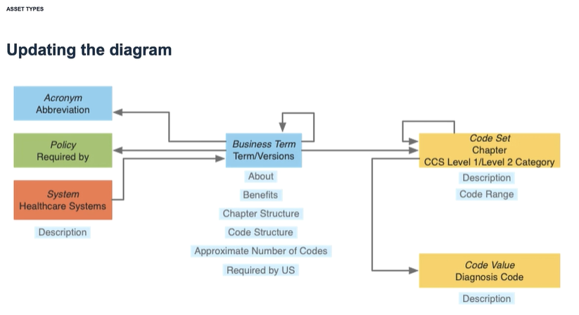

**Attribute Types**

**For each attribute, choose its attribute type**

**Strategy**

* Try to use OOTB types when possible
* Use verbalization for Object Role Modelling
* Leverage the Attribute Kinds to help identify

|  |  |  |
| --- | --- | --- |
| **Attribute kind** | **Description** | **Example** |
| Date | A date value can be selected using a date picker | 11/30/2018 |
| Multiple Selection | Multiple values can be selected form a predefined set | Monthly and Yearly |
| Number | An integer or fraction | 2, or ¾ |
| Selection | A value has to be selected from a predefined set | Confidential |
| Text | Textual input which may contain formatting. No input size limit. | This is a sample sentence. |
| True/False | True or false, yes or no, … | True |

**Choosing attributes from a predefined set**

1. **Selection Example**

We want to capture the security classification of the data in a particular column. There is only one possible choice of four classification levels.

Use an Attribute of the kind “Selection” Example values:

* Restricted
* Confidential
* Internal Only
* Public

1. Multiple selection example

We want to capture the frequency a report is published. The same report could be published weekly, on both Tuesday and Thursday.

Use an Attribute of the kind “Multiple Selection” Example values:

* Every Tuesday
* Every Thursday
* Weekly

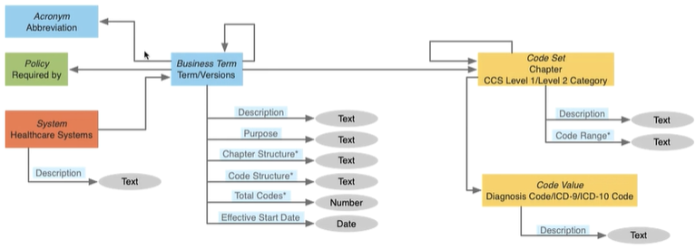

**Relation types**

**Settings -> characteristics -> relations**

**Review asset types and attribute type**

**Choosing relation types**

|  |  |
| --- | --- |
| **Verbalization strategy** | **Best practices** |
| Is the act of saying something out loud | Assets can use relation types involving their parent asset type |
| The activity of expressing something in words | Use the lowest level of the relation to avoid user mistakes |
| Can be used to determine attribute/relation types for assets | If context is misleading (role/co-role wording), create a custom relation type to help users understand the relation |
| We will use this strategy to determine relation types |  |