**Quick sight Pricing Details**:

|  |  |  |
| --- | --- | --- |
| **Type** | **Price** | **Included SPICE Capacity** |
| Annual plan | **$9 per user/month** | 10 GB per user 0.25 per GB for additional capacity |
| Monthly plan | $12 per user/month |

**Quick sight- access to s3 bucket details, how many ways to access it**:

Amazon Quick Sight can access Amazon S3 buckets in a few ways, including:

* Cross-account access

Quick Sight can access S3 buckets in other AWS accounts. This allows users to consolidate analytics and reporting from all their AWS accounts. To set up cross-account access, users can:

* 1. Update the S3 bucket policy in the other account
  2. Add the S3 bucket as a resource for the Quick Sight service role
  3. Allow the Quick Sight service role access to the AWS Key Management Service (AWS KMS) key for the S3 bucket
* Access S3 buckets linked to the Quick Sight account

Users can access S3 buckets that are linked to their Quick Sight account. To do this, users can:

* 1. Select their profile icon
  2. Select Manage Amazon Quick Sight
  3. Select Security & permissions
  4. Select Manage under Quick Sight access to AWS services
  5. Select S3 buckets
  6. Select the S3 buckets to access

Quicksight dashboard publish methods:

Use the following procedure to publish and optionally share a dashboard. You can also use this procedure to rename a published dashboard. A renamed dashboard retains its security and emailed report settings.

1. Open the analysis that you want to use. Choose **Publish**.
2. Do one of the following:
   * To create a new dashboard, choose **Publish new dashboard as**, and then type a dashboard name.
   * To replace an existing dashboard, do one of the following. Replacing a dashboard updates it without altering security or emailed report settings.
     + To update it with your changes, choose **Replace an existing dashboard** and then choose a dashboard from the list.
     + To rename it, choose **Replace an existing dashboard**, choose a dashboard from the list, and then choose **Rename**. Enter a new name to rename the existing dashboard. When you rename a dashboard, it also saves any changes you made to the analysis.

<https://docs.aws.amazon.com/quicksight/latest/user/creating-a-dashboard.html>

Postman GET method document:

Make sure you've downloaded and installed the Postman desktop app. When you're ready, open the Postman desktop app and send your first API request.

1. Select **+** in the workbench to open a new tab.
2. Enter postman-echo.com/get for the request URL.
3. Select **Send**.

Postman displays the response data sent from the server in the lower pane.

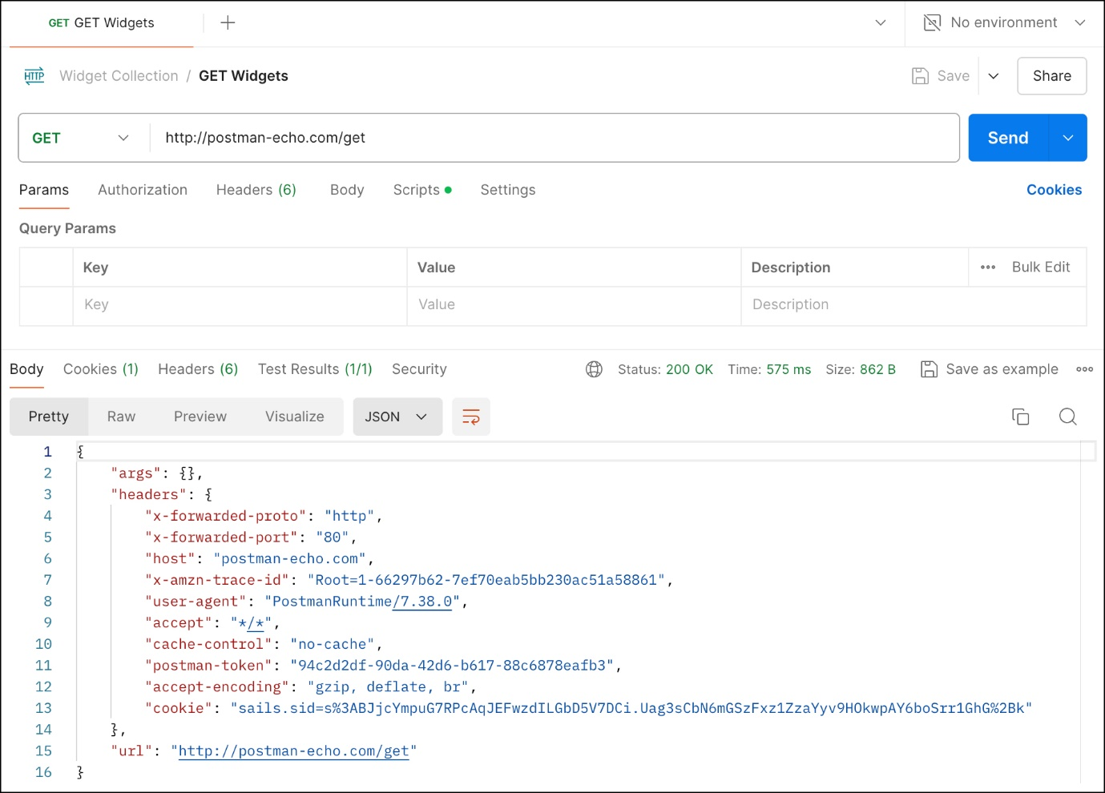

In this example, Postman is acting as the client application and is communicating with an API server. Here's what happened when you selected Send:

Postman sent a GET request to the Postman Echo API server located at postman-echo.com.

The API server received the request, processed it, and returned a response to Postman.

Postman received the response and displayed it in the Response pane.