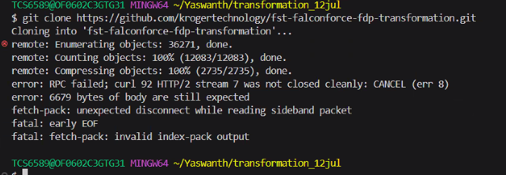

The 'RPC server is unavailable' error occurs when the Windows device is having a problem in communicating with other remote devices.

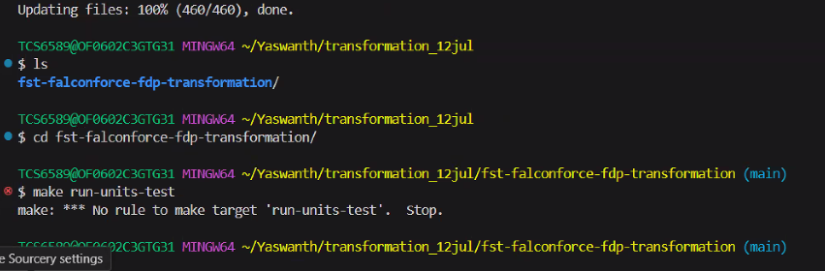

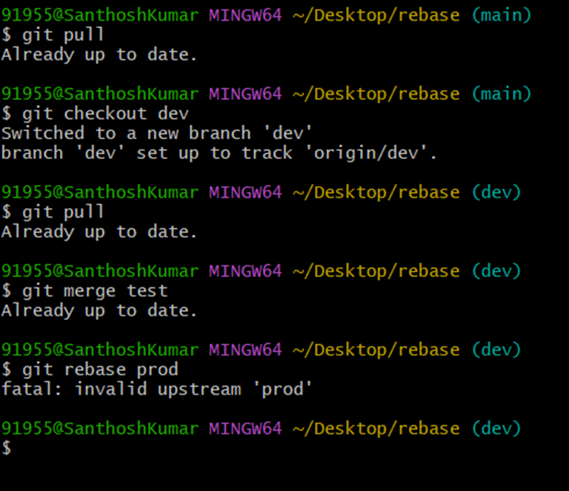

An "upstream" branch refers to the default remote branch that Git uses for reading and writing operations.

You need to checkout 'another-branch' locally before rebasing it.

git checkout -b another-branch origin/another-branch

Or, you need to pull all the branch after fetching

git pull --all

I think you have not added the remote upstream in your git yet.

run git remote add upstream https://github.com/alshedivat/al-folio.gi

I think you have not added the remote upstream in your git yet.

run git remote add upstream https://github.com/alshedivat/al-folio.git