WEBIFY

SUBMITTED BY:

* S.Laxman Vijay
* S.Durai Raj
* M.Santhosh

PROJECT GUIDE: Mr.K.Sundar

DEPARTMENT: Computer Science and Engineering

INSTITUTION: Velammal Engineering College

GUIDE SIGNATURE HOD SIGNATURE

ABSTRACT:

Webify is an IOT(Internet Of Things) project that aims to create an alternative cost effective solution to connect IOT devices to the cloud. The idea used is local tunnelling which provides the capability to the IOT device to connect online without any Internet drivers connected directly with the device. This simple alternative will save several thousands of money for large enterprises that are investing in IOT because the core of IOT (connection through internet) becomes simplified.

Existing IOT models use cloud systems like Google cloud platform, Amazon Web Services Microsoft Asure, IBM Watson, Losant for their IOT connection. These are not much reliable and providing our devices to the cloud is not reliable and may lead to monotony. Thus local tunnelling our devices and maintaining a ledger for the connected devices will be more democratic and will be a better solution and also prevents us from relying on IaaS(Infrastructure as a service ) providers like AWS. This solution is similar to torrents.Also it is estimated that by 2025, about 1 billion IOT devices will be online and the IOT enterprise business will sum up to a net total of 11 trillion dollars.( By Forbes,2015)Therefore this idea will have a bigger impact on the business economics if implemented.

# WHAT EXACTLY IS WEBIFY?

Webify is a simple and intuitive approach to achieve IOT through local tunnelling and to demonstrate the effectiveness of local tunnelling as a cost effective alternative to cloud platforms.

technology used:

software:

* node.js
* sockets connections
* local tunnelling
* software firmata
* web technologies

hardware:

* Arduino
* Relay switch
* Any physical electronical device for connecting to IOT.

The working mechanism:

* The User touches the button in the webpage.
* This triggers a socket event.
* The socket event then reaches the server where the IOT is connected.
* This propagation of signal is done through port forwarding and local tunnelling.
* The server then sends the signal to arduino.
* The arduino finally responds.
* This request response cycle continues as long as the server is tunnelled.

IOT:

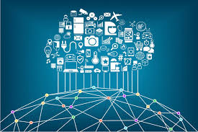

The **Internet of things** (**IoT**) is the network of physical devices, vehicles, home appliances and other items [embedded](https://en.wikipedia.org/wiki/Embedded_system) with [electronics](https://en.wikipedia.org/wiki/Electronics), [software](https://en.wikipedia.org/wiki/Software), [sensors](https://en.wikipedia.org/wiki/Sensor), [actuators](https://en.wikipedia.org/wiki/Actuator), and [network connectivity](https://en.wikipedia.org/wiki/Internet_access) which enables these objects to connect and exchange [data](https://en.wikipedia.org/wiki/Data). Each thing is uniquely identifiable through its embedded computing system but is able to inter-operate within the existing [Internet](https://en.wikipedia.org/wiki/Internet) infrastructure.

Experts estimate that the IoT will consist of about 30 billion objects by 2020. It is also estimated that the global market value of IoT will reach $7.1 trillion by 2020.

The IoT allows objects to be sensed or controlled remotely across existing network infrastructure, creating opportunities for more direct integration of the physical world into computer-based systems, and resulting in improved efficiency, accuracy and economic benefit in addition to reduced human intervention. When IoT is augmented with sensors and actuators, the technology becomes an instance of the more general class of [cyber-physical systems](https://en.wikipedia.org/wiki/Cyber-physical_system), which also encompasses technologies such as [smart grids](https://en.wikipedia.org/wiki/Smart_grid), [virtual power plants](https://en.wikipedia.org/wiki/Virtual_power_plant), [smart homes](https://en.wikipedia.org/wiki/Smart_home), [intelligent transportation](https://en.wikipedia.org/wiki/Intelligent_transportation) and [smart cities](https://en.wikipedia.org/wiki/Smart_city).

"Things", in the IoT sense, can refer to a wide variety of devices such as heart monitoring implants, [biochip](https://en.wikipedia.org/wiki/Biochip) transponders on farm animals, cameras streaming live feeds of wild animals in coastal waters, automobiles with built-in sensors, DNA analysis devices for environmental/food/pathogen monitoring, or field operation devices that assist firefighters in [search and rescue](https://en.wikipedia.org/wiki/Search_and_rescue) operations. Legal scholars suggest regarding "things" as an "inextricable mixture of hardware, software, data and service".

These devices collect useful data with the help of various existing technologies and then autonomously flow the data between other devices.

The term "the Internet of things" was coined by [Kevin Ashton](https://en.wikipedia.org/wiki/Kevin_Ashton) of [Procter & Gamble](https://en.wikipedia.org/wiki/Procter_%26_Gamble), later [MIT](https://en.wikipedia.org/wiki/Massachusetts_Institute_of_Technology)'s Auto-ID Center, in 1999.

BUSINESS INSIGHTS:

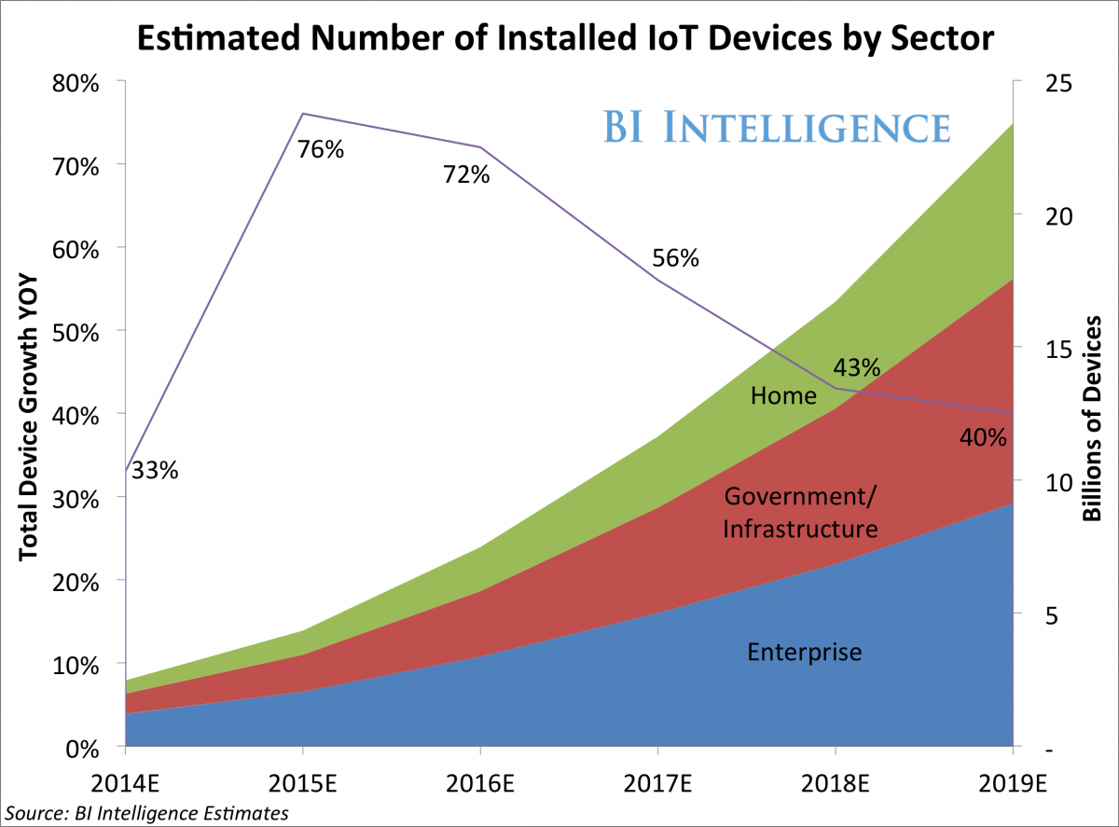

* [**The Internet of Things will be the largest device market in the world**](https://intelligence.businessinsider.com/the-internet-of-things-is-rising-examining-the-internet-of-things-2014-9?utm_source=House&utm_medium=Edit&utm_term=I-HUGEIoT-2014-10-9&utm_content=link&utm_campaign=BIIMobile)**.**We estimate that by 2019 it will be more than double the size of the smartphone, PC, tablet, connected car, and the wearable market *combined.*
* [**The IoT will result in $1.7 trillion in value added to the global economy in 2019**](https://intelligence.businessinsider.com/the-internet-of-things-is-rising-examining-the-internet-of-things-2014-9?utm_source=House&utm_medium=Edit&utm_term=I-HUGEIoT-2014-10-9&utm_content=link&utm_campaign=BIIMobile)**.**This includes hardware, software, installation costs, management services, and economic value added from realized IoT efficiencies.
* [**Device shipments will reach 6.7 billion in 2019 for a five-year CAGR of 61%**](https://intelligence.businessinsider.com/the-internet-of-things-is-rising-examining-the-internet-of-things-2014-9?utm_source=House&utm_medium=Edit&utm_term=I-HUGEIoT-2014-10-9&utm_content=link&utm_campaign=BIIMobile)**.**Revenue from hardware sales will be only $50 billion or 8% of the total revenue from IoT-specific efforts, as software makers and infrastructure companies will earn the lion's share.
* [**The enterprise sector will lead the IoT, accounting for 46% of device shipments this year**](https://intelligence.businessinsider.com/the-internet-of-things-is-rising-examining-the-internet-of-things-2014-9?utm_source=House&utm_medium=Edit&utm_term=I-HUGEIoT-2014-10-9&utm_content=link&utm_campaign=BIIMobile)**,**but that share will decline as the government and home sectors gain momentum. By 2019, government will be the leading sector for IoT device shipments.
* [**The main benefit of growth in the IoT will be increased efficiency and lower costs**](https://intelligence.businessinsider.com/the-internet-of-things-is-rising-examining-the-internet-of-things-2014-9?utm_source=House&utm_medium=Edit&utm_term=I-HUGEIoT-2014-10-9&utm_content=link&utm_campaign=BIIMobile)**.**The IoT promises increased efficiency within the home, city, and workplace by giving control to the user. However, many are hesitant to use devices as security problems are still an issue.
* [**The IoT lacks a common set of standards and technologies that would allow for compatibility and ease-of-use**](https://intelligence.businessinsider.com/the-internet-of-things-is-rising-examining-the-internet-of-things-2014-9?utm_source=House&utm_medium=Edit&utm_term=I-HUGEIoT-2014-10-9&utm_content=link&utm_campaign=BIIMobile)**.**There are currently few standards (or regulations) for what is needed to run an IoT device. Consortia that group together global industrial, tech, and electronics companies are involved in an effort to standardize the IoT and solve the most pressing security concerns.

NODE.JS:



Node.js® is a JavaScript runtime built on [Chrome's V8 JavaScript engine](https://developers.google.com/v8/). Node.js uses an event-driven, non-blocking I/O model that makes it lightweight and efficient. Node.js' package ecosystem, [npm](https://www.npmjs.com/), is the largest ecosystem of open source libraries in the world.

As an asynchronous event driven JavaScript runtime, Node is designed to build scalable network applications. In the following "hello world" example, many connections can be handled concurrently. Upon each connection the callback is fired, but if there is no work to be done, Node will sleep.

This is in contrast to today's more common concurrency model where OS threads are employed. Thread-based networking is relatively inefficient and very difficult to use. Furthermore, users of Node are free from worries of dead-locking the process, since there are no locks. Almost no function in Node directly performs I/O, so the process never blocks. Because nothing blocks, scalable systems are very reasonable to develop in Node. Just because Node is designed without threads, doesn't mean you cannot take advantage of multiple cores in your environment. Built upon that same interface is the [cluster](https://nodejs.org/api/cluster.html) module, which allows you to share sockets between processes to enable load balancing over your cores.

Socket connection

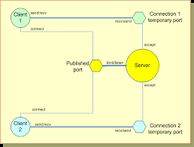

A **network socket** is an internal endpoint for sending or receiving data at a single [node](https://en.wikipedia.org/wiki/Node_(networking)) in a [computer network](https://en.wikipedia.org/wiki/Computer_network). Concretely, it is a representation of this endpoint in networking software ([protocol stack](https://en.wikipedia.org/wiki/Protocol_stack)), such as an entry in a table (listing communication protocol, destination, status, etc.), and is a form of [system resource](https://en.wikipedia.org/wiki/System_resource).

The term "socket" is analogous to physical [female connectors](https://en.wikipedia.org/wiki/Female_connector), communication between two nodes through a [channel](https://en.wikipedia.org/wiki/Channel_(communications)) being visualized as a cable with two [male connectors](https://en.wikipedia.org/wiki/Male_connector) plugging into sockets at each node. Similarly, the term "[port](https://en.wikipedia.org/wiki/Port_(computer_networking))" (another term for a female connector) is used for *external* endpoints at a node, and the term "socket" is also used for an internal endpoint of local [inter-process communication](https://en.wikipedia.org/wiki/Inter-process_communication) (IPC) (not over a network). However, the analogy is strained, as network communication need not be one-to-one or have a channel.

The distinctions between a socket (internal representation), socket descriptor (abstract identifier), and socket address (public address) are subtle, and these are not carefully distinguished in everyday usage. Further, specific definitions of a "socket" differ between authors and often refers specifically to an internet socket or TCP socket.

Software firmata

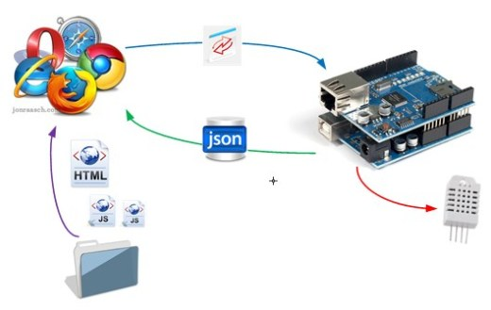

Firmata is a generic protocol for communicating with microcontrollers from software on a host computer. It is intended to work with any host computer software package. There are implementations for multiple microcontrollers and host software packages.

The **Firmata** library implements the [Firmata protocol](https://github.com/firmata/protocol" \t "_blank) for communicating with software on the host computer. This allows you to write custom firmware without having to create your own protocol and objects for the programming environment that you are using.

Web technologies:

### HTML:



**Hypertext Markup Language** (**HTML**) is the standard [markup language](https://en.wikipedia.org/wiki/Markup_language" \o "Markup language) for creating [web pages](https://en.wikipedia.org/wiki/Web_page) and [web applications](https://en.wikipedia.org/wiki/Web_application). With [Cascading Style Sheets](https://en.wikipedia.org/wiki/Cascading_Style_Sheets) (CSS) and [JavaScript](https://en.wikipedia.org/wiki/JavaScript) it forms a triad of cornerstone technologies for the [World Wide Web](https://en.wikipedia.org/wiki/World_Wide_Web).[[3]](https://en.wikipedia.org/wiki/HTML#cite_note-3) [Web browsers](https://en.wikipedia.org/wiki/Web_browser) receive HTML documents from a [web server](https://en.wikipedia.org/wiki/Web_server) or from local storage and render them into multimedia web pages. HTML describes the structure of a web page [semantically](https://en.wikipedia.org/wiki/Semantic_Web) and originally included cues for the appearance of the document.

[HTML elements](https://en.wikipedia.org/wiki/HTML_element) are the building blocks of HTML pages. With HTML constructs, [images](https://en.wikipedia.org/wiki/HTML_element#Images_and_objects) and other objects, such as [interactive forms,](https://en.wikipedia.org/wiki/Fieldset)may be embedded into the rendered page. It provides a means to create [structured documents](https://en.wikipedia.org/wiki/Structured_document) by denoting structural [semantics](https://en.wikipedia.org/wiki/Semantics) for text such as headings, paragraphs, lists, [links](https://en.wikipedia.org/wiki/Hyperlink), quotes and other items. HTML elements are delineated by *tags*, written using [angle brackets](https://en.wikipedia.org/wiki/Bracket#Angle_brackets). Tags such as <img /> and <input /> introduce content into the page directly. Others such as <p>...</p> surround and provide information about document text and may include other tags as sub-elements. Browsers do not display the HTML tags, but use them to interpret the content of the page.

HTML can embed programs written in a [scripting language](https://en.wikipedia.org/wiki/Scripting_language) such as [JavaScript](https://en.wikipedia.org/wiki/JavaScript) which affect the behavior and content of web pages. Inclusion of CSS defines the look and layout of content. The [World Wide Web Consortium](https://en.wikipedia.org/wiki/World_Wide_Web_Consortium) (W3C), maintainer of both the HTML and the CSS standards, has encouraged the use of CSS over explicit presentational HTML since 1997.[[4]](https://en.wikipedia.org/wiki/HTML#cite_note-deprecated-4)

### Css:



**Cascading Style Sheets** (**CSS**) is a [style sheet language](https://en.wikipedia.org/wiki/Style_sheet_language) used for describing the [presentation](https://en.wikipedia.org/wiki/Presentation_semantics) of a document written in a [markup language](https://en.wikipedia.org/wiki/Markup_language" \o "Markup language).[[1]](https://en.wikipedia.org/wiki/Cascading_Style_Sheets#cite_note-1) Although most often used to set the visual style of [web pages](https://en.wikipedia.org/wiki/Web_page) and user interfaces written in [HTML](https://en.wikipedia.org/wiki/HTML) and [XHTML](https://en.wikipedia.org/wiki/XHTML), the language can be applied to any [XML](https://en.wikipedia.org/wiki/XML) document, including [plain XML](https://en.wikipedia.org/wiki/Plain_Old_XML), [SVG](https://en.wikipedia.org/wiki/Scalable_Vector_Graphics) and [XUL](https://en.wikipedia.org/wiki/XUL), and is applicable to rendering in [speech](https://en.wikipedia.org/wiki/Speech_synthesis), or on other media. Along with HTML and [JavaScript](https://en.wikipedia.org/wiki/JavaScript), CSS is a cornerstone technology used by most websites to create visually engaging webpages, user interfaces for [web applications](https://en.wikipedia.org/wiki/Web_applications), and user interfaces for many mobile applications.[[2]](https://en.wikipedia.org/wiki/Cascading_Style_Sheets#cite_note-2)

CSS is designed primarily to enable the separation of presentation and content, including aspects such as the [layout](https://en.wikipedia.org/wiki/Page_layout), [colors](https://en.wikipedia.org/wiki/Color" \o "Color), and [fonts](https://en.wikipedia.org/wiki/Typeface).[[3]](https://en.wikipedia.org/wiki/Cascading_Style_Sheets#cite_note-3) This separation can improve content [accessibility](https://en.wikipedia.org/wiki/Accessibility), provide more flexibility and control in the specification of presentation characteristics, enable multiple HTML pages to share formatting by specifying the relevant CSS in a separate .css file, and reduce complexity and repetition in the structural content.

### Javascript:



**JavaScript** often abbreviated as **JS**, is a [high-level](https://en.wikipedia.org/wiki/High-level_programming_language), [dynamic](https://en.wikipedia.org/wiki/Dynamic_programming_language), [weakly typed](https://en.wikipedia.org/wiki/Weak_typing), [prototype-based](https://en.wikipedia.org/wiki/Prototype-based_programming), [multi-paradigm](https://en.wikipedia.org/wiki/Multi-paradigm_programming_language), and [interpreted](https://en.wikipedia.org/wiki/Interpreted_language) [programming language](https://en.wikipedia.org/wiki/Programming_language). Alongside [HTML](https://en.wikipedia.org/wiki/HTML) and [CSS](https://en.wikipedia.org/wiki/CSS), JavaScript is one of the three core technologies of [World Wide Web](https://en.wikipedia.org/wiki/World_Wide_Web)[content production](https://en.wikipedia.org/wiki/Content_engineering). It is used to make webpages interactive and provide online programs, including video games. The majority of [websites](https://en.wikipedia.org/wiki/Website) employ it, and all modern [web browsers](https://en.wikipedia.org/wiki/Web_browser) support it without the need for [plug-ins](https://en.wikipedia.org/wiki/Browser_extension) by means of a built-in [JavaScript engine](https://en.wikipedia.org/wiki/JavaScript_engine). Each of the many JavaScript engines represent a different implementation of JavaScript, all based on the [ECMAScript](https://en.wikipedia.org/wiki/ECMAScript" \o "ECMAScript) specification, with some engines not supporting the spec fully, and with many engines supporting additional features beyond ECMA.

As a multi-paradigm language, JavaScript supports [event-driven](https://en.wikipedia.org/wiki/Event-driven_programming), [functional](https://en.wikipedia.org/wiki/Functional_programming), and [imperative](https://en.wikipedia.org/wiki/Imperative_programming) (including [object-oriented](https://en.wikipedia.org/wiki/Object-oriented_programming) and [prototype-based](https://en.wikipedia.org/wiki/Prototype-based_programming)) [programming styles](https://en.wikipedia.org/wiki/Programming_paradigm). It has an [API](https://en.wikipedia.org/wiki/Application_programming_interface) for working with text, [arrays](https://en.wikipedia.org/wiki/Array_data_type), dates, [regular expressions](https://en.wikipedia.org/wiki/Regular_expression), and basic manipulation of the [DOM](https://en.wikipedia.org/wiki/Document_Object_Model), but the language itself does not include any [I/O](https://en.wikipedia.org/wiki/Input/output), such as networking, storage, or graphics facilities, relying for these upon the host environment in which it is embedded.

### Jquery:



**jQuery** is a [cross-platform](https://en.wikipedia.org/wiki/Cross-platform) [JavaScript library](https://en.wikipedia.org/wiki/JavaScript_library) designed to simplify the [client-side scripting](https://en.wikipedia.org/wiki/Client-side_scripting) of [HTML](https://en.wikipedia.org/wiki/HTML).[[3]](https://en.wikipedia.org/wiki/JQuery#cite_note-jquery.com-3) It is [free, open-source software](https://en.wikipedia.org/wiki/Free_and_open_source_software) using the permissive [MIT License](https://en.wikipedia.org/wiki/MIT_License).[[2]](https://en.wikipedia.org/wiki/JQuery#cite_note-jqorg-license-2) [Web](https://en.wikipedia.org/wiki/World_Wide_Web) analysis indicates that it is the most widely deployed JavaScript library by a large margin.[[4]](https://en.wikipedia.org/wiki/JQuery#cite_note-4)[[5]](https://en.wikipedia.org/wiki/JQuery#cite_note-libscore.com-5)

jQuery's syntax is designed to make it easier to navigate a document, select [DOM](https://en.wikipedia.org/wiki/Document_Object_Model) elements, create [animations](https://en.wikipedia.org/wiki/Animation), handle [events](https://en.wikipedia.org/wiki/Event_(computing)), and develop [Ajax](https://en.wikipedia.org/wiki/Ajax_(programming)) applications. jQuery also

provides capabilities for developers to create [plug-ins](https://en.wikipedia.org/wiki/Plug-in_(computing)) on top of the JavaScript library. This enables developers to

create [abstractions](https://en.wikipedia.org/wiki/Abstraction_(computer_science)) for low-level interaction and animation, advanced effects and high-level, themeable widgets. The modular approach to the jQuery library allows the creation of powerful [dynamic web pages](https://en.wikipedia.org/wiki/Dynamic_web_page) and Web applications.

##### Local tunnelling:

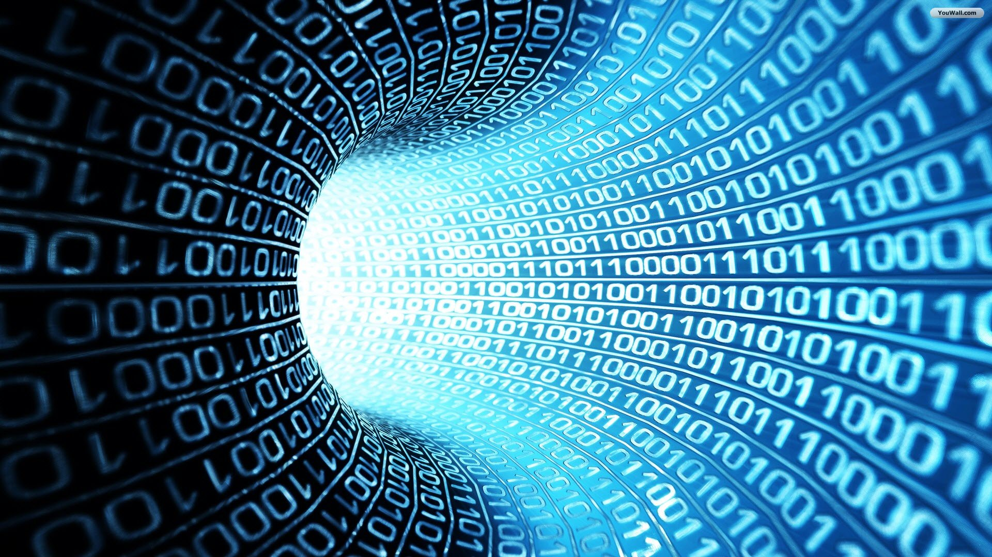

In [computer networking](https://en.wikipedia.org/wiki/Computer_networking), **port forwarding** or **port mapping** is an application of [network address translation](https://en.wikipedia.org/wiki/Network_address_translation) (NAT) that redirects a communication request from one [address](https://en.wikipedia.org/wiki/IP_address) and [port number](https://en.wikipedia.org/wiki/Port_number) combination to another while the [packets](https://en.wikipedia.org/wiki/Network_packet) are traversing a network gateway, such as a [router](https://en.wikipedia.org/wiki/Router_(computing)) or [firewall](https://en.wikipedia.org/wiki/Firewall_(computing)). This technique is most commonly used to make services on a host residing on a protected or [masqueraded](https://en.wikipedia.org/wiki/IP_masquerading) (internal) network available to hosts

on the opposite side of the gateway (external network), by remapping the destination IP address and port number of the communication to an internal host

localtunnel exposes your localhost to the world.

Arduino:

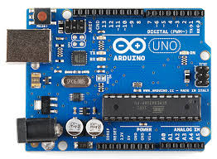

**Arduino** is an open source computer hardware and software company, project, and user community that designs and manufactures [single-board microcontrollers](https://en.wikipedia.org/wiki/Single-board_microcontroller) and [microcontroller](https://en.wikipedia.org/wiki/Microcontroller) kits for building digital devices and interactive objects that can sense and control objects in the physical world. The project's products are distributed as [open-source hardware](https://en.wikipedia.org/wiki/Open-source_hardware) and [software](https://en.wikipedia.org/wiki/Open-source_software), which are licensed under the [GNU Lesser General Public License](https://en.wikipedia.org/wiki/GNU_Lesser_General_Public_License) (LGPL) or the [GNU General Public License](https://en.wikipedia.org/wiki/GNU_General_Public_License) (GPL),[[1]](https://en.wikipedia.org/wiki/Arduino#cite_note-1) permitting the manufacture of Arduino boards and software distribution by anyone. Arduino boards are available commercially in preassembled form, or as [do-it-yourself](https://en.wikipedia.org/wiki/Do-it-yourself) (DIY) kits.

Arduino board designs use a variety of microprocessors and controllers. The boards are equipped with sets of digital and analog [input/output](https://en.wikipedia.org/wiki/Input/output) (I/O) pins that may be interfaced to various expansion boards (*shields*) and other circuits. The boards feature serial communications interfaces, including [Universal Serial Bus](https://en.wikipedia.org/wiki/Universal_Serial_Bus) (USB) on some models, which are also used for loading programs from personal computers. The microcontrollers are typically programmed using a dialect of features from the programming languages [C](https://en.wikipedia.org/wiki/C_(programming_language)) and [C++](https://en.wikipedia.org/wiki/C%2B%2B). In addition to using traditional compiler toolchains, the Arduino project provides an [integrated development environment](https://en.wikipedia.org/wiki/Integrated_development_environment) (IDE) based on the [Processing](https://en.wikipedia.org/wiki/Processing_(programming_language)) language project.

Relay switch:

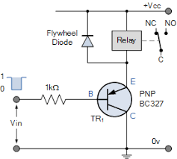

A **relay** is an [electrically](https://en.wikipedia.org/wiki/Electric) operated [switch](https://en.wikipedia.org/wiki/Switch). Many relays use an [electromagnet](https://en.wikipedia.org/wiki/Electromagnet) to mechanically operate a switch, but other operating principles are also used, such as [solid-state relays](https://en.wikipedia.org/wiki/Solid-state_relay). Relays are used where it is necessary to control a circuit by a separate low-power signal, or where several circuits must be controlled by one signal. The first relays were used in long distance [telegraph](https://en.wikipedia.org/wiki/Electrical_telegraph) circuits as amplifiers: they repeated the signal coming in from one circuit and re-transmitted it on another circuit. Relays were used extensively in telephone exchanges and early computers to perform logical operations.

A type of relay that can handle the high power required to directly control an electric motor or other loads is called a [contactor](https://en.wikipedia.org/wiki/Contactor" \o "Contactor). [Solid-state relays](https://en.wikipedia.org/wiki/Solid-state_relay)control power circuits with no [moving parts](https://en.wikipedia.org/wiki/Moving_parts), instead using a semiconductor device to perform switching. Relays with calibrated operating characteristics and sometimes multiple operating coils are used to protect electrical circuits from overload or faults; in modern electric power systems these functions are performed by digital instruments still called "[protective relays](https://en.wikipedia.org/wiki/Protective_relay)".

Magnetic latching relays require one pulse of coil power to move their contacts in one direction, and another, redirected pulse to move them back. Repeated pulses from the same input have no effect. Magnetic latching relays are useful in applications where interrupted power should not be able to transition the contacts.

The coding:

Front End:

|  |
| --- |
|  |
|  | <html lang="en"> |
|  | <head> |
|  | <meta charset="UTF-8"> |
|  | <meta name="viewport" content="width=device-width, initial-scale=1.0"> |
|  | <meta http-equiv="X-UA-Compatible" content="ie=edge"> |
|  | <link rel="stylesheet" href="https://www.w3schools.com/w3css/4/w3.css"> |
|  | <script src="https://ajax.googleapis.com/ajax/libs/jquery/3.2.1/jquery.min.js"></script> |
|  | <script src="https://cdnjs.cloudflare.com/ajax/libs/socket.io/2.0.3/socket.io.js"></script> |
|  |  |
|  |  |
|  | <title>Document</title> |
|  | </head> |
|  | <body> |
|  |  |
|  | <button id="on\_button" class="w3-button w3-teal">Turn on the light</button> |
|  | <button id="off\_button" class="w3-button w3-red">Turn off the light</button> |
|  |  |
|  | <script> |
|  | var socket=io.connect(); |
|  |  |
|  | $('#on\_button').click(()=>{ |
|  | socket.emit('on'); |
|  |  |
|  | }) |
|  |  |
|  |  |
|  | $('#off\_button').click(()=>{ |
|  | socket.emit('off'); |
|  | }) |
|  |  |
|  |  |
|  |  |
|  |  |
|  | </script> |
|  | </body> |
|  | </html> |

Client.js

|  |
| --- |
|  |
| socket=io.connect(); |
|  |  |
|  | $('#on\_button').click(()=>{ |
|  | alert("on"); |
|  | socket.emit('on'); |
|  |  |
|  | }) |
|  |  |
|  |  |
|  | $('#off\_button').click(()=>{ |
|  | socket.emit('off'); |
|  | }) |
|  |  |

Server.js

|  |
| --- |
| var socket=require('socket.io') |
|  | var express=require('express') |
|  | var app=express() |
|  | var port=3000 |
|  | var five = require('johnny-five'); |
|  | var board = new five.Board(); |
|  | var led; |
|  |  |
|  | board.on('ready', function() { |
|  | led = new five.Led(8); // pin 13 |
|  | led.off() |
|  | console.log("connected with arduino") |
|  | }); |
|  |  |
|  | var server=app.listen(port,()=>{ |
|  | console.log("running on "+port) |
|  | }) |
|  |  |
|  |  |
|  | app.get("/",(req,res)=>{ |
|  | res.sendFile(\_\_dirname+"/index.html") |
|  | }) |
|  |  |
|  |  |
|  | var io=socket(server); |
|  |  |
|  | io.on('connection',(socket)=>{ |
|  | console.log("client connected") |
|  |  |
|  | socket.on('on',()=>{ |
|  | led.on() |
|  | }) |
|  |  |
|  | socket.on('off',()=>{ |
|  | led.off() |
|  | }) |
|  |  |
|  | socket.on('disconnect',()=>{ |
|  | console.log("client disconnected") |
|  | }) |
|  |  |
|  | }) |

References:

* Wikipedia
* Business Insider
* Youtube
* W3Schools
* Stack Overflow
* Quora
* Github
* Npm

The end