MA374 Lab 1 Report

- Santhosh Reddy Banda

140123010

Q1)

The option values at t = 0 for corresponding M values are :

|  |  |  |
| --- | --- | --- |
| M value | Call option value | Put option value |
| 1 | 2.463367 | 1.816069 |
| 5 | 2.183245 | 1.535947 |
| 10 | 2.124835 | 1.477538 |
| 20 | 2.129583 | 1.482285 |
| 50 | 2.127215 | 1.479917 |
| 100 | 2.123667 | 1.476369 |
| 200 | 2.120209 | 1.472912 |
| 400 | 2.120065 | 1.472767 |

Q2)

As M increases, the value of the option decreases.

The value of call option is converging to 2.120065 as M increases from 1 to 400

The value of put option is converging to 1.472767 as M increases from 1 to 400

Plot of call option value at t = 0 obtained by varying M through 1-400 in steps of 1 is

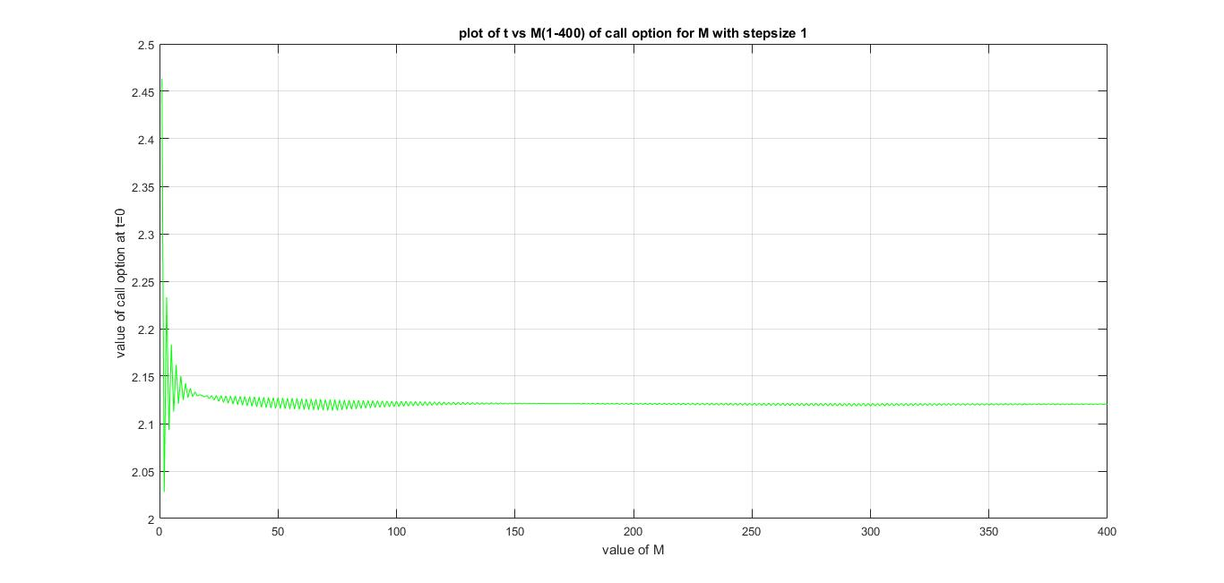

Plot of put option value at t = 0 obtained by varying M through 1-400 in steps of 1 is

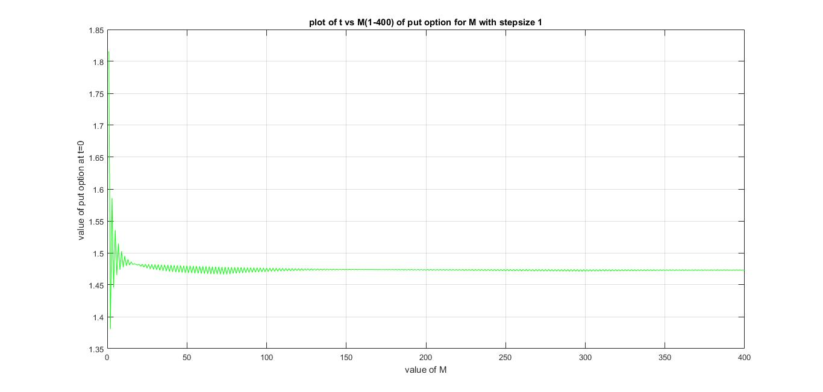

Plot of call option value at t = 0 obtained by varying M through 1-400 in steps of 5 is

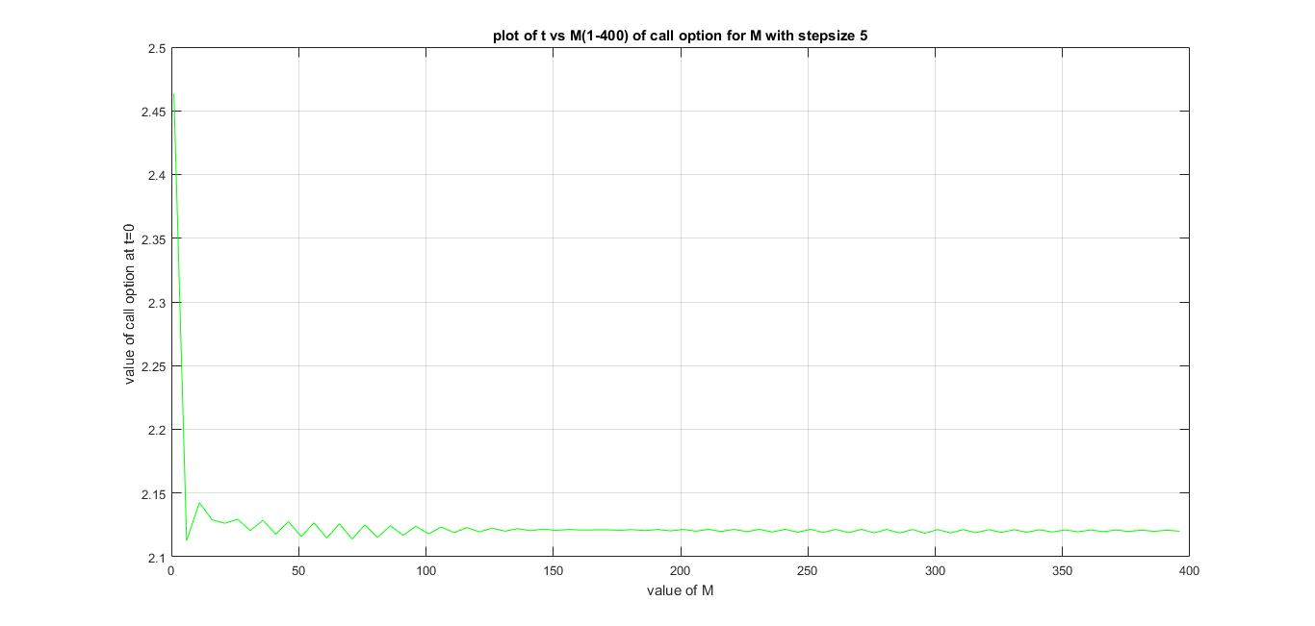

Plot of put option value at t = 0 obtained by varying M through 1-400 in steps of 5 is

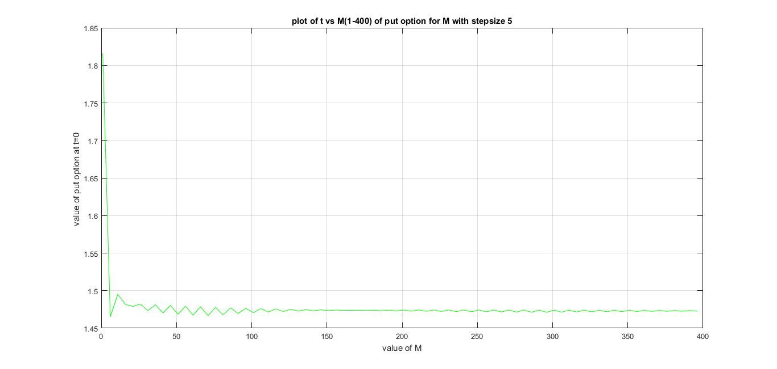

Q3)

Call option value at M = 20 for various t values are

|  |  |  |  |  |
| --- | --- | --- | --- | --- |
| t = 0 | t = 0.3 | t = 0.75 | t = 1.50 | t = 2.70 |
| 2.1296 | 3.7248 | 7.7407 | 20.2796 | 66.0571 |
|  | 1.9992 | 4.6752 | 14.1865 | 50.3233 |
|  | 0.9492 | 2.5443 | 9.3937 | 37.8520 |
|  |  | 1.2110 | 5.7170 | 27.9667 |
|  |  | 0.4877 | 3.0718 | 20.1311 |
|  |  | 0.1600 | 1.3855 | 13.9203 |
|  |  |  | 0.4934 | 8.9973 |
|  |  |  | 0.1279 | 5.0951 |
|  |  |  | 0.0212 | 2.1458 |
|  |  |  | 0.0017 | 0.4610 |
|  |  |  | 0 | 0 |
|  |  |  |  | 0 |
|  |  |  |  | 0 |
|  |  |  |  | 0 |
|  |  |  |  | 0 |
|  |  |  |  | 0 |
|  |  |  |  | 0 |
|  |  |  |  | 0 |
|  |  |  |  | 0 |

Put option value for M = 20 for various t values are

|  |  |  |  |  |
| --- | --- | --- | --- | --- |
| t = 0 | t = 0.30 | t = 0.75 | t = 1.50 | t = 2.70 |
| 1.4823 | 0.8236 | 0.2062 | 0.0005 | 0 |
|  | 1.4630 | 0.5147 | 0.0075 | 0 |
|  | 2.2877 | 1.0582 | 0.0498 | 0 |
|  |  | 1.8448 | 0.2057 | 0 |
|  |  | 2.8018 | 0.5983 | 0 |
|  |  | 3.8059 | 1.3200 | 0 |
|  |  |  | 2.3366 | 0 |
|  |  |  | 3.4840 | 0 |
|  |  |  | 4.5765 | 0.1438 |
|  |  |  | 5.5074 | 0.9106 |
|  |  |  | 6.2592 | 2.3929 |
|  |  |  |  | 3.9333 |
|  |  |  |  | 5.1543 |
|  |  |  |  | 6.1221 |
|  |  |  |  | 6.8892 |
|  |  |  |  | 7.4972 |
|  |  |  |  | 7.9792 |
|  |  |  |  | 8.3612 |
|  |  |  |  | 8.6641 |