MA374 lab 2 report

Santhosh Reddy Banda

140123010

Q1)

The initial call option value for the u, d set 1 is : 12.085380

The initial put option value for the u, d set 1 is : 4.397015

The initial call option value for the u, d set 2 is : 12.123047

The initial put option value for the u, d set 2 is : 4.434682

U, d set 1 plots :

Plot of call and put option values at t = 0 obtained by changing S(0) value from 50 – 150 is

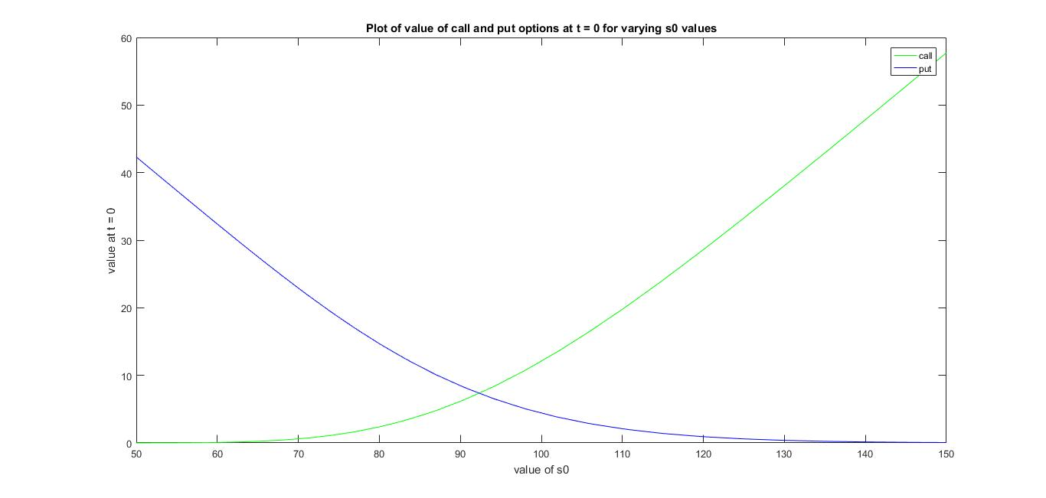

Plot of call and put option values at t = 0 obtained by varying K value from 50 – 150 is

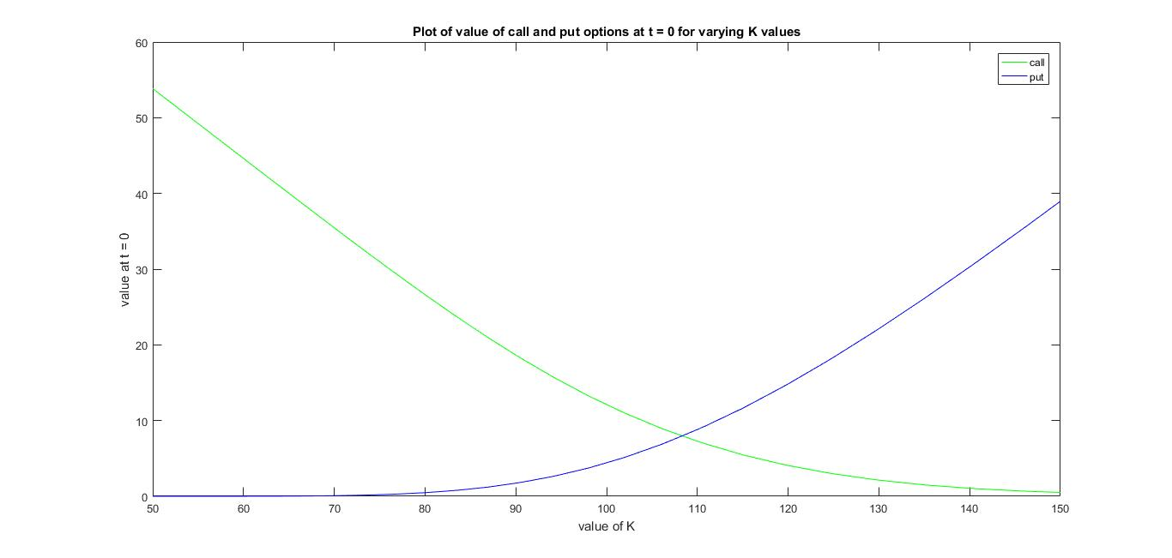

Plot of call and put option values at t = 0 obtained by changing r from 0.01 – 0.16 is

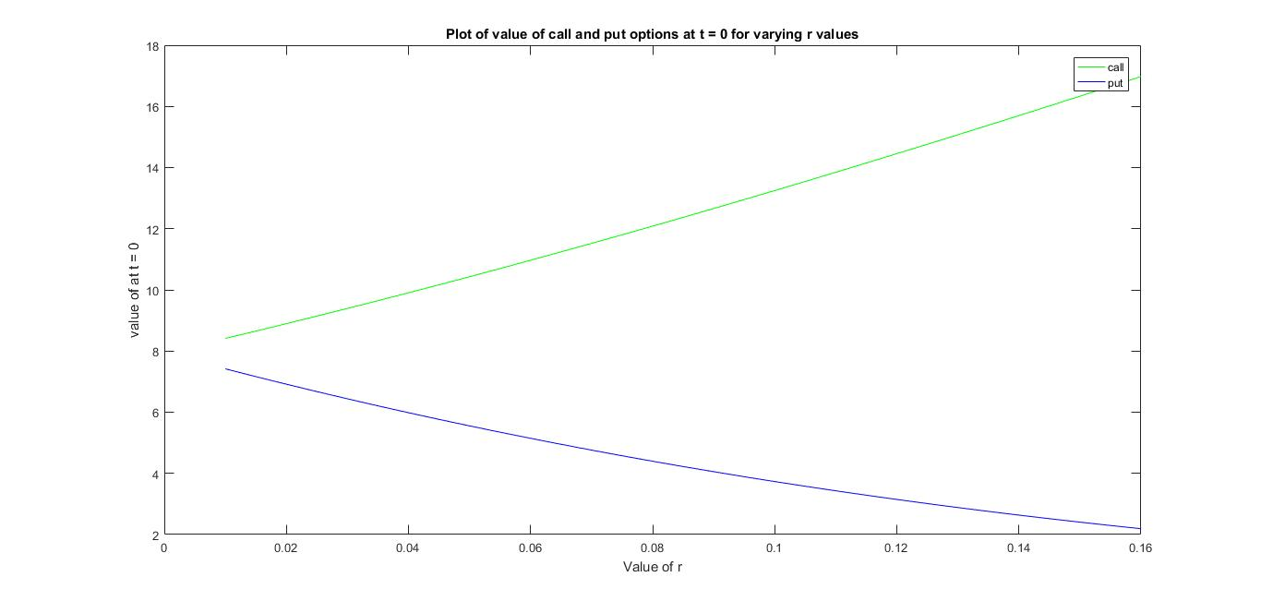

Plot of call and put option values at t = 0 obtained by changing sigma from 0.1 – 0.3 is

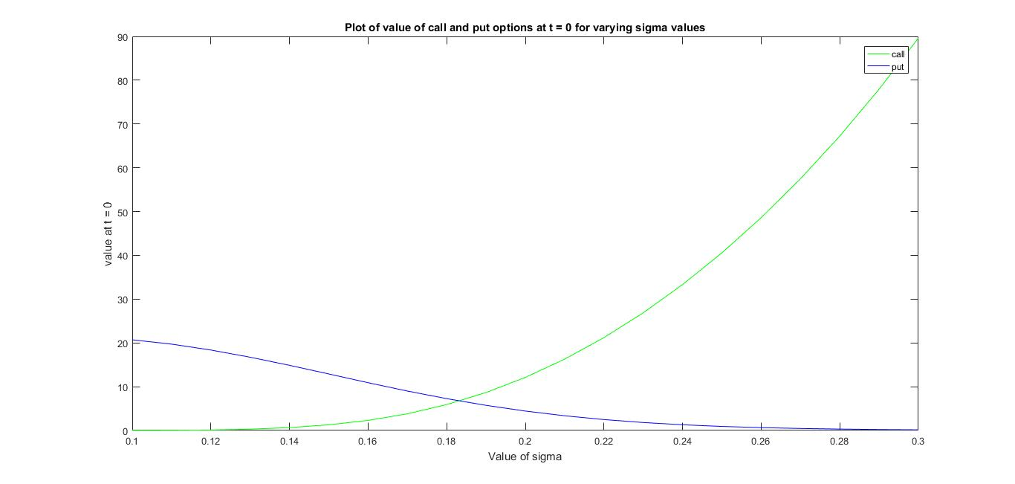

Plot of call option values at t = 0 obtained by changing M from 50 – 150 for K = 95 is

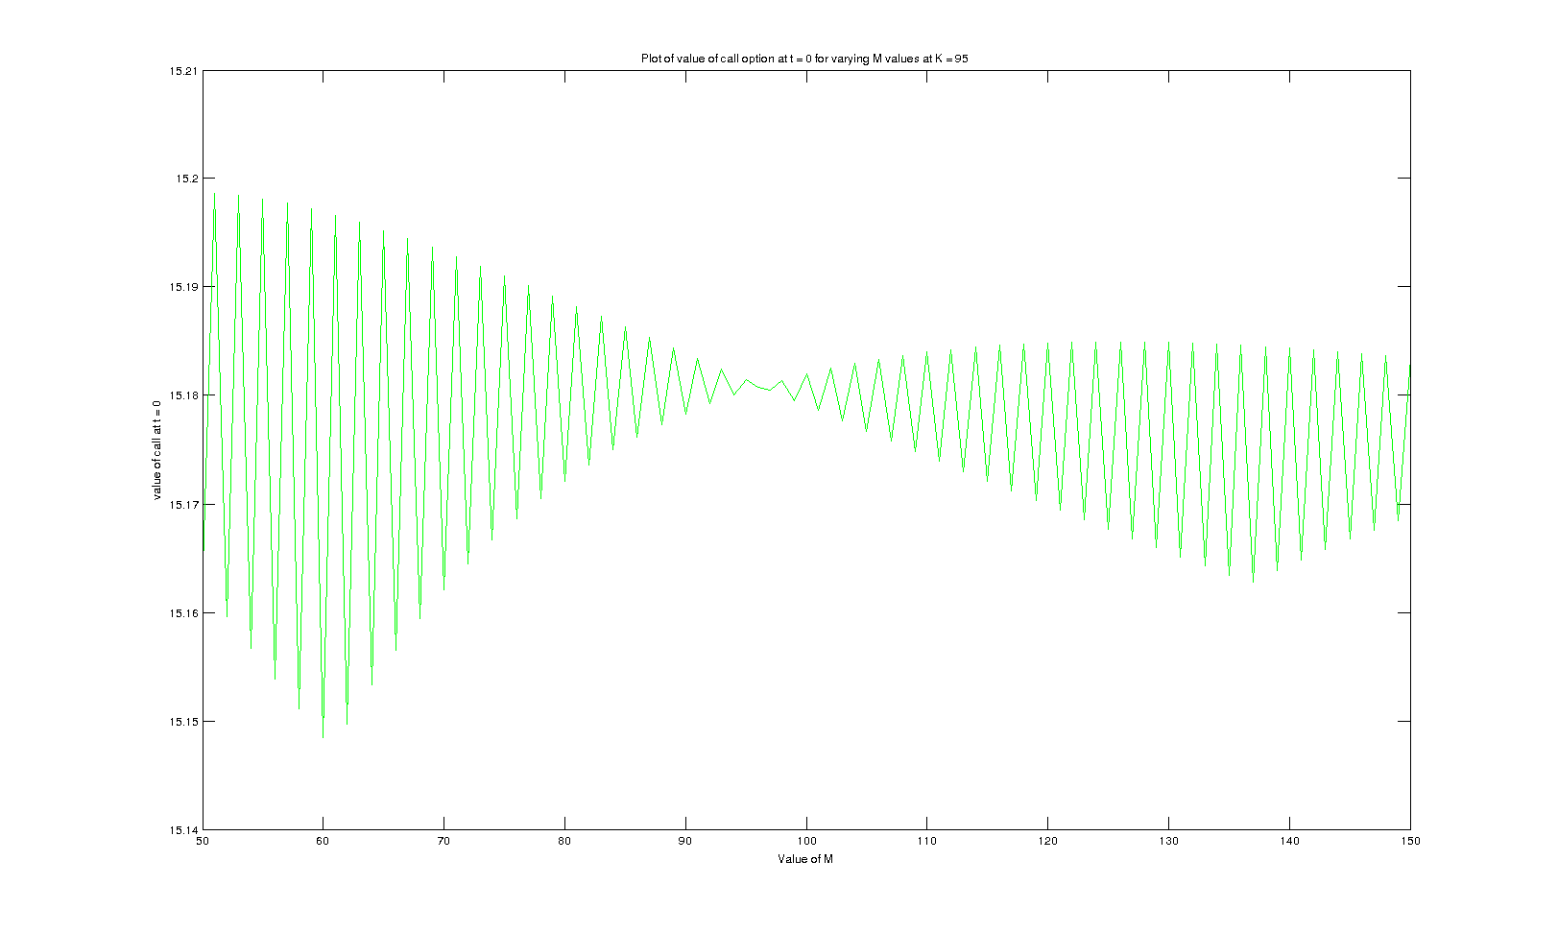

Plot of put option values at t = 0 obtained by changing M from 50 – 150 for K = 95 is

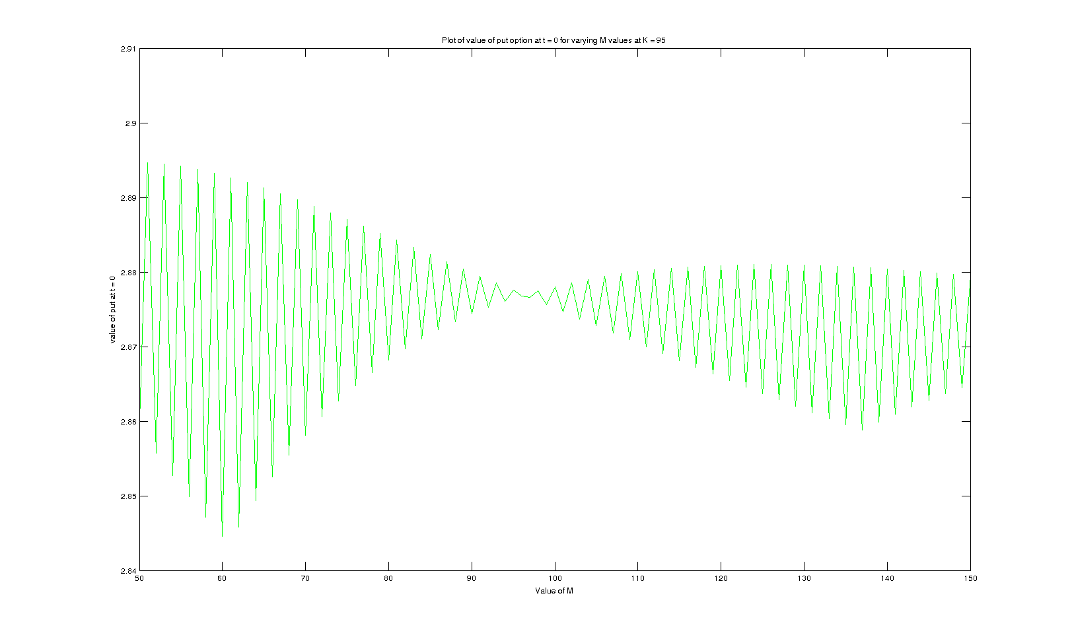

Plot of call option values at t = 0 obtained by changing M from 50 – 150 for K = 100 is

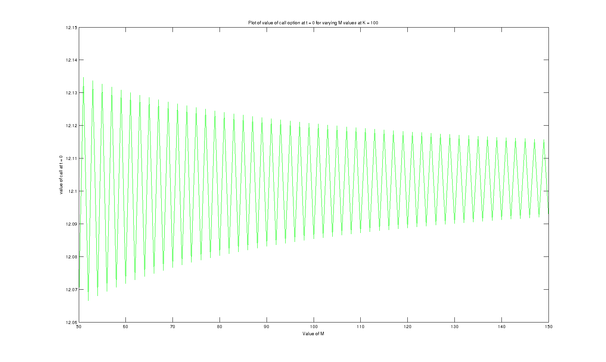

Plot of put option values at t = 0 obtained by changing M from 50 - 150 for K = 100 is

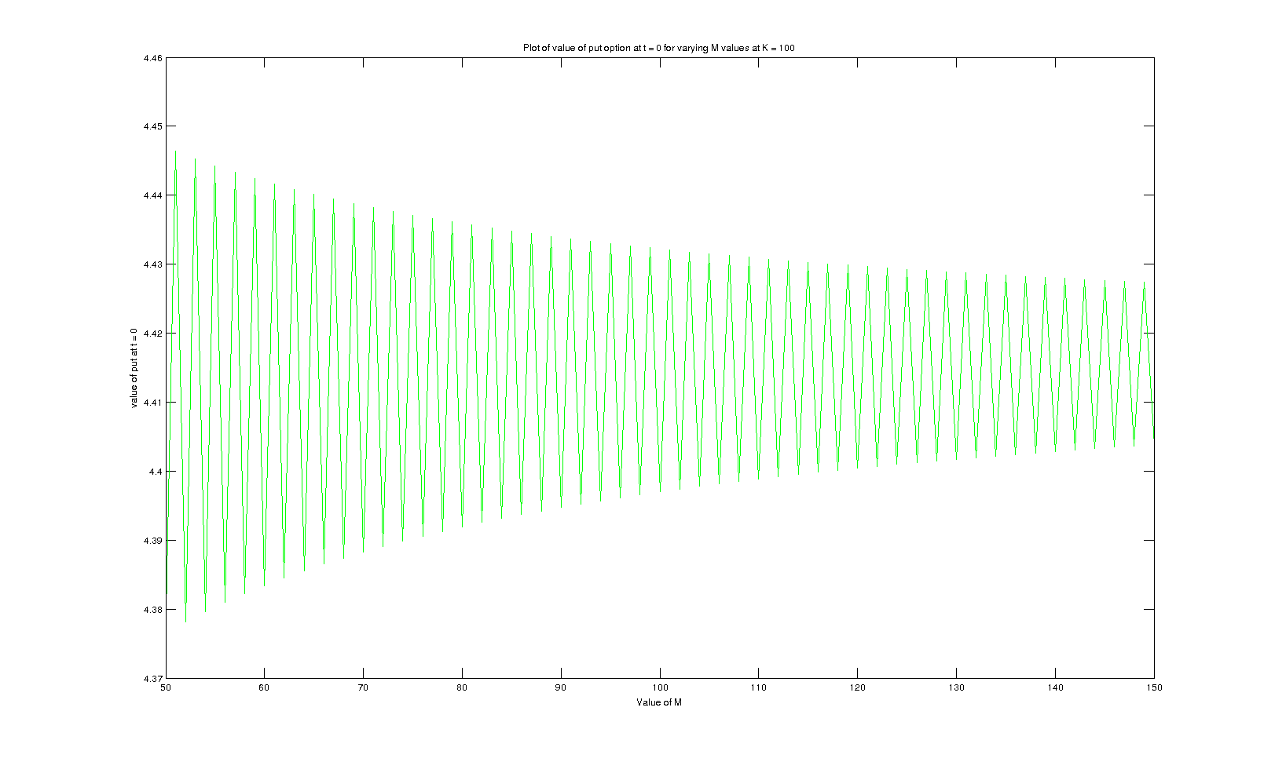

Plot of call option values at t = 0 obtained by changing M from 50 – 150 for K = 105 is

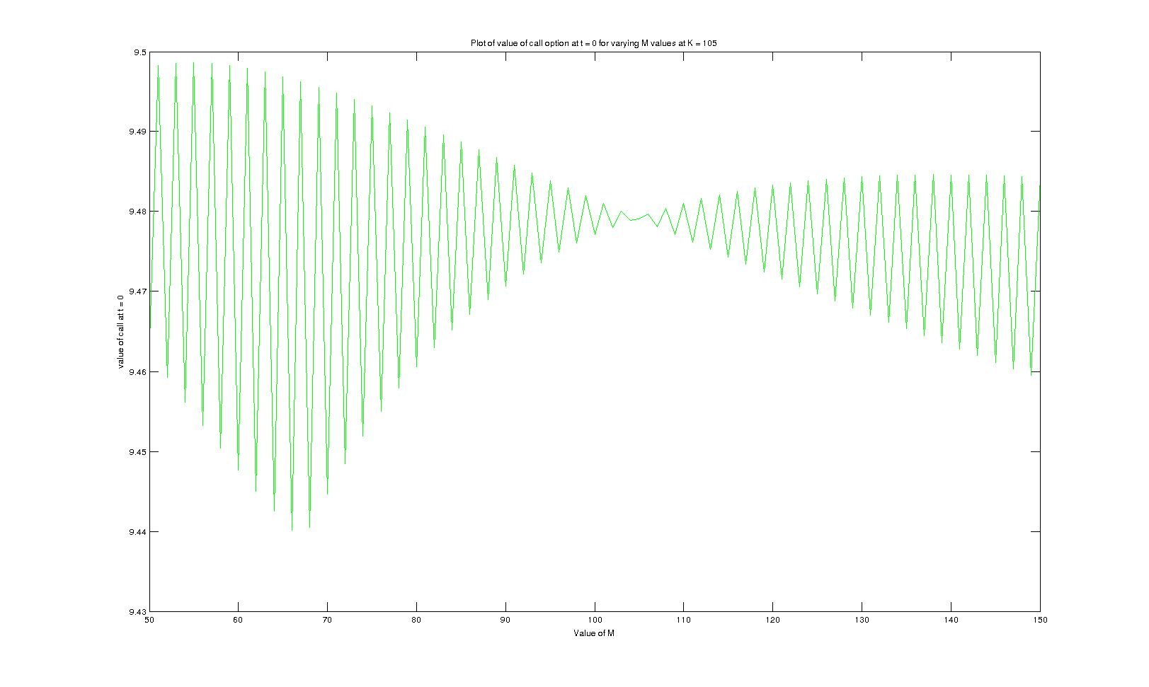

Plot of put option values at t = 0 obtained by changing M from 50 – 150 for K = 105 is

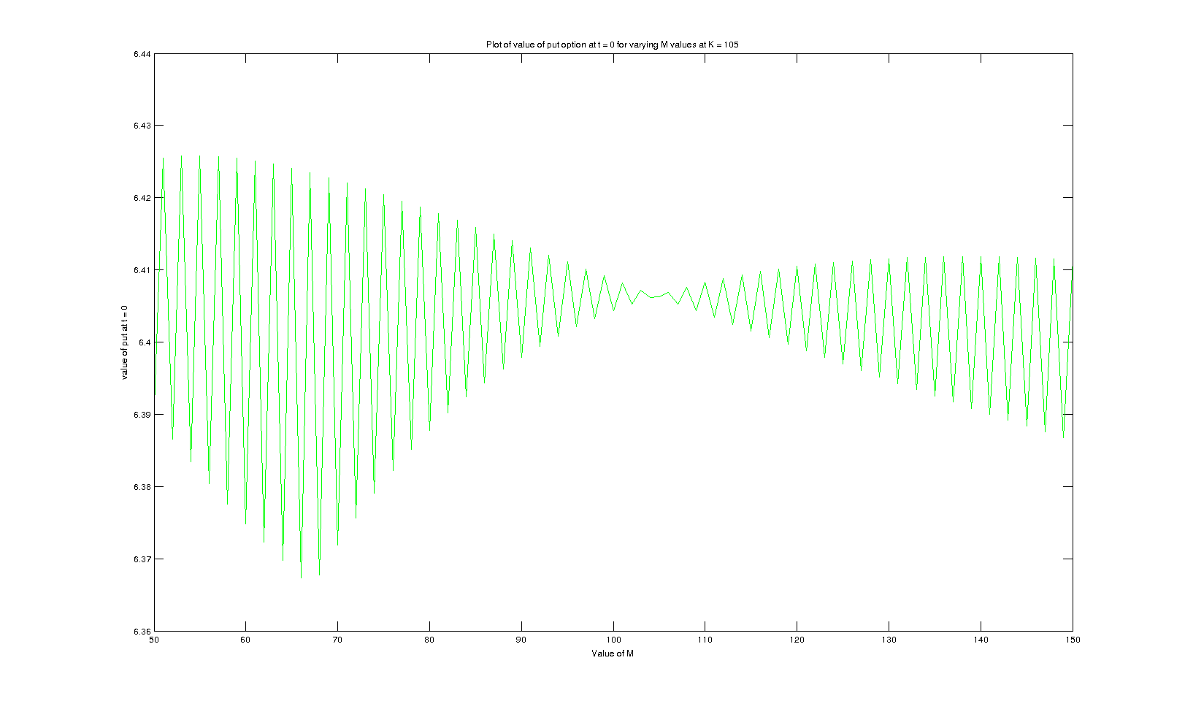

U, d set 2 plots :

Plot of call and put option values at t = 0 obtained by changing S(0) from 50 – 150 is

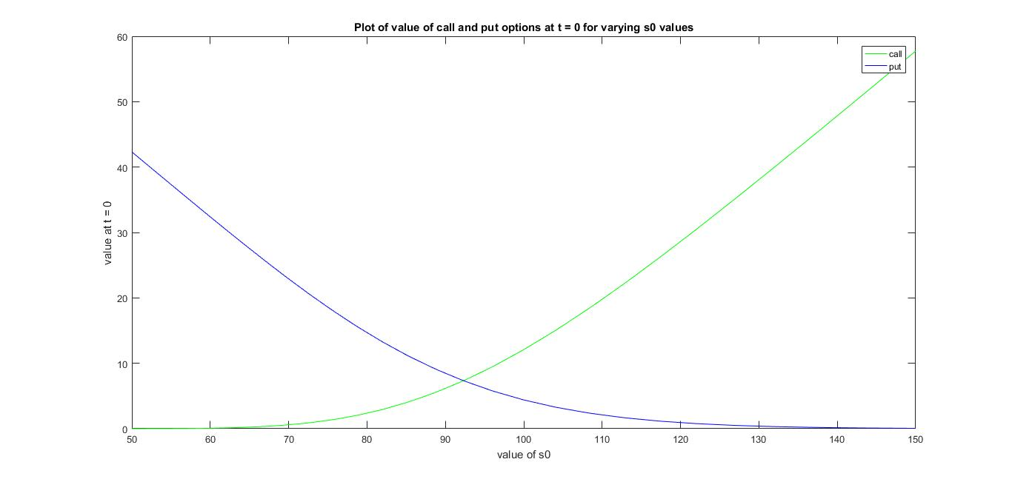

Plot of call and put option values at t = 0 obtained by changing K from 50 – 150 is

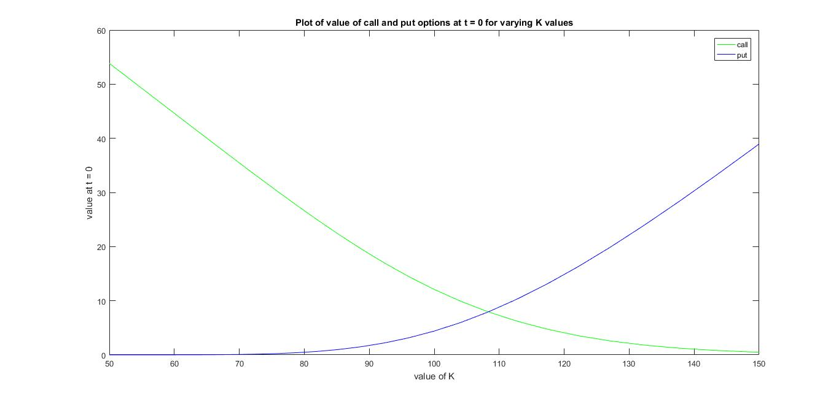

Plot of call and put option values at t = 0 obtained by changing r from 0.01 – 0.16 is

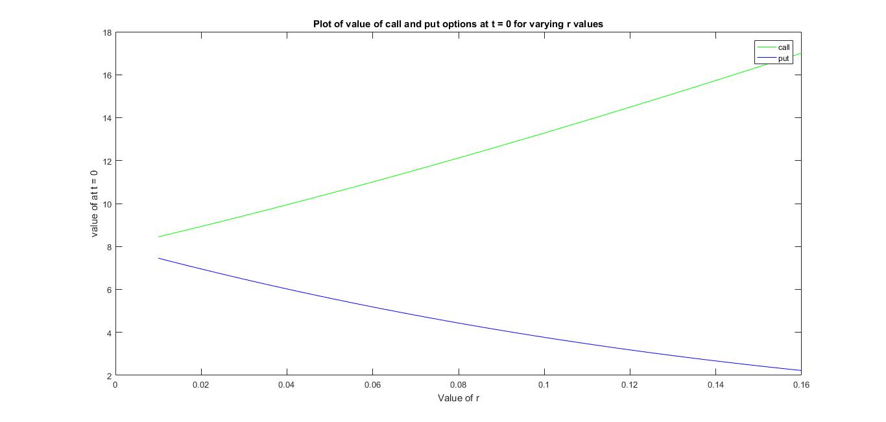

Plot of call and put option values at t = 0 obtained by changing sigma from 0.1 – 0.3 is

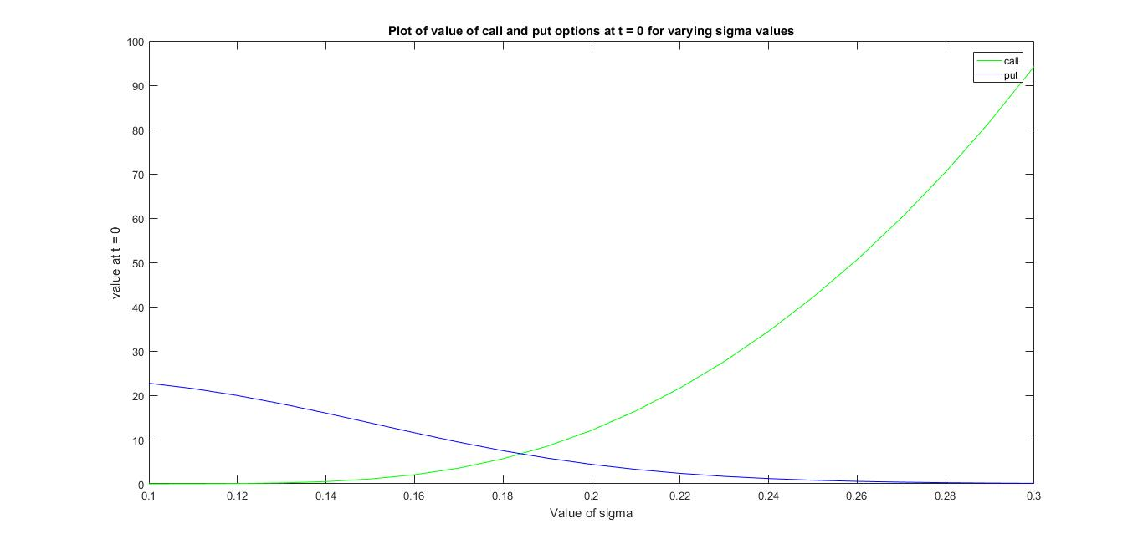

Plot of call option values at t = 0 obtained by changing M from 50 – 150 for K = 95 is

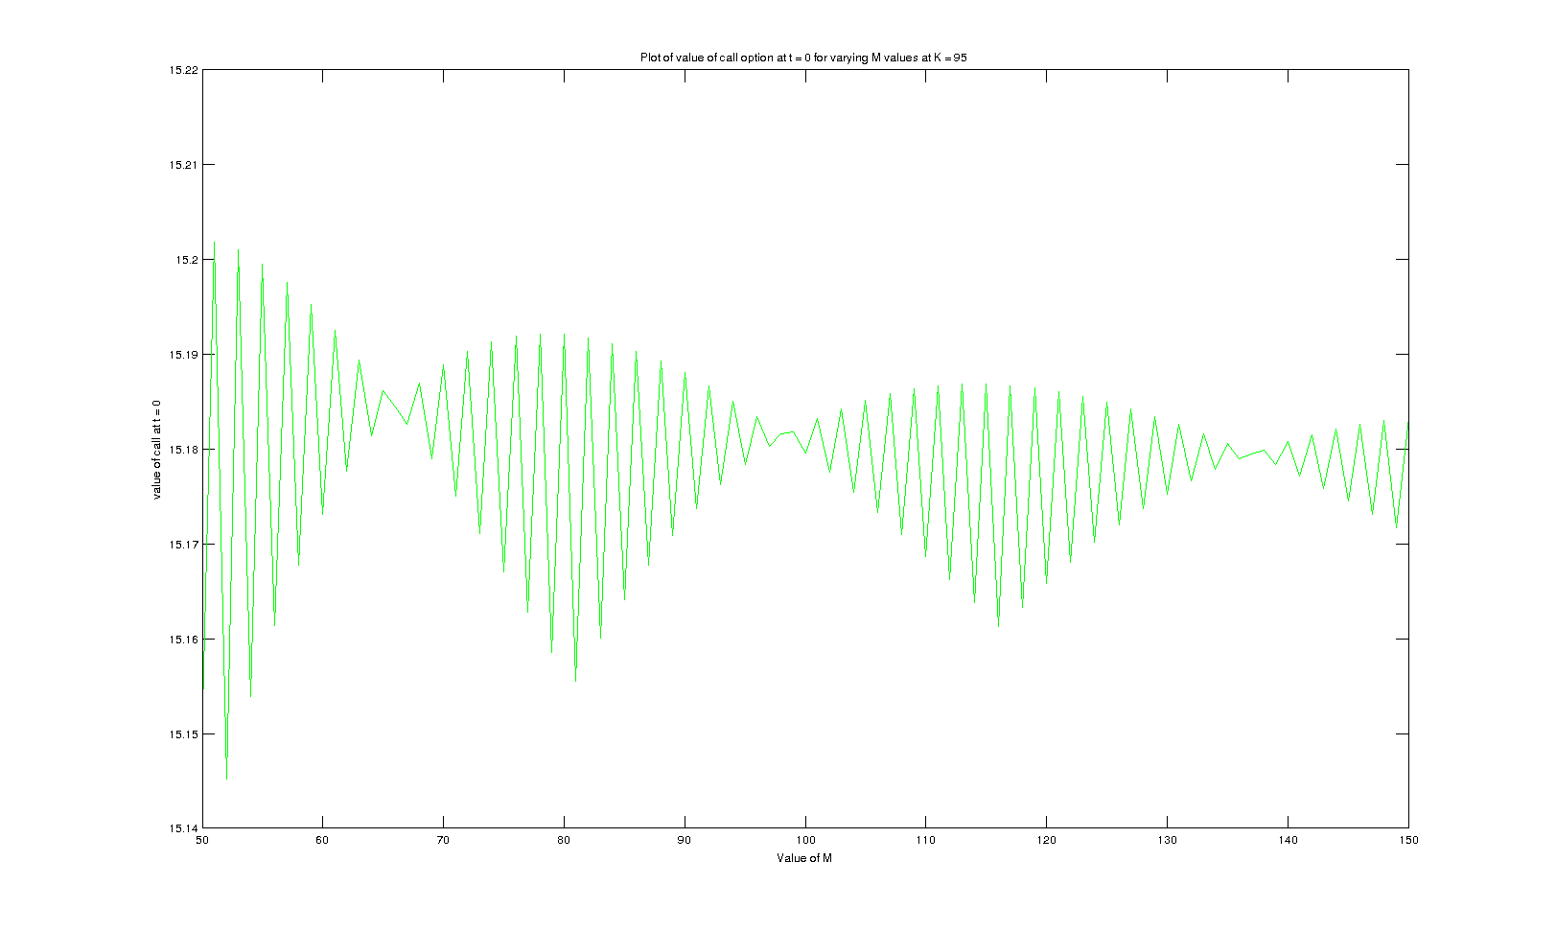

Plot of put option values at t = 0 obtained by changing M from 50 – 150 for K = 95 is

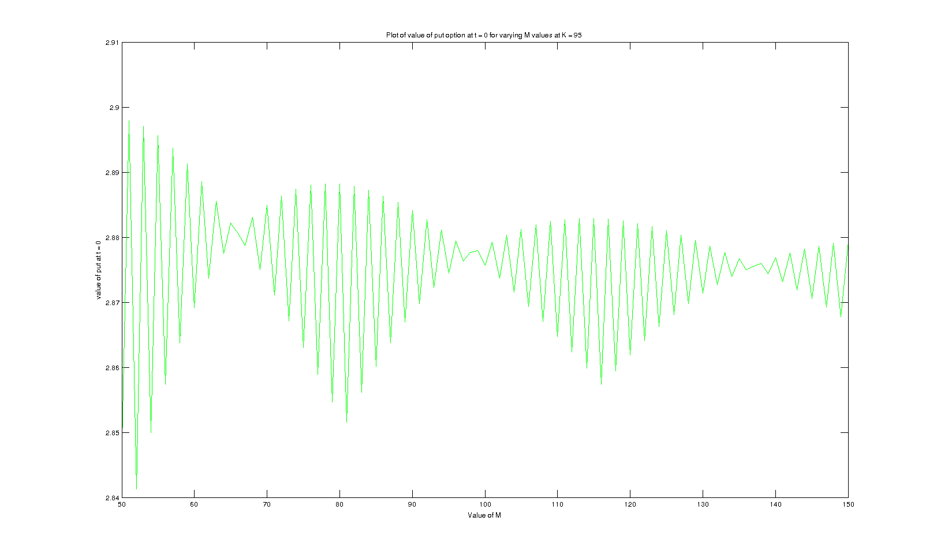

Plot of call option values at t = 0 obtained by changing M from 50 – 150 for K = 100 is

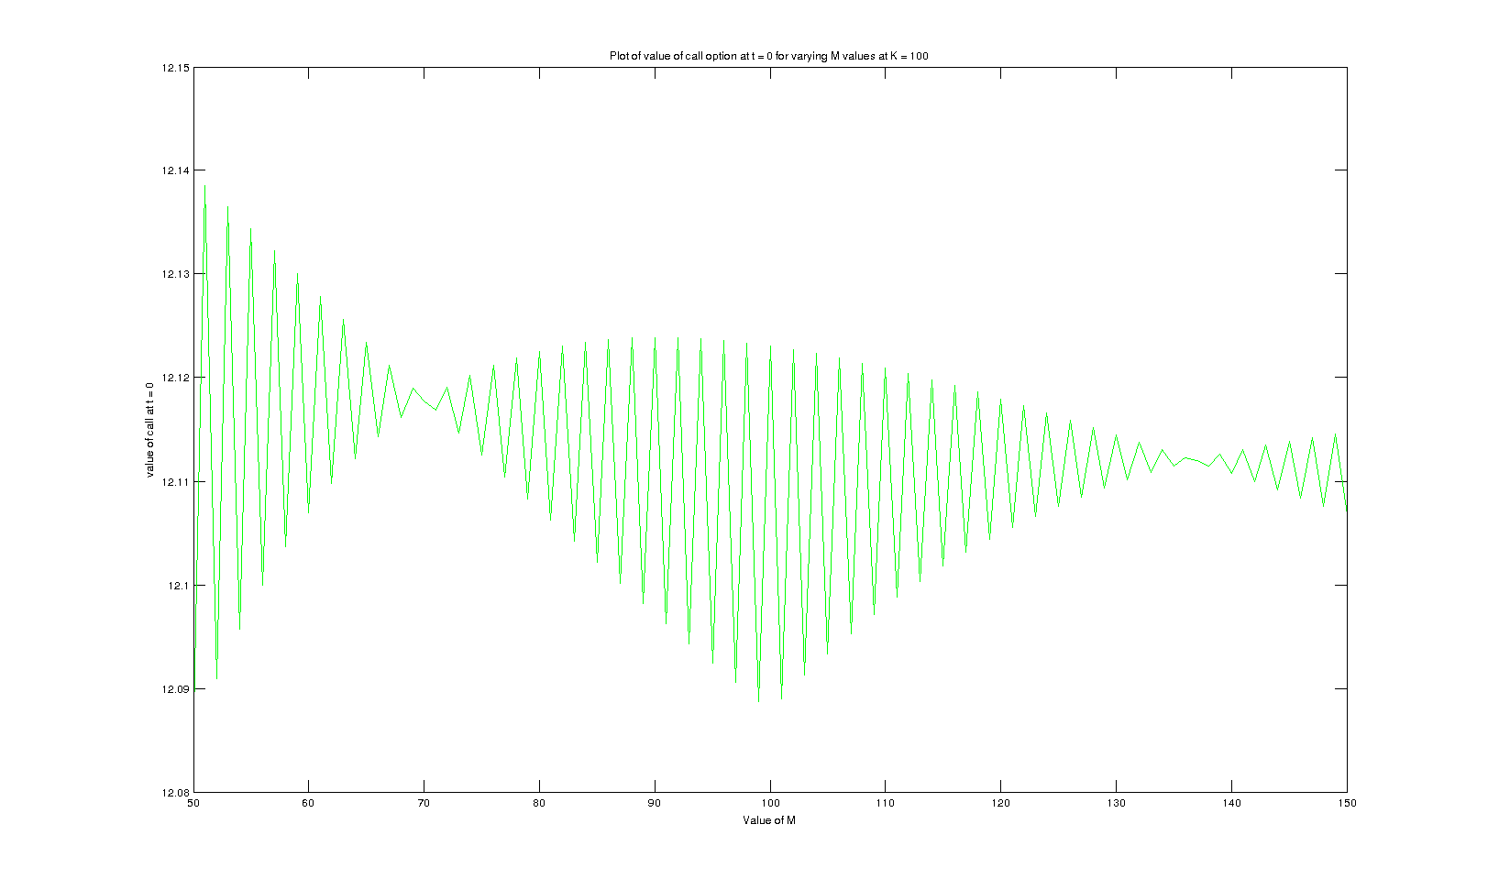

Plot of put option values at t = 0 obtained by changing M from 50 – 150 for K = 100 is

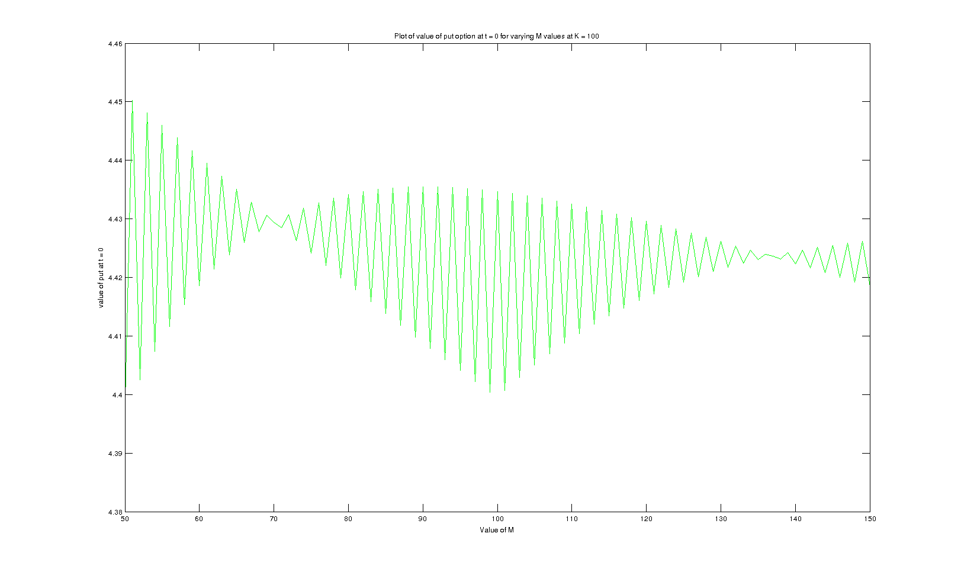

Plot of call option values at t = 0 obtained by changing M from 50 – 150 for K = 105 is

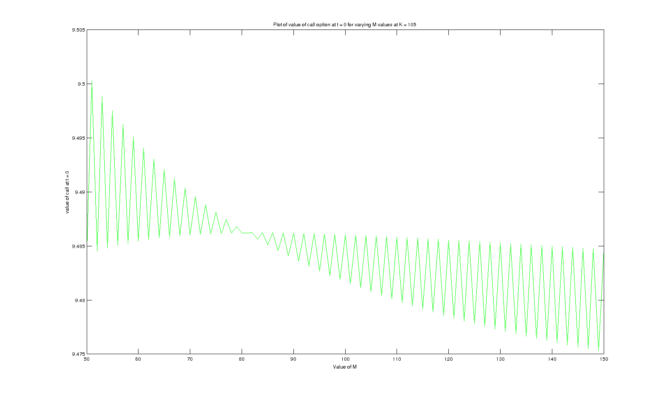

Plot of put option values at t = 0 obtained by changing M from 50 – 150 for K = 105 is

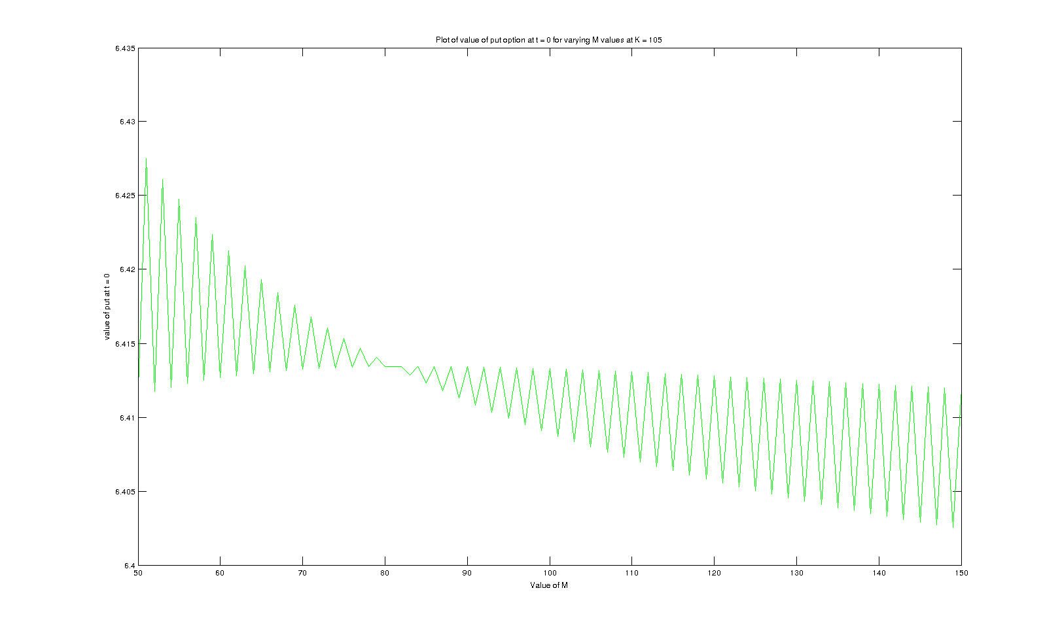

Q2)

I took American option as the path dependent option here and u, d set 1.

The value of call option at t = 0 is : 12.085380

The value of put option at t = 0 is : 5.266748

Plots :

Plot of call and put option values at t = 0 obtained by changing S(0) from 50 – 150 is

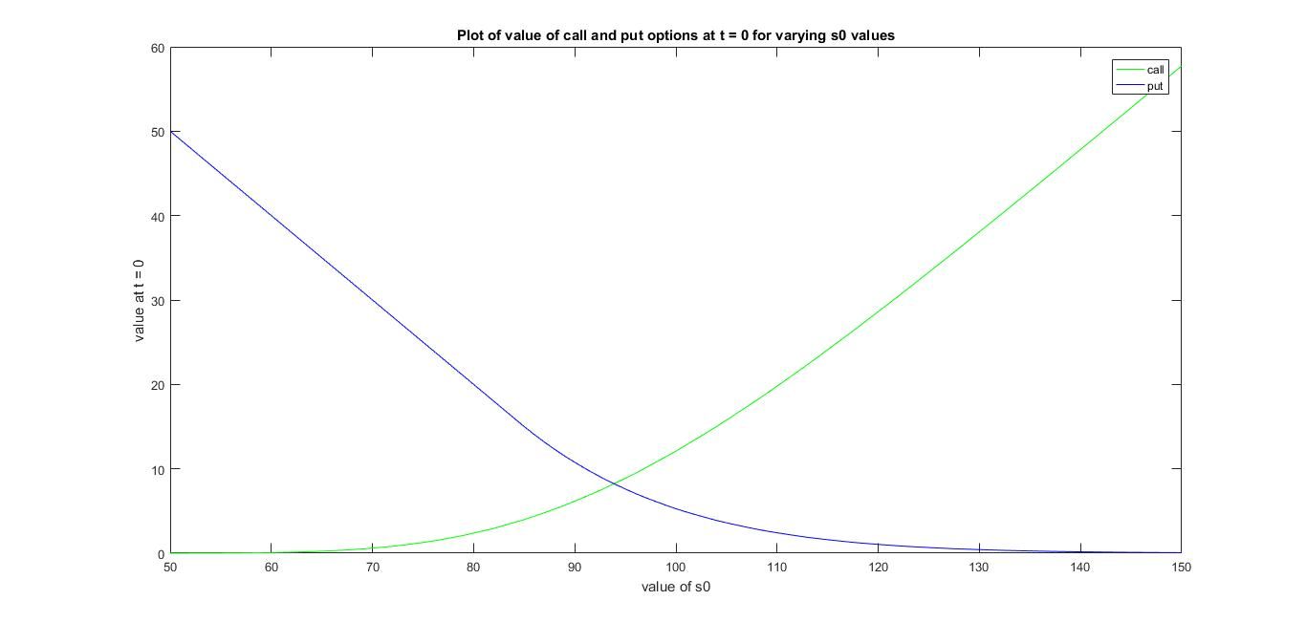

Plot of call and put option values at t = 0 obtained by changing K from 50 – 150 is

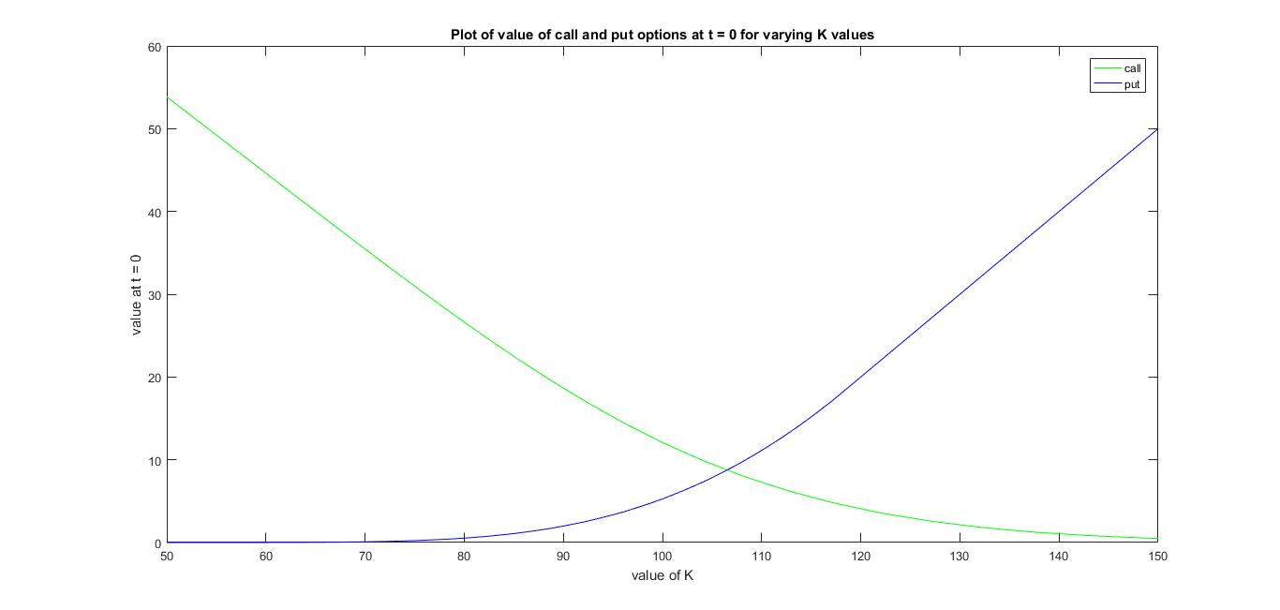

Plot of call and put option values at t = 0 obtained by changing r from 0.01 – 0.16 is

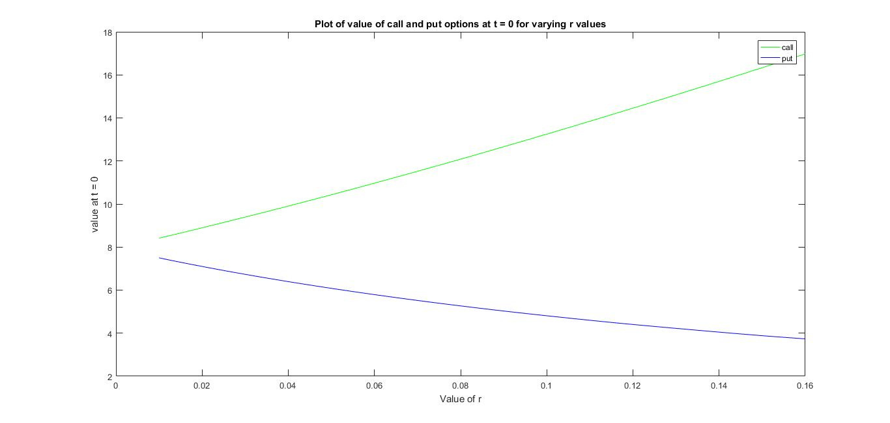

Plot of call and put option values at t = 0 obtained by changing sigma from 0.1 – 0.3 is

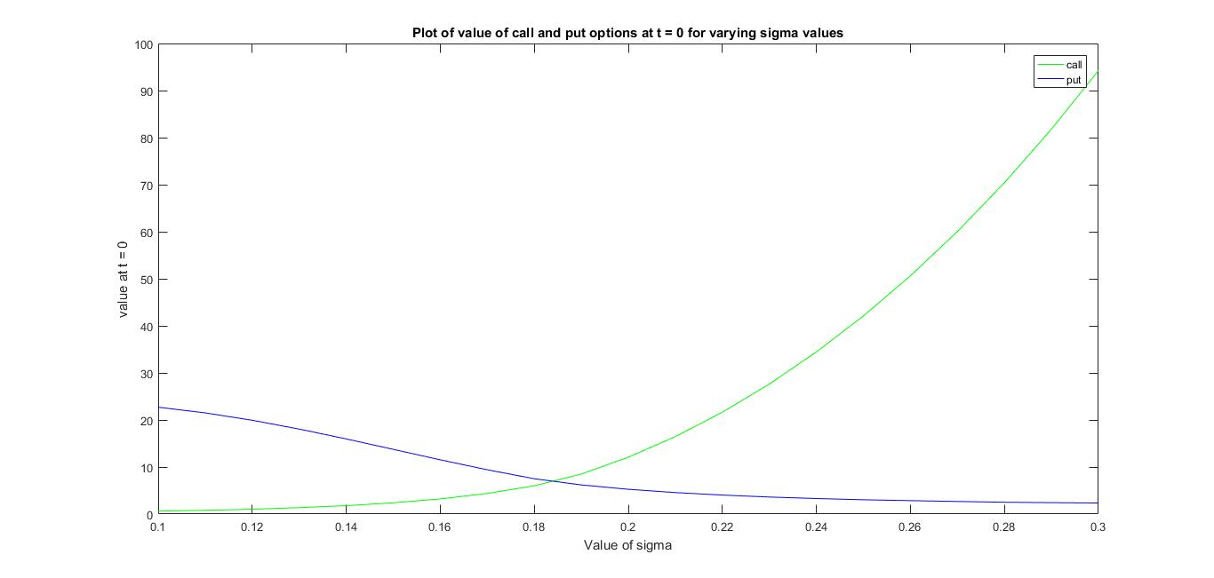

Plot of call option values at t = 0 obtained by changing M from 50 – 150 for K = 95 is

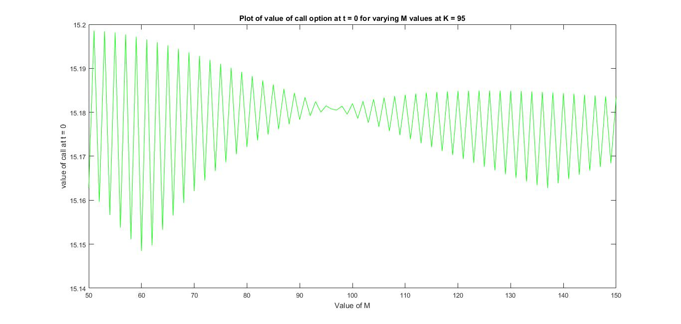

Plot of put option values at t = 0 obtained by changing M from 50 – 150 for K = 95 is

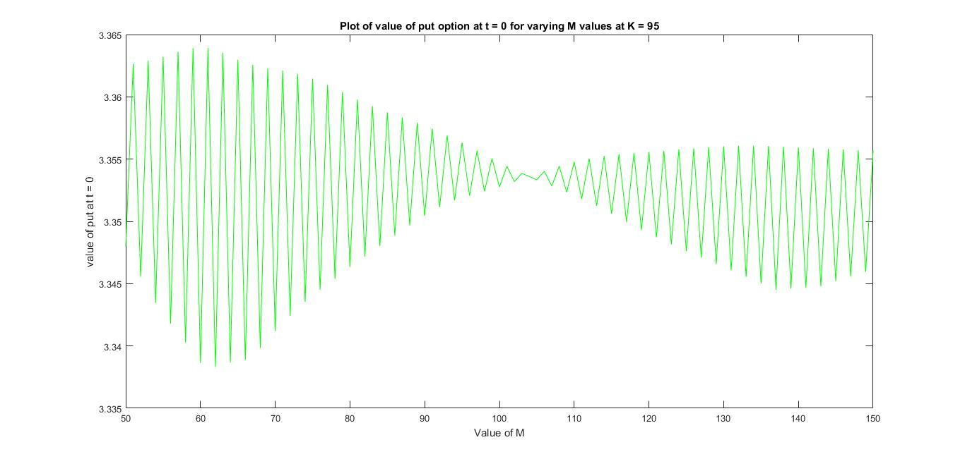

Plot of call option values at t = 0 obtained by changing M from 50 – 150 for K = 100 is

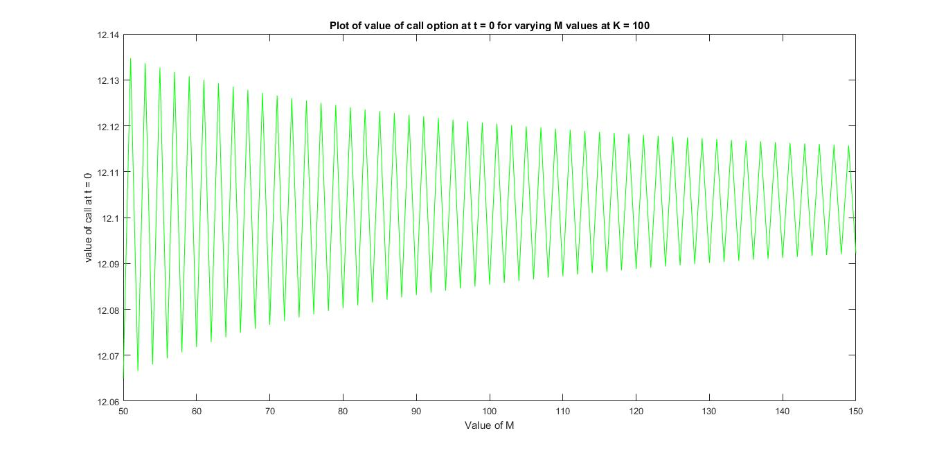

Plot of put option values at t = 0 obtained by changing M from 50 – 150 for K = 100 is

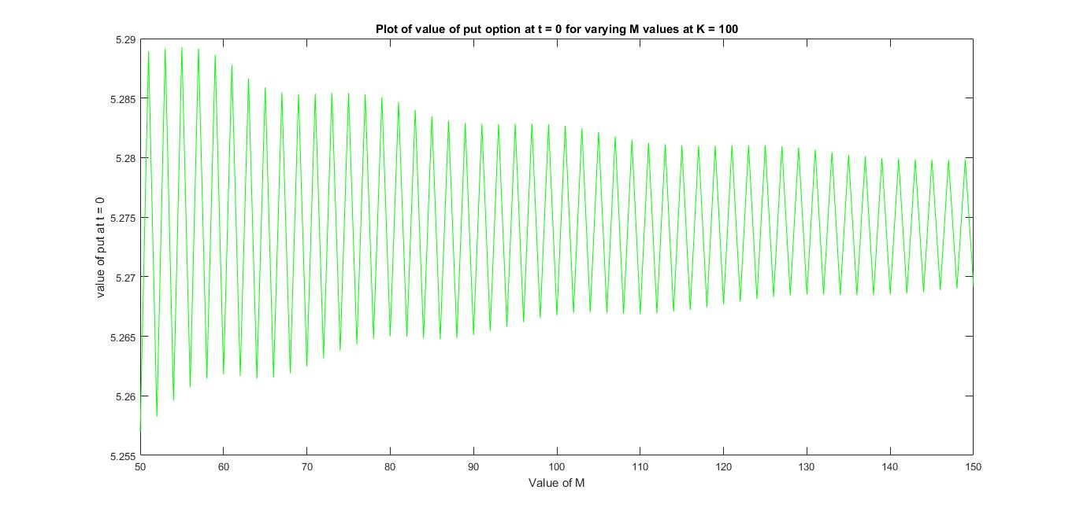

Plot of call option values at t = 0 obtained by changing M from 50 – 150 for K = 105 is

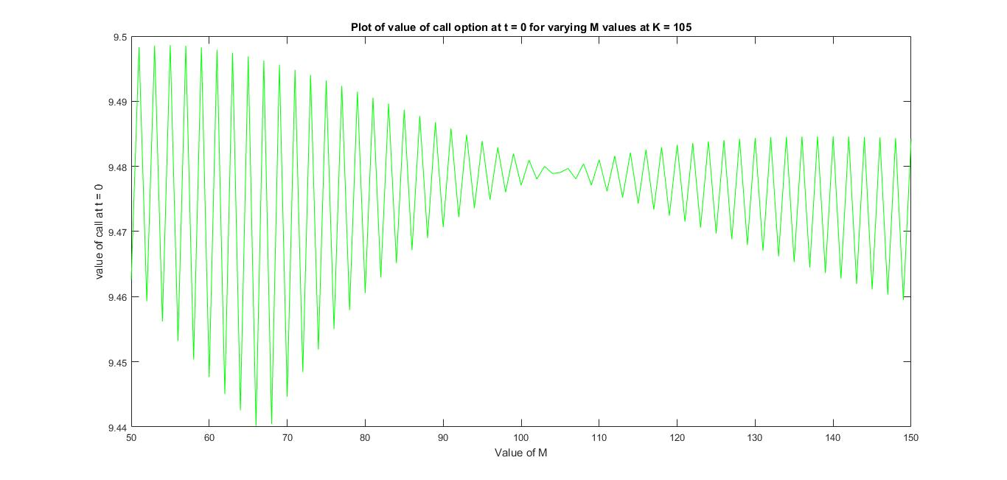

Plot of put option values at t = 0 obtained by changing M from 50 – 150 for K = 105 is

