MA 374 Lab 3 Report
- Santhosh Reddy Banda
140123010

Q1)

The initial value of American call option for the specifically mentioned data is : 12.123047

The initial value of American put option for the specifically mentioned data is : 5.279837

a)

By changing S(0) value and keeping others constant, we get the following graphs

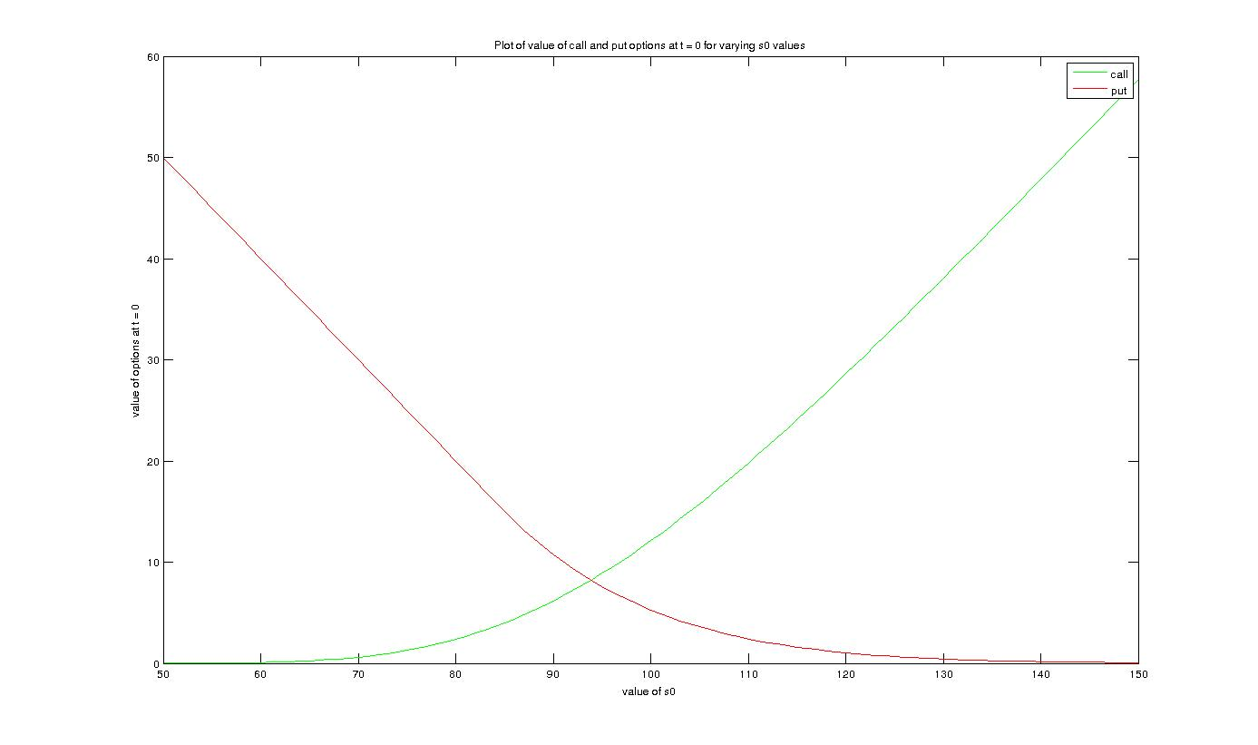

b)

By changing K and keeping other values constant, we get following graph

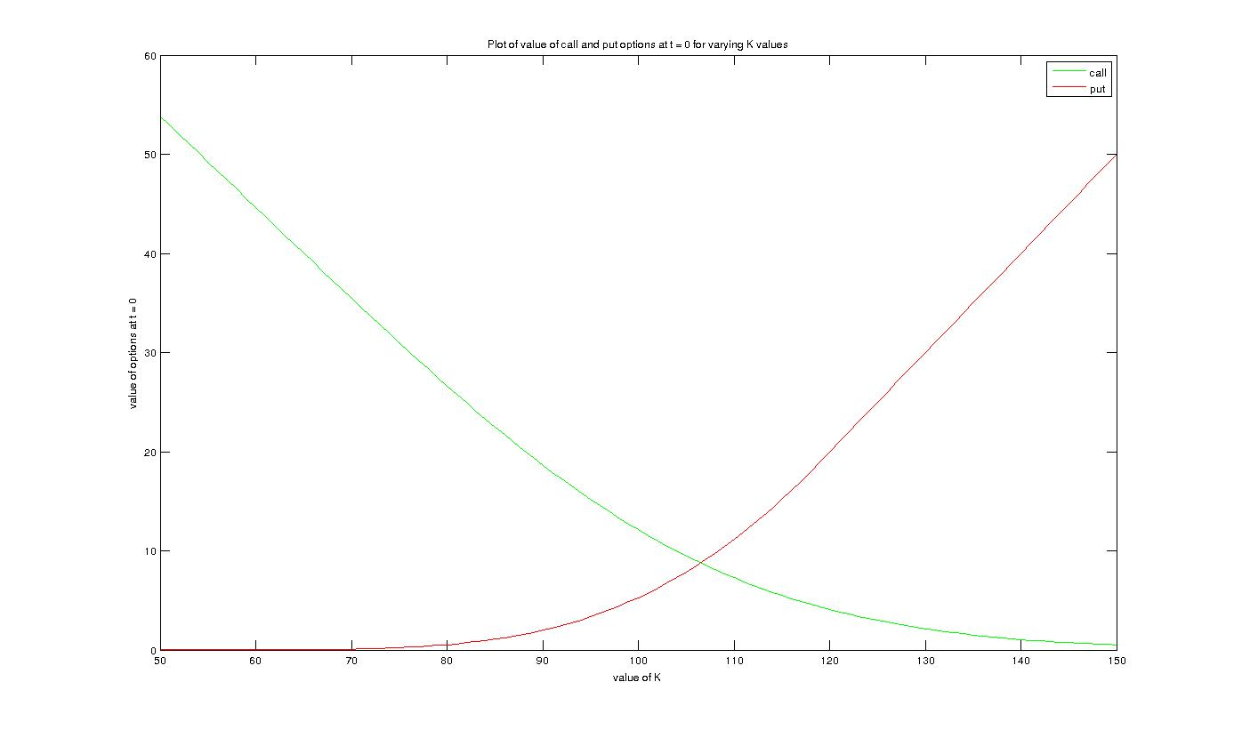

c)
By changing r and keeping other values constant, we get following graph

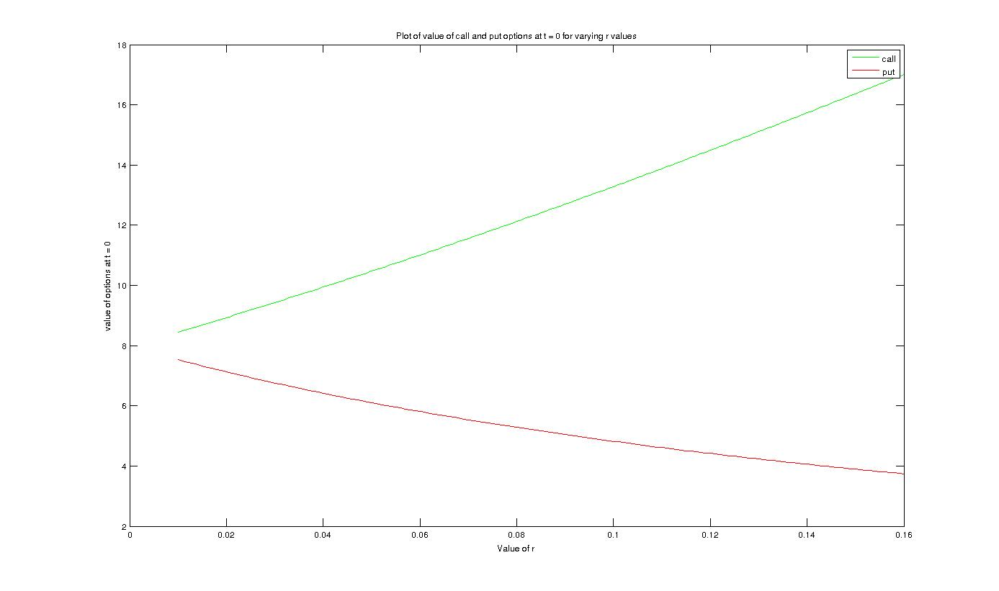
d)
By cahnging sigma and keeping other values constant, we get the following graph

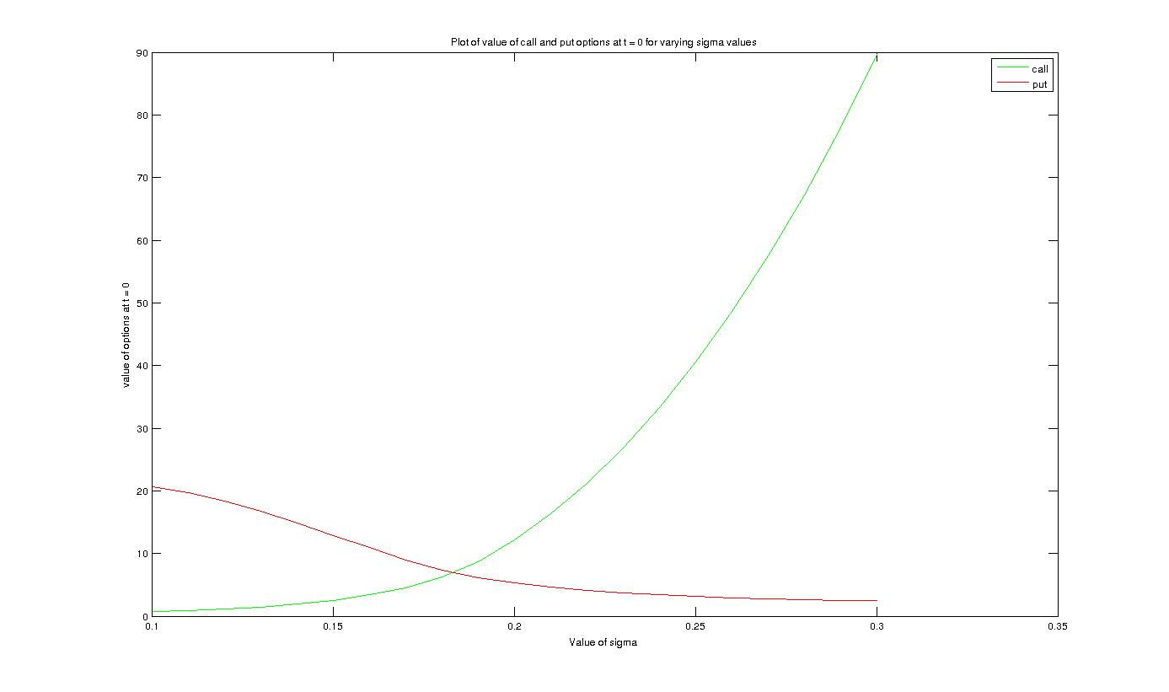

e)
By changing M and for K = 95, we get following graphs

call :

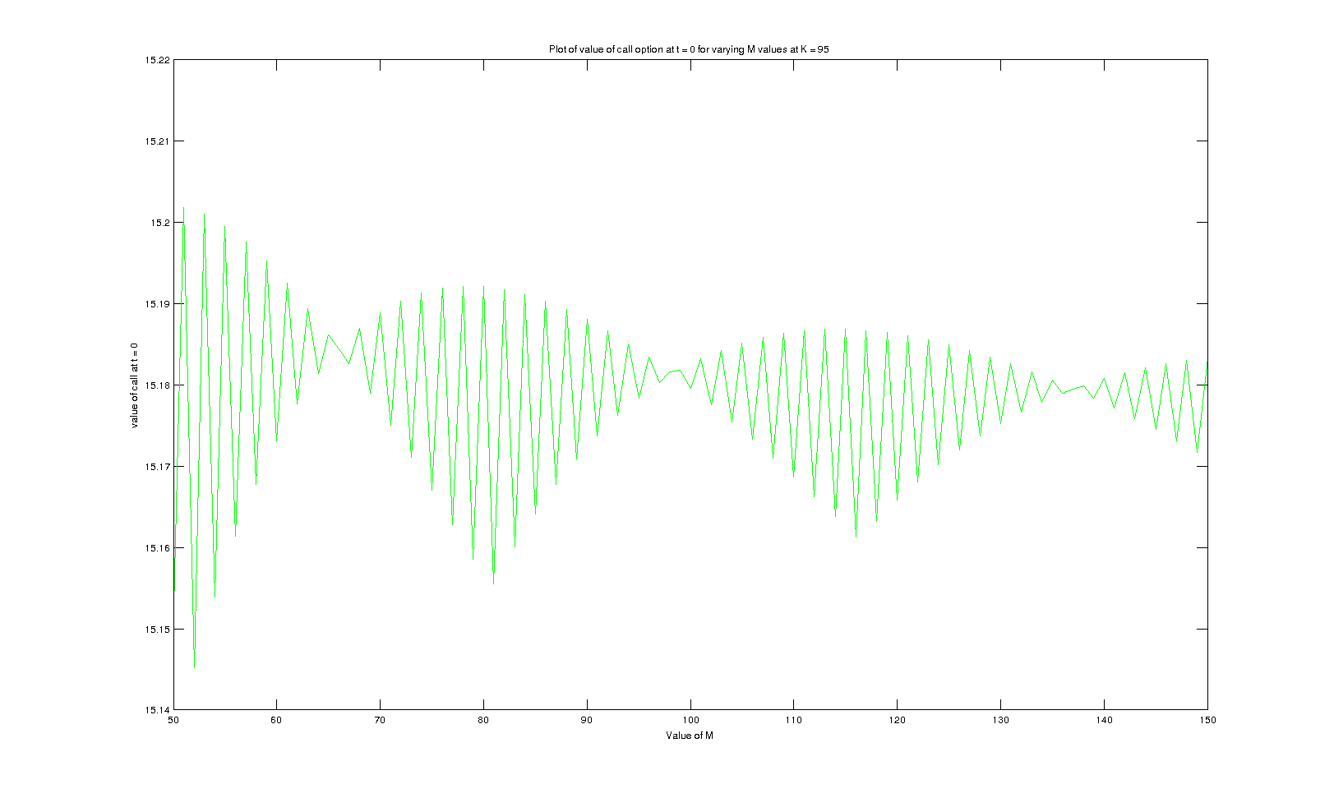
put :

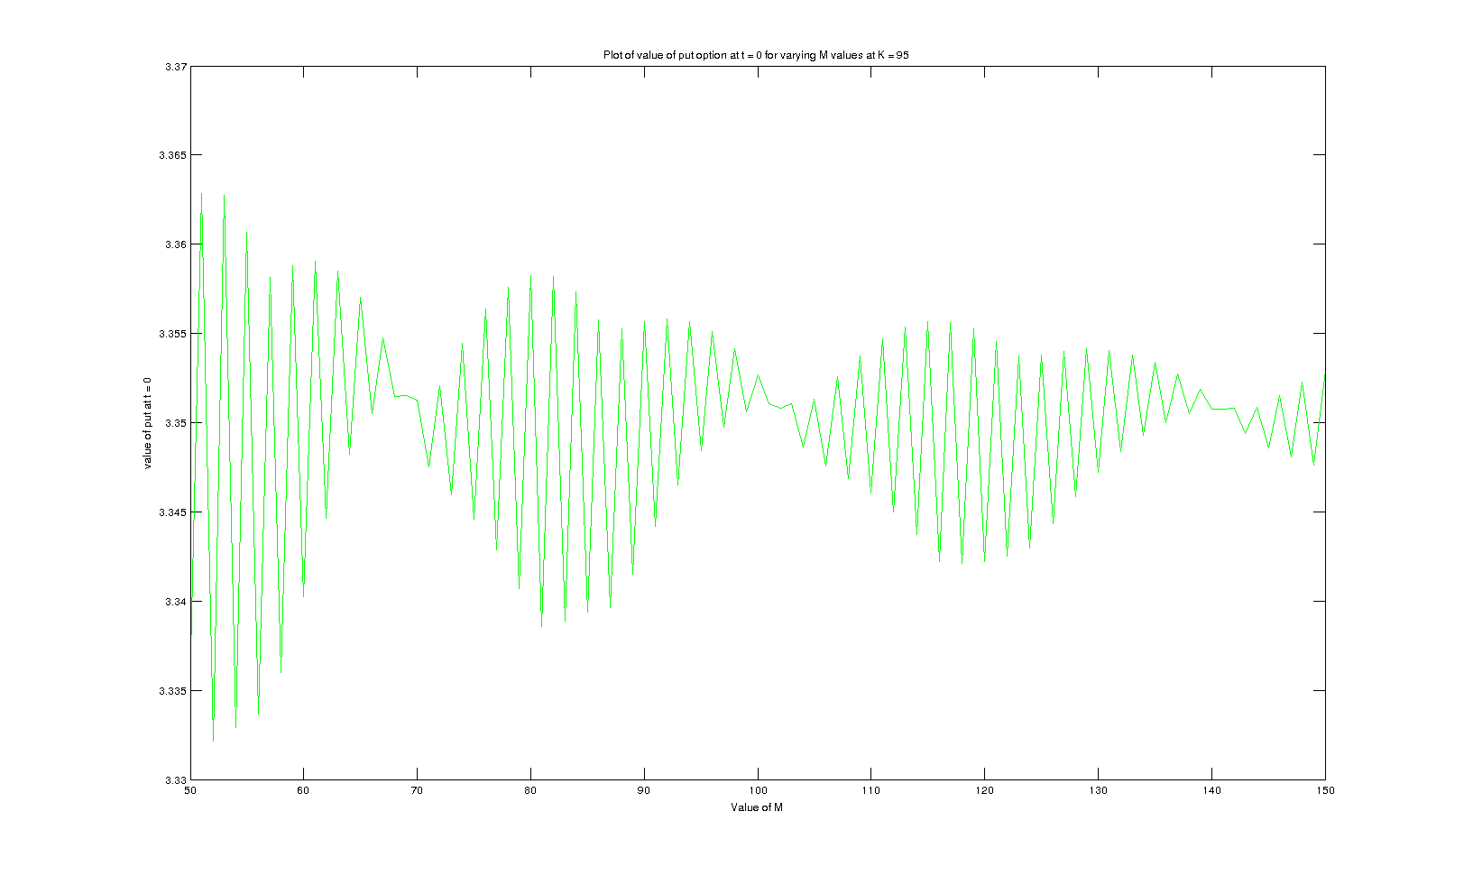
By changing M and K = 100, we get following graphs

call :

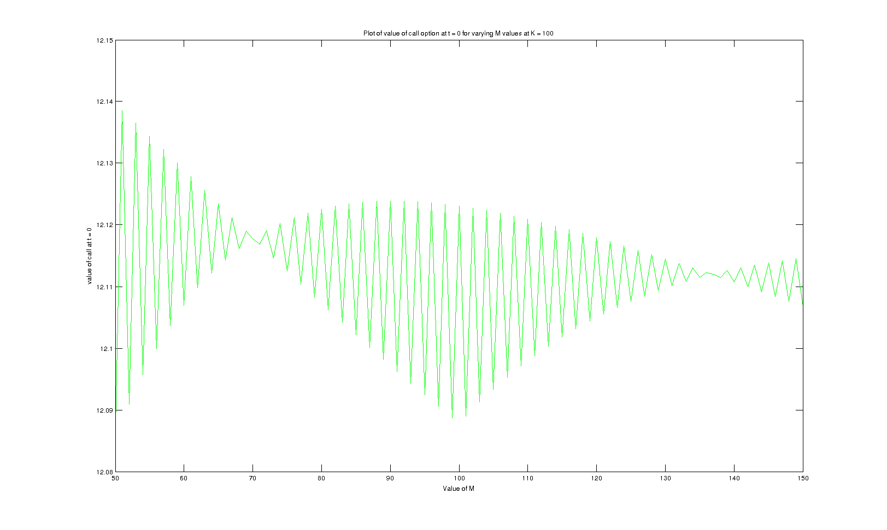

put :

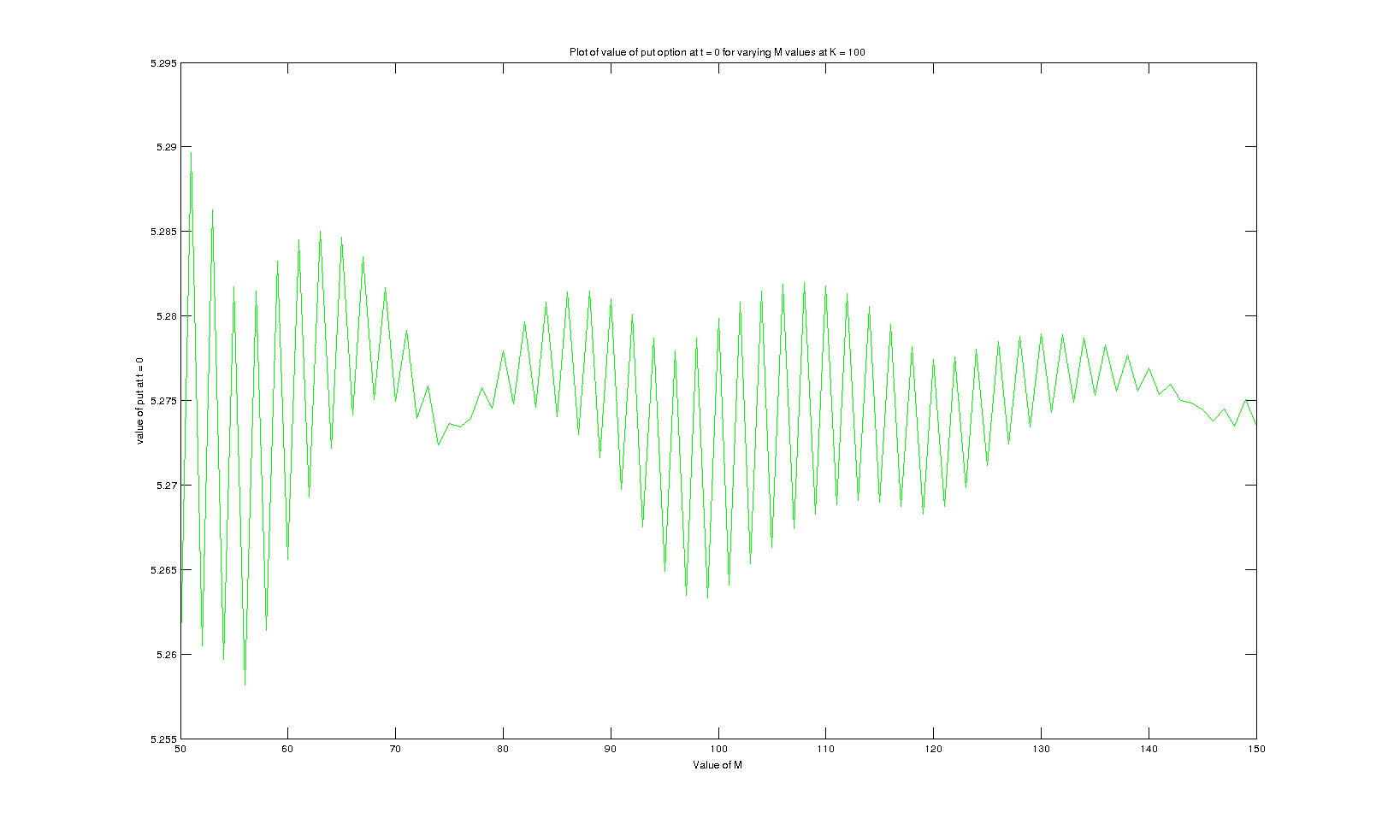
By changing M and K = 105, we get the following graphs

call :

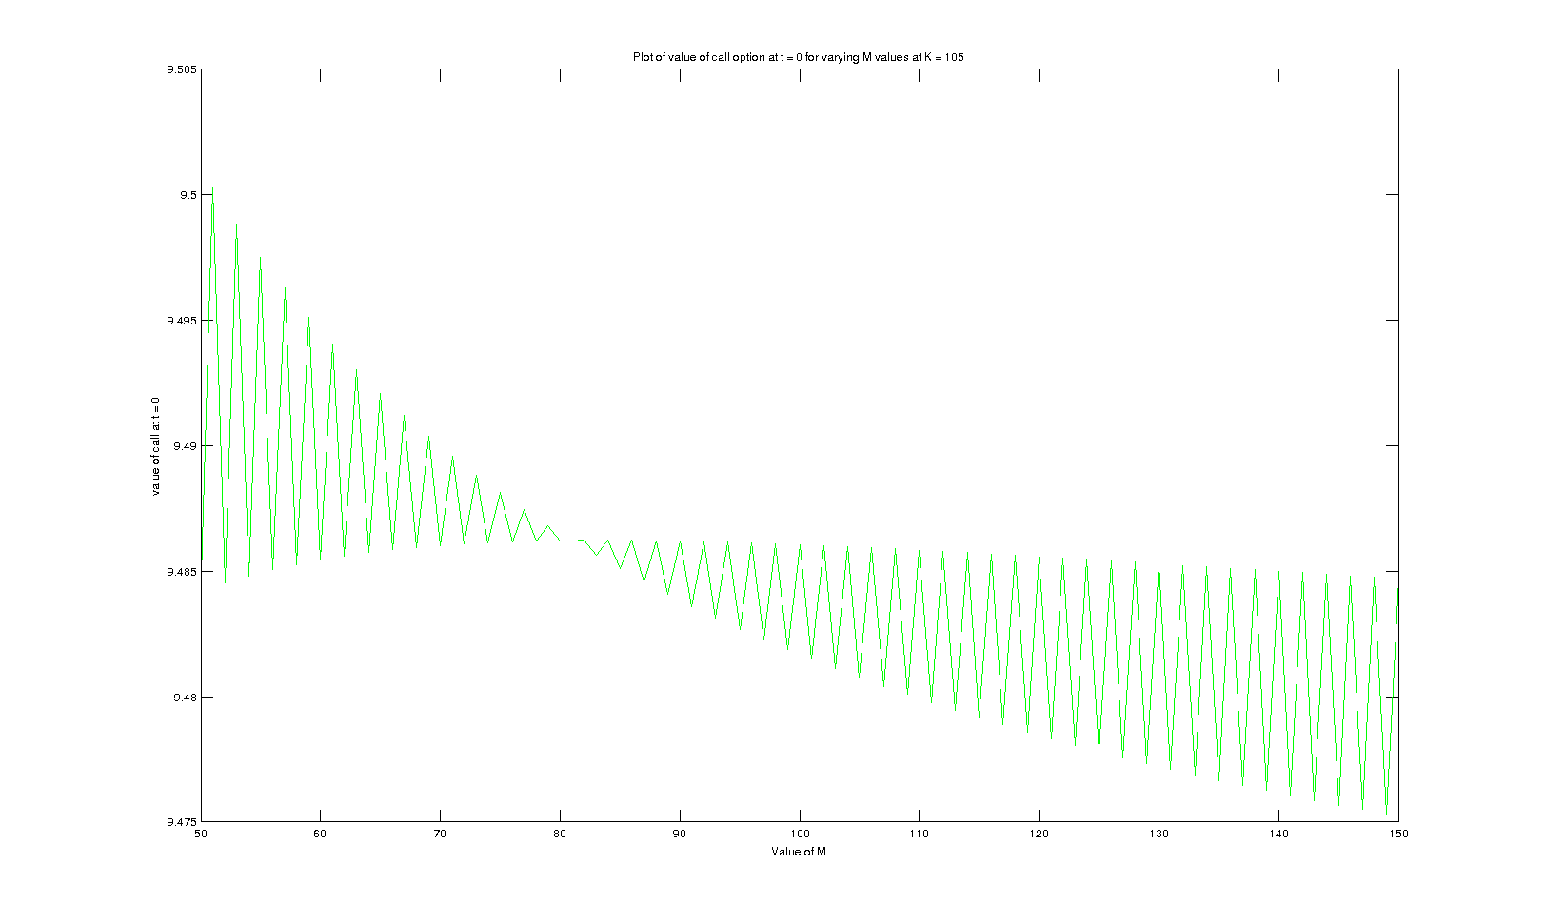
put :

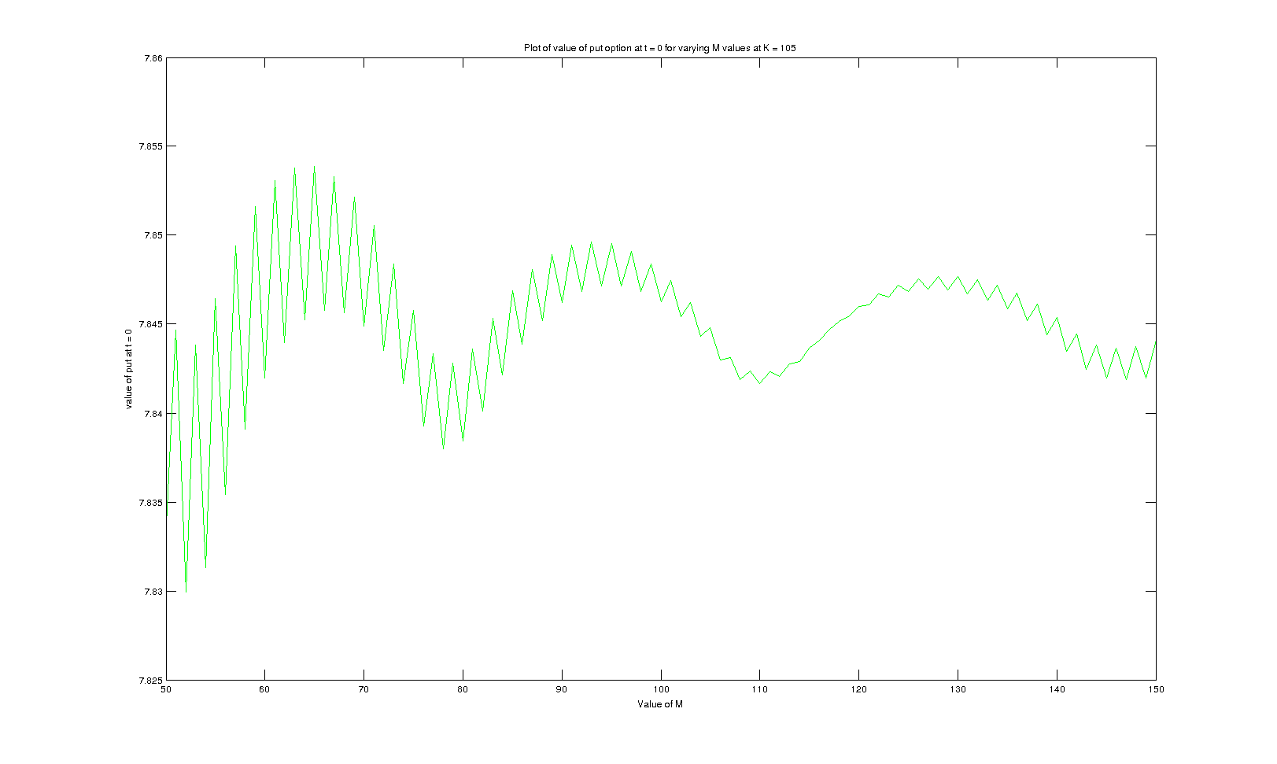

Q2)

A)

For M = 5, initial lookback option value is 9.1192989
For M = 10, initial lookback option value is 10.080582
For M = 20, initial lookback option value is 10.519165

The system isn't handling further higher M values

B)

The plot is as follows

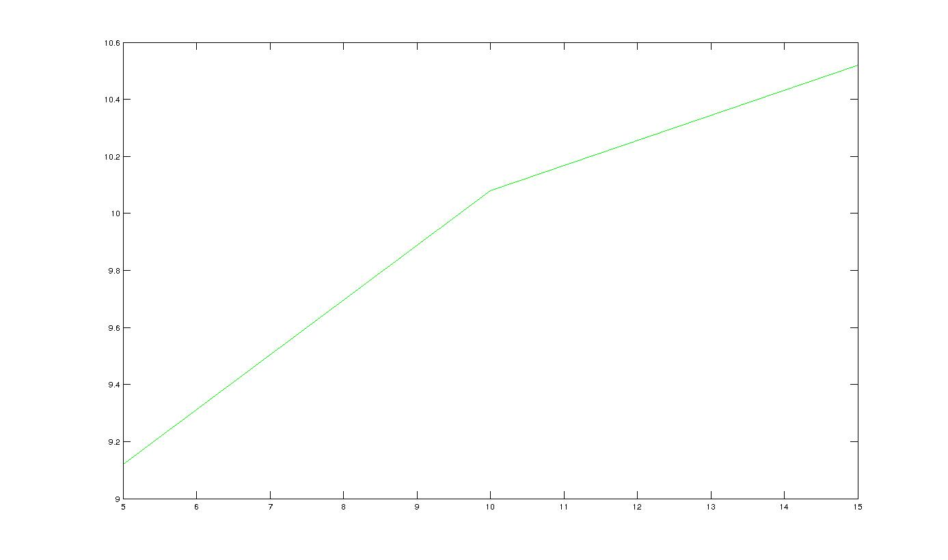

C)

The intermediate values of lookback option for M = 5 are :

8.1571 9.0280 8.5481 7.4168 5.5016 0
0 7.5492 9.7991 9.9553 9.5714 11.1814
0 0 7.1479 6.2019 4.6005 0
0 0 8.1940 13.7129 15.6319 19.4527
0 0 0 6.2019 4.6005 0
0 0 0 8.3246 8.0036 9.3499
0 0 0 5.1861 6.6808 6.3745
0 0 0 11.4667 21.1881 25.3946
0 0 0 0 4.6005 0
0 0 0 0 8.0036 9.3499
0 0 0 0 3.8469 0
0 0 0 0 13.0714 16.2664
0 0 0 0 3.8469 0
0 0 0 0 6.6926 13.5780
0 0 0 0 5.5865 13.5780
0 0 0 0 17.7175 29.4826
0 0 0 0 0 0
0 0 0 0 0 9.3499
0 0 0 0 0 0
0 0 0 0 0 16.2664
0 0 0 0 0 0
0 0 0 0 0 7.8184
0 0 0 0 0 5.3304
0 0 0 0 0 21.2350
0 0 0 0 0 0
0 0 0 0 0 7.8184
0 0 0 0 0 0
0 0 0 0 0 13.6020
0 0 0 0 0 0
0 0 0 0 0 11.3539
0 0 0 0 0 11.3539
0 0 0 0 0 24.6534

Q3)

