MA374 Lab 4 report

Santhosh Reddy Banda
140123010

1.

A) The Markowitz efficient frontier is:-

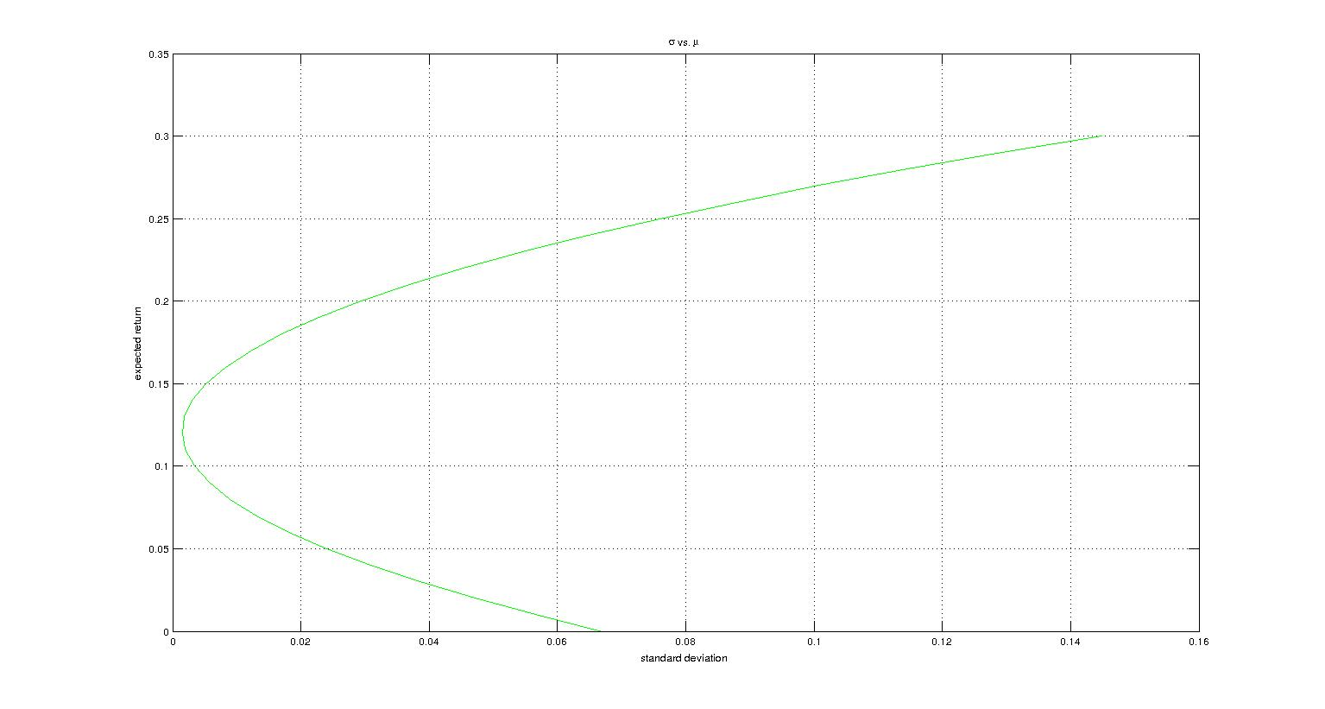

B)
For mean = 0.01000000, variance = 0.05659413

weights =

2.4073 -0.3927 -1.0147

For mean = 0.03000000, variance = 0.03852147

weights =

2.1211 -0.2789 -0.8422

For mean = 0.05000000, variance = 0.02402752

weights =

1.8349 -0.1651 -0.6697

For mean = 0.07000000, variance = 0.01311229

weights =

1.5486 -0.0514 -0.4972

For mean = 0.09000000, variance = 0.00577578

weights =

1.2624 0.0624 -0.3248

For mean = 0.11000000, variance = 0.00201798

weights =

0.9761 0.1761 -0.1523

For mean = 0.13000000, variance = 0.00183890

weights =

0.6899 0.2899 0.0202

For mean = 0.15000000, variance = 0.00523853

weights =

0.4037 0.4037 0.1927

For mean = 0.17000000, variance = 0.01221688

weights =

0.1174 0.5174 0.3651

For mean = 0.19000000, variance = 0.02277394

weights =

-0.1688 0.6312 0.5376

C)

Returns are
0.1896
0.0524

D)

Minimum Risk is
0.0170

E)

The Market Portfolio has weights
0.5938 0.3281 0.0781

The Capital Market Line is :-

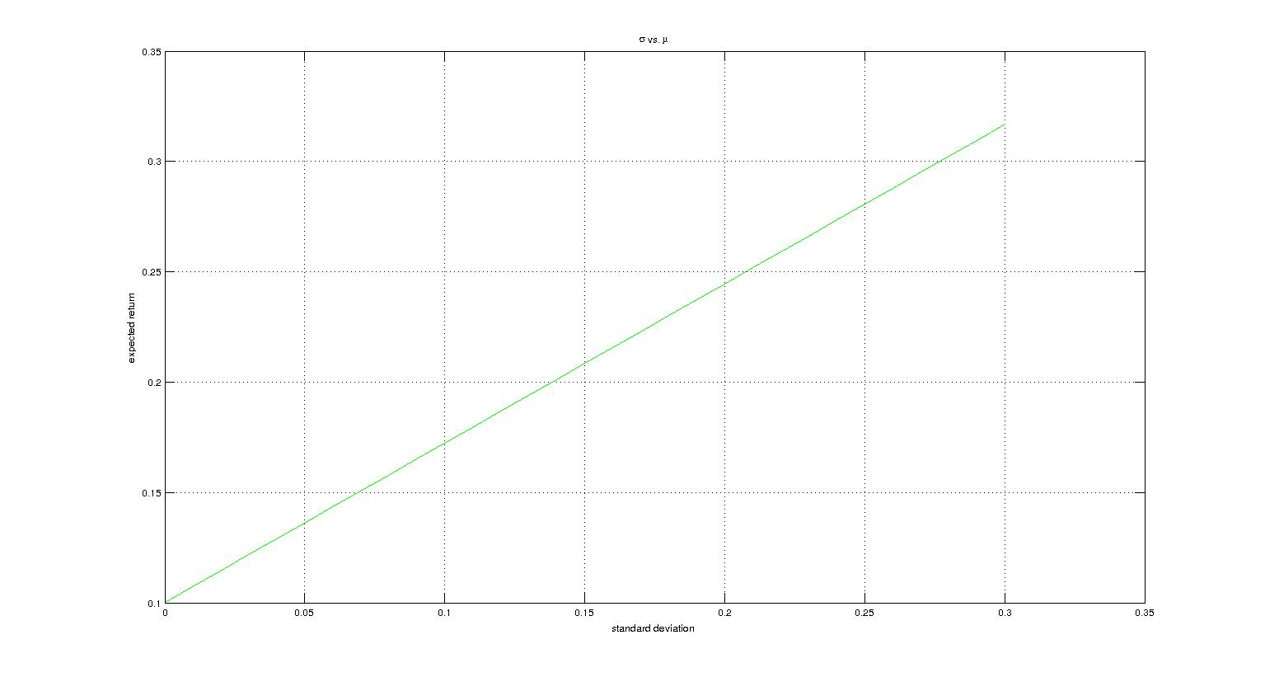

2.

a) The Markowitz Efficient Frontier is:-

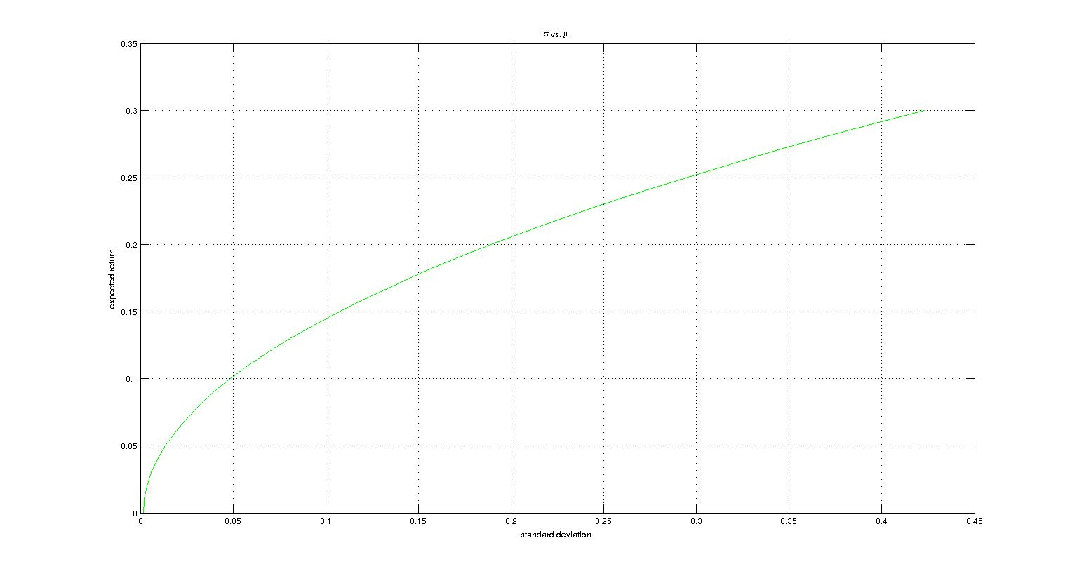

b) The Market Portfolio has weights:-

0.347025256233099, 0.250619815421355, -0.087226854582322, -0.076440180608388, 0.052366699315659, 0.046895339223592, -0.035720766443429, 0.004720874674299, 0.359815798353330, 0.137944018412804

c) The Capital Market Line is:-

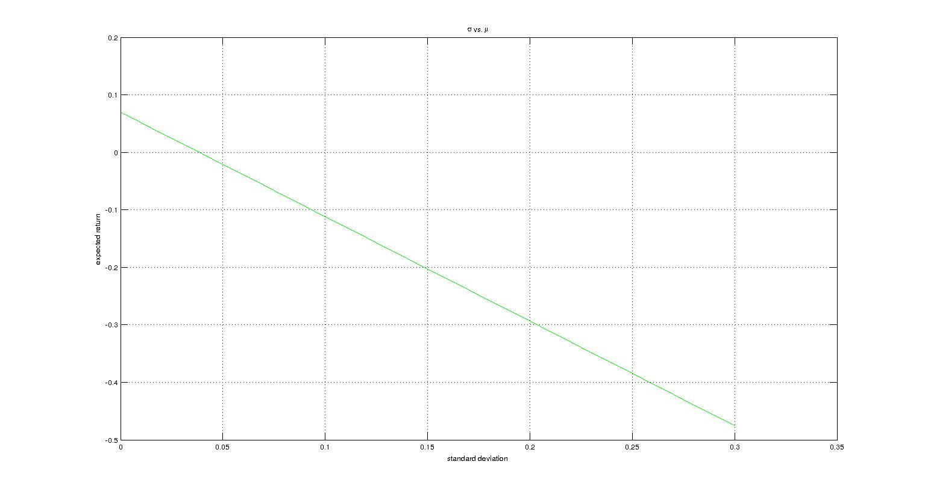

d) The Security Market Line is:-

