MA374 lab 5 report
Santhosh Reddy Banda
140123010

  - Feasible Region for No Short Sales with the Minimum Variance Curve
(Red Shaded Area)

Blue : Minimum Variance Curves for 2 stocks at a time (Stocks 1 & 2)
Black : Minimum Variance Curves for 2 stocks at a time (Stocks 2 & 3)
Yellow : Minimum Variance Curves for 2 stocks at a time (Stocks 3 & 1)

Green : Minimum Variance Curve with short sales allowed
(Efficient Frontier is the upper part of the curve)]

Red – Efficient Frontier (and essentially minimum variance curve)with short sales not allowed
(shown in the plot that follows)

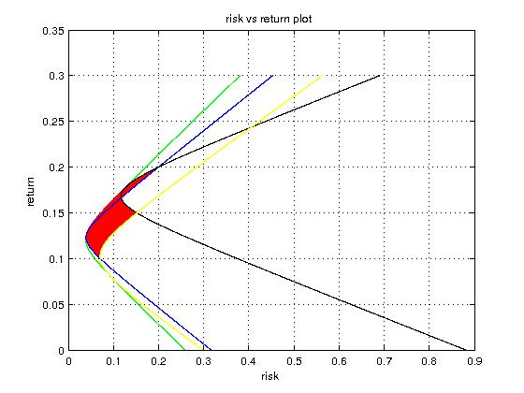

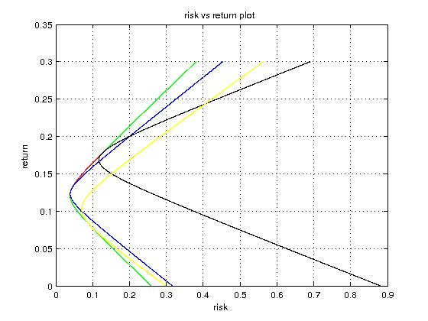

Weights corresponding to minimum variance curve

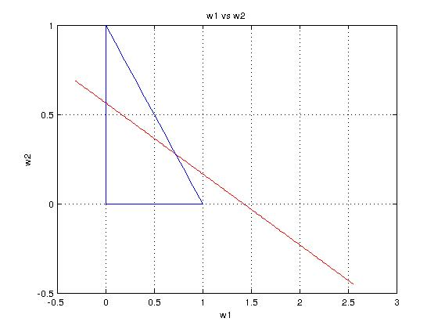

Equation that the weights satisfy (in terms of the portfolio mean)

w1 = 278/109 - (1560*x)/109,
w2 = (620*x)/109 - 49/109,
w3 = (940*x)/109 - 120/109

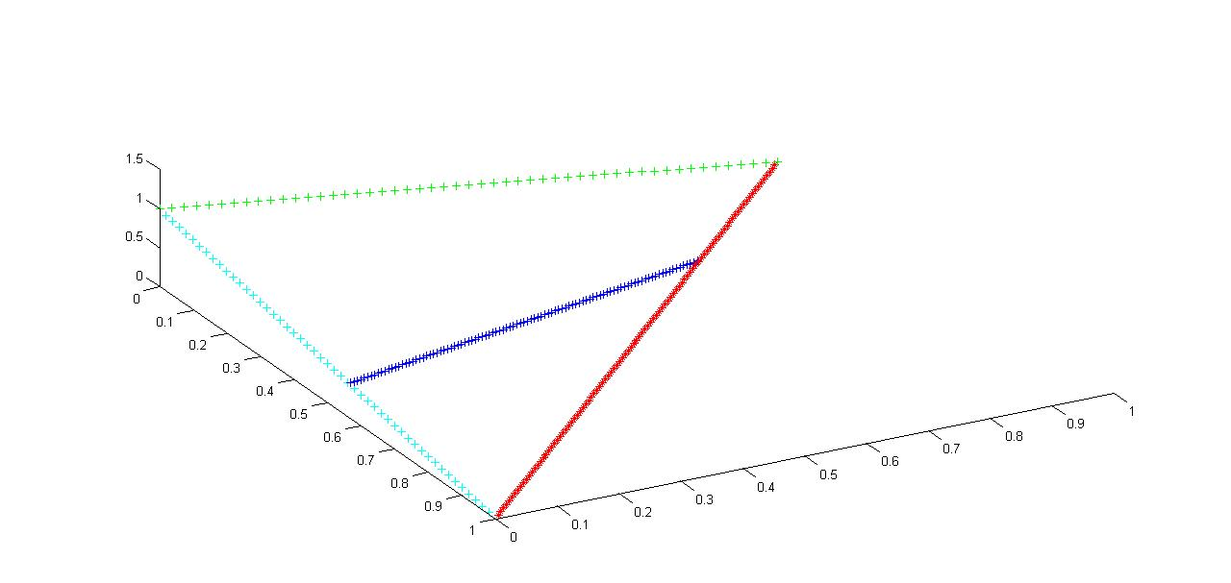
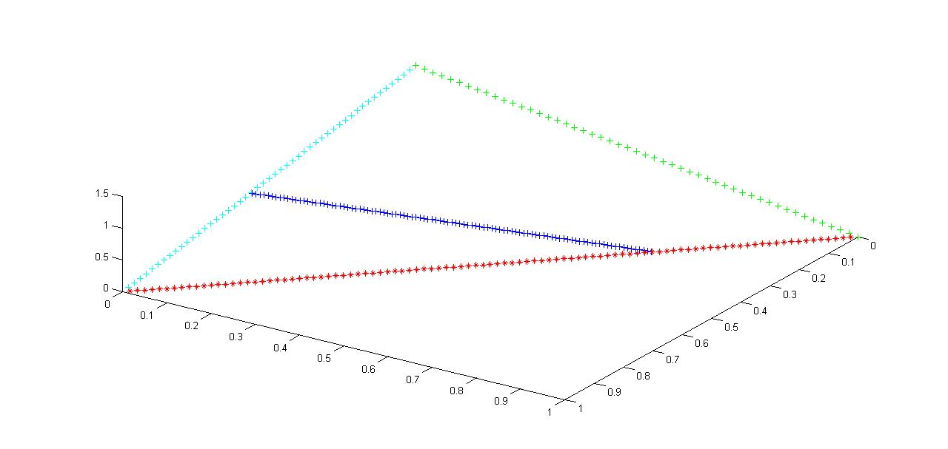
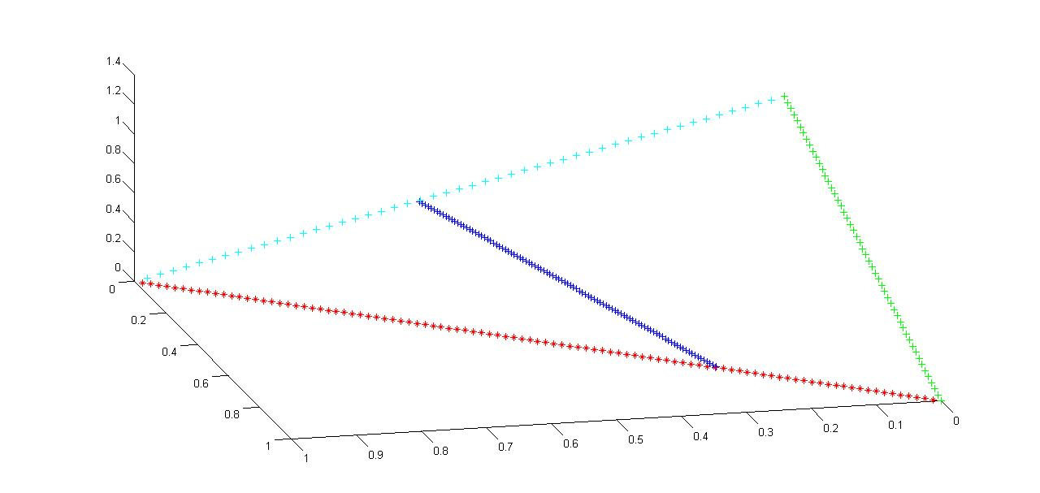

Above are the 3-D view of the weights w.r.t. different angles . They are essentially the same but only differ in their orientation.

2. Observations

Market Portfolio: BSE-Sensex

a) Stocks of BSE Sensex

Name of Stock | Beta
Reliance Industries | 0.0542592
Tata Steel | 0.0299974
Maruti Suzuki | 0.0691391
Axis Bank | 0.0570888
Infosys | 0.140498
Wipro | 0.0214921
Gail | 0.0196612
Dr. Reddy's Lab | 0.0744121
Sun Pharma | 0.0131446
Hero Motorcorp | 0.0863308

b) Stocks of NSE Nifty

Name of Stock | Beta
Pidlite | 0.00765317
Titan Company | 0.00802928
Apollo Hospitals | 0.026787
Britannia | 0.0244166
Jindal Steel | 0.023194
HCL Tech | 0.0259425
Larsen | 0.0550572
ICICI Bank | 0.0537974
NTPC | 0.0106422
TCS | 0.140547

Market Portfolio- NSE Nifty

c) Stocks of BSE Sensex

Name of Stock | Beta
Reliance Industries | 0.181464
Tata Steel | 0.100323
Maruti Suzuki | 0.231228
Axis Bank | 0.190927
Infosys | 0.46988
Wipro | 0.0718779
Gail | 0.0657546
Dr. Reddy's Lab | 0.248863
Sun Pharma | 0.0439607
Hero Motorcorp | 0.288724

d) Stocks of NSE Nifty

Name of Stock | Beta
Pidlite | 0.0255952
Titan Company | 0.026853
Apollo Hospitals | 0.0895861
Britannia | 0.0816586
Jindal Steel | 0.0775699
HCL Tech | 0.0867617
Larsen | 0.184133
ICICI Bank | 0.179919
NTPC | 0.0355916
TCS | 0.470042

The Beta(β) of the stocks listed on the NSE are higher on the NSE when the correlation is calculated is between NSE and BSE.
The above property is also observed for BSE stocks.

In finance, the beta (β) of an investment is a measure of the risk arising from exposure to general market movements as opposed to idiosyncratic factors. The market portfolio of all investable assets has a beta of exactly 1. A beta below 1 can indicate either an investment with lower volatility than the market, or a volatile investment whose price movements are not highly correlated with the market. An example of the first is a treasury bill, the price does not go up or down a lot, so it has a low beta. An example of the second is gold. The price of gold does go up and down a lot, but not in the same direction at the same time as the market.

A beta above one generally means both that the asset is volatile and tends to move up and down with the market. An example is a stock in a big technology company. Negative betas are possible for investments that tend to go down when the market goes up, and vice versa. There are few fundamental investments with consistent and significant negative betas, but some derivatives like equity put options can have large negative betas.

