MA 374 Lab 7 report
Santhosh Reddy Banda
140123010

Q1)

function [call, put] = q1(stockprice, strikeprice, T, t, r, sg)
format short;
dp = 1/(sg*sqrt(T-t))*(log(stockprice/strikeprice)+(r+0.5*sg*sg)*(T-t));
dn = 1/(sg*sqrt(T-t))*(log(stockprice/strikeprice)+(r-0.5*sg*sg)*(T-t));
call = (stockprice*normcdf(dp))-(strikeprice*exp(-r*(T-t))*normcdf(dn));
put = (strikeprice*exp(-r*(T-t))*normcdf(-dn))-(stockprice*normcdf(-dp));
end

Q2)

2D plots
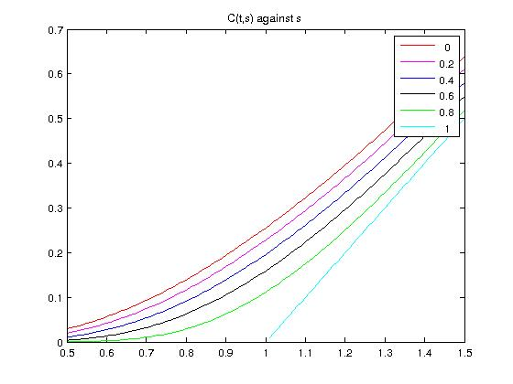

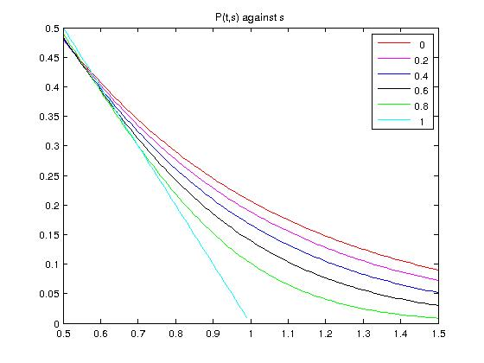

3D plots

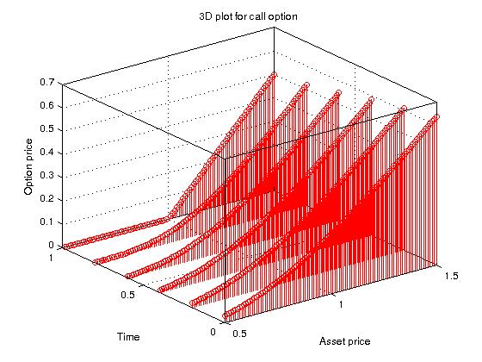

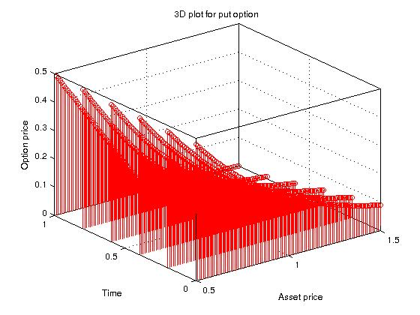

Q3)

call :

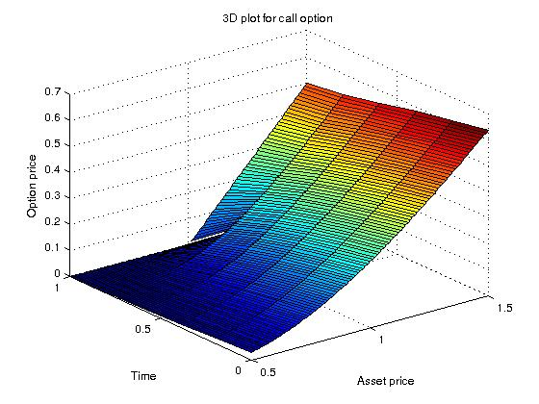

Put :

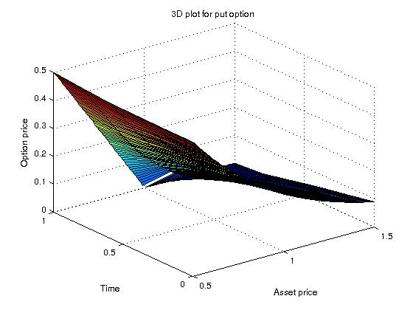

Q4)

Sensitivity w.r.t T (maturity):

2D plots :

call :

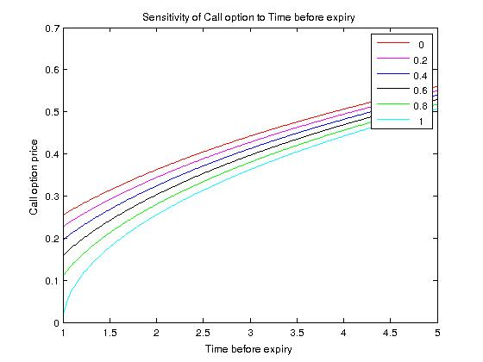

Put :

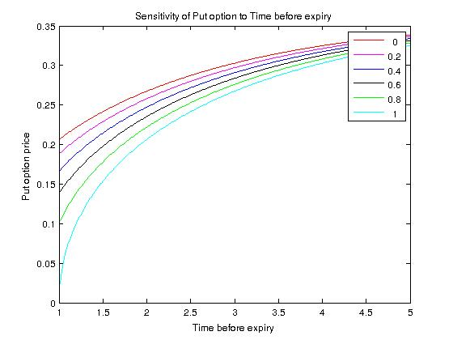

3D plots :

call :

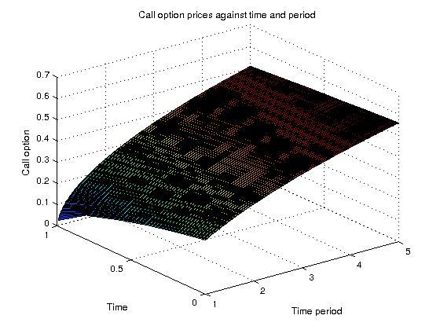

Put :

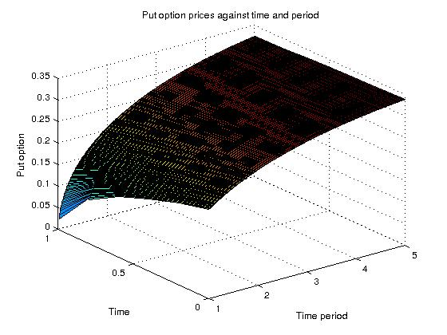

Sensitivity w.r.t r (interest rate) value :

2D plots :

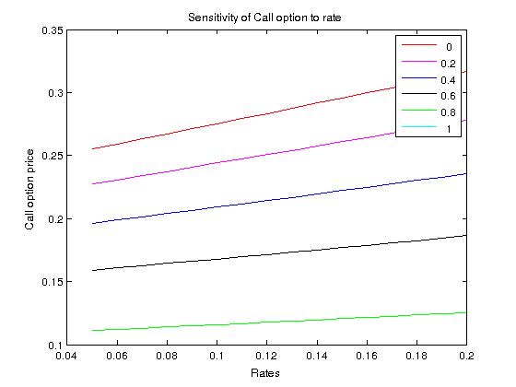

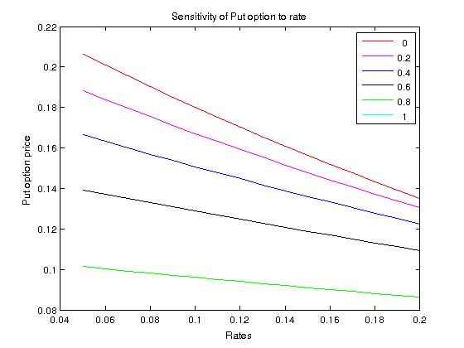

3D plots :

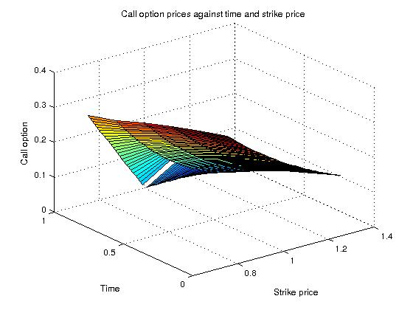

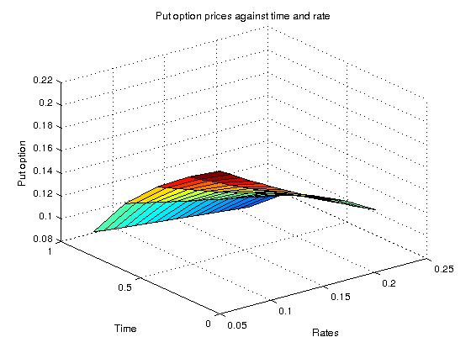

Sensitivity w.r.t Strike price K :

2D plots :

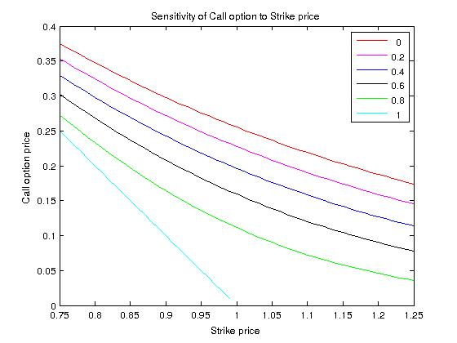

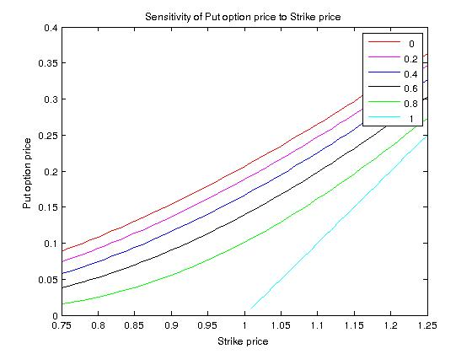

3D plots :

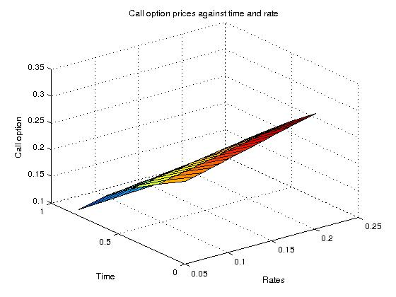

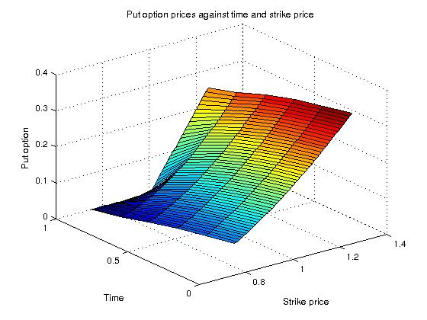

Sensitivity w.r.t sigma (volatility) :

2D plots :

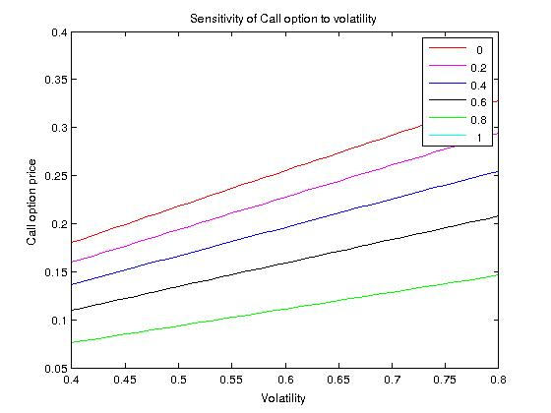

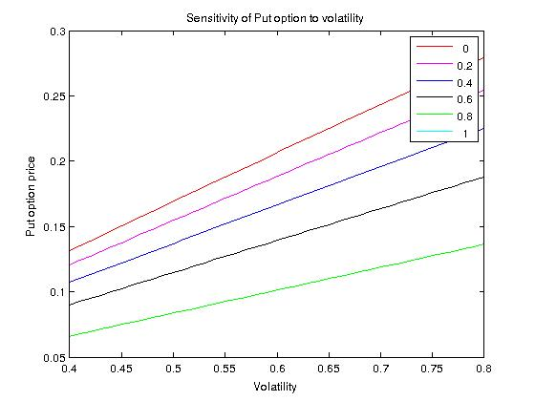

3D plots :

